**SCREENSHOTS:**

**CREATED A SIMPLE PIPELINE FIRST:**

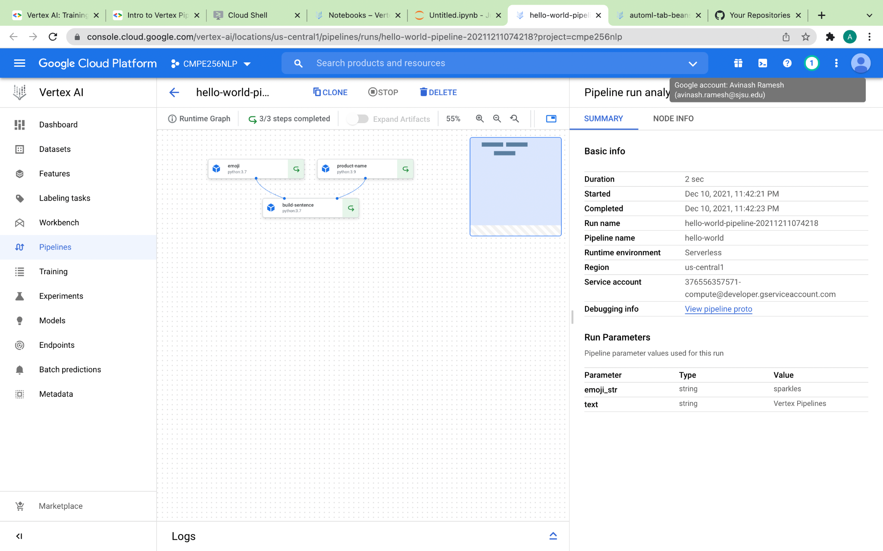

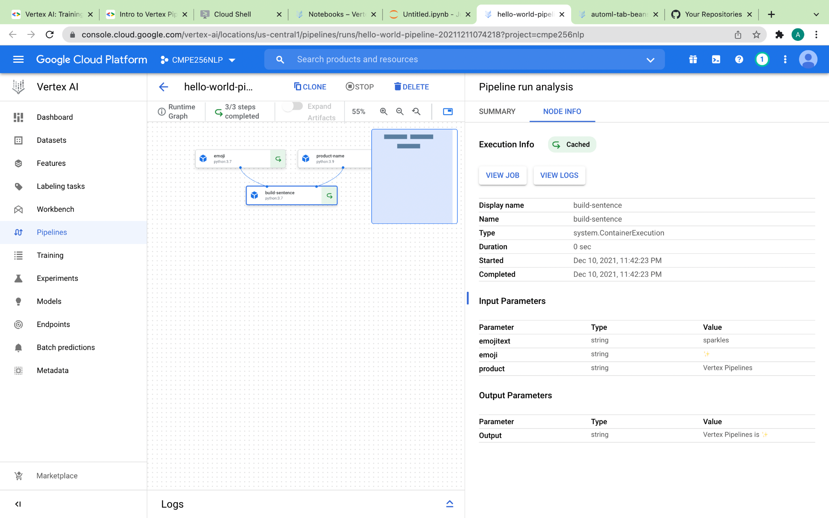

**CREATED AN END-TO-END PIPELINE**