Phase 4: Initial System Configuration & Security Implementation (Week 4):
1.Configure SSH with key-based authentication
Step performed (via SSH)
1.on the workstation:
Copy the public key to the server:
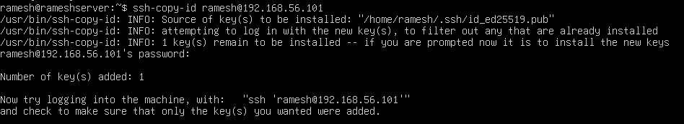
Test SSH key login:
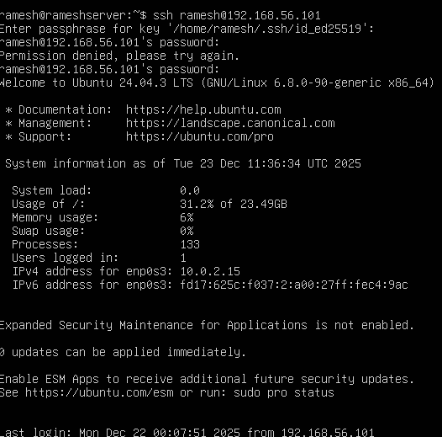
Configuration Change
File edited:
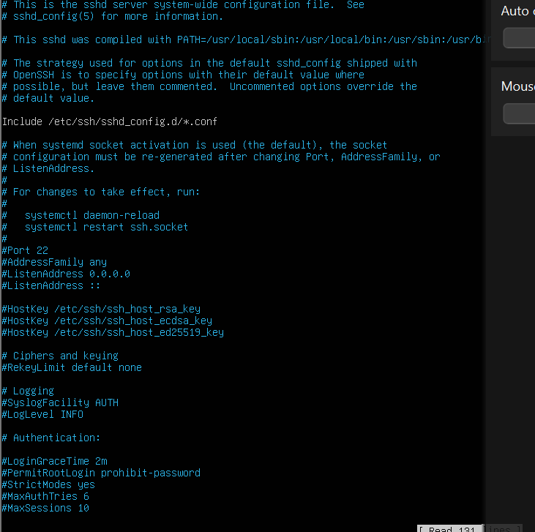

Restart SSH (Ubuntu 24.04):
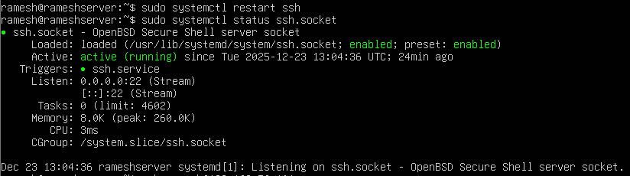
Test SSH login:
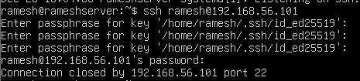

2. configure a firewall permitting SSH from one specific workstation only?
1.Firewall Configuration (UFW)
Enable firewall:
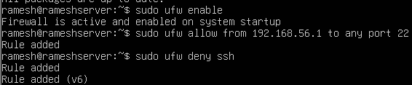

3.Manage users and implement privilege management, creating a non-root administrative user.
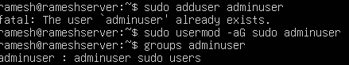

4.SSH Access Evidence showing successful connection screenshots?
Ans: SSH Access Evidence
Evidence Required
Screenshot showing:
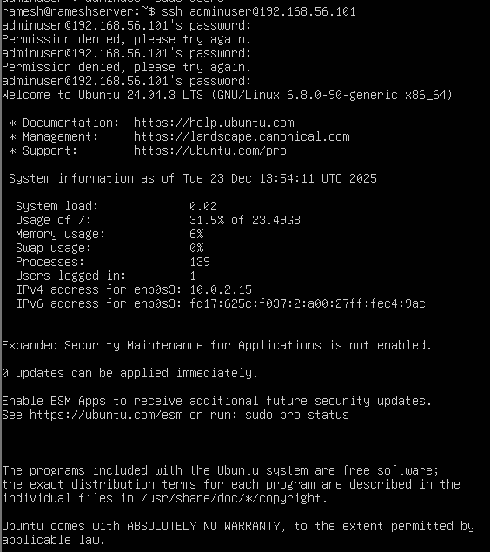

6. Firewall Documentation showing complete ruleset:
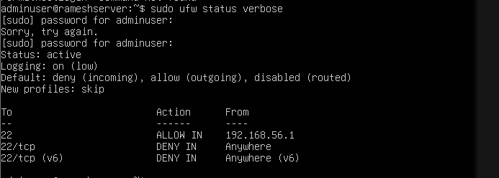

7. Remote Administration Evidence demonstrating commands executed via SSH?
