#MapSide Join .

Description: Map side join example.

Mapreduce Join operation is used to combine two large datasets. However, this process involves writing lots of code to perform the actual join operation. Joining two datasets begins by comparing the size of each dataset. If one dataset is smaller as compared to the other dataset then smaller dataset is distributed to every data node in the cluster.
Once a join in MapReduce is distributed, either Mapper or Reducer uses the smaller dataset to perform a lookup for matching records from the large dataset and then combine those records to form output records.

Types of Join
Depending upon the place where the actual join is performed, joins in Hadoop are classified into-
1. Map-side join – When the join is performed by the mapper, it is called as map-side join. In this type, the join is performed before data is actually consumed by the map function. It is mandatory that the input to each map is in the form of a partition and is in sorted order. Also, there must be an equal number of partitions and it must be sorted by the join key.
2. Reduce-side join – When the join is performed by the reducer, it is called as reduce-side join. There is no necessity in this join to have a dataset in a structured form (or partitioned).
Here, map side processing emits join key and corresponding tuples of both the tables. As an effect of this processing, all the tuples with same join key fall into the same reducer which then joins the records with same join key.
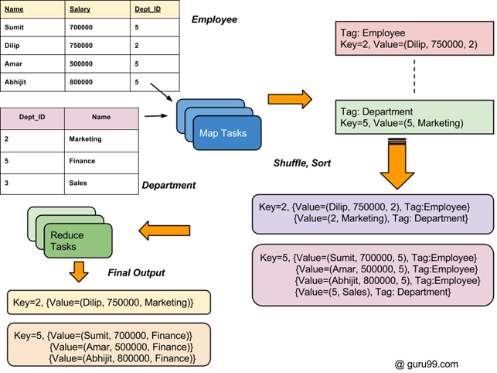

How to Join two DataSets: MapReduce Example
There are two Sets of Data in two Different Files (shown below). The Key Dept_ID is common in both files. The goal is to use MapReduce Join to combine these files
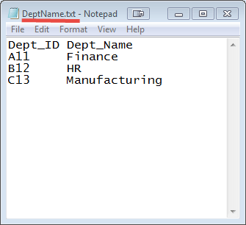

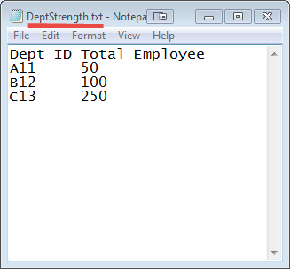
#Mapper side join class

Step 1: Create a java project called JoinTypes in eclipse.

File-> New-> Java Project-> Give the name of the project as “JoinTypes”
Step2: import all the hadoop related jar file to eclipse.
Right Click on “JoinTypes” project and click on properties
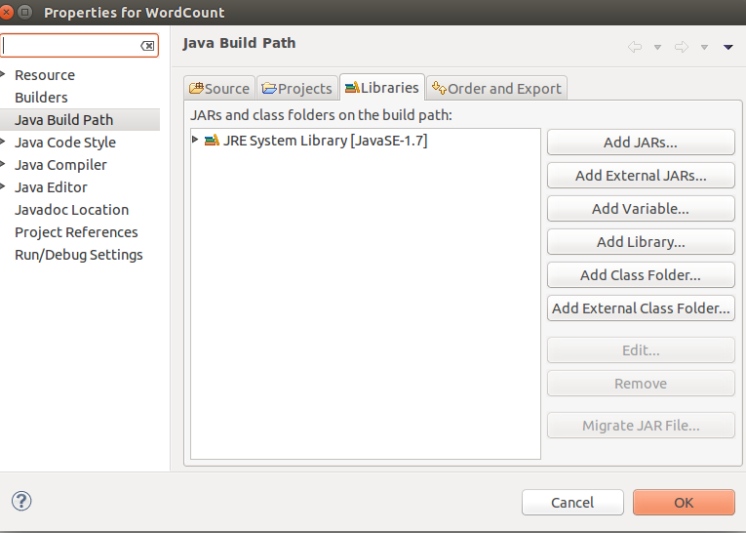
under libraries-> click on Add External JARs

import all below jar files from below paths,
from $HADOOP_HOME/share/hadoop/client path import all jars
select jar files and click ok.
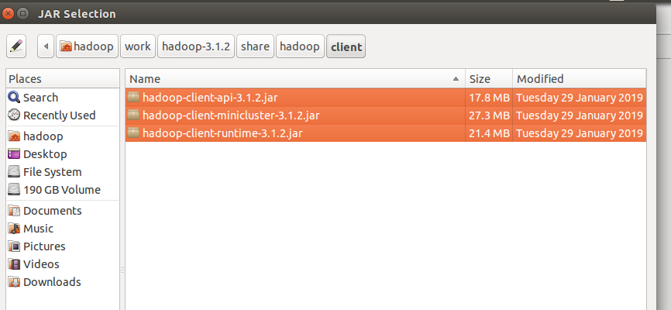
Again click on the Add External JARs and
import all below jar files from below paths,
from $HADOOP_HOME/share/hadoop/common path import all jars
select jar files and click ok.

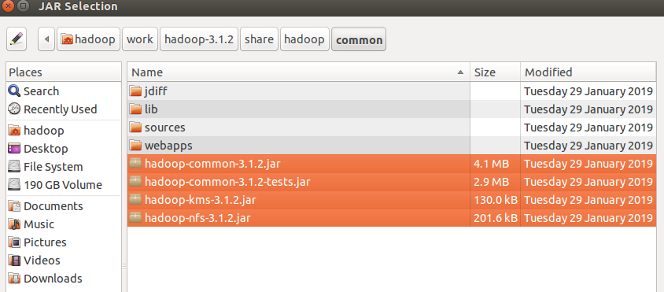
Again click on the Add External JARs and
import all below jar files from below paths,
from $HADOOP_HOME/share/hadoop/common/lib path import all jars
select jar files and click ok.

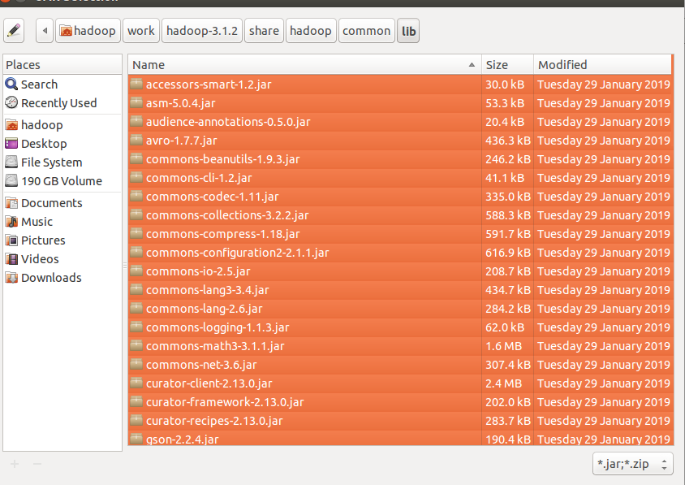
Again click on the Add External JARs and
import all below jar files from below paths,
from $HADOOP_HOME/share/hadoop/hdfs path import all jars
select jar files and click ok.

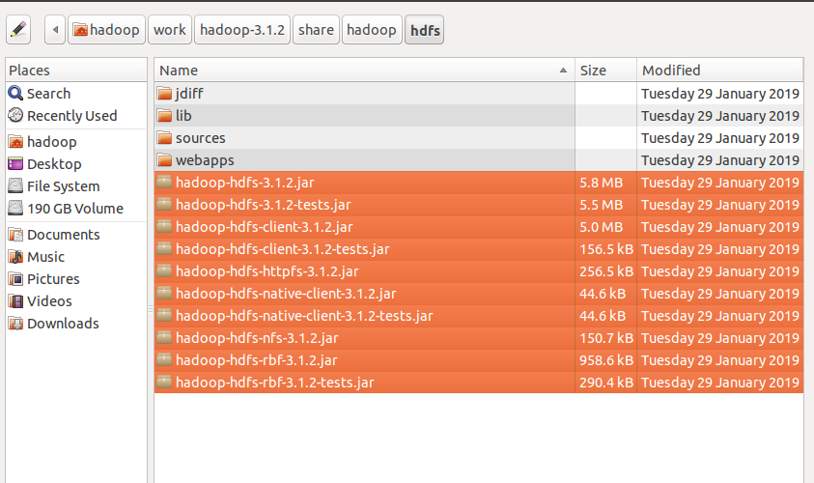

Again click on the Add External JARs and
import all below jar files from below paths,
from $HADOOP_HOME/share/hadoop/mapreduce path import all jars
select jar files and click ok.
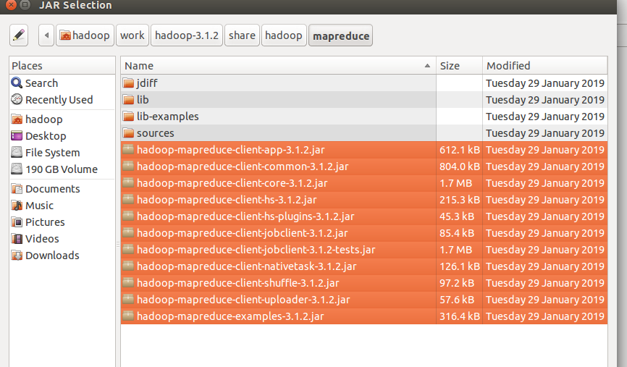
Again click on the Add External JARs and
import all below jar files from below paths,
from $HADOOP_HOME/share/hadoop/yarn path import all jars
select jar files and click ok.
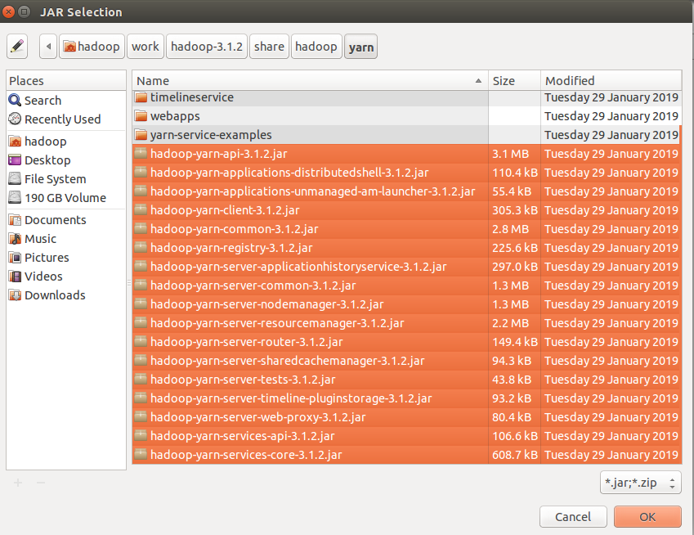

Step 3: Create a package in the package
right click on the src folder in “JoinTypes” project-> New ->package
give any package name as “com.ramesh.MapperJoin” -> Finish

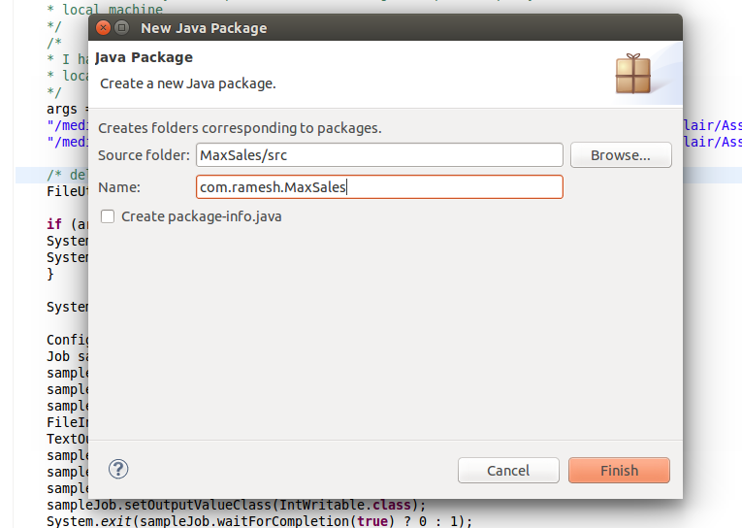

Step 4: create a class files
right click on the package name -> New ->class
give class name as “DeptEmpStrengthMapper.java” -> Finish
similarly DeptNameMapper.java
similarly create “MapSideJoinReducer.java” and MapSideJoin.java class
files.

Code for these class files is attached .

Mapper Class: DeptEmpStrengthMapper.java and DeptNameMapper.java

Reducer Class: MapSideJoinReducer.java

Driver Class: MapSideJoin.java
Custom Type: TextPair.java

input file:

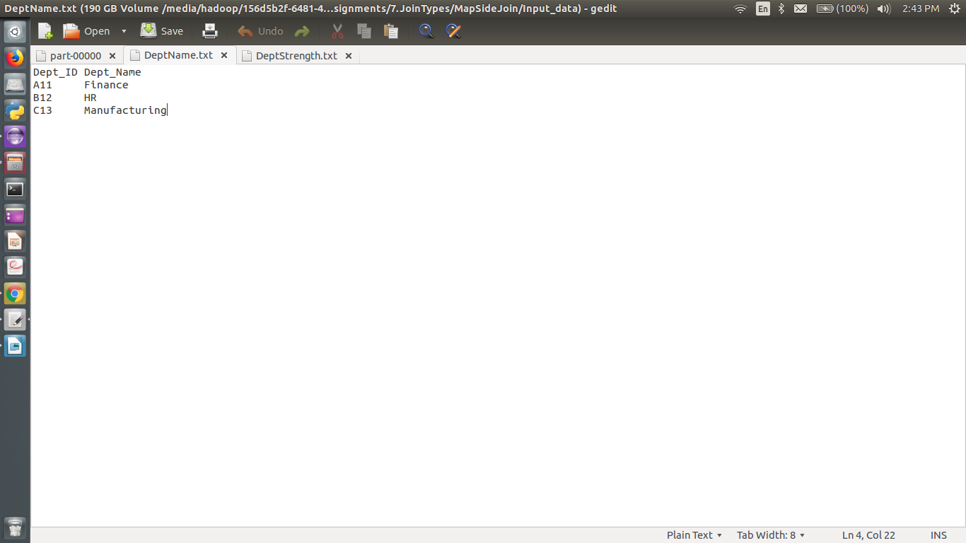

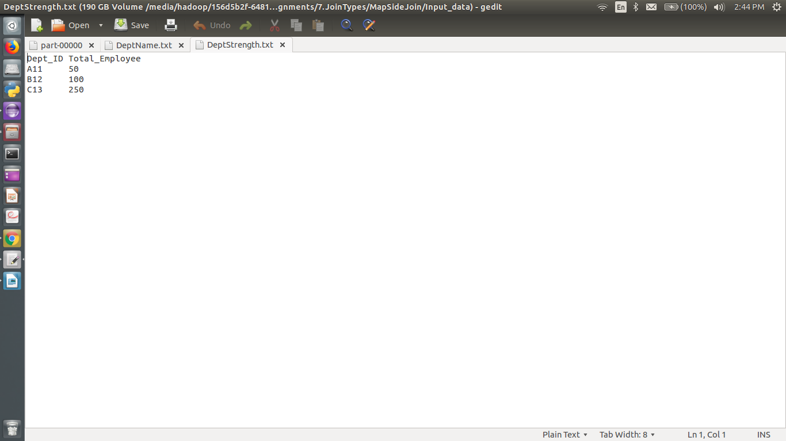

i am giving the path of the file in my local and output path in my local machine
Input path: "/media/hadoop/156d5b2f-6481-4a81-b1bb-56e2179981bb1/ramesh/2018 life/hadoop/DataFlair/Assignments/7.JoinTypes/ReduceSideJoin/Input_Path/sample_hlog.csv
"
"/media/hadoop/156d5b2f-6481-4a81-b1bb-56e2179981bb1/ramesh/2018 life/hadoop/DataFlair/Assignments/7.JoinTypes/ReduceSideJoin/Input_Path/sample_dsl.csv"

Output path: "/media/hadoop/156d5b2f-6481-4a81-b1bb-56e2179981bb1/ramesh/2018 life/hadoop/DataFlair/Assignments//7.JoinTypes/ReduceSideJoin/Output_Path
/"

Run the Job:
right click-> Run As -> Java Application

Verify the result in the Output path:

