#Custom Writable class family members and calculate their average age.

Description: Demonistration about custom writable class in mapreduce to calculate the average age of the family.
If you have gone through other Hadoop MapReduce examples, you will have noticed the use of “Writable” data types such as LongWritable, IntWritable, Text, etc… All values in used in Hadoop MapReduce must implement the Writable interface.
Although we can do a lot with the primitive Writables already available with Hadoop, there are often times when we want to transmit a variety of data and/or data types from Mapper to Reducer. Sometimes it is possible to convert all these data into strings and concatenate them to result in a single key or single value. However, this can get very messy, and is not recommended.

Implementing Writable requires implementing two methods,
- readFields(DataInput in)

write(DataOutput out).

Writables that are used as keys in MapReduce jobs must also implement Comparable (or simply WritableComparable). Overriding the toString() method is not necessary, but can be very helpful when storing your output data as text in HDFS.

Below is an example of a custom Writable that is used to store family member details.

create custom writable should implement Writable interface to use as a map reduce jobs value class.

1) write method

Override write method and add logic to write all the fields value. In case of list or collections, first write size of the collection variable and then write all the value into it.

2) readFields method

A read fields method will read all the fields value from input stream. We must follow the same order of read and write of a data members.

3) Add Default Constructor

The final step is to add one default constructor to allow serialization/deserialization of a custom data types.

Example:

In this example, We have created custom FamilyWritable data types to aggregate all the family members and calculate their average age. We have tried to make this example as easy as possible for better understanding.

Custom Writable class family members and calculate their average age

Step 1: Create a java project called FamilyMember in eclipse.

File-> New-> Java Project-> Give the name of the project as “FamilyMember”
Step2: import all the hadoop related jar file to eclipse.
Right Click on “FamilyMember” project and click on properties
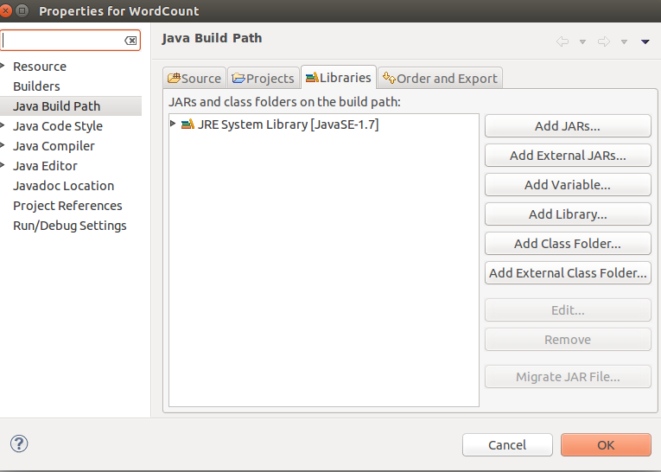
under libraries-> click on Add External JARs

import all below jar files from below paths,
from $HADOOP_HOME/share/hadoop/client path import all jars
select jar files and click ok.
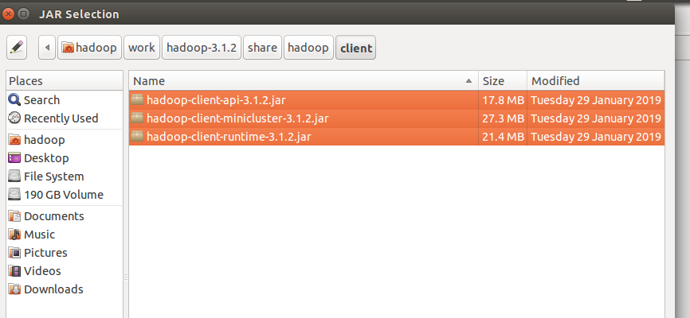
Again click on the Add External JARs and
import all below jar files from below paths,
from $HADOOP_HOME/share/hadoop/common path import all jars
select jar files and click ok.

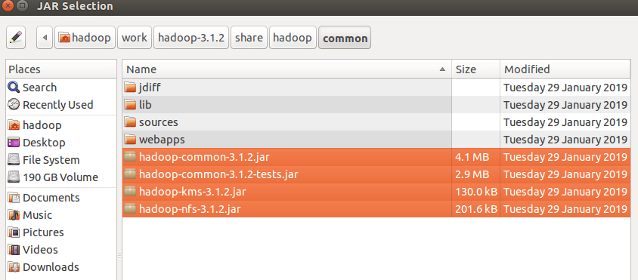
Again click on the Add External JARs and
import all below jar files from below paths,
from $HADOOP_HOME/share/hadoop/common/lib path import all jars
select jar files and click ok.

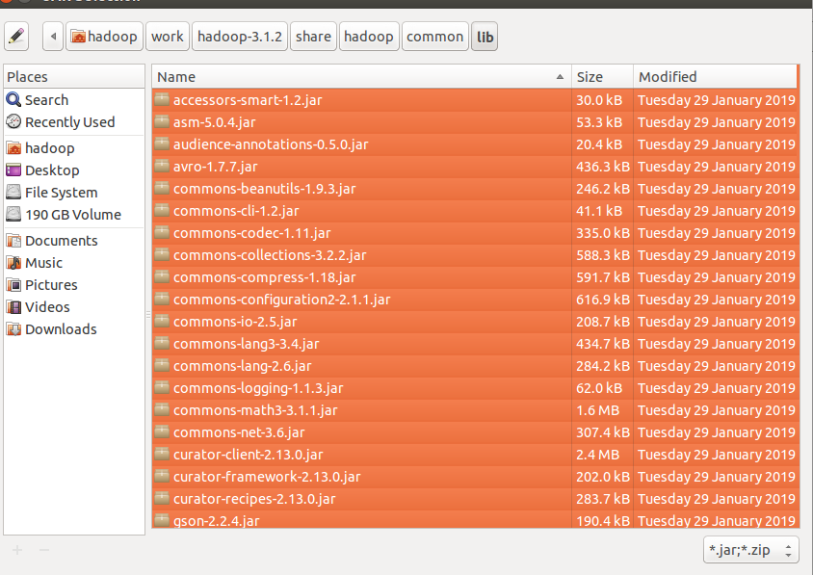
Again click on the Add External JARs and
import all below jar files from below paths,
from $HADOOP_HOME/share/hadoop/hdfs path import all jars
select jar files and click ok.

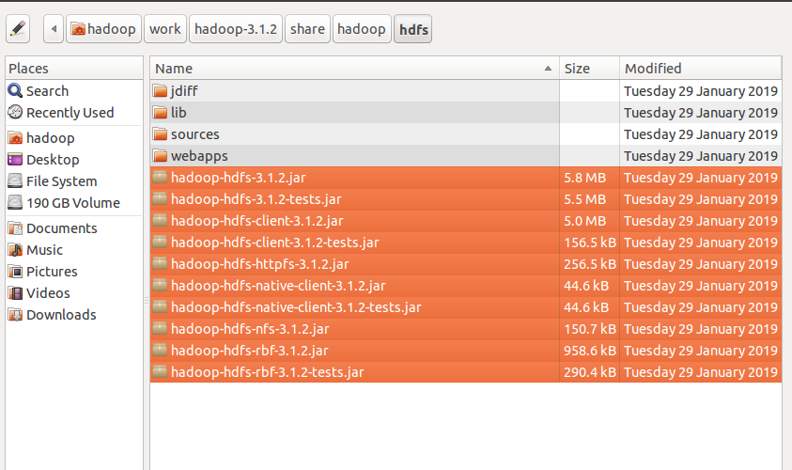

Again click on the Add External JARs and
import all below jar files from below paths,
from $HADOOP_HOME/share/hadoop/mapreduce path import all jars
select jar files and click ok.
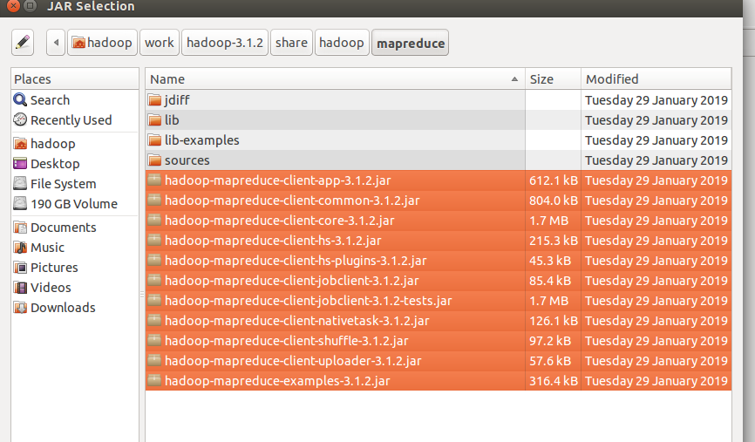
Again click on the Add External JARs and
import all below jar files from below paths,
from $HADOOP_HOME/share/hadoop/yarn path import all jars
select jar files and click ok.
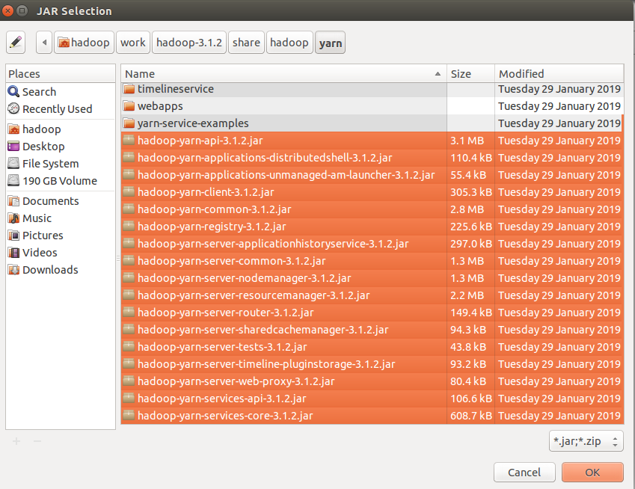

Step 3: Create a package in the package
right click on the src folder in “FamilyMember” project-> New ->package
give any package name as “com.ramesh.Family” -> Finish

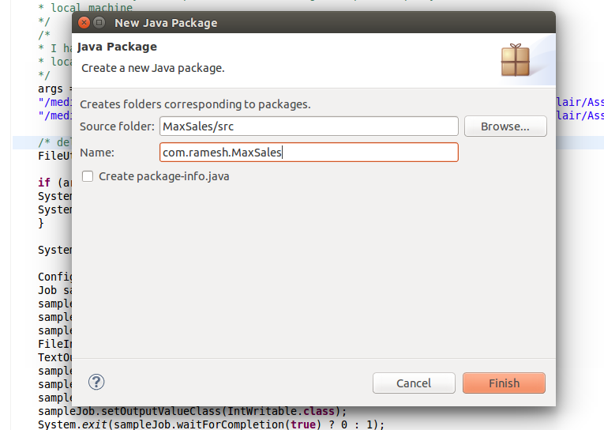

Step 4: create a class files
right click on the package name -> New ->class
give class name as “FamilyMapper” -> Finish

similarly create “FamilyReducer” and FamilyDriver class
files.

Create a CustomWritable class called FamilyWritable class and pass as mapper output value.

Code for these class files is attached .

Mapper Class: FamilyMapper.java

Reducer Class: FamilyReducer.java

Driver Class: FamilyDriver.java

input file:

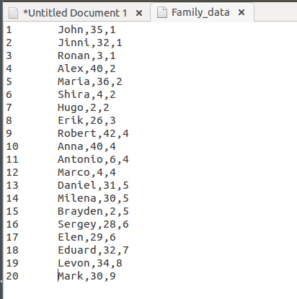

i am giving the path of the file in my local and output path in my local machine
Input path: "/media/hadoop/156d5b2f-6481-4a81-b1bb-56e2179981bb1/ramesh/2018 life/hadoop/DataFlair/Assignments/5.Writables/Input_Data/Family_data"

Output path: "/media/hadoop/156d5b2f-6481-4a81-b1bb-56e2179981bb1/ramesh/2018 life/hadoop/DataFlair/Assignments//5.Writables/Output_Data/"

Run the Job:
right click-> Run As -> Java Application

Verify the result in the Output path:

