#Custom Writable Comparable class .

Description: Demonistration about custom WritableComparable
class in mapreduce.

Let’s discuss all the steps to create our own custom writable data types which can be used as MapReduce key class or value class. In this example we will create a custom writable datatype which used as MapReduce key class as well as value class.

Implement WritableComparable Interface
create custom writable should implement WritableComparable interface to use as a map reduce jobs key and value class.

write method
Override write method and add logic to write all the fields value. In case of list or collections, first write size of the collection variable and then write all the value into it.

readFields method
A read fields method will read all the fields value from input stream. We must follow the same order of read and write of a data members.

Add Default Constructor
The final step is to add one default constructor to allow serialization/deserialization of a custom data types.

equals and hashCode
As we use our custom writable as a map-reduce key class we need to override equals and hashcode method to get the desired result.

compareTo
Override compareTo method and write logic of our custom data type sorting. This method is very important as if we do mistake in this method we may get the wrong result, duplicate key in reducer etc…

Problem Statement
Consider one new Project where we got requirements from one taxi agency and they want to analyze passenger rush in the different location of London city. Based on the result they will analyze results and can reschedule taxis to gain more money.
Taxi agency will collect all the taxi data from past 2 months and our job is to parse this input data and give location names where more number of passenger uses a taxi.

Solution
As we see in sample input, we have latitude, longitude, location names with all the taxiID along with a number of passengers take a trip. We need to write a custom writable class of geolocation data and compare at which location more number of passengers uses taxis.

#Custom Writable Comparable class

Step 1: Create a java project called PassengerRush in eclipse.

File-> New-> Java Project-> Give the name of the project as “PassengerRush”
Step2: import all the hadoop related jar file to eclipse.
Right Click on “PassengerRush” project and click on properties
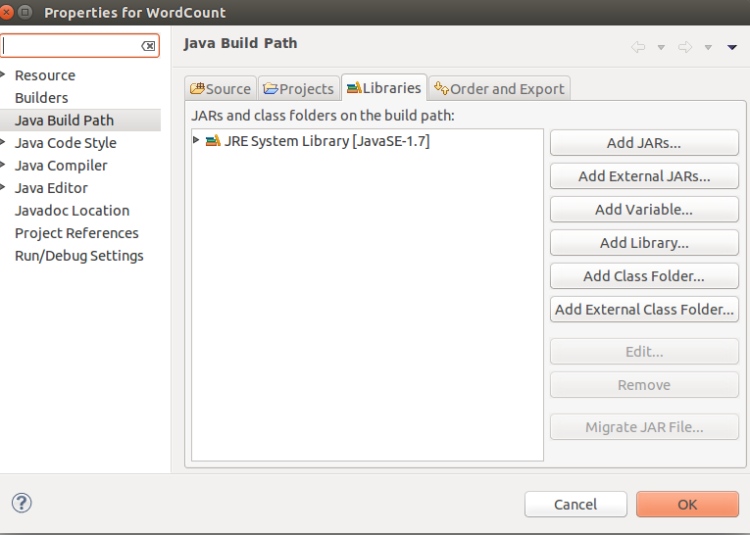
under libraries-> click on Add External JARs

import all below jar files from below paths,
from $HADOOP_HOME/share/hadoop/client path import all jars
select jar files and click ok.
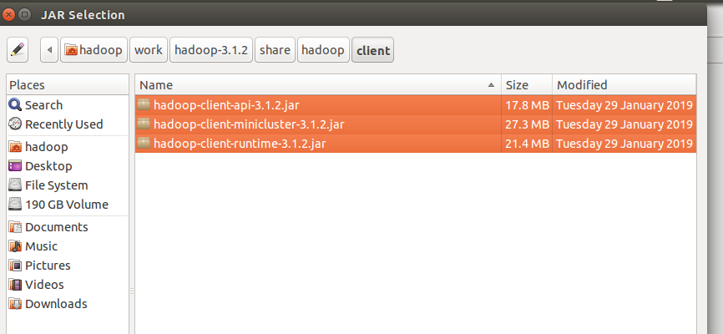
Again click on the Add External JARs and
import all below jar files from below paths,
from $HADOOP_HOME/share/hadoop/common path import all jars
select jar files and click ok.

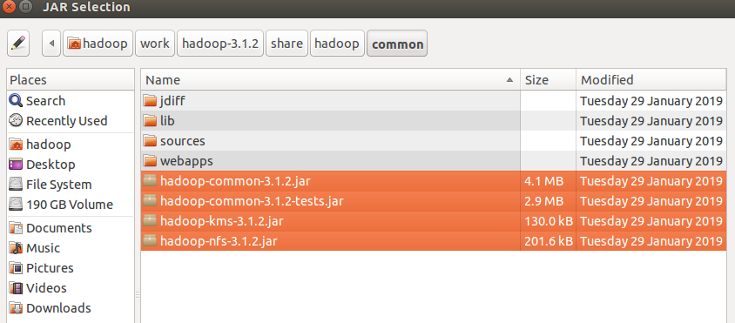
Again click on the Add External JARs and
import all below jar files from below paths,
from $HADOOP_HOME/share/hadoop/common/lib path import all jars
select jar files and click ok.

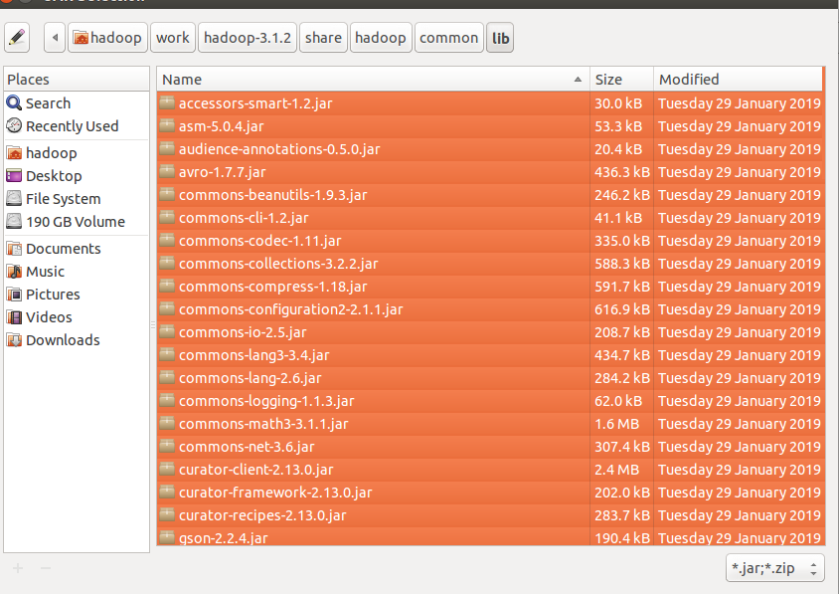
Again click on the Add External JARs and
import all below jar files from below paths,
from $HADOOP_HOME/share/hadoop/hdfs path import all jars
select jar files and click ok.

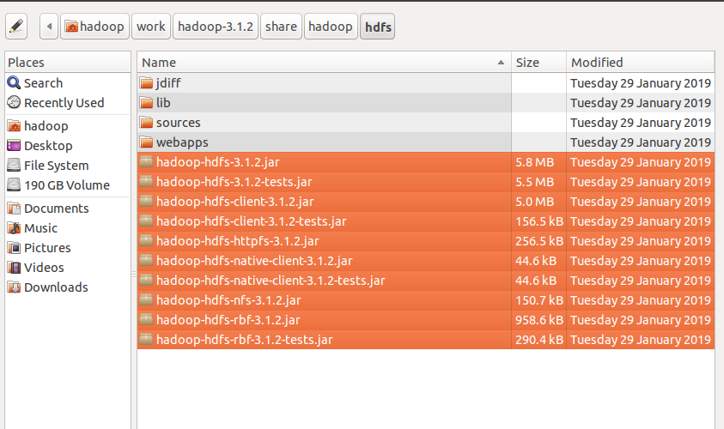

Again click on the Add External JARs and
import all below jar files from below paths,
from $HADOOP_HOME/share/hadoop/mapreduce path import all jars
select jar files and click ok.
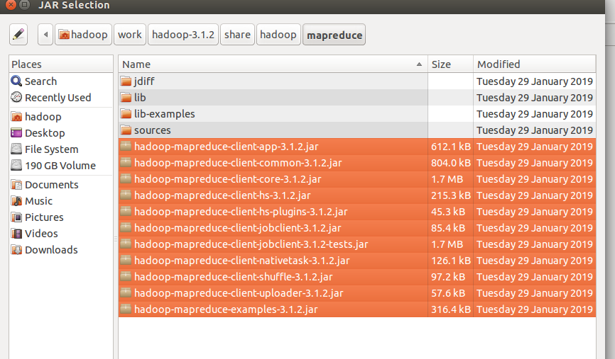
Again click on the Add External JARs and
import all below jar files from below paths,
from $HADOOP_HOME/share/hadoop/yarn path import all jars
select jar files and click ok.
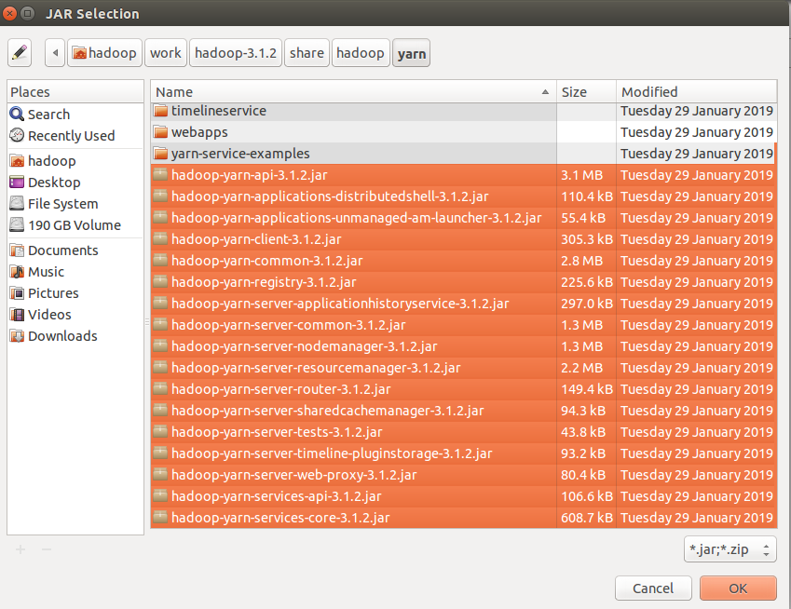

Step 3: Create a package in the package
right click on the src folder in “PassengerRush” project-> New ->package
give any package name as “com.ramesh.Passenger” -> Finish

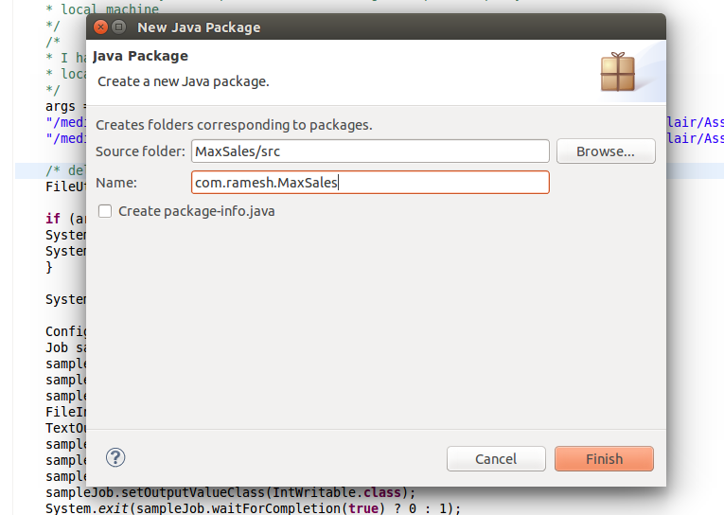

Step 4: create a class files
right click on the package name -> New ->class
give class name as “PassengerRushAnalysisMapper” -> Finish

similarly create “PassengerRushAnalysisReducer” and PassengerRushAnalysisDriver class
files.

Create a CustomWritable class called GeoLocationWritable class and pass as mapper output value.

Code for these class files is attached .

Mapper Class: PassengerRushAnalysisMapper.java

Reducer Class: PassengerRushAnalysisReducer.java

Driver Class: PassengerRushAnalysisDriver.java

input file:

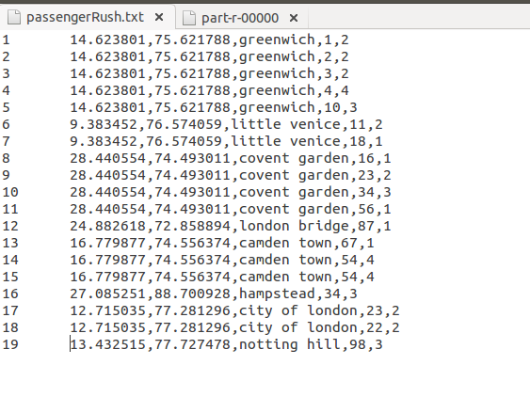

i am giving the path of the file in my local and output path in my local machine
Input path: "/media/hadoop/156d5b2f-6481-4a81-b1bb-56e2179981bb1/ramesh/2018 life/hadoop/DataFlair/Assignments/5.CustomWritableComparable/Input_Data/passengerRush.txt"

Output path: "/media/hadoop/156d5b2f-6481-4a81-b1bb-56e2179981bb1/ramesh/2018 life/hadoop/DataFlair/Assignments//5.CustomWritableComparable/Output_Data/"

Run the Job:
right click-> Run As -> Java Application

Verify the result in the Output path:

