#TOP N Records in a file using MapReduce program

Description: Demonistration about finding a top 10 records in a file using a map reduce program.
Following are the methods available in the Mapper class:
setup
map
run
cleanup
Let’s see each one of these in details:
4.1 Setup
Setup method as the name indicates is used to setup the map task and is used only once at the beginning of the task. All the logic needed to run the task is initialized in this method. Most of the time, it is not required to modify or overwrite this method.
It takes the Mapper.Context object as the parameter and throws IOException and InteruptedException.

protected void setup(Mapper.Context context) throws IOException, InterruptedException

4.2 Map

This is the most important method and is the once a developer should be most aware of. Map method is called once for every key/value pair in the input to the mapper task. This is the method which we need to overwrite in any of the application we develop and it should contain all the logic need to be performed in the map task.

protected void map(KEYIN key, VALUIN value, Mapper.Context context)
throws IOException, InterruptedException

This method takes the key and the value from the key-value pair in the input split and context. Map method can throw two kind of exception IOException and InterruptedException

4.3 Run
If we want to take more control of how the map task runs/executes this is the method we need to overwrite.
Run is the method which should not be modified without proper knowledge, it is the method which is responsible for running/execution of the map task. That is the reason extreme care is required in case the developer want to overwrite this method.
public void run(Mapper.Context context) throws IOException, InterruptedException

run method takes only one argument i.e. Mapper.Context and can throw two excetions similar to other methods i.e. IOException or InterruptedException

4.4 Cleanup

Cleanup is the method which is called only once at the end of the task. This method as the name indicates is responsible for the cleanup of the task residues if any.

proptected void cleanup(Mapper.Context context) throws IOException, InterruptedException

Similar to all other method this method also takes Mapper.Context as argument and can throw IOException and InterruptedException

Top_N_Records

with MapReduce example

Step 1: Create a java project called Top_N_Records in eclipse.

File-> New-> Java Project-> Give the name of the project as “Top_N_Records”
Step2: import all the hadoop related jar file to eclipse.
Right Click on “Top_N_Records” project and click on properties

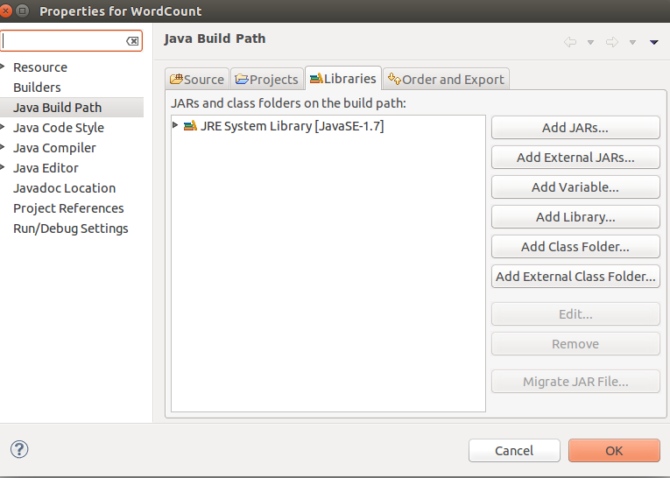
under libraries-> click on Add External JARs

import all below jar files from below paths,
from $HADOOP_HOME/share/hadoop/client path import all jars
select jar files and click ok.
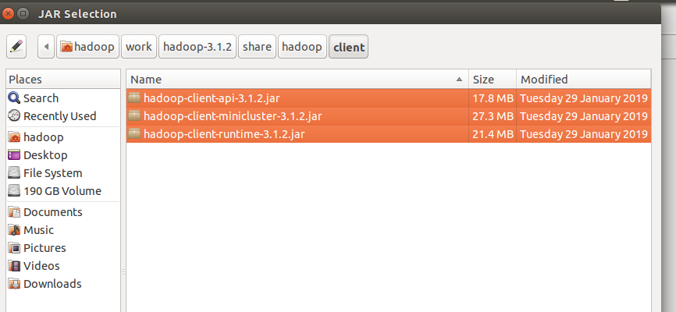
Again click on the Add External JARs and
import all below jar files from below paths,
from $HADOOP_HOME/share/hadoop/common path import all jars
select jar files and click ok.

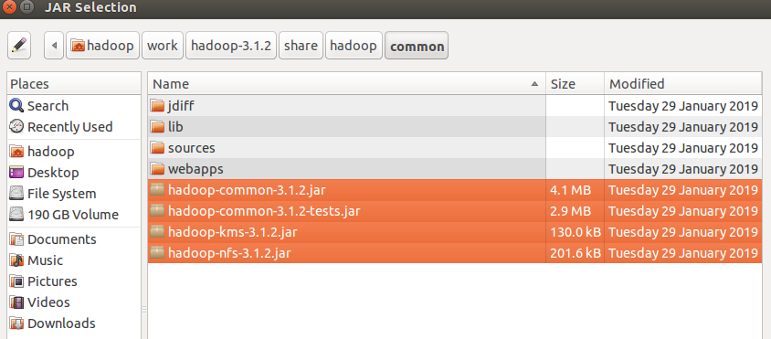
Again click on the Add External JARs and
import all below jar files from below paths,
from $HADOOP_HOME/share/hadoop/common/lib path import all jars
select jar files and click ok.

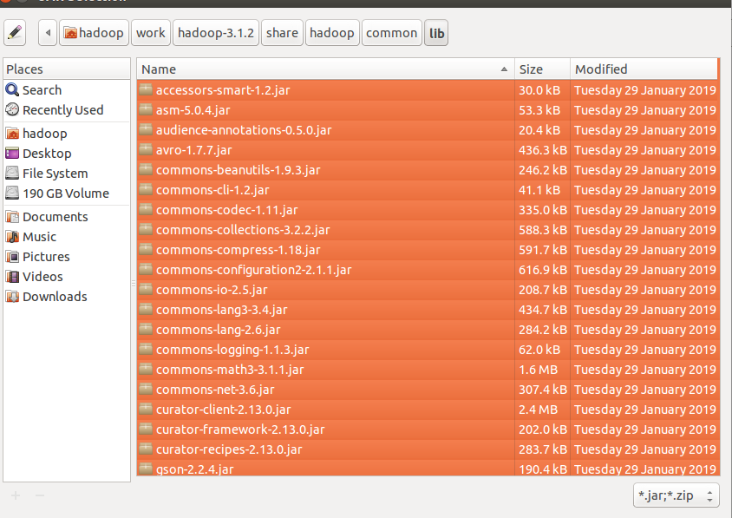
Again click on the Add External JARs and
import all below jar files from below paths,
from $HADOOP_HOME/share/hadoop/hdfs path import all jars
select jar files and click ok.

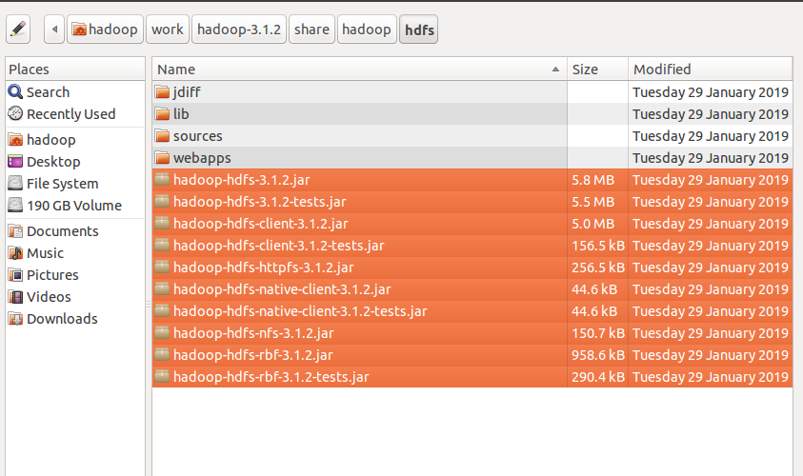

Again click on the Add External JARs and
import all below jar files from below paths,
from $HADOOP_HOME/share/hadoop/mapreduce path import all jars
select jar files and click ok.
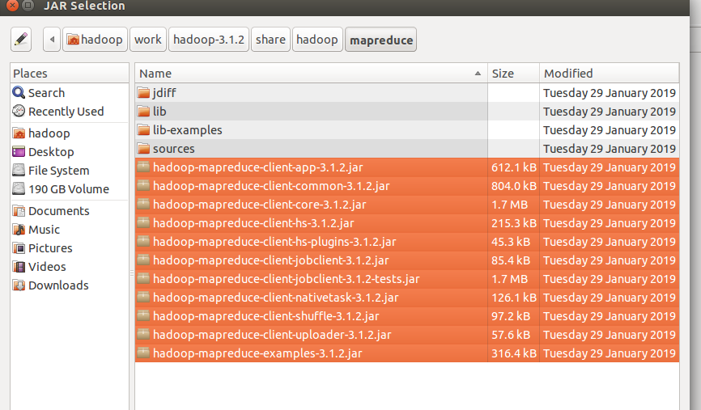
Again click on the Add External JARs and
import all below jar files from below paths,
from $HADOOP_HOME/share/hadoop/yarn path import all jars
select jar files and click ok.
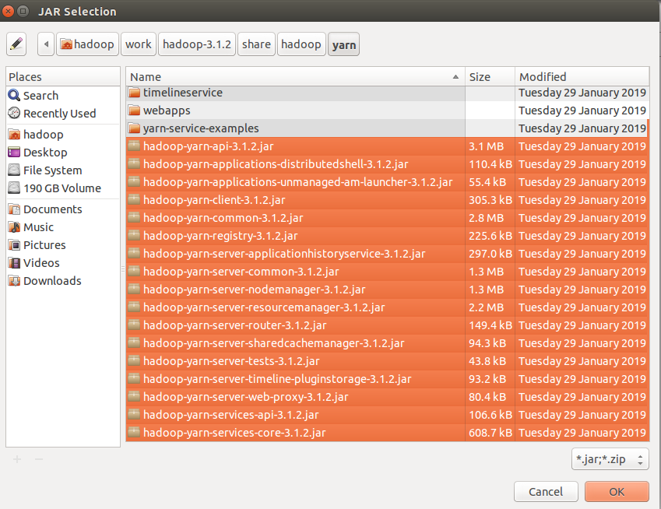

Step 3: Create a package in the package
right click on the src folder in “Top_N_Records” project-> New ->package
give any package name as “com.ramesh.Top_N_Records ” -> Finish

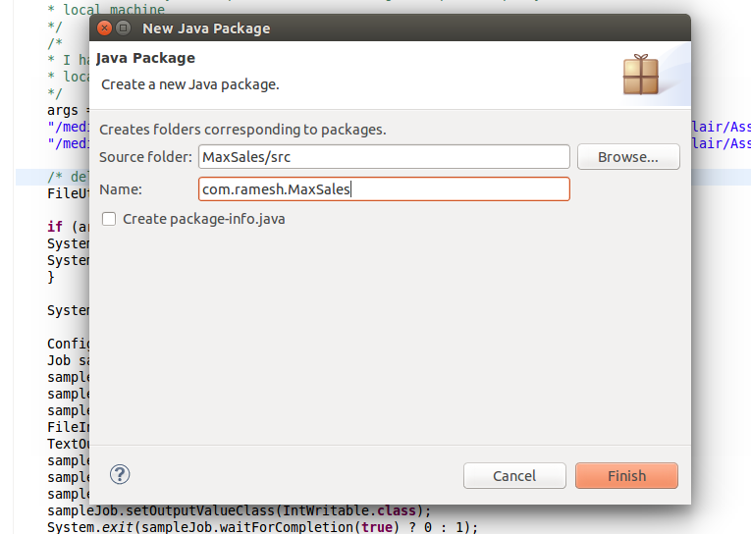

Step 4: create a class files
right click on the package name -> New ->class
give class name as “Top10MoviesMapper” -> Finish

similarly create “Top10MoviesReducer” and Top10MoviesDriver class files.

Code for these class files is attached .

Mapper Class: Top10MoviesMapper.java

Reducer Class: Top10MoviesReducer.java

Driver Class: Top10MoviesDriver.java

input file:

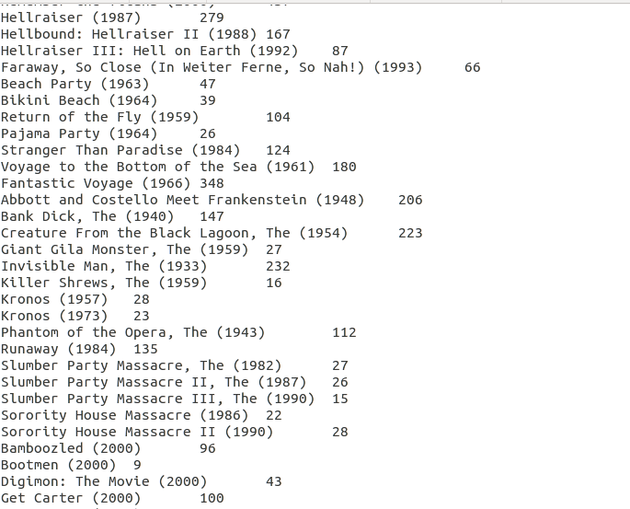

i am giving the path of the file in my local and output path in my local machine
Input path: "/media/hadoop/156d5b2f-6481-4a81-b1bb-56e2179981bb1/ramesh/2018 life/hadoop/DataFlair/Assignments/3.Setup_Cleanup/input_data/Movies.txt"

Output path: "/media/hadoop/156d5b2f-6481-4a81-b1bb-56e2179981bb1/ramesh/2018 life/hadoop/DataFlair/Assignments//3.Setup_Cleanup//output_data/"

Run the Job:
right click-> Run As -> Java Application

Verify the result in the Output path:

