#Custom InputFormat class .

Description: Demonistration about custom WritableComparable
class in mapreduce.

InputFormat describes the input-specification for a Map-Reduce job. (wiki)
The Map-Reduce framework relies on the InputFormat of the job to:
- Validate the input-specification of the job.
- Split-up the input file(s) into logical InputSplits, each of which is then assigned to an individual Mapper.
- Provide the RecordReader implementation to be used to glean input records from the logical InputSplit for processing by the Mapper.
The default behavior of file-based InputFormats, typically sub-classes of FileInputFormat, is to split the input into logical InputSplits based on the total size, in bytes, of the input files. However, the FileSystem blocksize of the input files is treated as an upper bound for input splits. A lower bound on the split size can be set via mapreduce.input.fileinputformat.split.minsize.
Clearly, logical splits based on input-size is insufficient for many applications since record boundaries are to be respected. In such cases, the application has to also implement a RecordReader on whom lies the responsibilty to respect record-boundaries and present a record-oriented view of the logical InputSplit to the individual task.
Hadoop supports processing of many different formats and types of data through InputFormat. The InputFormat of a Hadoop MapReduce computation generates the key-value pair inputs for the mappers by parsing the input data. InputFormat also performs the splitting of the input data into logical partitions, essentially determining the number of Map tasks of a MapReduce computation and indirectly deciding the execution location of the Map tasks. Hadoop generates a map task for each logical data partition and invokes the respective mappers with the key-value pairs of the logical splits as the input.

Why we need Custom Input Format?
We can implement custom InputFormat implementations to gain more control over the input data as well as to support proprietary or application specific input data file format as inputs to Hadoop Mapreduce computations.

#Custom InputFormat class

Step 1: Create a java project called CustomInputFormat in eclipse.

File-> New-> Java Project-> Give the name of the project as “CustomInputFormat”
Step2: import all the hadoop related jar file to eclipse.
Right Click on “CustomInputFormat” project and click on properties
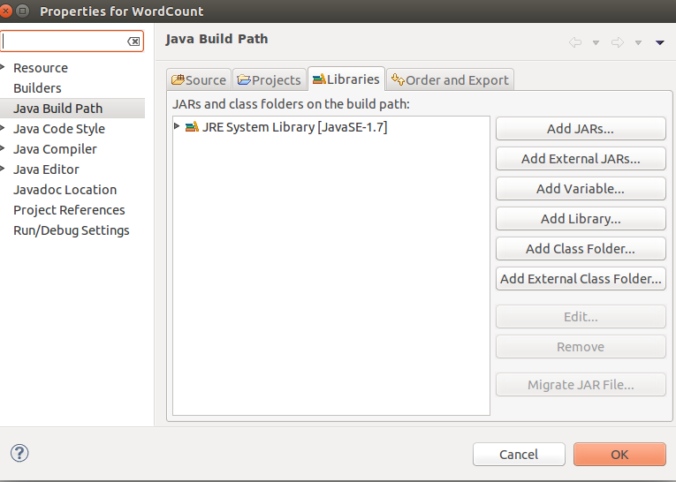
under libraries-> click on Add External JARs

import all below jar files from below paths,
from $HADOOP_HOME/share/hadoop/client path import all jars
select jar files and click ok.
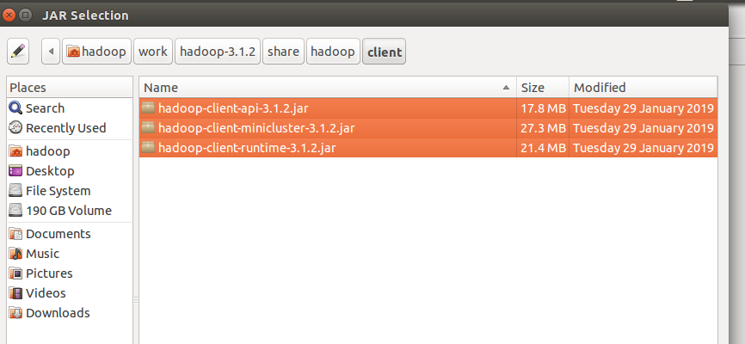
Again click on the Add External JARs and
import all below jar files from below paths,
from $HADOOP_HOME/share/hadoop/common path import all jars
select jar files and click ok.

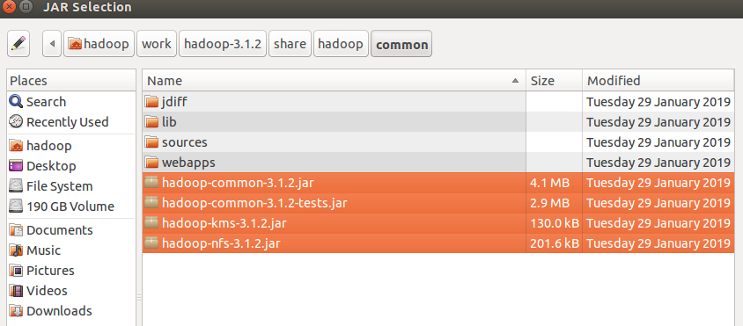
Again click on the Add External JARs and
import all below jar files from below paths,
from $HADOOP_HOME/share/hadoop/common/lib path import all jars
select jar files and click ok.

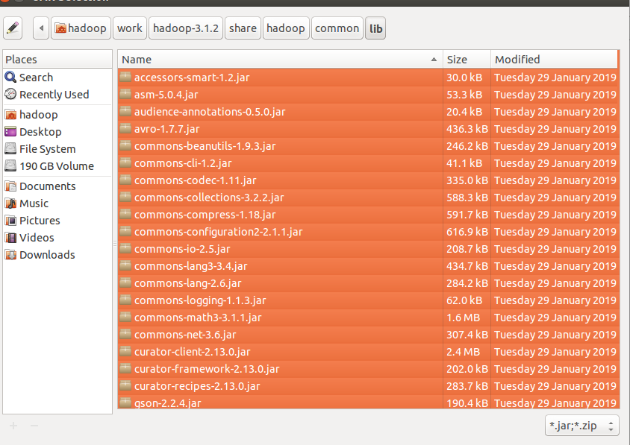
Again click on the Add External JARs and
import all below jar files from below paths,
from $HADOOP_HOME/share/hadoop/hdfs path import all jars
select jar files and click ok.

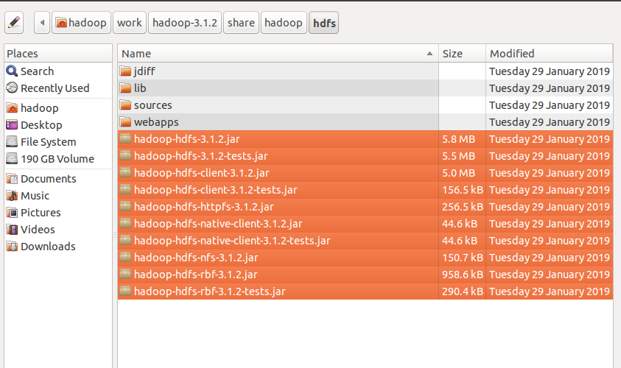

Again click on the Add External JARs and
import all below jar files from below paths,
from $HADOOP_HOME/share/hadoop/mapreduce path import all jars
select jar files and click ok.
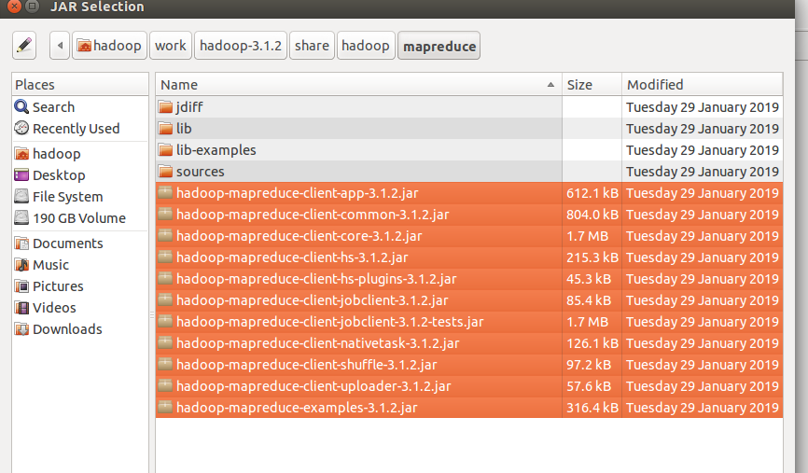
Again click on the Add External JARs and
import all below jar files from below paths,
from $HADOOP_HOME/share/hadoop/yarn path import all jars
select jar files and click ok.
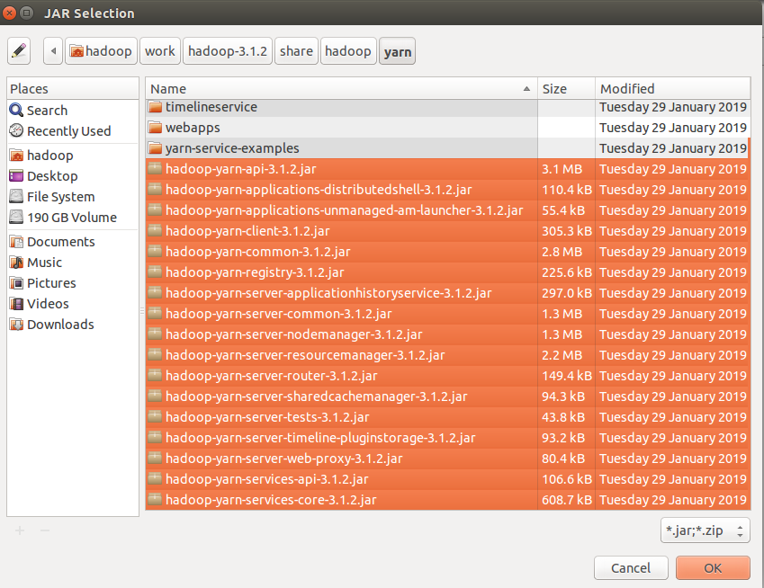

Step 3: Create a package in the package
right click on the src folder in “CustomInputFormat” project-> New ->package
give any package name as “com.ramesh.CTF” -> Finish

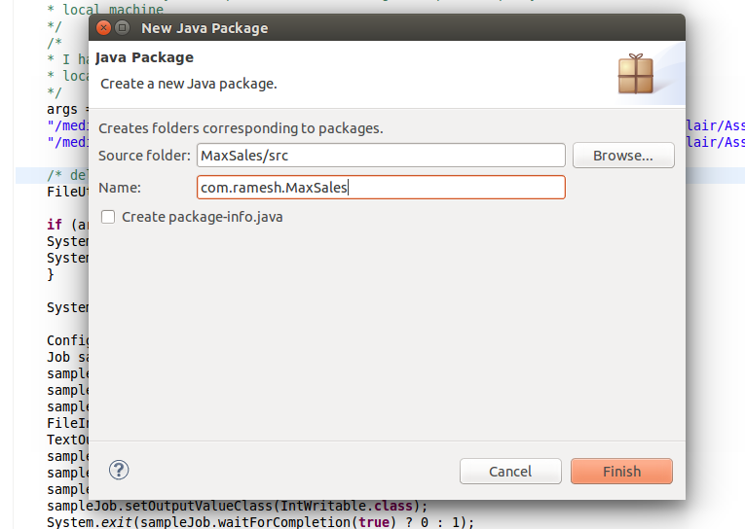

Step 4: create a class files
right click on the package name -> New ->class
give class name as “TempuratureMapper” -> Finish

similarly create “TempuratureReducer” and Tempurature class
files.

Code for these class files is attached .

Mapper Class: TempuratureMapper.java

Reducer Class: TempuratureReducer.java

Driver Class: Tempurature.java
InputFormat: SfaxInputFormat.java
SousseInputFormat.java
SousseRecordReader.java
SfaxRecordReader.java
CustomTypes: value type
CityTemperature.java
Key Type
CustomDate.java
input file:

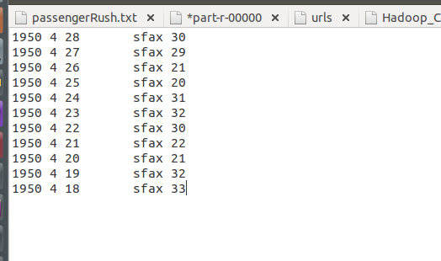

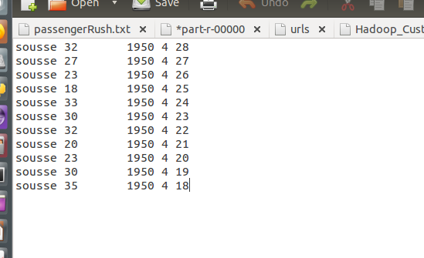

i am giving the path of the file in my local and output path in my local machine
Input path: "/media/hadoop/156d5b2f-6481-4a81-b1bb-56e2179981bb1/ramesh/2018 life/hadoop/DataFlair/Assignments/6.InputFormats/Input_Path/sfax.txt"
"/media/hadoop/156d5b2f-6481-4a81-b1bb-56e2179981bb1/ramesh/2018 life/hadoop/DataFlair/Assignments/6.InputFormats/Input_Path/sousse.txt"

Output path: "/media/hadoop/156d5b2f-6481-4a81-b1bb-56e2179981bb1/ramesh/2018 life/hadoop/DataFlair/Assignments//5.InputFormats/Output_Path/"

Run the Job:
right click-> Run As -> Java Application

Verify the result in the Output path:

