#Reduce Side Join .

Description: Reduce side join example.

A reduce side join is arguably one of the easiest implementations of a join in MapReduce, and therefore is a very attractive choice. It can be used to execute all types of joins like inner join,outer joins,anti joins and Cartesian product.This pattern has no limitation on the size of the data sets and also it can join as many data sets together at once as you need. But a reduce side join will likely require a large amount of network bandwidth because the bulk of the data is sent to the reduce phase.Unfortunately,if all of the data sets are large, reduce side join may be your only choice.

Use cases
1. Multiple large data sets are being joined by a foreign key. If all but one of the data sets can be fit into memory, try using the replicated join.
2. You want the flexibility of being able to execute any join operation.

A plain reduce side join puts a lot of strain on the cluster’s network. Because the foreign key of each input record is extracted and output along with the record and no data can be filtered ahead of time, pretty much all of the data will be sent to the shuffle and sort step. For this reason, reduce side joins will typically utilize relatively more reducers than your typical analytic so if possible try to use any other join patterns available in mapreduce like a replicated join or composite join.

#Mapper join types class

Step 1: Create a java project called JoinTypes in eclipse.

File-> New-> Java Project-> Give the name of the project as “JoinTypes”
Step2: import all the hadoop related jar file to eclipse.
Right Click on “JoinTypes” project and click on properties
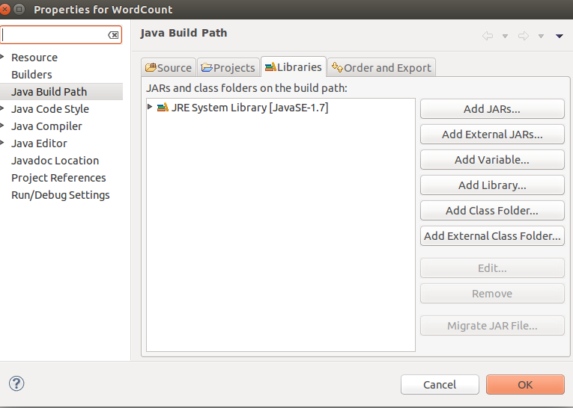
under libraries-> click on Add External JARs

import all below jar files from below paths,
from $HADOOP_HOME/share/hadoop/client path import all jars
select jar files and click ok.
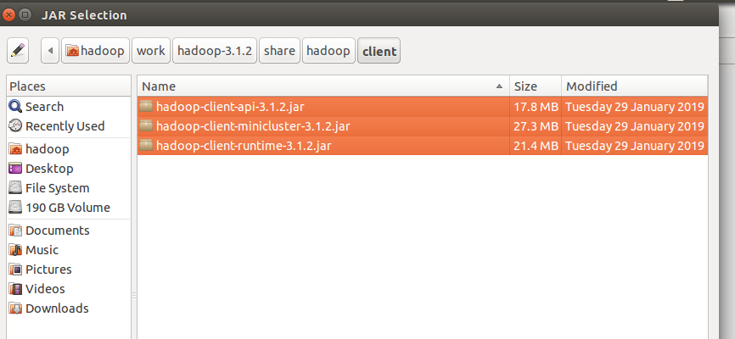
Again click on the Add External JARs and
import all below jar files from below paths,
from $HADOOP_HOME/share/hadoop/common path import all jars
select jar files and click ok.

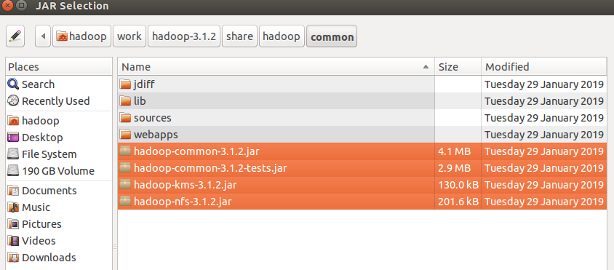
Again click on the Add External JARs and
import all below jar files from below paths,
from $HADOOP_HOME/share/hadoop/common/lib path import all jars
select jar files and click ok.

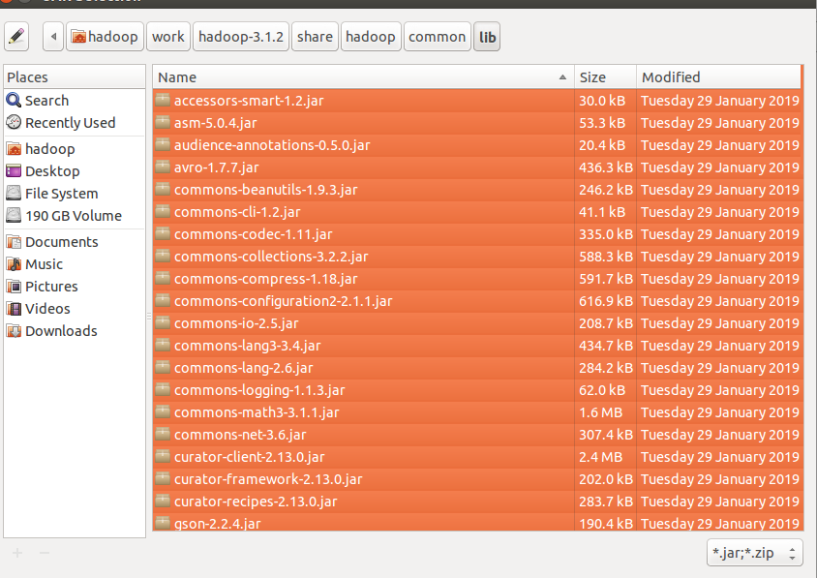
Again click on the Add External JARs and
import all below jar files from below paths,
from $HADOOP_HOME/share/hadoop/hdfs path import all jars
select jar files and click ok.

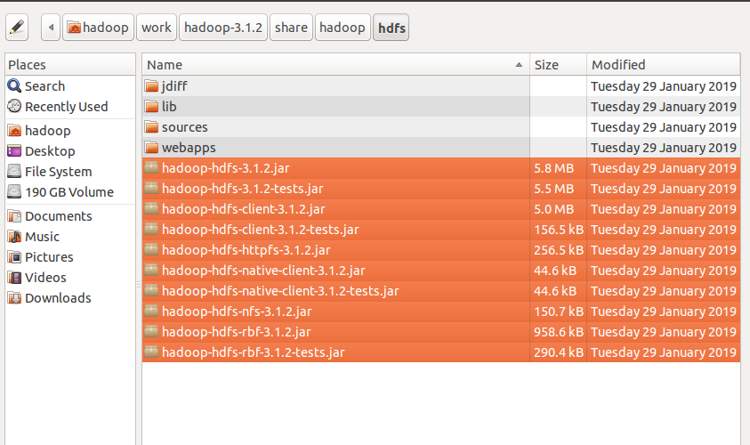

Again click on the Add External JARs and
import all below jar files from below paths,
from $HADOOP_HOME/share/hadoop/mapreduce path import all jars
select jar files and click ok.
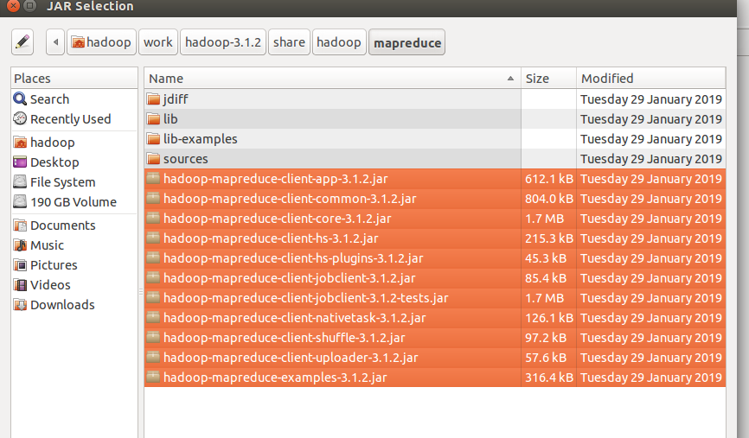
Again click on the Add External JARs and
import all below jar files from below paths,
from $HADOOP_HOME/share/hadoop/yarn path import all jars
select jar files and click ok.
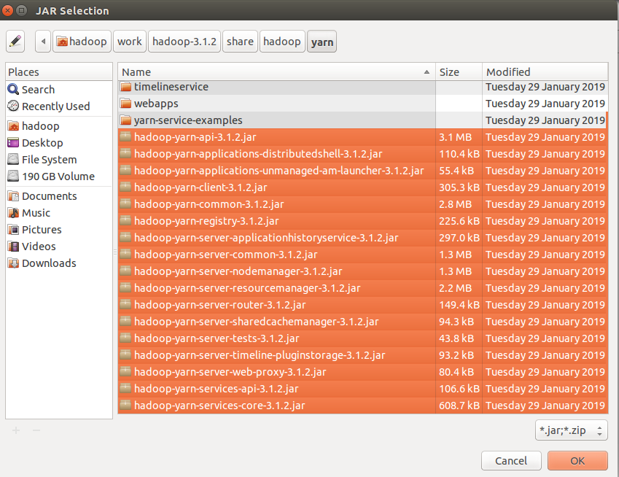

Step 3: Create a package in the package
right click on the src folder in “JoinTypes” project-> New ->package
give any package name as “com.ramesh.ReduceJoin” -> Finish

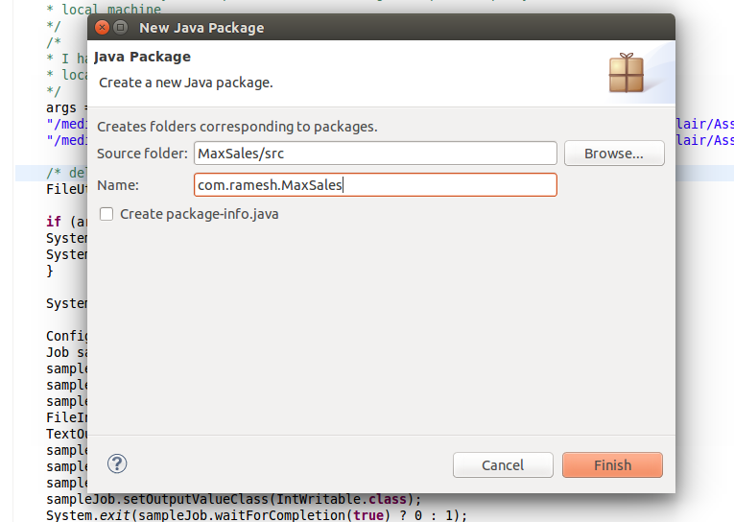

Step 4: create a class files
right click on the package name -> New ->class
give class name as “DsllDataMapper.java” -> Finish
similarly SpeedHlogDeltaDataMapper.java
similarly create “SpeedHlogDslJoinReducer.java” and DriverReduceSideJoin.java class
files.

Code for these class files is attached .

Mapper Class: DsllDataMapper.java and SpeedHlogDeltaDataMapper.java

Reducer Class: SpeedHlogDslJoinReducer.java

Driver Class: DriverReduceSideJoin.java

input file:

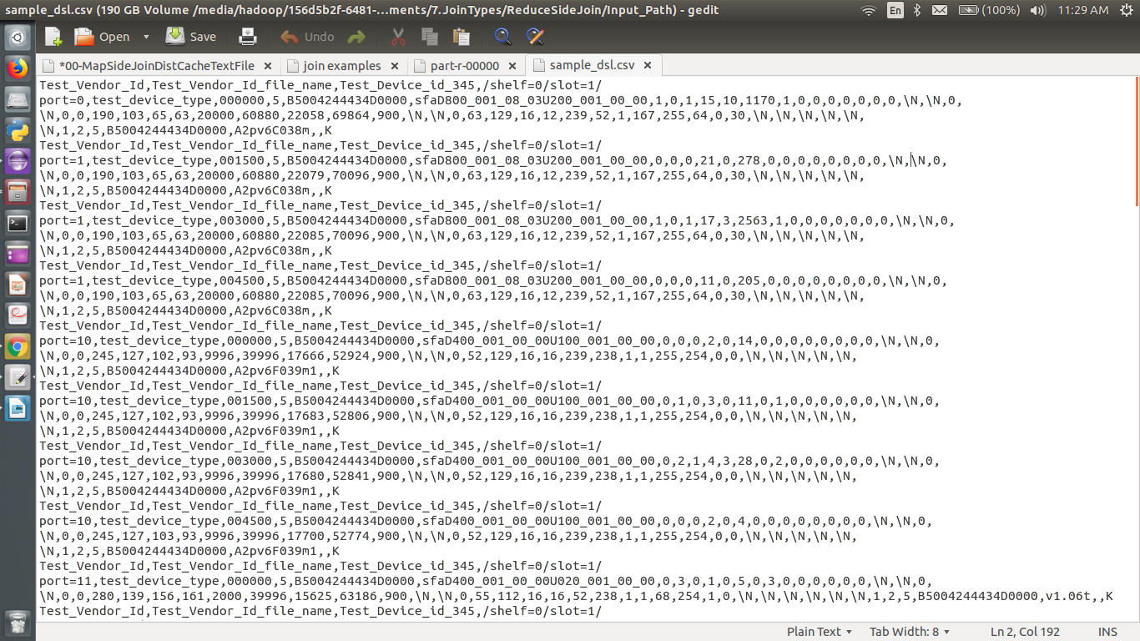

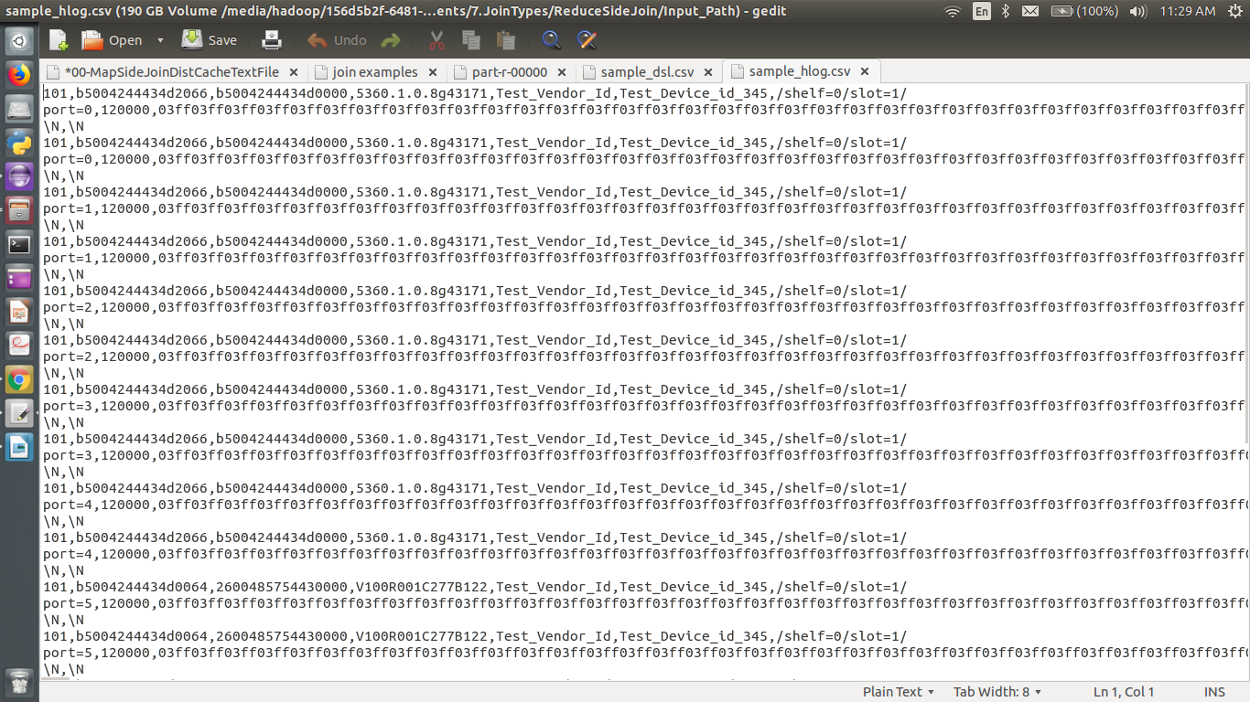

i am giving the path of the file in my local and output path in my local machine
Input path: "/media/hadoop/156d5b2f-6481-4a81-b1bb-56e2179981bb1/ramesh/2018 life/hadoop/DataFlair/Assignments/7.JoinTypes/ReduceSideJoin/Input_Path/sample_hlog.csv
"
"/media/hadoop/156d5b2f-6481-4a81-b1bb-56e2179981bb1/ramesh/2018 life/hadoop/DataFlair/Assignments/7.JoinTypes/ReduceSideJoin/Input_Path/sample_dsl.csv"

Output path: "/media/hadoop/156d5b2f-6481-4a81-b1bb-56e2179981bb1/ramesh/2018 life/hadoop/DataFlair/Assignments//7.JoinTypes/ReduceSideJoin/Output_Path
/"

Run the Job:
right click-> Run As -> Java Application

Verify the result in the Output path:

