#WordCount Map reduce program

Description: In this program we will find the number of words in the given input file using the mapreduce program.

Step 1: Create a java project called WordCount in eclipse.

File-> New-> Java Project-> Give the name of the project as “WordCount”
Step2: import all the hadoop related jar file to eclipse.
Right Click on “WordCount” project and click on properties

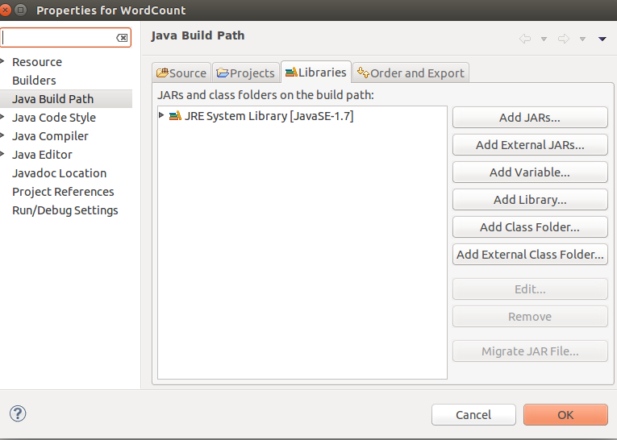
under libraries-> click on Add External JARs

import all below jar files from below paths,
from $HADOOP_HOME/share/hadoop/client path import all jars
select jar files and click ok.
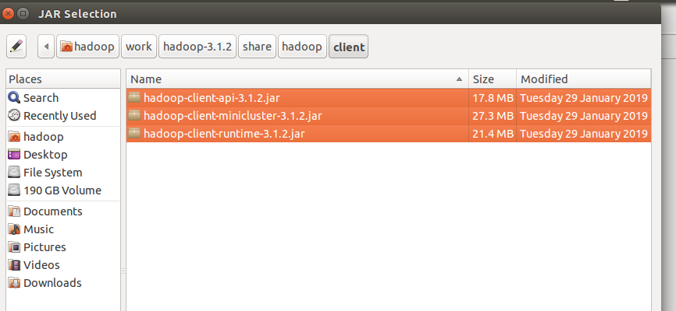
Again click on the Add External JARs and
import all below jar files from below paths,
from $HADOOP_HOME/share/hadoop/common path import all jars
select jar files and click ok.

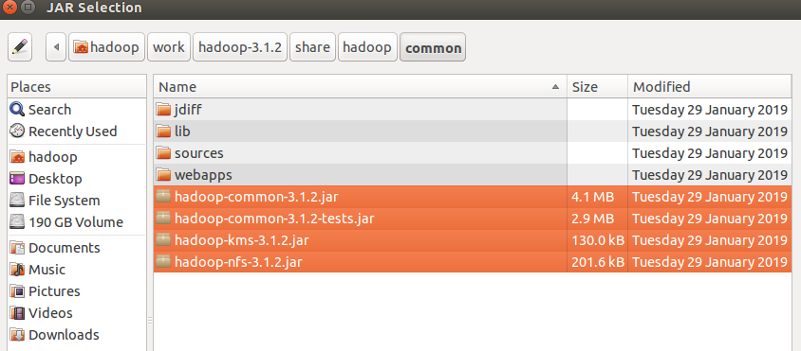
Again click on the Add External JARs and
import all below jar files from below paths,
from $HADOOP_HOME/share/hadoop/common/lib path import all jars
select jar files and click ok.

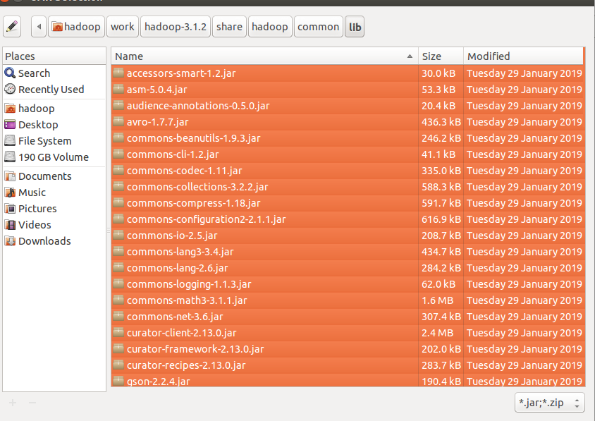
Again click on the Add External JARs and
import all below jar files from below paths,
from $HADOOP_HOME/share/hadoop/hdfs path import all jars
select jar files and click ok.

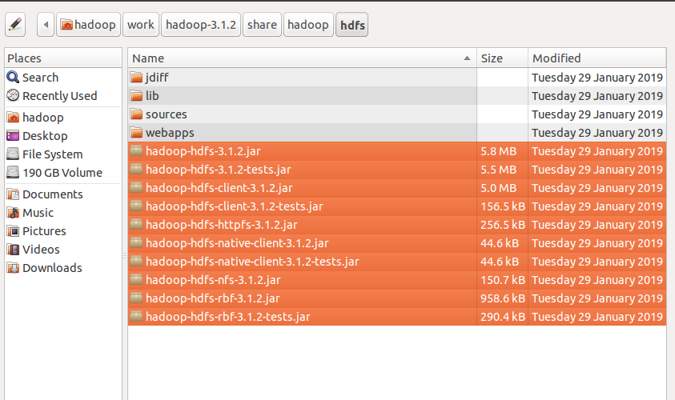

Again click on the Add External JARs and
import all below jar files from below paths,
from $HADOOP_HOME/share/hadoop/mapreduce path import all jars
select jar files and click ok.
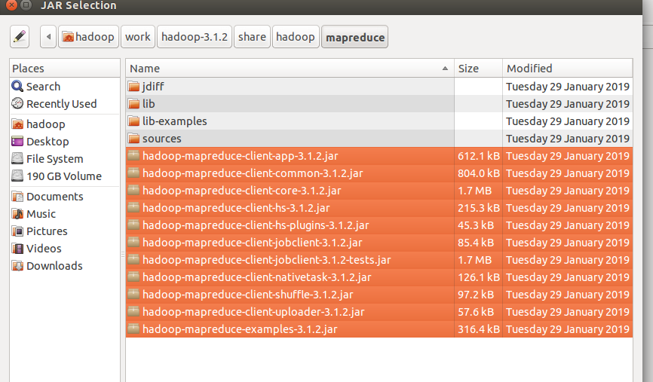
Again click on the Add External JARs and
import all below jar files from below paths,
from $HADOOP_HOME/share/hadoop/yarn path import all jars
select jar files and click ok.
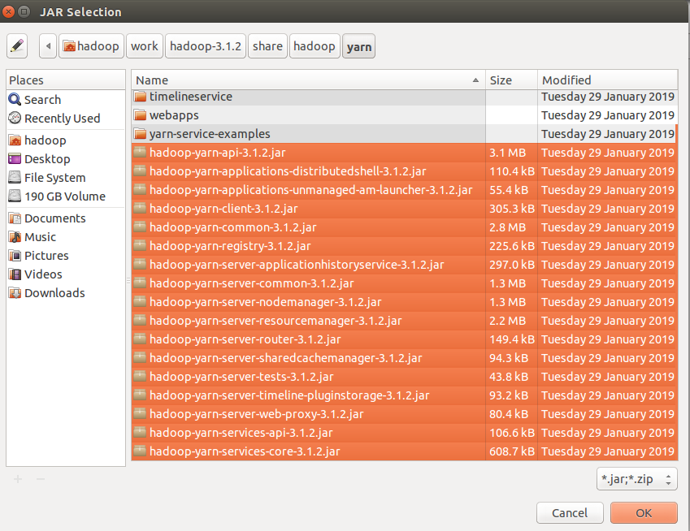

Step 3: Create a package in the package
right click on the src folder in “WordCount” project-> New ->package
give any package name as “com.ramesh.wordcount” -> Finish

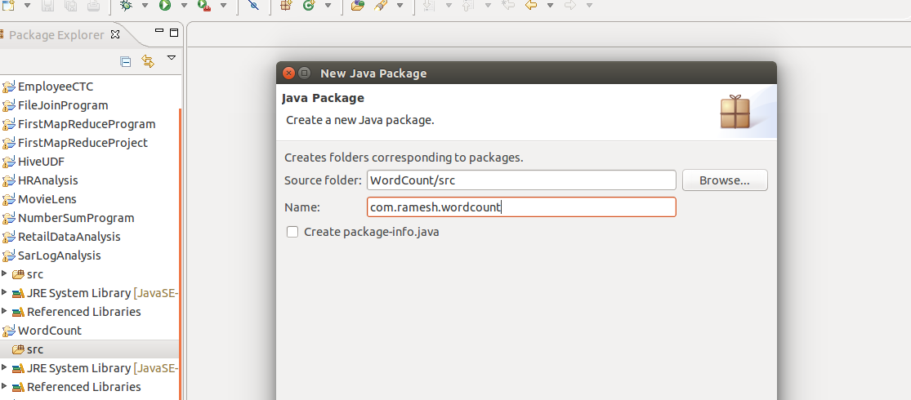

Step 4: create a class files
right click on the package name -> New ->class
give class name as “WordCountMapper” -> Finish

similarly create “WordCountReducer” and WordCountDriver class files.

Code for these class files is attached .

Mapper Class: WordCountMapper.java

Reducer Class: WordCountReducer.java

Driver Class: WordCountDriver.java

input file:
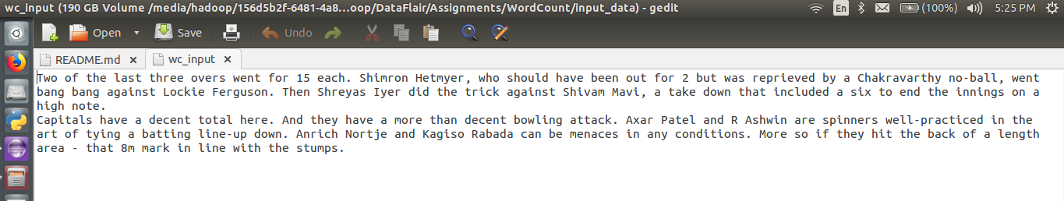
i am giving the path of the file in my local and output path in my local machine
Input path:"/media/hadoop/156d5b2f-6481-4a81-b1bb-56e2179981bb1/ramesh/2018 life/hadoop/DataFlair/Assignments/WordCount/input_data/wc_input"

Output path:"/media/hadoop/156d5b2f-6481-4a81-b1bb-56e2179981bb1/ramesh/2018 life/hadoop/DataFlair/Assignments/WordCount/output_data/"

Run the Job:
right click-> Run As -> Java Application
output file:

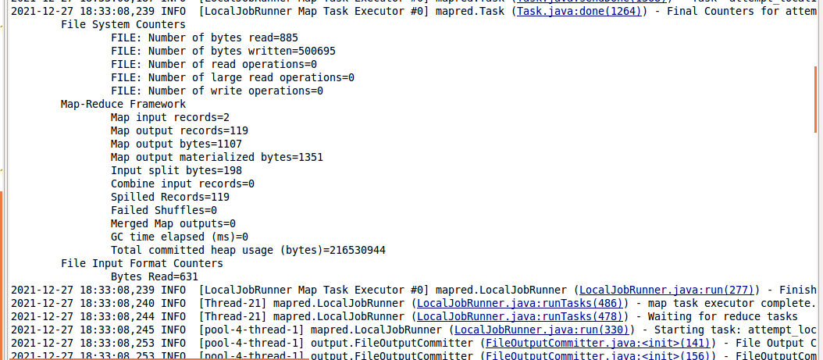

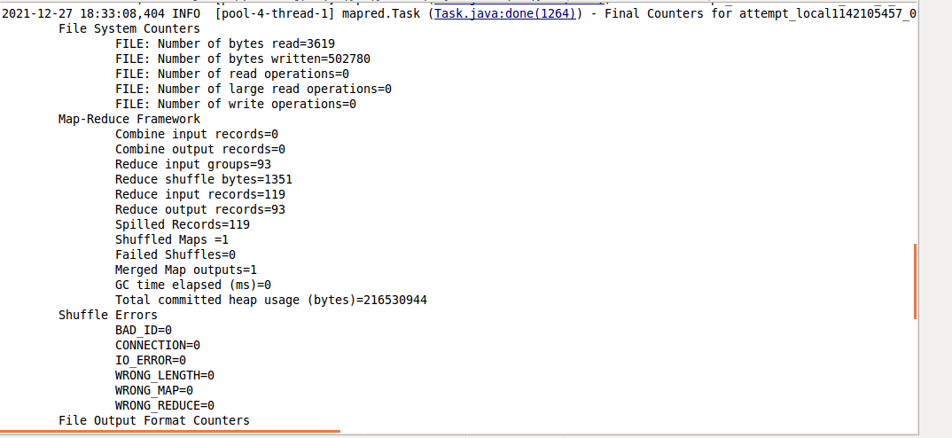
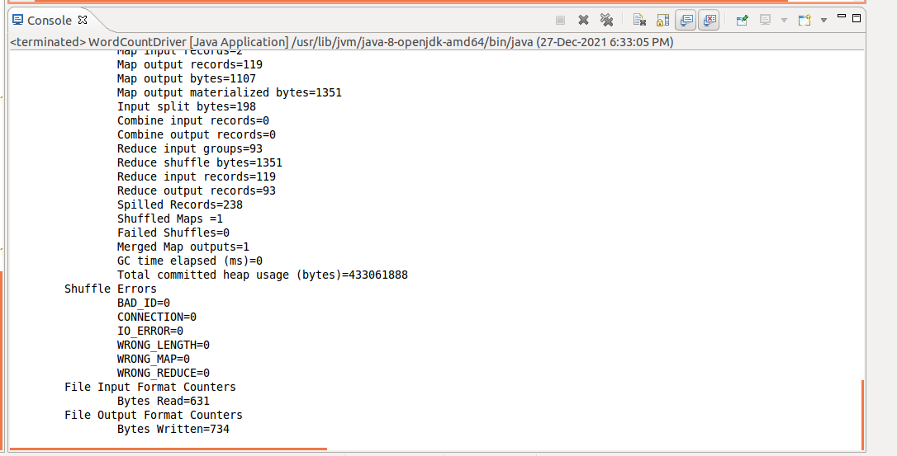

Verify the result in the Output path:

