**Assignment – 1**

1. Report View:

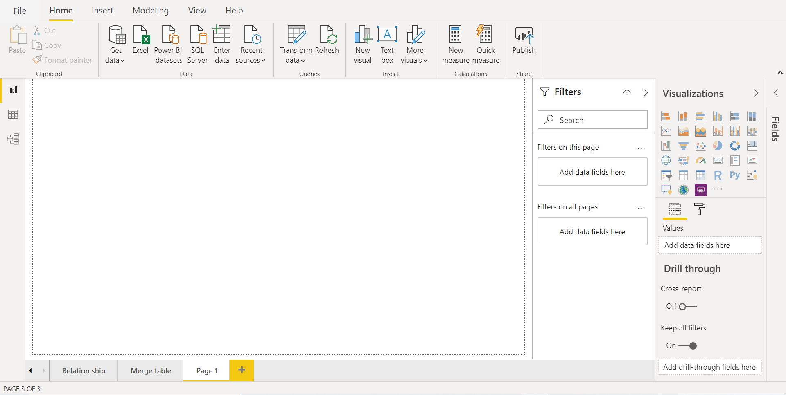

1. Data View:

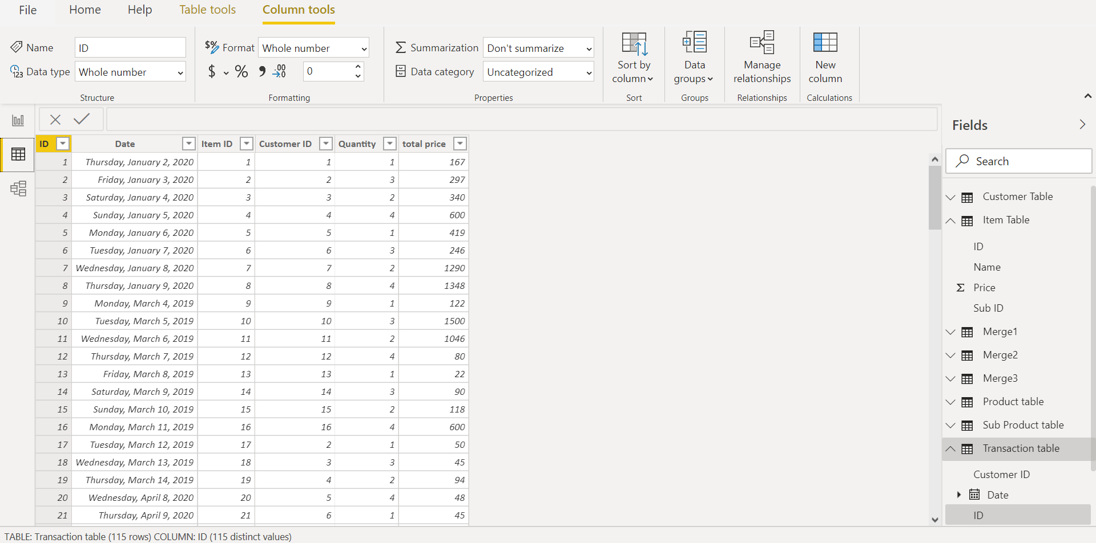

1. Model View:

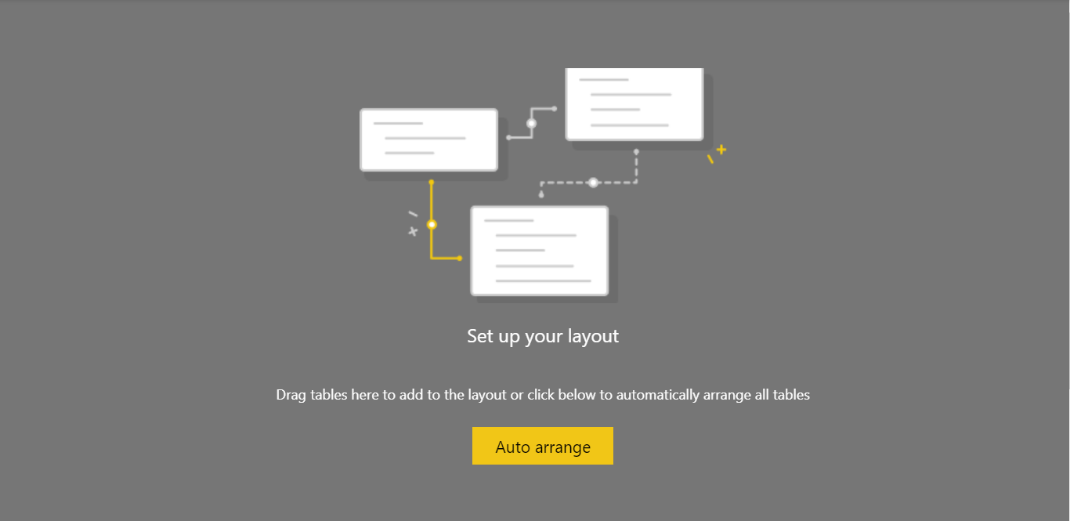

1. **Power Query Editor:**

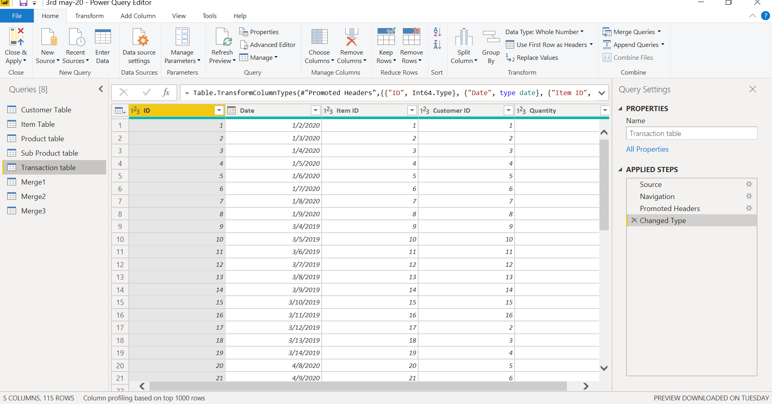

1. **Advanced Editor:**

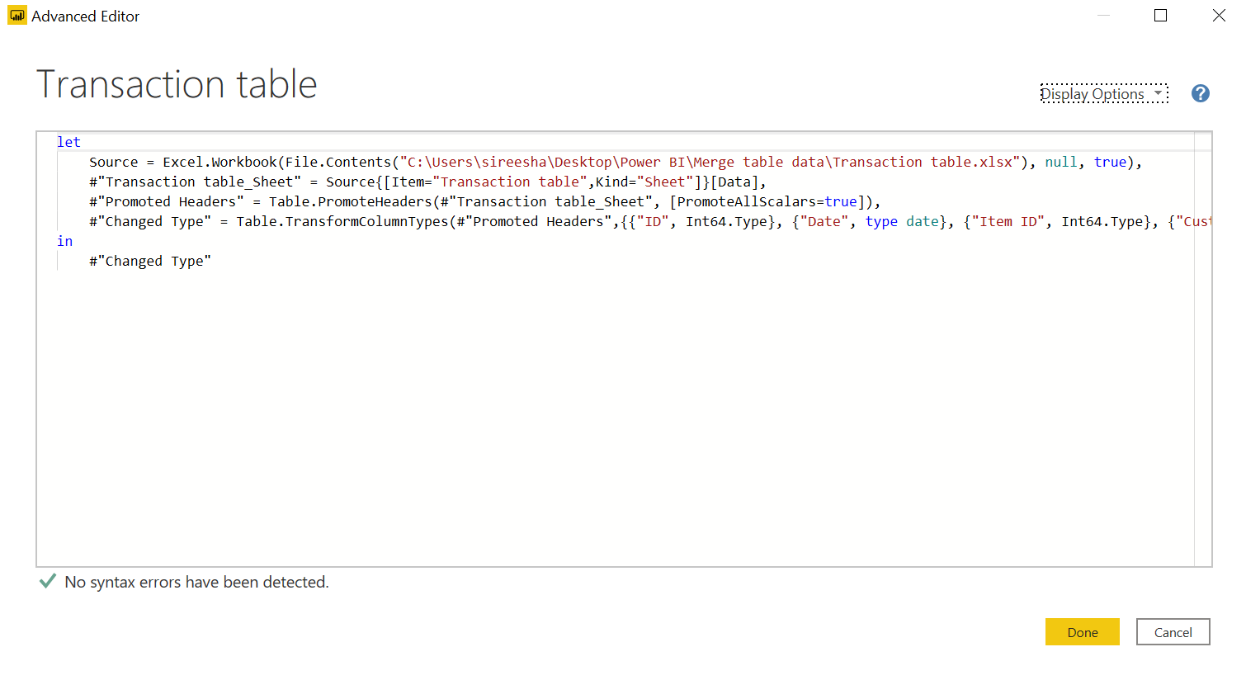

**Power BI Desktop:**

1. Power BI is Business intelligence tool which is used to generate the meaningful insights, those insights will help the high level management to drive their business in right direction.
2. This offering is free to any single user and includes data cleaning and preparation, custom visualizations and the ability to publish to the Power BI service.

**Power BI Pro:**

1. Power BI Pro is an individual user license that lets users read and interact with reports and dashboards that others have published to the Power BI service. Users with this license type can share content and collaborate with other Power BI Pro users
2. The Pro plan costs $9.99/user/month. It includes data collaboration, data governance, building dashboards with a 360-degree real-time view and the ability to publish reports anywhere. Users can try it a free trial for 60 days before purchasing the subscription.

**Power BI Premium:**

1. Power BI Premium is a tenant-level Office 365 subscription available in two SKU (Stock-Keeping Unit) families: P SKUs (P1-P5) for embedding and enterprise features, requiring a monthly or yearly commitment, billed monthly, and includes a license to install Power BI Report Server on-premises
2. The Premium plan starts at $4,995 a month per dedicated cloud compute and storage resource.