https://www.thefergusonclinic.com/wp-admin

https://admin.shopify.com/store/0cbdc7-6f/content/files?selectedView=all

Credentials.docx

Need to extract and go to folder
activate the environment
Terminal 1: python webhook_server.py
Terminal 2: .\ngrok http 1337

Create webhooks add your endpoint
When a product is created or updated or deleted respective webhook will be called with all necessary info

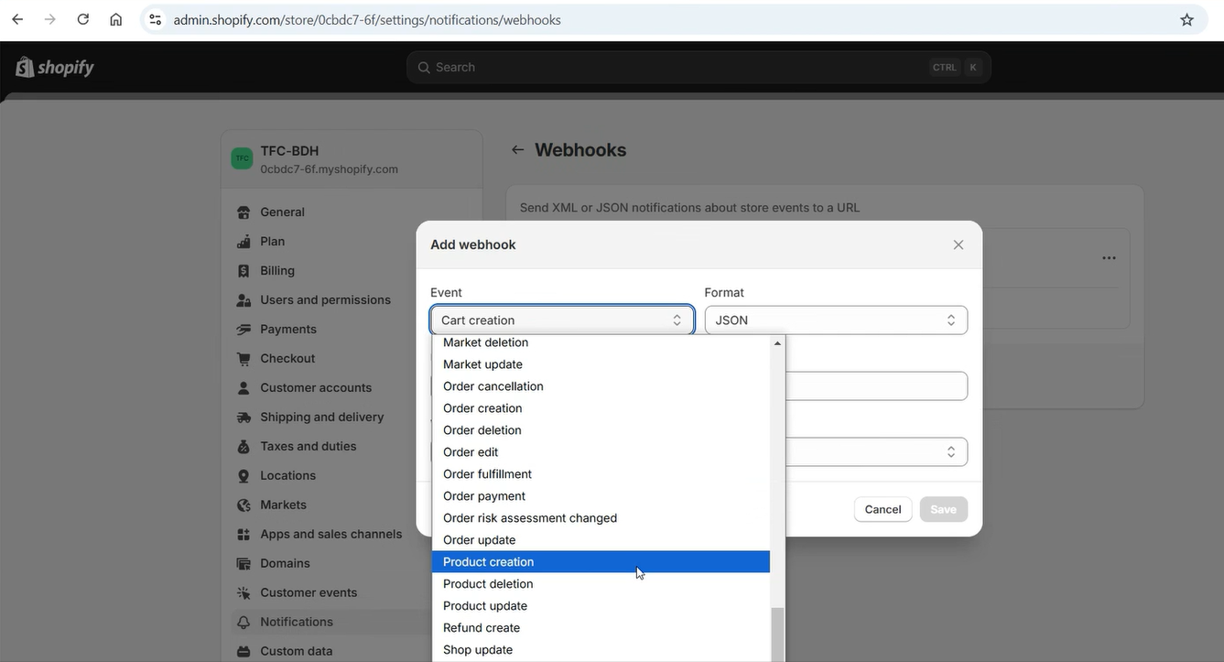


{
"admin_graphql_api_id": "gid://shopify/Product/7774842650739",
"body_html": "<h2>What is 360 Abdominal Liposuction?</h2>",
"created_at": "2024-09-17T01:49:58-10:00",
"handle": "360-abdominal-liposuction",
"id": 7774842650739,
"product_type": "",
"published_at": "2023-08-31T17:10:20-10:00",
"template_suffix": null,
"title": "360 Abdominal Liposuction",
"updated_at": "2024-11-15T02:04:21-10:00",
"vendor": "TFC-BDH",
"status": "active",
"published_scope": "global",
"tags": "",
"variants": [
{
"admin_graphql_api_id": "gid://shopify/ProductVariant/42307297837171",
"barcode": null,
"compare_at_price": null,
"created_at": "2024-09-17T01:49:59-10:00",
"id": 42307297837171,
"inventory_policy": "deny",
"position": 1,
"price": "100.00",
"product_id": 7774842650739,
"sku": null,
"taxable": true,
"title": "Consult",
"updated_at": "2024-11-13T07:16:09-10:00",
"option1": "Consult",
"option2": null,
"option3": null,
"image_id": 35839536955507,
"inventory_item_id": 44332664225907,
"inventory_quantity": 0,
"old_inventory_quantity": 0
},
{
"admin_graphql_api_id": "gid://shopify/ProductVariant/42307297869939",
"barcode": null,
"compare_at_price": null,
"created_at": "2024-09-17T01:49:59-10:00",
"id": 42307297869939,
"inventory_policy": "deny",
"position": 2,
"price": "8500.00",
"product_id": 7774842650739,
"sku": null,
"taxable": true,
"title": "Full",
"updated_at": "2024-11-13T07:16:10-10:00",
"option1": "Full",
"option2": null,
"option3": null,
"image_id": 35839536955507,
"inventory_item_id": 44332664258675,
"inventory_quantity": 0,
"old_inventory_quantity": 0
}
],
"options": [
{
"name": "Payment",
"id": 9909406859379,
"product_id": 7774842650739,
"position": 1,
"values": ["Consult", "Full"]
}
],
"images": [
{
"id": 35839536955507,
"product_id": 7774842650739,
"position": 1,
"created_at": "2024-09-17T01:50:02-10:00",
"updated_at": "2024-09-17T01:50:04-10:00",
"alt": "YOUR BEST YOU IS CLOSER THAN YOU THINK 11",
"width": 1080,
"height": 1080,
"src": "https://cdn.shopify.com/s/files/1/0618/6559/0899/files/YOUR-BEST-YOU-IS-CLOSER-THAN-YOU-THINK-11.png?v=1726573804",
"variant_ids": [42307297837171, 42307297869939],
"admin_graphql_api_id": "gid://shopify/ProductImage/35839536955507"
},
{
"id": 35839536889971,
"product_id": 7774842650739,
"position": 2,
"created_at": "2024-09-17T01:50:02-10:00",
"updated_at": "2024-09-17T01:50:04-10:00",
"alt": "YOUR BEST YOU IS CLOSER THAN YOU THINK 12",
"width": 1080,
"height": 1080,
"src": "https://cdn.shopify.com/s/files/1/0618/6559/0899/files/YOUR-BEST-YOU-IS-CLOSER-THAN-YOU-THINK-12.png?v=1726573804",
"variant_ids": [],
"admin_graphql_api_id": "gid://shopify/ProductImage/35839536889971"
}
],
"image": {
"id": 35839536955507,
"product_id": 7774842650739,
"position": 1,
"created_at": "2024-09-17T01:50:02-10:00",
"updated_at": "2024-09-17T01:50:04-10:00",
"alt": "YOUR BEST YOU IS CLOSER THAN YOU THINK 11",
"width": 1080,
"height": 1080,
"src": "https://cdn.shopify.com/s/files/1/0618/6559/0899/files/YOUR-BEST-YOU-IS-CLOSER-THAN-YOU-THINK-11.png?v=1726573804",
"variant_ids": [42307297837171, 42307297869939],
"admin_graphql_api_id": "gid://shopify/ProductImage/35839536955507"
},
"media": [
{
"id": 28078819672179,
"product_id": 7774842650739,
"position": null,
"created_at": "2024-09-17T01:50:02-10:00",
"updated_at": "2024-09-17T01:50:04-10:00",
"alt": "YOUR BEST YOU IS CLOSER THAN YOU THINK 11",
"status": "READY",
"media_content_type": "IMAGE",
"preview_image": {
"width": 1080,
"height": 1080,
"src": "https://cdn.shopify.com/s/files/1/0618/6559/0899/files/YOUR-BEST-YOU-IS-CLOSER-THAN-YOU-THINK-11.png?v=1726573804",
"status": "READY"
},
"variant_ids": [42307297837171, 42307297869939],
"admin_graphql_api_id": "gid://shopify/MediaImage/28078819672179"
},
{
"id": 28078819704947,
"product_id": 7774842650739,
"position": null,
"created_at": "2024-09-17T01:50:02-10:00",
"updated_at": "2024-09-17T01:50:04-10:00",
"alt": "YOUR BEST YOU IS CLOSER THAN YOU THINK 12",
"status": "READY",
"media_content_type": "IMAGE",
"preview_image": {
"width": 1080,
"height": 1080,
"src": "https://cdn.shopify.com/s/files/1/0618/6559/0899/files/YOUR-BEST-YOU-IS-CLOSER-THAN-YOU-THINK-12.png?v=1726573804",
"status": "READY"
},
"variant_ids": [],
"admin_graphql_api_id": "gid://shopify/MediaImage/28078819704947"
}
],
"variant_gids": [
{
"admin_graphql_api_id": "gid://shopify/ProductVariant/42307297869939",
"updated_at": "2024-11-13T17:16:10.000Z"
},
{
"admin_graphql_api_id": "gid://shopify/ProductVariant/42307297837171",
"updated_at": "2024-11-13T17:16:09.000Z"
}
],
"has_variants_that_requires_components": false,
"category": {
"admin_graphql_api_id": "gid://shopify/TaxonomyCategory/na",
"name": "Uncategorized",
"full_name": "Uncategorized"
}
}

