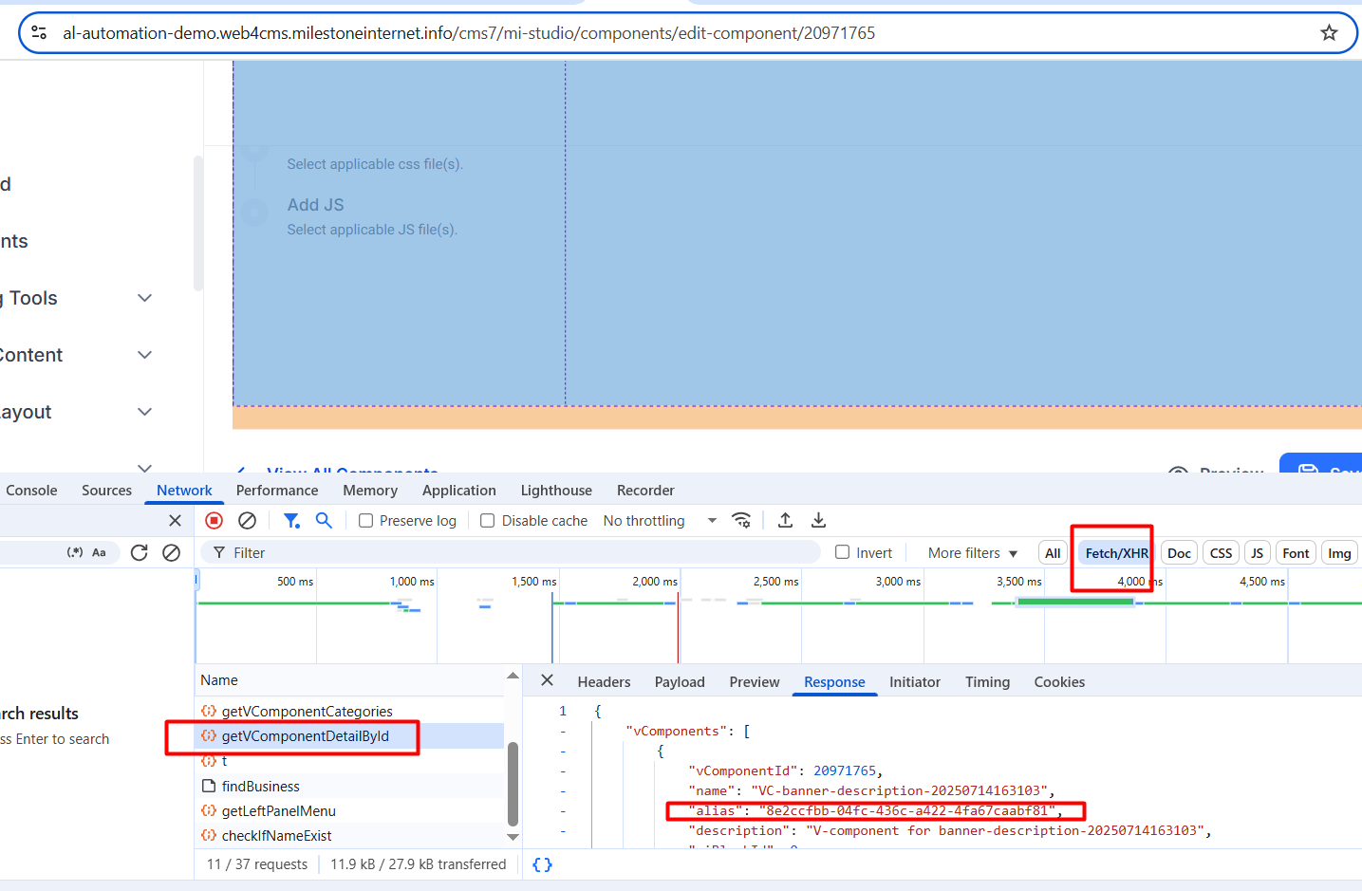

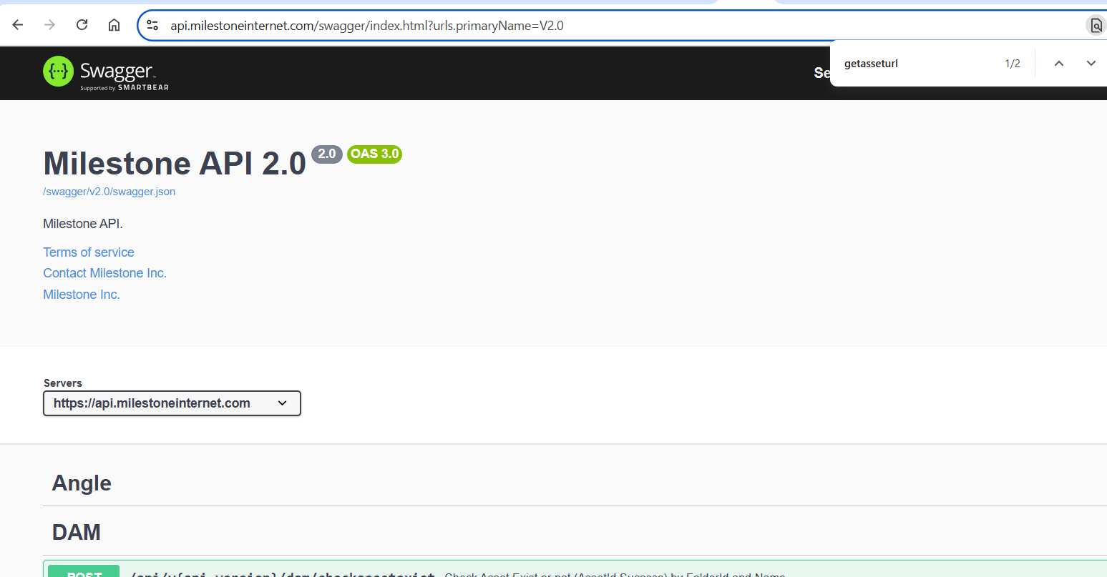

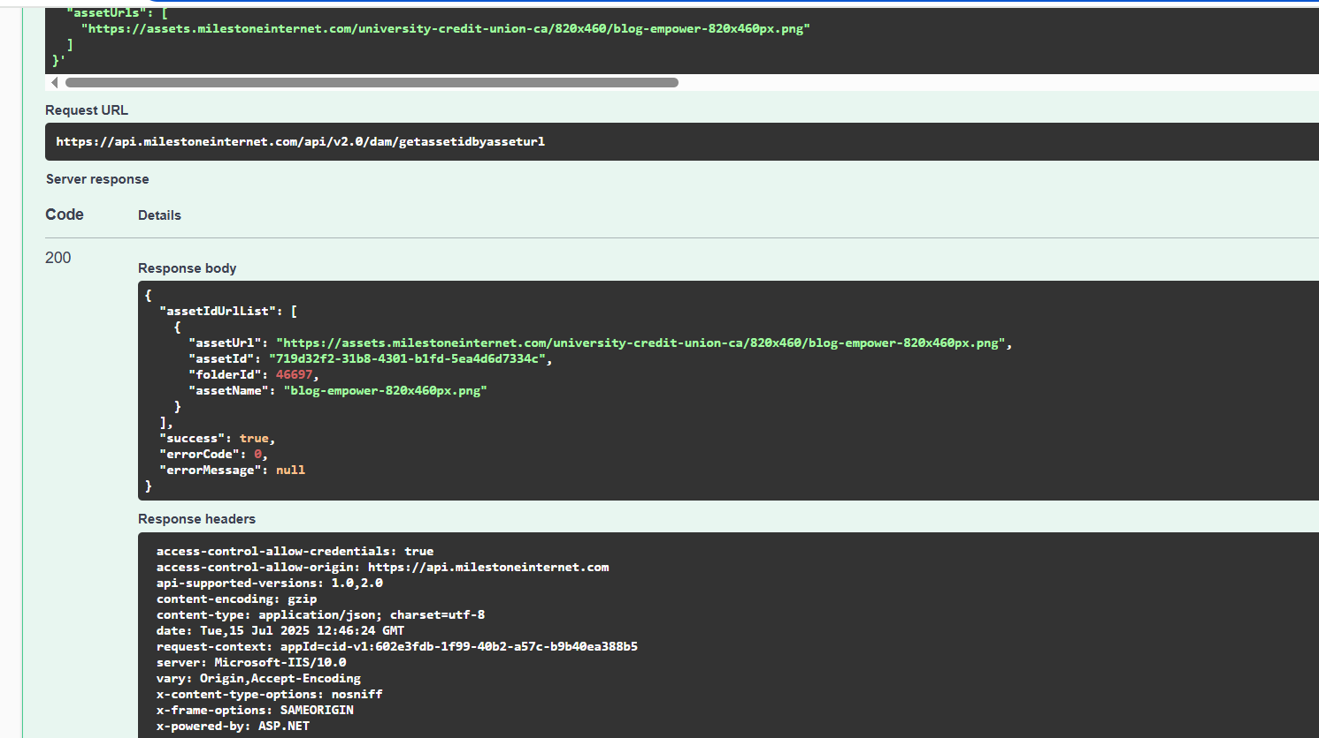

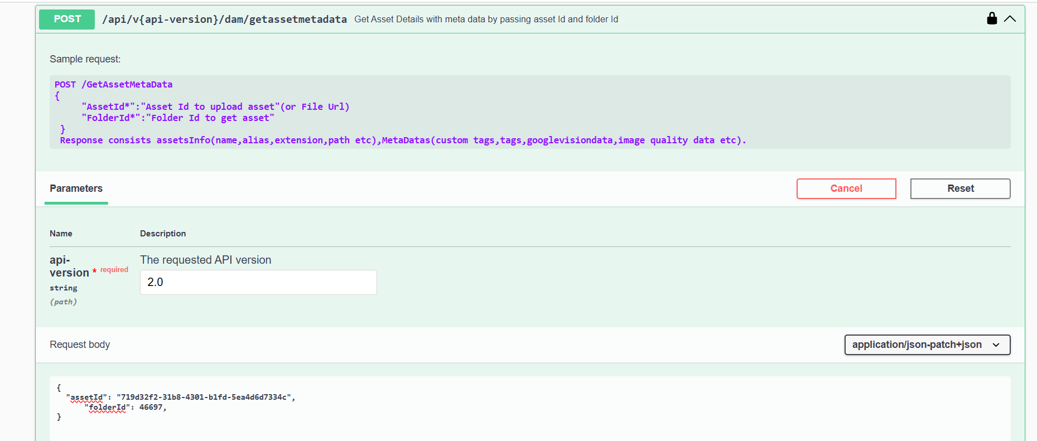

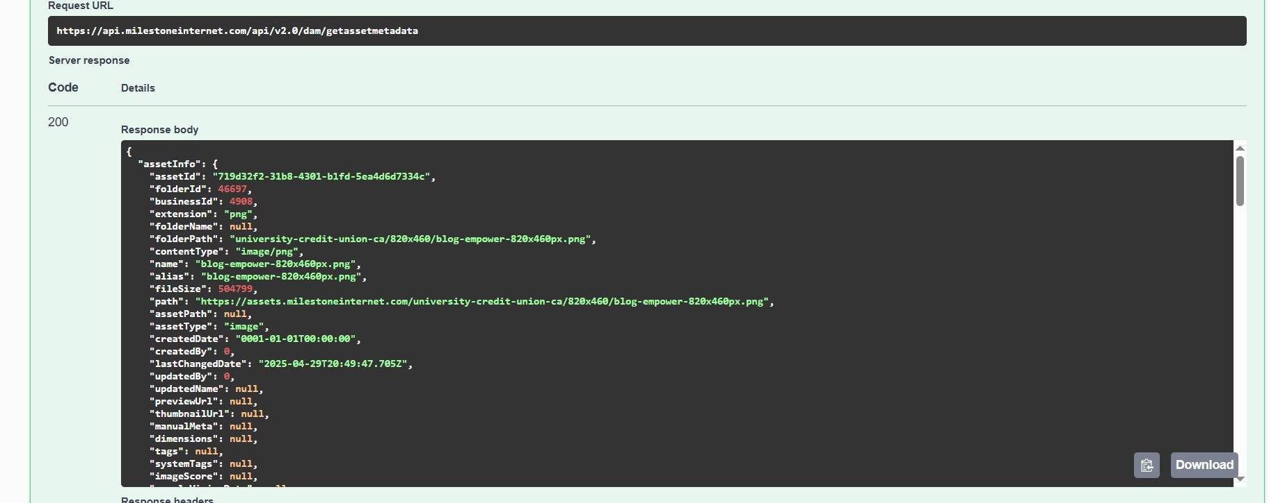

{
"assetInfo": {
"assetId": "719d32f2-31b8-4301-b1fd-5ea4d6d7334c",
"folderId": 46697,
"businessId": 4908,
"extension": "png",
"folderName": null,
"folderPath": "university-credit-union-ca/820x460/blog-empower-820x460px.png",
"contentType": "image/png",
"name": "blog-empower-820x460px.png",
"alias": "blog-empower-820x460px.png",
"fileSize": 504799,
"path": "https://assets.milestoneinternet.com/university-credit-union-ca/820x460/blog-empower-820x460px.png",
"assetPath": null,
"assetType": "image",
"createdDate": "0001-01-01T00:00:00",
"createdBy": 0,
"lastChangedDate": "2025-04-29T20:49:47.705Z",
"updatedBy": 0,
"updatedName": null,
"previewUrl": null,
"thumbnailUrl": null,
"manualMeta": null,
"dimensions": null,
"tags": null,
"systemTags": null,
"imageScore": null,
"googleVisionData": null,
"imageQualityData": null,
"stockImage": false,
"supportedDimensions": false
},
"metaDatas": {
"file": null,
"embeddedMeta": {
"Image Width": "820",
"Image Height": "460",
"Bits Per Sample": "8",
"Color Type": "True Color",
"Compression Type": "Deflate",
"Filter Method": "Adaptive",
"Interlace Method": "No Interlace",
"Pixels Per Unit X": "2835",
"Pixels Per Unit Y": "2835",
"Unit Specifier": "Metres",
"Detected File Type Name": "PNG",
"Detected File Type Long Name": "Portable Network Graphics",
"Detected MIME Type": "image/png",
"Expected File Name Extension": "png"
},
"manualMeta": {
"title": "Blog-empower-820x460px",
"description": "A woman with afro hair standing in front of mirror"
},
"googleVisionData": {
"labels": [
{
"Description": "Sleeve",
"Score": 98
},
{
"Description": "Lips",
"Score": 98
},
{
"Description": "Shoulder",
"Score": 97
},
{
"Description": "Neck",
"Score": 96
},
{
"Description": "Jheri curl",
"Score": 95
},
{
"Description": "Fashion",
"Score": 95
},
{
"Description": "Textile",
"Score": 95
},
{
"Description": "Afro",
"Score": 94
},
{
"Description": "Happiness",
"Score": 84
},
{
"Description": "Long-sleeved T-shirt",
"Score": 80
}
],
"landmarks": [],
"localizedObjects": [
{
"Name": "Person",
"Score": 73
},
{
"Name": "Person",
"Score": 70
},
{
"Name": "Person",
"Score": 67
},
{
"Name": "Outerwear",
"Score": 63
},
{
"Name": "Clothing",
"Score": 61
},
{
"Name": "Top",
"Score": 60
},
{
"Name": "Clothing",
"Score": 57
},
{
"Name": "Top",
"Score": 56
},
{
"Name": "Outerwear",
"Score": 55
}
],
"safesearch": {
"Adult": "VeryUnlikely",
"Medical": "Unlikely",
"Racy": "VeryUnlikely",
"Spoof": "VeryUnlikely",
"Violence": "Unlikely"
},
"textDetection": {}
},
"imageQualityData": {
"score": 10.318435822757777,
"description": "very good"
},
"tags": null,
"systemTags": [
"Sleeve",
"Lips",
"Shoulder",
"Neck",
"Jheri curl",
"Fashion",
"Textile",
"Afro",
"Happiness"
],
"customTags": null,
"previewUrl": "https://assets.milestoneinternet.com/university-credit-union-ca/820x460/blog-empower-820x460px.png?width=300&height=300",
"thumbnailUrl": "https://assets.milestoneinternet.com/university-credit-union-ca/820x460/blog-empower-820x460px.png?width=50&height=50",
"imageScore": 90,
"dimensions": {
"height": 460,
"width": 820
}
},
"success": true,
"errorCode": 0,
"errorMessage": null
}

