/\*1. Write a typescript program which contains one function named as Maximum. That function accepts

array of numbers and returns the largest number from array.

Input :

23

89

6

29

56

45

77

32

Output :

Maximum number is 89

\*/

function Maximum(arr:number[]):number{

var max:number = arr[0];

for(var i=1; i<arr.length; i++){

if(max < arr[i]){

max = arr[i];

}

}

return max;

}

//var arr1:number[] = new Array(3);

//arr1= [23,89,20];

var arr1:number[] = [23,89,6,29,56,45,77,32];

console.log("Maximum number is "+Maximum(arr1));

Output:-

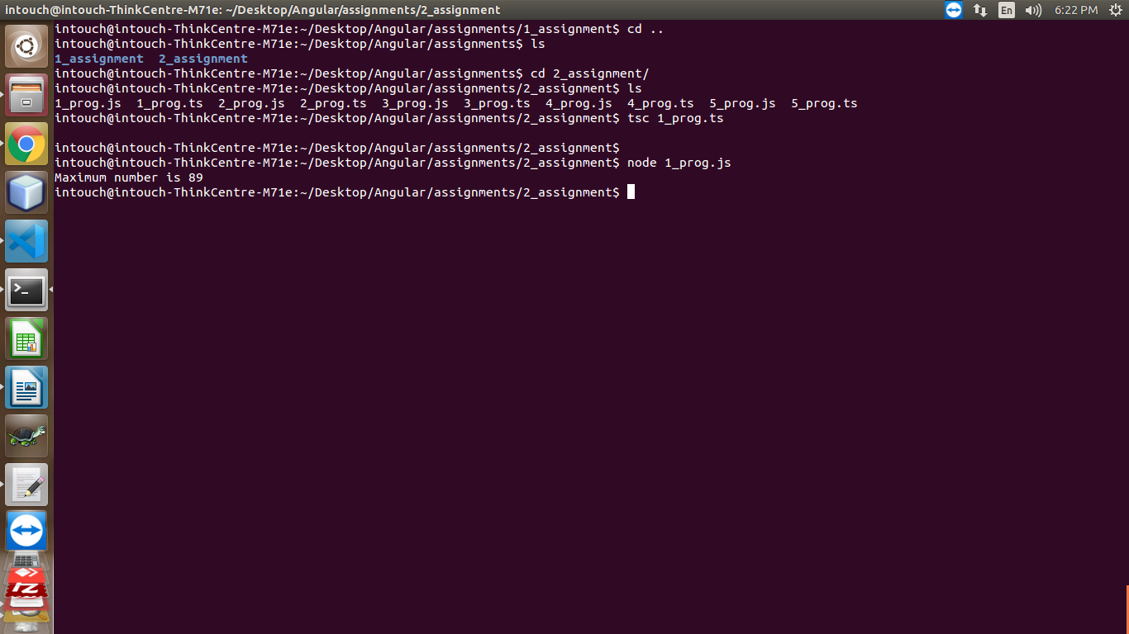

/\*2. Write a typescript program which contains one function named as Summation. That function

accepts array of numbers and returns the summation of each number from array.

Input :

23

6

7

4

5

7

Output :

Addition is 52

\*/

function Summation(arr:number[]):number{

var sum:number = 0;

for(var i=0; i<arr.length; i++){

sum = sum + arr[i];

}

return sum;

}

//var arr1:number[] = new Array(3);

//arr1= [23,89,20];

var arr1:number[] = [23,6,7,4,5,7];

console.log("Addition is "+Summation(arr1));

Output:-

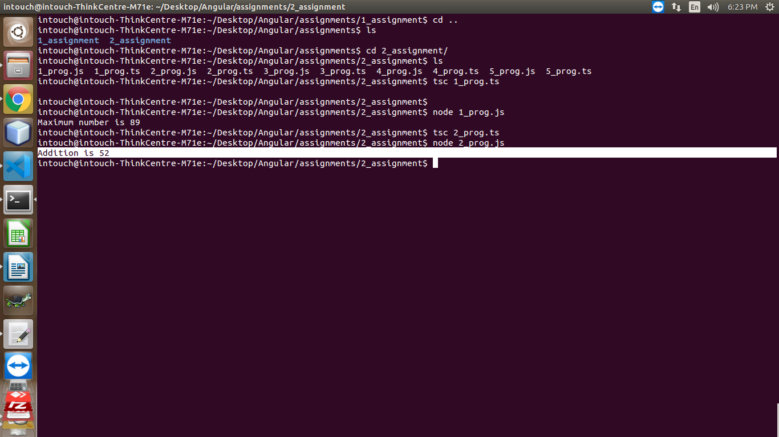

/\*3. Write a typescript program which contains one function named as Maximum. That function accepts

array of numbers and returns the second largest number from array.

Input :

23

89

6

29

56

45

77

32

Output : Second Maximum number is 77 \*/

function Maximum(arr:number[]):number{

var max:number = arr[0];

var secondmax:number = arr[0];

for(var i=0; i<arr.length; i++){

if (arr[i] > max) {

secondmax = max;

max = arr[i];

} else if (arr[i] > secondmax) {

secondmax = arr[i];

}

}

return secondmax;

}

var arr1:number[] = [23,89,6,29,56,45,77,32];

console.log("Second Maximum number is "+Maximum(arr1));

Output:-

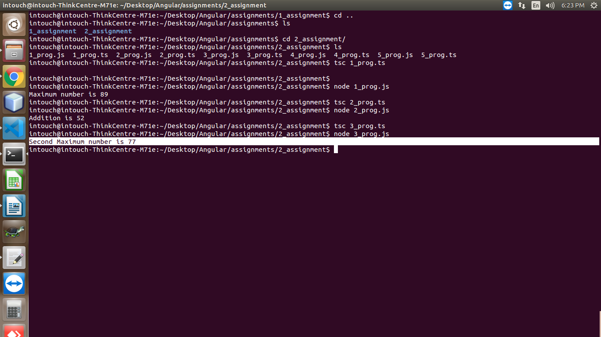

/\*4. Write a typescript program which contains one arrow function named as ChkArmstrong. That

function accepts one numbers and check whether number is Armstrong number or not.

Input :

153

Output :

It is Armstrong number

\*/

function ChkArmstrong(num:number){

var arm:number=0,a:number,temp:number;

temp=num;

while(temp>0){

a=temp%10;

// temp=parseInt(temp/10); // convert float into Integer

temp=Math.floor(temp/10);

arm=arm+a\*a\*a;

}

if(arm==num){

console.log("It is Armstrong number");

}

else{

console.log("It is Not Armstrong number");

}

}

ChkArmstrong(153);

Output:-

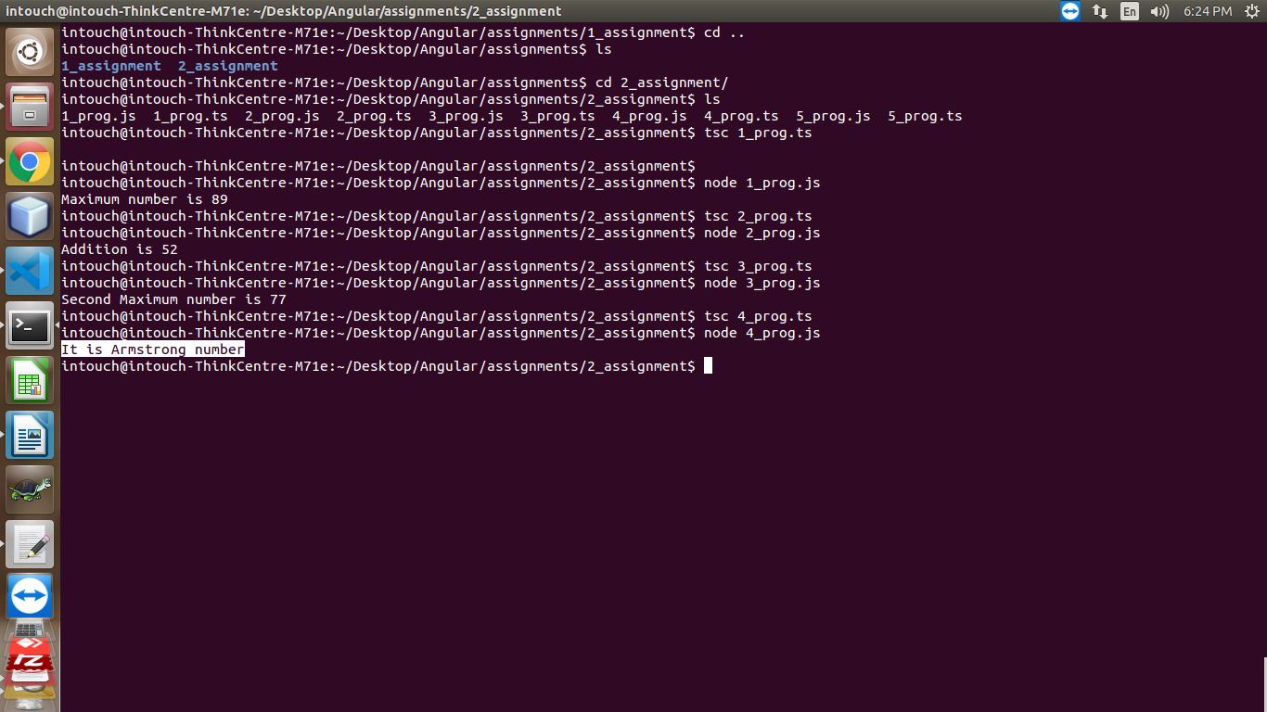

/\*5. Write a typescript program which contains one function named as ChkString. That function accept

one string and check whether that string contains “Marvellous” word or not.

Input :

“Pune Kothrud Marvellous Infosystems”

Output :

String contains Marvellous in it.

\*/

function ChkString(str:string){

var str2 = "Marvellous";

var strlen = str.length;

var str2len = str2.length;

// console.log(str2len);

for(var i=0; i<=strlen-str2len ;i++){

var j;

for(j=0; j<str2len; j++)

if (str[i + j] != str2[j])

break;

if (j == str2len) {

// return j;

console.log("String contains Marvellous in it.");

}

}

}

var str1 = "Pune Kothrud Marvellous Infosystems";

ChkString(str1);

Output:-

