AUTHOR:- RAMESH GHULE

1.Create first basic Angular application.

As we want to create our first application use below commands

ng new MarvellousFirst

cd MarvellousFirst

ng serve

[http://localhost:4200](http://localhost:4200/)

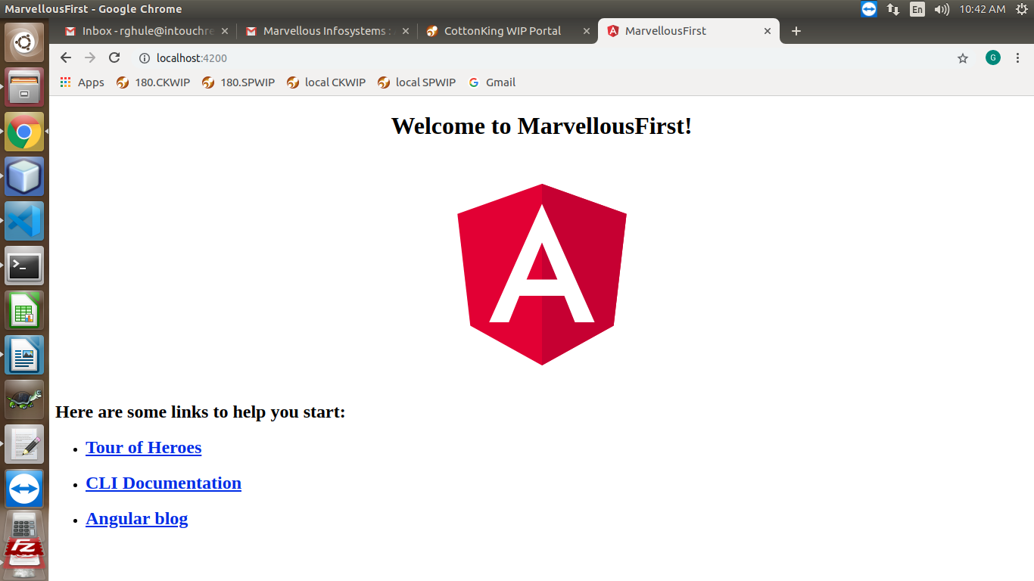

2. Create Angular application which will display “Welcome to Marvellous

Infosystem’s First Application!” on page. [MarvellousFirstApp].

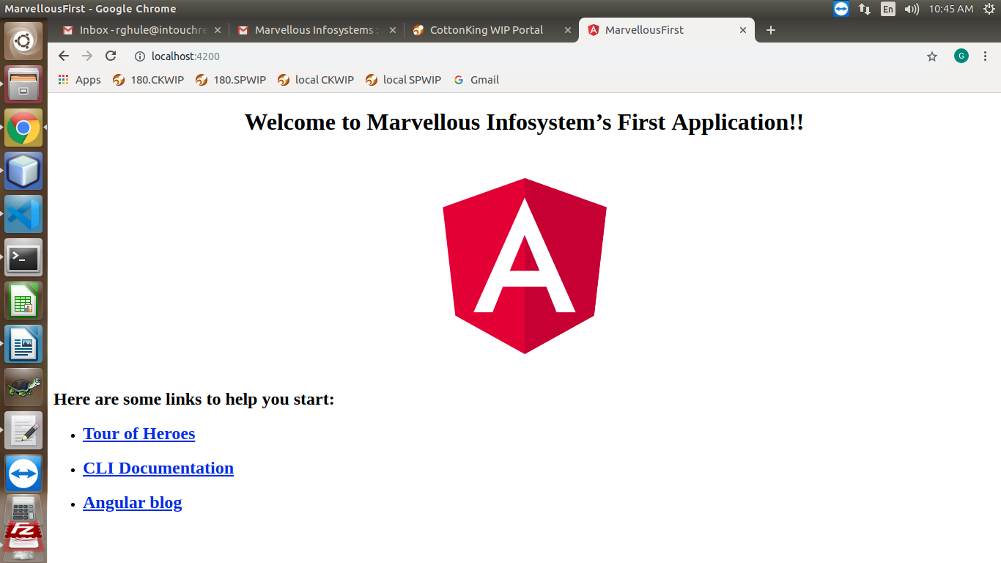

3. Create Angular application which will display one textfield and one static text

“Marvellous Infosystems” on page. [MarvellousLabel].

To do this remove whole code from app.component.html and write statements to add label

and text field.

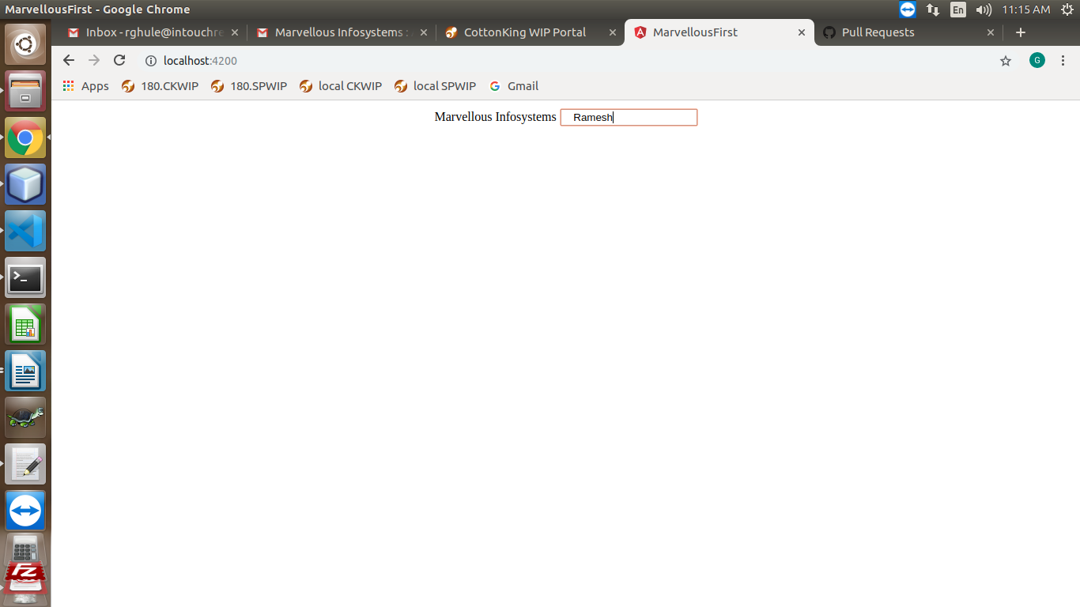

4. Create Angular application which creates one Custom component named as

Demo. Render that Demo component from app component.

To do this use below command

ng generate component Demo

Add the selector of Demo component into app component.

