1.2 Survey on Existing Works

Numerous studies have explored ﬂood prediction methods, ranging from traditional hydrological models to modern data-driven approaches. Traditional methods rely on physical parameters such as rainfall, river discharge, and topography.

Modern approaches integrate remote sensing data, real-time monitoring, and machine learning to improve prediction accuracy.

Key contributions in the ﬁeld include:

* **Machine learning-based ﬂood forecasting models.**
* **Use of satellite imagery for inundation mapping.**
* **Integration of IoT sensors for real-time ﬂood monitoring.**

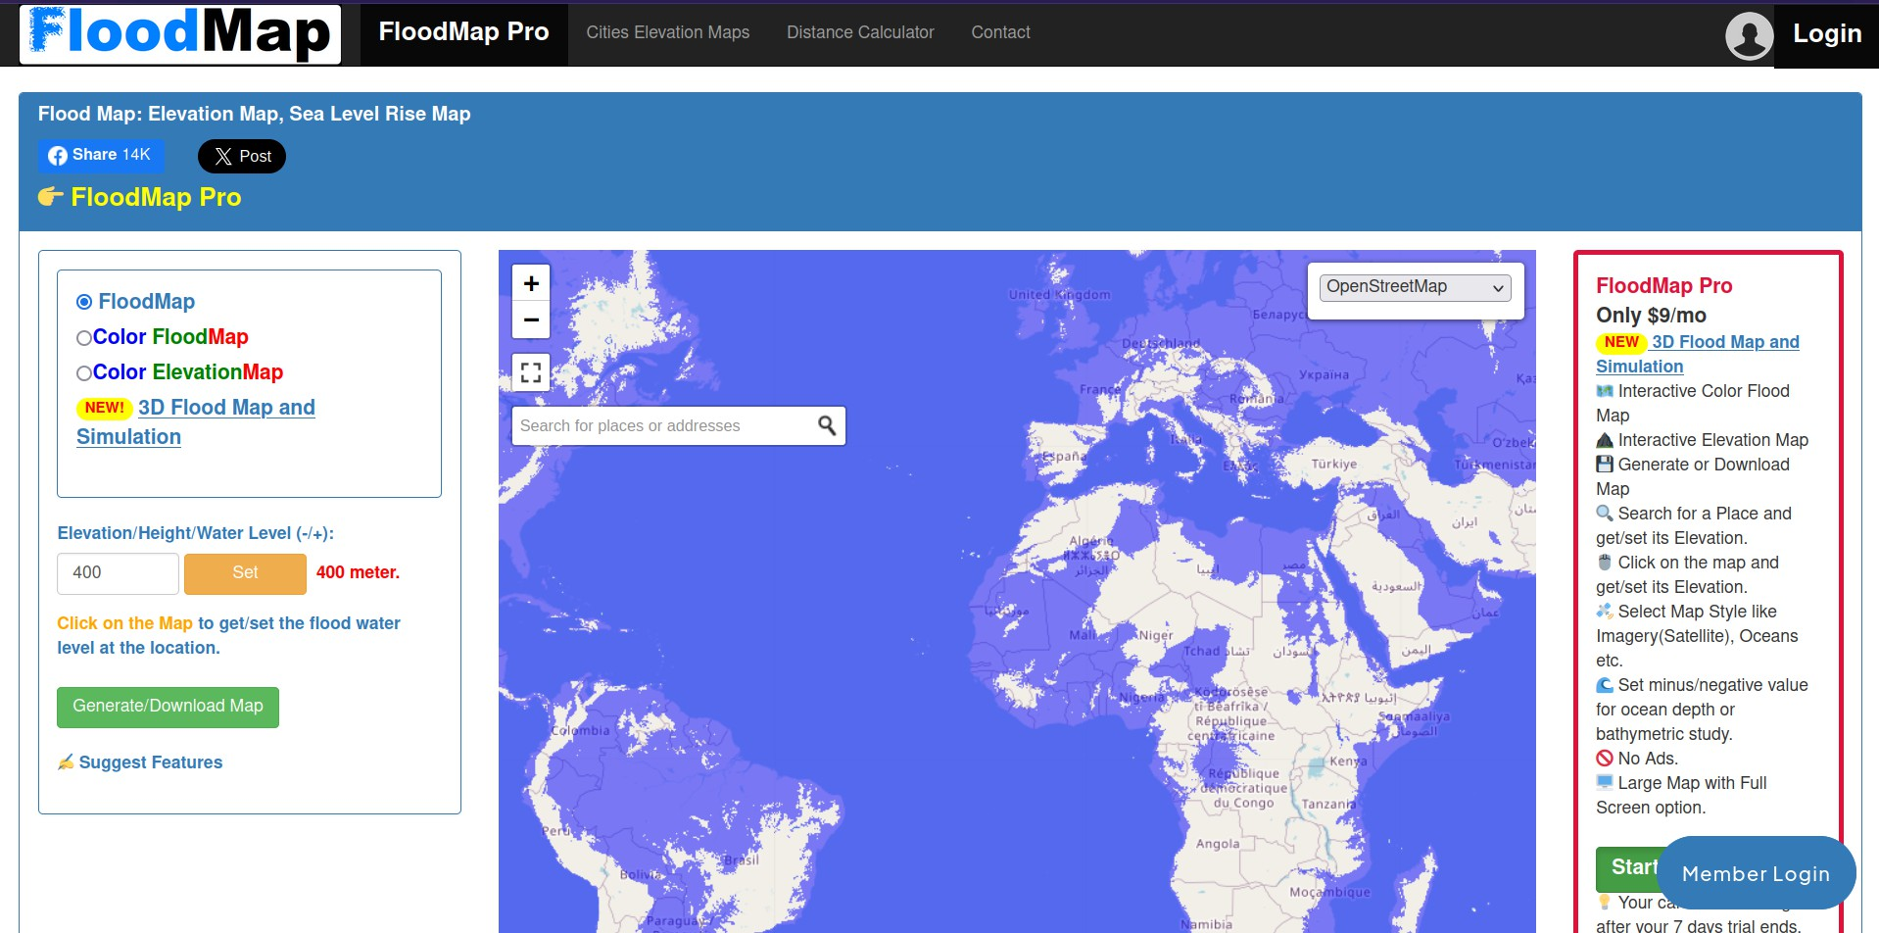

|  |  |  |  |  |
| --- | --- | --- | --- | --- |
| **Name of the website** | **Link** | **Key feature** | **Tech Stack (Front End)** | **Tech stack (Back End)** |
| **Floodmap net** | [**link**](https://www.floodmap.net/#google_vignette) | 1. **ﬂood map (world map)** 2. **color ﬂood map 3)Elevation/Height/Water Level (-/+)** | **html css** | **express.js node.js**  **js** |
| **Aregis Pro** | [**link**](https://pro.arcgis.com/en/pro-app/latest/help/mapping/simulation/simulation-in-arcgis-pro.htm) | 1. **3rd model simulation** 2. **video to understand the simulation only for premium customer** 3. **some documentations** | **html css** | **don't now** |
| **ﬂood.concord** | [**link**](https://flood.concord.org/) | 1. **Water level simulation map of different areas** 2. **Static map** 3. **video player of water level** | **html css** |  |
| **FEMA Flood Map Service Center** | [**link**](https://msc.fema.gov/portal/home) | 1. **World map with**   **area-speciﬁc ﬂood view**   1. **No customized ﬂood zone** | **html css js** | **apis node expres.js** |
| **HydroSheds** | [**link**](https://www.hydrosheds.org/) | 1. **Flood documentation by area** 2. **Categorized data product** 3. **no 3d effect** | **html css js** | **js node**  **expres.js** |
| **European Flood Awareness System (EFAS)** | [**link**](https://european-flood.emergency.copernicus.eu/en) | 1. **Latest ﬂood news and events** 2. **EFAS real time forecasts are only accessible** 3. **any previous incident** | **html css js** | **js** |