Image Management Service API Documentation

1. Architecture Diagram
The diagram below shows the high-level serverless architecture using API Gateway, Lambda, S3, and DynamoDB. LocalStack emulates these services locally.
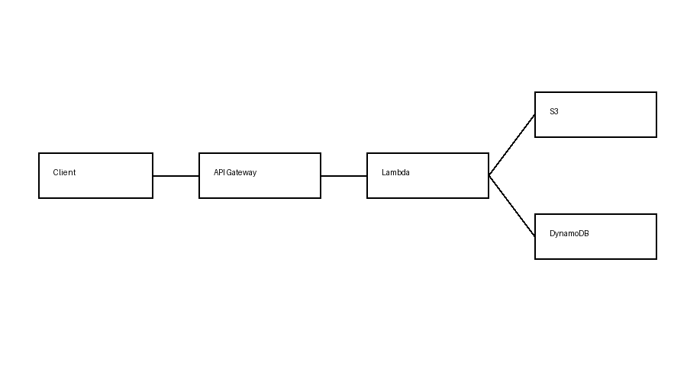

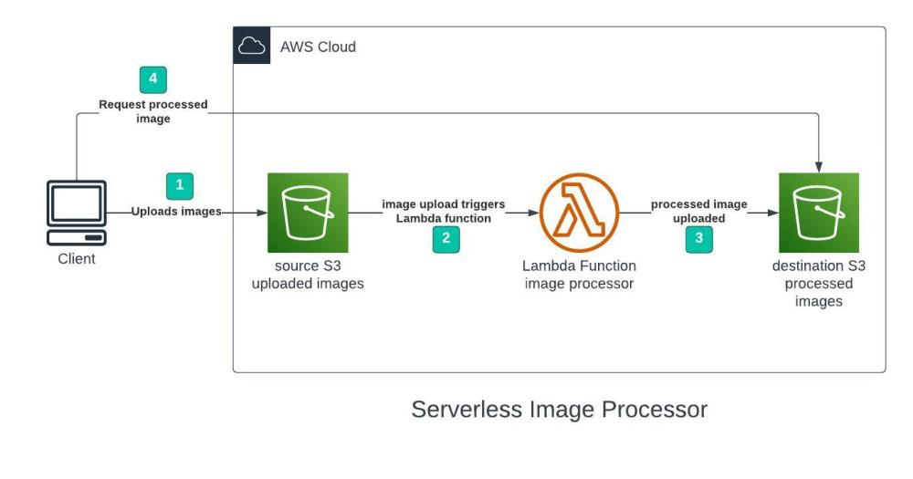
API Documentation

2. Introduction
The Image Management Service is a scalable, serverless backend module similar to Instagram’s image service.
It allows users to upload images, store metadata, list images with filters, view or download images, and delete images.
The service is built using:
- API Gateway (REST APIs)
- AWS Lambda (Python 3.7+)
- Amazon S3 (image storage)
- Amazon DynamoDB (metadata storage)
- LocalStack (for local development and testing)

2. Architecture Overview
The client interacts with REST APIs exposed through API Gateway.
API Gateway triggers Lambda functions that perform business logic.
Images are stored in Amazon S3, while image metadata is persisted in DynamoDB.
The system is stateless and fully serverless, allowing it to scale automatically to support multiple concurrent users.

3. Base URLs

Local Development (LocalStack)
http://localhost:4566

Production (AWS)
https://<api-id>.execute-api.<region>.amazonaws.com/prod

4. Authentication
Currently, no authentication is enforced for simplicity.
This can be extended using:
- AWS Cognito
- JWT-based authentication
- API Keys

5. API Endpoints Summary
HTTP Method | Endpoint | Description
POST | /images/upload | Upload image with metadata
GET | /images | List images with filters
GET | /images/{image_id} | View or download image
DELETE | /images/{image_id} | Delete image

6. API Details

6.1 Upload Image with Metadata
Endpoint
POST /images/upload
Description
Uploads an image file to cloud storage and saves its metadata in DynamoDB.
Request Type
multipart/form-data
Request Parameters
Name | Type | Required | Description
file | Image file | Yes | Image to be uploaded
user_id | String | Yes | ID of the user
tags | String | No | Comma-separated tags
Sample Request
POST /images/upload
Success Response (201)
{
"image_id": "img_123abc",
"message": "Image uploaded successfully"
}
Error Responses
- 400 – Invalid request
- 500 – Internal server error

6.2 List Images (With Filters)
Endpoint
GET /images
Description
Returns a list of images with optional filters.
Query Parameters
Name | Required | Description
user_id | No | Filter images by user
tag | No | Filter images by tag
Sample Request
GET /images?user_id=123&tag=travel
Success Response (200)
{
"items": [
{
"image_id": "img_123abc",
"user_id": "123",
"tags": ["travel", "beach"],
"created_at": "2026-01-01T10:00:00Z"
}
]
}

6.3 View / Download Image
Endpoint
GET /images/{image_id}
Description
Returns a downloadable URL or image content for the given image ID.
Path Parameter
Name | Description
image_id | Unique image identifier
Sample Request
GET /images/img_123abc
Success Response (200)
{
"download_url": "https://s3.amazonaws.com/bucket/img_123abc.jpg"
}
Error Responses
- 404 – Image not found
- 500 – Internal server error

6.4 Delete Image
Endpoint
DELETE /images/{image_id}
Description
Deletes the image from S3 and removes metadata from DynamoDB.
Path Parameter
Name | Description
image_id | Unique image identifier
Sample Request
DELETE /images/img_123abc
Success Response (200)
{
"message": "Image deleted successfully",
"image_id": "img_123abc"
}

7. Error Handling
Status Code | Description
400 | Bad request / missing parameters
404 | Resource not found
500 | Internal server error

8. Scalability and Performance
- API Gateway automatically scales for concurrent requests
- Lambda functions execute in parallel
- S3 supports unlimited image storage
- DynamoDB auto-scales metadata access
- Stateless design ensures horizontal scalability

9. Usage Instructions (LocalStack)
- Start LocalStack using Docker
- Ensure S3 and DynamoDB services are running
- Use Postman or curl to invoke APIs
- Validate responses and metadata persistence

10. Conclusion
This Image Management Service demonstrates a scalable, serverless architecture suitable for high-traffic applications.
It supports concurrent users, ensures high availability, and provides clear API contracts for integration and testing.

