ONLINE STUDENT RESULT MANAGEMENT SYSTEM
A BCA Final Year Project Report
Submitted By:
Ramesh Kumar Sah
Course:
Bachelor of Computer Applications (BCA)
University:
Bangalore North University
Academic Year:
2024 – 2025
A BCA Final Year Project Report
Submitted By:
Ramesh Kumar Sah
Course:
Bachelor of Computer Applications (BCA)
University:
Bangalore North University
Academic Year:
2024 – 2025

CERTIFICATE
This is to certify that the project entitled 'Online Student Result Management System' is a bonafide work carried out by Ramesh Kumar Sah, a student of Bachelor of Computer Applications (BCA), Bangalore North University, in partial fulfillment of the requirements for the award of the degree of Bachelor of Computer Applications. The work embodied in this project is original and has not been submitted to any other university or institution for the award of any degree.
This is to certify that the project entitled 'Online Student Result Management System' is a bonafide work carried out by Ramesh Kumar Sah, a student of Bachelor of Computer Applications (BCA), Bangalore North University, in partial fulfillment of the requirements for the award of the degree of Bachelor of Computer Applications. The work embodied in this project is original and has not been submitted to any other university or institution for the award of any degree.
This is to certify that the project entitled 'Online Student Result Management System' is a bonafide work carried out by Ramesh Kumar Sah, a student of Bachelor of Computer Applications (BCA), Bangalore North University, in partial fulfillment of the requirements for the award of the degree of Bachelor of Computer Applications. The work embodied in this project is original and has not been submitted to any other university or institution for the award of any degree.

DECLARATION
I hereby declare that the project report titled 'Online Student Result Management System' submitted in partial fulfillment of the requirements for the award of the degree of Bachelor of Computer Applications is my original work. The information and data presented in this report are based on my own study and implementation. This work has not been submitted previously for any degree or diploma.
I hereby declare that the project report titled 'Online Student Result Management System' submitted in partial fulfillment of the requirements for the award of the degree of Bachelor of Computer Applications is my original work. The information and data presented in this report are based on my own study and implementation. This work has not been submitted previously for any degree or diploma.
I hereby declare that the project report titled 'Online Student Result Management System' submitted in partial fulfillment of the requirements for the award of the degree of Bachelor of Computer Applications is my original work. The information and data presented in this report are based on my own study and implementation. This work has not been submitted previously for any degree or diploma.

ACKNOWLEDGEMENT
I express my sincere gratitude to my project guide and all faculty members of the Department of Computer Applications for their valuable guidance, encouragement, and continuous support throughout the course of this project. I am also thankful to my friends and family members for their cooperation and motivation, which helped me in the successful completion of this project.
I express my sincere gratitude to my project guide and all faculty members of the Department of Computer Applications for their valuable guidance, encouragement, and continuous support throughout the course of this project. I am also thankful to my friends and family members for their cooperation and motivation, which helped me in the successful completion of this project.
I express my sincere gratitude to my project guide and all faculty members of the Department of Computer Applications for their valuable guidance, encouragement, and continuous support throughout the course of this project. I am also thankful to my friends and family members for their cooperation and motivation, which helped me in the successful completion of this project.

ABSTRACT
The Online Student Result Management System is a web-based application designed to manage, store, and display student academic results in a systematic and efficient manner. Traditional result processing methods involve manual calculations and paperwork, which are time-consuming and prone to errors. This project aims to automate the result management process using modern web technologies. The system provides separate modules for administrators and students, allowing secure data entry, result calculation, and online marksheet generation. The application is developed using HTML, Tailwind CSS, and JavaScript, with LocalStorage serving as a lightweight client-side database.
The Online Student Result Management System is a web-based application designed to manage, store, and display student academic results in a systematic and efficient manner. Traditional result processing methods involve manual calculations and paperwork, which are time-consuming and prone to errors. This project aims to automate the result management process using modern web technologies. The system provides separate modules for administrators and students, allowing secure data entry, result calculation, and online marksheet generation. The application is developed using HTML, Tailwind CSS, and JavaScript, with LocalStorage serving as a lightweight client-side database.
The Online Student Result Management System is a web-based application designed to manage, store, and display student academic results in a systematic and efficient manner. Traditional result processing methods involve manual calculations and paperwork, which are time-consuming and prone to errors. This project aims to automate the result management process using modern web technologies. The system provides separate modules for administrators and students, allowing secure data entry, result calculation, and online marksheet generation. The application is developed using HTML, Tailwind CSS, and JavaScript, with LocalStorage serving as a lightweight client-side database.

TABLE OF CONTENTS
1. Introduction
2. Problem Statement
3. Objectives of the Project
4. Scope of the Project
5. Literature Review
6. System Analysis
7. Existing System
8. Proposed System
9. System Architecture
10. Technologies Used
11. Module Description
12. Database Design
13. ER Diagram
14. Data Flow Description
15. Algorithm & Logic
16. User Interface Design
17. Security Considerations
18. Testing
19. Advantages
20. Limitations
21. Future Enhancements
22. Conclusion
23. Bibliography
1. Introduction
2. Problem Statement
3. Objectives of the Project
4. Scope of the Project
5. Literature Review
6. System Analysis
7. Existing System
8. Proposed System
9. System Architecture
10. Technologies Used
11. Module Description
12. Database Design
13. ER Diagram
14. Data Flow Description
15. Algorithm & Logic
16. User Interface Design
17. Security Considerations
18. Testing
19. Advantages
20. Limitations
21. Future Enhancements
22. Conclusion
23. Bibliography

INTRODUCTION
In recent years, educational institutions have increasingly adopted digital technologies to improve administrative efficiency and accuracy. One of the critical academic activities is the management of student results. The Online Student Result Management System is designed to address the challenges of manual result processing by providing a reliable and automated solution. This system enables faster result generation, reduces errors, and improves transparency in academic evaluation.
In recent years, educational institutions have increasingly adopted digital technologies to improve administrative efficiency and accuracy. One of the critical academic activities is the management of student results. The Online Student Result Management System is designed to address the challenges of manual result processing by providing a reliable and automated solution. This system enables faster result generation, reduces errors, and improves transparency in academic evaluation.
In recent years, educational institutions have increasingly adopted digital technologies to improve administrative efficiency and accuracy. One of the critical academic activities is the management of student results. The Online Student Result Management System is designed to address the challenges of manual result processing by providing a reliable and automated solution. This system enables faster result generation, reduces errors, and improves transparency in academic evaluation.
In recent years, educational institutions have increasingly adopted digital technologies to improve administrative efficiency and accuracy. One of the critical academic activities is the management of student results. The Online Student Result Management System is designed to address the challenges of manual result processing by providing a reliable and automated solution. This system enables faster result generation, reduces errors, and improves transparency in academic evaluation.

PROBLEM STATEMENT
Manual result management systems require significant time and effort for data entry, calculation, and verification. Such systems are susceptible to human errors and delays. There is a need for a computerized system that can handle result processing efficiently and provide instant access to academic records.
Manual result management systems require significant time and effort for data entry, calculation, and verification. Such systems are susceptible to human errors and delays. There is a need for a computerized system that can handle result processing efficiently and provide instant access to academic records.
Manual result management systems require significant time and effort for data entry, calculation, and verification. Such systems are susceptible to human errors and delays. There is a need for a computerized system that can handle result processing efficiently and provide instant access to academic records.
Manual result management systems require significant time and effort for data entry, calculation, and verification. Such systems are susceptible to human errors and delays. There is a need for a computerized system that can handle result processing efficiently and provide instant access to academic records.

OBJECTIVES OF THE PROJECT
The main objectives of this project are to automate the result management process, reduce manual workload, minimize errors, and provide a user-friendly platform for students and administrators. The project also aims to generate professional and printable marksheets.
The main objectives of this project are to automate the result management process, reduce manual workload, minimize errors, and provide a user-friendly platform for students and administrators. The project also aims to generate professional and printable marksheets.
The main objectives of this project are to automate the result management process, reduce manual workload, minimize errors, and provide a user-friendly platform for students and administrators. The project also aims to generate professional and printable marksheets.
The main objectives of this project are to automate the result management process, reduce manual workload, minimize errors, and provide a user-friendly platform for students and administrators. The project also aims to generate professional and printable marksheets.

SCOPE OF THE PROJECT
This project is suitable for schools, colleges, and universities that require a simple and effective result management system. The application is currently designed as a client-side system but can be enhanced with backend and database support in the future.
This project is suitable for schools, colleges, and universities that require a simple and effective result management system. The application is currently designed as a client-side system but can be enhanced with backend and database support in the future.
This project is suitable for schools, colleges, and universities that require a simple and effective result management system. The application is currently designed as a client-side system but can be enhanced with backend and database support in the future.
This project is suitable for schools, colleges, and universities that require a simple and effective result management system. The application is currently designed as a client-side system but can be enhanced with backend and database support in the future.

SYSTEM ANALYSIS
System analysis involves identifying the functional and non-functional requirements of the application. The system was analyzed to understand data flow, user interactions, and storage requirements, which helped in designing an efficient solution.
System analysis involves identifying the functional and non-functional requirements of the application. The system was analyzed to understand data flow, user interactions, and storage requirements, which helped in designing an efficient solution.
System analysis involves identifying the functional and non-functional requirements of the application. The system was analyzed to understand data flow, user interactions, and storage requirements, which helped in designing an efficient solution.
System analysis involves identifying the functional and non-functional requirements of the application. The system was analyzed to understand data flow, user interactions, and storage requirements, which helped in designing an efficient solution.

EXISTING SYSTEM
The existing result management system is largely manual and paper-based. It involves significant paperwork, delayed processing, and higher chances of errors.
The existing result management system is largely manual and paper-based. It involves significant paperwork, delayed processing, and higher chances of errors.
The existing result management system is largely manual and paper-based. It involves significant paperwork, delayed processing, and higher chances of errors.
The existing result management system is largely manual and paper-based. It involves significant paperwork, delayed processing, and higher chances of errors.

PROPOSED SYSTEM
The proposed system automates result processing and provides digital storage of records. It offers a centralized platform for result management and improves efficiency and accuracy.
The proposed system automates result processing and provides digital storage of records. It offers a centralized platform for result management and improves efficiency and accuracy.
The proposed system automates result processing and provides digital storage of records. It offers a centralized platform for result management and improves efficiency and accuracy.
The proposed system automates result processing and provides digital storage of records. It offers a centralized platform for result management and improves efficiency and accuracy.

SYSTEM ARCHITECTURE
The system architecture follows a client-side model consisting of user interface, business logic, and LocalStorage-based data storage. This architecture ensures simplicity and ease of deployment.
The system architecture follows a client-side model consisting of user interface, business logic, and LocalStorage-based data storage. This architecture ensures simplicity and ease of deployment.
The system architecture follows a client-side model consisting of user interface, business logic, and LocalStorage-based data storage. This architecture ensures simplicity and ease of deployment.
The system architecture follows a client-side model consisting of user interface, business logic, and LocalStorage-based data storage. This architecture ensures simplicity and ease of deployment.

TECHNOLOGIES USED
HTML5 is used for structuring web pages. Tailwind CSS is used for designing responsive and modern user interfaces. JavaScript is used for implementing application logic and data handling. LocalStorage is used as a client-side database.
HTML5 is used for structuring web pages. Tailwind CSS is used for designing responsive and modern user interfaces. JavaScript is used for implementing application logic and data handling. LocalStorage is used as a client-side database.
HTML5 is used for structuring web pages. Tailwind CSS is used for designing responsive and modern user interfaces. JavaScript is used for implementing application logic and data handling. LocalStorage is used as a client-side database.
HTML5 is used for structuring web pages. Tailwind CSS is used for designing responsive and modern user interfaces. JavaScript is used for implementing application logic and data handling. LocalStorage is used as a client-side database.

MODULE DESCRIPTION
The system includes Admin Module for managing results, Student Module for viewing results, and Marksheet Module for generating printable marksheets.
The system includes Admin Module for managing results, Student Module for viewing results, and Marksheet Module for generating printable marksheets.
The system includes Admin Module for managing results, Student Module for viewing results, and Marksheet Module for generating printable marksheets.
The system includes Admin Module for managing results, Student Module for viewing results, and Marksheet Module for generating printable marksheets.

DATABASE DESIGN (LOCALSTORAGE)
The application uses LocalStorage to store student records in JSON format. Each record includes registration number, student name, semester, subject-wise marks, total marks, percentage, and result status.
The application uses LocalStorage to store student records in JSON format. Each record includes registration number, student name, semester, subject-wise marks, total marks, percentage, and result status.
The application uses LocalStorage to store student records in JSON format. Each record includes registration number, student name, semester, subject-wise marks, total marks, percentage, and result status.
The application uses LocalStorage to store student records in JSON format. Each record includes registration number, student name, semester, subject-wise marks, total marks, percentage, and result status.

ER DIAGRAM
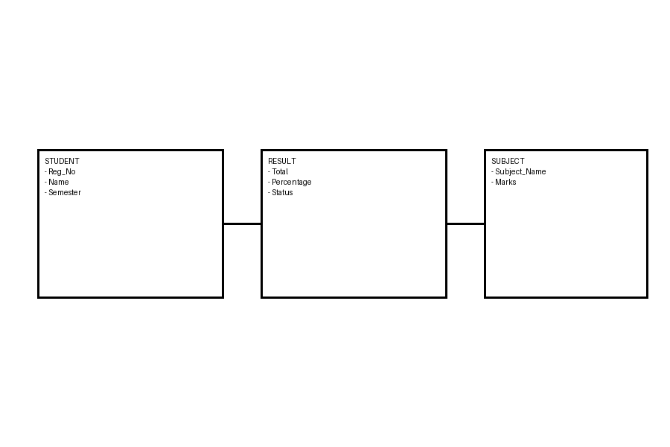
The Entity Relationship diagram represents the relationship between Student, Result, and Subject entities. It helps in understanding the logical structure of the system.
The Entity Relationship diagram represents the relationship between Student, Result, and Subject entities. It helps in understanding the logical structure of the system.

SCREENSHOTS
This section includes screenshots of the Admin Dashboard, Student Login Page, and Generated Marksheet. These screenshots demonstrate the working of the application and validate its functionality.
This section includes screenshots of the Admin Dashboard, Student Login Page, and Generated Marksheet. These screenshots demonstrate the working of the application and validate its functionality.
This section includes screenshots of the Admin Dashboard, Student Login Page, and Generated Marksheet. These screenshots demonstrate the working of the application and validate its functionality.

TESTING
The system was tested using various test cases including login validation, data storage, result calculation, and PDF generation to ensure correct functionality.
The system was tested using various test cases including login validation, data storage, result calculation, and PDF generation to ensure correct functionality.
The system was tested using various test cases including login validation, data storage, result calculation, and PDF generation to ensure correct functionality.

ADVANTAGES
The system is easy to use, reduces paperwork, provides quick access to results, and supports offline usage.
The system is easy to use, reduces paperwork, provides quick access to results, and supports offline usage.
The system is easy to use, reduces paperwork, provides quick access to results, and supports offline usage.

LIMITATIONS
As the system is client-side based, it has limited security and storage capacity. It is not suitable for handling very large databases.
As the system is client-side based, it has limited security and storage capacity. It is not suitable for handling very large databases.
As the system is client-side based, it has limited security and storage capacity. It is not suitable for handling very large databases.

FUTURE ENHANCEMENTS
Future enhancements include backend integration, database support, enhanced security, and multi-semester result tracking.
Future enhancements include backend integration, database support, enhanced security, and multi-semester result tracking.
Future enhancements include backend integration, database support, enhanced security, and multi-semester result tracking.

CONCLUSION
The Online Student Result Management System successfully meets its objectives by providing a simple, efficient, and reliable solution for managing academic results.
The Online Student Result Management System successfully meets its objectives by providing a simple, efficient, and reliable solution for managing academic results.
The Online Student Result Management System successfully meets its objectives by providing a simple, efficient, and reliable solution for managing academic results.

BIBLIOGRAPHY
1. https://developer.mozilla.org
2. https://tailwindcss.com
3. https://fontawesome.com
4. https://github.com/eKoopmans/html2pdf
1. https://developer.mozilla.org
2. https://tailwindcss.com
3. https://fontawesome.com
4. https://github.com/eKoopmans/html2pdf

