# Introduction

**Composition and responsibilities of each team player:**

* Team Leader: A.B.P.R. Lakshani
  + Coordinating with internal and external communication during the project
  + Responsible for overall project
* Document manager: H.L.M. Hansini
  + Responsible for maintenance of project documentation and final preparation
* System Analyst: S.G. Kumarawadu
  + Dealing with the business environment and analysing the requirements of the client
* Developers: C.M.N.D. Pathirana
  + Responsible for developing the software systems in accordance with the client’s requirements

## Client

**Name of the business**: “Hotel T.K. Green Garden”

**Register Number** : MA/1/227

**Contact Details**

1. Name of the client: Mr. Tennyson Kumarawadu
2. Position hold/relationship to the owner Proprietor of the business
3. Postal Addres Hotel T.K. Green Garden,

Polhena,

Matara

1. Telephone 041-2222603

**Company structure**

It consists of 16 rooms with A/C and non A/C facilities including 5 exceptional luxury rooms, 1 wedding hall which has the capacity of nearly 300 people. In addition the selected organization is expecting to extend their service to start a catering service for the area.

**Staff details**

Figure 1.1:Hierarchical view of the staff

## Business Problem

The client expects an automated information system to keep track of the bookings (room and hall) and two simple integrated subsystem to keep track of details of the staff members and transaction details for each day.

Furthermore in order to achieve the goal of the expansion plan for next 3 years, client wishes to have a website for the selected organization which will helps in provide the facility advertising and online room bookings, in order to a give broad exposure for the company.

## Vision

### System objectives:

Increase the efficiency and reliability in the process of information management in the business by replacing the manual information system which the currently use.

### Business benefits

* Replace the manual methods by computerized system.
* Provide online boking facility for customers
* Provide a user friendly and centralized information system with controlled access to each party
* Publicize services and facilities provided by the hotel

### System capabilities

* Manager of the hotel is provided with an interface which has access to all the details and the ability to enter details.
* Monthly/ annual reports should be generated by the system itself and should be accessible by the manager or the relevant party.
* Receptionist should be provided with an interface which has the ability to access information about the available rooms and wedding halls and enter details on bookings.
* Customer logs and details will be stored with secured acces.
* System is capable of storing staff details

### System scope

# Inception Phase

## Introduction

## Stakeholder Analysis

Identify stakeholders and their category, role, product focus, schedule focus and cost focus .

## Risk Identification and Feasibility analysis

Identify any possible risks and analyze the feasibility of the project.

## Requirement analysis

### Requirement gathering methods

Briefly describe the methods you used for requirement gathering. (Detailed descriptions are not required. Maximum half a page)

### Essential Use Case list

Identify and **LIST** the most critical use cases in your business scenario. (Detailed descriptions are not required)

### Non Functional requirements

Briefly describe any non-functional requirements of the system.(Detailed descriptions are not required. Maximum half a page)

# Elaboration Phase

## Introduction

Clearly state individual contributions.

## Domain Modeling

### Event table

|  |  |  |  |  |  |
| --- | --- | --- | --- | --- | --- |
| **Event** | **Triggered** | **Use case** | **Source** | **Response** | **Destination** |
| 1. Room booking by customers | Booking request | Reserving room | Customer | Message of confirmation | Customer |
| 1. Customer Check availability of rooms | Room detail inquiry | Look up room details | Customer | Message of availability | Customer |
| 1. Customer asking for details | Logistic detail inquiry | Look up logistic details | Customer |  | Customer |
| 1. Wedding hall bookings by the customer | Wedding hall booking Request. | Book wedding hall | Manager  Or receptionist | Message of confirmation |  |
| 1. Updating the room prices and special Offers. | System update Request | Updating rates | Admin | Message of confirmation | Admin |
| 1. Update wedding hall ratings | System update Request | Updating the rates | Assistant Manager | Message of confirmation |  |
| 1. Adding details of advance payments by the Manager | Transaction detail update request | Update transaction details | Receptionist | Message of confirmation |  |
| 1. Notify about wedding hall bookings | “2 days before the booked date” | Notification for Assistant Manager and Manager |  | Notification | Manager Assistant Manager |
| 1. Receptionist register payments | Transaction update request | Update payment | Receptionist |  |  |
| 1. Notify remainder to pay | 12.00am on the day of departure | Notify receptionist |  | Balance notification | Receptionist |
|  | | | | | |
| 1. Adding a staff member to the system by Manager | Add employee request | Adds a new employee | Manager | Message of confirmation |  |
| 1. Updating details of staff members Manager | Edit request | Update employee details | Manager | Message of confirmation |  |
| 1. Archiving staff member details by Manager | Staff detail change request | Updating archived staff table in database | Manager | Staff member detail being archived |  |
| 1. Generate employee salary report | “End of month” | Calculating salary of employees by the system |  | Employee salary report | Manager  Assistant manager |
| 1. Adding details of extra payments for employees by Manager | Salary update request | Update employee salary details | Manager  Or assistant manager | Message of confirmation |  |
| 1. Notify birthdays of employees | “1 hour before birthday” | System notification |  | Notification or a reminder | Assistant manager |

**Event based approach**

### Use case diagram

Figure 3.1:Use case diagram for the project

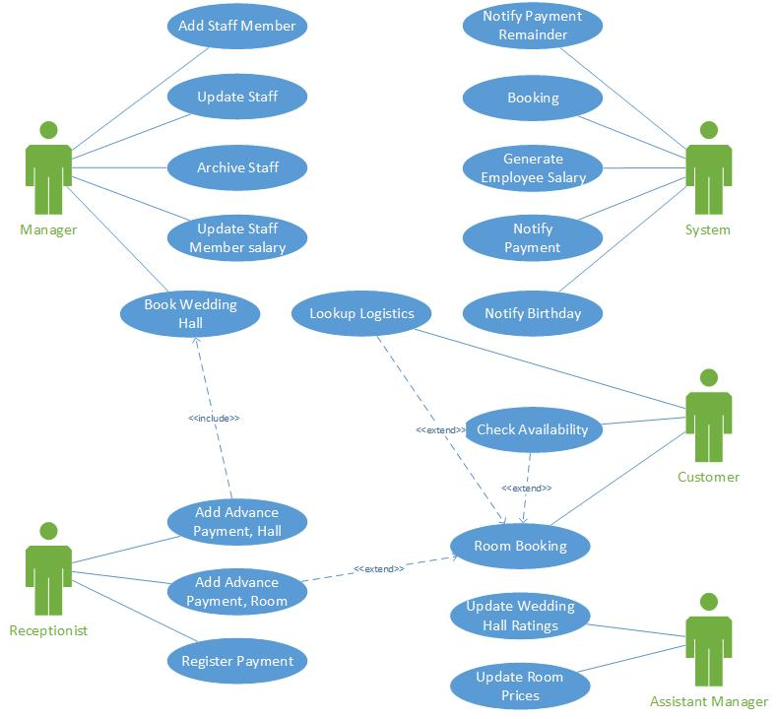

### Use case detailed descriptions

Provide use case detailed descriptions ***at least*** for the essential use case list identified for 2.6.2.

Each member of the group should prepare at least one **essential** use case description.

### Activity Diagrams

Activity diagrams ***at least*** for the essential use case list identified for 2.6.2.

### System Sequence Diagrams

SSD s ***at least*** for the essential use case list identified for 2.6.2.

**Entity based approach**

### Domain class diagram

Domain class diagram for the full system

### State chart diagrams

Identify the objects that have multiple states during their lifecycle, and draw the state chart diagrams for those objects.