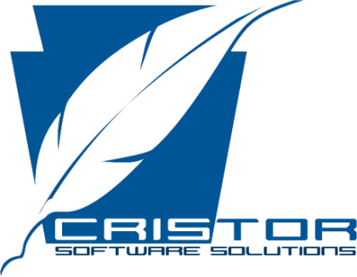

**Cristor Software Solutions**

No:136/4, Dharmarathna Mw,

Uyanwatta, Matara.

E-mail: cristorsoftware@gmail.com

Phone: +94 773399818

**Team Members:**

* Piyumi Rameshka
* Malsha Hansini
* Sabeena Kumarawadu
* Nethmi Pathirana