AIOPS PROGRAM · WEEK 2 · AS-BUILT
Closed-Loop RCA Assistant
A retrieval-augmented diagnostic assistant over ServiceNow's own resolved-incident history — built so that every case it can't yet resolve becomes the training data for the next one, without retraining a model.

How a new incident is handled
Two pipelines share one FAISS index: a build-time pipeline that keeps the corpus current, and a query-time pipeline that serves new incidents. The path on the right is what closes the loop.
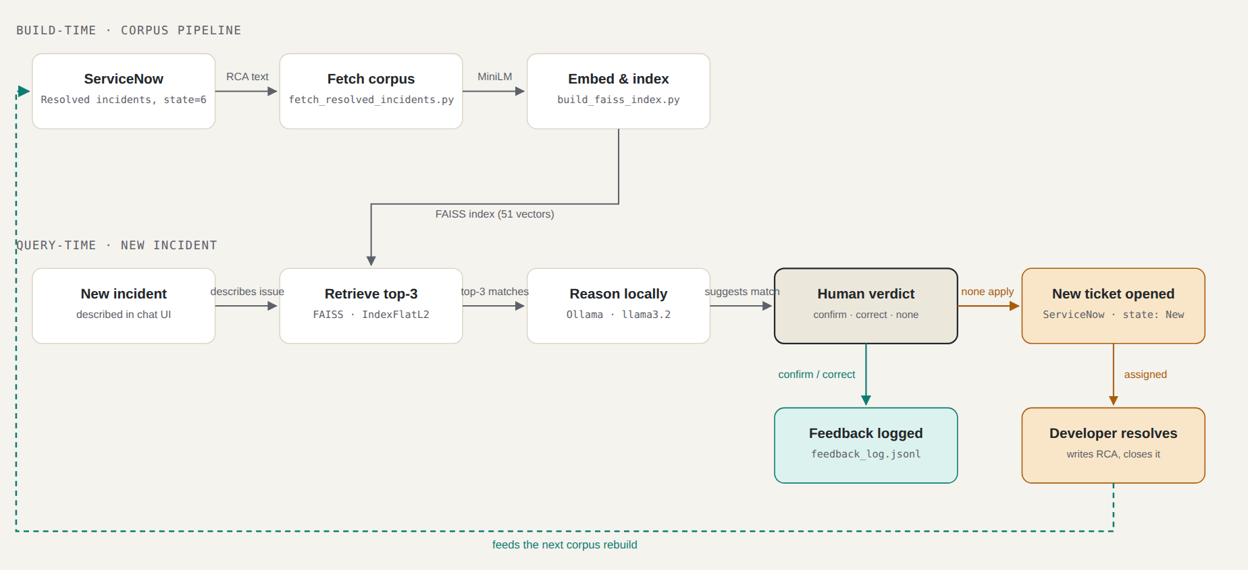
The build-time and query-time pipelines share one FAISS index. When the assistant has no confident match, escalating opens a real ServiceNow ticket rather than just a log entry — and once a developer resolves it, re-running the fetch + index scripts folds it back into the corpus, so the same problem is recognized automatically the next time it happens.

Components
Every box in the diagram above corresponds to a real script, model, or ServiceNow object — nothing here is conceptual.
Corpus source  ServiceNow (dev354741) | 50 seeded UiPath production incidents plus every incident the assistant has since escalated and had resolved — each with a full Root Cause and Resolution written into close_notes at the time it's closed.
Embedding model  all-MiniLM-L6-v2 | Converts each incident's short_description + close_notes, and every new query, into the same 384-dimension vector space, via sentence-transformers. Cached in memory after first load so repeated queries don't reload it.
Vector index  FAISS · IndexFlatL2 | An exhaustive (exact, not approximate) nearest-neighbour search over the corpus. Rebuilt from scratch on every run of build_faiss_index.py — there is no incremental update, which keeps the index always consistent with whatever's currently resolved in ServiceNow.
Reasoning model  Ollama · llama3.2 (local) | A small language model running entirely on the laptop — no incident data leaves the machine. It never memorizes RCAs; it's handed the top three retrieved incidents in the prompt and reasons over just those, an approach that works precisely because the facts it needs are supplied, not recalled.
Interface  app.py + static/index.html | A small Flask app wrapping the exact same retrieval/generation functions the command-line tool uses, with a chat UI in front of them — incident cards, a confidence score per match, and buttons in place of typed y/n prompts.
Human verdict gate  query_incident.py | Nothing is final until a person confirms it. Every verdict — confirmed, corrected, or rejected — is appended to feedback_log.jsonl, an audit trail of every judgment the assistant has ever been given.

Three ways a query can end
The same retrieval and reasoning steps run every time; what happens next depends entirely on the human's verdict.
Path 1  Confirmed  The SLM's top pick is correct, and its reasoning holds up. Human answers y.  human_verdict: "confirmed" | Path 2  Corrected  A real match exists in the corpus, but the SLM picked the wrong one of the three retrieved. Human selects the right one.  human_verdict: "corrected" | Path 3  Escalated  None of the three retrieved incidents actually apply — a genuinely new problem. A ServiceNow ticket is opened for a developer.  status: "unresolved_by_ai"

Design decisions
Flat, exact FAISS index — not IVF/HNSW | At ~50–100 records, an exhaustive search is already instant. An approximate index only earns its complexity once the corpus is large enough that exhaustive search is the bottleneck — not the case here yet.
A local SLM, not a cloud LLM | The laptop this runs on has 8GB of RAM, and incident data shouldn't need to leave it. A 3B-parameter model is enough here because retrieval already supplies the facts — the model only has to reason over three short documents, not recall anything from memory.
Corpus writes go through the API, never the UI | ServiceNow's UI has its own default-value business rules (e.g. auto-filling a placeholder close note when the caller and resolver are the same account) that can silently write junk into a field the corpus depends on. The API path writes exactly what's sent, with nothing implicit.
Human-in-the-loop on every single answer, for now | This is deliberately the most conservative point on the automation maturity curve: a person reviews every suggestion before it's final. feedback_log.jsonl exists so that a future confidence threshold can be set from real judgment history, rather than a guess.
Escalation opens a real ticket, not just a log line | A local log entry only a script can see doesn't get worked. Escalating into ServiceNow means an unresolved incident reaches the same queue a person already checks, and its eventual resolution is what the corpus grows from.

Validated before demo
All three verdict paths were exercised end-to-end against 30 hand-built test incidents (10 per path — see test_scenarios.md), including one full closed-loop run: an incident escalated into ServiceNow, resolved as though by a developer, folded back into the corpus on rebuild, and correctly recognized on the next query — with a noticeably tighter match distance than when it was still unresolved.

Where this sits on the automation curve
This is stage one of three. Today, every answer is human-in-the-loop: reviewed before it's final. As feedback_log.jsonl accumulates real judgments, high-confidence, consistently-confirmed categories can graduate to human-on-the-loop — the answer goes out immediately, with a person auditing afterward rather than gating beforehand. Only after that, for a narrow, explicitly whitelisted set of incident types with a long track record, does full elimination of L1/L2 review become defensible — not as a blanket goal from day one, but as something earned category by category.

