# Mobile QA assignment

StuDocu Mobile QA Engineer Assignment for ReactNative App using Appium, WebDriverIO, Typescript, Mocha
This repository shows an example of how to create Android automation testcases for react native mobile app using Appium, WDIO, TS, Mocha ect.

Tools and libraries:
- Appium: 2.0.1
- WebDriver.IO: 8.24.6
- Typescript: 5.3.2
- Allure Reporter: 8.24.2
- Spec Reporter: 8.24.2
- appium-uiautomator2: 2.34.2
- Android sdk: 33
- Android Studio: 2022.3.1
- Appium Inspector: 2023.11.1
- Mocha
Functional Testcases Covered for com.studocuproject App:

- TC_1: Search Book By ISBN and check given search result
- TC_2: Search Book By BookName Keyword and check search result
- TC_3: Verify Book search result contains appropriate details and matching results
- TC_4: Add Book to Current Reading list (in next steps we will be validating book details)
- TC_5: Add Book to Wish List (There is no separate Wishlist section where I can verify if it’s added)
- TC_6: Access Currently Reading Book List and compare the book title with search result
- TC_7: Remove Book from currently reading list using currently reading book list screen (This is not Working as Expected, user can’t remove book from this list)
- Remove Book from currently reading list using Search Result screen and validate if removed
- Remove Book from Wishlist from the search result screen
- Select 1st Book from the above search result. Open Book and validate book details. Compare it with search result book details data for accuracy
- Add Book to Currently Reading List from Opened Book screen and compare Title/details

How to run test from VS Code, CMD and android studio on windows:
Prerequisites:
- Ensure you have Node.js and npm installed.
- Download app source code, compile the app using android studio (instruction given in assignment app source code readme.md) Pls follow that
- Launch the android emulator
- Install app on Android Emulator/Physical device (This will be done automatically once app is compiled in android studio in above steps)
- Take clone of automation source code and open in VScode Studio (it should download the dependencies mentioned in project node module /package.json/tsconfig.json )
if not downloaded then pls follow the below command
-npm install
https://webdriver.io/docs/gettingstarted (reference can be taken from here to setup Wdio)
- Once the setup is completed including all dependencies, app installed, emulator running.
Test Execution from VS Code:
- Open Automation project in VSCode if not opened already.
- Go to Terminal and run below command npm run wdio or npx wdio wdio.conf.ts
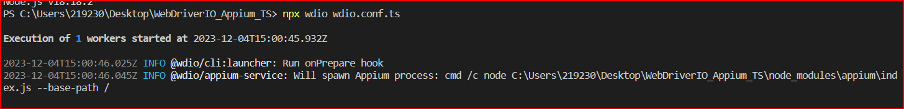
Test Execution from CMD on Windows:
1. Navigate to your project directory
2. Run Command given npm run wdio or npx wdio wdio.conf.ts
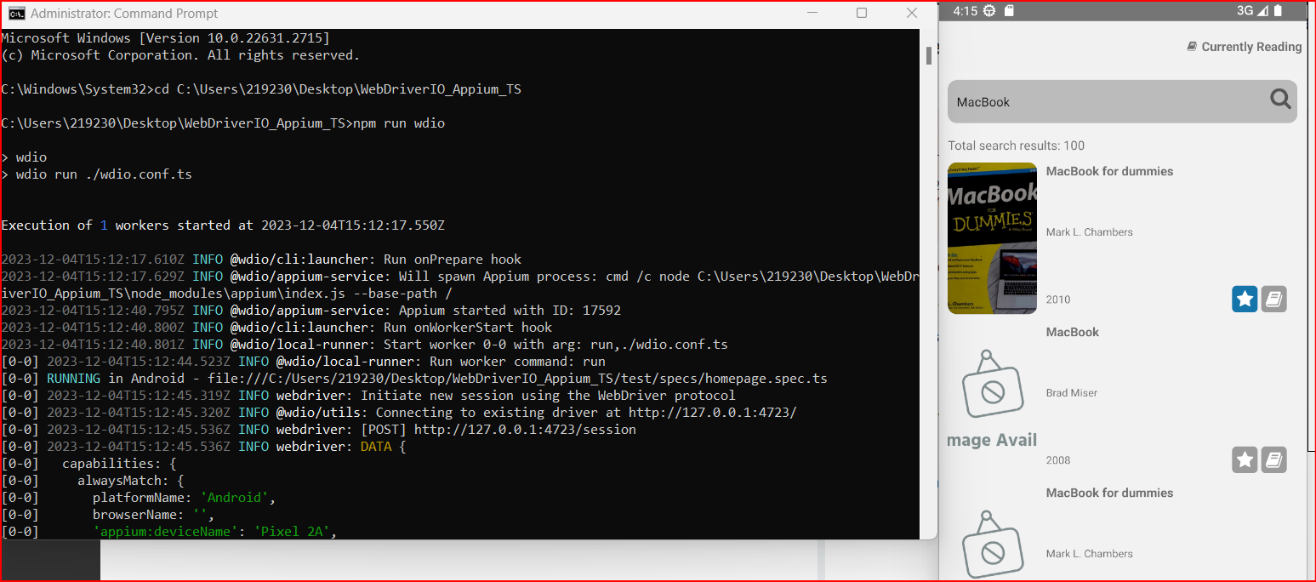

How to generate and find Allure HTML Report for Test execution on Windows:
Here's a general approach to Find the HTML Report, by default, they are located in:
- Your project/allure-result, allure-report, the execution results and steps store in Json file
- We need to generate HTML Report from json file.
- Go to VS Code terminal/CMD (Project Dir) and run (npm run report or allure generate allure-results --clean && allure open )
- This will generate HTML Report and open in your default system browser refer below
Allure Reporter:
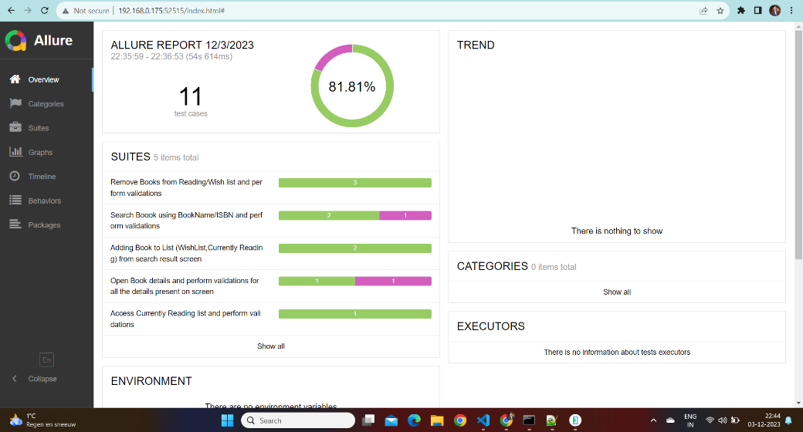
Spec Reporter:
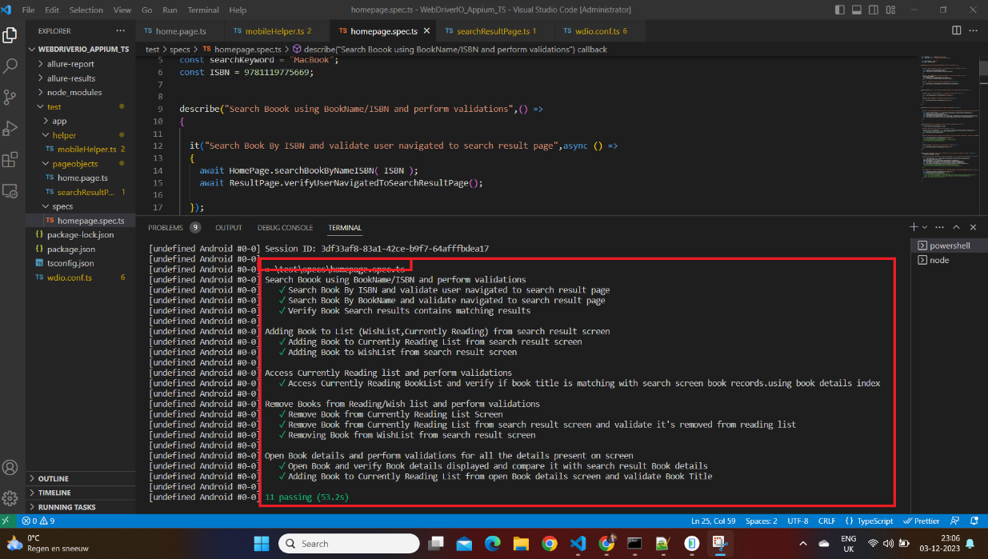
Integrate Jacco for code coverage and generate report:
To Be Done????

Integrate parallel execution run: currently Max Instance is set as 5. To execute parallel
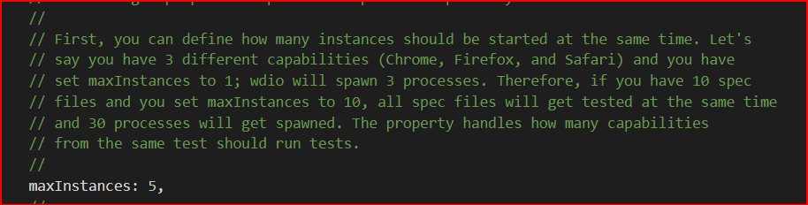
Configuration added for failure Screenshot and Logging purpose:
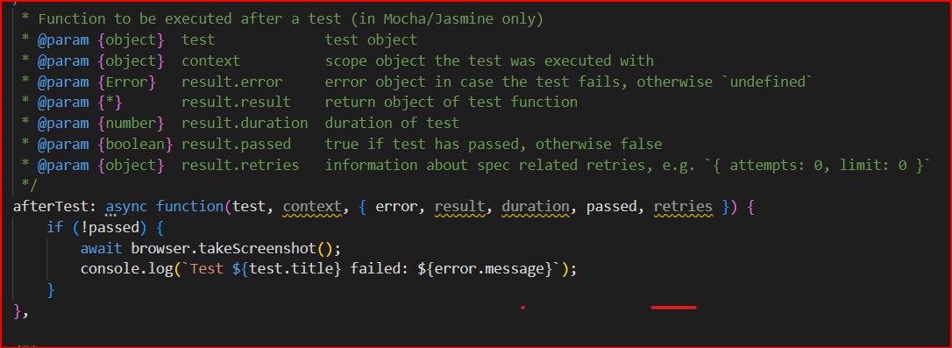
Configuration for Test Reporter: Spec, Allure
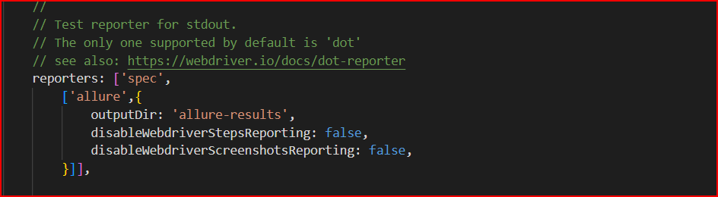
Number of Failed Retries after execution: currently set as 1 but can be changed accordingly
// The number of times to retry the entire spec file when it fails
specFileRetries: 1,

WebdriverIO and Appium, both driver and browser are instances of the WebdriverIO browser object and can be used interchangeably.
The choice between using driver or browser name is largely a matter of personal preference and the naming conventions the team have decided to follow.
Note: I observed app crash issue on android Emulator

