**This is endpoint to start the ptoject**

<http://localhost:8090/products/new>

<http://localhost:8090/products/productForm>

<http://localhost:8090/products/view-productList>

**1.Home Screen**

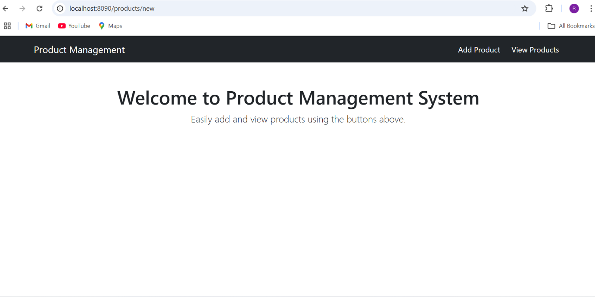

**2.Add Products**

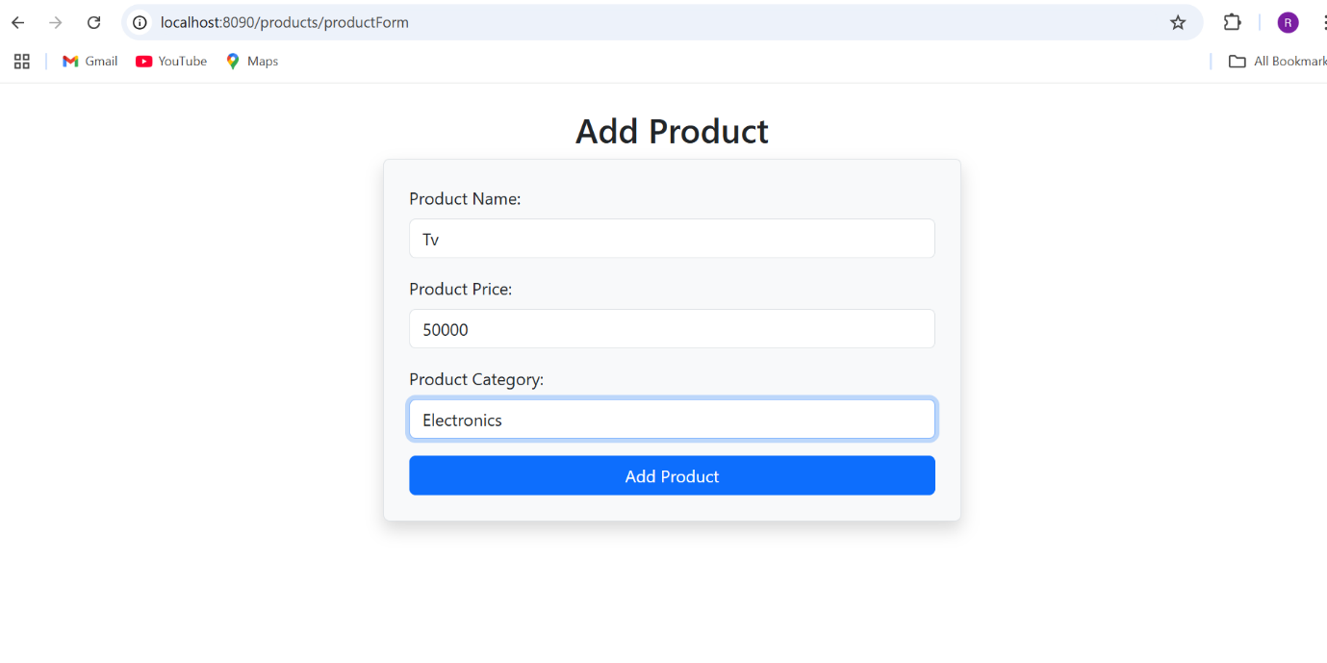

**3.View All products:**

