Contents
INTRODUCTION 2
LIST INTERFACES – CLASS DIAGRAM 3
QUEUE INTERFACES – CLASS DIAGRAM 3
MAP INTERFACES – CLASS DIAGRAM 4
SET INTERFACES – CLASS DIAGRAM 4
COMPARISON OF DATA STRUCTURES 5
ARRAYLIST –VS– VECTOR 5
ARRAYLIST –VS– LINKEDLIST 5
HASHSET –VS– TREESET 5
HASHMAP –VS– HASHTABLE 5
LINKEDBLOCKINGQUEUE –VS– ARRAYBLOCKINGQUEUE 6
IDENTITYHASHMAP –VS– HASHMAP 6
HASHMAP 7
How Hashmap Works 7
Hash code Of the Object for a Map Key 7
Summary 7
ITERATORS 7
Introduction 7
Difference between Iterator and Enumeration 8
ListIterator 8
ConcurrentModificationException 8
How Iterators detect and throw ConcurrentModificationException 9
Methods of Iterator 10
Fail-Fast vs Fail-Safe Iterators 10
Summary 10
BLOCKING QUEUE – PRODUCER-CONSUMER MODEL 11
CONCRETE COLLECTIONS - LIST 12
ArrayList 12
LinkedList 12
CopyOnArrayList 12
CONCRETE COLLECTIONS – SET 13
HashSet 13
TreeSet 13
LinkedHashSet 13
CONCRETE COLLECTIONS – MAP 13
LinkedHashMap 13
WeakHashMap 13
IdentityHashMap 13
NavigableMap 13
CONCERTE COLLECTIONS – QUEUE 14
IMPLEMENTATIONS 16
LRU Cache using LinkedHashMap 16
Ways to create a PriorityQueue 17
How the Priority in the Prority Queue is defined 17
Collections.binarySearch 18
LAMBDAS TO COLLECTIONS 19
SUMMARY 20
FAQS 20
Arrays.asList 20
REFERENCES 20
References (Web Sites) 20
References (Books) 20
INTERVIEW QUESTIONS 21

INTRODUCTION
Collections framework was first introduced with the Java 2 platform Standard Edition (i.e., version 1.2).

The Java classes in the Collections Framework encapsulate both the data structures and the algorithms associated with these abstractions. The framework provides a standard programming interface to many of the most common abstractions, without burdening the programmer with too many procedures and interfaces.

When designing software with the Collections Framework, it is useful to remember the following hierarchical relationships of the four basic interfaces of the framework:-
- The Collection interface is a group of objects, with duplicates allowed.
- The Set interface extends Collection but Set forbids duplicates.
- The List interface extends Collection, allows duplicates, and introduces positional indexing.
- The Map interface extends neither Set nor Collection.
- The Queue interface is a linear collection that supports element insertion and removal at both ends

Prior to Generics, Collection Interface was the root was the collection framework. From 1.5, Iterable is the root interface for the Collection framework
Collection is the root of the Collection framework (before 1.5)
Collection<E>extends Iterable<E> (Java 1.5 onwards)

LIST INTERFACES – CLASS DIAGRAM
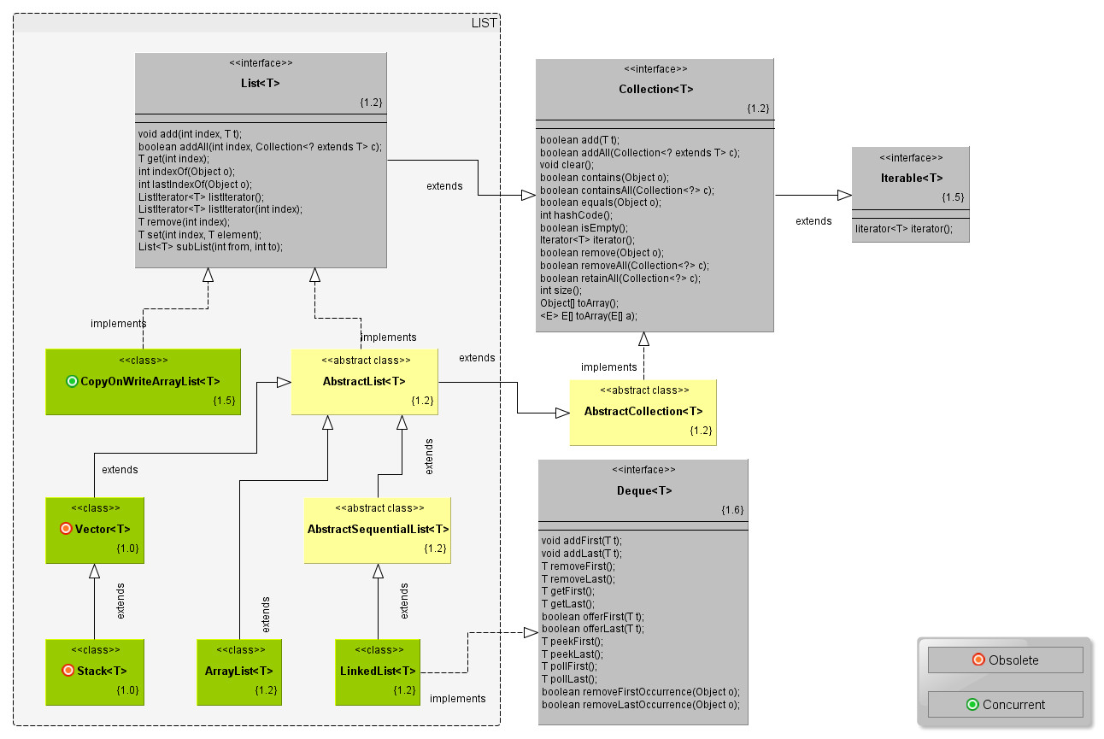

QUEUE INTERFACES – CLASS DIAGRAM

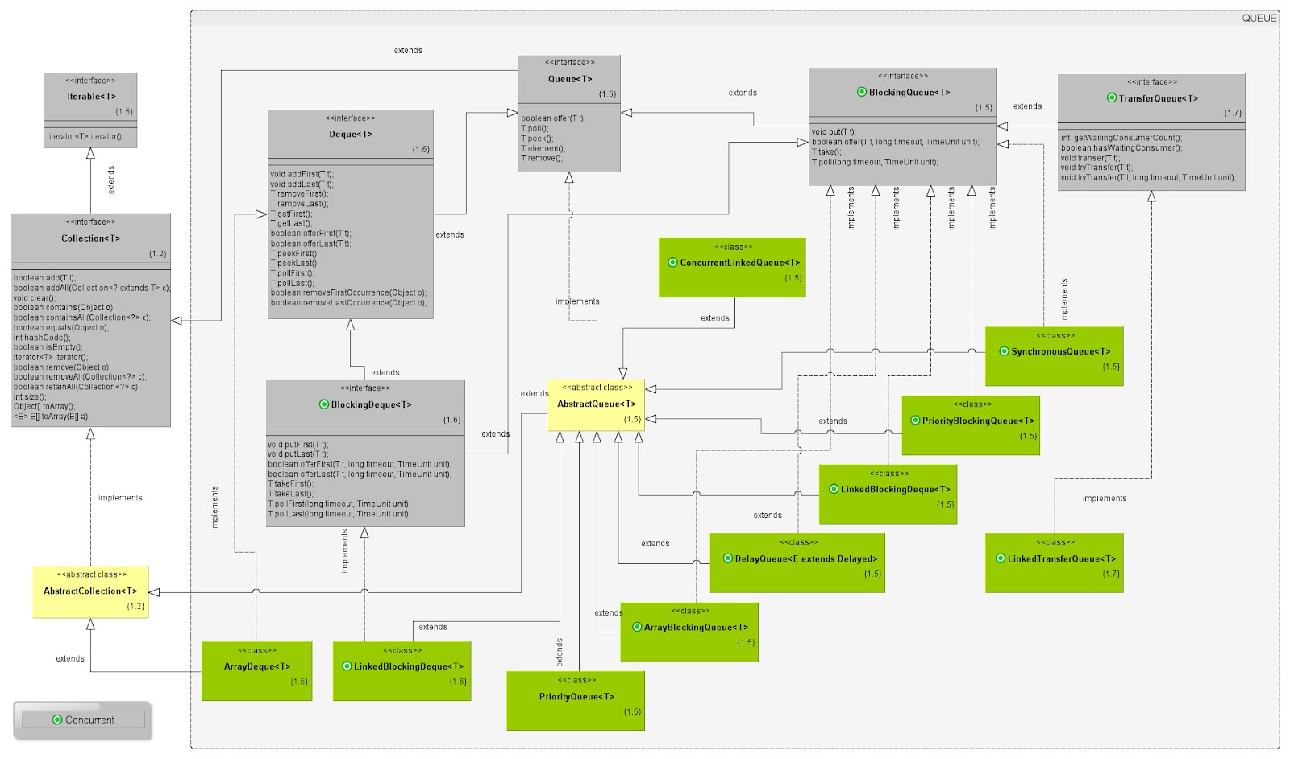

MAP INTERFACES – CLASS DIAGRAM

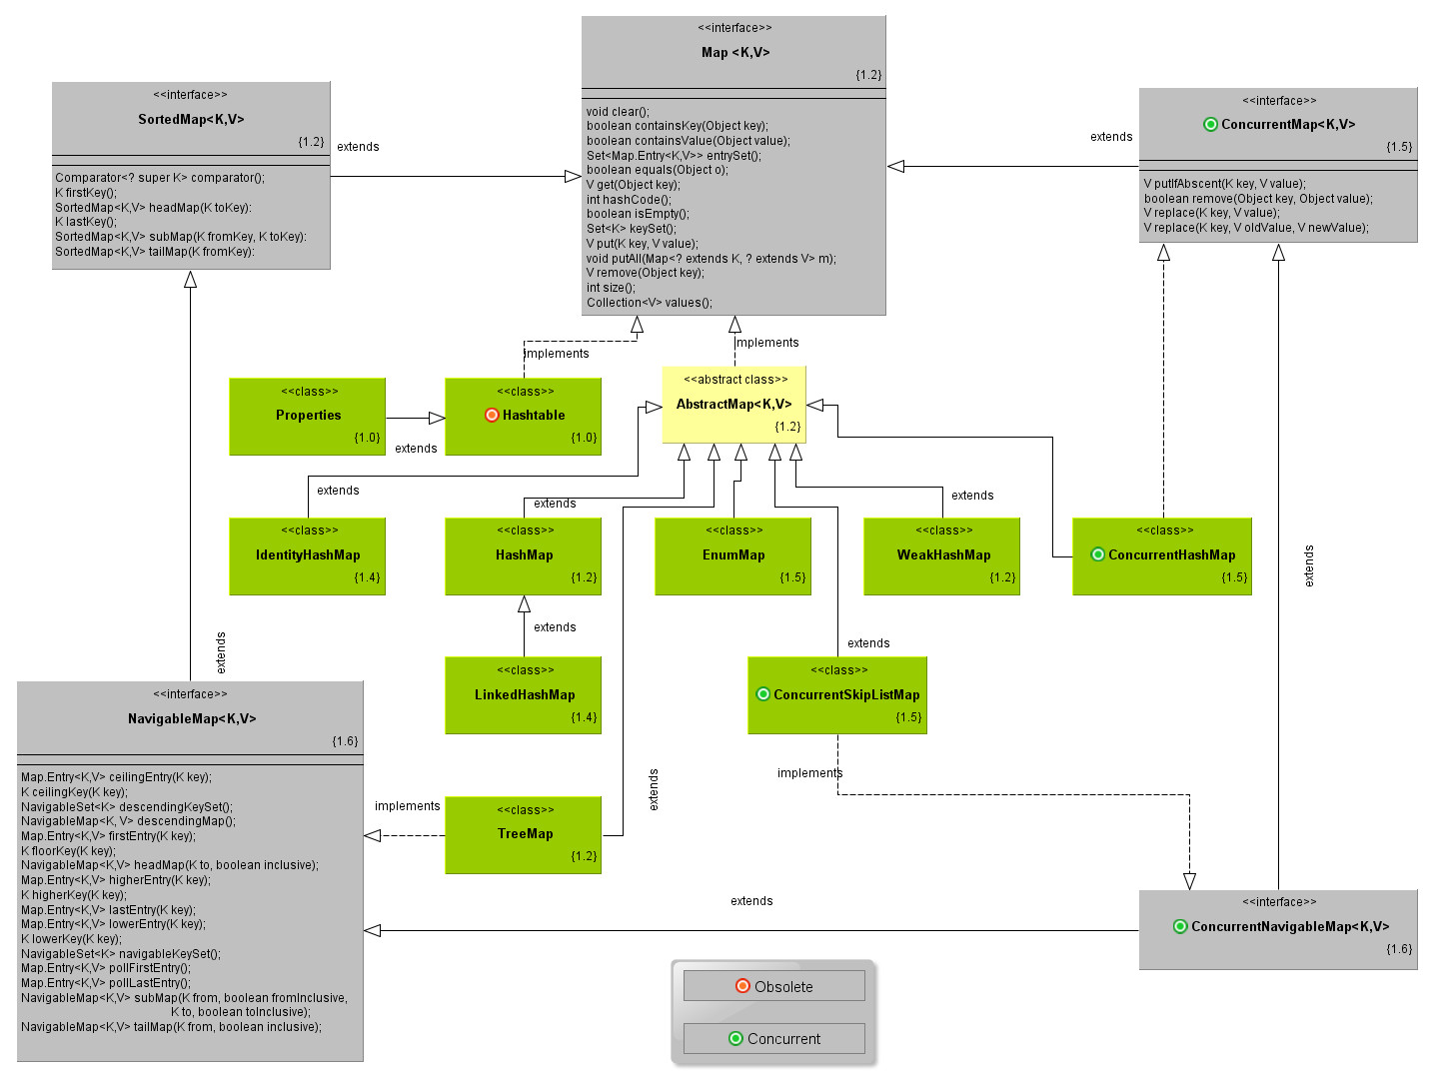

SET INTERFACES – CLASS DIAGRAM

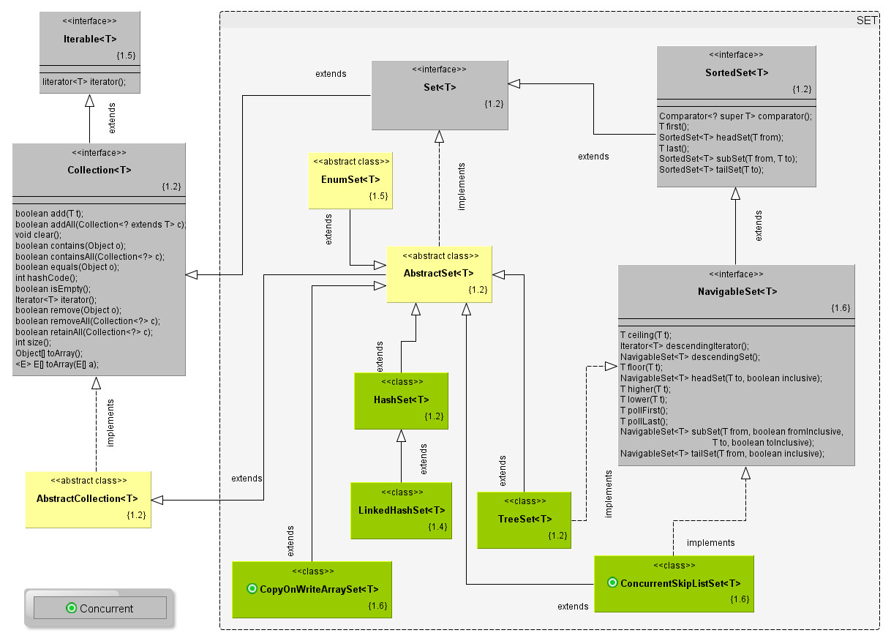

COMPARISON OF DATA STRUCTURES

ARRAYLIST –VS– VECTOR

- Vectors are synchronized. ArrayList is unsynchronized. If you don't need a thread-safe collection, use the ArrayList.
- Both the ArrayList and Vector hold onto their contents using an Array.
- When you insert an element into an ArrayList or a Vector, the object will need to expand its internal array if it runs out of room. A Vector defaults to doubling the size of its array, while the ArrayList increases its array size by 50 percent.
- It's always best to set the object's initial capacity to the largest capacity that your program will need. By carefully setting the capacity, you can avoid paying the penalty needed to resize the internal array later. If you don't know how much data you'll have, but you do know the rate at which it grows, Vector does possess a slight advantage since you can set the increment value(growth) for Vector.
- Both the ArrayList and Vector are good for retrieving elements from a specific position in the container or for adding and removing elements from the end. However, adding and removing elements from any other position proves more expensive. These operations are more expensive because you have to shift all elements at index i and higher over by one element. The LinkedList can add or remove an element at any position in constant time. But, LinkedList also creates an internal object for each element inserted.

ARRAYLIST –VS– LINKEDLIST

An ArrayList uses an array to store its elements. This means it's fast for random access because the array index gets you right to that element.

ArrayList is slow for adding and deleting at the beginning and middle of the list, since you have to then copy all the later elements forward or back. It also suffers when you fill up the array, and then have to create a new one and copy the old elements into it.

A linked list uses a node that stores its element and a pointer to the next element. A singly linked list only has pointers to next. A doubly linked list has a pointer to the next and the previous element. This makes walking the list backward easier.

Linked lists are slow for random access. Getting an element means you have to walk either forward from the beginning or backward from the end (depending on whether 9832 is less than or greater than half the list size), calling next or previous, until you get to that element.

Linked lists are fast for inserts and deletes anywhere in the list, since all you do is update a few next and previous pointers. Each element of a linked list (especially a doubly linked list) uses a bit more memory than its equivalent in array list, due to the need for next an d previous pointers.

HASHSET –VS– TREESET

The TreeSet implementation is useful when you need to extract elements from a collection in a sorted manner. In order to work property, elements added to a TreeSet must be sortable.

To optimize HashSet space usage, you can tune the initial capacity and load factor. The TreeSet has no tuning options, as the tree is always balanced, ensuring log(n) performance for insertions, deletions, and queries.

TreeSet does not allow null. For HashSet only one null value insertion is possible. When we try to add more null values the add method returns false and null is not added.

HASHMAP –VS– HASHTABLE

HashMap allows null (any type of object to be used as either as key or value including null). Hashtable doesn’t accept null keys. HashMap is not synchronized and Hashtable is synchronized. All retrieval and storage operations are synchronized unlike HashMap.

LINKEDBLOCKINGQUEUE –VS– ARRAYBLOCKINGQUEUE

The ArrayBlockingQueue is bounded with the capacity argument supplied when constructing it. If the Queue turns out to be short when rate of object adding gets high it will block and this may reduce the objects "passing through" the queue in a unit time.

Whereas in the LinkedBlockingQueue, bounding is optional and the highest capacity is Integer.MAX_VALUE and it can grow up to that value if no lower bound is specified. This should allow more objects to be added to the queue without blocking thereby increasing the throughput.

IDENTITYHASHMAP –VS– HASHMAP

HashMap uses equals method to determine the uniqueness of the Key. IdentityHashMap uses the equality operator(==) for comparing the keys
Map identityMap = new IdentityHashMap();
Map hashMap = new HashMap();
identityMap.put("a", 1);
identityMap.put(new String("a"), 2);
identityMap.put("a", 3);

hashMap.put("a", 1);
hashMap.put(new String("a"), 2);
hashMap.put("a", 3);

System.out.println("Identity Map KeySet Size :: " + identityMap.keySet().size());
System.out.println("Hash Map KeySet Size :: " + hashMap.keySet().size());

Identity Map KeySet Size :: 2
Hash Map KeySet Size :: 1

The Key size of Identity Map is 2 because here a and new String(“a”) are considered two different Object. The comparison is done using == operator.

HASHMAP

How Hashmap Works

The hashCode of a key object is used to find an index into an internal array. (by doing hashCode()%array.length). So even if your hashCodes are unique the index they map to will not be unique.

Each element in the array is a linked list. So the appropriate linked list is retreived from the array. The next step is to scan through all of the elements in the list to see if any of them equals the key object. (this is where the equals(Object o) method comes into it)

If an element that is equal(key) is found then you have a matching key and you can associate the specifed value with it (acutally done with Map.Entry objects)

So basically. If two objects are equal they must (according to the contract) produce the same hashCode. If they are not equal then they should produce different values for hashCode but it does not matter if they produce the same value.

Hash code Of the Object for a Map Key

If you're going to use a hash-backed collection or map, make sure the elements (or keys) have well-behaved equals/hashCode methods. Overriding only hashCode() won't work since two objects which do not compare equals() can still have the same hash value. x.equals(y) implies x.hashCode() == y.hashCode(), but the converse is not true.

If you override equals() and hashCode(), you should ensure that if x.equals(y), then x.hashCode() == y.hashCode(). Keep in mind that if two objects are equal according to their equals(Object) method, then the hashCode() of those two objects must return the same integer value.

To make it clear:
- equal hashcodes - the objects MIGHT be equal - two different values might generate the same hashcode.
- equal objects - their hashcodes MUST be equal.

get() method on HashMap fails to return correct value:
Overide the hashCode(). Two objects are equal if their hashCodes are equal. And because I had not overriden hashCode() Java will always return a unique hashCode even if I consider two Car objects equal and hence get() will fail.

Summary

HashMap provides almost constant time performance for put and get. Although in principle it’s constant time performance, it is only attainable with no collisions. It can be closely approached by use of rehashing to control the load and thereby to minimize the number of collisions.

ITERATORS

Introduction

An iterator is a mechanism that permits all elements of a collection to be accessed sequentially, with some operation being performed on each element.

Iterator design pattern is a behavioral pattern, whose key idea is "to take the responsibility for access and traversal out of the list [ed. think collection] object and put it into an iterator object.

There are three iterators available in java.util package:
- Iterator
- ListIterator and
- Enumeration

Only Iterator and ListIterator are part of the collection framework.
In Java 1.0 and 1.1, the two primary collection classes were Vector and Hashtable, and the Iterator design pattern was implemented in a class called Enumeration. In retrospect this was a bad name for the class. Do not confuse the class Enumeration with the concept of enum types, which didn't appear until Java 5.

Iteration in Java 8 is mostly done via streams. Collections and arrays can be used to generate streams

The ListIterator is a subinterface of Iterator which is designed to work with List objects and can iterate bidirectionally.

To get Iterator:
List al = new ArrayList();
Iterator it = al.iterator();
ListIterator litr = al.listIterator(); // Only possible for List interfaces and Not available for Set
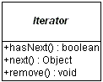 | 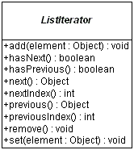

Types of Iterators (as per data structures):
- Based on Traversal
  - Uni-directional iterators
    - Forward iterator
    - Reverse iterator
  - Bi-directional iterators
- Based on Functionality
  - Read-only iterator
  - Updatable iterator
  - Observable iterators

Difference between Iterator and Enumeration
- Both Iterator and Enumeration are Interfaces and have the same functionality. But, Iterator improves on Enumeration by adding an extra method called remove().
- Method names have been shortened in Iterator. For instance hasMoreElements() in Enumeration was renamed to next(), so that should help you differentiate.
- Iterator is Java 1.2 and Enumeration is Java 1.0. Eventually I think Sun will deprecate the Enumeartion interface.Enumeration will remain a part of the java.util package, mainly for the backward compatibility with the legacy JDK API.

ListIterator

The List interface also provides for working with a subset of the collection, as well as iterating through the entire list in a position friendly manner:
ListIterator listIterator()
ListIterator listIterator(int startIndex)
List subList(int fromIndex, int toIndex)

The ListIterator interface extends the Iterator interface to support bi-directional access, as well as removing or changing (Only modify, cannot add) elements in the underlying collection.

ListIterator is available only to those collections that implement the List interface

ConcurrentModificationException

Multi-threaded Environment
If you are using an Iterator to traverse a collection while underlying collection is being modified by another thread, then the Iterator fails immediately by throwing a ConcurrentModificationException (another RuntimeException). That means the next time an Iterator method is called, and the underlying collection has been modified, the ConcurrentModificationException exception gets thrown.

Modification in same thread:
Note that this exception does not always indicate that an object has been concurrently modified by a different thread. If a single thread issues a sequence of method invocations that violates the contract of an object, the object may throw this exception.

Example 1 (Same Thread):
if a thread modifies a collection directly while it is iterating over the collection with a fail-fast iterator, the iterator will thow this exception.
for (Iterator it = myCollection.iterator(); it.hasNext())
{
Object myObject = it.next();
if (someConditionIsTrue) {
//myCollection.remove(myObject); //← wrong can throw ConcurrentModificationException
it.remove(myObject); //← right
}
}

Example 2 (Same Thread)
Recently one of my friend, who is doing her Core Java Course called me and told she is getting java.util.ConcurrentModificationException. She asked do you know why this occur and how to get rid of this? As everyone ask, my question was also, are you using Threading? she replied 'NO' - Surprised.

Here is the snippet of the code
List foundList = new ArrayList();
Iterator foundListIterator = foundList.iterator();
for (String string : inputList) {
if(exist()){
foundList.add(string);
}
}
while(foundListIterator.hasNext()){
System.out.println(foundListIterator.next());
}

Yes foundListIterator.next() can throw ConcurrentModificationException, because the content of the iterator is modified after the iterator was created.

Solution: Create the Iterator only when you need and not in advance. The better option is to use the Java 5 for..each statement in such scenario instead of using iterator.

How Iterators detect and throw ConcurrentModificationException

The iterators of the Collection implementations of the Java runtime throw a ConcurrentModificationException when they detect that another thread has modified the Collection while a thread is iterating over it. Such iterators are generally called fail-fast iterators.

Looking at the implementation one can see how this has been made possible. The Collection subclass maintains an integer modCount that is incremented on every operation that structurally modifies the collection (like add, remove, clear). The fail-fast iterators also contain an integer field expectedModCount which is initialized to the modCount while the iterator is created. Later on, during every iteration, the iterator verifies if the expectedModCount is same as the modCount of the collection it is iterating over. A mismatch means that the collection has been modified during the life cycle of the iterator and a ConcurrentModificationException is thrown. The same happens during the collection serialization process. The modification count prior to writing to the stream should be same as the count after writing to the stream. Unlike operations directly on the collection, the modCount is not incremented on any operations in the Iterator.

But is this behavior guaranteed? Are these iterators always fail-fast? I used to think so, until I saw the declaration of the modCount field in the Collection implementations.

The modCount field is not marked as volatile. This would mean - while a thread makes structural changes to the collection and increments the modCount field, the other thread that performs the iteration or serialization might not see the incremented value of the modCount field. It might end up doing a comparison with the stale modCount that is visible to it. This might cause the fail-fast iterators to behave in a different way and failing at a later point. The field is non-volatile in Apache Harmony too.

A bug in Sun Java explains this. It says the modCount was intentionally made non-volatile. Making it volatile would have added contention at every collection modification operation because of the memory fencing that’s required. Hence, the fail-fast behaviour is not guaranteed.

Also the Javadoc clearly says “fail-fast behaviour cannot be guaranteed as it is, generally speaking, impossible to make any hard guarantees in the presence of unsynchronized concurrent modification”.

This behaviour would be the same even on the Synchronized wrapper's of these collections.

http://java.sun.com/j2se/1.5.0/docs/api/java/util/ConcurrentModificationException.html
http://bugs.sun.com/bugdatabase/view_bug.do?bug_id=6625725
http://stackoverflow.com/questions/7237886/why-does-it-next-throw-java-util-concurrentmodificationexception

Methods of Iterator

Fail-Fast vs Fail-Safe Iterators
Fail-fast Iterator
Fail-fast occurs in an Iterator when a structure of Collection is modified since Iteration has begun. Fail-fast is identified internally using a modification count for the collection and if the iterator realizes that the count is changed, it will throw a ConcurrentModificationException

Fail-safe Iterator
Fail-safe are similar to fast-fail but they do not throw an Exception when Collection is modified since they work on a clone of the collection. CopyOnWriteArrayList and iterator returned by ConcurrentHashMap keySet are fail-safe iterators which work on a copy of a collection for modification.

Summary
Structural Modification using Iterator: Can only remove from Iterator (to the underlying collection). In the case of ListIterator can additionally do modify using iterator.set() only on the current index. Otherwise, only remove is the only structural modification possible with iterators.

BLOCKING QUEUE – PRODUCER-CONSUMER MODEL

Introduction:
Before Java 5, there was no standard queue implementation in Java. The production/consumption model had to be performed using the low-level Object.wait() , Object.notify() constructs which essentially provides a way for one thread to notify another thread that it is done doing some work. Code using wait/notify is usually ugly, and unintuitive.

Benefits of Producer-Consumer Pattern :
- A common reason for having a separate producer and consumer is to disconnect the request sequence (usually existing on a thread interacting with the user) from the request processing effort. In simpler terms, the producer thread is not burdened with the effort of handling the request, and can instead focus on accepting requests and handing them off. This seperation can cause benefit in multiple ways:
- The production thread can immediately go back to work in the normal case, accepting more user input or, in the case of a UI program, rendering graphics, etc.
- If there is a mismatch in performance (meaning either the producer or consumer is faster on average), more threads can be assigned to the slower side so multiple requests can be produced or consumed at a time to offset the mismatch
- Simple development. you can Code Producer and Consumer independently and Concurrently, they just need to know shared object
- Producer doesn't need to know about who is consumer or how many consumers are there. Same is true with Consumer

Using Blocking Queue:
With introduction of BlockingQueue Data Structure in Java 5 Its now much simpler because BlockingQueue provides this control implicitly by introducing blocking methods put() and take(). Now you don't require to use wait and notify to communicate between Producer and Consumer. BlockingQueue put() method will block if Queue is full in case of Bounded Queue and take() will block if Queue is empty

BlockingQueue doesn’t accept null values and throw NullPointerException if you try to store null value in the queue.

Sample implementationof Producer-Consumer Pattern :
public class ProducerConsumerPattern {
public static void main(String args[]) {
//Creating shared object
BlockingQueue<String> sharedQueue = new LinkedBlockingQueue<String>();
//Creating Producer and Consumer Thread
Thread prodThread = new Thread(new Producer(sharedQueue));
Thread consThread = new Thread(new Consumer(sharedQueue));

//Starting producer and Consumer thread
prodThread.start();
consThread.start();
}
}

class Producer implements Runnable {
private final BlockingQueue<String> sharedQueue;
public Producer(BlockingQueue<String> sharedQueue) {
this.sharedQueue = sharedQueue;
}
@Override
public void run() {
for(int i=0; i<10; i++){
try {
System.out.println("Produced: " + i);
sharedQueue.put(""+i);
} catch (InterruptedException ex) { }
}
}
}

class Consumer implements Runnable{
private final BlockingQueue<String> sharedQueue;
public Consumer (BlockingQueue<String> sharedQueue) {
this.sharedQueue = sharedQueue;
}
@Override
public void run() {
while(true){
try {
System.out.println("Consumed: "+ sharedQueue.take());
} catch (InterruptedException ex) {
Logger.getLogger(Consumer.class.getName()).log(Level.SEVERE, null, ex);
}
}
}
}

Output:
Produced: 0
Produced: 1
Consumed: 0
Produced: 2
Consumed: 1

>>>

TODO http://sungur.wordpress.com/2011/02/10/java-delayqueue-test/

Queue implementations generally do not allow insertion of null elements, although some implementations, such as LinkedList, do not prohibit insertion of null. Even in the implementations that permit it, null should not be inserted into a Queue, as null is also used as a special return value by the poll method to indicate that the queue contains no elements.

http://stackoverflow.com/questions/6746604/delayqueue-with-capacity
http://javarevisited.blogspot.sg/2012/02/producer-consumer-design-pattern-with.html
http://javarevisited.blogspot.sg/2012/12/blocking-queue-in-java-example-ArrayBlockingQueue-LinkedBlockingQueue.html
http://sungur.wordpress.com/2011/02/10/java-delayqueue-test/
http://www.javalobby.org/java/forums/t16278.html

<<<<

CONCRETE COLLECTIONS - LIST

ArrayList

LinkedList
Double-linked list implementation of the List interface, which is efficient for insertion and deletion of elements at any location. Implementation of the Linked list in java is a doubly-linked list and it implements the Deque Interface

CopyOnArrayList
CopyOnArrayList is to ArrayList what ConcurrentHashMap is to HashMap. As the name CopyOnWrite says, a copy of the whole list is made each time you write to the list like adding an element or remove an element. As you can figure out yourself, this can be pretty expensive when your list is large. This means that a CopyOnWriteArrayList (and CopyOnWriteArraySet) is mostly useful when you have few modifications but many reads because reads are very cheap and don’t require synchronization.

When you iterate over a CopyOnWriteArrayList and CopyOnWriteArraySet the iterator uses a snapshot of the underlying list (or set) and does not reflect any changes to the list or set after the snapshot was created. The iterator will never throw a ConcurrentModificationException.

CONCRETE COLLECTIONS – SET

HashSet

TreeSet

LinkedHashSet
LinkedHashSet class is used in exactly the same way as the HashSet class. It has no additional methods and has constructors that take identical parameters as the HashSet. The only difference is that the LinkedHashSet maintains the order of the items added to the Set. It does this by maintaining a doubly linked list containing the hash and the original order of the items. A Set is not required to maintain the elements of the Set in the order they are added although the LinkedHashSet does maintain order.

CONCRETE COLLECTIONS – MAP

LinkedHashMap
Unlike HashMap, A LinkedHashMap remembers the order in which entries were added or the access order of the entries. LinkedHashMap is a variant of HashSet. Its entries are kept in a doubly-linked list. The iteration order is the order in which entries were inserted. Null elements are allowed.

WeakHashMap
A WeakHashMap is a special-purpose implementation of Map for storing only weak references to the keys. This allows for the key-value pairs of the map to be garbage collected when the key is no longer referenced outside of the WeakHashMap.

IdentityHashMap
IdentityHashMap is a variant on HashMap which tests equality by reference instead of by value. Basically, keys and values are compared for equality by checking if their references are equal rather than by calling the “equals” function.

NavigableMap
The java.util.NavigableMap interface is a subtype of the java.util.SortedMap interface. It has a few extensions to the SortedMap which makes it possible to navigate the map. The java.util.TreeMap and java.util.concurrent.ConcurrentSkipListMap are the concrete implementation classes of the NavigableMap interface

Prominent methods of NavigableMap Interface:
ceilingEntry(K key) This method returns a key-value mapping associated with the least key greater than or equal to the given key, or null if there is no such key.
ceilingKey(K key) This method returns the least key greater than or equal to the given key, or null if there is no such key.
descendingKeySet( ) This method returns a reverse order NavigableSet view of the keys contained in this map.
descendingMap( ) This method returns a reverse order view of the mappings contained in this map.
firstEntry( ) Returns a key-value mapping associated with the least key in this map, or null if the map is empty.
lastEntry( ) Returns a key-value mapping associated with the greatest key in this map, or null if the map is empty.
floorEntry(K key) This method returns a key-value mapping associated with the greatest key less than or equal to the given key, or null if there is no such key.
floorKey(K key) This method returns the greatest key less than or equal to the given key, or null if there is no such key.
headMap(K toKey) This method returns a view of the portion of this map whose keys are strictly less than toKey.

NavigableMap<Integer,String> navmap = new TreeMap<Integer,String>();
navmap.put(2, "two");
navmap.put(1, "one");
navmap.put(3, "three")

CONCERTE COLLECTIONS – QUEUE

Broadly, there three categories in Queue Types.
- Queue
- BlockingQueue
- BlockingDeQueue

Methods Common to all BlockingQueues
 | Throws Exception | Special Value | Blocking | Blocking without Timeout
Insert | add(e) | offer(e) | put(e) | offer(e, time,timeunit)
Remove | remove() (Retrieves and removes the head of this queue. This method differs from poll only in that it throws an exception if this queue is empty.) | poll() (Retrieves and removes the head of this queue, or returns null if this queue is empty.) | take() | poll(time, timeunit)
Examine | element() (Retrieves, but does not remove, the head of this queue. This method differs from peek only in that it throws an exception if this queue is empty.) | peek() (Retrieves without removal from the head of this queue, or returns null if this queue is empty. | N/A

Queue
The following are the Queue implementations in the Java Collections API:
- java.util.LinkedList
- java.util.PriorityQueue
- java.util.concurrent.ConcurrentLinkedQueue – It doesn’t implement Blocking Queue and Thread-Safe using CAS.

Queue
A Queue is the data structure used when you need First-in, First-out behavior as items are added to, and removed from, a collection. Normally a queue is used to model a sequence of items using the insertion time as the default comparator between elements. Hence, comparator is not mandatory for a normal queue.

PriorityQueue
The Priority Queue is a related structure that behaves like a queue, except that the items in the queue all have an associated priority. In a priority queue, each item is added with an associated priority. The priority is not necessarily defined by a integer. But, it is the specific ordering/comparator that determines the priority.
In Java, Priority Queue is unbounded priority queue based on a priority heap. It’s unbounded. But, has an internal capacity governing the size of an array used to store the elements on the queue.The head of this queue is the least element with respect to the specified ordering. If multiple elements are tied for least value, the head is one of those elements -- ties are broken arbitrarily. In Java, cannot add null to the priority queue. It will throw NullPointerException if the specified element is null and ClassCastException if the specified element cannot be compared with elements currently in this priority queue

BlockingQueue is an interface, you need to use one of its implementations to use it. The java.util.concurrent package has the following implementations of the BlockingQueue interface (in Java 6):
ArrayBlockingQueue
LinkedBlockingQueue
PriorityBlockingQueue
DelayQueue
SynchronousQueue
TransferQueue

Synchronous Queue: A blocking queue in which each put must wait for a take, and vice versa. A synchronous queue does not have any internal capacity, not even a capacity of one. You cannot peek at a synchronous queue because an element is only present when you try to take it; you cannot add an element (using any method) unless another thread is trying to remove it; you cannot iterate as there is nothing to iterate. It implements a rendezvous approach (producer waits until consumer is ready, consumer waits until producer is ready) behind the interface of Queue. A hand-pattern. Producer(s) block until there is a consumer available; consumer(s) block until there is an enqueued message.

ArrayBlockingQueue: Similar to the SynchronousQueue, except the queue can contain a pre-set number of items before the queue producer(s) block on queue insertion.
ArrayBlockingQueue(int capacity)
ArrayBlockingQueue(int capacity, boolean fair)
ArrayBlockingQueue(int capacity, boolean fair, Collection<? extends E> c)
BlockingQueue<String> queue = new ArrayBlockingQueue<String>(50); // capacity of 50

ArrayBlockingQueue is a bounded, blocking queue that stores the elements internally in an array. That it is bounded means that it cannot store unlimited amounts of elements. There is an upper bound on the number of elements it can store at the same time. You set the upper bound at instantiation time, and after that it cannot be changed

DelayQueue: Elements placed in the queue are not available for removal until their delay time has expired. Items that are furthest past their expiration time are available for removal first. Calls to put() do not block since this queue is unbounded, although calls to take() will block until an expired message is available. The delay queue allows the objects in the queue to 'ripen' for a delay before they become available to the take() operation - this queue only supports java.util.concurrent.Delayed objects (objects that implement the Delayed interface). In other words, a queue that was empty, if given a new Delayed object through the put (Object) method with a delay of 5 seconds, will appear empty for 5 seconds.

Implementation of DelayQueue: Object class that inside the queue should implement the “Delayed” interface. This interface forces you to implement 2 methods: boolean:getDelay,compareTo(Delayed o) and int:getDelay(TimeUnit unit) method is important because Java decides to dequeue element from queue if getDelayed<=0

Usage of DelayQueue:
1) Control flow - we know that an order takes 60 seconds to process, so don't read the next order off of the queue until the object has been there for at least 60 seconds.
2) Message flow - A highly asynchronous system where we send off requests to 2 or 3 external services and then release the next task to process the order N seconds later once we know the first batch of jobs will at least have had a chance of completing.
3) Message batching - maybe orders of a certain type are bursty, so lets not process orders received in the last N seconds so we can see if similar orders come in shortly after that can be processed as a batch on the next run.
4) Message priorities - different messages or different customers could get a slightly higher quality of service with a lower or zero delay.
5) Timed Actions - A (non-multithreaded) server that needs to perform certain timed actions, e.g. connection ping on each connection

PriorityBlockingQueue : The PriorityBlockingQueue is an unbounded queue and calls to put() never block. Calls to take(), however, will block until a queued item is available for removal. All elements inserted into the PriorityBlockingQueue must implement the java.lang.Comparable interface. The elements thus order themselves according to whatever priority you decide in your Comparable implementation. Notice that the PriorityBlockingQueue does not enforce any specific behaviour for elements that have equal priority (compare() == 0). Also, in case you obtain an Iterator from a PriorityBlockingQueue, the Iterator does not guarantee to iterate the elements in priority order.

LinkedBlockingQueue: Similar to an ArrayBlockingQueue, but where queue growth is allowed. However, the queue constructor does accept an optional parameter to constrain the growth to a maximum number of items. The LinkedBlockingQueue keeps the elements internally in a linked structure

BlockingQueue<String> unbounded = new LinkedBlockingQueue<String>(); (← No Upper Bound)
BlockingQueue<String> bounded = new LinkedBlockingQueue<String>(1024); (← Optional Upper Bound)

LinkedTransferQueue: Similar to SynchronousQueue, except the queue is unbounded in size and calls to put() never block. Calls to take(), however, will block until a queued item is available for removal.

IMPLEMENTATIONS

LRU Cache using LinkedHashMap

LinkedHashMap is a subclass of java.util.HashMap that adds a couple of useful features. By default the iteration order reflects the order that entries are added to the map.

LinkedHashMap has an option to use access-order instead of insertion order.This makes it well suited for creating LRU caches.

One of the constructors allows us to specify that we use access order instead of insert order.
public LinkedHashMap(int initialCapacity, float loadFactor, boolean accessOrder)
where accessOrder - (the ordering mode , true for access-order & false for insertion-order)

Example Implementation
public class Cache extends LinkedHashMap {
private final int capacity;
private long accessCount = 0;
private long hitCount = 0;

public Cache(int capacity) {
super(capacity + 1, 1.1f, true);
this.capacity = capacity;
}

public Object get(Object key) {
accessCount++;
if (containsKey(key)) {
hitCount++;
}
Object value = super.get(key);
return value;
}
@Override
protected boolean removeEldestEntry(Entry eldest) {
return size() > capacity;
}
public long getAccessCount() {
return accessCount;
}
public long getHitCount() {
return hitCount;
}
}
One measure of how well a cache is performing is Hit Rate, which tells us how many cache accesses are "hits" - that is, how many times the required data was found in the cache for a given number of accesses.

The removeEldestEntry(Entry eldest) method overrides a default implementation in LinkedHashMap and is where we determine the policy for removing the oldest entry. In this case, we return true when the cache has more entries than our defined capacity. It should return true if the eldest entry should be removed from the map; false if it should be retained.
eldest - The least recently inserted entry in the map, or if this is an access-ordered map, the least recently accessed entry. This is the entry that will be removed if this method returns true.

http://java-planet.blogspot.com/2005/08/how-to-set-up-simple-lru-cache-using.html
https://www.tutorialspoint.com/java/util/linkedhashmap_removeeldestentry.htm

Ways to create a PriorityQueue

The various ways to create a PriorityQueue

PriorityQueue()
Creates a PriorityQueue with the default initial capacity (11) that orders its elements according to their natural ordering.

PriorityQueue(Collection<? extends E> c)
Creates a PriorityQueue containing the elements in the specified collection.

PriorityQueue(int initialCapacity)
Creates a PriorityQueue with the specified initial capacity that orders its elements according to their natural ordering.

PriorityQueue(int initialCapacity, Comparator<? super E> comparator)
Creates a PriorityQueue with the specified initial capacity that orders its elements according to the specified comparator.

PriorityQueue(PriorityQueue<? extends E> c)
Creates a PriorityQueue containing the elements in the specified priority queue.

PriorityQueue(SortedSet<? extends E> c)
Creates a PriorityQueue containing the elements in the specified sorted set.

How the Priority in the Prority Queue is defined

The priority of the items added to the PriorityQueue is derived from the Comparator.

public class PriorityComparator implements Comparator<Pair> {
public int compare(Pair first, Pair second) {
return first.priority - second.priority; → Case 1
//return second.priority - first.priority; → Case 2
}
}
public class Pair {
int key;
int priority;
}
public class SamplePriorityQueue {
public static void main(String[] args) {
PriorityComparator comp = new PriorityComparator();
PriorityQueue<Pair> pq = new PriorityQueue<Pair>(10, comp);

pq.add(new Pair(1000, 5));
pq.add(new Pair(2000, 10));
pq.add(new Pair(3000, 7));
pq.add(new Pair(4000, 3));

while (!pq.isEmpty()) {
System.out.println(pq.remove());
}
}
}

In case 1:
(4000,p=3)
(1000,p=5)
(3000,p=7)
(2000,p=10)

In case 2:
(2000,p=10)
(3000,p=7)
(1000,p=5)
(4000,p=3)

The main thing to emphasize with the above code example is that the priority get assigned and derived by the Comparator or the ordering specified.

Reference
http://archive.oreilly.com/oreillyschool/courses/data-structures-algorithms/priorityQueue.html

Collections.binarySearch

In order for binarySearch() to work, your list must be sorted. equals() and hashCode() have nothing to do with sorting. your objects need to be Comparable, or you must have a relevant Comparator.
Either way, you must sort the List first

If your collection is sorted, binarySearch() will be O(log n) as opposed to indexOf()'s O(n) and you will definitely see an improvement.

5) How does unmodifiable<<Collection>> work to make the Collections unmodifiable?.

http://www.docjar.com/html/api/java/util/Collections.java.html ->
See method public static <T> List<T> unmodifiableList(List<? extends T> list)

But, there is a catch
An unmodifiable List contains the same object references as were in the original List at the time of creation.
a) You can't add any more objects to the unmodifiable List, but you can add new objects to the old List.
b) You can't remove any objects from the unmodifiable List, but you can remove objects from the original List.
c) You can't modify any objects from the unmodifiable List, but you can modify objects from the original List.
List<String> one = new ArrayList<String>();
one.add("A");
one.add("B");
one.add("C");
one.add("D");
List<String> two = Collections.unmodifiableList( one );
System.out.println( two.get(1) );
one.add( 1 , "E" );
System.out.println( two.get(1) );
one.add("F");
System.out.println( two.get(5) );

LAMBDAS TO COLLECTIONS
The internal iteration is rather a minor feature. What is actually interesting in regards to bulk data operations is the new Stream API. The new java.util.stream package has been added to JDK which allows us to perform filter/map/reduce-like operations with the collections in Java 8.

The Stream API would allow us to declare either sequential or parallel operations over the stream of data
List<Person> persons = …
// sequential version
Stream<Person> stream = persons.stream();
//parallel version
Stream<Person> parallelStream = persons.parallelStream();

Filter
Stream interface exposes a filter method that takes in a Predicate (http://javadocs.techempower.com/jdk18/api/java/util/function/Predicate.html ) SAM that allows us to use lambda expression to define the filtering criteria

Map
The map operations allow us to apply a function (http://javadocs.techempower.com/jdk18/api/java/util/function/Function.html),that takes in a parameter of one type, and returns something else. First, let’s see how it would have been described in the good old way, using an anonymous inner class:

@FunctionalInterface
public interface Function<T,R>
Represents a function that accepts one argument and produces a different result. This is a functional interface whose functional method is apply(Object).

Stream<Student> students = persons.stream()
.filter(p -> p.getAge() > 18)
.map(new Function<Person, Student>() {
@Override
public Student apply(Person person) {
return new Student(person);
}
});
Converting this example into lambda syntax we get the following:
Stream<Student> map = persons.stream()
.filter(p -> p.getAge() > 18)
.map(person -> new Student(person));

Collect
The Stream API provides a number of “terminal” operations. The collect() method is one of those terminals that allows us to collect the results of the operations:

List<Student> students = persons.stream()
.filter(p -> p.getAge() > 18)
.map(Student::new)
.collect(new Collector<Student, List<Student>>() { … });

Fortunately, in most cases you wouldn’t need to implement the Collector interfaces yourself. Instead, there’s a Collectors utility class for convenience:

List<Student> students = persons.stream()
.filter(p -> p.getAge() > 18)
.map(Student::new)
.collect(Collectors.toList());

Or in case if we would like to use a specific collection implementation for collecting the results:
List<Student> students = persons.stream()
.filter(p -> p.getAge() > 18)
.map(Student::new)
.collect(Collectors.toCollection(ArrayList::new));

SUMMARY
- Set interface doesn't allow duplicates.
- List interface permit duplicates and has precise control on where in the list the item is inserted.
- List interface can access elements by their integer index (position in the list).
- The ListIterator interface extends the Iterator interface to support bi-directional access as well as adding or removing or changing elements in the underlying collection
- The Map interface is not an extension of Collection interface. Instead the interface starts of it’s own interface hierarchy.
- The Map interface is used for maintaining key-value associations.
- HashSet and TreeSet are Set interfaces. Hence, doesn't allow duplicates.
- TreeSet gives an orderly collection (sorted order) whereas HashSet doesn't have that capability.
- SortedMap maintains elements in a sorted order (sorted on the keys.)

FAQS

Arrays.asList
Arrays.asList(array) returns ArrayList. Can we issue get,set,add methods on the returned collection?. Which one of them work?.
Integer[] arr =new Integer[] {12,34,56,78,98,23};
List<Integer> aList = Arrays.asList(arr);
aList.add(new Integer(1232)); // → Exception in thread "main" java.lang.UnsupportedOperationException at java.util.AbstractList.add(AbstractList.java:131)
Arrays.asList Returns a fixed-size list backed by the specified array.
If you want a modifiable list you can do something like "ArrayList anotherList = new ArrayList(aList)".
You cannot change the size of the list. But you can do the following aList.set(2, 22);

REFERENCES

References (Web Sites)
http://java.sun.com/developer/onlineTraining/collections/Collection.html
http://ltiwww.epfl.ch/sJava/version2/Introduction/Collections/index.html
http://muralis.wordpress.com/2008/03/04/diff-bet-hashset-hashmap-hashtable/
http://www.java2s.com/Code/Java/Collections-Data-Structure/SimpledemonstrationsoftheCollectionsutilities.htm
http://www.orb-data.com/index.php?pageId=698
http://www.devx.com/Java/Article/29207/0/page/2
http://www.javalobby.org/java/forums/t76297.html - ConcurrentModificationException
http://java-planet.blogspot.com/2005/08/how-to-set-up-simple-lru-cache-using.html - LRU Cache using LinkedHashMap
http://www.karambelkar.info/2012/06/java-collections-uml-class-diagrams.html
http://www.javatpoint.com/difference-between-arraylist-and-linkedlist
http://zeroturnaround.com/rebellabs/java-8-explained-applying-lambdas-to-java-collections/ - Lambdas to Collections

References (Books)

Collection Views and Wrappers
Thread-safe collections
Singleton collections
Read-only collections

INTERVIEW QUESTIONS

