Table of Contents
Unit Tests and Code Coverage 1
Metrics and Monitoring Performance 1
UI Tests using Playwright 2
Continous Integration using GitHub Actions 2

Unit Tests and Code Coverage
Written Junit Test and used Mockito framework

Included Jacoco to generate Code Coverage Report and also to enforce minimum needed Code Coverage and Branch Coverage Percentage

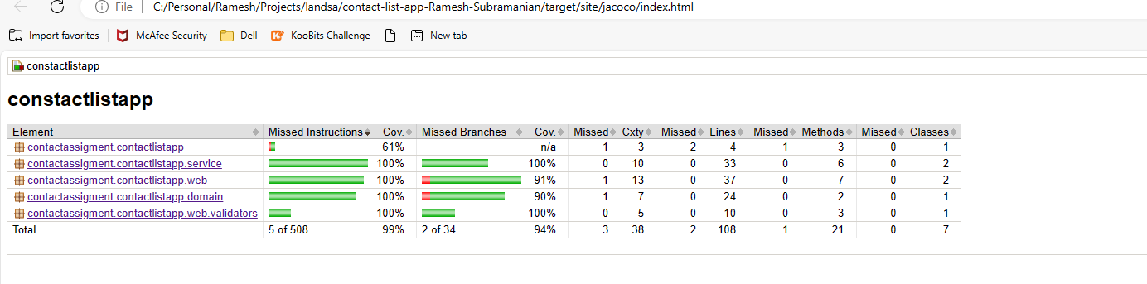

Specified Minimum Code Coverage needed. Package of application will fail if the coverage falls below the limit
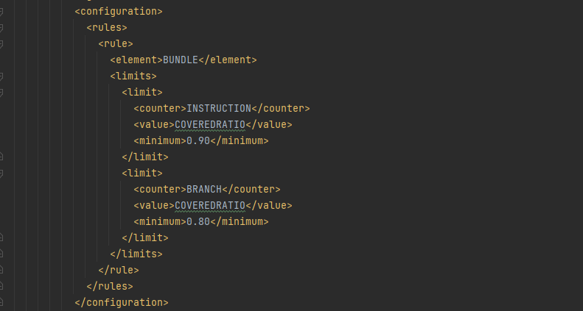

Metrics and Monitoring Performance
Have added a minimal instructions to monitor using Actuator
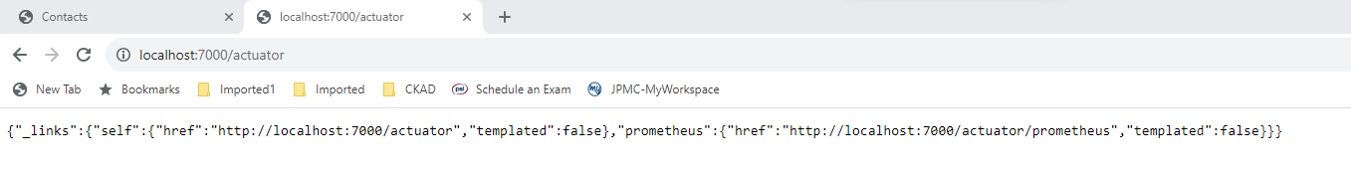

Using the endpoint http://localhost:7000/actuator/prometheus can monitor the JVM Memory, DB Connection Pool etc.,

Also, have added a metric called “searchcontacts_time” which observes the time taken to do the search operation of the contacts.

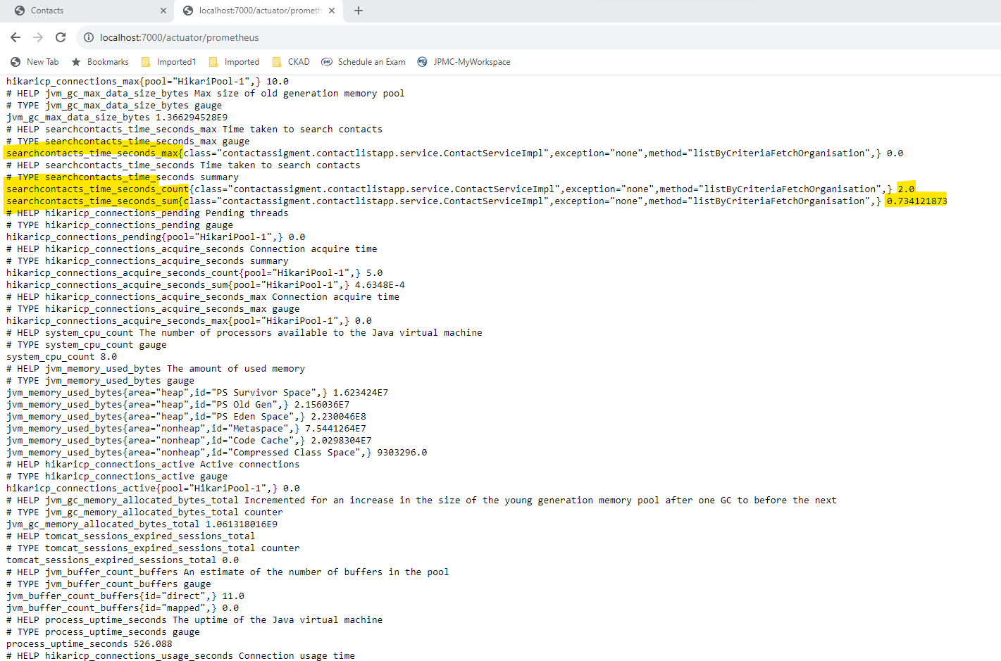

UI Tests using Playwright
Have written few UI Tests using Playwright
It will record the test runs by taking UI screenshots
The screenshots will be available at the target/site folder location

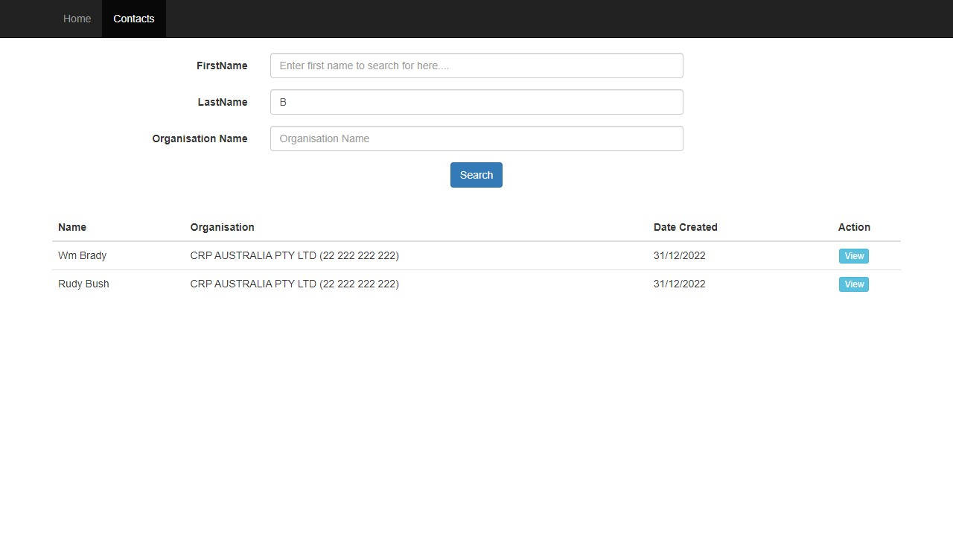

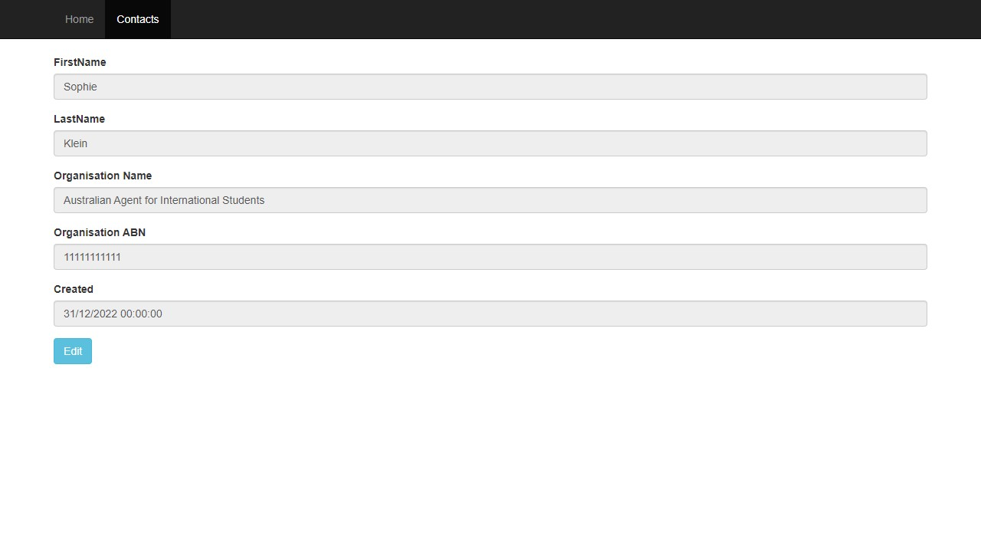

Continous Integration using GitHub Actions
Purpose
- To build application (using maven)
- Create image
- Push Image to DockerHub

Please refer to the below repo: https://github.com/rameshrepo/contact-list-app

Job Run on Push of Code to Repo
https://github.com/rameshrepo/contact-list-app/actions/runs/5995808048/job/16259383659
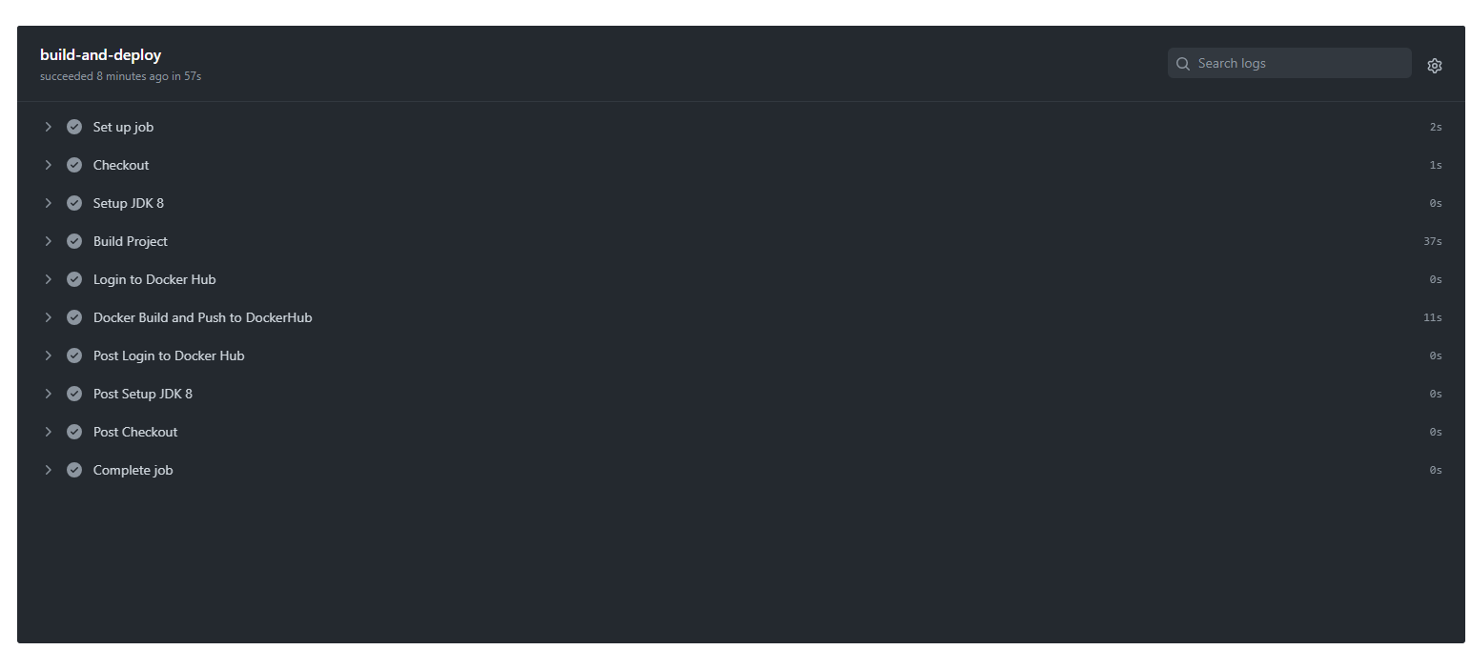

Screen shot of Image pushed by pipeline to my DockerHub
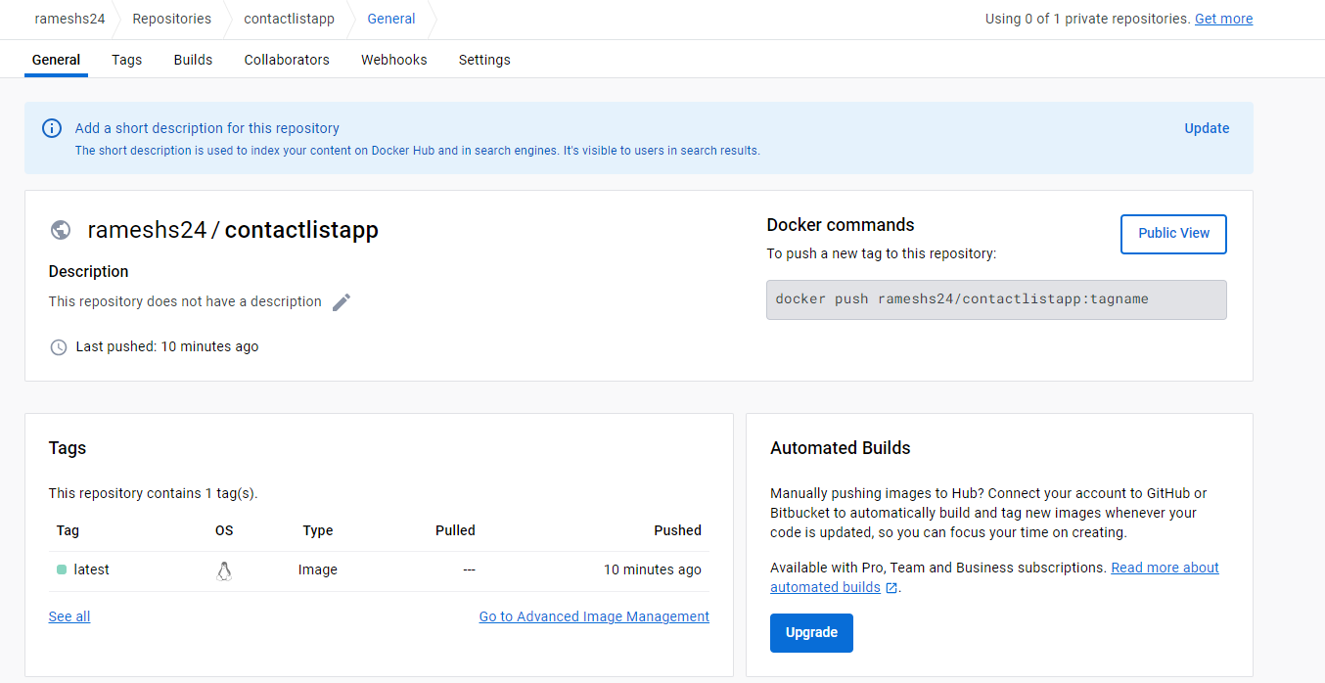

Run the application
