Eclipse Setup and Execution Guide
Project: Idempotent Background Transaction Processing Service

Prerequisites
- Java 17 or later installed
- Eclipse IDE for Enterprise Java and Web Developers
- Apache Maven 3.8+
- Postman for API testing
- Git (optional)

Import Project into Eclipse
- Open Eclipse IDE
- File -> Import
- Maven -> Existing Maven Projects
- Select project root folder
- Click Finish
- Wait for Maven dependency download

Configure Java 17
- Right click project -> Properties
- Java Compiler -> Set release to 17
- Project Facets -> Java 17
- Apply and Close

Update Maven Dependencies
- Right click project
- Maven -> Update Project
- Select Force Update of Snapshots/Releases
- Click OK

Run Spring Boot Application
- Locate Application.java
- Right click -> Run As -> Spring Boot App
- Verify application startup logs

Verify the database
- Open the browser and type http://localhost:8080/h2-console
- And enter the password as password and click connect

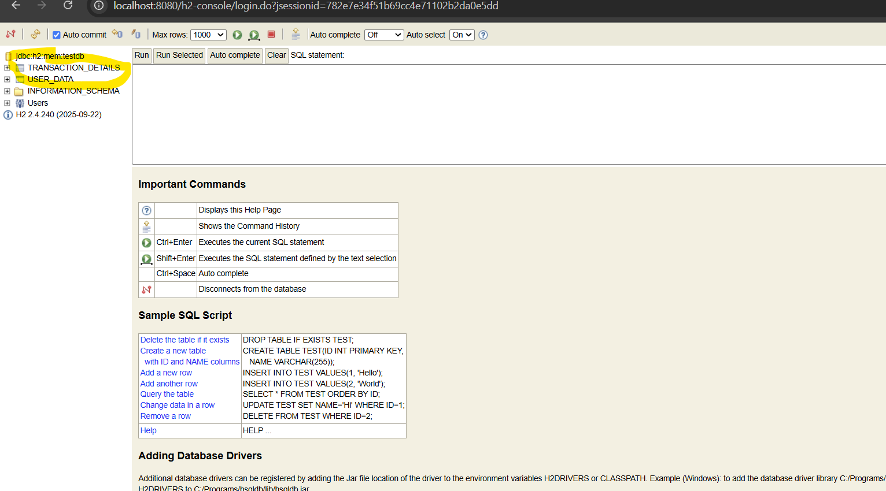

The marked table must be created .

Test APIs with Postman

- For first transacton:::
- POST http://localhost:8080/transactions
- Add JSON request body with transaction details
- {
- "accountId": "ACC-2002",
- "transactionId":"TXN-20002",
- "accountId": "ACC-202",
- "transactionType": "CREDIT",
- "amount": 500,
- "currencyCode":"INR",
- "sequenceNumber": 4,
- "idempotencyKey":"rer4"
- }

- Verify Transaction Accepted response
- Repeat same idempotencyKey and verify duplicate prevention

:::::::::::Curl request sample ::::::::

- curl --location 'http://localhost:8080/transactions' \
- --data '{
- "accountId": "ACC-2002",
- "transactionId":"TXN-20002",
- "accountId": "ACC-202",
- "transactionType": "CREDIT",
- "amount": 500,
- "currencyCode":"INR",
- "sequenceNumber": 4,
- "idempotencyKey":"rer4"

}'

- Duplicate Transaction Ignored

Just fire the same request and check the response would be Duplicate Transaction Ignored.

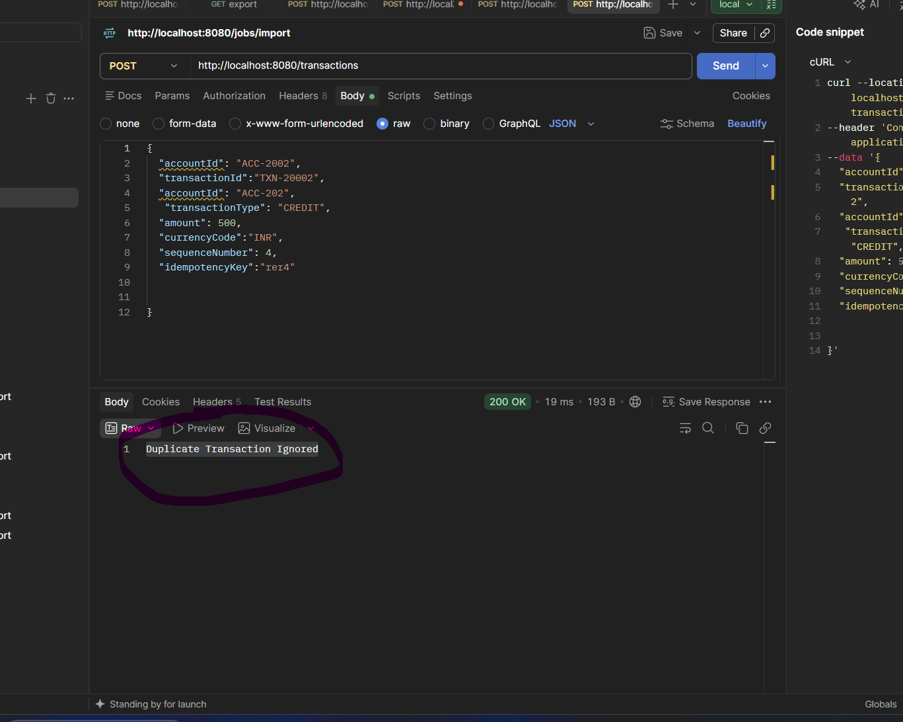

To Retry and schedular checking open the database home page and fire the below query (please follow below image)

http://localhost:8080/h2-console

- UPDATE TRANSACTION_DETAILS
SET STATUS='FAILED'
WHERE ACCOUNT_ID='ACC-202';

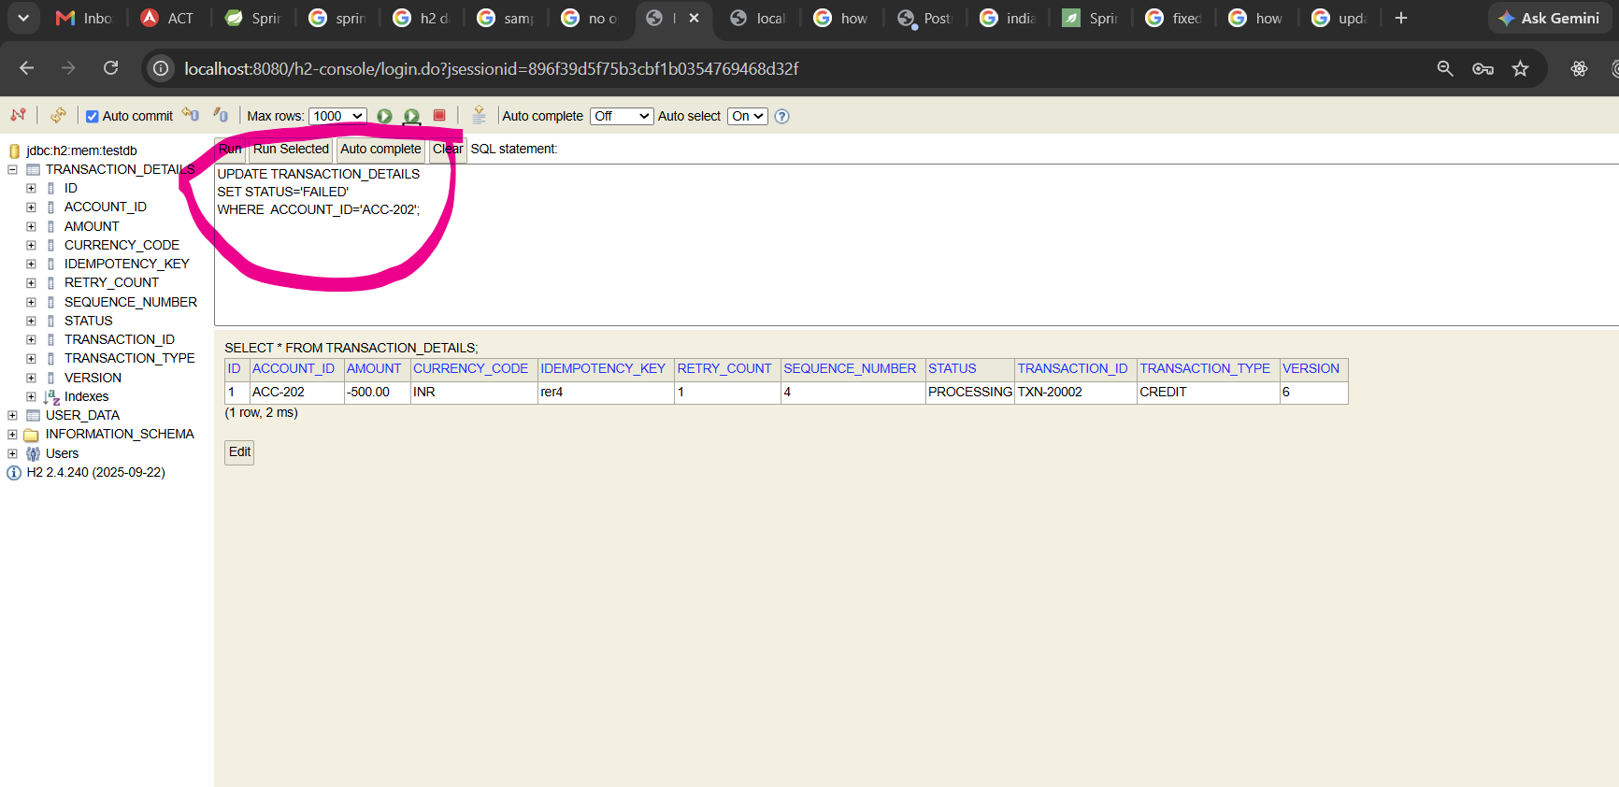

In eclipse console you can find update job after one minute

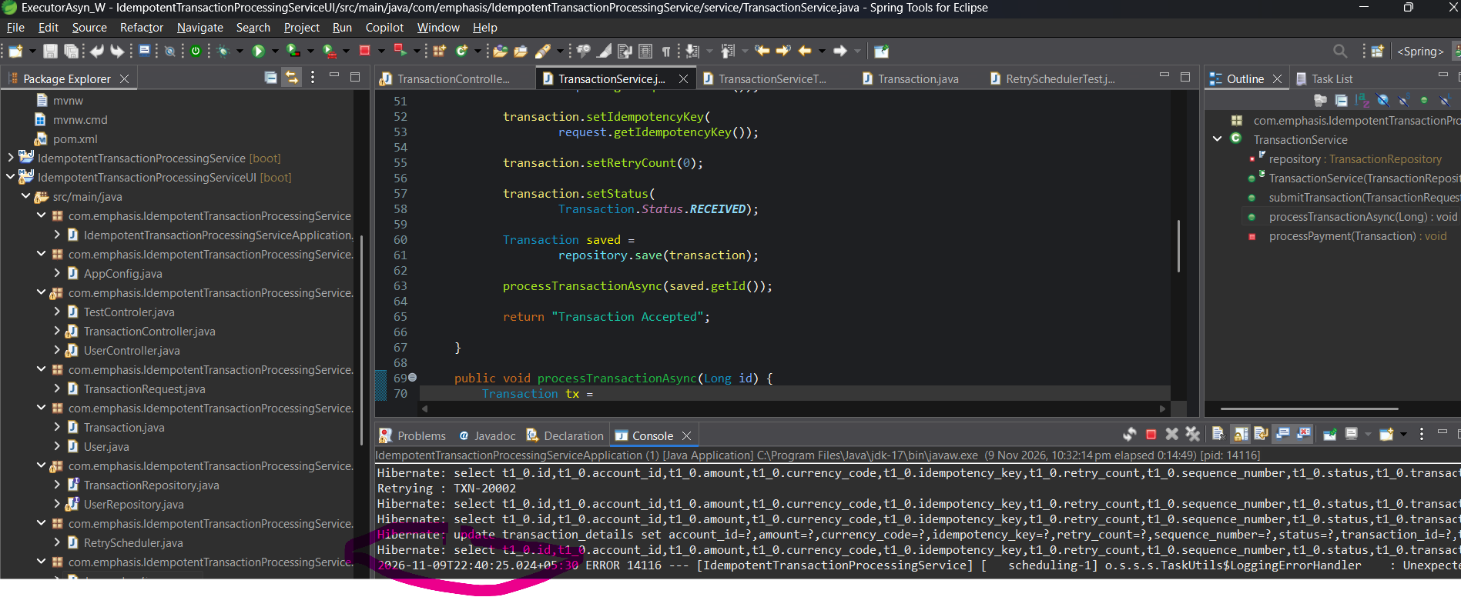

Now status has changed from FAILED TO PROCESSING.

Run JUnit Tests
- Right click src/test/java
- Run As -> JUnit Test
- Verify all tests pass

Scheduler Retry Validation
- Verify retry execution until max retry limit
To Retry and schedular checking open the database home page and fire the below query (please follow below image)

http://localhost:8080/h2-console

- UPDATE TRANSACTION_DETAILS
SET STATUS='FAILED'
WHERE ACCOUNT_ID='ACC-202';

In eclipse console you can find update job after one minute

Now status has changed from FAILED TO PROCESSING.

Common Issues
- Java version mismatch
- Maven dependencies not downloaded
- Port 8080 already in use
- Database configuration errors

