E-Commerce Database Management Project
Project Documentation
Prepared by: Ramesh Satta
E-Commerce Database Management System

Table of Contents

1. Executive Summary
2. Project Overview & Objectives
3. Database Schema (SQL Table Definitions)
4. Entity-Relationship Diagram (ERD)
5. Data Generation & Characteristics
6. Key SQL Queries & Insights (5 selected)
7. Business Applications
8. How to Run the Project (Files & Import Steps)
9. Limitations & Assumptions
10. Future Work

1. Executive Summary
This project demonstrates the design, implementation, and analysis of a realistic e-commerce database. It includes a normalized schema with seven interrelated tables, synthetic but realistic data spanning the period 2022-2023, and a set of business-focused SQL queries that provide actionable insights.

Key Deliverables
- Normalized database schema (7 tables) with PK–FK relationships.
- Synthetic dataset (≈1000 rows per main table) with realistic values.
- SQL queries for product, category, time-series, geographic, and customer analyses.
- PowerPoint slides and documentation suitable for academic submission.

2. Project Overview & Objectives
Purpose: To simulate an e-commerce platform's data and demonstrate how a relational database supports business analytics and decision-making.
Scope: Customers, Products, Categories, Orders, Order_Items, Shipping, Payments (7 tables).

Objectives
- Design a normalized relational schema for an e-commerce business.
- Generate a realistic dataset that reflects market prices, geographic information, and transaction behavior.
- Implement and run SQL queries to extract meaningful business insights.
- Document methodology, queries, and business implications for presentation and submission.

3. Database Schema (SQL Table Definitions)
Below are the logical table definitions used in the project. Tables and primary columns (brief):
- Customers(customer_id PK, first_name, last_name, email, phone, city, state, pincode, created_at)
- Categories(category_id PK, category_name)
- Products(product_id PK, product_name, category_id FK, unit_price)
- Orders(order_id PK, customer_id FK, order_date, payment_method, order_status, order_total)
- Order_Items(order_item_id PK, order_id FK, product_id FK, quantity, unit_price, total_price)
- Shipping(shipping_id PK, order_id FK, shipping_city, shipping_state, shipping_pincode, shipping_status)
- Payments(payment_id PK, order_id FK, payment_method, payment_amount, payment_status, payment_date)
Note: Primary and Foreign Keys ensure referential integrity and enable joins for analytics. For presentation, the CREATE TABLE screenshots are shown in the slide.

4. Entity-Relationship Diagram (ERD)
The ERD visually represents relations between entities (Customers, Orders, Products, etc.).
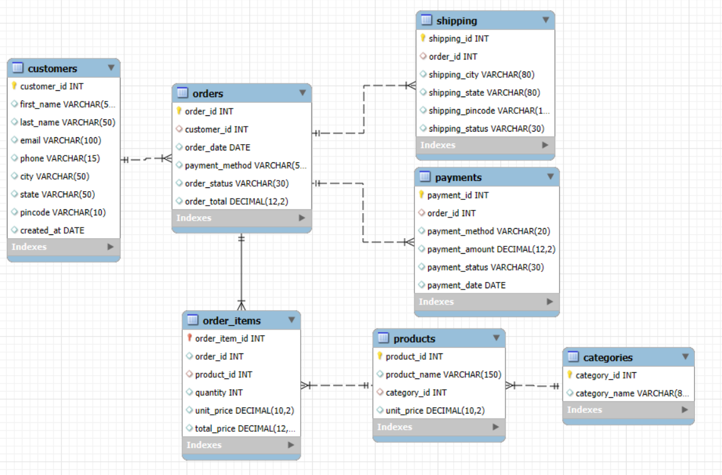

5. Data Generation & Characteristics
Dataset time period: January 1, 2022to December 31, 2023.

Key characteristics
- Approx. 1000 records per main table (Customers, Products, Orders, Payments, Shipping).
- Names include a diverse mix (Hindu, Muslim, Christian, Sikh), with female and male names.
- Email patterns vary to resemble real users (clean names, underscores, occasional numbers).
- City–State–Pincode consistency enforced using a location mapping dictionary.
- Product prices sampled from realistic category-based ranges (mobiles, laptops, groceries, etc.).
- UPI payments limited to ₹100,000 per transaction to reflect realistic limits.
Data generation: Programmatic scripts produce CSV files for each table.

6. Key SQL Queries & Insights (Selected)
Five business-critical queries were selected for presentation and analysis. Each query is followed by a short explanation and practical business use.

6.1 Top 5 Products Driving Revenue
SELECT p.product_name, SUM(oi.total_price) AS revenue
FROM Order_Items oi
JOIN Products p ON oi.product_id = p.product_id
GROUP BY p.product_id, p.product_name
ORDER BY revenue DESC
LIMIT 5;
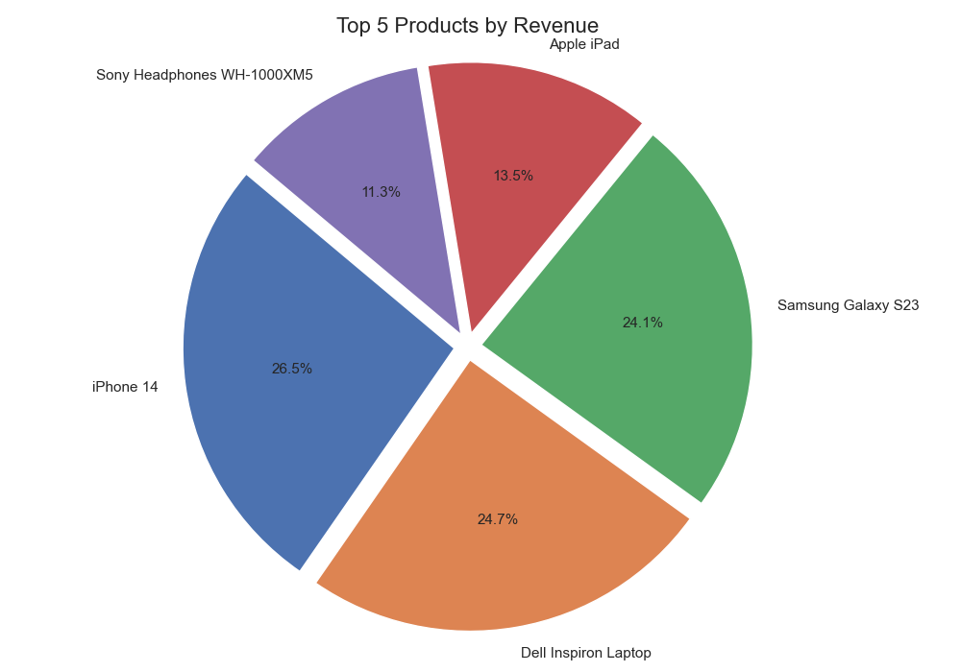

Explanation: Joins order items with product details, aggregates revenue per product and lists top revenue-generating products.
Business use: Identify products to promote, prioritize inventory and plan marketing campaigns.

6.2 Revenue Contribution by Category
SELECT c.category_name, SUM(oi.total_price) AS revenue
FROM Order_Items oi
JOIN Products p ON oi.product_id = p.product_id
JOIN Categories c ON p.category_id = c.category_id
GROUP BY c.category_id, c.category_name
ORDER BY revenue DESC;

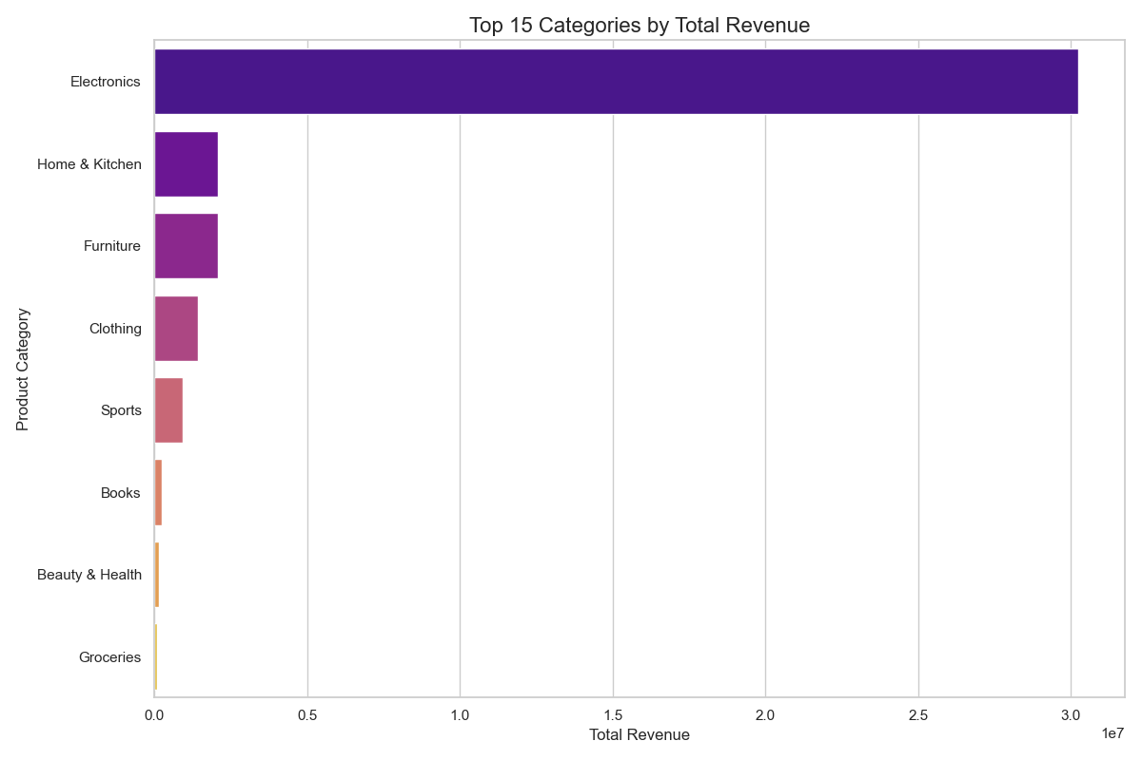
Explanation: Sums revenue by product category to show which categories contribute the most.
Business use: Strategic allocation of advertising budget and assortment planning.

6.3 Monthly Sales Trend (Successful Payments)
SELECT DATE_FORMAT(p.payment_date, '%Y-%m') AS month, SUM(p.payment_amount) AS total_revenue
FROM Payments p
WHERE p.payment_status = 'Success'
GROUP BY month
ORDER BY month;

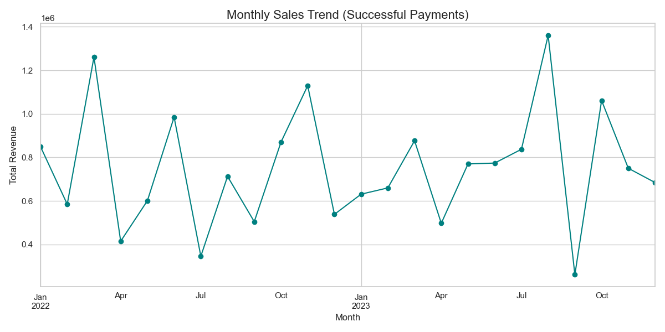

Explanation: Aggregates successful payments by month to reveal seasonality and growth trends.
Business use: Plan promotional campaigns and inventory for peak months.

6.4 Top States by Order Volume
SELECT c.state, COUNT(o.order_id) AS num_orders
FROM Orders o
JOIN Customers c ON o.customer_id = c.customer_id
GROUP BY c.state
ORDER BY num_orders DESC
LIMIT 10;

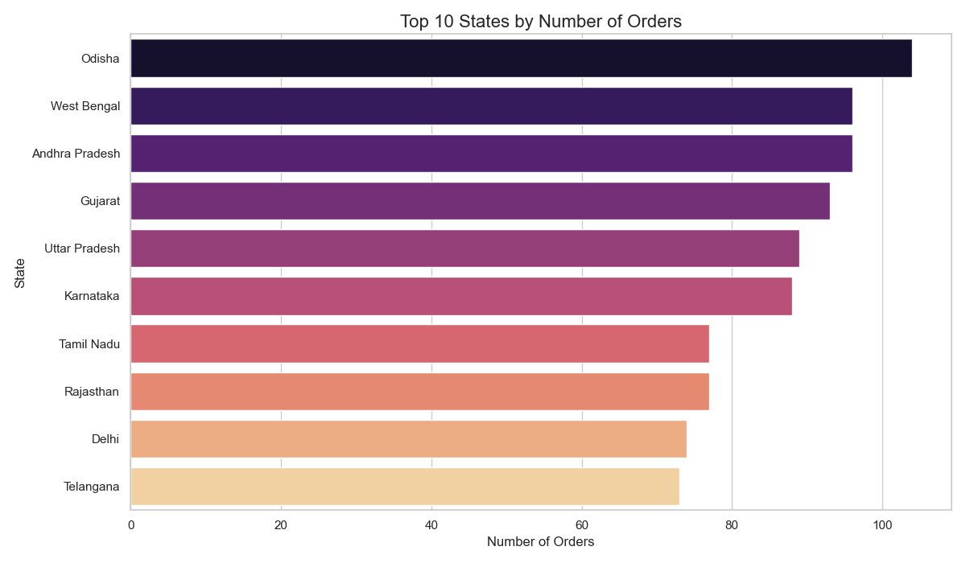

Explanation: Counts orders per state to identify regional demand hotspots.
Business use: Optimize logistics, warehouses, and target marketing.

6.5 Identifying VIP Customers (Above-Average Spend)
SELECT c.customer_id, c.first_name, c.last_name, SUM(p.payment_amount) AS total_spent
FROM Customers c
JOIN Orders o ON c.customer_id = o.customer_id
JOIN Payments p ON o.order_id = p.order_id
WHERE p.payment_status = 'Success'
GROUP BY c.customer_id, c.first_name, c.last_name
HAVING total_spent > (SELECT AVG(payment_amount) FROM Payments WHERE payment_status='Success')
ORDER BY total_spent DESC
LIMIT 10;

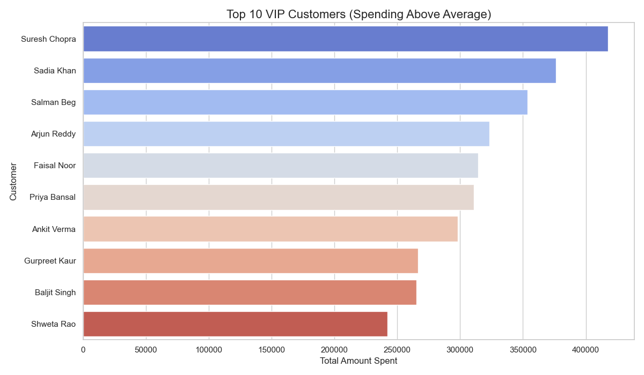

Explanation: Identifies customers whose aggregate successful payments exceed the platform average.
Business use: Develop loyalty programs and targeted retention offers for high-value customers.

7. Business Applications
- Marketing: Target promotions to high-revenue products and categories.
- Logistics: Identify states with high order volume for warehousing decisions.
- Customer Retention: Design loyalty and reward programs for VIPs.
- Inventory: Prioritize restocking for fast-moving items.
- Compliance & Risk: Validate payment limits and detect address mismatches.

8. How to Run the Project (Files & Import Steps)
Files included: customers.csv, categories.csv, products.csv, orders.csv, order_items.csv, shipping.csv, payments.csv, E-commerce_DBMS_Workbench_file.sql
Import order: 1) Categories, 2) Products, 3) Customers, 4) Orders, 5) Order_Items, 6) Shipping and 7) Payments
How to import: Navigator > Schemas > Database > Table > Right click on the column > Table Data Import Wizard

9. Limitations & Assumptions
- Synthetic data: The dataset is generated to resemble real-world patterns, but is not real customer data.
- UPI limit enforcement: UPI transactions capped to ₹100,000 per transaction as an assumption for realism.
- Geography coverage: Location mapping covers major cities and pincodes but is not exhaustive for all India.
- No real payment processing: Payments are simulated; no external gateway is integrated.

10. Future Work
- Add Inventory and Supplier tables to support procurement analytics.
- Integrate product reviews and ratings for recommendation features.
- Use more granular location data (district-level) and implement a geographical heatmap.
- Expand dataset size and introduce time-series forecasting for demand prediction.

