**CONTENTS:**

ABSTRACT

1.INTRODUCTION TO ONLINE VOTING SYSTEM

1.1.BACKGROUND OF STUDY

1.2.SIGNIFICANCE OF THE STUDY

1.3.OBJECTIVES OF THE PROJECT

1.4.PROJECT JUSTIFICATION

1.5.SCOPE OF STUDY

1.6.SECURITY ISSUES OF THE ONLINE VOTING

1.7.DRAWBACKS OF THE EARLIER SYSTEM

2.REQUIREMENT ANALYSIS

2.1.HARDWARE REQUIREMENTS

2.2.SOFTWARE REQUIREMENTS

3.DESIGN ANALYSIS

3.1.ARCHITECTURE

3.2.DATA FLOW DIAGRAM

3.3.TABLE CREATION

3.3.1.DATABASE TABLES

3.4.SNAPSHOTS

4.CONCLUSION

REFERENCES

**ABSTRACT:**

# The word “vote” means to choose from a list, to elect or to determine. The main goal of voting (in a scenario involving the citizens of a given country) is to come up with leaders of the people’s choice.Most countries, India not an exception have problems when it comes to voting. Some of the problems involved include ridging votes during election, insecure or inaccessible polling stations, inadequate polling materials and also inexperienced personnel.This online voting/polling system seeks to address the above issues. It should be noted that with this system in place, the users, citizens in this case shall be given ample time during the voting period. They shall also be trained on how to vote online before the election time.

**1.INTRODUCTION TO ONLINE VOTING SYSTEM:**

“ONLINE VOTING SYSTEM” is an online voting technique. In this system people who have citizenship of INDIA and whose age is above 18 years of age and any sex can give his\her vote online without going to any physical polling station. There is a database which is maintained in which all the names of voters with complete information is stored. Registration is mainly done by the system administrator for security reasons. The system Administrator registers the voters on a special site of the system visited by him only by simply filling a registration form to register voter.Citizens seeking registration are expected to contact the system administrator to submit their details. After the validity of them being citizens of India has been confirmed by the system administrator by comparing their details submitted with those in existing databases such as those as the Registrar of Persons, the citizen is then registered as a voter. After registration, the voter is assigned a secret Voter ID with which he/she can use to log into the system and enjoy services provided by the system such as voting. If invalid/wrong details are submitted, then the citizen is not registered to vote.

**1.1.BACKGROUND OF STUDY:**

The Online voting system (OVS) also known as e-voting is a term encompassing several different types of voting embracing both electronic means of counting votes. Electronic voting technology can include punched cards, optical scan voting systems and specialized voting kiosks (including self contained direct-recording electronic voting systems or DRE). It can also involve transmission of ballots and votes via telephones, private computer networks, or the internet. Online voting is an electronic way of choosing leaders via a web driven application. The advantage of online voting over the common “queue method” is that the voters have the choice of voting at their own free time and there is reduced congestion. It also minimizes on errors of vote counting. The individual votes are submitted in a database which can be queried to find out who of the aspirants for a given post has the highest number of votes. This system is geared towards increasing the voting percentage in Kenya since it has been noted that with the old voting method {the Queue System}, the voter turnout has been a wanting case. With system in place also, if high security is applied, cases of false votes shall be reduced. With the “ONLINE VOTING SYSTEM”, a voter can use his\her voting right online without any difficulty. He\She has to register as a voter first before being authorized to vote. The registration should be done prior to the voting date to enable data update in the database. However, not just anybody can vote. For one to participate in the elections, he/she must have the requirements. For instance, he/she must be a registered citizen i.e. must be 18 and above years old. As already stated, the project „Online Voting' provides means for fast and convenient voting and access to this system is limited only to registered voters. Internet voting systems are appealing for several reasons which include; People are getting more used to work with computers to do all sorts of things, namely sensitive operations such as shopping and home banking and they allow people to vote far from where they usually live, helping to reduce absenteeism rate.

**1.2.SIGNIFICANCE OF THE STUDY:**

The main purposes of OVS include:

Provision of improved voting services to the voters through fast, timely and convenient voting.Reduction of the costs incurred by the INDIA Electoral Commission during voting time in paying the very many clerks employed for the sake of the success of the manual system.Check to ensure that the members who are registered are the only ones to vote. Cases of “Dead People” voting are also minimized.Online voting system (OVS) will require being very precise or costomize cutting to produce an effective election management system.

Therefore crucial points that this (OVS) emphasizes on are listed below:

Require less number of staff during the election.This system is a lot easier to independently moderate the elections and subsequently reinforce its transparency and fairness.Less capital, less effort, and less labor intensive, as the primary cost and effort will focus primarily on creating, managing, and running a secure online portal. Increased number of voters as individual will find it easier and more convenient to vote, especially those abroad.

**1.3.OBJECTIVES OF THE PROJECT:**

The specific objectives of the project include:

Reviewing the existing/current voting process or approach in INDIA.Coming up with an automated voting system in INDIA;Implementing a an automated/online voting system;Validating the system to ensure that only legible voters are allowed to vote.

**1.4.PROJECT JUSTIFICATION:**

The ONLINE VOTING SYSTEM-INDIA shall reduce the time spend making long queues at the polling stations during voting. It shall also enable the voters to vote from any part of the globe as explained since this is an online application available on the internet. Cases of vote miscounts shall also be solved since at the backend of this system resides a well developed database using MYSQL that can provide the correct data once it‟s correctly queried. Since the voting process shall be open as early as possible, the voters shall have ample time to decide when and whom to vote for.

**1.5.SCOPE OF STUDY:**

It is focused on studying the existing system of voting in INDIA and to make sure that the peoples vote is counts, for fairness in the elective positions. This is also will produce: Less effort and less labor intensive, as the primary cost and focus primary on creating, managing, and running a secure web voting portal. Increasing number of voters as individuals will find it easier and more convenient to vote, especially those abroad.

**1.6.SECURITY ISSUES OF THE ONLINE VOTING:**

Foreign experience revealed that they are often confronted by security issues while the online voting system is running. The origin of the security issues was due to not only outsider (such as voters and attackers) but also insider (such as system developers and administrators), even just because the inheritance of some objects in the source code are unsuitable. These errors caused the voting system to crash. The proposed solutions were correspondingly outlined to hold back these attacks. For example, to avoid hacker making incursion into the voting system via network, we can design our system to transmit data without network. Another example is to limit voter to input particular data, so that we can prevent the command injection from running

**Requirements:**

1) Registration of the voter is done by ELECTION COMMISION OF INDIA.

2) ELECTION COMMISION OF INDIA can change the information any time if required.

3) Registration of the Voter depends upon the information filled by the user.

4) Voter is given a unique ID and PASSWORD.

5) In the DATABASE information of every voter is stored.

6) Database shows the information of every user.

**1.7.DRAWBACKS OF THE EARLIER VOTING SYSTEM:**

The problems of the existing manual system of voting include among others the following:

1. Expensive and Time consuming: The process of collecting data and entering this data into the database takes too much time and is expensive to conduct, for example, time and money is spent in printing data capture forms, in preparing registration stations together with human resources, and there after advertising the days set for registration process including sensitizing voters on the need for registration, as well as time spent on entering this data to the database.

2. Too much paper work: The process involves too much paper work and paper storage which is difficult as papers become bulky with the population size.

3. Errors during data entry: Errors are part of all human beings; it is very unlikely for humans to be 100 percent efficient in data entry.

4. Loss of registration forms: Some times, registration forms get lost after being filled in with voters‟ details, in most cases these are difficult to follow-up and therefore many remain unregistered even though they are voting age nationals and interested in exercising their right to vote.

5. Short time provided to view the voter register: This is a very big problem since not all people have free time during the given short period of time to check and update the voter register.

6. Above all, a number of voters end up being locked out from voting.

**2.REQUIREMENTS ANALYSIS :**

**2.1.HARDWARE REQUIREMENTS:**

Microsoft Windows XP Professional SP3/Vista SP1/Windows 7 Professional:

Processor: 800MHz Intel Pentium III or equivalent

Memory: 512 MB

Disk space: 750 MB of free disk space

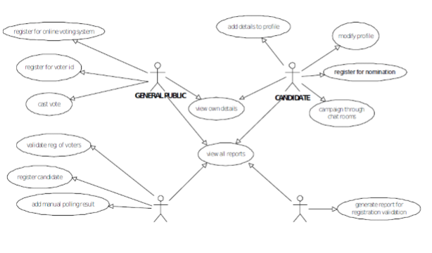**FIGURE.4:BLOCK-DIAGRAM**

**2.2.SOFTWARE REQUIREMENTS:**

MYSQL DBMS- It allows combination, extraction, manipulation and organization of data in the voters‟ database. It is platform independent and therefore can be implemented and used across several such as Windows, Linux server and is compatible with various hardware mainframes. It is fast in performance, stable and provides business value at a low cost.NetBeans IDE 7.1.2- The NetBeans IDE is an award-winning integrated development environment available for Windows, Mac, Linux, and Solaris. The NetBeans project consists of an open-source IDE and an application platform that enable developers to rapidly create web, enterprise, desktop, and mobile applications using the Java platform, as well as PHP, JavaScript and Ajax, Groovy and Grails, and C/C++.The NetBeans project is supported by a vibrant developer community and offers extensive documentation and training resources as well as a diverse selection of thirdparty plugins.JAVA coding-This is for advanced user who find PHP codes easy to work with.Testing- is done via XAMPP.Web browsers-Mozilla Firefox, Google chrome, Opera and Internet ExplorerReporting Tool i.e. through Data Report.

**3.DESIGN ANALYSIS:**

**3.1.ARCHITECTURE:**

**One Tier Architecture:**

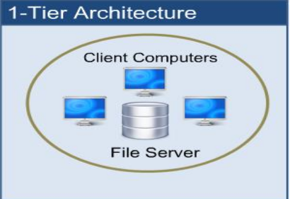

When automation first hit business, it was in the form of a huge "Mainframe" computer. Here, a central computer served the whole business community and was accessed via dumb terminals. All processing took place on a single computer - and therefore in one place. All resources associated with the computer (tape and disk drives, printers etc.) were attached to this same computer. This is single tier (or 1-tier) computing. It is simple, efficient, uncomplicated, but terribly expensive to run. All users run their programs from a single machine. The ease with which deployment and even development occurs makes this model very attractive. The cost of the central machine makes this architecture prohibitive for most companies, especially as system costs and return on investment (ROI) are looked at carefully nowadays.

**E-R DIAGRAM OF ONLINE VOTING SYSTEM:**

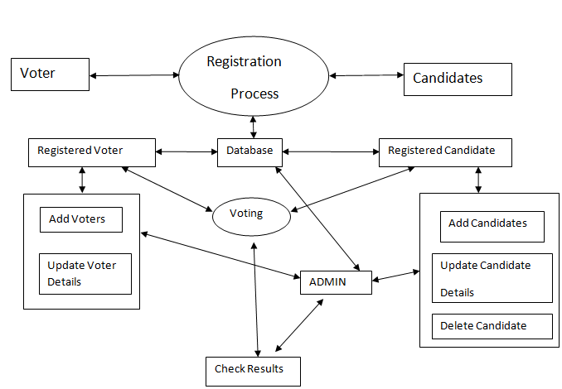**FIGURE.1-ER DIAGRAM:**

* **/The following is the explanation about the E-R Diagram of The ONLINE VOTING SYSTEM**

**3.2.DATA-FLOW DIAGRAM OF THE ONLINE VOTING SYSTEM:**

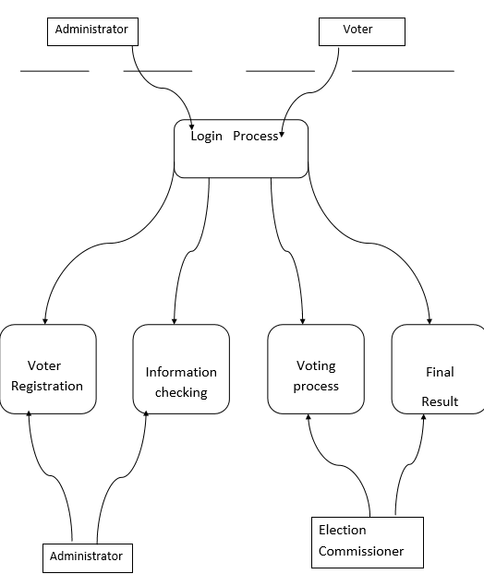

**FIGURE2:DATAFLOW DIAGRAM**

**3.3.TABLE CREATION:**

**3.3.1.Data Base Tables:**

This project uses many tables:

* Admin
* Voter
* Candidates

**Admin Table:**

|  |  |  |
| --- | --- | --- |
| Field Name | Data Type | Description |
| Username | Varchar | Login id for Admin.(Primary key) |
| Password | Varchar | Password for Login |

In this table, 2 details about Admin is given where ,Username is the primary key of type varchar and Password is of the type varchar,wherein the Admin requires Login-id and Password for login.

**Voter Table:**

|  |  |  |
| --- | --- | --- |
| Field Name | Data Type | Description |
| VoterId | Integer | Login id for Voter(Primary key) |
| Name | Varchar | Name of the voter |
| Sex | Varchar | Sex of voter |
| Age | Integer | Age of voter |
| City | Varchar | City of voter |
| Security | Varchar | Security Question |
| Status | Boolean | Status of voter(he/she can vote or not) |

In this table, 7 details about the Voter is given where, Voter-id is the primary key of the integer type and it is used for the login for voter,Name is of the type varchar where you enter the name of the voters,Sex is the key of the type varchar where you enter the sex of the voter,Age is of the type Integer where you enter the age of the voter,City is the key of type varchar where you enter the city of the voter,Security is the key of type varchar where you enter the Security Question araised,Status is the key of the type Boolean,which has the status of the voter-wether he or she can vote or not.

**Candidate Table:**

|  |  |  |
| --- | --- | --- |
| Field Name | Data Type | Description |
| Symbol | Varchar | Party Symbol (Primary key) |
| Name | Varchar | Name of the voter |
| Sex | Varchar | Sex of voter |
| Age | Integer | Age of voter |
| City | Varchar | City of voter |
| Count | Integer | Count the no of votes |

In this table,6 details about the Candidates is given where,Symbol is the primary key of the datatype varchar which consists of the party symbol,Name is of the type varchar which consists of the name of the voter,Sex is of the type varchar which consists of the sex of the voter,Age is of the integer type which consists of the age of the voter,City is of the type varchar which consists of the city of the voter,Count is of the integer type which consists of the count of the total number of votes.

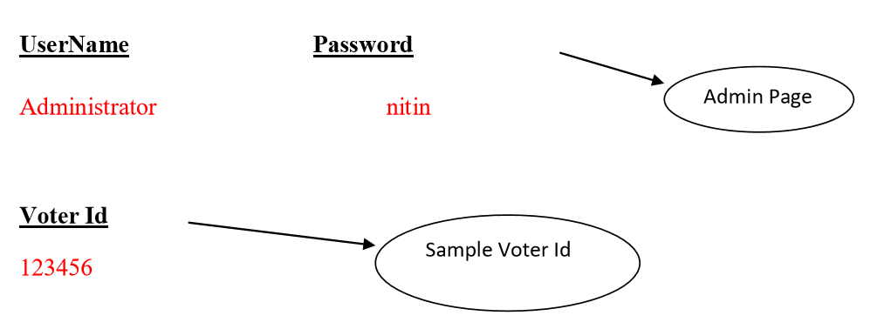

**FIGURE:3**

**3.4.SNAPSHOTS:**

* The following picture shows the page of the ADMINISTRATION CONTROL PANEL:

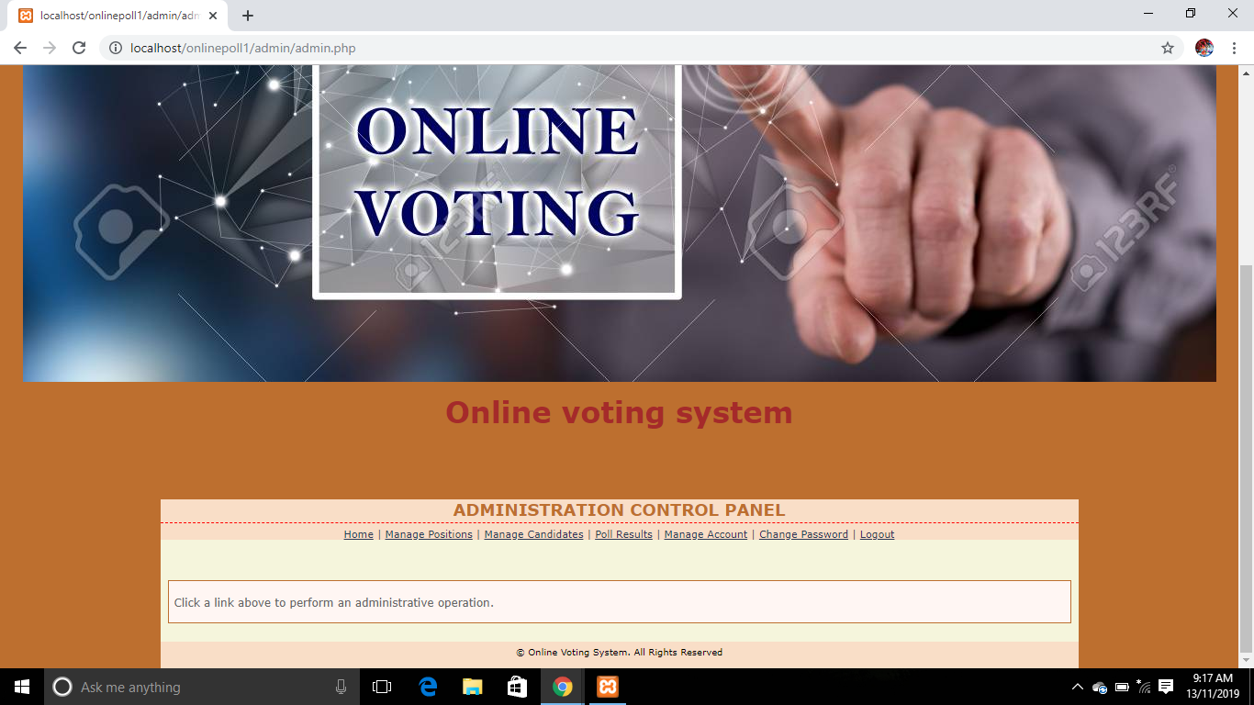the above snapshot shows the description about the ADMIN features which consists of Login,manage Administrators,Manage Candidates,Poll Results,Manage Accounts,Change Passwords and the Logout.

* The following picture shows the page of the STUDENT LOGIN:
* 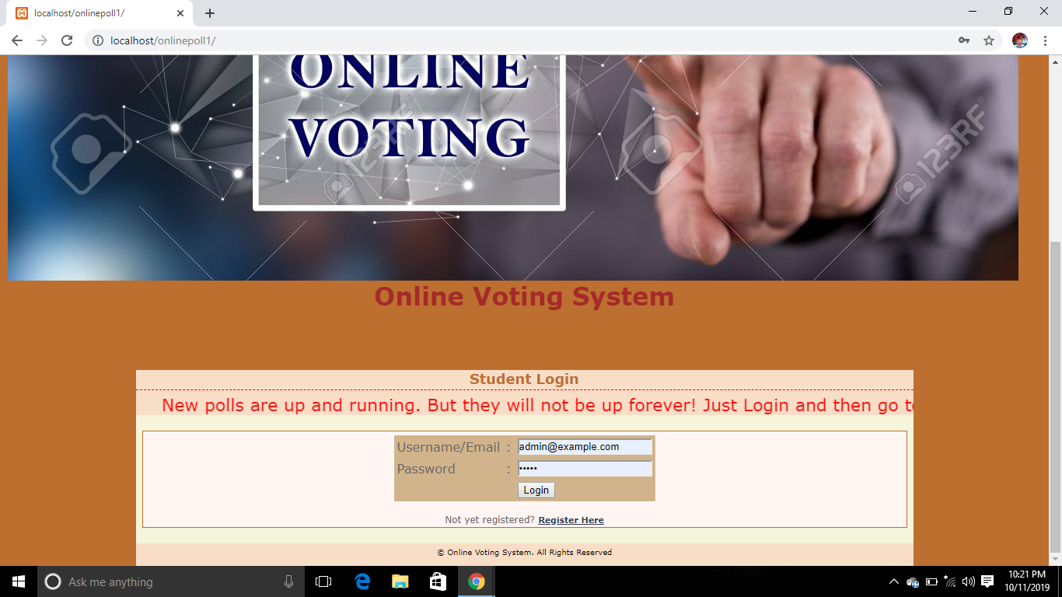

The above snapshot shows the student login homepage,where the student can login into,by using the correct Username/Email and the Password.

* The following picture shows page used to MANAGE CANDIDATES:

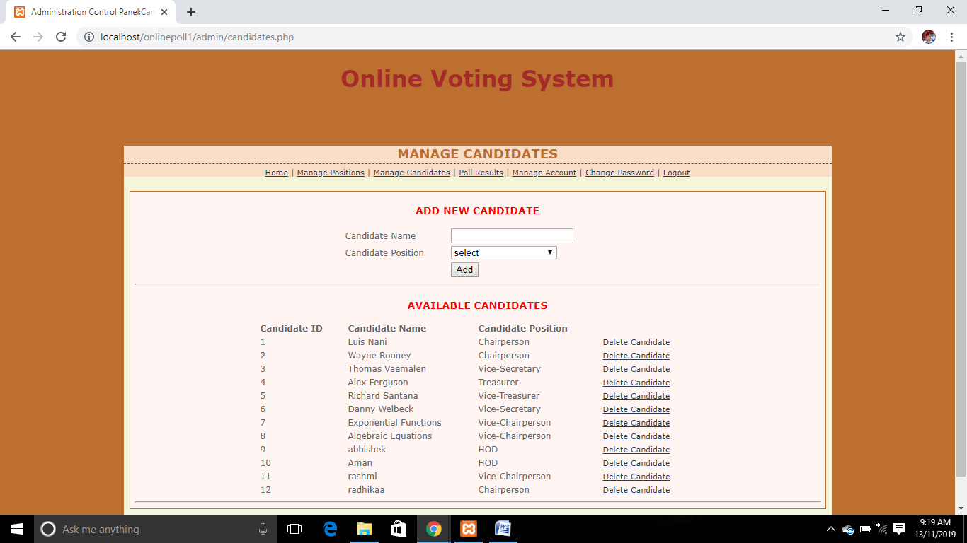

The above snapshot shows the information of how to manage the candidates by adding,deleteing and also modifying the present candidates related information.here you also get to know about the Poll Results,you can manage the accounts,change the Password and at last Logout.

* The following shows the page used display the Poll Result**:**

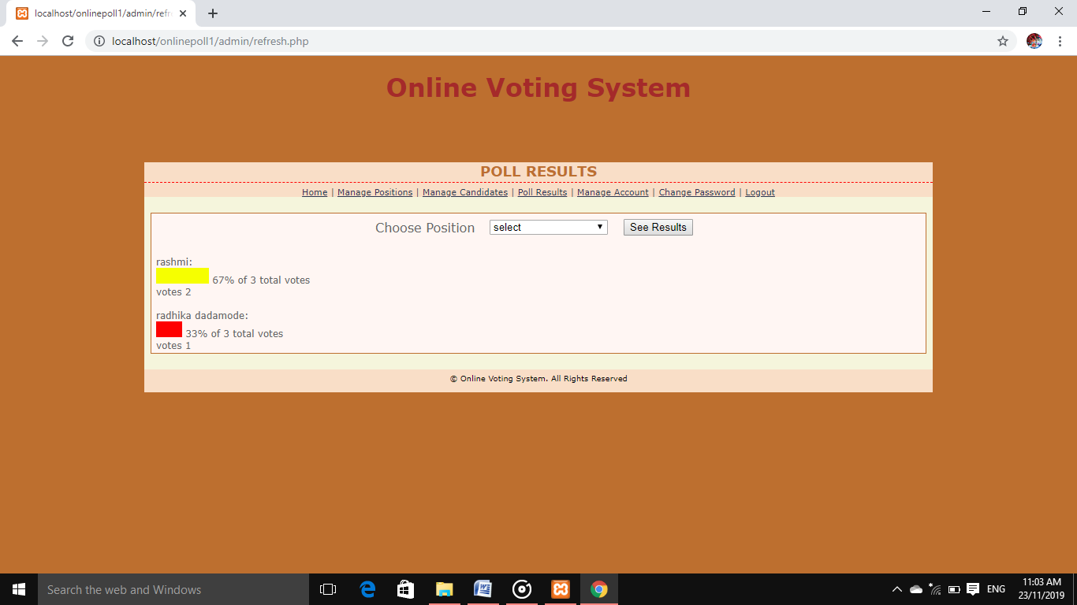

The above snapshot shows the Poll Results of the cxandidates who have participated in the Election through the ONLINE VOTING SYSTEM.

**4.CONCLUSION:**

This Online Voting system will manage the Voter‟s information by which voter can login and use his voting rights. The system will incorporate all features of Voting system. It provides the tools for maintaining voter‟s vote to every party and it count total no. of votes of every party. There is a DATABASE which is maintained by the ELECTION COMMISION OF INDIA in which all the names of voter with complete information is stored.In this user who is above 18 year‟s register his/her information on the database and when he/she want to vote he/she has to login by his id and password and can vote to any party only single time. Voting detail store in database and the result is displayed by calculation. By online voting system percentage of voting is increases. It decreases the cost and time of voting process. It is very easy to use and It is vary less time consuming. It is very easy to debug.

**REFERENCES:**

**WEB LINKS:**

[www.google.com](http://www.google.com)

[www.wikipedia.com](http://www.wikipedia.com)

[www.project-management-basic.com](http://www.project-management-basic.com)

**For PHP**

<https://www.w3schools.com/php/default.asp>

<https://www.sitepoint.com/php/>

<https://www.php.net/>

**For MySQL**

<https://www.mysql.com/>

<https://www.mysqltutorial.org>

**For XAMPP**

[**https://www.apachefriends.org/download.html**](https://www.apachefriends.org/download.html)