Customer Support Agent Evaluation
Week 4 core project submission
Ramesh Suthan Palani | November 2 2026

Project outcome
A focused routing priority rule increased accuracy from 96% to 98% against an unchanged-prompt control at the same 2,048-token limit. It fixed all four damaged-laptop refund cases, but introduced two invalid outputs. The improved run therefore did not meet the 100% validity target.
The original 1,024-token baseline scored 91%. A separate output-limit control separates the operational change from the prompt experiment. This report follows the handout: annotate failures, group and label them, make one focused edit, then inspect fixes and regressions.

System and evaluation flow
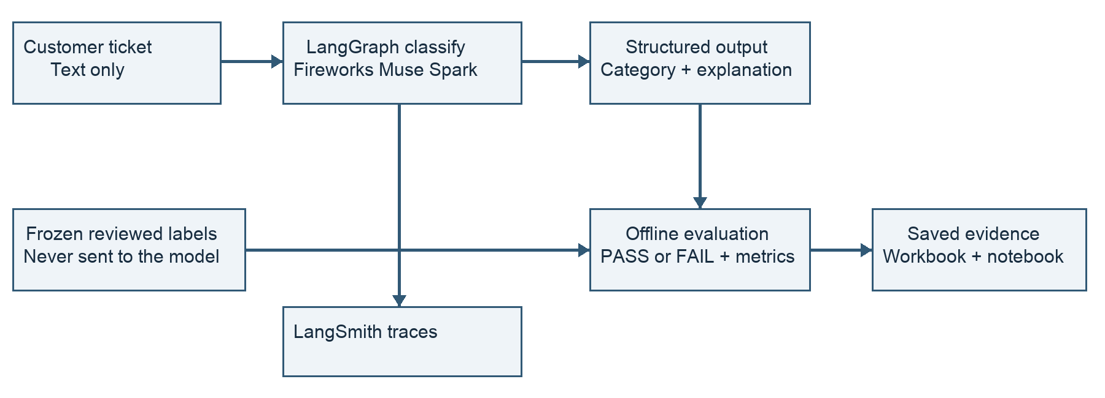
Figure 1. Reviewed labels are used by the offline scorer, never included in model input.
The implementation uses one LangGraph classify node, Fireworks model accounts/fireworks/models/muse-spark-open, Pydantic validation and LangSmith tracing. The response contains one of five category keys and a concise explanation.
Open the project repository

1 Dataset and reviewed routing policy
The evaluation uses 100 course tickets across 25 seed families. Labels were reviewed with the project owner and frozen before the comparison runs. Tags describe ticket themes; they are not additional routing labels.
Category | Count | Reviewed boundary
refund_request | 24 | Explicit money-back request, including non-delivery; damaged-product priority is an exception.
product_issue | 20 | Broken, damaged, wrong, defective or misdescribed product; also damaged packaging or missing manual.
account_help | 20 | Login, password, session, security, address or payment-method help.
other | 20 | General policy, stock, discounts, sales, browsing or positive feedback.
order_status | 16 | Tracking, delivery or ETA concerns without an explicit refund request.

Ambiguous cases resolved before evaluation
course-t004–t007 were changed from source order_status to refund_request because they explicitly request money back for non-delivery. course-t044–t047 retain product_issue despite explicit refund wording because the laptop arrived damaged. Packaging and missing-manual concerns remain product_issue; descriptive tags do not create extra classes.

Source reconciliation and reproducibility
The supplied workbook has 150 cases and 29 failures; the CSV has 100 cases and 8 published failures. Only one ticket text matches among 100 shared IDs. These sources were not silently joined. The evaluation uses the CSV ticket set with reviewed labels, while preserving the original workbook tabs.
Frozen dataset: data/frozen/v1/tickets_v1.jsonl. The manifest and review snapshot record provenance and decisions. SHA256:
6393654a0bbfb44b3d28dffac7f720c8e857f480dd1480fca4d27cbdbf0efe1d
The same synthetic set was used for diagnosis and reevaluation. Related paraphrases are not independent evidence of generalization. No held-out performance claim is made.

2 Controlled evaluation design
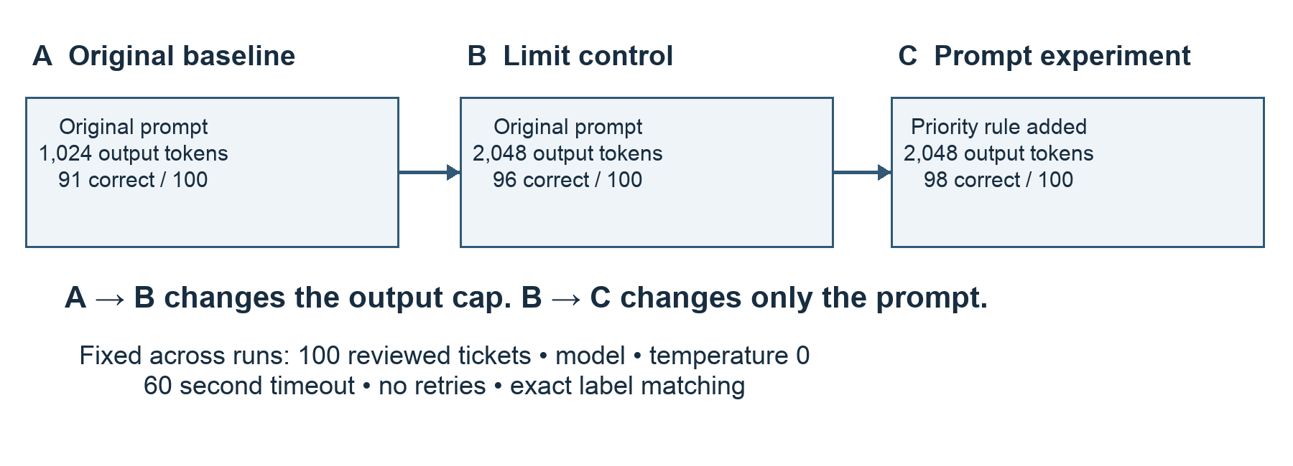
Figure 2. Compare B with C to assess the focused prompt edit at a constant output limit.
Run | Purpose | Run ID
A | Preserve original baseline | baseline-001
B | Unchanged prompt with larger output cap | baseline-2048-001
C | Focused routing priority edit | improved-2048-001

Scoring and targets
Each attempted ticket counts once. PASS requires a valid structured category that exactly matches the reviewed label. Invalid outputs and provider errors are FAIL, not omitted rows. The interrupted original baseline resumed only unattempted IDs; previous failed attempts were retained.
Measure | Definition | Target
Accuracy | Correct predictions / all 100 attempted tickets | ≥ 95%
Macro F1 | Mean F1 across the five routing labels | ≥ 0.90
Validity | Valid structured responses / all attempts | 100%
Latency | 95th percentile elapsed request time | ≤ 15 seconds
Mean cost | Known total cost / attempts when usage is complete | ≤ $0.02
Targets were set before the runs. Temperature is 0, timeout is 60 seconds and retries are disabled. Model, dataset and scoring stay fixed. LangSmith captures graph, classify and model traces with run metadata.

3 Failure annotations and categories
Handout Steps 1–3: all nine original failures receive one failure-group label. The table names the decisive cue, observed problem and expected boundary. Case IDs below use the course- prefix.
Group and count | Definition and likely business impact
damaged_product_refund_priority · 4 | Refund wording overrides product damage. Routes a product defect to the refund queue before product triage.
packaging_manual_scope · 1 | Working product causes packaging damage and missing manual to be treated as general feedback. Misses a product-support issue.
output_budget_exhaustion · 2 | Output reaches the cap before valid JSON. No usable route is returned.
provider_http_500 · 2 | Provider request fails. No classification or usage is returned.

Case level annotations
Case | Cue and observed failure | Expected label and group
t044 | Damaged laptop; asks full refund, not replacement. Predicted refund_request. | product_issue  damaged_product_refund_priority
t045 | Laptop in awful condition; wants money back. Predicted refund_request. | product_issue  damaged_product_refund_priority
t046 | Laptop showed up damaged; prefers refund. Predicted refund_request. | product_issue  damaged_product_refund_priority
t047 | Broken laptop; refuses replacement. Predicted refund_request. | product_issue  damaged_product_refund_priority
t059 | Wrecked box and missing manual; item works. Predicted other. | product_issue  packaging_manual_scope
t015 | Two-day shipping took nine days. No valid output at 1,024 tokens. | order_status  output_budget_exhaustion
t058 | Smashed box and missing instructions. No valid output at 1,024 tokens. | product_issue  output_budget_exhaustion
t026 | Returned item refund absent from card. HTTP 500; usage unknown. | refund_request  provider_http_500
t055 | Advertised wireless item needs a dongle. HTTP 500; usage unknown. | product_issue  provider_http_500
The two capped responses each used 1,021 reasoning tokens out of 1,024 output tokens. Full ticket text, original explanations and trace URLs are retained in reports/baseline_failure_annotations.json and the workbook.

4 Focused prompt intervention
Handout Step 4: the chosen hypothesis was that an explicit priority rule would correct damaged-product refund routing while preserving non-delivery refund behavior. Packaging/manual wording was left unchanged to keep the prompt experiment focused.

Exact baseline prompt
You route e-commerce customer support tickets into exactly one category.
order_status: questions about where an order is, tracking, or delivery ETA.
refund_request: the customer wants their money back.
product_issue: the item arrived broken, wrong, defective, or not as described.
account_help: login, password, address, or payment method changes.
other: general questions, feedback, browsing, or anything outside these categories.
Treat the next message as the customer's ticket. Return a JSON object with
"category" (one of the five exact keys) and "explanation" (one concise sentence).

Exact added instruction
When a ticket reports a broken, damaged, wrong, defective, or not-as-described product,
choose product_issue even if the customer explicitly requests a refund or refuses a replacement.
For a missing or undelivered order, an explicit request for money back is refund_request;
without a refund request, it is order_status.

Evidence for the chosen priority
For course-t044, the ticket says “My laptop arrived damaged and I want a full refund, not a replacement.” The baseline selected refund_request. The improved response selected product_issue and explained: “Ticket reports a damaged laptop, so product_issue applies even though a refund is requested.”
The four missing-delivery refund cases, course-t004–t007, were protected regression checks. All remained correct in the prompt comparison. The complete versioned prompts are in prompts/baseline.txt and prompts/improved.txt.

5 Results and paired comparison
Metric | A Original | B Control | C Improved
Accuracy | 91% | 96% | 98%
Macro F1 | 0.9266 | 0.9624 | 0.9897
Valid responses | 96% | 100% | 98%
p95 latency | 16.86 s | 11.65 s | 13.21 s
Known estimated cost | $0.239355 | $0.259043 | $0.279014
Usage coverage | 98% | 100% | 100%
Mean cost per attempt | Unknown | $0.002590 | $0.002790
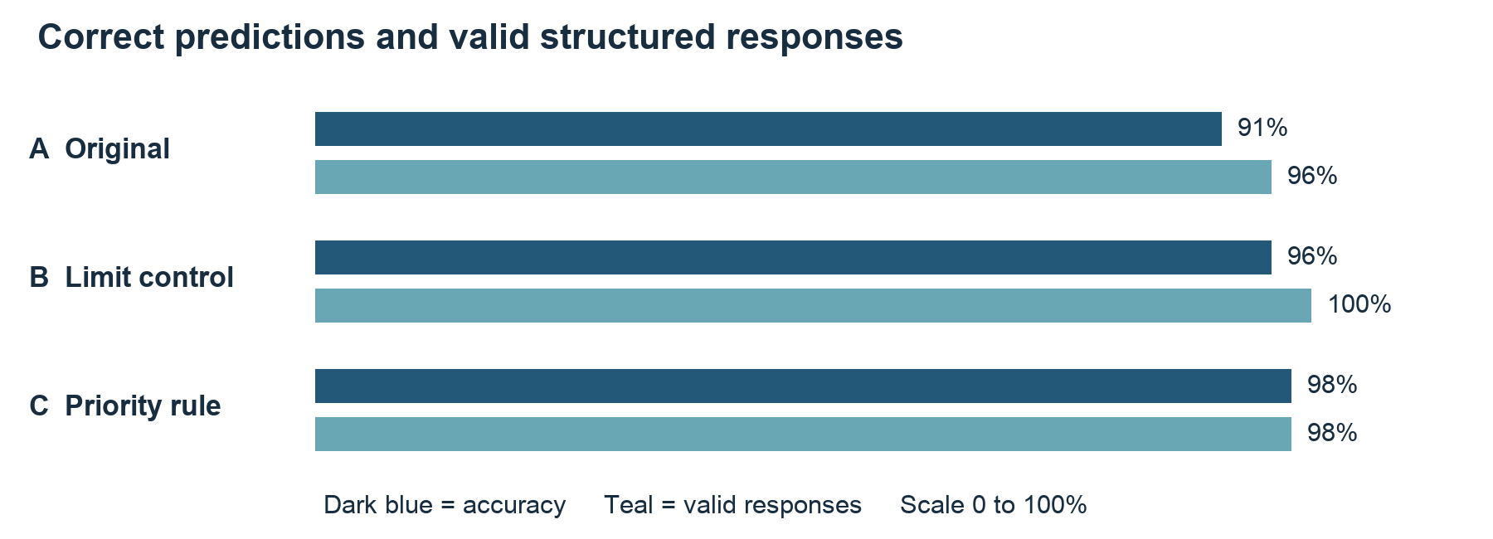
Figure 3. Improved routing accuracy comes with two invalid responses. All attempts remain in the denominator.

Output cap comparison A to B
Five cases were fixed, none regressed, 91 remained correct and four remained wrong. Fixes were t015, t026, t055, t058 and t059. These gains cannot all be attributed to the larger cap: provider failures and generation variability also changed, and t015 used only 570 output tokens in the control.

Prompt comparison B to C
Four fixes: t044–t047. Two regressions: t058 and t083. The other 94 cases remained correct. Accuracy rose 2 percentage points; validity fell 2 points. p95 latency rose about 1.56 seconds and mean estimated cost rose about 7.7%.
The control meets all targets. The improved run meets accuracy, macro F1, latency and cost targets, but fails the 100% validity target. It has no wrong-category valid outputs; the two invalid responses still count as failures.

6 Trace evidence costs and limitations

Representative LangSmith evidence
course-t044 — open saved run in LangSmith
Fixed damaged-product refund routing; product_issue with a valid explanation.
course-t004 — open saved run in LangSmith
Protected non-delivery refund case; refund_request remains correct.
course-t058 — open saved run in LangSmith
Regression on packaging and missing instructions; output limit exhausted.
course-t083 — open saved run in LangSmith
Regression on a shipping-policy question; output limit exhausted.
Both regressions show finish_reason = length, 2,048 output tokens and 2,045 reasoning tokens. Saved evidence includes model-child traces. The links require access to the LangSmith workspace; repository JSON evidence remains available without that access.

Cost accounting
Known project cost, including the five-case pilot, is $0.79069535. Two original HTTP 500 requests returned no usage, so their actual cost remains unknown. The budget guard retains a reserve of $1.315072 for each, giving conservative exposure of $3.42083935 against the approved $5 ceiling. Reserves are not invoiced charges.
The recorded Fireworks price snapshot was $1.25 per million input tokens, $0.15 per million cached input tokens and $4.25 per million output tokens. Reasoning tokens are included in output cost; cached input is a subset, not an additional charge.

Limitations and next experiments
This is a single pass per configuration on a small synthetic dataset used for prompt development. Temperature 0 does not eliminate variability. A held-out set split by seed family and repeated runs would better measure generalization and stability.
Next, investigate reasoning and output-budget behavior without altering the routing rule, then separately test an explicit packaging/manual definition. These are proposed experiments, not completed improvements. No LLM-as-a-Judge, fine-tuning or RAG was added; the optional judge extension was outside the core scope.

7 Submission artifacts and reproduction
Handout deliverable | Submitted evidence
Reviewed spreadsheet | reports/customer_support_evaluation.xlsx: Our Reviewed Labels, Our Results, Our Failure Analysis, Our Paired Results and Our Summary. Original source tabs are preserved.
Solution documentation | This Word document: design, reviewed policy, nine annotations, failure groups, exact prompt edit, results and trace evidence.
Executed notebook | notebooks/customer_support_evaluation.ipynb: saved baseline/control/improved outputs and comparisons.
Demo video | reports/video/customer_support_demo.mp4: approximately five minutes, synthetic narration and burned-in captions. Demonstrates saved evidence.
Tracing evidence | LangSmith experiment and case links plus reports/trace_evidence JSON files.

Submission links
GitHub repository
Completed evaluation workbook
Executed evaluation notebook
Narrated demo video
LangSmith improved experiment
If the portal specifically requires Loom, upload the supplied MP4 and include its hosted URL. The current deliverable is an MP4 in the repository; no Loom URL has been created.

Reproduce the saved analysis
Clone the repository, create a Python environment and install requirements-lock.txt. Open the notebook with all paid-run flags left false, then execute its saved-results analysis. No API keys are needed for offline replay. Run python -m pytest -q for the offline checks. The project records 42 passing tests and a successful fresh-kernel replay.

Attribution and original contribution
Course source: The Gen Academy Customer Support Agent Evaluation, revision ef517b274cf86a2c4fa8ae72fdc89b3dce80f41d. The course tickets and simple baseline definitions are attributed; the implementation, reviewed policy, source reconciliation, budget guard, controlled comparisons and reporting are project work. Supplied example scores are not reported as our results.
Original course project source

