**USER MANUAL GUIDE**

* Introduction
* Set up of Raspberry Pi
* Connecting to database
* Data extraction using HTML

**Introduction:**

Internet of Things(IOT) is a system of computing devices involving embedded electronics, software, sensors, actuators that are connected through a network enabling them to connect and exchange data. The Key component of IoT is the database which holds all the data received from electronic devices and paves way for data exchange. Similarly, this project involves a system of sensors connecting to a database (Firebase) from where the data could be structured and extracted to a web application.

**Main components of the project:**

1. Set up a circuit involving light sensor, motion sensor, Temperature and Humidity sensor, LEDs, Capacitor resistors using Raspberry pi
2. Python programming is used to collect all the data from the sensors and store them in Firebase
3. Finally, HTML is used to structure the recorded data and display it on the web application

**Set up of Raspberry pi:**

**Motion Sensor for input-** A motion sensor is used to detect and record the time motion is detected

IO 23 connects to output, 5V connects to VCC, and GND connects to GND

**Light Sensor for input-** A light sensor is used to detect current ambient light level based on the data range

+ve terminal connects to 3.3 V, IO 4 connects to the node between the light sensor and Capacitor

**Temperature and Humidity sensor for input-** This sensor measures the relative humidity in the air and temperature in the surroundings

VCC connects to 3.3 V, IO 6 connects to output and GND connects to GND

**LED for output-** LED is turned on whenever a motion is detected

IO 24 connects to a resistor and then the LED, finally the LED connects to GND

**Buttons for input-** These buttons simulate real life actions. We have introduced the button to monitor the door status

IO 16 connect to resistors, then to door button and finally back to ground.

The picture below shows the complete setup involving all the sensors (I/0).

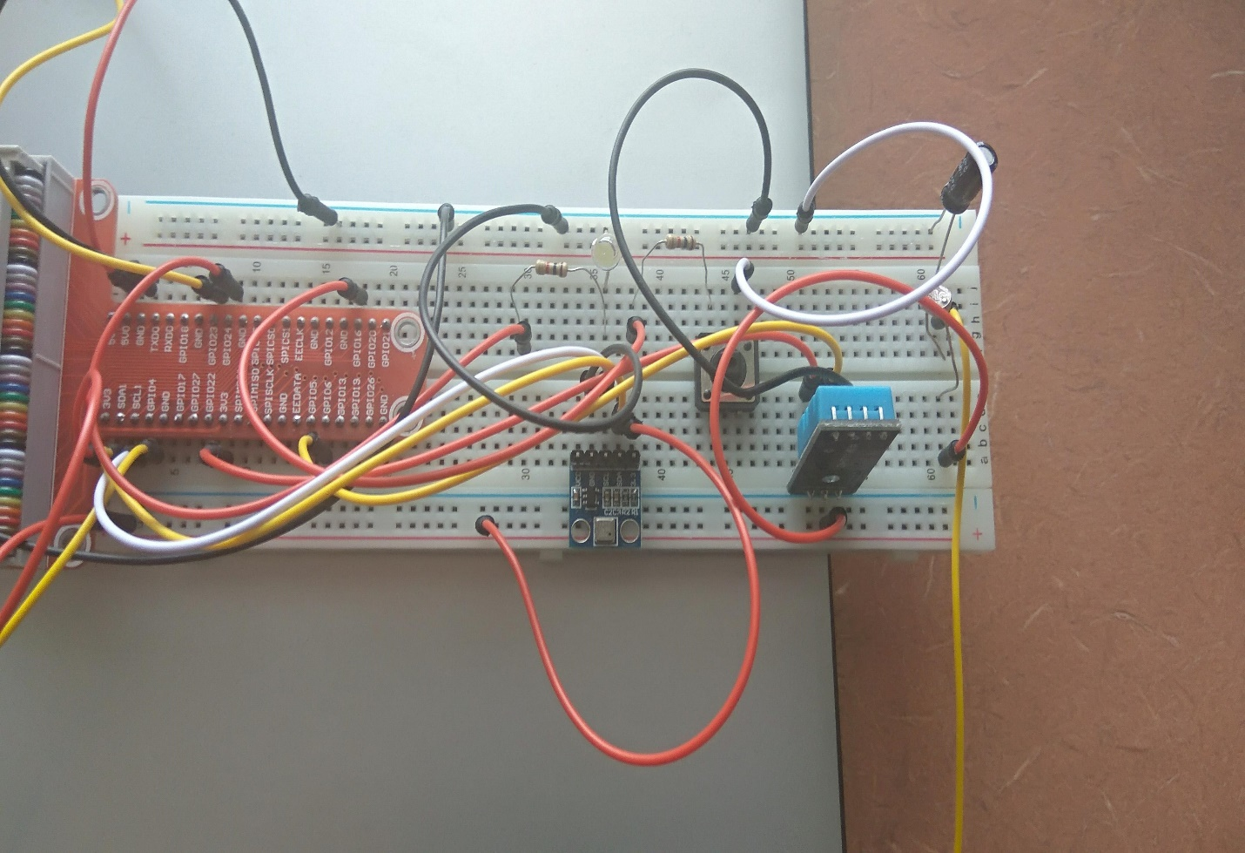

**Connecting to Firebase:**

To verify that our system is connected to Firebase, open the file named “iotfall2017.py” located in the same drop box folder and open Firebase with the given account information. Now, with the circuit set up and Firebase being open, run the python code. To test it, press a button or move your hand in front of motion sensor and make sure that the data and time are recorded on Firebase. The picture below clearly indicates that whenever a sensor detects a value, it stores the data as well as updates the status on Firebase.

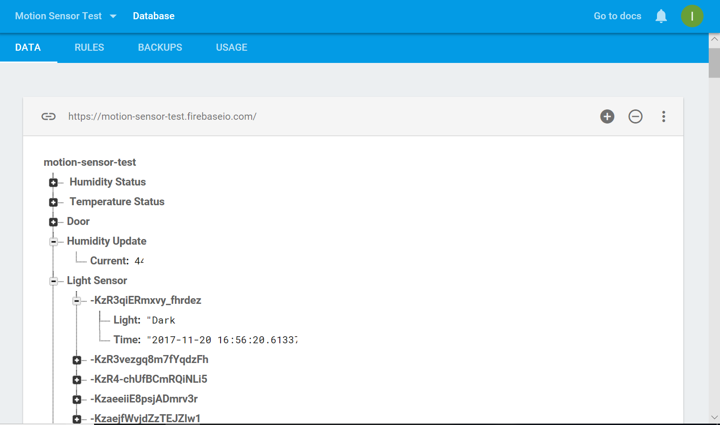

**Data Extraction using HTML:**

A web application has been created using Wix to display the status of all sensors in a user-friendly way. HTML code has been introduced on Wix website to extract all data from database and display it on the website. The data flows in a manner as depicted by the picture below.

**Conclusion:**

With the complete setup, now you can navigate to <https://iotfall2017.wixsite.com/mysite> on a web browser of your choice. You could see the status of all sensors and the status updates itself when the sensors detect a new value. You could also view the sensor history and time detected by clicking on any of the tabs on the left side of webpage. Currently, we have five sensors working in parallel with the temperature, humidity and light sensor updating itself for every 3 minutes, while the other two sensors update when a new value is detected.