# Git

# Version control system is a tool that helps to track changes in code.

* Git is a version control system.

It is: -

1. Popular
2. Free and Open source
3. Fast and scalable

Git helps us to –

1. Track the history / Save version of project
2. Collaborate with others
3. Revert back to previous versions if something goes wrong

# GitHub

* GitHub is a platform that helps developers collaborate, manage code versions, and host projects.
* Basically, it is a website that allows developers to store and manage their code using Git.
* GitHub is a **cloud-based platform** that stores your Git repositories online and helps you:

1. Collaborate with others
2. Review code
3. Manage projects

* <https://github.com/>
* Create a GitHub profile by using this link.
* Create a new repository.
* Click on new button .
* Provide name of repository.

### Follow These Steps:

#### 1. Create a Repository on GitHub

Go to [github.com](https://github.com) ➡️ Click **New Repository** ➡️ Name it: XYZ

✅ Choose **Public**  
✅ Check **Add a README file**  
✅ Click **Create Repository**

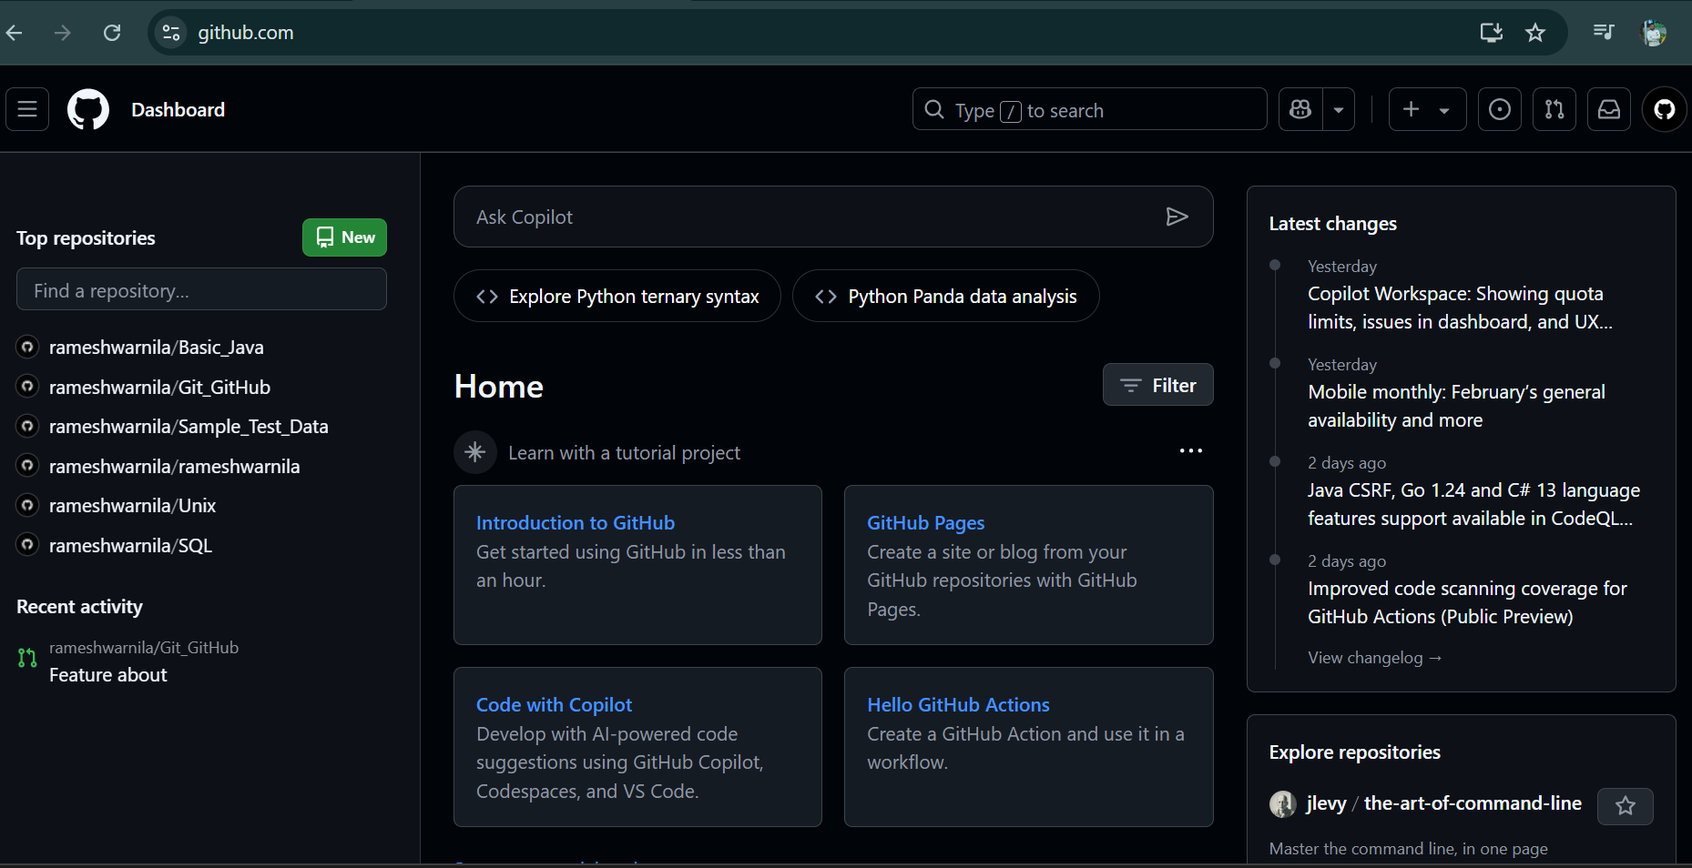

Here's a quick overview of what you can learn:

**1. Basics**

* What is Git vs GitHub?
* How to create a GitHub account
* Setting up Git on your local machine
* Creating repositories
* Cloning repositories

**2. Version Control**

* Git basics (commit, push, pull, merge)
* Branching and merging
* Pull requests (PRs)
* Resolving merge conflicts

**3. Collaboration**

* Forking repositories
* Code reviews
* Issues and bug tracking
* Discussions

**4. Advanced Git**

* Rebasing
* Stashing
* Git tags
* Managing large projects

**5. CI/CD (Continuous Integration/Continuous Deployment)**

* GitHub Actions
* Automated testing

**6. Project Management**

* GitHub Projects (Kanban boards)
* Milestones
* Labels

**7. Security & Access Control**

* Managing collaborators
* Branch protection rules
* Secrets and tokens

**8. Hosting Projects**

* GitHub Pages for static websites

How to create GitHub profile?