Responses to Reviewer Comments for Manuscript ID: je-2018-012328
Histogram-free reweighting with grand canonical Monte Carlo: Post-simulation optimization of non-bonded potentials for phase equilibria
by
Richard A. Messerly, Mohammad Soroush Barhaghi,
Jeffrey J. Potoff, and Michael R. Shirts

Overview
We are grateful for the feedback we received from each reviewer. We are also encouraged that each reviewer feels the manuscript is ready for publication with only minor revisions. We have included a response for each comment. We believe that the review process has strengthened this manuscript and that it is ready to be published. We appreciate your consideration of the revised manuscript for publication in the Journal of Chemical & Engineering Data.

Itemized List of Changes to Manuscript (Page numbers refer to revised manuscript.)
Response to Reviewer 1, Comment 1: pg. 2 (Abstract)
Response to Reviewer 1, Comment 2: pp. 3-4
Response to Reviewer 1, Comment 3: pg. 4
Response to Reviewer 1, Comment 4: pp. 5, 43-44
Response to Reviewer 1, Comment 5: pp. 6-8, S3 (Figure S1)
Response to Reviewer 1, Comment 6: pp. 11, S4 (Table S4)
Response to Reviewer 1, Comment 7: pp. 31, 35
Response to Reviewer 2, Comment 1: pp. 37-38, 40, 42, Figures 8-9 and Figure S2
Response to Reviewer 2, Comment 2: pg. 10
Response to Reviewer 2, Comment 3: No changes
Response to Reviewer 2, Comment 4: pp. 40, S23-S24, S26-S27 (Figures S4-S5 and S7-S8)
Response to Reviewer 2, Comment 5: pg. 11
Response to Reviewer 2, Comment 6: No changes
Response to Reviewer 2, Comment 7: pp. 2, 13, 26
Response to Reviewer 3, Comment 1: No changes
Response to Reviewer 3, Comment 2: pg. 42
Response to Reviewer 3, Comment 3: pg. 44
Response to Reviewer 3, Comment 4: No changes

All additions to the manuscript have been highlighted in red

Michael: Although you are welcome to provide feedback on any comment, I would really appreciate your feedback for the comments marked in green
At Revision:
MANUSCRIPT:
- Abbreviate all journal titles in the References as per CASSI.
- Include the date of access in Reference 49.
- Update the publication information in References 51 and 52 when available.
Response #1
We have abbreviated all journal titles and included the date of access for Reference 50 (previously Reference 49). Unfortunately, the publication information is still not available for References 52 and 53 (previously References 51 and 52).
SUPPORTING INFORMATION:
- Re-label "Table SI.I," "Table SI.II," etc. as "Table S1," "Table S2," etc.
- Re-label "Figure SI.1," "Figure SI.2," etc. as "Figure S1," "Figure S2," etc.
Response #1
We have relabeled the tables and figures accordingly. We also relabeled the page numbers and sections as S1, S2, etc.

Reviewer #1
Recommendation: Publish after minor revisions noted.
General:
This interesting work by Messerly et al. introduces a new computational scheme (GCMC-MBAR) to optimize non-bonded force filed parameters for phase equilibria by reweighting configurations from GCMC simulations rather than histograms (GCMC-HR). This is a follow-up work of the authors’ paper (Ref. 16) in which they applied the same idea to integrate MBAR method with ITIC for predicting vapor-liquid coexistence properties. In this manuscript the authors demonstrate the advantages of GCMC-MBAR over MBAR-ITIC but also point out the existing limitation of the approach and give useful suggestions for the adoption of this method. The key applications of this approach include accurately estimating the prediction of forcefield j using the configurations from GCMC simulations with forcefield i, and optimizing forcefield non-bonded parameters starting from a reference forcefield, which are discussed about in section 3.3 and 3.4 respectively. In general, the authors clearly demonstrate this new and interesting scheme with quite sufficient technical details provided. I suggest publication of this work after the authors address my following comments:

Comment #1
The abstract is too long and much detail is duplicated with the introduction. Please revise and make it concise.
Response #1
As shown below, we have consolidated the first and second paragraphs of the Abstract to reduce the redundancy with the Introduction.
Comment #2 To be reviewed by Michael
On page 4 in the first paragraph the authors write “The proposed GCMC-MBAR method is identical to the traditional GCMC-HR approach except that MBAR reweights configurations rather than histograms.” It is very natural for the readers to concern about the memory burden and computational cost of this approach since a big amount of additional data needs to be saved from the simulation. The authors address this issue by adopting the basis function in the latter part of the manuscript, but it is better to mention it somewhere early in the paper.
Response #2
We agree with the reviewer that some readers might be concerned about the additional memory burden of storing configuration files. Although we discuss later in the manuscript how basis functions can ease this concern, we have modified the sentence on pages 3-4 to help clarify this issue from the outset:
Comment #3
On page 4 in the third paragraph the authors talk about the bad performance of MBAR-ITIC when the changes of 𝜎 and 𝜆 are large. Can you add a short explanation from the cited paper here?
Response #3
Molecular configurations in the liquid phase depend primarily on close-range repulsive interactions (i.e., the size and repulsive exponent parameters). Therefore, two vastly different values of 𝜎 or 𝜆 will sample from very different regions of configurational space, which leads to poor overlap. We have provided the following explanation on page 4:
Comment #4 To be reviewed by Michael
On page 5 in the third paragraph the authors admit that GCMC-MBAR is very similar to HS-GCMC in nature. They are both powerful tools to optimize force field parameters and the authors list several advantages of GCMC-MBAR over HS-GCMC in their opinion. I think this is a very important comparison that the authors need to address more. Does HS-GCMC possess the same capability as GCMC-MBAR and does it suffer from the same problem that GCMC-MBAR has when predicting the liquid phase saturation properties at 𝜃_{𝑟𝑟} ≉ 𝜃_{𝑟𝑒𝑓}? It will be very helpful to see some simulation result comparison in the paper between these two methods.
Response #4
We agree with the reviewer that it is important to compare HS-GCMC with GCMC-MBAR. Although GCMC-MBAR and HS-GCMC have some clear similarities, GCMC-MBAR possesses some significant capabilities that HS-GCMC does not. Most importantly, GCMC-MBAR can predict phase equilibria properties for any force field parameter set ($θ)$, whereas HS-GCMC can only estimate phase equilibria properties for force field parameter sets that are sampled directly. In other words, it is actually not possible to compare their performance for predicting liquid phase saturation properties for $θ_{rr}≠θ_{ref}$ because HS-GCMC is only applicable for $θ_{rr}=θ_{ref}$. To clarify this important difference, we have added this statement to page 5:
Although the objectives of HS-GCMC and GCMC-MBAR are similar, the methods for achieving this objective are actually quite different. HS-GCMC modifies the sampling while GCMC-MBAR modifies the data analysis. Therefore, HS-GCMC and GCMC-MBAR are actually not competing methods. In fact, it is conceivable to combine the two methods into a hybrid HS-GCMC-MBAR approach, where HS is used for sampling and MBAR for post-processing. To clarify this point, we have elaborated the discussion regarding HS-GCMC on pages 43-44:
Furthermore, a rigorous comparison of simulation results for the two methods is unrealistic in the time frame granted for review. We are not aware of any open source Monte Carlo code that includes HS-GCMC. Writing our own HS-GCMC code could require months of testing to ensure reliability. For this reason, we are limited to discussing their algorithmic similarities and differences, rather than performing a benchmark study of their respective efficiencies.
Comment #5
On page 6 in the force fields section, authors mention that the bond stretching potential is neglected for all the force fields. They compared their result with those from Mick et al. but Mick also used fixed bond models. This is not valid justification. Have the authors conducted any tests showing that the bond stretching has no influence on the simulation result or is this reported from literatures in the similar systems? The same question comes to electrostatic interactions. Please show evidence that it is valid to ignore these interactions.
Response #5
The purpose of comparing our results with those of Mick et al. is to validate that GCMC-MBAR and GCMC-HR yield consistent values. Therefore, this comparison would be invalid if we utilized flexible bonds. We have clarified this on pages 6-7:
In addition, we have compared the NERD results reported by Mick et al. (fixed bonds) and Nath et al. (flexible bonds). Note that Nath et al. only reported saturated liquid and vapor densities, so we do not compare vapor pressures or enthalpy of vaporization. In all cases, the fixed and flexible results agree to within the combined uncertainties for liquid density. The agreement for vapor density is not as good, but most compounds agree to within the combined uncertainty. Note that Mick et al. utilized GCMC-HR while Nath et al. used GEMC. Therefore, it is also possible that the different methods, simulation codes, and data analysis are the cause of these subtle deviations in vapor phase properties. This figure has been included on page S3 in Supporting Information:
Electrostatics are not included in the MiPPE, TraPPE, and NERD united-atom force fields for the hydrocarbons examined in this study. Even though a force field for these compounds could be developed which includes electrostatics, such a modification would require a reparameterization of the MiPPE, TraPPE, and NERD Lennard-Jones (Mie) potential. Again, a valid comparison of our GCMC-MBAR results with the GCMC-HR results of Mick et al. and Soroush Barhaghi et al. necessitates that we not modify the underlying force field. Furthermore, Soroush Barhaghi et al. demonstrated that the inclusion of electrostatics in the optimization of the MiPPE parameters for alkynes did not improve the agreement with experimental phase properties. Therefore, it is unlikely that much improvement would be achieved by including electrostatics for the MiPPE cyclohexane parameterization. The following sentence was added on page 8 to clarify this point:
Comment #6
On page 10 in the last paragraph, the authors state that they use CBMC moves to enhance the insertion acceptance rate. It would be nice to show the actual acceptance ratio from sample simulations in the supporting information.
Response #6
We appreciate this suggestion from the reviewer. In accordance, we have provided the following table on page S4 in Supporting Information:
We also reference this table on page 11 in the manuscript:
Comment #7 To be reviewed by Michael
In section 3.3, the authors show the effective snapshot results for GCMC-MBAR and use them to explain the bad performance of the method in predicting liquid phase properties. They also compare with MBAR-ITIC but the comparison is not very clear to me. It would be nice to have some data from MBAR-ITIC listed in the comparison. Also the authors listed two of their hypothesis that GCMC-MBAR would experience better overlap than MBAR-ITIC when 𝜃_{𝑟𝑟} ≉ 𝜃_{𝑟𝑒𝑓}. Are these hypotheses proved to be correct after the comparison? Does GCMC-MBAR still do relatively better even for liquid phase since the two hypothesis the authors raise should hold true for liquid phase?
Response #7
Our results support both of our initial hypotheses.
However, it is actually not possible to include some data from MBAR-ITIC because MBAR-ITIC does not compute K_{eff} at saturated liquid or vapor conditions. Recall that ITIC is a vastly different approach than GCMC for computing phase equilibria. ITIC performs a series of NVT simulations along a supercritical temperature and along compressed liquid isochores. The lowest temperature along the liquid isochore is a “near-saturation” liquid state point though. As such, it is the most important state point for determining the reliability of MBAR-ITIC at predicting the saturated liquid phase, i.e., MBAR-ITIC will be unreliable for $ρ_{liq}^{sat}$ and$U_{liq}^{sat}$ if K_{eff} < 50 at this near-saturated liquid state point. Therefore, the best comparison that can be made with the GCMC-MBAR saturated liquid K_{eff} values are the MBAR-ITIC K_{eff} values at the lowest temperature isochore state point.
For the scenario where 𝜃_{𝑟𝑟} ≉ 𝜃_{𝑟𝑒𝑓}, i.e., TraPPE -> MiPPE ($λ_{ref}=12$ and $λ_{rr}=16)$ Messerly et al. reported for MBAR-ITIC that $K_{eff}≈1$ at this near-saturated liquid state point. In other words, only a single configuration contributes to the MBAR estimate because there is essentially no overlap between the two force fields. By contrast, $K_{eff}>1$ for the saturated liquid with GCMC-MBAR. Therefore, Figures 5 and 7 do support our initial hypothesis that GCMC-MBAR will experience better overlap for the saturated liquid compared to MBAR-ITIC..
Furthermore, although the GCMC-MBAR saturated liquid $K_{eff}$ values are still typically less than 50 for TraPPE -> MiPPE, the phase equilibria estimates are significantly more reliable than those obtained with MBAR-ITIC with similar $K_{eff}$ values. This supports our second hypothesis that, in contrast to MBAR-ITIC, GCMC-MBAR does not fail catastrophically in the case of poor overlap ($K_{eff}<50)$.
We added the following statements to emphasize the improvement of GCMC-MBAR relative to MBAR-ITIC.

Page 31:
Page 35:
Page 35:

Reviewer #2
Recommendation: Publish after minor revisions noted.
General:
The manuscript concerns molecular simulations of phase equilibria and optimization of force field parameters. The authors apply MBAR to GCMC simulations for calculating phase equilibria and use the property of MBAR that reweighting can be conducted for intensive state variables (T and chemical potentials) as well as for Hamiltonian parameters (theta), on equal ground. This strong-point of MBAR is used for optimization of force field parameters.
This study is an important contribution to the field and should be published after some minor revision, as detailed below. Very fine work, indeed.
Comment #1
section 3.4: this case study ignores a paper where a Mie force field (also lamda=16) was earlier proposed for cyclohexane, with (I guess) essentially the same results. Differences should appear only because the objective function is slightly different here. The conclusion of this work is that the here proposed force field is „the most accurate“. Omitting the previous study is (at least) awkward, because the authors seem to be aware of the line of developments from these authors, as the reference list shows. Is there a reason for omitting the study mentioned above from the list of „most reliable force fields from literature. Ref 22,24,27,55,56,57“ ?
Response #1
We sincerely apologize for this omission. Despite our great familiarity with the TAMie series of publications, we failed to consider the TAMie Mie parameters for cyclohexane.
In fact, the newly optimized MiPPE parameters for cyclohexane agree very closely with the TAMie parameters. As the TAMie parameters were never considered prior to this reviewer’s comment, the good agreement between the MiPPE and TAMie parameters provides supporting evidence that our GCMC-MBAR optimization scheme is both reliable and efficient, i.e., we convert from the TraPPE to near-TAMie parameters in one to two iterations.

To better represent the literature, we now depict the TAMie parameters in Figure 8:
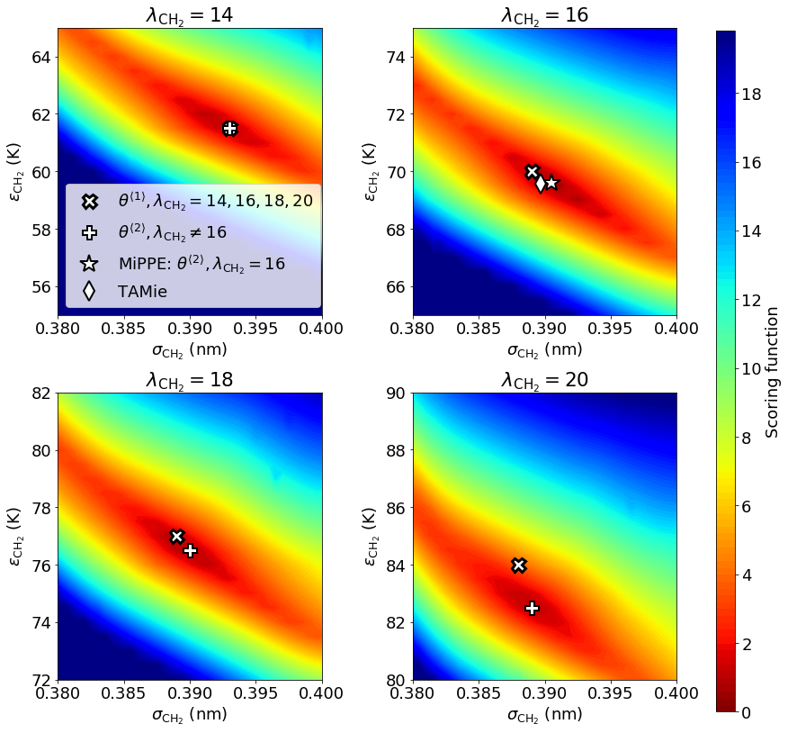
And refer the reader to this addition on page 37:
We also added the following statements to discuss the close agreement between MiPPE and TAMie.

Page 38:
Page 42:

We now include the reported TAMie values (Weidler et al., grey circles) in Figure 9:
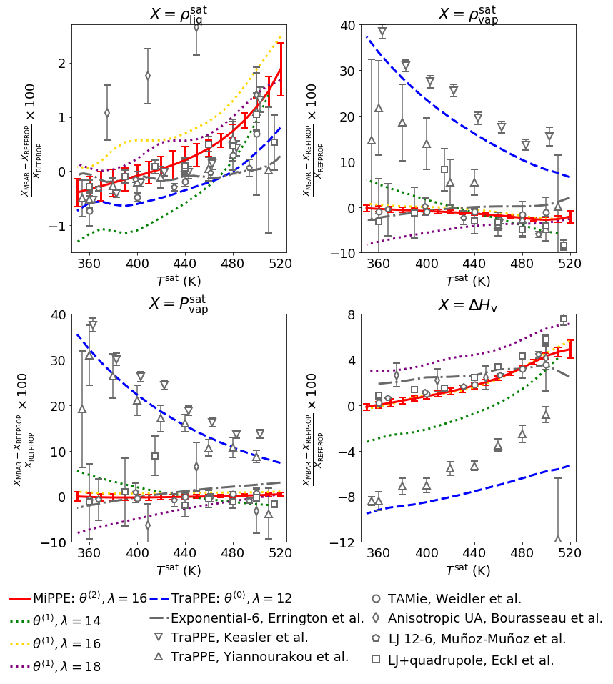

And in Figure S2 of Supporting Information:
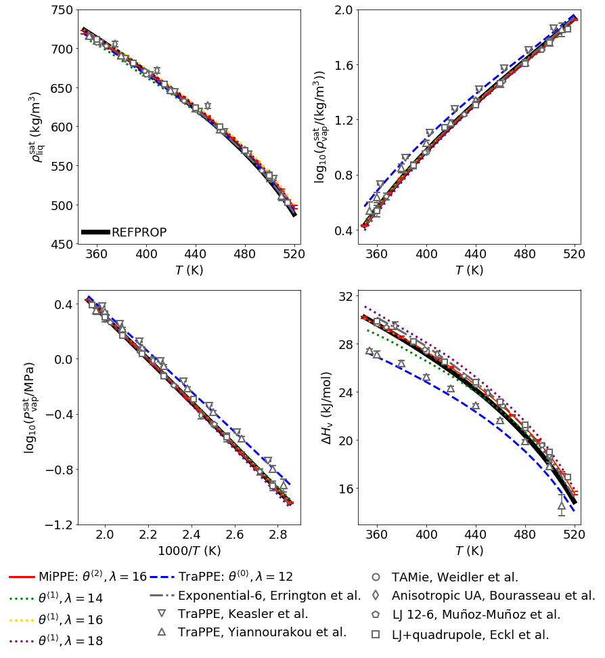
We also refer the reader to the supporting information for a detailed comparison of MiPPE and TAMie (see comment #4) on page 40:
Comment #2
page 9 reads: „The system volume is constant with respect to mu and T for a given compound“. This statement is confusing. Things would be clear if the statement simply read: „The system volume is constant for a given compound“. Do the authors combine simulations for several volumes (for various (mu,T)-conditions)?? It would be unclear to me how this is realized technically (and would thus require clear explanations). And it would be questionable conceptually, because finite size scaling effects would be obscured.
Response #2
To improve clarity, we have modified this sentence on page 10 as suggested:
Comment #3 To be reviewed by Michael
comment about equation 13: I am glad that the sign of the mu*N term is now corrected to be negative. I assumed the positive sign to be a misprint in the first MBAR paper. But when the wrong positive sign reappeared in subsequent publications I started to have doubt about whether some intricacy existed about the sign.
Response #3
The reviewer is right that the negative sign found in equation 13 is correct. An upcoming review of MBAR will help clarify the sign error found in previous MBAR publications.
Comment #4
Eq. 17: internal energies for vapor phases are suffering strong finite size scaling effects in GCMC simulations with low number / vanishing number of molecules. Among all quantities considered in this work, it is probably the least size-robust quantity. The enthalpy of vaporization determined from eq. 17 therefore suffers from substantial finite size effects. Robust values for enthalpies of vaporization that more closely resemble infinite size systems are determined from the Clausius-Clapeyron equation (as stated by Weidler and Gross, 2016, see above). The derivative dln(p_sat)/d(beta) is a native quantity in the spirit of histogram reweighing.
Response #4
Although we agree with the reviewer that it is important to consider the impact of finite-size effects, we have verified that finite-size effects are negligible for $ΔH_{v}$ at low temperatures. This validation was performed by repeating the analysis for 20 replicate simulations with a larger box size (3.5 nm box length instead of 3.0 nm). This box size (volume of 42.875 nm³) is consistent with that utilized by Weidler and Gross.
The results suggest that finite-size effects are only statistically significant for $ΔH_{v}$ (and $ρ_{vap}^{sat}$) near the critical point. However, this deviation of 1% to 2% near the critical point is unrelated to the reason presented by the reviewer, i.e., a vapor phase suffering from low number / vanishing number of molecules. The behavior near the critical point is well-known and not a consequence of Eq 17 or the data analysis. The following paragraph has been added to page 40 to discuss the finite-size test:
The corresponding figures found on pages S26 and S27 of Supporting Information are also presented below:
In addition, because Sections 3.1, 3.2, and 3.3 compare GCMC-MBAR results with GCMC-HR results from the previous publications of Mick et al. and Soroush Barhaghi et al., it is important that we utilize the same approach for estimating $ΔH_{v}$, namely, Eq 17. Although we could utilize the $\frac{dln\left(p_{sat}\right)}{dβ}$ in our cyclohexane optimization, we are concerned that utilizing two different methods would create confusion and would be inconsistent with how MiPPE was parameterized in previous studies.
More importantly, we have computed the cyclohexane phase equilibria for the TAMie force field (labeled “TAMie, This work” in the figures below). The close agreement between our TAMie $ΔH_{v}$ values (obtained with Eq 17) and those reported by Weidler et al. (computed with $\frac{dln\left(p_{sat}\right)}{dβ}$) suggests that these two methods are consistent. We also include the MiPPE results to demonstrate that the MiPPE and TAMie predictions are statistically indistinguishable for most properties and temperatures (recall Comment #1). These figures have been added to the Supporting Information on pages S23 and S24:
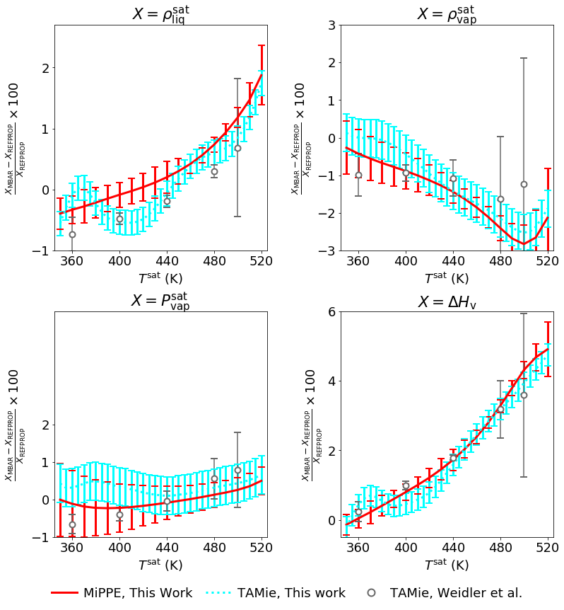
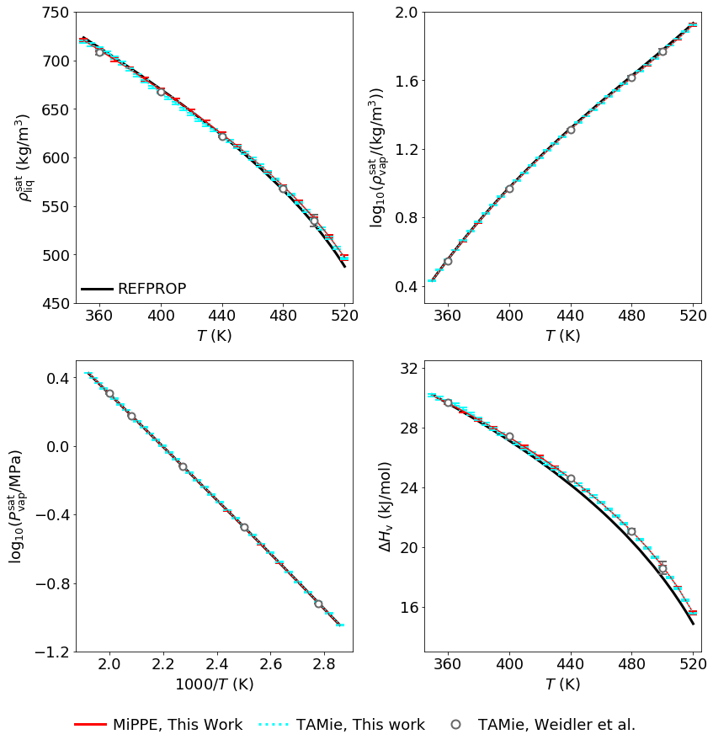
Comment #5
page 10: the authors speak about molecule swap moves. What is meant, I guess, is insertion and deletion moves. However, „swap moves“ for most readers will suggest identity swap moves often performed for efficiently sampling the N-space of mixtures. I suggest modifying the terminology.
Response #5
We have replaced the term “swap moves” with “insertion and deletion moves.” The text on page 11 now reads:
Comment #6 To be reviewed by Michael
why is the pressure defined along a slope extrapolation? In HR-GCMC it is simply determined from the probability density function at N=0, where it the value relates to the grand canonical partition function.
Response #6
The reviewer is correct that some studies (e.g., Weidler et al.) determine the ideal gas limit by computing the probability density at N=0. However, we are utilizing the same method as Mick et al. and Soroush Barhaghi et al. to allow for a consistent comparison with these previous publications. Both methods are equally valid. In our experience, the difference between the pressures computed with these two methods is negligible. For these reasons, no changes were made to the manuscript.
Comment #7
Writing:
page 2: it is more appropriate to speak of „large number of simulations“ instead of „large amount of simulations“. Two appearances. (I think - I am not a native speaker).
Response
Despite the reviewer admitting that (s)he is not a native English speaker, we agree with the reviewer’s grammatical correction. We have removed both instances of “large amount of simulations.”
page 13, bottom: I propose to clarify that K_snaps,i denotes the number of uncorrelated configuration samples of simulation i.
Response
We have added “uncorrelated configuration” to the description of K_{snaps},i on page 13:
Eq. 23: The explanation for the derivative terms (Eq.25) is given at the end of the section (page 23). I would think many readers would appreciate the explanation be moved forward to eq. 25.
Response
We agree with the reviewer’s assessment. However, when we tried to move Eq 25 and/or the explanation of derivatives closer to Eq 23, the discussion of weights is then out of place as it precedes the paragraph where the weights are explained. We think that the current ordering is clearer and, therefore, we did not modify the manuscript.
page 26: Weigler should read Weidler.
Response
We appreciate the reviewer’s attention to detail. This typo has been corrected.

Reviewer #3
Recommendation: Publish after minor revisions noted.
General:
The authors have demonstrated use of histogram-free reweighting for optimizing the van der Waals component of the non-bonded interactions for the simulation of vapor--liquid phase equilibria. This is very good work, and the paper is clearly written. I recommend publication of this work subject to minor revisions. The authors may want to consider the following points:
Comment #1
In figure 2, the authors perform small local variations to identify a slightly shifted local minima for the different molecules. Have the authors considered performing larger variations in the scaling factor for the well-depth to check if there is an even lower minima in the scoring (error) function? It may be useful to also show the sensitivity of these plots to reasonable variations in the scoring function. (Let's say vary the distribution of weights between liquid density and vapor pressure by about 10%).
Response #1
We appreciate the reviewer’s suggestion. Figure 2 presents results from a 1-D optimization of a highly pre-tuned force field. Consistent with the results of Weidler et al., the magnitude of the scaling parameter $\left(ψ\right)$ is approximately unity. We have also explored a wider range of $ψ$ values, but the errors grow monotonically for $ψ>1$ and $ψ<1$. Figures 6 and 8 also demonstrate that, over a wide range of $ϵ$ values, a unique optimal value of $ϵ$ exists for a given $σ$ value. Therefore, we already have strong evidence that we have obtained the global optimal $ψ$ values.
To provide a fair assessment of the transferability of the original MiPPE parameter set, the scoring function (and the underlying experimental dataset) must be consistent between the MiPPE and the individualized MiPPE (iMiPPE). Varying the weights in the scoring function would inevitably impact the optimal scaling parameter value and, therefore, most compounds would result in $ψ≠1$. This would unfairly characterize the MiPPE parameters as being non-transferable.
For these reasons, no changes were made to the manuscript.
Comment #2 To be reviewed by Michael
The authors present a very clear example of cyclohexane to demonstrate the utility of this approach in parametrizing new force fields. Can the authors comment on the complexity of the optimization
process when more than two parameters need to be optimized (for example, a molecule comprising of more than one type of interaction site)? Further, while this may be beyond the scope of this work, it may be
useful to comment on the ease/difficulty of using this approach when vapor--liquid equilibria of mixtures are considered as part of the scoring function.
Response #2
We agree with the reviewer that it would be beneficial to discuss how to perform the optimization for a compound with more than one united-atom site. The primary reason we performed a single-site optimization is that the 2-D heat maps are easy to visualize. For a higher dimensional optimization, a grid search based scheme would likely no longer be feasible. Instead, a derivative-free approach, such as a genetic algorithm, would be preferred. Furthermore, if employing basis functions, additional basis functions would need to be computed for each of the $ii, jj,$and $ij$ pair interactions. To assist future application of this approach, the following paragraph has been added to page 42:
We agree with the reviewer that including mixtures in the scoring function is both of interest but also outside of the scope of the present work. We do not wish to address this topic as it merits an entire paper for an adequate discussion.
Comment #3 To be reviewed by Michael
For polar molecules, do the authors anticipate that the GCMC-MBAR approach will be capable of parametrizing the electrostatic charges with a similar efficiency as it can be done for the non-polar interactions?
Response #3
GCMC-MBAR is applicable to parameterizing electrostatics. In general, with sufficient overlap (high number of effective snapshots), MBAR will provide accurate estimates regardless of the parameter type. However, we would only be able to speculate as to the size of the reliability region for electrostatic parameters, e.g., the point charge parameter (q). The following paragraph has been added to the discussion section on page 44:
Comment #4
Typographical corrections:
Page 4, line 3: "scheme"
Page 15, line 20: "probably"
Response #4
The word on page 4, line 3 is actually “schema.” Definition – a representation of a plan or theory in the form of an outline or model
The word on page 15, line 20 is actually “provably.” Definition – in a way that is capable of being proved.
No changes were made.

