Responses to Reviewer Comments for Manuscript ID:   FPE-D-19-00218

**Mie 16-6 force field predicts viscosity with faster-than-exponential pressure dependence for 2,2,4-trimethylhexane**

by

Richard A. Messerly, Michelle C. Anderson, S. Mostafa Razavi, and J. Richard Elliott

# **Overview**

We are grateful that both reviewers found this manuscript to be of high quality and to merit publication in *Fluid Phase Equilibria*. We have included a response for each of the reviewer comments. We believe that the review process has strengthened this manuscript and that it is ready for publication in the *Special Issue of Fluid Phase Equilibria 10th IFPSC*.

Reviewer #1: I think the authors have done a really thorough and complete investigation as part of the 10th Industrial Fluid Properties Simulation Challenge.  It seems to me that the authors have addressed all reasonable questions and have done thoroughly.  Therefore I would be happy to see the manuscript published as it is.  
  
**Author response:** We are greatly appreciative that Reviewer #1 finds this manuscript to be thorough and without need for any major or minor modifications.   
  
Reviewer #2: This article, which is a contribution to the 10th IFPS Challenge, deals with the predictive capabilities of the MiPPE empirical force field when applied to deal with viscosity of fluids under high pressures. The paper is well written, relatively clear and the results are sensible. The work has been achieved with great care and all technical details are provided. The only drawback may be the choice of the force field which seems to be inadequate for the system studied here.

However, before publication, I have some minor comments to be addressed.

**Author response:** We appreciate that Reviewer #2 also finds this manuscript to be well written, of high quality, and only in need of minor modifications.

We share the reviewer’s concern that the MiPPE force field is somewhat inadequate for the system studied, at least at the highest pressures. However, the deficiency in the force field was unknown *a priori*. In fact, our previous study (Messerly et al., Fluid Phase Equilibria VSI: Molecular Simulation, 483, 101-115, 2018) suggested that MiPPE was the most reliable united-atom force field for predicting the viscosity – pressure trend of similar compounds over a wide range of pressures. Furthermore, MiPPE behaved remarkably well towards pressures of 600 MPa, outperforming all other united-atom models that competed in the challenge.

1)      It is not clear to me why the authors focus only on the torsional potential (+ non-bonded potential) to investigate the parameters uncertainty. Even if the work of Carlos Nieto-Draghi et al. was convincing regarding the impact of such internal degree of freedom on viscosity, I guess that harmonic angular potential affects much more viscosity while having a negligible effect on thermodynamics properties (see Galliero, Chem Eng Res Des, 92, 2014 for example).

**Author response:** It is true that the angular potential likely impacts viscosity to a similar extent as the torsional potential, and bond lengths for that matter. The main reason we investigated the uncertainty in the torsional potential was because the work of Nieto-Draghi demonstrated that moderate changes in the torsional potential can lead to large changes in viscosity. We decided to investigate the uncertainty in the non-bonded potential as a follow-up to one of our previous publications (Messerly et al. Journal of Chemical Physics, 149 (11) 114109, 2018). We were surprised that, in the end, the uncertainty of both the torsional and non-bonded potentials were negligible compared to numerical uncertainties.

We could have continued our uncertainty investigation by considering angular parameters but we were limited by the time constraint imposed by the challenge. The uncertainties in bond lengths could also be an important consideration, but is challenging due to the correlation between bond lengths and non-bonded parameters. We have included the following statement on page 25 to recommend future work look into these additional sources of uncertainty, particularly for the angular potential:

It is important to note that, although Galliero (reference [44]) demonstrated a large dependence of viscosity on the harmonic angular force constant, the range considered (k = 0 to 20) is much larger than we would consider with our uncertainty analysis (typically 10-50% of the literature value). We would expect the uncertainties in equilibrium bond angles to also be no more than a few degrees. Galliero uses an equilibrium bond angle of 180 degrees, which is significantly different than those of the MiPPE force field. Therefore, it is not readily obvious if the observations of Galliero apply to our model.

2)      It would have been interesting to look at the viscosity data through the thermodynamics scaling approach (e.g. Fragiadakis et al., J. Chem. Phys. 134, 2011), in particular to estimate the gamma parameter which is quite simply related to the effective repulsive exponent (e.g. Delage-Santacreu et al., J. Chem. Phys. 142, 2016). This may be a way to better quantify the weakness of the 16-6 Mie potential (by looking on the gamma value) to deal with high pressures systems from a viscosity point of view.

**Author response:** According to Fragiadakis et al., the gamma parameter is obtained by “plotting a dynamic property variable [viscosity] versus $TV^{γ}$, with $γ$ adjusted to collapse the data onto a master curve.” However, because we have viscosity data at only a single temperature, it is not possible to determine a unique value of $γ$ that collapses the data, i.e., for a single temperature any value of $γ$ will yield a single curve (see figure below).

As an estimate for gamma, we employed the empirical equation provided by Delage-Santacreu (Eq. 8) which yields a gamma value around 6.435 for n = 16. Note that this relationship between n and gamma was intended simply for the Mie monomer, not a complex structure such as the challenge compound. Notwithstanding this concern, we compare the Delage-Santacreu gamma value with gamma = 6.4 and 6.5 in the figure below. Each value of gamma shows a reasonable trend where a strong non-linearity results around P = 500. This non-linearity, however, is consistent with the trends presented in Figure 1 of Fragiadakis et al. and Figure 3 of Delage-Santacreu et al. Therefore, performing this thermodynamic scaling analysis does not seem to provide any additional evidence for deficiency in the Mie 16-6 potential. Perhaps this would be more beneficial if simulations were performed over a range of temperatures. However, this is outside of the scope of the challenge.

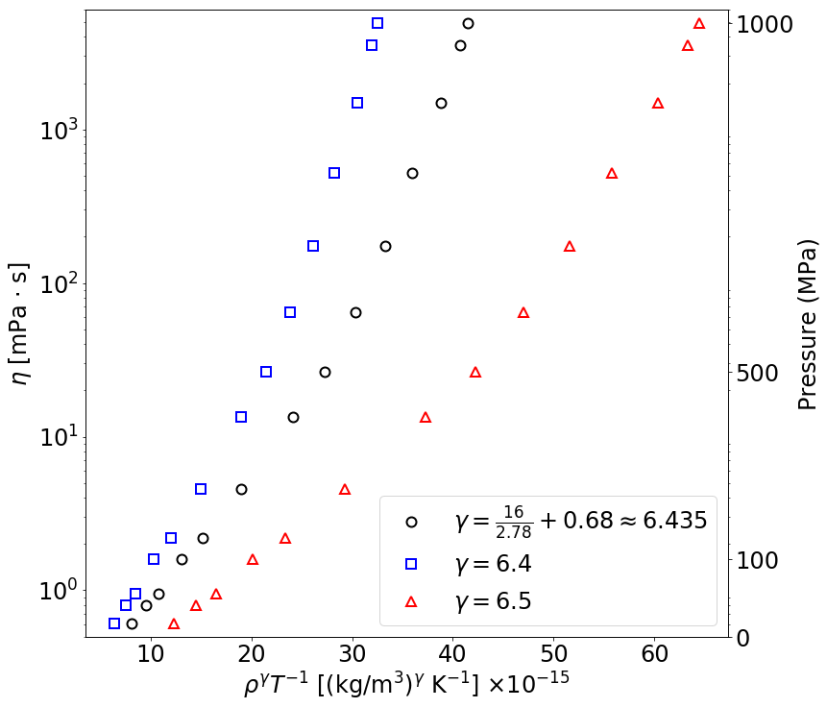

3)      Page 12: The use of NEMD scheme to deal with viscous system was mainly guided by its ability to study rheology (in particular shear thinning) which is not possible using EMD. It was not "preferred" ... And the extrapolation to a zero shear rate (Newtonian plateau) is not always a simple task to achieve …

**Author response:** The reviewer is correct that one of the key advantages of NEMD is the ability to model shear thinning. We also agree with the reviewer that the extrapolation to the zero shear rate can be challenging, although NEMD and EMD should (when applied properly) yield consistent viscosity estimates in the zero shear rate limit.

While NEMD may not be “preferred” due to the added complexity and uncertainty, NEMD does seem to be more common than EMD for predicting highly viscous systems. In fact, the top two finishers in the IFPSC10 challenge utilized the NEMD method.

The statement in question was mainly intended to highlight that NEMD is a common approach in the literature for high viscosity systems, but we utilize EMD as in our previous study to demonstrate its applicability. We have modified the paragraph on page 12 to better convey this intent:

4)      Pages 12-13: I was wondering if the minimum image criteria (including the "molecule size", i.e. its end to end vector) was fully respected at the highest pressure.

**Author response:** The box size does not change much even at the highest pressures (the difference in box length is approximately 10% from 0.1 MPa to 1000 MPa). Also, because the challenge compound is relatively small, there were no issues with minimum image criteria.

5)      Page 24-25: The so-called time-temperature superposition method is an interesting option, widely employed in the polymer community. However, the shift factor is not easy to quantify and such procedure is usually only qualitative and so not applicable to get accurate estimate like that obtained in this work.

**Author response:** The reviewer makes a valid point that determining the shift factor is challenging, and one of the major drawbacks of the time-temperature superposition (TTS) method. Some recent studies seem to suggest, however, that TTS can yield semi-quantitative results (e.g., References [45-46]) and even one competitor in the challenge attempted to use TTS. But we do not wish to elaborate on the pros and cons of this alternative approach as this might lead to unnecessary debate.