RXREVEAL
Predict. Flag. Protect.
Project Proposal

1. Executive Summary
RxReveal is a machine learning system designed to predict the risk of harmful drug-drug interactions before they reach a patient. The project focuses on pairwise interactions — two drugs taken together — using the chemical structure of each drug and known biological interaction data to estimate an interaction risk score and likely side effects, even for drug pairs that have never been formally studied together.

2. Problem Statement
Patients on multiple medications are routinely exposed to interaction risks that clinical trials never tested for, since most trials evaluate drugs individually or in small pre-approved combinations. This gap creates several recurring problems:
- Untested Combinations: Millions of possible drug pairings exist, but only a small fraction have been clinically studied for interaction effects, leaving prescribers to rely on incomplete information.
- Static Reference Tools: Existing interaction checkers are largely rule-based lookups of previously documented cases. They cannot assess a pair that has no prior recorded interaction, even when the underlying chemistry suggests risk.
- Delayed Detection: Dangerous interactions are often identified only after a patient experiences an adverse reaction, rather than being flagged proactively at the point of prescription.
- Limited Explainability: When existing tools do flag a risk, they rarely explain which biological mechanism is responsible, making it harder for a prescriber to judge severity or relevance.

3. Proposed Solution
RxReveal addresses these problems through a focused, two-part prediction pipeline:

3.1 Molecular Structure Encoding
Feature Each drug is converted from its chemical notation (SMILES) into a molecular graph, where atoms are nodes and chemical bonds are edges. A Graph Neural Network (GNN) processes this graph to learn structural patterns associated with biological activity.
Benefit The model can reason about a drug's chemistry directly, rather than depending only on prior documented cases — allowing it to make informed predictions even for drug pairs with no interaction history.

3.2 Pairwise Interaction Prediction
Feature The structural encodings of two drugs are combined in a fusion layer, which outputs an overall interaction risk score along with probabilities for a fixed set of common side effects (e.g., dizziness, nausea, bleeding risk).
Benefit Prescribers or researchers get a single, interpretable risk estimate for a specific drug pair, rather than having to manually cross-reference multiple fragmented sources.

3.3 Baseline Comparison
Feature A simpler baseline model (logistic regression or random forest) trained on standard molecular descriptors is built alongside the GNN model.
Benefit Provides a clear, measurable basis for demonstrating that the graph-based approach adds real predictive value over conventional methods, rather than assuming it does.

3.4 Explainability
Feature Attention weights from the model are used to highlight which substructures of each drug contributed most strongly to a given prediction.
Benefit Gives an early, human-readable indication of why a pair was flagged, supporting trust in the model's output even in a research setting.

3.5 Data Scope & Honesty Constraint
RxReveal is intentionally limited to pairwise (two-drug) prediction. Multi-drug (three or more) interaction prediction is excluded from this project's core deliverable, since public datasets provide very limited labelled data for higher-order combinations. Extending to multi-drug prediction is noted as future work rather than claimed as a current capability, to keep validation honest and defensible.

4. Technology Stack
Layer | Technology | Notes
Data Processing | Pandas, RDKit | Parses SMILES strings into molecular graphs
Model Development | PyTorch, PyTorch Geometric | Graph Neural Network for structure encoding
Baseline Model | scikit-learn | Logistic regression / random forest comparison
Training Data | DrugBank, SIDER | Public drug structures and documented side effects
Visualisation | Matplotlib / Plotly | Performance metrics and attention-weight plots
Demo Interface | FastAPI + simple web front-end | Lets a user input two drugs and view predicted risk

5. System Architecture
The diagram below illustrates how the pipeline moves from raw drug data to a final risk prediction.
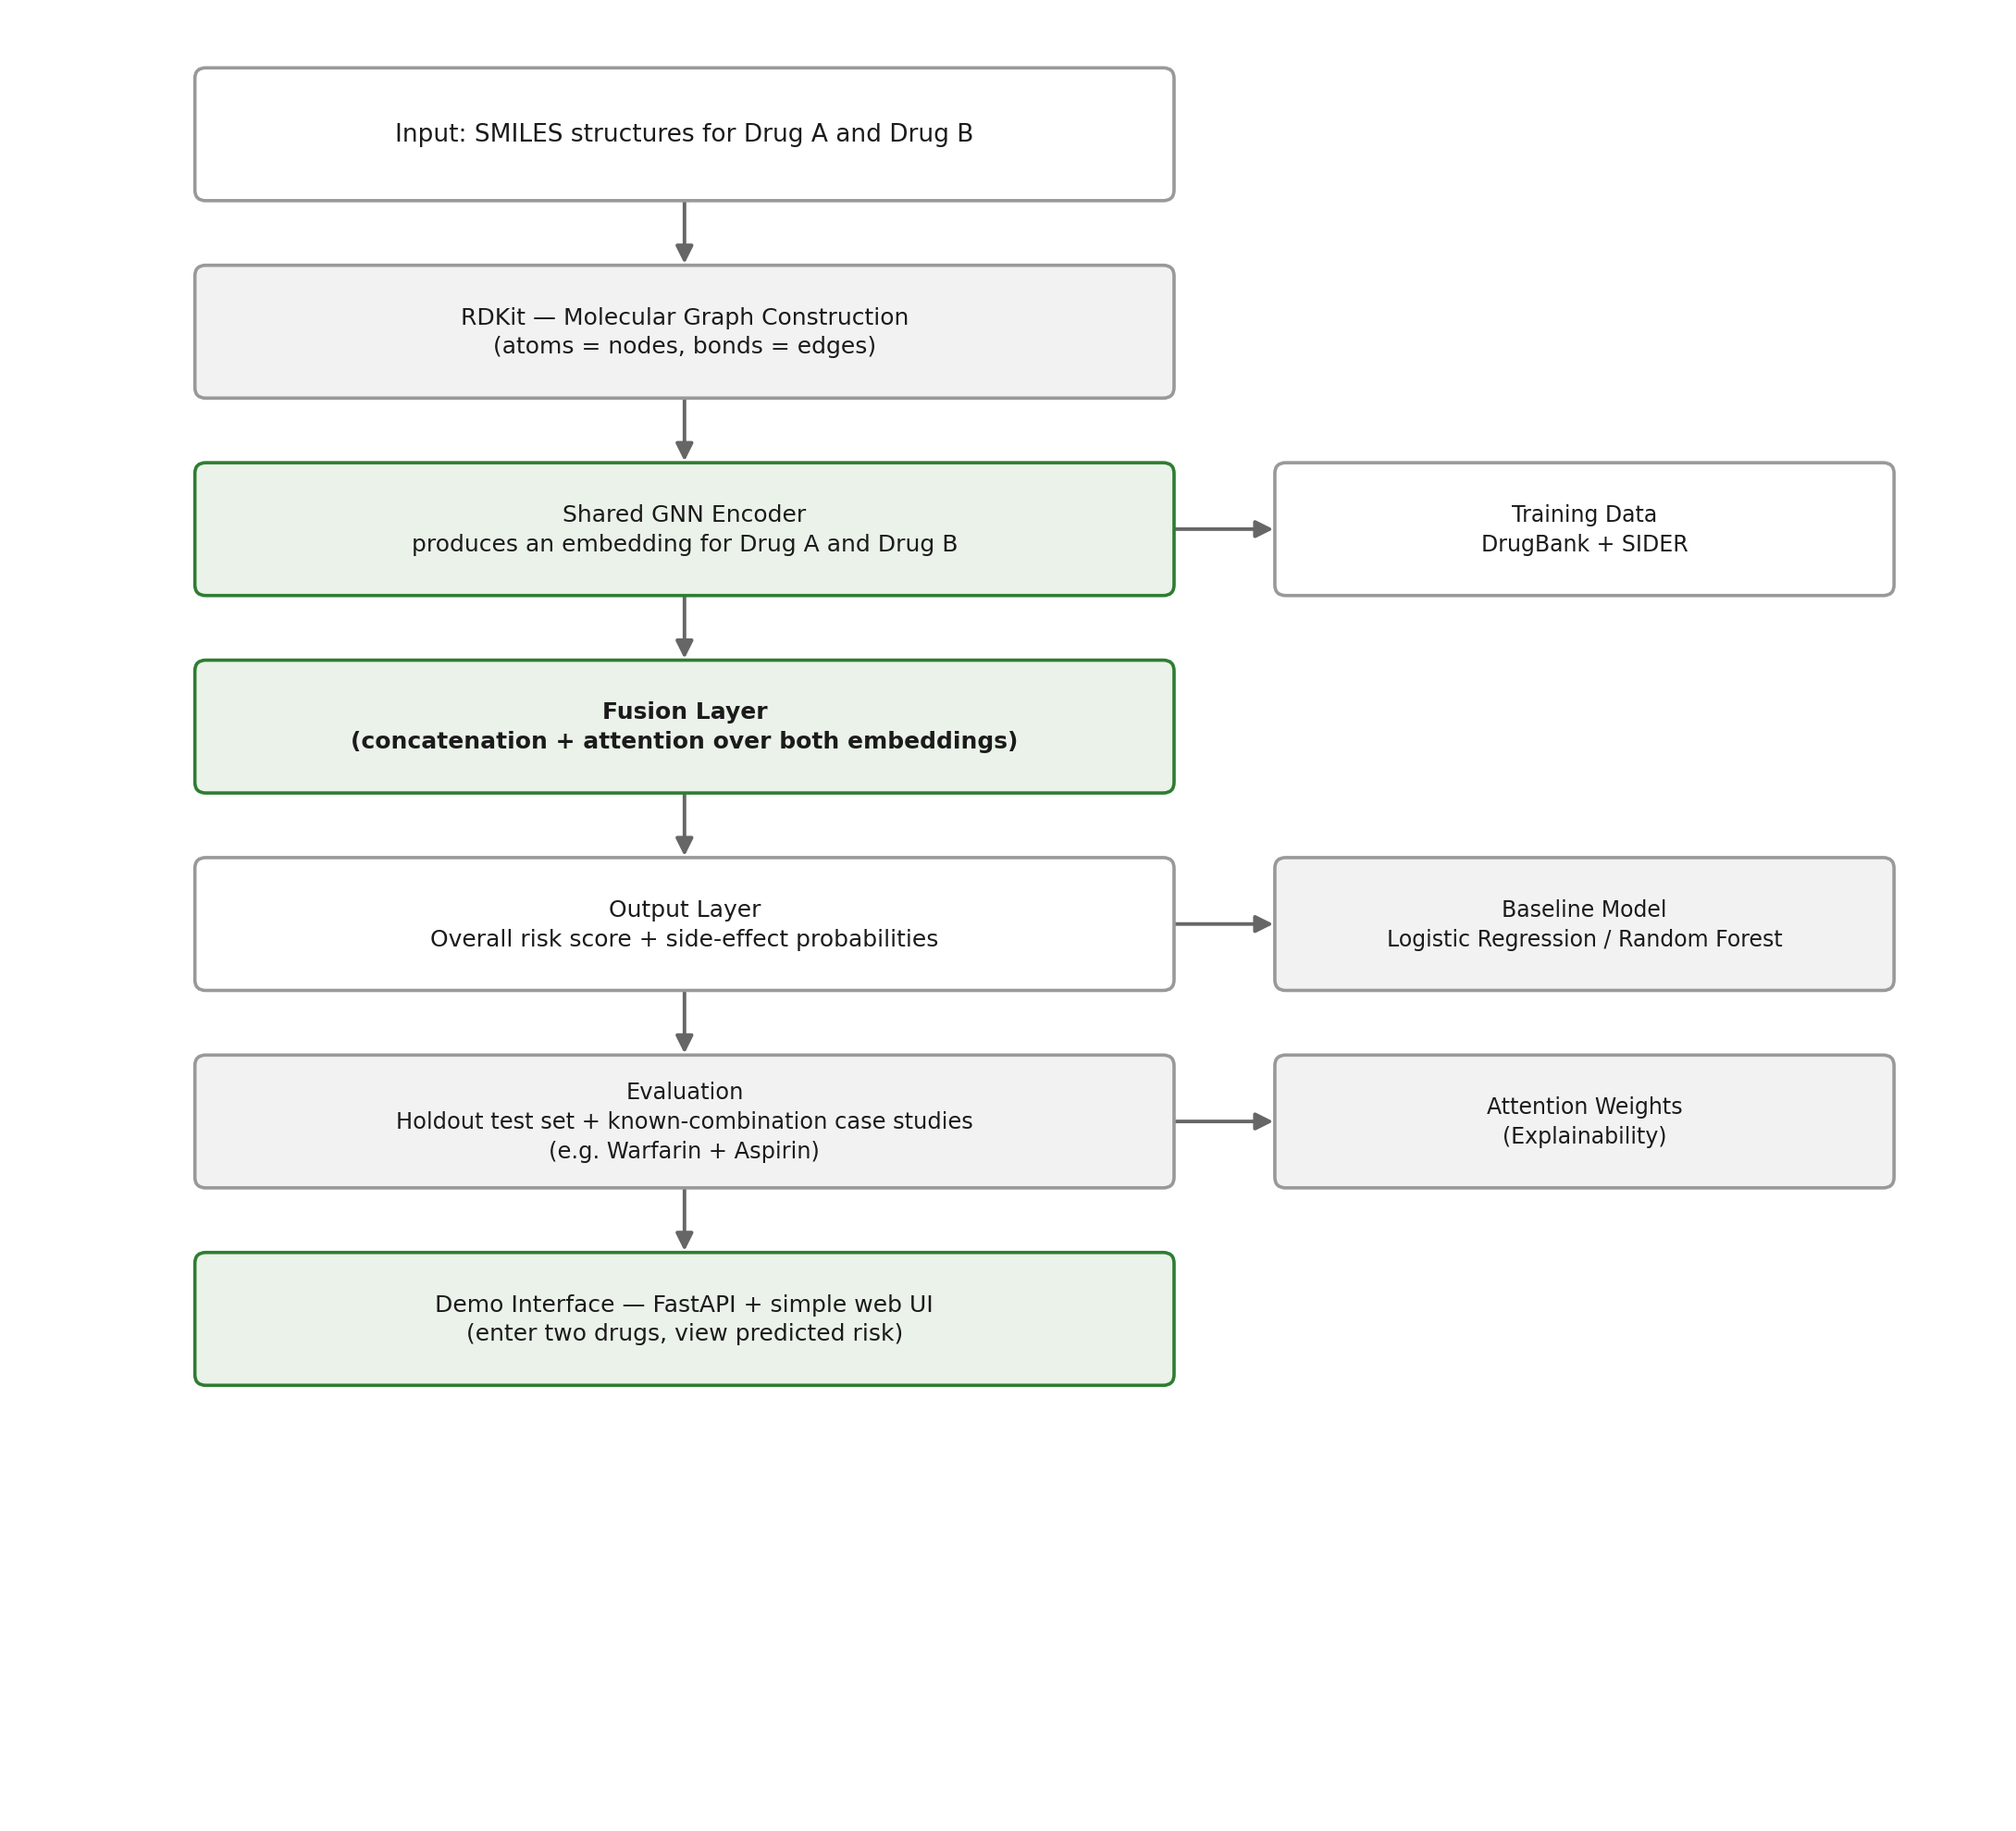
Drug A and Drug B are each converted into a molecular graph via RDKit, then passed through the same GNN encoder to produce fixed-length embeddings. These embeddings are combined in a fusion layer, which outputs both an overall interaction risk score and probabilities for a defined set of side effects. In parallel, the same input pairs are used to train the baseline model, allowing direct performance comparison. Attention weights captured during the GNN forward pass are retained for the explainability layer, and the trained pipeline is wrapped in a lightweight API for the demo interface.

6. Expected Outcomes
Upon successful completion, RxReveal is expected to deliver the following measurable outcomes:
Outcome | Description
Validated Risk Model | A trained pairwise interaction model with documented accuracy, precision, recall, and AUC-ROC against a holdout test set.
Demonstrated Value Over Baseline | Quantified performance comparison showing whether the GNN approach outperforms conventional molecular descriptor methods.
Case Study Confirmation | Model correctly flags a small set of well-known dangerous combinations (e.g., Warfarin + Aspirin) as high-risk.
Interpretable Output | Attention-based explanation of which structural features drove a given risk prediction.

7. Development Phases
RxReveal will be delivered in two phases to keep the core deliverable scoped and defensible:

Phase 1 — Core Pipeline (MVP)
- Molecular graph construction from SMILES using RDKit
- GNN encoder for single-drug structural embedding
- Pairwise fusion layer producing risk score and side-effect probabilities
- Baseline model for performance comparison
- Evaluation on holdout data and known-combination case studies

Phase 2 — Expansion
- Attention-based explainability visualisation
- Auxiliary biological features (drug-target/protein data) as additional model input
- Lightweight demo interface for interactive querying
- Exploratory groundwork for multi-drug (3+) prediction, contingent on data availability

8. Conclusion
RxReveal represents a scoped, achievable application of graph-based machine learning to a real and persistent gap in pharmacological safety tooling. By focusing on pairwise prediction and validating rigorously against a baseline, the project delivers a defensible research result rather than an overextended claim.
Molecular structure encoding, baseline comparison, and evaluation all rely on mature, well-documented public tools and datasets, keeping the project technically achievable within an academic timeline, while the explainability layer adds meaningful interpretability without expanding the core scope. The project is deliberately bounded to avoid claiming multi-drug prediction capability that current public data cannot support.
RxReveal is ready to move from proposal to development.

