Animal Kingdom Application:  
This is the home screen from where the user can go to the Animal Details and Species Details screen by clicking the buttons on this screen.

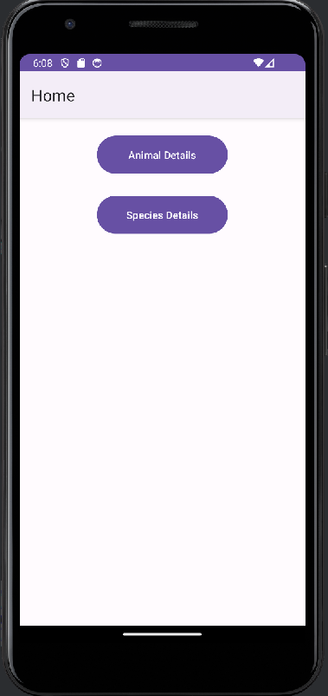

This screen is Animal Details screen where a list of animal records from Room db are listed and also have floating add button which opens an add dialog to add new animal.

Similar to the Animal details screen, a user can navigate to the Species Details screen from the Home screen and see a list of species fetched from Room db, and the user will have the option to add new species with the help of an add floating button.

