EXPLORATORY DATA ANALYSIS REPORT
Drought Severity Classification Using Multinomial Logistic Regression
A statistical profile of the climatic predictors and the drought severity target variable, prepared ahead of model development.

1. Introduction
This report presents an exploratory data analysis (EDA) of the drought dataset that will be used to train a multinomial logistic regression model for drought severity classification. The dataset contains 1,000 observations of five climatic and hydrological predictors — Temperature, Rainfall, Humidity, Soil Moisture, and Wind Speed — each labeled with an observed drought severity class. The purpose of this analysis is to understand the structure, quality, and distribution of the data, and to identify which variables are likely to drive classification performance before model fitting begins.

2. Dataset Overview
The dataset was checked for completeness and structural integrity prior to analysis. Key characteristics:
- Total records: 1,000
- Predictor features: 5 (Temperature, Rainfall, Humidity, Soil Moisture, Wind Speed) — all numeric
- Target variable: Drought_Severity (categorical, 4 observed classes)
- Missing values: none detected across any column
- Duplicate rows: none detected
No imputation, deduplication, or type conversion was required before analysis.

3. Summary Statistics
Descriptive statistics for each numeric feature are summarized below. All five predictors are continuous and span distinct natural ranges.
Feature | Mean | Std Dev | Min | 25% | Median | 75% | Max | Skew
Temperature (°C) | 31.80 | 5.84 | 22.1 | 26.68 | 31.90 | 36.90 | 42.0 | 0.04
Rainfall (mm) | 101.40 | 58.44 | 0.6 | 48.18 | 103.75 | 152.12 | 199.9 | -0.06
Humidity (%) | 55.17 | 20.35 | 20.0 | 38.28 | 55.00 | 73.12 | 89.8 | -0.02
Soil Moisture (%) | 41.78 | 21.49 | 5.0 | 23.18 | 41.30 | 60.30 | 80.0 | 0.03
Wind Speed (km/h) | 14.88 | 5.74 | 5.0 | 9.88 | 14.90 | 19.80 | 25.0 | 0.03
Table 1. Descriptive statistics for all numeric predictors.
Skewness values for every feature are close to zero (between -0.06 and 0.04), and kurtosis values are consistently negative (around -1.2), indicating that each predictor is approximately symmetric but flatter than a normal distribution — closer to a uniform spread across its range. This is confirmed visually in the histograms below (Figure 1), where each feature shows a roughly flat, evenly-spread distribution rather than a central peak.
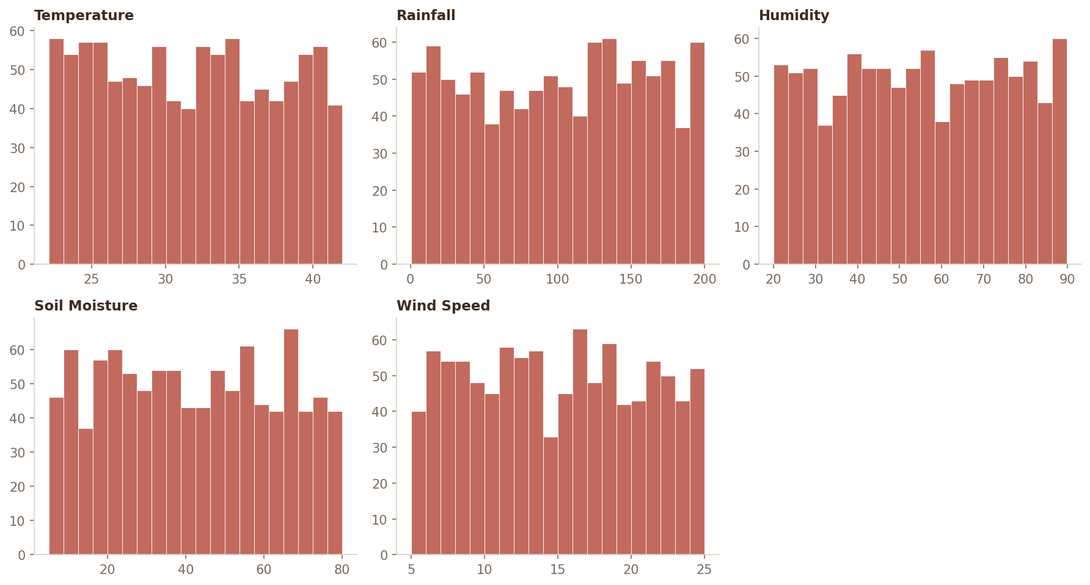
Figure 1. Distribution of each predictor variable across the full dataset.

4. Target Variable: Drought Severity
The target variable contains four observed severity levels: No Drought, Mild, Moderate, and Severe. No records labeled "Extreme" are present in this dataset.
Severity Class | Count | Percentage
No Drought | 706 | 70.6%
Mild | 190 | 19.0%
Moderate | 73 | 7.3%
Severe | 31 | 3.1%
Table 2. Class frequency and proportion of the target variable.
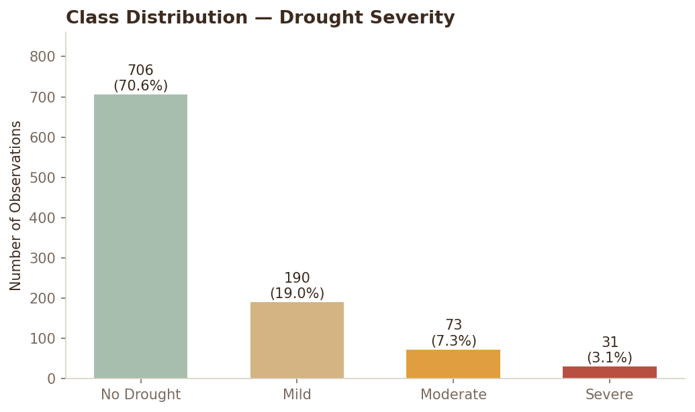
Figure 2. Class distribution of drought severity.
The class distribution is heavily imbalanced: 70.6% of observations fall in the "No Drought" category, while the "Severe" class accounts for only 3.1% of records. This imbalance has direct implications for model training — without adjustment (e.g., class weighting, stratified sampling, or resampling), a classifier may be biased toward predicting the majority class and perform poorly on minority classes such as Moderate and Severe. Stratified train/test splitting and per-class evaluation metrics (precision, recall, F1) are recommended over relying on overall accuracy alone.

5. Feature Relationships with Drought Severity
Mean values of each predictor were compared across severity classes to identify which variables carry signal relevant to classification (Table 3), and boxplots (Figure 3) show the full distribution of each feature broken out by class.
Severity Class | Temp (°C) | Rainfall (mm) | Humidity (%) | Soil Moist. (%) | Wind (km/h)
No Drought | 32.00 | 123.38 | 55.33 | 47.96 | 14.90
Mild | 31.14 | 59.08 | 54.34 | 32.08 | 14.80
Moderate | 31.78 | 35.08 | 52.90 | 19.75 | 14.81
Severe | 31.31 | 16.46 | 61.84 | 12.15 | 15.14
Table 3. Mean feature values by drought severity class.
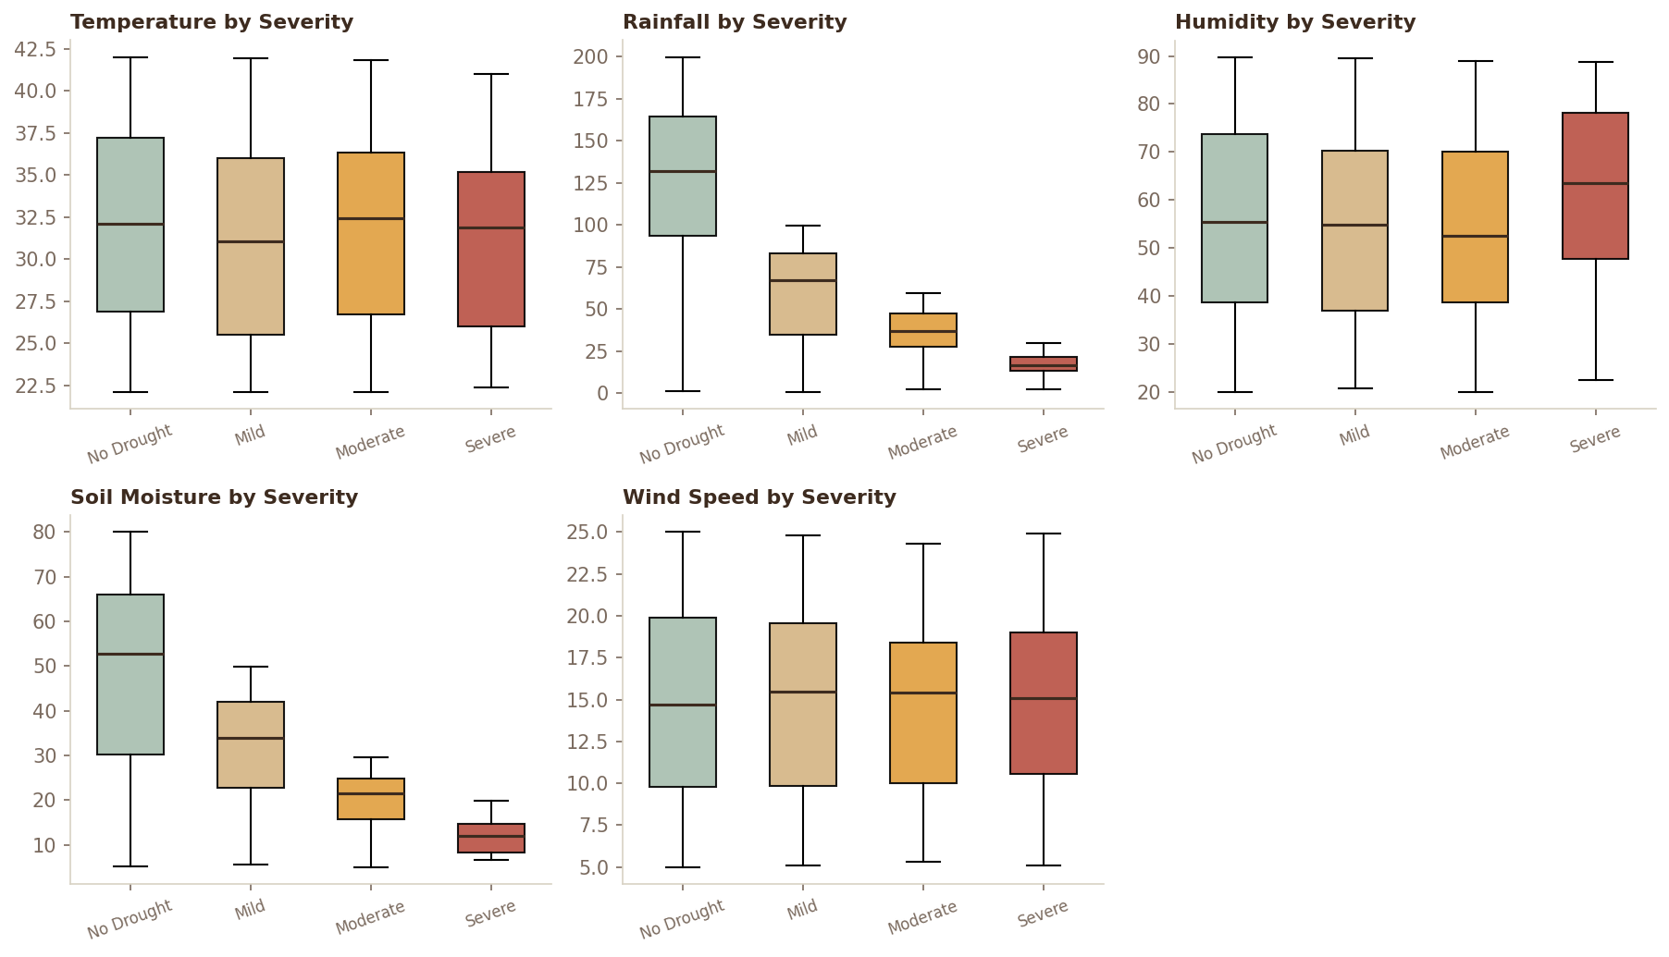
Figure 3. Distribution of each predictor by drought severity class.
Rainfall and Soil Moisture show a clear, monotonic relationship with drought severity: both decline steadily from "No Drought" through to "Severe" (Figure 4). Mean rainfall drops from 123.4 mm in the No Drought class to 16.5 mm in the Severe class, and mean soil moisture drops from 48.0% to 12.1% over the same classes. These two variables appear to be the dominant drivers of drought severity in this dataset.
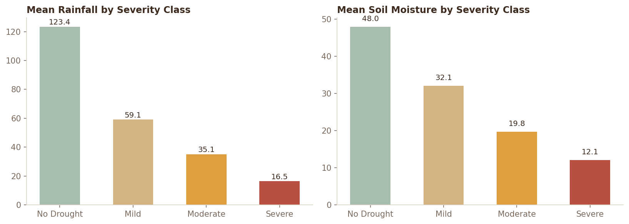
Figure 4. Mean Rainfall and Soil Moisture decrease consistently with increasing drought severity.
By contrast, Temperature, Humidity, and Wind Speed show little to no separation across severity classes — their class means stay within a narrow band regardless of drought level (Table 3, Figure 3). These features are unlikely to contribute strong discriminative power on their own, though they may still provide minor interaction effects once combined in a multivariate model.

6. Correlation Analysis
A Pearson correlation matrix was computed across all five numeric predictors to check for multicollinearity, which can distort coefficient estimates in logistic regression.
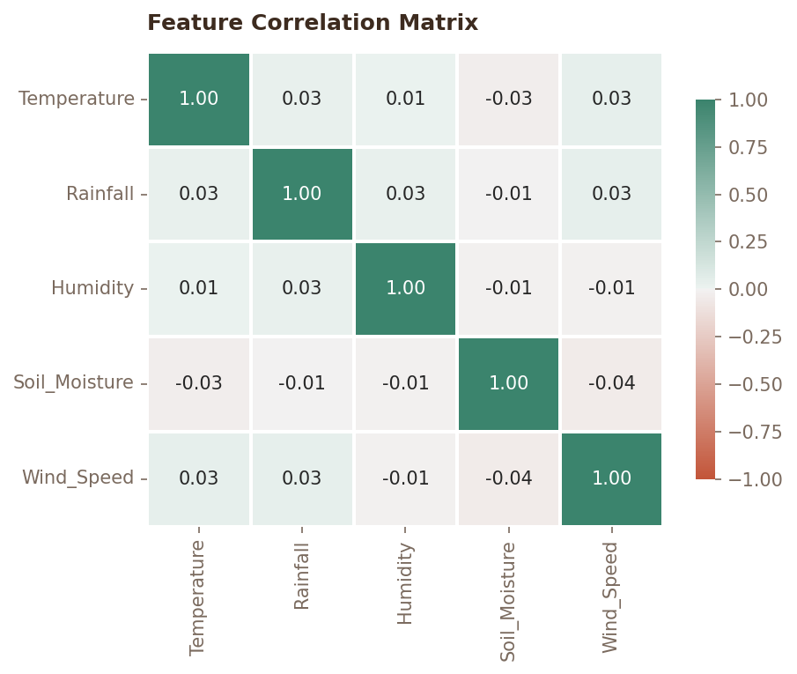
Figure 5. Correlation matrix of numeric predictor variables.
All pairwise correlations are negligible, ranging from -0.04 to 0.03. The predictors are effectively independent of one another, so multicollinearity is not a concern for this dataset — each feature can be included in the regression model without inflating coefficient variance.

7. Key Observations
- The dataset is clean: no missing values, no duplicate rows, and no type-conversion issues.
- All five predictors are approximately uniformly distributed across their respective ranges.
- The target classes are imbalanced (70.6% / 19.0% / 7.3% / 3.1%), requiring stratified sampling and class-aware evaluation metrics.
- Rainfall and Soil Moisture are strongly associated with drought severity and are likely to be the most influential predictors.
- Temperature, Humidity, and Wind Speed show minimal variation across severity classes.
- Predictors are nearly uncorrelated with one another, so multicollinearity is not expected to be an issue for logistic regression.

8. Recommendations for Model Development
- Apply stratified train/test splitting to preserve class proportions in both sets.
- Standardize all numeric features before fitting, since logistic regression is scale-sensitive.
- Consider class weighting or resampling (e.g., SMOTE) to address the imbalance toward "No Drought."
- Evaluate the model with per-class precision, recall, and F1-score rather than overall accuracy alone.
- Expect Rainfall and Soil Moisture to carry the largest regression coefficients; retain Temperature, Humidity, and Wind Speed for completeness and potential interaction effects.

9. Conclusion
This exploratory analysis confirms that the dataset is well-structured and suitable for multinomial logistic regression modeling. Rainfall and Soil Moisture emerge as the primary signals separating drought severity classes, while the remaining features contribute comparatively little on their own. The main modeling challenge is class imbalance rather than data quality, and should be addressed explicitly during training and evaluation to ensure the Moderate and Severe classes are classified reliably.

