**Internet of Things using Raspberry Pi and clouds**

**PROJECT REPORT**

1. **Architecture:**

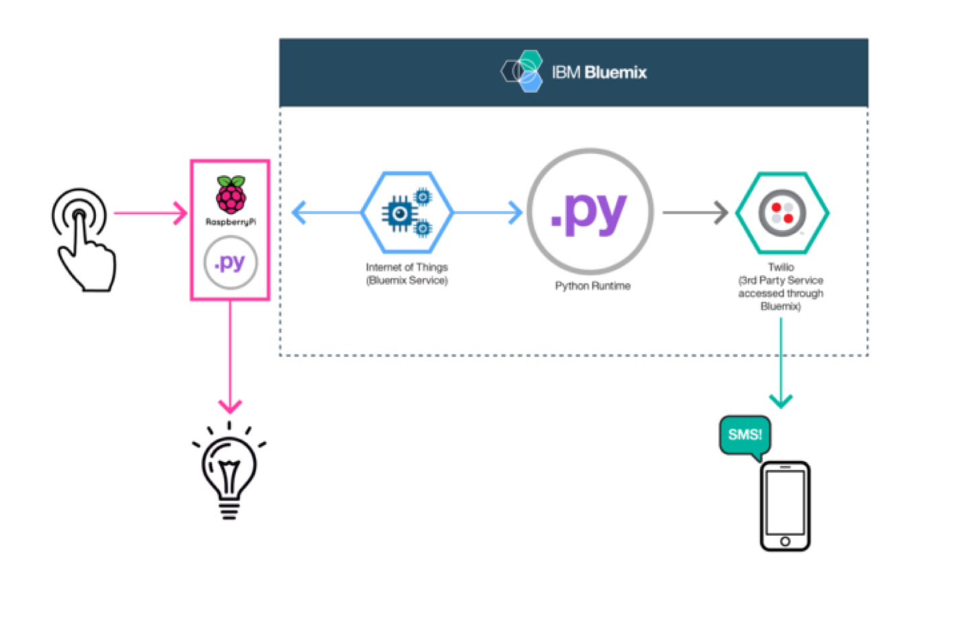

1. **Roles of Components:**

* Bread-board and other hardware components:

1. Bread-board: This facilitates the connections from raspberry pi to the LED.
2. LED: This is the eponymous ‘thing’ in the internet of things. We will be manipulating the state of LED for our project.
3. Wires: This allows the raspberry pi to communicate with and manipulate the LED.

* Raspberry-pi:

1. The raspberry-pi has to be setup with 3 software components which perform various tasks:
2. WiringPi: This is the helper library for using GPIO so that we can send signals through the relevant ports to turn the LED on and off.
3. The IoT library: This helps us obtain a unique device-id with which the application on the cloud identifies the raspberry-pi. Using this library, we can also start the IoT service with which the raspberry-pi communicates with the cloud
4. Client: The client.py, which is the python app. It receives the signals we send and manipulates the signals sent to the LED through WiringPi
5. The raspberry-pi also has hardware components, namely the ports, which send signals through the wires to the bread-board to switch the light on and off.
6. The raspberry-pi also makes use of Ethernet port to connect to the internet. It also has one HDMI port is used to connect the raspberry-pi to a display.

* Cloud:

IBM bluemix has the following components with which we implement our project:

1. iot-twilio: This is the interface with which the cloud interacts with Twilio, a 3rd party service. Twilio in turn exposes an interface to a mobile device so that we can manipulate the LED through a phone using SMS
2. lightsabre: Our application. This application is a server that runs on bluemix and interacts with the raspberry-pi to relay information from the phone(commands to switch the bulb on and off) and from the bulb to the phone (information regarding whether the button has been pushed or not)
3. **Conceptual architecture of home IoT. You can expand the concept of lab #3 to understand a simple architecture of home IoT. You need to include:**
4. Raspberry Pi and cloud server
5. Home IoT devices, such as Phillips Hue, Samsung SmartThings, etc.

1. Homepage and smartphone application as interface of the system.
2. Component(s) for monitoring home and home devices
3. Component(s) for analyzing home and home devices

Below is a picture that describe the conceptual architecture of home IoT:



As shown in the picture, a home IoT usually consists of five components:

Raspberry Pi and cloud server (the “hub“, and the “cloud” part), Home IoT devices (the “devices that control” and “controlled devices”), homepage and smartphone application as interface of the system (the “remote” part), component(s) for monitoring home and home devices (the “sensor” & “devices that control”), and component(s) for analyzing home and home devices(the “analytics & data storage” part).

1. **Roles of the components. In particular, you should describe why we need clouds and Pi instead of not using clouds to control the home devices. (Network perspective, such as connection or IP) This is to understand a brief architecture of IoT service of cloud service providers, such as IBM or Amazon.**

**Raspberry Pi and cloud server:**

The role of Raspberry Pi and cloud server is to provide broad network access, which is one of the essential characteristics of cloud. By using a cloud server, capabilities are available over the network and accessed through standard mechanisms that promote use by heterogeneous thin or thick client platforms (e.g., mobile phones, tablets, laptops, and workstations). The cloud is further necessary for IoT management because of its rapid elasticity. Since the cloud has the ability to scale rapidly outward and inward commensurate with demand, the user can distribute the computation and storage, to achieve lower latency and receive feedback in a timely manner. In the case of a health-monitoring home IoT App, life-saving measures would be impossible without the cloud.

**Home IoT device:**

Home IoT devices are usually made up of sensors, actuators and embedded communication hardware. The major role is to sense the physical environment with sensors, communicate with the cloud server with embedded communication hardware, and eventually, affect the physical environment with actuators.

**Homepage and smartphone application as interface of the system:**

The homepage and smartphone application provides a user-friendly interface for the users to interact with the Home IoT device via Internet or their mobile device from anywhere. The user can easily monitor, or change the status of the Home IoT device by clicking a button on the homepage.

**Component(s) for monitoring home and home devices:**

The component(s) for monitoring home and home devices monitor the device in order to being able to guarantee a constant flow of reliable monitoring data. The monitoring data is either about the objects in the home or about the home devices itself. The monitoring data is then sent to the cloud server for further analysis. The user can then use the monitoring data to determine if the home environment is in a desired state or if the home devices are working properly.

**Component(s) for analyzing home and home devices:**

Usually, the component(s) for analyzing home and home devices resides on cloud. Once the Pi collects the device data from the home devices and sends it to the cloud server, the analytics component on the cloud server can process the data and turn it into valuable information. The information is then useful for optimizing the IoT application by integrating device data, thereby improving the user experience.

**Why Use Pi and cloud server instead of not using the clouds:**

The raspberry-pi is the device primarily responsible for receiving messages from the cloud and in-turn sends a signal to the home devices using pi’s GPIO ports and vice versa. Without pi we cannot send signals/power to the home devices that needs monitoring and control. We need some kind of interface over the internet to control raspberry pi. This is achieved using the connection between raspberry-pi and IoT in cloud. The interface is deployed on a cloud PaaS and it acts as the user facing application to receive/send actions. It achieves the connection using an api-token based authentication and the device id in raspberry pi.

**Team Members:**

* Rakesh Manoharan (rxm143130)
* Ram Prasath Parthasarathy (rxp111330)
* Vignesh Venkatraman (vxv140930)