The Complete

Homeowners’ Guide

To Going Solar

RENEWABLE ENERGY SYSTEMS

Revised 01-2016

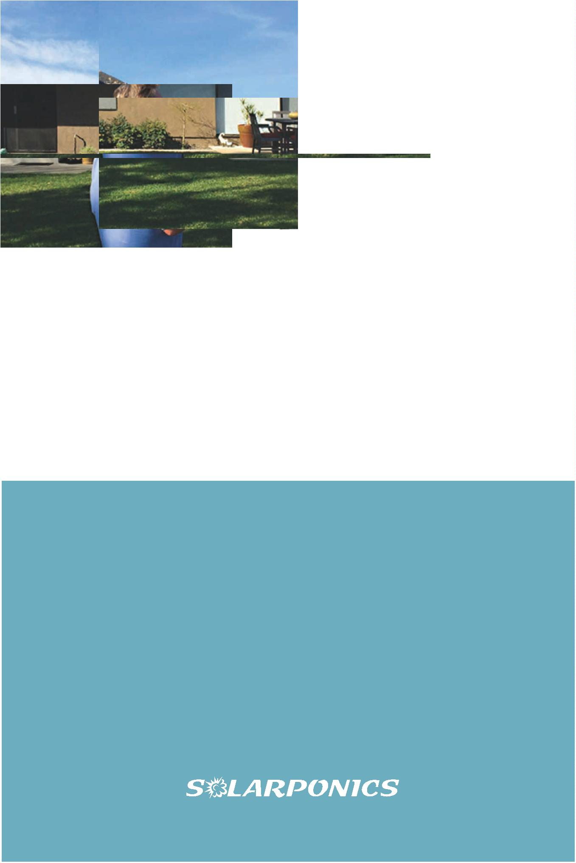

Solarponics

4

700 El Camino Real

Atascacero, CA 93422

Established 1975.

©

2016 Solarponics, Inc.

The Complete Homeowners’ Guide To Going Solar

Solar PV has been around for many years, but the complex nature of the technology

makes it somewhat daunting for homeowners to understand. From ꢀnding the right

contractor, to ꢀnancing, there are dozens of decisions one has to make that can cost

the homeowner thousands of dollars more than it should, or save them tens of

thousands more over the life of the system.

The solar energy industry is rapidly

changing and evolving. The information

in this guide is expected to remain

relevant through 2016. We expect to

release a revised edition for 2017.

©

2016 Solarponics, Inc.

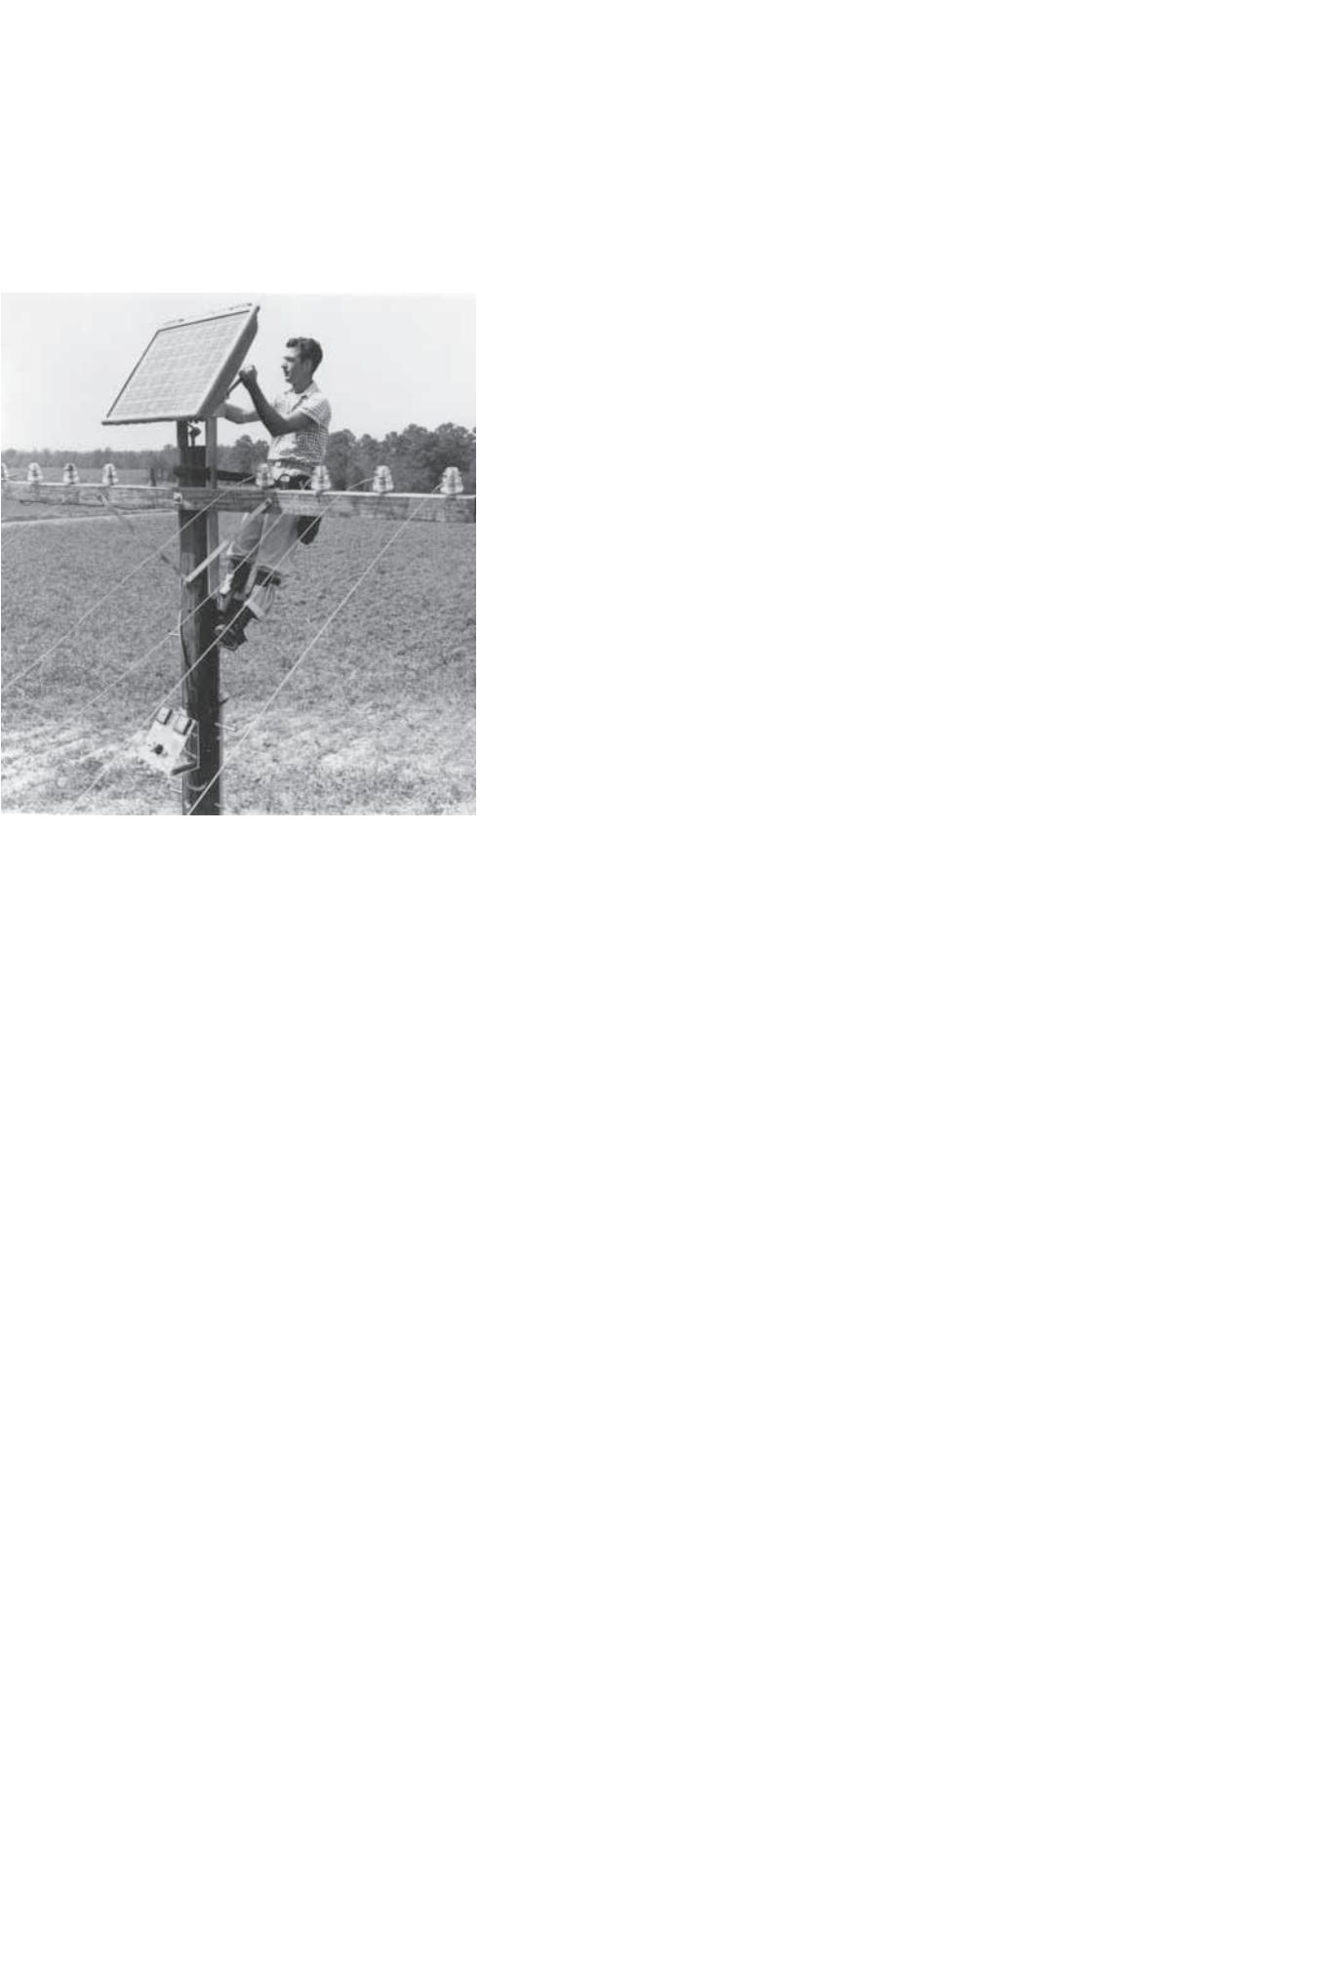

The Complete Homeowners’ Guide To Going Solar

1

2

3

4

5

6

7

8

9

1

1

1

1

1

1

1

1

.

.

.

.

.

.

.

.

Intro To Solar Energy

Distributed Generation and Oꢀ-Grid vs. Grid Tied

Net Energy Metering

Investment Tax Credit

Federal, State and Local Policy and Legislation

Is My Home Solar Compatible?

How Much Can I Save

Purchase Options: Lease, Finance, or Buy

Choosing a Solar Contractor

Choosing The Right Solar Panels

Inverters

.

0.

1.

2.

3.

4.

5.

6.

7.

Signing the Contract

Production Schedule: How Long Will This Take?

Warranty and Maintenance

Monitoring

You’re online. Now what?

Solar Energy FAQ’s

©

2016 Solarponics, Inc.



1

The Complete Homeowners’ Guide To Going Solar

#

1: Intro To Solar Energy

In 1839, Alexandre Edmond Bequerel discovered that certain materials produced

small amounts of electric current when exposed to light. Selenium photovoltaic cells

(PV) were converting light into electricity at a 1 to 2 percent eꢀciency. Today, we’e

seeing PV panels enter the market that are near 20% eꢀciency, and lab models

producing in excess of 40% eꢀciency. The typical solar panel that is being installed

on rooftops today is about 15% to 17% eꢀcient.

In 1977, solar energy cost about $76/watt. In 1987, the cost had dropped to $10/watt.

Today, solar energy costs around $0.50/watt, and is near or at a level we call price

parity. In other words, solar energy costs about the same per watt as the low tier

utility generated energy. But utility generated energy has multiple tiers. The more

you use, the higher rate you pay, and this rate is constantly increasing at a historic

average of 6% per year.

Over the last 20 years, California has been home to a number of "world's largest" solar

facilities. In 1991, the 354-MW solar thermal SEGS plant (located in the Mojave Desert

in San Bernardino County, California) held the title, until being bested by the 392-MW

Ivanpah Solar Electric Generating System, a concentrated solar thermal plant located

in San Bernardino County near the Nevada border. In 2014, the 550-MWAC Topaz

Solar Farm became the new "world's largest operational" solar facility when it went

online in Riverside County, California. A second 550-MW facility by First Solar, Desert

Sunlight, also went online in Riverside County in 2014. Both of these were super-

seded, however, by the Solar Star photovoltaic project that went online with 279

MVAC in June 2015 in Antelope Valley, California (located on Los Angeles and Kern

counties). While California hosts the three largest photovoltaic facilities in the world

(as of July 2015), there are yet several proposals for even larger facilities seeking

regulatory approval in California.1

California also leads the nation in the number of homes which have solar panels

installed, totaling over 230,000. Many were installed because of the Million Solar Roof

Initiative. 2

1

. Wesoꢁ, Eric (26 June 2015). "Solar Star, Largest PV Power Plant in the World, Now Operational". Greentech Media. Retrieved 28 July 2015.

2

. https://nccleantech.ncsu.edu

©

2016 Solarponics, Inc.



1

The Complete Homeowners’ Guide To Going Solar

#

1: Intro To Solar Energy

How does solar energy work?3 : The sun generates enough energy on our plant’s

surface in one second to power the entire planet for one year. We can change

sunlight into electricity using solar cells. Particles of light, called photons, are

captured in a solar cell and produce electrons of direct current or “DC”power. The

electrons ꢀow out of the solar cell into an inverter that converts the DC energy into

alternating current or “AC”power, the kind of electricity that everything in your home

uses.

A net energy meter (NEM) keeps track of all the power that your solar system

produces. Any solar energy that you do not immediately consume on site in your

home goes back into the grid through the meter.

The three basic components of a solar energy system; the solar panels, the inverter,

and the meter. All will be discussed in more detail in a later section.

NOTE: Usually at this point, most homeowners ask, “With such rapid

advancements in the industry, is it more beneꢁcial to wait until costs

drop further, or for when a newer, better technology comes along”?

Our answer is, “no, it does not serve you to wait.”

Why? First, the rapid advancements are taking very small steps

forward. The latest and greatest technology is also usually the most

expensive, which will increase your payback time. Products on the

market today are tried and tested, and designed for optimum return

on investment. Remember that the sooner you go solar, the greater

your savings are, because you start saving the day your solar energy

system is turned on. To wait a year is to give up a year of savings.

Additionally, other incentives and tax credits may be available today

that will not be available tomorrow. More on that later.

3

. http://www.gosolarcalifornia.ca.gov/solar_basics/how.php

©

2016 Solarponics, Inc.



1

The Complete Homeowners’ Guide To Going Solar

#

1: Intro To Solar Energy

Why should I go solar now?

If you own your home, have an energy bill of $75 or more, and have roof space,

you should go solar. Some of the beneꢀts include:

•

•

•

•

•

•

•

•

•

Lock in your energy rate at current prices for 20+ years.

Take advantage of low panel prices.

Homeowners are still eligible for the 30% Investment tax credit.

Help reduce greenhouse gas emissions by reducing our need for other fossil fuels.

Take some of the burden oﬀ of our electric generating infrastructure.

You are making a conscious decision to change the way you live for the better.

You will save tens of thousands of dollars.

You are creating jobs and generating a local tax revenue base.

You are increasing the value of your home by more than the cost of the

solar energy system.4

•

•

You are helpoing create energy security for our country.

You will be saving water. Solar power uses less than 1 oz. of water per kWh of

energy produced. Coal electric generation uses 140 oz. of water per kWh.5

4

5

. http://costofsolar.com/is-my-home-worth-more-with-solar-energy/

. http://solarenergy.net/News/infographic-world-water-day-go-solar-save-water/

©

2016 Solarponics, Inc.



2

The Complete Homeowners’ Guide To Going Solar

#

2: Distributed Generation and Oꢀ-Grid vs. Grid-Tied

Distributed generation (DG) refers to electricity that is produced at or near where it is to be

used. The term distributed generation distinguishes these systems from the large, centralized

power plants that provide the vast majority of the nation’s power. Distributed solar energy is

usually located on rooftops or ground mounted arrays, and is typically connected to the local

utility distributed grid. Distributed Generation also refers to utility-scale solar farms that

produce and feed energy into the grid. We will use the term distributed generation as it

pertains to residential solar installations.

The beneꢀts of DG are quite simple6. In addition to being good for the environment, solar

arrays on home rooftops and ground mount arrays in backyards employ local tradespeople to

install. The DG model supports local ꢀnancial markets. DG reduces energy imports, thus

decreases the stress on infrastructure, and reduces the need to build as many additional

centralized power plants. DG increases tax revenue in local communities. DG takes advantage

of unused space. DG makes the entire grid infrastructure more secure, with less reliance on

single point s of generation. DG can help meet peak power needs.

So, now that we understand distributed generation, we can talk about grid-tied vs. oꢁ-grid

solar energy systems. Simply put, grid-tied solar means a homeowner is still connected to the

public utility grid. You still have a meter, still pay a connection fee, and still get a statement

every month.

6

. http://www.greentechmedia.com/articles/read/RMI-New-Insights-into-the-Real-Value-of-Distributed-Solar

http://pureenergies.com/us/residential-solar/

©

2016 Solarponics, Inc.

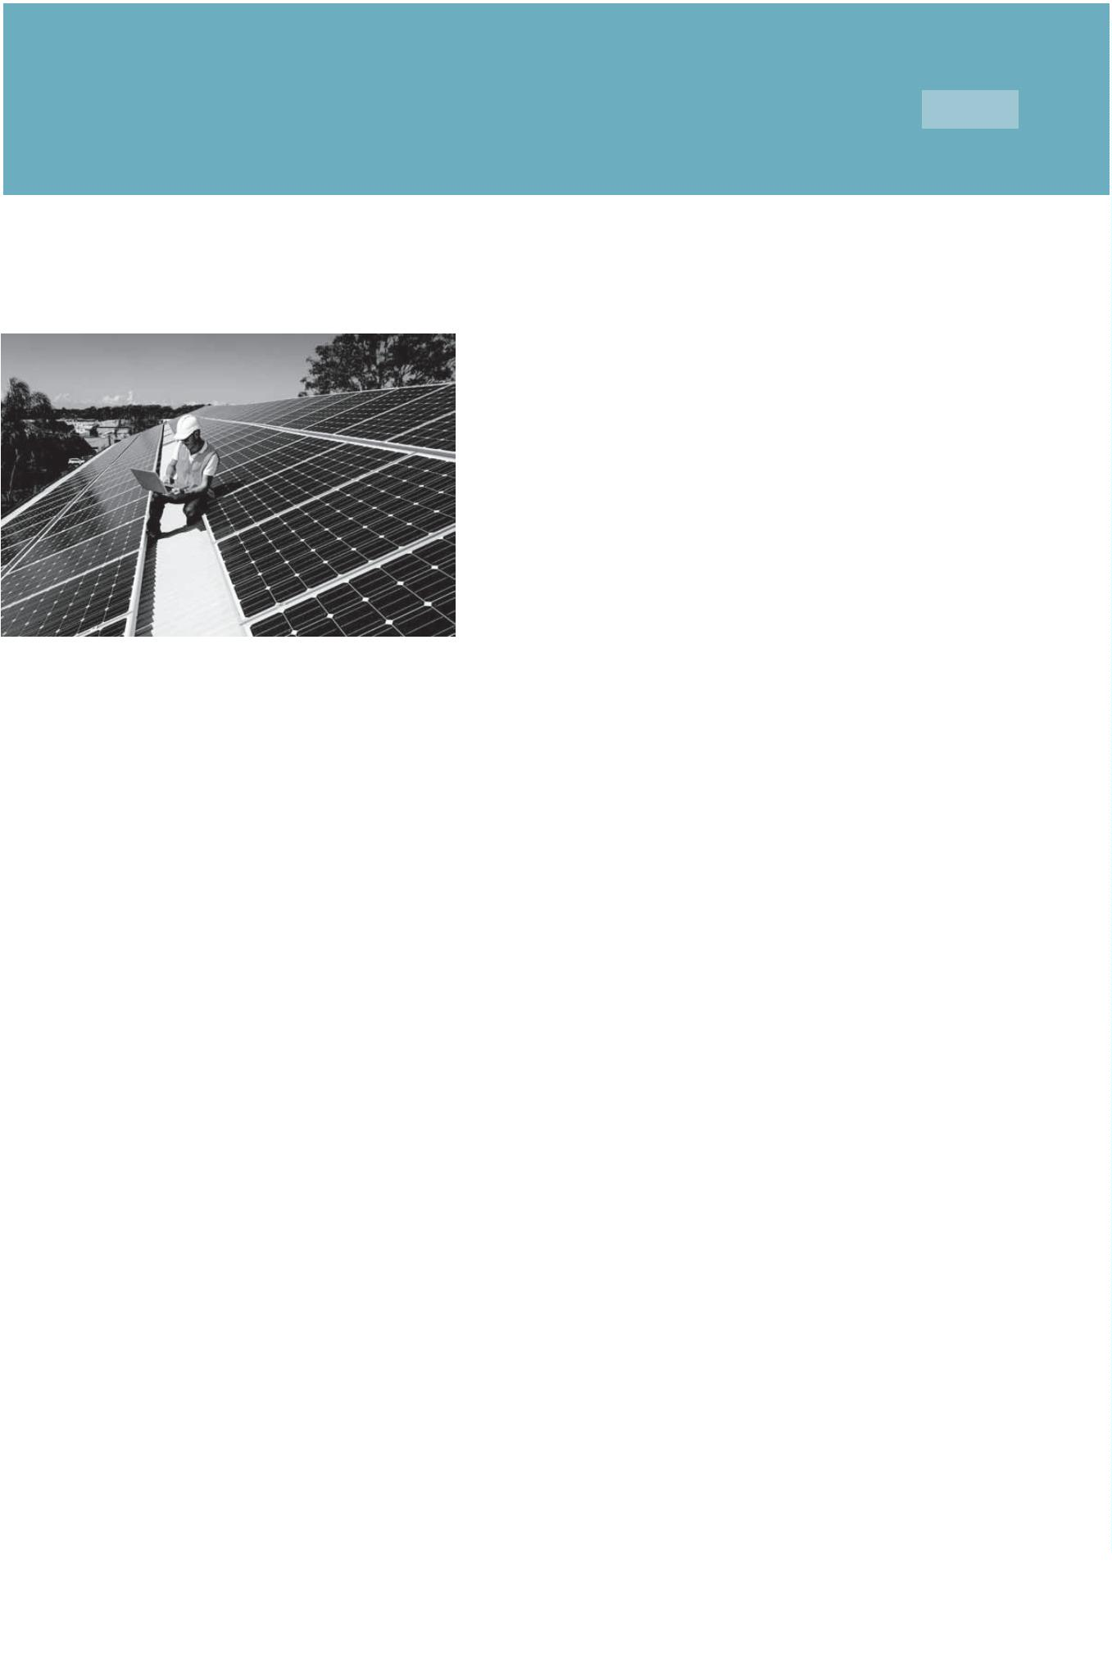

2

The Complete Homeowners’ Guide To Going Solar

#

2: Distributed Generation and Oꢀ-Grid vs. Grid-Tied

Here’s how a grid-tied solar energy system works:

The sun shines on a solar panel, creating energy. The energy passes through an inverter.

Whatever energy is needed by the home at that moment is supplied by the solar energy

system directly through the inverter. Any excess that is produced is passed through the smart

meter and fed into the grid, for use elsewhere down the transmission lines. In the summer, a

home rooftop array will overproduce, sending most of the energy generated into the grid for a

credit. At night, when the solar system is not producing, the home draws energy from the grid,

using credits. This structure is called Net Energy Metering (see part 3).

Grid-tied systems account for 99% of all home solar systems being installed today7.

7

. http://solarsimpliꢀed.org/connecting-to-the-grid/ongrid-oꢁgrid

©

2016 Solarponics, Inc.

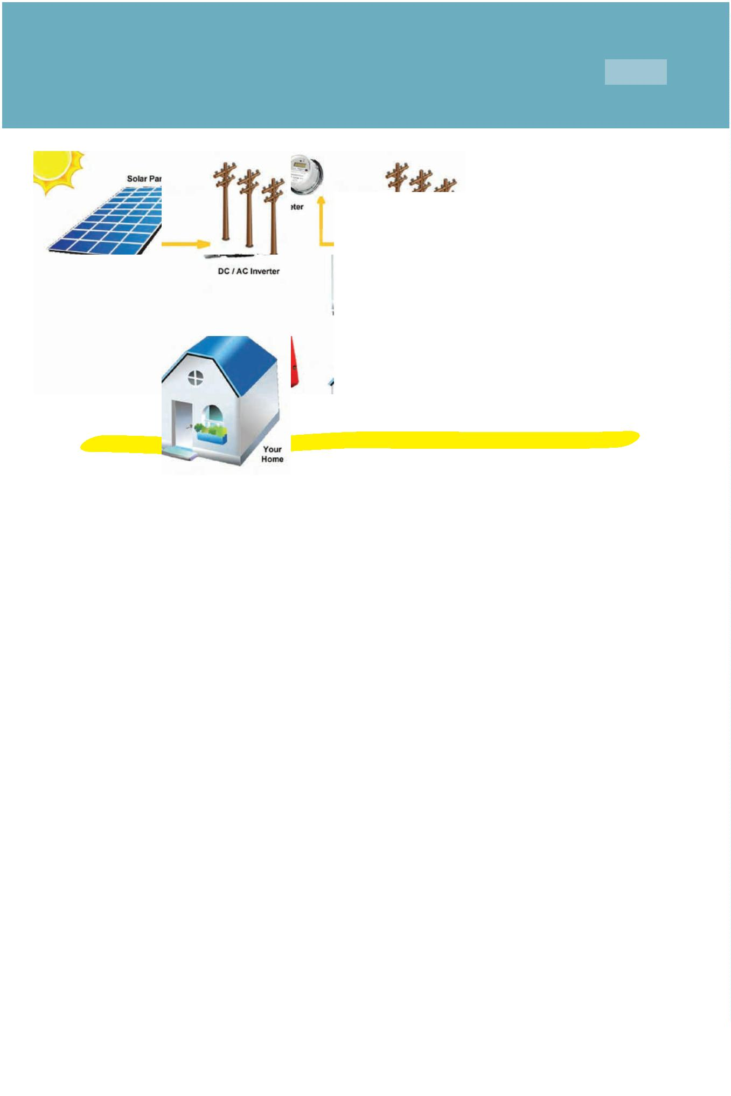

2

The Complete Homeowners’ Guide To Going Solar

#

2: Distributed Generation and Oꢀ-Grid vs. Grid-Tied

Here’s how an oꢀ-grid solar energy system works:

Oꢀ-grid means that a home or structure is not connected to the grid. Thus, the structure

must have an alternative source of power, enough to cover 100% of the structures energy

needs. Since solar panels cannot produce energy at night, an oꢀ-grid system requires either

the use of a battery storage system and/or a gas-powered generator.

Oꢀ-grid systems are most common in remote areas without utility service. The current

downside of an oꢀ-grid solar energy system with battery storage is the added expense. The

battery storage component can add 30-50% more to the cost of the solar energy system.

NOTE: Less than 1% of solar energy installs are oꢀ-grid. Oꢀ-grid

systems are NOT connected to a public utility. This system is good for

those who are in remote locations, or want total energy indepen-

dence, without any support or bill from a public utility entity.

©

2016 Solarponics, Inc.

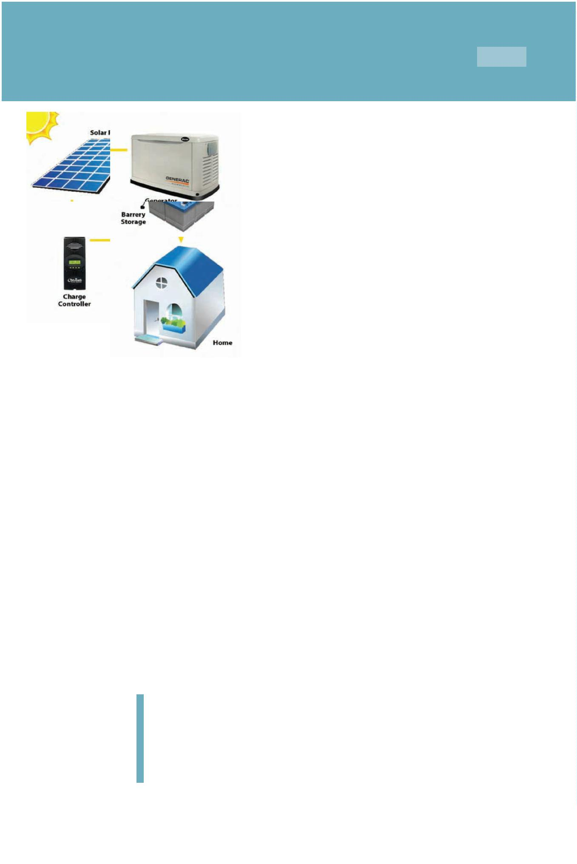

2

The Complete Homeowners’ Guide To Going Solar

#

2: Distributed Generation and Oꢀ-Grid vs. Grid-Tied

There is a third type of oꢀ-grid system, which is worthy of mentioning.

A Hybrid System. A hybrid system is a grid-tied solar energy system with battery back-up.

The batteries store excess energy generated during the day, for use at night, and/or when the

power goes out. The structure is still grid-tied, and still able to buy or sell energy through the

grid. Hybrid energy systems may also include systems with multiple power sources such as

the addition of a wind turbine or gas generator.

The beneꢁt of a hybrid system is that the excess power you are generating gets stored in your

battery bank for use by you at a later time. Now, instead of buying back energy when you

need it, at possibly a higher rate, you simply draw against your batteries. Also good for a

homeowner who needs a reliable back-up power supply in case the grid fails.

Hybrid systems are becoming more popular as the utility companies impose more and more

fees for solar customers. In California, our Net Energy Metering policy currently states that the

utility company issue a net credit for that excess energy. This policy is expected to reach its

cap by June 2016, at which time NEM 2.0 will take eꢀect. NEM 2.0 currently proposes that the

utility sets the price they pay for your excess energy, and set the price you pay for the energy

you will need at night, when your array is not producing (see Net Energy Metering, part 3).

©

2016 Solarponics, Inc.

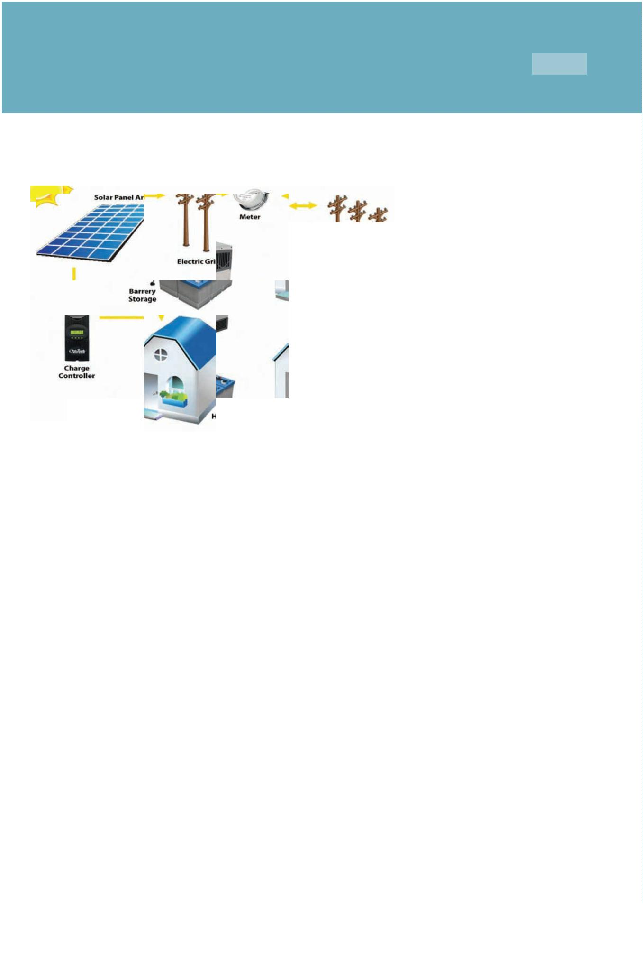

3

The Complete Homeowners’ Guide To Going Solar

#

3: Net Energy Metering

Net Energy Metering (NEM) in California:

Net energy metering, or "NEM", is a special billing arrangement that provides credit to

customers with solar PV systems for the full retail value of the electricity their system

generates. Under NEM, the customer's electric meter keeps track of how much electricity is

consumed, and how much excess electricity is generated by the system and sent back into

the electric utility grid. Current California NEM is a watt for watt credit.

A customer on NEM gets a monthly statement, NOT A BILL. The statement shows total energy

use and total energy production, as well as any credit due or amount owed.

At the end of a 12-month cycle, the customer gets a “true-up”bill from the utility company.

The true-up bill will show a credit or payment due, the diꢀerence between how much energy

the home used vs. how much it generated, plus all of the connection fees, charges, taxes and

what not for the year.

Even a solar energy system that was designed to produce 100% of the homes energy needs

will have a true-up bill of approximately $180, which is about $15 month in connection fees,

taxes and the what-nots.

An NEM meter is a smart meter. Smart meters are designed to record the amount of energy

being used and being generated at your home. The meter provides two-way communication

between your home and the utility using secure wireless network technology to communi-

cate usage data to your local utility.

NOTE: NEM has a cap that limits the amount of solar energy installa-

tions in MW of installed solar. Once the cap is reached, the current

NEM regulations expire. The current NEM policy is estimated to reach

its cap and expire by June 2016, at which time, NEM 2.0 will take eꢀect

(see next page).

©

2016 Solarponics, Inc.



3

The Complete Homeowners’ Guide To Going Solar

#

3: Net Energy Metering

NEM 2.0 was approved by California legislatures. This means that future net metering will

preserve retail payments for residential solar. However, the proposal will allow new intercon-

nection costs and non-bypassable charges to NEM 2.0 solar customers. The one-time

intercnnection fee could range from $75 to $150 cahrged to the homeowner.

Non-bypassable charges that all utility customers pay equate to about 2 -3 cents per

kilowatt-hour of energy used. These charges are used to fund low-income and eꢀcicency

programs. Solar cusotmers may have a net zero energy use, and thus do not currently pay

non-bypassable charges. The new proposal states that solar customers should pay for

non-bypassable charges on all energy they consume from the grid, regardless of the amount

of energy they have exported to the grid. This could amount to the 2 -3 cents per kilowatt-

hour of energy used from the grid.

The current NEM structure is set to reach its cap by June, 2016, so a new agreement must be

reached and approved before that time. All solar installs that are online before the cap is met,

are guarantees the original NEM policy for 20 years.

Should You Act Now? YES. NEM 2.0 is not as solar-friendly as NEM 1.0. All solar installs that

are online before the cap is met, are guarantees the original NEM policy for 20 years.

2

.0

©

2016 Solarponics, Inc.



4

The Complete Homeowners’ Guide To Going Solar

#

4: Investment Tax Credit

Investment Tax Credit (ITC): Solar consumers are eligible for federal tax incentives for the

purchase and installation of eligible solar systems, including both solar photovoltaics (PV)

and some solar hot water (solar thermal) systems, as well as other limited renewable energy

investments.

This federal tax credit is a one-time credit, but may be carried forward (and possibly back) if

not completely useable in the system installation tax year. Rules about carrying forward and

backward may vary between residential and commercial tax ꢀlers; please consult a tax

professional for the current rules.

On December 18, Congress passed a spending package that

includes multi-year extensions of solar and wind tax credits, plus

one-year extensions for a range of other renewable energy

technologies. Under the legislation, the 30% Investment Tax

Credit for solar will be extended for another four years. It will then

ramp down incrementally thru 2021, and remain at 10% perma-

nently beginning 2022.

History:

Solar tax credits were enacted in 2008 as part of the Emergency Economic Stabilization Act,

which included $18 billion in incentives for clean and renewable energy technologies, as well

as for energy eꢁciency improvements. The 2008 legislation extended the solar investment

tax credit (ITC) through December 31, 2016 and made other modiꢀcations to the tax credits.

Resources:

The IRS current federal tax form for the Investment Credits is Form 3468 is available at

www.irs.gov/formspubs

http://www.gosolarcalifornia.ca.gov/consumers/taxcredits.php

©

2016 Solarponics, Inc.



5

The Complete Homeowners’ Guide To Going Solar

#

5: Federal, State and Local Policy and Legislation

History: California, with its abundant natural resources, has a long history of support for

renewable energy. In 2009, 11.6% of all electricity came from renewable resources such as

wind, solar, geothermal, biomass and small hydroelectric facilities. Large hydro plants

generated another 9.2 percent of our electricity.8

In 2002, California established its Renewables Portfolio Standard (RPS) Program, with the goal

of increasing the percentage of renewable energy in the state's electricity mix to 20 percent

of retail sales by 2017. The 2003 Integrated Energy Policy Report recommended accelerating

that goal to 20 percent by 2010, and The 2004 Energy Report Update further recommended

increasing the target to 33 percent by 2020. The state's Energy Action Plan supported this

goal. In 2006 under Senate Bill 107, California's 20 percent by 2010 RPS goal was codiꢀed. The

legislation required retail sellers of electricity to increase renewable energy purchases by at

least 1 percent per year with a target of 20 percent renewables by 2010. Publicly owned

utilities set their own RPS goals recognizing the intent of the legislature to attain the 20

percent by 2010 target.

On November 17, 2008, Governor Arnold Schwarzenegger signed Executive Order S-14-08

requiring that "...[a]ll retail sellers of electricity shall serve 33 percent of their load with

renewable energy by 2020." The following year, Executive Order S-21-09 directed the

California Air Resources Board, under its AB 32 authority, to enact regulations to achieve the

goal of 33 percent renewables by 2020.

In the ongoing eꢁort to codify the ambitious 33 percent by 2020 goal, SBX1-2 was signed by

Governor Edmund G. Brown, Jr., in April 2011. In his signing comments, Governor Brown

noted that "This bill will bring many important beneꢀts to California, including stimulating

investment in green technologies in the state, creating tens of thousands of new jobs,

improving local air quality, promoting energy independence, and reducing greenhouse gas

emissions."

This new RPS preempts the California Air Resources Board's 33 percent Renewable Electricity

Standard and applies to all electricity retailers in the state including publicly owned utilities,

investor-owned utilities, electricity service providers, and community choice aggregators. All

of these entities must adopt the new RPS goals of 20 percent of retails sales from renewables

by the end of 2013, 25 percent by the end of 2016, and the 33 percent requirement being

met by the end of 2020.

8

. http://www.energy.ca.gov/renewables/

©

2016 Solarponics, Inc.



5

The Complete Homeowners’ Guide To Going Solar

#

5: Federal, State and Local Policy and Legislation

San Luis Obispo County is a solar friendly county. Most municipal city jurisdictions are also

very solar friendly. Ordinance No. 3301 was written and approved with the express intent of

streamlining the permitting process for residential rooftop solar energy systems. Generally,

your local solar contractor will handle all of the permitting process and paperwork for you.9

9

. http://www.slocounty.ca.gov/search-results?q=solar%20energy

©

2016 Solarponics, Inc.

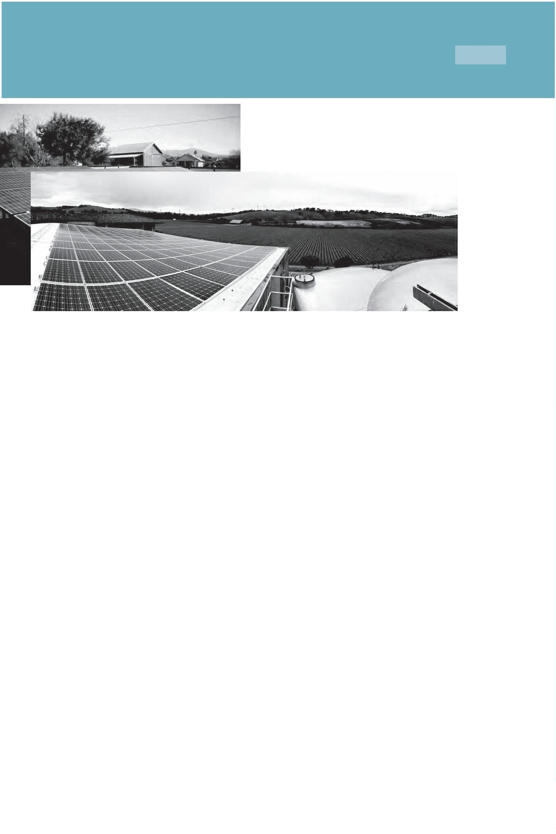

6

The Complete Homeowners’ Guide To Going Solar

#

6: Is My Home Solar Compatible?

Here is a guide to help you determine if your home is a good candidate for solar energy.

There are really the three main considerations

1

2

. Do you own your home? Yes is the best answer. However, we have installed

many projects for owners of rental property.

. Is your energy bill above $75? Again, Yes is the best answer. We have installed

many solar systems for homeowners whose energy bill is as low as $45. In these

cases becoming more energy independent is the primary goal.

. Is your roof south facing? Yes is the best answer, but East or West facing roofs

are still completely viable, just less eꢀcient. There are ways to minimize these

ineꢀciencies.

. In lieu of compatible roof space, do you have a suitable ground area that is not

shaded? Rural properties, and homes on a large lot have the option of installing

the solar array on a ground-mount system. Ground-mount systems can be

3

4

optimization for direction, and occupy previously unused space.

Other variables that can aꢁect the design and placement of a solar energy system include

potential shading issues from trees, chimney, or vents; roof space and/or roof condition.

Prior to the install of a solar energy system, it is important to look at ways to easily and

cost-eꢁectively reduce energy use. Upgrading an old ineꢀcient clothes dryer to a new

Energy-Star rated clothes dryer could reduce two solar panels, with the savings more than

paying for the new dryer. Thus, a basic energy audit is always beneꢂcial.

Solarponics’energy audit consists of looking at a full year of energy use. We look at the age

and energy eꢀciency of major appliances, as well as the biggest energy consumer next to

your HVAV, the water heater. In more than a few cases, we are able to upgrade an aging water

heater to an energy eꢀcient water heater and eliminate two or three solar panels from a

proposed solar energy array, for the same cost of solar only.

©

2016 Solarponics, Inc.

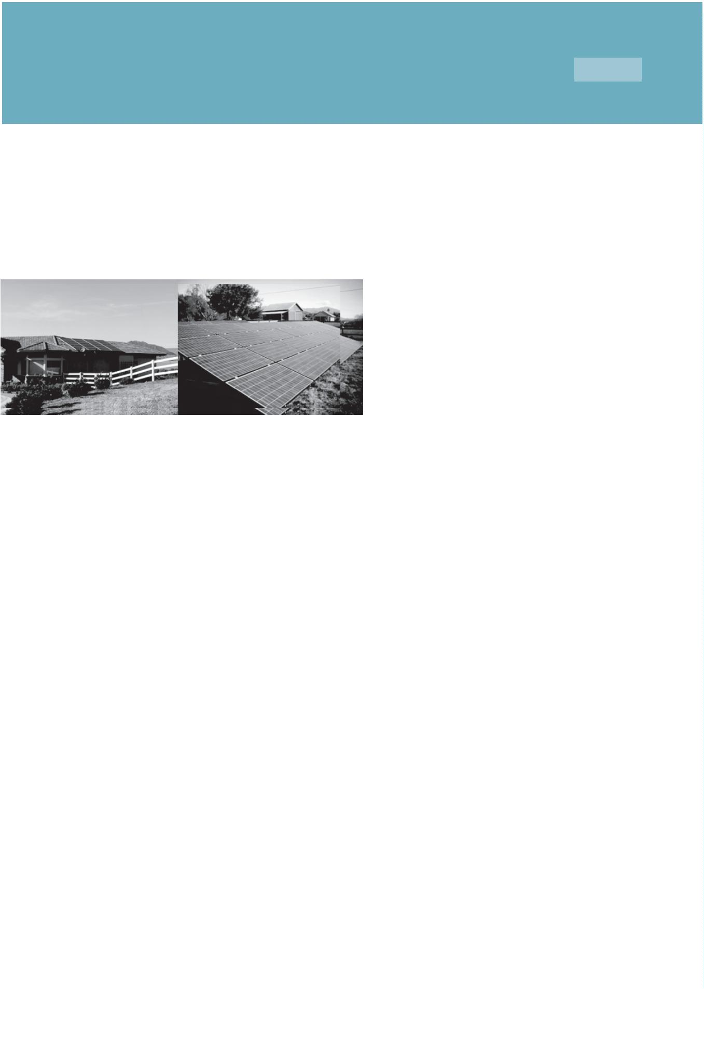

7

The Complete Homeowners’ Guide To Going Solar

#

7: How Much Can I Save?

This is the part of your solar energy proposal that you should spend the most time on. The

diꢀerence between a well-designed solar energy system, and a generic solar energy system

can be tens of thousands of dollars in savings.

Let’s start with the basics. It is your energy use that you are oꢀsetting, not the size of your

home, or the size of your roof area. We recommend sizing the solar energy system to produce

as close to 100% of your energy needs as possible. By doing so, you are maximizing your

investment, and your rate of return. An improperly sized solar energy system could poten-

tially cost you thousands of dollars in lost savings.

If you are considering ꢁnancing your solar energy system, leasing or signing a Power

Purchase Agreement (PPA), it is of paramount importance that you understand the diꢀerence

in total costs and total savings over the life of the system.

Consider this: On average, California homeowners pay 18¢/watt for energy from the public

utility company, with an historic average increase of 6%/year. Solar energy costs less than

1

$

1¢/watt, and is ꢁxed at that rate for 20+ years. This amounts to between $44 and

187/month savings during the ꢁrst year of operation, increasing every year.10

The average 20-year savings of a homeowner in California who has gone solar is $34,260.11

1

1

0. http://www.solar-nation.org/can-switching-to-solar-panels-save-me-money

1. http://cleantechnica.com/2014/02/03/much-can-solar-panels-save/

©2016 Solarponics, Inc.

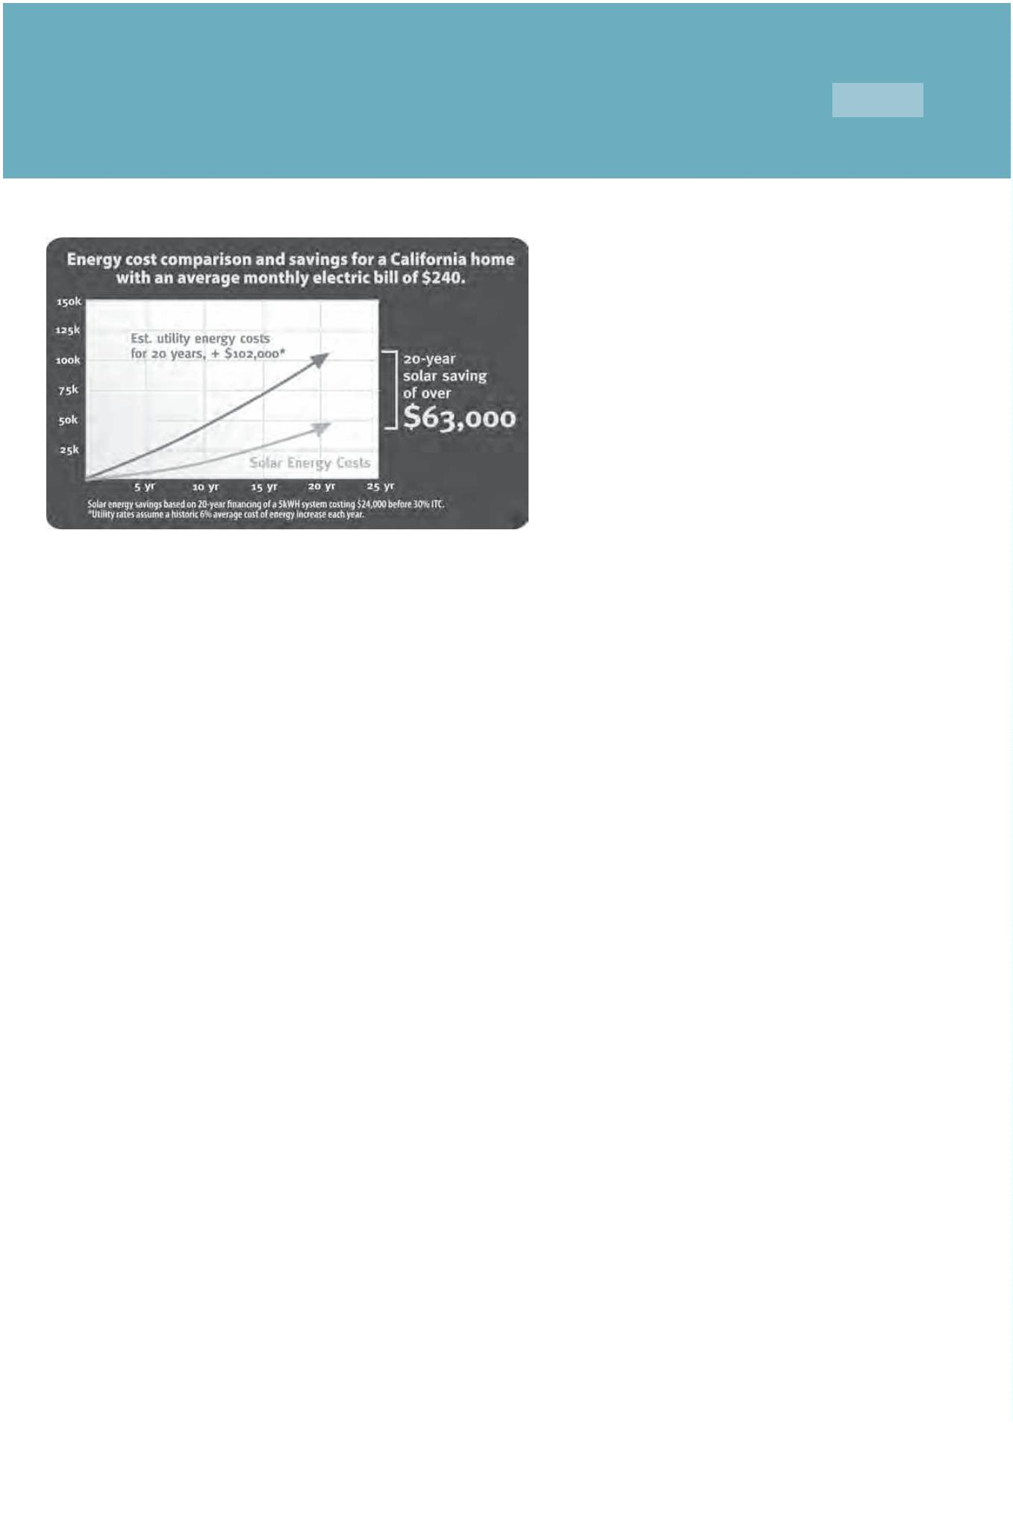

8

The Complete Homeowners’ Guide To Going Solar

#

8: Purchase Options: Lease, Finance, Buy

Going solar is one thing. Making sure that you maximize your investment to save the most

money is quite another. In some cases, solar installers are in the volume game. They want to

install as many solar energy systems as possible, as fast as possible. They have learned that a

system that can be installed in one day yields the greatest proꢀt. So, oftentimes, systems are

designed with this in mind, either under-sizing or oversizing the system to make it a one day

install and maximize the installer proꢀt. It is unfortunate, but that is the corporate world we

live in.

You want to look for a local installer who will custom design a system to yield the results that

YOU want it to yield. Usually those results are saving the most money. So we suggest you

look at TWO ꢀgures. First, your new monthly out of pocket expense for solar, including any

ꢀ

nance payment, interest, and the remaining utility fees. The second number you should look

at is your total savings over a 20-year period.

You will ꢀnd great diꢁerences in the types of ꢀnancing available. Here are some things to

consider.

1

. CASH. A cash payment yields the greatest rate of return and greatest savings

with a rate of return as high as 18% or more.

2

. FINANCING. Your rate of return can still be as high as 10% to 12% even after

paying a 6% interest rate. In the ꢀnancing category, there are diꢁerent loan types.

A. Home Equity Line of Credit (HELOC).

Currently low rates, available thru your local credit union, bank

or ꢀnancial lender.

GOOD FOR A HOMEOWNER WHO:

•

•

•

•

•

can take advantage of the 30% federal tax credit

doesn't want to add any reported debt

has equity in their home

wants to take advantage of the historically low interest rates

wants the ﬂexibility of interest only payment or prepayment

without penalty

B. Green Loans.

Solar Energy Green Loans are renewable energy and eꢂciency loan

administered by a community bank or credit union. Traditionally classiꢀed

as an unsecured loan, but the default rate is much lower, allowing for

better terms and greater savings.

©

2016 Solarponics, Inc.



8

The Complete Homeowners’ Guide To Going Solar

#

8: Purchase Options: Lease, Finance, Buy

B. Green Loans continued

BENEFITS:

•

•

•

•

Eligible for the 30% federal Tax Credit

Interest may be tax deductible

Available with ANY panel manufacturer and equipment

Greatest ﬂexibility of terms and equipment option(s)

GOOD FOR A HOMEOWNER WHO:

•

•

can take advantage of the 30% federal tax credit

does not want to take out a second mortgage, but wants a

lower interest rate than an unsecured loan oﬀers. A green loan

must be used for qualiﬁed energy eﬃcient upgrades only, which

includes solar electric

C. Property Assessed Clean Energy (PACE). Property assessed clean

energy, or PACE, ﬁnancing allows property owners to fund energy

eﬃciency, water eﬃciency and renewable energy projects including solar

PV with little or no up-front costs. With PACE, residential and commercial

property owners living within a participating district can ﬁnance up to

1

00% of their project and pay it back over time as a voluntary property tax

assessment through their existing property tax.

BENEFITS:

•

•

•

•

•

•

•

•

Eligible for the 30% federal Tax Credit

No credit checks

100% Financing

No Banks

No Added Debt

May be Tax Deductible

Fast & Simple Approval

Easily Transferrable If Property Is Sold.

GOOD FOR A HOMEOWNER WHO:

•

•

•

•

•

wants greater solar savings than a lease oﬀers

wants to OWN their solar energy system

doesn't have great credit

MAY sell their home in the next 20 years

wants the added beneﬁt of deducting the interest on the solar

ﬁnancing (consult your tax advisor).

CAUTION: Read your lease carefully. Approach with caution.

Reference: Why a Solar Lease May Not Be Good For a Homeowner. http://wapo.st/1ZyNbxZ

Are Solar Leases Actually Bad For Homeowners? http://bit.ly/1mZkdpb

©

2016 Solarponics, Inc.



8

The Complete Homeowners’ Guide To Going Solar

#

8: Purchase Options: Lease, Finance, Buy

D. emPOWER Central Coast. (Available in select counties in California only)

This is a program that is a ꢀnancing partnership with a local bank or credit

union and the California Energy Commission. It is an easy to qualify

unsecured loan that allows the homeowner to install multiple energy

saving upgrades with one manageable monthly payment.

BENEFITS:

•

Making your home more comfortable, eﬃcient and safe just

got easier. emPower provide a variety of services that includes

rebates up to $6,500, low interest ﬁnancing, free expert energy

advice, personalized

•

•

Upgrade outdated Equipment

Solar energy system is eligible for the 30% Federal Tax Credit

GOOD FOR A HOMEWOWNER WHO:

•

has a grossly energy ineﬃcient home that needs multiple

energy saving upgrades. Multiple upgrades can be ﬁnanced

together

•

doesn't have great credit and cannot qualify for other

unsecured loan.

3

. LEASE. The main practical distinction between buying and leasing a solar PV

system is in ownership. If you buy a solar panel system, you own the system, either

outright (if purchasing with cash) or after repaying your solar loan. When you lease

the system or sign a power purchase agreement (PPA), a third party owns the solar

panel system. This distinction impacts the cost, maintenance, terms, ﬁnancial

oﬀsets, and savings/returns on investment. With a lease, you pay a ﬁxed monthly

“rent”to the solar provider for use of the system. With a PPA, you pay a ﬁxed rate per

kWh for the power generated.

BENEFITS:

•

•

You don’t need a good credit rating to qualify

You only pay for the energy that the system generates.

GOOD FOR A HOMEWOWNER WHO:

•

•

Does not plan on selling the home for the duration of the lease.

Does not have good enough credit to qualify for ﬁnancing.

DOWNSIDE: The homeowner does not get the 30% investment tax credit.

A solar lease or PPA is the most expensive way to add solar to

your roof. While you may still save money each month over

your current energy bill, most of your savings will go to the

leasing company. A lease may also come with an escalator,

which allows your lease payment to increase from 1-3% each

year, further reducing your savings.

©

2016 Solarponics, Inc.



9

The Complete Homeowners’ Guide To Going Solar

#

9: Choosing A Solar Contractor

Choosing a solar installation contractor is a lot like searching for and choosing any other

home contractor. Basically, that consists of doing a little bit of homework on your part. Here

are the top 8 tips that almost all industry insiders agree on.

1

. Recommendations. Beyond just asking a neighbor, “who did you use for your install”,

ask more important questions like, was the project on budget, on time, as planned, was

installation clean, was the crew professional, etc… Check multiple online review sites, not just

one source.

2

. Meet face to face. Is your salesperson focused on educating or selling? You want

a salesperson who has your best interest in mind, not theirs. Also, an in-person visit to your

home insures that the contractor knows the condition of your roof, your current shading

issues, roof venting, access issues, condition of your breaker box, etc…These things cannot be

assssed via Google Earth. Also, does your salesperson know who will be installing the system?

Or will it be a sub-contracted crew from out-of-town?

3

ꢀ

. Get more than one quote. Hand in hand with this is, do not be pressured into signing the

rst quote you get, or any quote until you feel comfortable, informed and ready. The

Department of Energy recommends that you use a LOCAL solar contractor.

. Don’t let price be your only guide. Lowest bid is not what you want when placing a mini

4

power plant on your roof. Contractors do not work for free, so other corners are being cut to

get the price so low. If one quote is considerably more than another, the contractor should be

able to communicate why their price is so high. A high price MAY come with actual added

value. A number of possible reasons come to mind; quality of service, quality of installation,

quality of equipment, service, warranty, trust, etc… Lastly, when comparing quotes, make sure

you are comparing apples to apples. The size of the system in kW DC, equivalent panels,

warranties, service, savings, etc. It is not what the system costs, but what the system will save

you over its lifetime.

5

. Know your equipment. Anyone can say anything about a product. We all want to believe

that American-made panels are great, and all Chinese-made panels are poor. The fact is, there

are inferior American-made panels and superior-made foreign panels. Same with inverters.

Solar panels fall in three main categories, like most all other manufactured products;

economy, standard and premium. You’re not buying a sofa. The quality of your panels will

invariably dictate the rate of return on your investment. Select the highest quality panels you

can aꢁord for your needs. The increase in reliability and eꢂciency will more than pay for itself.

6

. Financing: Your solar contractor can be a key resource in the type of ꢀnancing that is

available to you. However, you must always be your own advocate. Make sure you are doing

what is right for you. Do not settle or be pressured into one type of ꢀnancing that the

contractor oꢁers. Know your total cost of installation and ꢀnancing, NOT just your adjusted

new monthly payment.

©

2016 Solarponics, Inc.



9

The Complete Homeowners’ Guide To Going Solar

#

9: Choosing A Solar Contractor

7

. Experience. The solar industry saw the single largest increase in contractors entering the

market in 2008, the same year as the Energy Improvement and Extension Act was passed, with

dozens of contractors joining the list every day. Having said that, experience is not entirely

based on the number of years a company has been in the business. I know of companies that

have been around for 50 years, in spite of the low quality work and service they perform. I can

say this, the more time we spend on rooftops, the more we learn. Even with over 5,000 solar

energy installs, we still encounter unique situations, but have the experience to know what to

do and not to do. We suggest your contractor have at least 500 installs under their belt, with

a crew lead that has at least four years of solar experience with that company.

8

. Service: Does your solar energy install contractor fully service the systems they install?

Most all systems will promise a 10-year and 25-year warranty. It is important to know who will

be performing the service if and when needed. This is where a local company can potentially

be a huge advantage. Certainly it is not optimum that your solar install contractor be located

1

00 or more miles from your location. Local service also goes hand in hand with experience.

The more experienced your solar contractor is, the less likely you are to need service in the

rst place.

ꢀ

©

2016 Solarponics, Inc.



10

The Complete Homeowners’ Guide To Going Solar

#

10: Choosing the Right Solar Panels

First oꢀ, we recommend that your solar installer choose the right panels for your needs.

Having said that, you will need to know a little something about the panels your contractor is

recommending.

Almost 90% of the world’s photovolaics are manufactured using on some variation of silicon.

The more perfectly aligned the silicon molecules are, the better the solar cell will be at

converting solar energy into electricity. All solar panel frames are made of aluminum. All solar

cells are encased in glass. All of the quality of these components will vary, and will aꢀect the

performance and reliability of the panel. Let’s look at each component.

The frame. All solar panel frames are made of aluminum. The main diꢀerence we have

noticed here is the precision of the corners and screws. The quality and thickness of the

aluminum frame itself can have a structural impact on the panels’lifespan. A more rigid panel

will be less likely to bend, sag or break.

The glass. There are two types of glass used for solar panel frames; tempered and plate.

Tempered glass is what most automotive glass is. Solar panel tempered glass is also clearer,

allowing higher energy conversion. Plate glass is found in cheap panels and may cloud over

time, decreasing the eꢁciency of the panel.

Solar panel color. Typically, monocrystalline solar cells are a dark black color, and the corners

of the cells are usually missing. Polycrystalline solar cells are identiꢂed by their signature light

and dark blue color, and non uniform structure. Both monocrystalline and polychristalline

solar panels can have a black aluminum frame, or an uncoated silver aluminum frame color.

Color as a matter of appearance and aesthetics can be a major factor in choosing a solar

panel manufacturer, but it should not be the primary factor.

Monocrystalline solar cells are quite easy to recognize by an external even coloring and

uniform look, indicating a high-purity silicon. Polycrystalline solar cells look irregular, and can

be in full sheets, not contained cells as you see in monocrystalline panels.

©

2016 Solarponics, Inc.



10

The Complete Homeowners’ Guide To Going Solar

#

10: Choosing the Right Solar Panels

Monocrystaline panels tend to perform better than similarly rated polycrystalline solar panels

and because of their higher eꢀciency, and are slightly more expensive. More eꢀcient panels

means less roof space is needed, so monocrystalline panels are good for limited roof area and

worth the premium. The downside of monocrystaline panels is if a portion of a panel is

covered in shade, dirt, or leaves, the entire string (or circuit) drops production. The use of

micro-inverters can solve this problem. See Part 11: Inverters.

Polycrystalline solar cells. The ꢁrst solar panels based on polycrystalline silicon, which also

is known as polysilicon (p-Si) and multi-crystalline silicon (mc-Si), were introduced to the

market in 1981 Raw silicon is melted and poured into a mold, which is cooled and cut into

square wafers. Generally, polycrystalline solar cells are slightly less eꢀcient, requiring a

greater area to produce the same energy. The advantage is that they are more aꢂordable.

©

2016 Solarponics, Inc.



10

The Complete Homeowners’ Guide To Going Solar

#

10: Choosing the Right Solar Panels

Top solar panel manufacturers. Solar panel manufacturers that have been in the game for

many years, weathered downturns, are ꢀnancially secure, deliver a good product, and have

great warranty service, are limited. Having knowledge and experience with the manufactur-

ers can make a good solar contractor a great solar contractor. We visit the manufacturing

facilities in person in many cases so we can see for ourselves the level of quality and service

the manufacturer delivers.

Our Top Ranked Panels for 2016 based on panel quality, price, reliability, durability,

eꢁciency, degredation, availability and warranty service:

Premium – Both LG and SolarWorld score the highest with consumer ratings.

•

LG Solar: LG Solar brings world-class engineering and 50 years of experience as a global

pioneer in electronics technology. LG panels are as beautiful as they are durable and eꢁcient.

SolarWorld; SolarWorld’s Sunmodule panels are designed and manufactured to the highest

•

standards of quality, performance and durability. SolarWorld also has the advantage of being

made in Hillsboro, Oregon, USA.

Standard:

•

Kyocera: Kyocera is the world’s largest vertically-integrated producers and suppliers of solar

panels. Kyocera has a US-based subsidiary located in Scottsdale, AZ, that served North

America. Established in 1975, Kyocera has produced over 7 million modules.

•

Canadian Solar: Although relatively still a young company, Canadian solar has established

itself as a reliable manufacturer of quality solar products that it sells to customers in 50

countries.

Economy:

•

RenaSola: Renasola oꢂers a range of mono and polycrystalline solar panels. RenaSolar

panels have a high output and are amongst the most eꢁcient on the market today. RenaSola

is active in 19 countries and is well positioned for continued growth not only in the solar panel

market, but also in LED lighting solutions.

•

Trina Solar: Trina Solar has expanded from its roots as an installation company to become

one of the largest manufacturers in the world. They currently hold 575 patents relating to

solar.

Summary: An experienced solar energy analyst will pair your needs and energy goals with

the right panel that will save you the most money. It is your job to ꢀnd the right, experienced,

trusted contractor. Read your contract. Ask questions.

©

2016 Solarponics, Inc.



11

The Complete Homeowners’ Guide To Going Solar

#

11: Inverters

Since your panels produce energy in DC, and your home runs on AC, the power inverter is the

heart and brains of your solar energy system. Most homes only need a single inverter that is

the go-between the solar array, the home and the grid. The larger the solar array gets, the

more inverters that are needed. Adding battery-backup and energy storage to a system adds

another dimension to the function of the inverter.

Your solar energy installer will worry about things like inverter sizing, stacking, battery

interface, charge controllers, load ratings, wiring requirements, shut-oꢀs, monitoring, etc…

This is a specialized area that beneꢁts from the expertise of an in-house system designer.

There are good inverter manufacturers and not-so-good inverter manufacturers. Some

inverters work better with some panels than others. The more solar experience a solar install

contractor has, it is safe to say the more knowledge and experience he or she has about solar

inverters. Selecting a properly sized and matched inverter will deliver a better performing

system. Here are a few that we have used for many years and have found to be very capable;

SMA - As a leading global specialist for photovoltaic system technology, SMA is

setting the standards today for the decentralized and renewable energy supply of

tomorrow. More than 5,000 SMA employees in 21 countries have devoted

themselves to this task. SMA Inverters claim a 96% or greater eꢂciency rating, and

maximum service life.

SolarEdge - The SolarEdge inverter combines sophisticated digital control

technology with eꢂcient power conversion architecture to achieve superior solar

power harvesting and best-in-class reliability. SolarEdge inverters have built-in

module-level monitoring receiver and carry a 12-year warranty.

Enphase – Enphase products are designed to deliver more power, but also with

less need for maintenance and repairs. Our state-of-the-art testing facility is tough

on our equipment, so we know it will stand up to the test of time. Enphase

microinverters get more power from the same solar panels. This means greater

savings for you. Each microinverter connects to a single solar panel so, unlike other

types of inverters, if there is a dirty, shaded or problem panel, the rest of the system

keeps running smoothly.

OutBack Power – OutBack Power inverter/chargers have a reputation of delivering

superior product performance for remote oꢀ-grid power systems. With the recent

introduction of the Radian Series Inverter/Charger, OutBack now oꢀers an ideal

solution for advanced Grid/Hybrid applications and full ꢃexibility for

grid-interactive and oꢀ-grid installations.

©

2016 Solarponics, Inc.



12

The Complete Homeowners’ Guide To Going Solar

#

12: Signing The Contract

Know what you are getting. It is not enough to simply know that your system will produce

kWh of energy. Brands and model type of panels and inverters are important, and can vary

5

widely in price, quality and performance, as we have seen. Also, system size should be listed

in AC. The AC output will be a lower ꢀgure than a DC output. That is because there is a loss in

conversion from DC to AC. A contractor should not show you a proposal with an AC kWh

ꢀ

gure. This is misleading, as it makes the system appear larger than it really is.

Know what you are paying, not just in a monthly payment amount, but over the life of the

system, whether you pay cash, ꢀnance or lease. We present our customers with three options

that all address their wants and needs, and vary in equipment and cost from premium to

economy. With each option, the homeowner can see what his or her out-of-pocket is, the rate

of return, as well as the total investment over time. Look at your new monthly payment,

payment terms, and total payments at end of term.

NOTE: Understand that you will still have a statement due from your public utility,

even if your system is designed to produce 100% of your energy needs.

What you see is what you get. Make sure that everything that was promised in the “sell”is

included in the contract. Trenching, if you need it to run conduit, should be included. But if

the contractor hits rock while trenching, or other unknown obstacles, there may very well be

an adder.

Escalator or ꢀxed Price for a PPA: Over the term of the PPA there will be a ꢀxed or escalat-

ing price. For example, it could be set at 3% each year. If there is a price escalator then you

want to understand whether it is monthly, annually or bi-annually.

Operations and Maintenance: If the system comes with monitoring, knowing who is

responsible for this is very important. Typically, if your system stops producing for whatever

reason, you are responsible to notify the appropriate parties, and are NOT entitled to lost

energy compensation.

Incentives and Rebates: Before you sign, make sure that you fully understand your costs and

opportunities regarding the ITC, rebates, or other incentives. We advise you to contact your

tax professional.

©

2016 Solarponics, Inc.



12

The Complete Homeowners’ Guide To Going Solar

#

12: Signing The Contract

Payment Schedule: Understand what you will owe and when. Oftentimes a deposit is

required before the job starts, with future payments due at installation milestones.

Property Sale: Know your options if you have to move at any time during the course of your

ꢀ

nancing, lease agreement or PPA. Some leases carry a lien on the property.

Schedule: It is always a good idea to know the timeframe of the install. Solar energy installs

take about 10-12 weeks on average from start to ꢀnish. However, if you sign with a contractor

who is overbooked, your wait could be up to 6-months or longer.

3

-Day Right To cancel: Of course, you have three days to cancel the contract for any reason

after you sign.

©

2016 Solarponics, Inc.



13

The Complete Homeowners’ Guide To Going Solar

#

13: Production Schedule: How Long Will Install Take

A solar energy install generally takes about 10-12 weeks from start to completion.

First, a project designer designs your system. This includes drawings of your roof, electrical

components, pitch, setbacks, extrusions, etc… The system is designed around your roof,

angle, position to sun, and your energy needs. Additionally, an experienced designer will take

into eꢀect the aesthetics of the design from the roof position to ground-level perspective.

Typically the technical drawing of your system will not be too far oꢀ from the proposal you

saw before signing your contract, so there are no surprises here.

Once complete, you should be presented with a plan that shows the size, placement, and

position of your system, including electrical runs, inverter(s), and tie-in. Once you approve

the design, your permit and design is submitted to the building & planning oꢁce.

Once approved by the planning oꢁce, your system equipment is ordered. Upon arrival of

equipment, your job is scheduled for install. Depending on the size and complexity, your

install could take from one day to a week or longer.

Once installed, your system gets inspected and either passes or needs some adjustments

based on the inspectors ꢂndings. Once it passes, a Permission To Operate (PTO) is ꢂled with

the utility company. The utility company has 30 days to review and approve. Once your PTO is

approved, we ꢃip the switch, and you begin generating your own solar energy.

Note: Ask what your install schedule is, and what happens if that schedule needs

adjusting. Some contractors are small and overbook, pushing installs out 6-months

or longer. Even a few months of lost solar energy production can cost you several

hundred dollars or more in energy savings.

On the next page, see example ꢂg. 1, is our sample production expectation form. We created

this to help homeowners understand the process with more certainty, and understand the

timeline. It is also a sort of promise on our part to follow their project through in a timely and

responsible manner.

©

2016 Solarponics, Inc.



1

3

The Complete Homeowners’ Guide To Going Solar

©

2016 Solarponics, Inc.

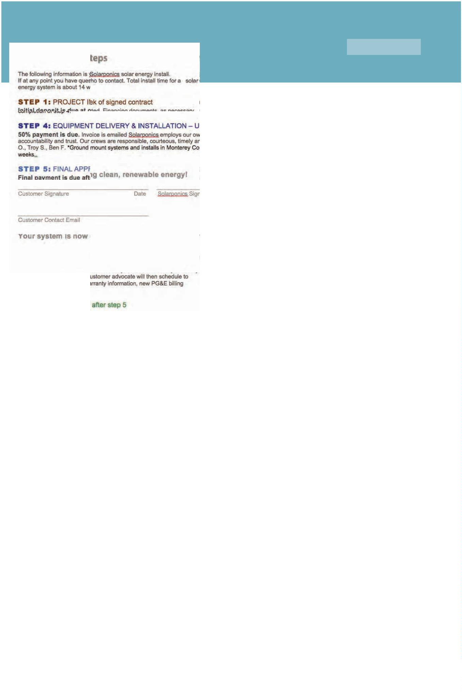

14

The Complete Homeowners’ Guide To Going Solar

#

14: Warranty & Maintenance

Once your utility has issued a PTO, your billing structure changes. See Net Energy Metering,

Part 3. As there are no moving parts, a solar energy system is very reliable and does not

require much maintenance. Having said that, there are some important things to understand

about your solar energy system even BEFORE you purchase.

If you decide to lease a system, you will be told that all service and maintenance is

covered under the terms of the lease. This IS NOT TRUE. Warranty issues are covered.

Maintenance is not. Read your lease agreement closely.

Warranty coverage: Nearly all of the solar panel manufacturers that we have researched

oꢀer a 25-year panel performance warranty. These performance warranties guarantee that

the panel will perform within a certain eꢁciency that decreases over time, for 25 years. Most

manufacturers guarantee at least 80% output at year 20. Inverters typically come with a

1

0-year or 12-year warranty. Warranty for workmanship varies. Typically, your roof warranty

should be a minimum of ꢂve years, and can be as long as ten years.

Solar panels really are built to last and are not the component that is most likely to fail. This is

because the PV technology results in very little breakdown of the materials over time, much

like transistors and computer chips. However, solar panels are the components most

susceptible to damage from hail, hurricanes and other weather born threats.

So what is maintenance? Solar panels get dirty. Dirty panels can reduce eꢁciency by 15% or

more. In dusty areas, it is a good idea to wash oꢀ your solar panels as needed. It is also a good

idea to make sure that trees do not grow and shade part of your array. We also recommend

that you occasionally check and clean your inverter fan, to make sure there are no obstruc-

tions or debris build-up. Loose wire connections are also a major cause of system disruption.

This is mostly the cause of inferior installation quality. And although the service call to

trouble-shoot and correct a loose wire problem should be covered under a warranty, the lost

energy generation, your lost savings, are not covered. All of these maintenance suggestions

will keep your system in top working condition, and potentially reduce failure and/or

warranty issues.

©

2016 Solarponics, Inc.



15

The Complete Homeowners’ Guide To Going Solar

#

15: Monitoring

Monitoring: Solar energy monitoring is the process of connecting your inverter to cloud-

based software that aggregates and organizes large amounts of performance data, making it

easy to monitor the performance of systems. The data is typically available via an app on a

smartphone or tablet (ꢀg. 1). Monitoring systems will either require an on-site internet

connection at the location or use a cell-based connection.

Whether or not you want monitoring should be a decision you should discuss with your solar

install contractor. System monitoring may require special equipment and system design

upfront. It is also important to understand the costs of monitoring vs. the beneꢀts.

Customers who do not have system monitoring can easily check the status of their solar

energy system by simply looking at the display on the inverter (ꢀg. 2).

ꢀg. 1

ꢀg. 2

©

2016 Solarponics, Inc.

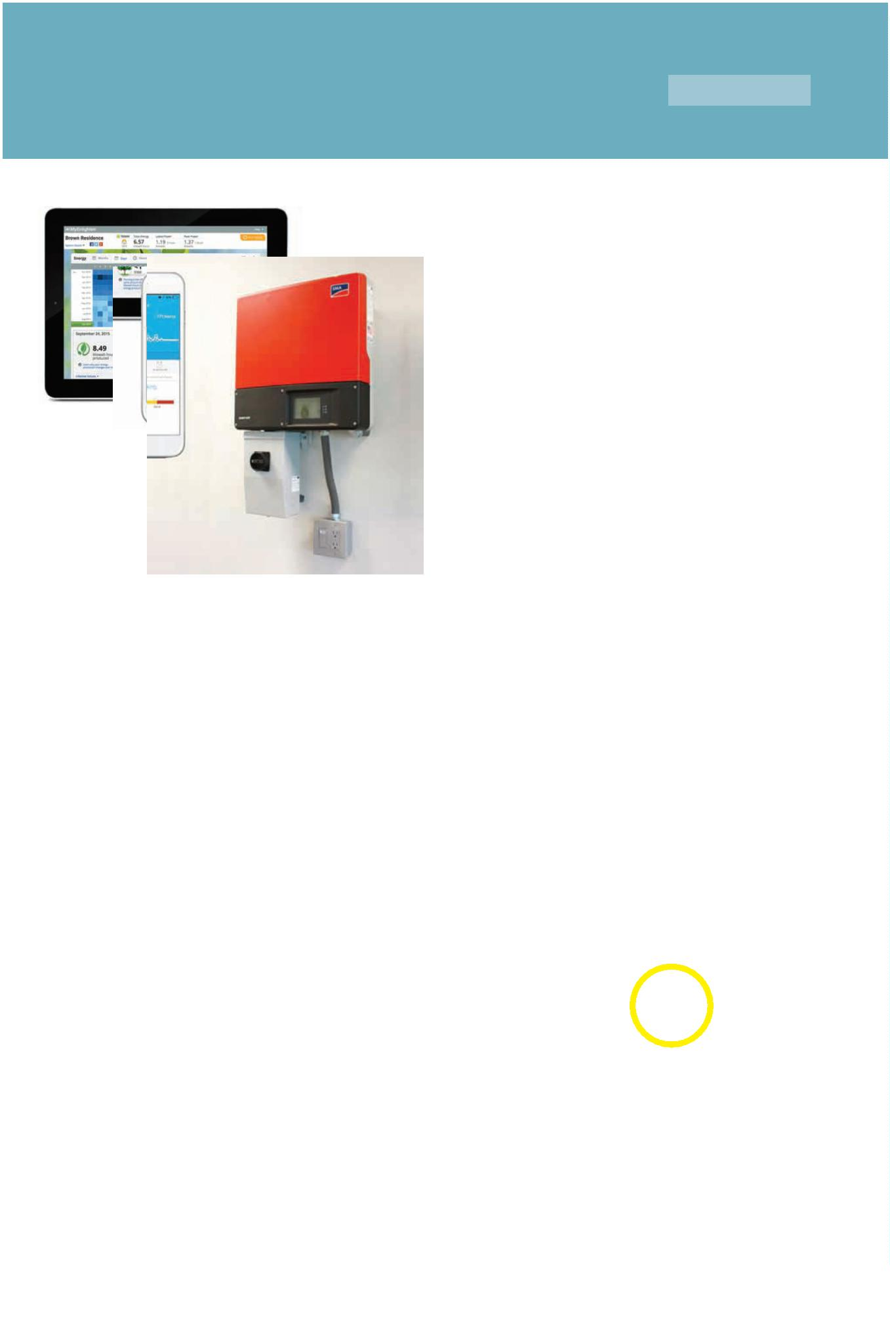

16

The Complete Homeowners’ Guide To Going Solar

#

16: You’re Online. Now What.

Once your utility has issued a PTO, your billing structure changes.

See Net Energy Metering, Part 3.

As there are no moving parts, a solar energy system is very reliable and does not require

much maintenance. If you live in a rural, dusty area, it is recommended that you inspect your

solar array for a buildup of dust, and wash the panels clean with water and a mild window-

cleaning solution, or specialty solar panel solution. Dirty panels can aꢀect energy production

by as much as 30%.

You will want to periodically check your inverter to make sure it is operating eꢁciently,

making sure the fan is clear, and there is also no build up of debris around the vented areas.

We also recommend that you read your energy statement every month, and look for any

anomalies in your energy production vs. usage. Aside from weekly or daily monitoring, your

statement is your best guide to system performance and your energy use.

Production Output: Residential solar panels are designed to produce upwards of 95% in the

ꢂrst 10 years, and degrade slowly. Most panels are guaranteed to produce at least 80% of

their stated production levels for 25 years.

Buying an Electric Car: If you know you will be buying an electric vehicle at some point in

the near future, you should discuss this with your installer and size your solar panel system

accordingly, accounting for the increased future electric usage. The same goes for any

appliances that are huge energy hogs, like a spa, second refridgerator, or second AC unit.

Adding panels after the fact. It is possible, but not ideal, to add panels to your system at a

later date after the initial install. There are two main considerations here aside from the

added cost. First is the size of your inverter. The inverter needs to be sized appropriately for

the system that you currently have for maximum eꢁciency. Typically you may be able to add

two panels and still be within the operational range of the existing inverter. Second, the new

panels will need to be the same make and model, and sourcing these panels may be diꢁcult.

Equipment Replacement: Your inverter should last at least ten years or more. You will most

likely have to replace the inverter before year 15.

Good luck on your journey to greater energy independence.

©

2016 Solarponics, Inc.



17

The Complete Homeowners’ Guide To Going Solar

#

17: Frequently Asked Questions

How much does a solar electric system cost?

The cost of your solar investment will vary greatly depending on the size of the system, your location and

available incentives. The average cost is around $20,000 for a home with an energy bill of $200/month.

It is better to understand payback time, which is averaging 5 years.

Can my electric bill really be $0?

Your charges for energy use can be $0, but you will still have connection fees and utility taxes.

What incentives are available to me?

Purchases are eligible for the U.S. 30% federal tax credit. Additional state, local and utility incentives exist

in some areas, further lowering the net cost of your investment. No other incentives or rebates are

available to homeowners in California.

Do I get paid for my extra energy production?

Currently, most of America is under a system known as Net Metering, which allows your net electricity

costs to be reduced to zero, but no further. In a select few places in the U.S., you can be paid for any

excess electricity you create, in what is known as a Feed-In Tariꢀ system. But you will be paid a very low,

wholesale rate.

Can I install solar panels myself?

It is not recommended. The process requires both licensed electrical and rooꢁng skills to ensure the solar

power system is safe and optimally designed for 25+ years of production.

How does a solar system aꢀect my roof integrity?

With proper design and installation following industry best practices, your roof should maintain all its

pre-solar integrity. Be sure to ask your installer about any guarantees they oꢀer on their installation

quality.

Is solar a viable option in cold climates?

Yes. A general rule of thumb is that if you can clearly see your solar panels, they can produce electricity. In

fact, given equal sunlight, a solar panel on a cold day will out-produce a solar panel on a hot day.

How does snow aꢀect a solar system’s performance?

While snow will decrease production while it is on your panels, it should not damage your system when

designed and installed properly. Given the angle of the panels and their tendency to produce some heat,

the snow will fall oꢀ your panels faster than it would fall oꢀ your roof, quickly returning your system to its

full potential.

How do solar systems fair in extreme weather conditions?

That depends on the quality of the manufacturer. SolarWorld Sunmodule solar panels can withstand

high wind and snow loads. In fact, they are rated higher than any other solar panels under UL standards.

Will my system still generate power during a blackout?

For the safety of workers attempting to ꢁx power outages, solar systems that are connected to the

electrical grid are required by utility regulations to shut oꢀ during blackouts

©

2016 Solarponics, Inc.



17

The Complete Homeowners’ Guide To Going Solar

#

17: Frequently Asked Questions

Can I take my home oꢀ the electrical grid?

Yes, provided you install optional battery-backup systems to provide power when your demands exceed

your production, such as at night. Batteries add signiꢀcant costs to your system, extending your payback

period. But staying connected to the grid ensures you will rarely ever be without power, unlike batteries

that have a limited lifespan and storage capacity.

Can my HOA or neighbors prevent me from installing a solar system?

In most cases, no. According to DESIRE (Datsbase of State Incentives For Renewable Eꢁciency), “HOA’s are

barred from restricting a homeowner’s rights to install solar panels. California has laws that override any

HOA contracts seeking to deny the right to install solar PV systems.

I don’t plan on being in my home for 25 years. Why would I add solar?

People move more frequently now than ever before, but that shouldn't impact your solar decision. A

solar system can save you money today and even pay for itself in as little as ꢀve years. Even if you move

before your solar investment is completely paid oꢂ, studies show the cost will likely be returned in added

value to your home. Plus, your home will most likely sell faster.

Will adding solar energy raise my property taxes?

People move more frequently now than ever before, but that shouldn't impact your solar decision. A

solar system can save you money today and even pay for itself in as little as ꢀve years. Even if you move

before your solar investment is completely paid oꢂ, studies show the cost

Will a solar system work on cloudy days?

Yes, though they will be less eꢁcient. A heavy fog day in San Francisco can drop eꢁciency by up to 80%.

How can I tell if my system is producing?

If you have monitoring set up, simply log in to your account to see what current production is. If you do

not have monitoring, you can simply look for a green light on your inverter, indicating the system is

operating correctly. Additionally, most inverters have a small display screen that will show you current

production. Your smart meter will also be an indication of solar energy production.

How heavy is a solar panel?

The average solar panel weighs about 45lbs. and is roughly 65”x 40”, consisting of 72 cells.

Where can I learn about solar companies in my area?

http://www.gosolarcalifornia.ca.gov/csi/step2.php

www.homeadvisor.com

National Solar Database - http://www.seia.org/research-resources/national-solar-database

www.mysolarinstaller.com

www.AngiesList.com

www.solar-estimate.org

©

2016 Solarponics, Inc.



The Complete Homeowners’ Guide To Going Solar

Originally published by Solarponics, Inc., December 23, 2013.

About Solarponics.

Solarponics was founded in 1975 by Cal Poly engineering graduate, Mike Emrich, holding the title of the

oldest, continuously operating solar energy company in California. The company has grown from 12 to

4

0 employees since 2012, when Kristian Emrich took over the day-to-day duties of President, COO. Mike

Emrich continues to serve Solarponics as chairman and CFO.

Solarponics was voted Green Business of the Year in 2012, Atascadero Business of the Year in 2014, and

Paciꢀc Coast Business Times Family-Owned Business of the Year in 2015. Solarponics wrote and lobbied

for the resolution to proclaim June 21st “Solar Energy Day”in San Luis Obispo County in 2014. Employees

are regular guest visitors in local classrooms from the 2nd grade thru 12th grade and at Cuesta College.

Solarponics has participated in two Solarize programs sponsored by the Community Environmental

Council, and is currently participating in the emPower Central Coast Program, supporting and

encouraging home energy eꢁciency and energy reduction county-wide. For more information, contact

Frank Scotti at (805) 466-5595.

To date, Solarponics has installed over 5,ooo renewable energy systems for Central Coast California

homeowners and business owners. Solarponics specialize in solar water heating, solar pool heating,

radiant heating, wind energy, battery storage and back-up systems, DIY kits and solar electric systems for

residential and commercial projects. Solarponics can be reached at (805) 466-5595, at

www.solarponics.com or via email to kristian@solarponics.com.

About Frank Scotti

Mr. Scotti is an award-winning marketing professional with 25-years of experience. He has worked at

several global ad agencies including Ogilvy & Mather, Leo Burnett, J. Walter Thompson, BBDO, and

Asatsu. His past clients include; Allstate, American Express, CNN International, Coca-Cola, IBM, Lexus,

Morgan Stanley, Marines, Phillip Morris, Proctor & Gamble, and Royal Carribian Cruises, Ltd., to name a

few. His began working with Solarponics in 2008, through Whizbang, their marketing agency of record.

During the next four years, Mr. Scotti saw the unprecedented potential for growth of renewable energy

and joined Solarponics full-time in 2012.

Frank Scotti can be reached at: frank@solarponics.com, or ww.linkedin.com/in/frankscotti

Solarponics president, Kristian Emrich can be reached at kristian@solarponics.com

©

2016 Solarponics, Inc.

©

2016 Solarponics, Inc.

