A PROJECT REPORT ON

ELDER FALLING DETECTION SYSTEM USING SPI PROTOCOL WITH ADXL 345 IMPLEMENTED ON FPGA BOARD



Submitted by
CH. RAM GOPAL
G. STALIN
B.C. GOVARDHAN

Under the guidelines of:
Mr.Sudheer Reddy Mr.P. Tejeswara Rao
Chairman and founder of SSIT FPGA Consultant

Abstract:

Falls are among the most serious health risks for the elderly, often resulting in injury, loss of independence, or even fatality when immediate assistance is not available. With the increasing aging population, the need for reliable and real-time fall detection systems is more important than ever. According to statistics, falls are the primary cause of injury or death for the elderly over 65 years old. About 30% of the elderly over 65 years old fall every year. Along with the increase in the elderly fall accidents each year, it is urgent to find a fast and effective fall detection method to help the elderly fall.
To solve the above problem, in this paper, we propose an approach for the designing and implementation of a wearable fall detection system using the ADXL345 3-axis accelerometer interfaced with an Artix-7 FPGA (also called as Nexys A7 board) through the SPI protocol.
The system continuously monitors acceleration data to identify fall events based on a combination of free-fall detection, impact recognition, and subsequent inactivity. The detection logic is implemented in Verilog HDL using a threshold-based finite state machine (FSM) that processes real-time sensor data. Upon detecting a fall, the system triggers a visual and/or audible alert via an LED or buzzer, enabling timely response from caregivers or emergency systems.

Introduction:

As the global population continues to age, ensuring the safety and well-being of elderly individuals has become a growing concern in both healthcare and home environments. Among the various health risks faced by seniors, falls represent one of the most common and dangerous incidents. According to the World Health Organization (WHO), falls are the second leading cause of unintentional injury deaths worldwide, with individuals aged 65 and above being particularly vulnerable. About 30% of the elderly over 65 years old fall every year. In 2015, there were 29 million elderly falls in the United States, of which 37.5% required medical treatment or restricted activities for 1 day or more, and about 33,000 people died. Falls not only make the elderly suffer moderate or severe injuries, but also bring a mental burden and economic pressure to the elderly and their relatives. Faced with this situation, it is particularly important to quickly and effectively detect the fall of the elderly and provide emergency assistance. In a word, it is extremely important for those who fall and cannot call for help to be found in time and to be treated.
Traditional fall detection methods include manual alarms, wearable buttons, or camera-based monitoring systems. However, these approaches either require user intervention—which is not always feasible after a fall—or raise privacy concerns in personal spaces. To address these limitations, wearable sensor-based solutions have emerged as a more effective and privacy-preserving alternative. Among these, accelerometers play a vital role due to their ability to detect motion, impact, and orientation changes in real-time.
This project presents a real-time fall detection system using the ADXL345 accelerometer and Artix-7 FPGA (Nexys A7) via SPI communication. It uses a Verilog-coded FSM to analyse acceleration data and detect falls based on free-fall, impact, and inactivity patterns. When a fall is detected, an alert is triggered through a buzzer or LED. The system highlights how FPGA-based designs can provide fast, reliable, and privacy-friendly solutions for wearable health monitoring.

Objectives:
- Establish Communication Between ADXL345 and FPGA via SPI Protocol
The first objective is to set up reliable and continuous communication between the ADXL345 accelerometer and the Artix-7 FPGA using the SPI protocol. This includes writing Verilog code for an SPI master that can read and write to the sensor’s internal registers.
- Configure the ADXL345 for Real-Time Acceleration Measurement
Proper configuration of the ADXL345 is critical. This includes writing to its control registers to enable measurement mode, setting the output data format, and defining the measurement range (e.g., ±2g or ±4g), so the sensor can accurately capture sudden motion changes associated with a fall.
- Acquire and Process 16-bit Signed Acceleration Data from X, Y, and Z Axes
The FPGA should continuously fetch the raw acceleration values from the sensor, correctly combine the low and high bytes for each axis, and perform sign extension to preserve the signed 16-bit format. This processed data will serve as the core input for fall detection.
- Implement a Threshold-Based Fall Detection Algorithm in Verilog
Using the acceleration data, a logic module (FSM) will analyse the magnitude and patterns to detect fall events. The detection logic should identify sequences like free-fall, sudden impact, and subsequent inactivity, which are typical indicators of a fall.
- Trigger Visual or Auditory Alerts When a Fall is Detected
Upon detecting a fall, the system must immediately activate a buzzer or light up an LED to alert caregivers or nearby individuals. This objective ensures the system can respond instantly and visibly in real-world situations.
- Achieve Real-Time and Low-Latency Operation Using FPGA Hardware
By implementing the entire detection mechanism in hardware (Verilog on FPGA), the system should be able to process inputs and make decisions within milliseconds, unlike software systems that may introduce lag. This objective is vital for time-sensitive medical response.

Hardware Requirements:
Artix-7 FPGA Development Board :
The Artix-7 FPGA family from Xilinx is manufactured using a cutting-edge 28nm high-performance, low-power (HPL) CMOS process, which provides an excellent balance of power efficiency and high logic density. This makes the Artix-7 ideal for applications that require low power consumption without sacrificing computational power. Depending on the specific device model, the Artix-7 offers a wide range of resources, including up to 215,360 logic cells, 740 DSP slices for intensive digital signal processing, and as much as 13,800 Kbits of fast block RAM. These features allow it to handle both simple control tasks and complex, high-speed computations effectively.
In addition to its computational resources, the Artix-7 supports a versatile set of memory and interface options. It is compatible with DDR3 and DDR3L memory standards, enabling high-bandwidth data storage and retrieval. The FPGA also features numerous user-accessible I/O pins, often exceeding 500, which support multiple communication protocols such as SPI, UART, I²C, and high-speed LVDS serial interfaces. These interfaces ensure seamless connectivity with external sensors, memory modules, and communication devices.
One of the notable built-in peripherals is the XADC (Xilinx Analog-to-Digital Converter), a 12-bit ADC capable of sampling analog signals at up to 1 million samples per second. This enables the Artix-7 to perform mixed-signal processing and monitor analog inputs without requiring external ADC components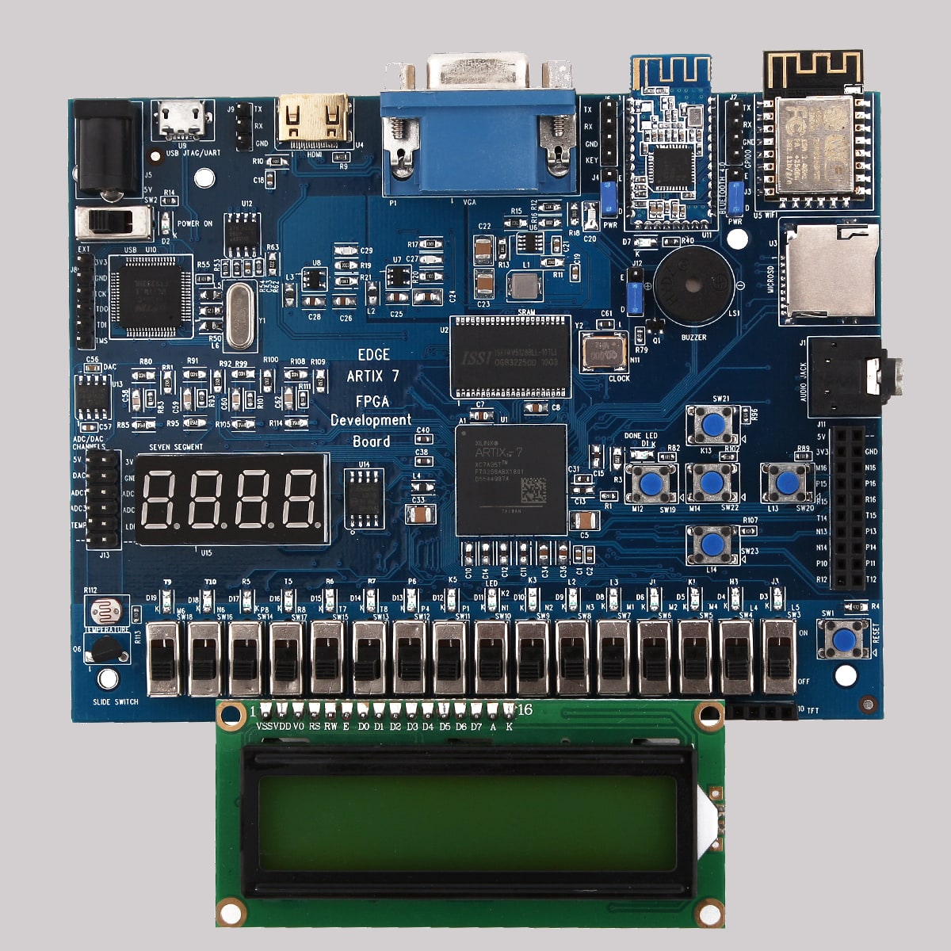

A popular implementation of the Artix-7 FPGA is found on the Digilent Nexys A7 development board, which uses the XC7A100T-1CSG324C chip. This particular FPGA model provides 15,850 logic slices, 240 DSP slices, and 4,860 Kbits of block RAM, along with access to over 200 user I/O pins. Additional onboard components like LEDs, pushbuttons, switches, 7-segment displays, VGA output, and audio codec support make it an excellent platform for prototyping diverse embedded systems.Overall, the Artix-7 FPGA series stands out as a cost-effective, power-efficient, and highly flexible platform for modern digital design. Its combination of high logic capacity, rich peripheral support, and efficient power management makes it ideal for applications such as real-time signal processing, embedded control systems, and advanced sensor interfacing, including projects like fall detection systems.

ADXL345 Accelerometer Module:
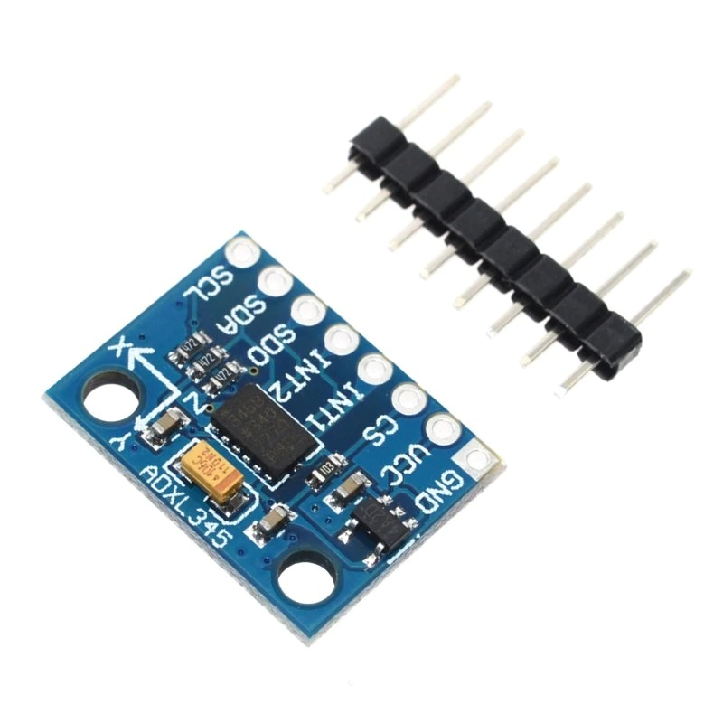
The ADXL345 is a compact, low-power, 3-axis digital accelerometer manufactured by Analog Devices. Built with advanced microelectromechanical system (MEMS) technology, it provides high-resolution motion sensing in a small footprint, making it an excellent choice for embedded systems that require precise measurement of acceleration, tilt, and vibration.
This sensor can measure acceleration with a selectable range of ±2g, ±4g, ±8g, and ±16g, allowing for flexibility in detecting both subtle movements and rapid motions. It outputs data digitally via either a standard I²C or SPI interface, facilitating easy integration with microcontrollers, FPGAs, or other digital platforms. The ADXL345 supports a data rate from 0.1 Hz up to 3200 Hz, providing fast and responsive motion tracking suitable for real-time applications.
One of the ADXL345’s strengths lies in its onboard 13-bit analog-to-digital converter (ADC), which ensures accurate and high-resolution readings. Combined with its programmable interrupts and configurable thresholds, it can detect events like free-fall, tap, double tap, and activity/inactivity, offloading these processing tasks from the host processor and improving system efficiency.
The sensor’s low power consumption (typically around 40 µA during measurement mode) makes it highly suitable for battery-powered and portable devices. Its supply voltage ranges from 2.0 to 3.6 V, allowing compatibility with common embedded power rails.
Commonly used in applications such as motion-based gesture recognition, device orientation sensing, and fall detection systems, the ADXL345’s compact size, versatile interface options, and advanced features make it a popular choice for developers aiming to add motion awareness to their projects.
The ADXL345 accelerometer combines high accuracy, flexible measurement ranges, and power-efficient operation within a small MEMS package. These characteristics make it ideal for applications ranging from wearable devices and gaming controllers to healthcare monitoring systems, where precise and reliable motion sensing is critical.

Buzzer or LED for Alert Output
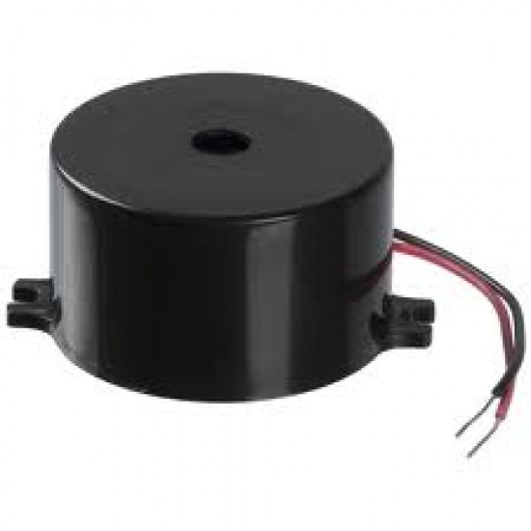
Used to give a clear visual or audible signal when a fall is detected by the system.
- Jumper Wires
Required to connect the sensor and output devices to the appropriate pins on the FPGA board.
- Breadboard
Helps in testing and organizing connections without soldering during the development and debugging phase.

Software Required:
- Xilinx Vivado Design Suite
Used for writing Verilog code, synthesizing the design, assigning pin constraints, and programming the FPGA.
- Intel Quartus Prime (if you are using DE-10 NANO board)
This is the primary development environment used to write, compile, and synthesize Verilog code, assign pin constraints, and program the DE10-Nano FPGA.
- Verilog HDL
The hardware description language used to develop the SPI communication module, ADXL345 interface logic, fall detection FSM, and alert control logic
.
Working principle:
The Elder Fall Detection System uses a digital 3-axis accelerometer (ADXL345) interfaced with the FPGA (here the FPGA is Artix-7) to detect sudden or sustained orientation changes that indicate a fall. The system continuously monitors the Z-axis acceleration values and activates an alert if the Z-axis value remains below a set threshold for a specified time duration (e.g., 3 seconds), suggesting the person is lying down after a fall.

1. Sensor Initialization via SPI
The FPGA initializes the ADXL345 sensor using SPI communication:
- The SPI master module sends a write command to enable measurement mode (0x02 to register 0x2D).
- It then enters a continuous loop of burst reads starting at register 0x0E to collect X, Y, and Z axis data.

2. Data Collection
- The SPI master captures 16-bit signed data for each axis.
- For simplicity, the data is reduced to 5 significant bits per axis (configurable) and latched into an output register accelerometer data at every read cycle (~100 Hz).

3. Fall Detection Logic
- The top module reads accelerometer data and sign-extends the Z-axis component to a full 16-bit signed value.
- It checks if z axis data is continuously less than a threshold (e.g., -900), which indicates the person is likely on the ground (low vertical acceleration).
- A counter increments for every clock cycle (assumed 100 MHz) while the Z value remains below the threshold.
- If the condition persists for 3 seconds (i.e., 300 million clock cycles), the system activates a buzzer to signal a possible fall incident.

4. Reset Behaviour
- If the Z value rises above the threshold (indicating movement or recovery), the counter and buzzer are reset immediately, ensuring no false alarms if the person is just briefly idle.
System Design:
a. Block diagram:
ADXL345 Accelerometer
|
SPI
|
FPGA (Artix-7)
┌───────────────┐
│ Fall Detection│
│ FSM Logic │
└───────────────┘
|
ALERT SYSTEM
(LED / Buzzer)

b. Sensor Interface:
- Communication Protocol: SPI
- SPI mode: 3
- Device Address: SPI-based chip select (no I2C address)
- Important Registers:
  - POWER_CTL (0x2D): Set to 0x08 to enable measurement mode
  - DATA_FORMAT (0x31): Configured for ±2g or ±4g range
  - DATAX0 – DATAZ1 (0x32 – 0x37): 16-bit signed axis data

c. FSM flow:
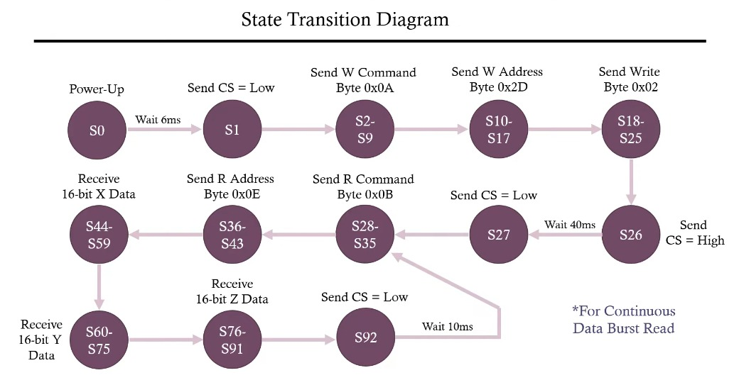

The FSM starts at the power-up state (S0) with a 6 ms wait for sensor stabilization. In S1, CS is pulled low to begin SPI communication. The FSM then sends a write command (0x0A), the POWER_CTL register address (0x2D), and the data byte 0x02 to enable measurement mode (states S2–S25). After setting CS high in S26 and waiting 40 ms, the FSM moves to the read phase. It pulls CS low again (S27), sends a read command (0x0B) and the data start address (0x0E) (states S28–S43). The FSM then reads 16-bit acceleration data for X (S44–S59), Y (S60–S75), and Z (S76–S91) axes. After reading, it sets CS high (S92), waits 10 ms, and loops back to the read phase for continuous data acquisition.
OPERATION OF ELDER FALLING SYSTEM:
State Machine Flow for SPI Communications with 3-Axis Accelerometer
1. Wait for 6ms to allow sensor to power up and go into standby mode
2. Send a write instruction (0x0A)
3. Send the register address to write to (0x2D)
4. Send the data to be written (0x02) <-- sets mode to measurement mode
5. Wait for 40ms to allow sensor to calculate valid data after being put into measurement mode
6. Send a read instruction (0x0B)
7. Send the register address to read from (0x0E) <-- LSB of X axis data
8. Read X axis LSB
9. Read X axis MSB
10. Read Y axis LSB
11. Read Y axis MSB
12. Read Z axis LSB
13. Read Z axis MSB
14. Wait for 10ms to allow calculation of another set of valid data, loop back to 6.
Notes about the sensor retrieved from the ADXL362 datasheet:
- The sensor defaults to standby mode 5ms after power up
- No measurement functions are active in standby mode
- After putting sensor in measurement mode it takes 40ms to produce first data set
- The default data rate of the sensor is 100Hz <-- 10ms for a new data set
- The SPI Mode of the sensor is CPOL = CPHA = 0 <-- SPI Mode 0
- The max. SCLK for the sensor is 8MHz, min. is 12.5kHz
- Recommended SCLK speed is 1MHz to 8MHz
- For a burst read only the address of the first register to read from is needed, the
register address pointer in the sensor is auto-incremented to the next register in
hex order couting up until communications have been disabled by the master
- The sensor only reacts to 3 different instructions:
- 0x0A : write register
- 0x0B : read register
- 0x0D : read FIFO (for more information on the FIFO, see the datasheet)

IMPLEMENT SYNTHESIS
CODE
module spi_master(
input iclk, // 4MHz
input miso, // master in
output sclk, // 1MHz
output reg mosi = 1'b0, // master out
output reg cs = 1'b1, // slave chip select
output [14:0] acl_data // 15 bit data, 5 each axis
);

// Control sclk output for spi mode
reg sclk_control = 1'b0;

// Create a 1MHz signal from a 4MHz signal
// For a 50% duty cycle
// 4 x 10^6 / 1 x 10^6 / 2 = 2
reg clk_counter = 1'b0;
reg clk_reg = 1'b1;

always @(posedge iclk) begin
clk_counter <= clk_counter + 1;
if(clk_counter == 1'b1)
clk_reg <= ~clk_reg; // this is sclk
end

reg [7:0] write_instr = 8'h0A; // Sensor write instruction
reg [7:0] mode_reg_addr = 8'h2D; // Mode register address
reg [7:0] mode_wr_data = 8'h02; // Data to write to mode register
reg [7:0] read_instr = 8'h0B; // Sensor read instruction
reg [7:0] x_LSB_addr = 8'h0E; // X data LSB address, auto-increments to following 5 data registers
reg [14:0] temp_DATA = 15'b0; // 15 bits, 5 bits for each axis
reg [15:0] X = 15'b0; // X data MSB and LSB from sensor
reg [15:0] Y = 15'b0; // Y data MSB and LSB from sensor
reg [15:0] Z = 15'b0; // Z data MSB and LSB from sensor
reg [31:0] counter = 32'b0; // State machine sync counter - 4000 ticks per ms at 4MHz
wire latch_data;

// 93 states for state machine
localparam [6:0] POWER_UP = 7'h00, // Wait 6ms, CS = 0, SCLK = idle = 0
// SPI WRITE
BEGIN_SPIW = 7'h01,
// Send write instruction 0x0A
SEND_WCMD7 = 7'h02,
SEND_WCMD6 = 7'h03,
SEND_WCMD5 = 7'h04,
SEND_WCMD4 = 7'h05,
SEND_WCMD3 = 7'h06,
SEND_WCMD2 = 7'h07,
SEND_WCMD1 = 7'h08,
SEND_WCMD0 = 7'h09,
// Send register address to write to 0x2D
SEND_WADDR7 = 7'h0A,
SEND_WADDR6 = 7'h0B,
SEND_WADDR5 = 7'h0C,
SEND_WADDR4 = 7'h0D,
SEND_WADDR3 = 7'h0E,
SEND_WADDR2 = 7'h0F,
SEND_WADDR1 = 7'h10,
SEND_WADDR0 = 7'h11,
// Send byte to put into measurement mode 0x02
SEND_BYTE7 = 7'h12,
SEND_BYTE6 = 7'h13,
SEND_BYTE5 = 7'h14,
SEND_BYTE4 = 7'h15,
SEND_BYTE3 = 7'h16,
SEND_BYTE2 = 7'h17,
SEND_BYTE1 = 7'h18,
SEND_BYTE0 = 7'h19,
// Wait for first valid data after init measurement mode = 40ms
WAIT = 7'h1A,
// SPI READ
BEGIN_SPIR = 7'h1B,
// Send read instruction 0x0B
SEND_RCMD7 = 7'h1C,
SEND_RCMD6 = 7'h1D,
SEND_RCMD5 = 7'h1E,
SEND_RCMD4 = 7'h1F,
SEND_RCMD3 = 7'h20,
SEND_RCMD2 = 7'h21,
SEND_RCMD1 = 7'h22,
SEND_RCMD0 = 7'h23,
// Send X data LSB register address 0x0E
SEND_RADDR7 = 7'h24,
SEND_RADDR6 = 7'h25,
SEND_RADDR5 = 7'h26,
SEND_RADDR4 = 7'h27,
SEND_RADDR3 = 7'h28,
SEND_RADDR2 = 7'h29,
SEND_RADDR1 = 7'h2A,
SEND_RADDR0 = 7'h2B,
// Receive X data LSB from 0x0E
REC_XLSB7 = 7'h2C,
REC_XLSB6 = 7'h2D,
REC_XLSB5 = 7'h2E,
REC_XLSB4 = 7'h2F,
REC_XLSB3 = 7'h30,
REC_XLSB2 = 7'h31,
REC_XLSB1 = 7'h32,
REC_XLSB0 = 7'h33,
// Receive X data MSB from 0x0F
REC_XMSB7 = 7'h34,
REC_XMSB6 = 7'h35,
REC_XMSB5 = 7'h36,
REC_XMSB4 = 7'h37,
REC_XMSB3 = 7'h38,
REC_XMSB2 = 7'h39,
REC_XMSB1 = 7'h3A,
REC_XMSB0 = 7'h3B,
// Receive Y data LSB from 0x10
REC_YLSB7 = 7'h3C,
REC_YLSB6 = 7'h3D,
REC_YLSB5 = 7'h3E,
REC_YLSB4 = 7'h3F,
REC_YLSB3 = 7'h40,
REC_YLSB2 = 7'h41,
REC_YLSB1 = 7'h42,
REC_YLSB0 = 7'h43,
// Receive Y data MSB from 0x11
REC_YMSB7 = 7'h44,
REC_YMSB6 = 7'h45,
REC_YMSB5 = 7'h46,
REC_YMSB4 = 7'h47,
REC_YMSB3 = 7'h48,
REC_YMSB2 = 7'h49,
REC_YMSB1 = 7'h4A,
REC_YMSB0 = 7'h4B,
// Receive Z data LSB from 0x12
REC_ZLSB7 = 7'h4C,
REC_ZLSB6 = 7'h4D,
REC_ZLSB5 = 7'h4E,
REC_ZLSB4 = 7'h4F,
REC_ZLSB3 = 7'h50,
REC_ZLSB2 = 7'h51,
REC_ZLSB1 = 7'h52,
REC_ZLSB0 = 7'h53,
// Receive Z data MSB from 0x13
REC_ZMSB7 = 7'h54,
REC_ZMSB6 = 7'h55,
REC_ZMSB5 = 7'h56,
REC_ZMSB4 = 7'h57,
REC_ZMSB3 = 7'h58,
REC_ZMSB2 = 7'h59,
REC_ZMSB1 = 7'h5A,
REC_ZMSB0 = 7'h5B,
// End SPI communications
END_SPI = 7'h5C; // Wait 10ms, loop back to BEGIN_SPIR

// State Register
reg [6:0] state_reg = POWER_UP; // Initial state of state register

always @(posedge iclk) begin
counter <= counter + 1; // Increment state machine sync counter
case(state_reg)
POWER_UP : begin
if(counter == 32'd23999) // Wait for 6ms, for sensor to reach standby mode
state_reg <= BEGIN_SPIW;
end

// Begin SPI write communication with sensor by sending CS line low

BEGIN_SPIW : begin // 24000
if(counter == 32'd24001) begin
state_reg <= SEND_WCMD7;
cs <= 1'b0; // 24002
end
end

// Send the write command to initiate a write sequence

SEND_WCMD7 : begin // 24002
sclk_control <= 1'b1; // 24003
mosi <= write_instr[7]; // 24003
if(counter == 32'd24005)
state_reg <= SEND_WCMD6;
end
SEND_WCMD6 : begin // 24006
mosi <= write_instr[6]; // 24007
if(counter == 32'd24009)
state_reg <= SEND_WCMD5;
end
SEND_WCMD5 : begin // 24010
mosi <= write_instr[5]; // 24011
if(counter == 32'd24013)
state_reg <= SEND_WCMD4;
end
SEND_WCMD4 : begin // 24014
mosi <= write_instr[4]; // 24015
if(counter == 32'd24017)
state_reg <= SEND_WCMD3;
end
SEND_WCMD3 : begin // 24018
mosi <= write_instr[3]; // 24019
if(counter == 32'd24021)
state_reg <= SEND_WCMD2;
end
SEND_WCMD2 : begin // 24022
mosi <= write_instr[2]; // 24023
if(counter == 32'd24025)
state_reg <= SEND_WCMD1;
end
SEND_WCMD1 : begin // 24026
mosi <= write_instr[1]; // 24027
if(counter == 32'd24029)
state_reg <= SEND_WCMD0;
end
SEND_WCMD0 : begin // 24030
mosi <= write_instr[0]; // 24031
if(counter == 32'd24033)
state_reg <= SEND_WADDR7;
end

// Send the address to write to, in this case the 0x2D register, to configure sensor to measurement mode

SEND_WADDR7 : begin // 24034
mosi <= mode_reg_addr[7]; // 24035
if(counter == 32'd24037)
state_reg <= SEND_WADDR6;
end
SEND_WADDR6 : begin // 24038
mosi <= mode_reg_addr[6]; // 24039
if(counter == 32'd24041)
state_reg <= SEND_WADDR5;
end
SEND_WADDR5 : begin // 24042
mosi <= mode_reg_addr[5]; // 24043
if(counter == 32'd24045)
state_reg <= SEND_WADDR4;
end
SEND_WADDR4 : begin // 24046
mosi <= mode_reg_addr[4]; // 24047
if(counter == 32'd24049)
state_reg <= SEND_WADDR3;
end
SEND_WADDR3 : begin // 24050
mosi <= mode_reg_addr[3]; // 24051
if(counter == 32'd24053)
state_reg <= SEND_WADDR2;
end
SEND_WADDR2 : begin // 24054
mosi <= mode_reg_addr[2]; // 24055
if(counter == 32'd24057)
state_reg <= SEND_WADDR1;
end
SEND_WADDR1 : begin // 24058
mosi <= mode_reg_addr[1]; // 24059
if(counter == 32'd24061)
state_reg <= SEND_WADDR0;
end
SEND_WADDR0 : begin // 24062
mosi <= mode_reg_addr[0]; // 24063
if(counter == 32'd24065)
state_reg <= SEND_BYTE7;
end

// Send the value to write to the 0x2D register, in this case 0x02, for measurement mode

SEND_BYTE7 : begin // 24066
mosi <= mode_wr_data[7]; // 24067
if(counter == 32'd24069)
state_reg <= SEND_BYTE6;
end
SEND_BYTE6 : begin // 24070
mosi <= mode_wr_data[6]; // 24071
if(counter == 32'd24073)
state_reg <= SEND_BYTE5;

end
SEND_BYTE5 : begin // 24074
mosi <= mode_wr_data[5]; // 24075
if(counter == 32'd24077)
state_reg <= SEND_BYTE4;

end
SEND_BYTE4 : begin // 24078
mosi <= mode_wr_data[4]; // 24079
if(counter == 32'd24081)
state_reg <= SEND_BYTE3;

end
SEND_BYTE3 : begin // 24082
mosi <= mode_wr_data[3]; // 24083
if(counter == 32'd24085)
state_reg <= SEND_BYTE2;

end
SEND_BYTE2 : begin // 24086
mosi <= mode_wr_data[2]; // 24087
if(counter == 32'd24089)
state_reg <= SEND_BYTE1;

end
SEND_BYTE1 : begin // 24090
mosi <= mode_wr_data[1]; // 24091
if(counter == 32'd24093)
state_reg <= SEND_BYTE0;

end
SEND_BYTE0 : begin // 24094
mosi <= mode_wr_data[0]; // 24095
if(counter == 32'd24097) begin
state_reg <= WAIT;
counter <= 32'd0;
cs <= 1'b1; // Turn OFF CS
sclk_control <= 1'b0; // Turn OFF SCLK
end

end

// Wait for 40ms after setting measurement mode to allow first valid data, 160,000 ticks + 3 to line up SCLK

WAIT : begin // 0
if(counter == 32'd160002) begin
counter <= 32'd0;
state_reg <= BEGIN_SPIR;
end
end

// Begin SPI read communication with sensor by sending CS low

BEGIN_SPIR : begin // 0
if(counter == 32'd1) begin
state_reg <= SEND_RCMD7;
cs <= 1'b0; // 2
sclk_control <= 1'b1; // 2
end

end

// Send the read command to initiate a read sequence

SEND_RCMD7 : begin // 2
mosi <= read_instr[7]; // 3
if(counter == 32'd4)
state_reg <= SEND_RCMD6;
end
SEND_RCMD6 : begin // 5
mosi <= read_instr[6]; // 6
if(counter == 32'd8)
state_reg <= SEND_RCMD5;
end
SEND_RCMD5 : begin // 9
mosi <= read_instr[5]; // 10
if(counter == 32'd12)
state_reg <= SEND_RCMD4;
end
SEND_RCMD4 : begin // 13
mosi <= read_instr[4]; // 14
if(counter == 32'd16)
state_reg <= SEND_RCMD3;
end
SEND_RCMD3 : begin // 17
mosi <= read_instr[3]; // 18
if(counter == 32'd20)
state_reg <= SEND_RCMD2;
end
SEND_RCMD2 : begin // 21
mosi <= read_instr[2]; // 22
if(counter == 32'd24)
state_reg <= SEND_RCMD1;
end
SEND_RCMD1 : begin // 25
mosi <= read_instr[1]; // 26
if(counter == 32'd28)
state_reg <= SEND_RCMD0;
end
SEND_RCMD0 : begin // 29
mosi <= read_instr[0]; // 30
if(counter == 32'd32)
state_reg <= SEND_RADDR7;
end

// Send register address to read from, in this case 0x0E, the x data LSB

SEND_RADDR7 : begin // 33
mosi <= x_LSB_addr[7]; // 34
if(counter == 32'd36)
state_reg <= SEND_RADDR6;
end
SEND_RADDR6 : begin // 37
mosi <= x_LSB_addr[6]; // 38
if(counter == 32'd40)
state_reg <= SEND_RADDR5;
end
SEND_RADDR5 : begin // 41
mosi <= x_LSB_addr[5]; // 42
if(counter == 32'd44)
state_reg <= SEND_RADDR4;
end
SEND_RADDR4 : begin // 45
mosi <= x_LSB_addr[4]; // 46
if(counter == 32'd48)
state_reg <= SEND_RADDR3;
end
SEND_RADDR3 : begin // 49
mosi <= x_LSB_addr[3]; // 50
if(counter == 32'd52)
state_reg <= SEND_RADDR2;
end
SEND_RADDR2 : begin // 53
mosi <= x_LSB_addr[2]; // 54
if(counter == 32'd56)
state_reg <= SEND_RADDR1;
end
SEND_RADDR1 : begin // 57
mosi <= x_LSB_addr[1]; // 58
if(counter == 32'd60)
state_reg <= SEND_RADDR0;
end
SEND_RADDR0 : begin // 61
mosi <= x_LSB_addr[0]; // 62
if(counter == 32'd64)
state_reg <= REC_XLSB7;
end

// Receive x data LSB[7:0], store in LSB of X data reg

REC_XLSB7 : begin // 65
X[7] <= miso; // 66
if(counter == 32'd68)
state_reg <= REC_XLSB6;
end
REC_XLSB6 : begin // 69
X[6] <= miso; // 70
if(counter == 32'd72)
state_reg <= REC_XLSB5;
end
REC_XLSB5 : begin // 73
X[5] <= miso; // 74
if(counter == 32'd76)
state_reg <= REC_XLSB4;
end
REC_XLSB4 : begin // 77
X[4] <= miso; // 78
if(counter == 32'd80)
state_reg <= REC_XLSB3;
end
REC_XLSB3 : begin // 81
X[3] <= miso; // 82
if(counter == 32'd84)
state_reg <= REC_XLSB2;
end
REC_XLSB2 : begin // 85
X[2] <= miso; // 86
if(counter == 32'd88)
state_reg <= REC_XLSB1;
end
REC_XLSB1 : begin // 89
X[1] <= miso; // 90
if(counter == 32'd92)
state_reg <= REC_XLSB0;
end
REC_XLSB0 : begin // 93
X[0] <= miso; // 94
if(counter == 32'd96)
state_reg <= REC_XMSB7;
end

// Receive x data MSB[7:0], store in MSB of X data reg

REC_XMSB7 : begin // 97
X[15] <= miso; // 98
if(counter == 32'd100)
state_reg <= REC_XMSB6;
end
REC_XMSB6 : begin // 101
X[14] <= miso; // 102
if(counter == 32'd104)
state_reg <= REC_XMSB5;
end
REC_XMSB5 : begin // 105
X[13] <= miso; // 106
if(counter == 32'd108)
state_reg <= REC_XMSB4;
end
REC_XMSB4 : begin // 109
X[12] <= miso; // 110
if(counter == 32'd112)
state_reg <= REC_XMSB3;
end
REC_XMSB3 : begin // 113
X[11] <= miso; // 114
if(counter == 32'd116)
state_reg <= REC_XMSB2;
end
REC_XMSB2 : begin // 117
X[10] <= miso; // 118
if(counter == 32'd120)
state_reg <= REC_XMSB1;
end
REC_XMSB1 : begin // 121
X[9] <= miso; // 122
if(counter == 32'd124)
state_reg <= REC_XMSB0;
end
REC_XMSB0 : begin // 125
X[8] <= miso; // 126
if(counter == 32'd128)
state_reg <= REC_YLSB7;
end

// Receive y data LSB[7:0], store in LSB of Y data reg

REC_YLSB7 : begin // 129
Y[7] <= miso; // 130
if(counter == 32'd132)
state_reg <= REC_YLSB6;
end
REC_YLSB6 : begin // 133
Y[6] <= miso; // 134
if(counter == 32'd136)
state_reg <= REC_YLSB5;
end
REC_YLSB5 : begin // 137
Y[5] <= miso; // 138
if(counter == 32'd140)
state_reg <= REC_YLSB4;
end
REC_YLSB4 : begin // 141
Y[4] <= miso; // 142
if(counter == 32'd144)
state_reg <= REC_YLSB3;
end
REC_YLSB3 : begin // 145
Y[3] <= miso; // 146
if(counter == 32'd148)
state_reg <= REC_YLSB2;
end
REC_YLSB2 : begin // 149
Y[2] <= miso; // 150
if(counter == 32'd152)
state_reg <= REC_YLSB1;
end
REC_YLSB1 : begin // 153
Y[1] <= miso; // 154
if(counter == 32'd156)
state_reg <= REC_YLSB0;
end
REC_YLSB0 : begin // 157
Y[0] <= miso; // 158
if(counter == 32'd160)
state_reg <= REC_YMSB7;
end

// Receive y data MSB[7:0], store in MSB of Y data reg

REC_YMSB7 : begin // 161
Y[15] <= miso; // 162
if(counter == 32'd164)
state_reg <= REC_YMSB6;
end
REC_YMSB6 : begin // 165
Y[14] <= miso; // 166
if(counter == 32'd168)
state_reg <= REC_YMSB5;
end
REC_YMSB5 : begin // 169
Y[13] <= miso; // 170
if(counter == 32'd172)
state_reg <= REC_YMSB4;
end
REC_YMSB4 : begin // 173
Y[12] <= miso; // 174
if(counter == 32'd176)
state_reg <= REC_YMSB3;
end
REC_YMSB3 : begin // 177
Y[11] <= miso; // 178
if(counter == 32'd180)
state_reg <= REC_YMSB2;
end
REC_YMSB2 : begin // 181
Y[10] <= miso; // 182
if(counter == 32'd184)
state_reg <= REC_YMSB1;
end
REC_YMSB1 : begin // 185
Y[9] <= miso; // 186
if(counter == 32'd188)
state_reg <= REC_YMSB0;
end
REC_YMSB0 : begin // 189
Y[8] <= miso; // 190
if(counter == 32'd192)
state_reg <= REC_ZLSB7;
end

// Receive z data LSB[7:0], store in LSB of Z data reg

REC_ZLSB7 : begin // 193
Z[7] <= miso; // 194
if(counter == 32'd196)
state_reg <= REC_ZLSB6;
end
REC_ZLSB6 : begin // 197
Z[6] <= miso; // 198
if(counter == 32'd200)
state_reg <= REC_ZLSB5;
end
REC_ZLSB5 : begin // 201
Z[5] <= miso; // 202
if(counter == 32'd204)
state_reg <= REC_ZLSB4;
end
REC_ZLSB4 : begin // 205
Z[4] <= miso; // 206
if(counter == 32'd208)
state_reg <= REC_ZLSB3;
end
REC_ZLSB3 : begin // 209
Z[3] <= miso; // 210
if(counter == 32'd212)
state_reg <= REC_ZLSB2;
end
REC_ZLSB2 : begin // 213
Z[2] <= miso; // 214
if(counter == 32'd216)
state_reg <= REC_ZLSB1;
end
REC_ZLSB1 : begin // 217
Z[1] <= miso; // 218
if(counter == 32'd220)
state_reg <= REC_ZLSB0;
end
REC_ZLSB0 : begin // 221
Z[0] <= miso; // 222
if(counter == 32'd224)
state_reg <= REC_ZMSB7;
end

// Receive z data MSB[7:0], store in MSB of Z data reg

REC_ZMSB7 : begin // 225
Z[15] <= miso; // 226
if(counter == 32'd228)
state_reg <= REC_ZMSB6;
end
REC_ZMSB6 : begin // 229
Z[14] <= miso; // 230
if(counter == 32'd232)
state_reg <= REC_ZMSB5;
end
REC_ZMSB5 : begin // 233
Z[13] <= miso; // 234
if(counter == 32'd236)
state_reg <= REC_ZMSB4;
end
REC_ZMSB4 : begin // 237
Z[12] <= miso; // 238
if(counter == 32'd240)
state_reg <= REC_ZMSB3;
end
REC_ZMSB3 : begin // 241
Z[11] <= miso; // 242
if(counter == 32'd244)
state_reg <= REC_ZMSB2;
end
REC_ZMSB2 : begin // 245
Z[10] <= miso; // 246
if(counter == 32'd248)
state_reg <= REC_ZMSB1;
end
REC_ZMSB1 : begin // 249
Z[9] <= miso; // 250
if(counter == 32'd252)
state_reg <= REC_ZMSB0;
end
REC_ZMSB0 : begin // 253
Z[8] <= miso; // 254
if(counter == 32'd256) begin
cs <= 1'b1; // disable chip select
sclk_control <= 1'b0; // disable sclk
state_reg <= END_SPI;
end
end

// End read communications, wait 10ms for 100Hz data rate = 40,000 ticks

END_SPI : begin // 257
if(counter == 32'd40259) begin
counter <= 32'd0; // reset counter
state_reg <= BEGIN_SPIR;
end
end
endcase
end

// Data Buffer
always @(negedge iclk)
if(latch_data) begin // latch 1&1/2 tick after entering state END_SPI
temp_DATA <= { X[11:7], Y[11:7], Z[11:7] }; // latch sign bit + 4 data bits each axis
end

// Output accelerometer data
assign acl_data = temp_DATA;

assign latch_data = ((state_reg == END_SPI) && (counter == 32'd258)) ? 1 : 0;
assign sclk = (sclk_control) ? clk_reg : 0;

endmodule

module top_module (
input clk, // 100 MHz system clock
input rst, // Reset signal
input miso, // SPI MISO from ADXL345
output sclk, // SPI clock
output mosi, // SPI MOSI
output cs, // SPI Chip Select
output reg buzzer, // Buzzer output
output [14:0] acl_data
);

// Threshold for detecting fall (tuned as needed)
parameter THRESH_FREEFALL = 16'd10;
parameter THREE_SECONDS = 300_000_000; // 3 seconds @ 100 MHz

wire [4:0] z_data_short = acl_data[4:0]; // 5-bit Z data from spi_master
wire signed [15:0] z_data_ext = { {11{z_data_short[4]}}, z_data_short }; // sign-extend to 16-bit

reg [31:0] fall_counter = 0;

// Instantiate SPI Master
spi_master accel_reader (
.iclk(clk), // Assuming clk is 4MHz (adjust if not)
.miso(miso),
.sclk(sclk),
.mosi(mosi),
.cs(cs),
.acl_data(acl_data)
);

// Fall detection logic
always @(posedge clk or posedge rst) begin
if (rst) begin
fall_counter <= 0;
buzzer <= 0;
end else begin
if (z_data_ext < THRESH_FREEFALL) begin
if (fall_counter < THREE_SECONDS)
fall_counter <= fall_counter + 1;
else
buzzer <= 1;
end else begin
fall_counter <= 0;
buzzer <= 0;
end
end
end

endmodule

RTL For Elder Falling Detection: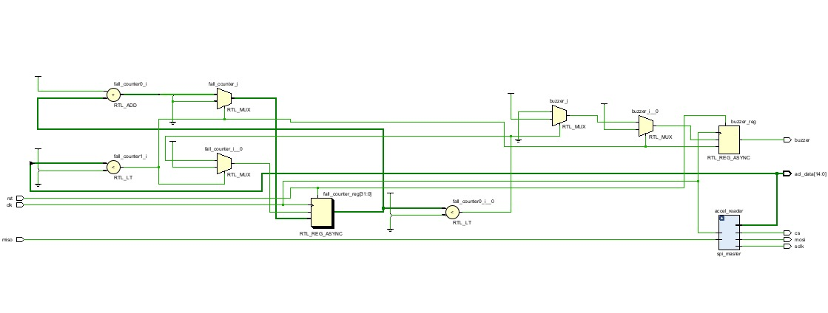
RTL OF ELDER FALLING DETECTION

CONSTRAINS
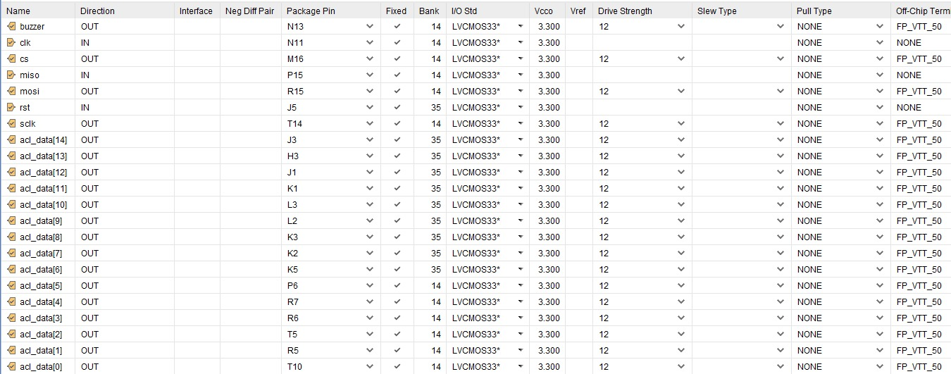
RESULT:
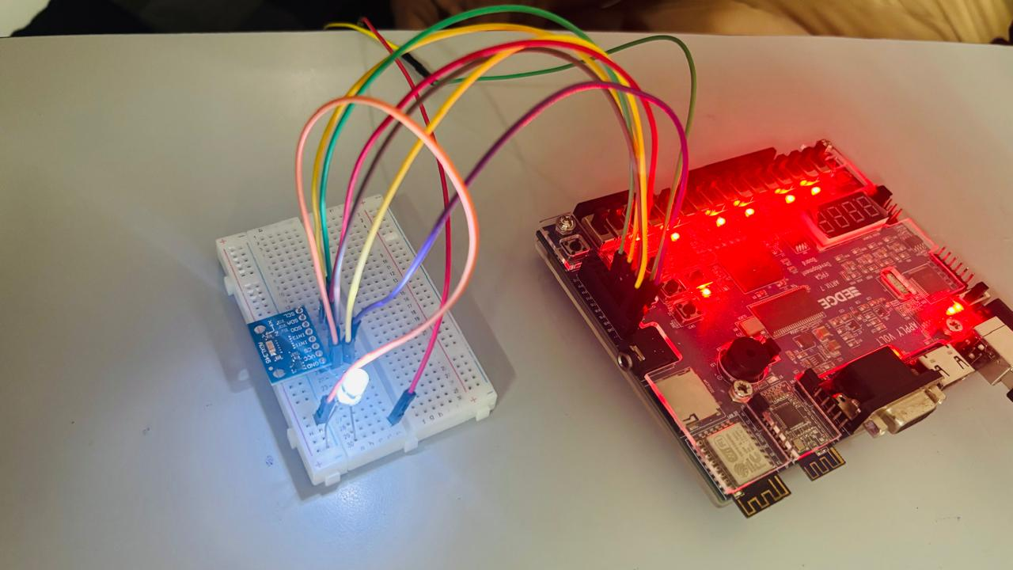
HARDWARE COMMUNICATION:
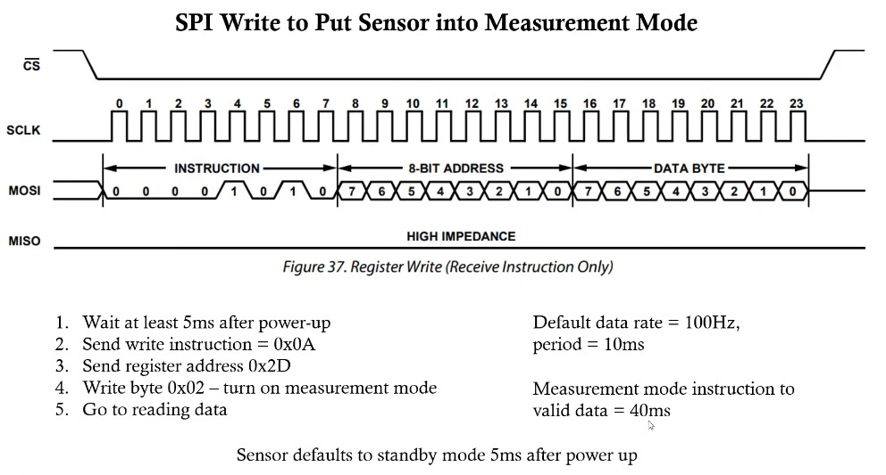

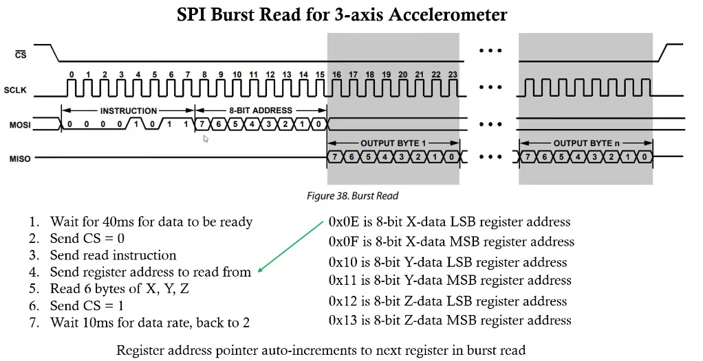

CONCLUSION:
This project shows how we can build a real-time fall detection system using the ADXL345 sensor and an FPGA board like the Artix-7 or DE10-Nano. The system constantly checks for sudden movements and falls by reading data from the sensor and processing it using logic written in Verilog. When it detects a fall, it immediately turns on a buzzer or LED to alert someone nearby. The setup is fast, reliable, and doesn’t invade privacy, making it great for use in wearable devices or smart homes for elderly care. It also has room to grow—you can add features like wireless alerts or smarter detection using AI in the future.

