**Exercise 1: Inventory Management System**

**Scenario:**

You are developing an inventory management system for a warehouse. Efficient data storage and retrieval are crucial.

**Steps:**

1. **Understand the Problem:**
   * Explain why data structures and algorithms are essential in handling large inventories.
   * Discuss the types of data structures suitable for this problem.
2. **Setup:**
   * Create a new project for the inventory management system.
3. **Implementation:**
   * Define a class Product with attributes like **productId**, **productName**, **quantity**, and **price**.
   * Choose an appropriate data structure to store the products (e.g., ArrayList, HashMap).
   * Implement methods to add, update, and delete products from the inventory.
4. **Analysis:**
   * Analyze the time complexity of each operation (add, update, delete) in your chosen data structure.
   * Discuss how you can optimize these operations.

**Source Code:**

class Product {

int productId;

String productName;

int quantity;

double price;

public Product(int productId, String productName, int quantity, double price) {

this.productId = productId;

this.productName = productName;

this.quantity = quantity;

this.price = price;

}

public void setProductName(String productName) {

this.productName = productName;

}

public void setQuantity(int quantity) {

this.quantity = quantity;

}

public void setPrice(double price) {

this.price = price;

}

public String toString() {

return "ID: " + productId + ", Name: " + productName + ", Quantity: " + quantity + ", Price: " + price;

}

}

class Inventory {

Product[] products;

int size;

public Inventory(int capacity) {

products = new Product[capacity];

size = 0;

}

public void addProduct(Product product) {

if (size < products.length) {

products[size] = product;

size++;

}

}

public void updateProduct(int productId, String name, int quantity, double price) {

for (int i = 0; i < size; i++) {

if (products[i].productId == productId) {

products[i].setProductName(name);

products[i].setQuantity(quantity);

products[i].setPrice(price);

break;

}

}

}

public void deleteProduct(int productId) {

for (int i = 0; i < size; i++) {

if (products[i].productId == productId) {

for (int j = i; j < size - 1; j++) {

products[j] = products[j + 1];

}

products[size - 1] = null;

size--;

break;

}

}

}

public void displayAllProducts() {

for (int i = 0; i < size; i++) {

System.out.println(products[i]);

}

}

}

public class InventorySystem {

public static void main(String[] args) {

Inventory inventory = new Inventory(100);

Product p1 = new Product(1, "Laptop", 10, 75000.0);

Product p2 = new Product(2, "Mouse", 50, 500.0);

inventory.addProduct(p1);

inventory.addProduct(p2);

inventory.updateProduct(1, "Gaming Laptop", 8, 95000.0);

inventory.displayAllProducts();

inventory.deleteProduct(2);

inventory.displayAllProducts();

}

}

**Output:**



**Exercise 2: E-commerce Platform Search Function**

**Scenario:**

You are working on the search functionality of an e-commerce platform. The search needs to be optimized for fast performance.

**Steps:**

1. **Understand Asymptotic Notation:**
   * Explain Big O notation and how it helps in analyzing algorithms.
   * Describe the best, average, and worst-case scenarios for search operations.
2. **Setup:**
   * Create a class **Product** with attributes for searching, such as **productId, productName**, and **category**.
3. **Implementation:**
   * Implement linear search and binary search algorithms.
   * Store products in an array for linear search and a sorted array for binary search.
4. **Analysis:**
   * Compare the time complexity of linear and binary search algorithms.
   * Discuss which algorithm is more suitable for your platform and why.

**Source Code:**

class Product {

int productId;

String productName;

String category;

public Product(int productId, String productName, String category) {

this.productId = productId;

this.productName = productName;

this.category = category;

}

public String toString() {

return "ID: " + productId + ", Name: " + productName + ", Category: " + category;

}

}

public class SearchFunction {

public static Product linearSearch(Product[] products, String name) {

for (int i = 0; i < products.length; i++) {

if (products[i].productName.equalsIgnoreCase(name)) {

return products[i];

}

}

return null;

}

public static Product binarySearch(Product[] products, String name) {

int low = 0;

int high = products.length - 1;

while (low <= high) {

int mid = (low + high) / 2;

int result = products[mid].productName.compareToIgnoreCase(name);

if (result == 0) {

return products[mid];

} else if (result < 0) {

low = mid + 1;

} else {

high = mid - 1;

}

}

return null;

}

public static void sortProductsByName(Product[] products) {

for (int i = 0; i < products.length - 1; i++) {

for (int j = i + 1; j < products.length; j++) {

if (products[i].productName.compareToIgnoreCase(products[j].productName) > 0) {

Product temp = products[i];

products[i] = products[j];

products[j] = temp;

}

}

}

}

public static void main(String[] args) {

Product[] products = new Product[4];

products[0] = new Product(101, "Laptop", "Electronics");

products[1] = new Product(102, "Shoes", "Fashion");

products[2] = new Product(103, "Watch", "Accessories");

products[3] = new Product(104, "Phone", "Electronics");

Product result1 = linearSearch(products, "Phone");

if (result1!=null){

System.out.println("Linear Search Result: " + result1);

} else {

System.out.println("Linear Search Result: Not found");

}

sortProductsByName(products);

Product result2 = binarySearch(products, "Phone");

if (result2!=null){

System.out.println("Binary Search Result: " + result1);

} else {

System.out.println("Binary Search Result: Not found");

}

}

}

**Output Code:**



**Exercise 3: Sorting Customer Orders**

**Scenario:**

You are tasked with sorting customer orders by their total price on an e-commerce platform. This helps in prioritizing high-value orders.

**Steps:**

1. **Understand Sorting Algorithms:**
   * Explain different sorting algorithms (Bubble Sort, Insertion Sort, Quick Sort, Merge Sort).
2. **Setup:**
   * Create a class **Order** with attributes like **orderId**, **customerName**, and **totalPrice**.
3. **Implementation:**
   * Implement **Bubble Sort** to sort orders by **totalPrice**.
   * Implement **Quick Sort** to sort orders by **totalPrice**.
4. **Analysis:**
   * Compare the performance (time complexity) of Bubble Sort and Quick Sort.
   * Discuss why Quick Sort is generally preferred over Bubble Sort.

**Source Code:**

class Order {

int orderId;

String customerName;

double totalPrice;

public Order(int orderId, String customerName, double totalPrice) {

this.orderId = orderId;

this.customerName = customerName;

this.totalPrice = totalPrice;

}

public String toString() {

return "Order ID: " + orderId + ", Name: " + customerName + ", Total: ₹" + totalPrice;

}

}

public class OrderSorting {

public static void bubbleSort(Order[] orders) {

int n = orders.length;

for (int i = 0; i < n - 1; i++) {

for (int j = 0; j < n - i - 1; j++) {

if (orders[j].totalPrice < orders[j + 1].totalPrice) {

Order temp = orders[j];

orders[j] = orders[j + 1];

orders[j + 1] = temp;

}

}

}

}

public static void quickSort(Order[] orders, int low, int high) {

if (low < high) {

int pivotIndex = partition(orders, low, high);

quickSort(orders, low, pivotIndex - 1);

quickSort(orders, pivotIndex + 1, high);

}

}

public static int partition(Order[] orders, int low, int high) {

double pivot = orders[high].totalPrice;

int i = low - 1;

for (int j = low; j < high; j++) {

if (orders[j].totalPrice >= pivot) {

i++;

Order temp = orders[i];

orders[i] = orders[j];

orders[j] = temp;

}

}

Order temp = orders[i + 1];

orders[i + 1] = orders[high];

orders[high] = temp;

return i + 1;

}

public static void main(String[] args) {

Order[] orders1 = {

new Order(101, "Alice", 2500.0),

new Order(102, "Bob", 1500.0),

new Order(103, "Charlie", 4000.0),

new Order(104, "David", 1000.0),

new Order(105, "Eve", 3000.0)

};

System.out.println("Original Orders:");

for (Order order : orders1) {

System.out.println(order);

}

bubbleSort(orders1);

System.out.println("\nSorted by Bubble Sort (Descending by Total Price):");

for (Order order : orders1) {

System.out.println(order);

}

Order[] orders2 = {

new Order(101, "Alice", 2500.0),

new Order(102, "Bob", 1500.0),

new Order(103, "Charlie", 4000.0),

new Order(104, "David", 1000.0),

new Order(105, "Eve", 3000.0)

};

quickSort(orders2, 0, orders2.length - 1);

System.out.println("\nSorted by Quick Sort (Descending by Total Price):");

for (Order order : orders2) {

System.out.println(order);

}

}

}

**Output:**

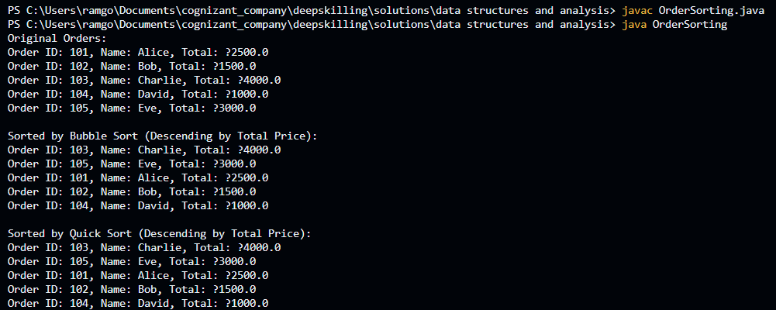

**Exercise 4: Employee Management System**

**Exercise 4: Employee Management System**

**Scenario:**

You are developing an employee management system for a company. Efficiently managing employee records is crucial.

**Steps:**

1. **Understand Array Representation:**
   * Explain how arrays are represented in memory and their advantages.
2. **Setup:**
   * Create a class Employee with attributes like **employeeId**, **name**, **position**, and **salary**.
3. **Implementation:**
   * Use an array to store employee records.
   * Implement methods to **add**, **search**, **traverse**, and **delete** employees in the array.
4. **Analysis:**
   * Analyze the time complexity of each operation (add, search, traverse, delete).
   * Discuss the limitations of arrays and when to use them

**Source Code:**

class Employee {

int employeeId;

String name;

String position;

double salary;

public Employee(int employeeId, String name, String position, double salary) {

this.employeeId = employeeId;

this.name = name;

this.position = position;

this.salary = salary;

}

public String toString() {

return "ID: " + employeeId + ", Name: " + name + ", Position: " + position + ", Salary: ₹" + salary;

}

}

public class EmployeeManagementSystem {

static Employee[] employees = new Employee[100];

static int count = 0;

public static void addEmployee(Employee emp) {

if (count < 100) {

employees[count] = emp;

count++;

} else {

System.out.println("Employee list is full.");

}

}

public static Employee searchEmployee(int id) {

for (int i = 0; i < count; i++) {

if (employees[i].employeeId == id) {

return employees[i];

}

}

return null;

}

public static void deleteEmployee(int id) {

for (int i = 0; i < count; i++) {

if (employees[i].employeeId == id) {

for (int j = i; j < count - 1; j++) {

employees[j] = employees[j + 1];

}

employees[count - 1] = null;

count--;

System.out.println("Employee with ID " + id + " deleted successfully.");

}

}

}

public static void traverseEmployees() {

if (count == 0) {

System.out.println("No employees to display.");

}

for (int i = 0; i < count; i++) {

System.out.println(employees[i]);

}

}

public static void main(String[] args) {

addEmployee(new Employee(1, "Alice", "Manager", 75000));

addEmployee(new Employee(2, "Bob", "Developer", 60000));

addEmployee(new Employee(3, "Charlie", "Designer", 50000));

System.out.println("All Employees:");

traverseEmployees();

System.out.println("\nSearching for Employee with ID 2:");

Employee emp = searchEmployee(2);

if (emp != null) {

System.out.println(emp);

} else {

System.out.println("Employee not found.");

}

System.out.println("\nDeleting Employee with ID 1:");

deleteEmployee(1);

System.out.println("\nAll Employees after Deletion:");

traverseEmployees();

}

}

**Output:**

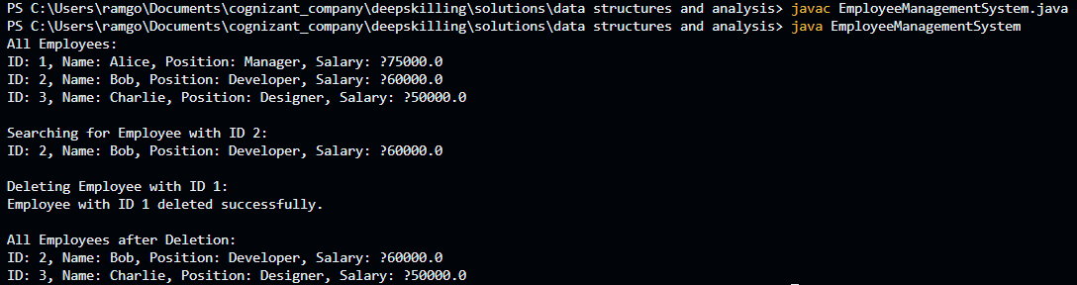

**Exercise 5: Task Management System**

**Scenario:**

You are developing a task management system where tasks need to be added, deleted, and traversed efficiently.

**Steps:**

1. **Understand Linked Lists:**
   * Explain the different types of linked lists (Singly Linked List, Doubly Linked List).
2. **Setup:**
   * Create a class **Task** with attributes like **taskId**, **taskName**, and **status**.
3. **Implementation:**
   * Implement a singly linked list to manage tasks.
   * Implement methods to **add**, **search**, **traverse**, and **delete** tasks in the linked list.
4. **Analysis:**
   * Analyze the time complexity of each operation.
   * Discuss the advantages of linked lists over arrays for dynamic data.

**Source Code:**

class Task {

int taskId;

String taskName;

String status;

public Task(int taskId, String taskName, String status) {

this.taskId = taskId;

this.taskName = taskName;

this.status = status;

}

public String toString() {

return "Task ID: " + taskId + ", Name: " + taskName + ", Status: " + status;

}

}

class TaskNode {

Task task;

TaskNode next;

public TaskNode(Task task) {

this.task = task;

this.next = null;

}

}

class TaskLinkedList {

TaskNode head;

public void addTask(Task task) {

TaskNode newNode = new TaskNode(task);

if (head == null) {

head = newNode;

} else {

TaskNode temp = head;

while (temp.next != null) {

temp = temp.next;

}

temp.next = newNode;

}

}

public Task searchTask(int id) {

TaskNode temp = head;

while (temp != null) {

if (temp.task.taskId == id) {

return temp.task;

}

temp = temp.next;

}

return null;

}

public void deleteTask(int id) {

if (head == null) return;

if (head.task.taskId == id) {

head = head.next;

return;

}

TaskNode prev = head;

TaskNode curr = head.next;

while (curr != null) {

if (curr.task.taskId == id) {

prev.next = curr.next;

return;

}

prev = curr;

curr = curr.next;

}

System.out.println("Task not found.");

}

public void traverseTasks() {

if (head == null) {

System.out.println("No tasks available.");

return;

}

TaskNode temp = head;

while (temp != null) {

System.out.println(temp.task);

temp = temp.next;

}

}

}

public class TaskManagementSystem {

public static void main(String[] args) {

TaskLinkedList taskList = new TaskLinkedList();

taskList.addTask(new Task(1, "Design UI", "Pending"));

taskList.addTask(new Task(2, "Develop Backend", "In Progress"));

taskList.addTask(new Task(3, "Testing", "Pending"));

System.out.println("All Tasks:");

taskList.traverseTasks();

System.out.println("\nSearching for Task ID 2:");

Task found = taskList.searchTask(2);

if (found != null) {

System.out.println(found);

} else {

System.out.println("Task not found.");

}

System.out.println("\nDeleting Task ID 1:");

taskList.deleteTask(1);

System.out.println("\nTasks after deletion:");

taskList.traverseTasks();

}

}

**Output:**

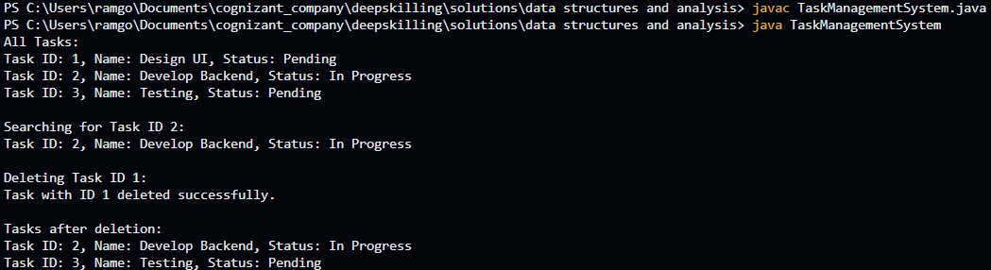

**Exercise 6: Library Management System**

**Scenario:**

You are developing a library management system where users can search for books by title or author.

**Steps:**

1. **Understand Search Algorithms:**
   * Explain linear search and binary search algorithms.
2. **Setup:**
   * Create a class **Book** with attributes like **bookId**, **title**, and **author**.
3. **Implementation:**
   * Implement linear search to find books by title.
   * Implement binary search to find books by title (assuming the list is sorted).
4. **Analysis:**
   * Compare the time complexity of linear and binary search.
   * Discuss when to use each algorithm based on the data set size and order.

**Source Code:**

class Book {

int bookId;

String title;

String author;

public Book(int bookId, String title, String author) {

this.bookId = bookId;

this.title = title;

this.author = author;

}

public String toString() {

return "Book ID: " + bookId + ", Title: " + title + ", Author: " + author;

}

}

public class LibraryManagementSystem {

public static Book linearSearch(Book[] books, String title) {

for (Book book : books) {

if (book.title.equalsIgnoreCase(title)) {

return book;

}

}

return null;

}

public static void sortBooksByTitle(Book[] books) {

int n = books.length;

for (int i = 0; i < n - 1; i++) {

for (int j = 0; j < n - 1 - i; j++) {

if (books[j].title.compareToIgnoreCase(books[j + 1].title) > 0) {

Book temp = books[j];

books[j] = books[j + 1];

books[j + 1] = temp;

}

}

}

}

public static Book binarySearch(Book[] books, String title) {

int low = 0, high = books.length - 1;

while (low <= high) {

int mid = (low + high) / 2;

int cmp = books[mid].title.compareToIgnoreCase(title);

if (cmp == 0) {

return books[mid];

} else if (cmp < 0) {

low = mid + 1;

} else {

high = mid - 1;

}

}

return null;

}

public static void displayBooks(Book[] books) {

for (Book book : books) {

System.out.println(book);

}

}

public static void main(String[] args) {

Book[] books = {

new Book(101, "Java Programming", "James Gosling"),

new Book(102, "Data Structures", "Narasimha Karumanchi"),

new Book(103, "Operating Systems", "Silberschatz"),

new Book(104, "Clean Code", "Robert C. Martin"),

new Book(105, "Design Patterns", "Erich Gamma")

};

System.out.println("All Books:");

displayBooks(books);

Book result1 = linearSearch(books, "Clean Code");

System.out.println("Linear Search Result:");

System.out.println(result1 != null ? result1 : "Book not found");

sortBooksByTitle(books);

Book result2 = binarySearch(books, "Clean Code");

System.out.println("Binary Search Result:");

System.out.println(result2 != null ? result2 : "Book not found");

}

}

**Output:**

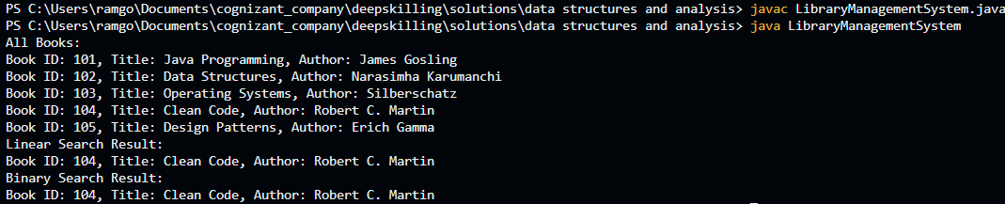

**Exercise 7: Financial Forecasting**

**Scenario:**

You are developing a financial forecasting tool that predicts future values based on past data.

**Steps:**

1. **Understand Recursive Algorithms:**
   * Explain the concept of recursion and how it can simplify certain problems.
2. **Setup:**
   * Create a method to calculate the future value using a recursive approach.
3. **Implementation:**
   * Implement a recursive algorithm to predict future values based on past growth rates.
4. **Analysis:**
   * Discuss the time complexity of your recursive algorithm.
   * Explain how to optimize the recursive solution to avoid excessive computation.

**Source Code:**

public class FinancialForecasting {

public static double futureValue(double presentValue, double rate, int years) {

if (years == 0) {

return presentValue;

} else {

return futureValue(presentValue * (1 + rate), rate, years - 1);

}

}

public static void main(String[] args) {

double presentValue = 10000;

double rate = 0.08;

int years = 5;

double result = futureValue(presentValue, rate, years);

System.out.printf("Future value after %d years: ₹%.2f%n", years, result);

}

}

**Output:**



**Note**: In above Outputs (?) Represents the Rupee Symbol (₹)