HUMANOID – A Heart Disease Predictor

Sri Sai Narayana Ram Gopal Mangena
University of Missouri-Kansas City
smgtb@mail.umkc.edu

Achyuth Reddy Nalamadgu
University of Missouri-Kansas City
an322@mail.umkc.edu

Abstract: One of the most important thing in humans life is the importance which one individual would give towards their health. There are a lot of advancements happening in the field of medical assistance which utilizes several software services and technology advancements. Usually the medical data related to human health is information rich and the data is pretty hard to handle manually. In the last decade Data mining tools were used in handling such issues. Although the data mining tools achieved good results, but they fell short of handling advanced problems such as automatic prediction of certain patterns in human body. Thus with the use of Machine Learning and Deep Learning we developed a predictive system for health of human heart. We can use several data mining techniques like Decision trees, Navie Bayes, Deep Neural networks are applied to health data sets which are extracted from existing machine learning data sets or can be generated form smart fitness trackers like Fitbit, Garmin. In the view of medical practitioners also the amount of work they are expected to put is also reduced, as the patient’s data is readily available online and can be accessed from anywhere. In this application user need to provide some pre-defined personal information.

Index Terms – Deep Neural Network, Machine Learning, Deep Learning

Introduction
The purpose of application is to reduce the cost of getting to know about how healthy your heart is ? With our application user can come to know the performance of his heart functioning. There is no need of people going to doctors for checking up their health, they can sit at home and contact with doctor to evaluate their heart health. Through deep learning techniques a lot has been proved and many other challenges are easily solved which were defined to be complex. For example if we consider Image classification case, through Tensor flow there is a 97% accuracy reported.

In Human body Heart is an important functional organ, to know how efficiently our heart functions, our application lets you know what is the status of your heart. In our application we collected the data set of UCI machine learning and used them as training set for our model. Below table describes the data set and its characteristics.

TABLE 1
S.No | Attribute | Description
1 | Age | Age in years
2 | Sex | Gender 1=male, 0=female
3 | CP | Chest pain,  -- Value 1: typical angina  -- Value 2: atypical angina  -- Value 3: non-angina pain  -- Value 4: asymptomatic
4 | Trestbps | Resting blood pressure (in mm Hg on admission to the hospital)
5 | Chol | serum cholestoral in mg/dl
6 | Fbs | fbs: (fasting blood sugar > 120 mg/dl) (1 = true; 0 = false)
7 | Restecg | restecg: resting electrocardiographic results  -- Value 0: normal  -- Value 1: having ST-T wave abnormality (T wave inversions and/or ST elevation or depression of > 0.05 mV)  -- Value 2: showing probable or definite left ventricular hypertrophy by Estes' criteria
8 | Thalach | maximum heart rate achieved
9 | Exang | exercise induced angina (1 = yes; 0 = no)
10 | Oldpeak | oldpeak = ST depression induced by exercise relative to rest
11 | Slope | the slope of the peak exercise ST segment  -- Value 1: upsloping  -- Value 2: flat  -- Value 3: down sloping
12 | Ca | number of major vessels (0-3) colored by flourosopy
13 | Thal | 3 = normal; 6 = fixed defect; 7 = reversable defect
14 | Num | diagnosis of heart disease (angiographic disease status)  -- Value 0: < 50% diameter narrowing  -- Value 1: > 50% diameter narrowing

Here we have used Deep Neural Network as a classifier to classify the characteristics which produces the results of presence or absence of heart disease. We also produce visualization for accuracy through Tensor flow.

Proposed work
To work on this application we have used UCI machine learning repository which is used as training data set for our Deep Neural Network model for predicting the chances of occurring heart disease. Along with this heart data, we also get data from Fitbit which is a activity tracker, which tracks the heart rate in bpm (beats per minute). We are trying to use this data to be testing data set. We get the Fitbit data from Google fit, which is an application where all our activity can be synced from Fitbit to Google fit repository. To implement this sync process we have used Python pip3 and OAuth 2.0 to get access the data dynamically. Once we enter the parameter list provided, then we get the results predicted for the data provided.
Implementation & Evaluation
- System Design and Architecture

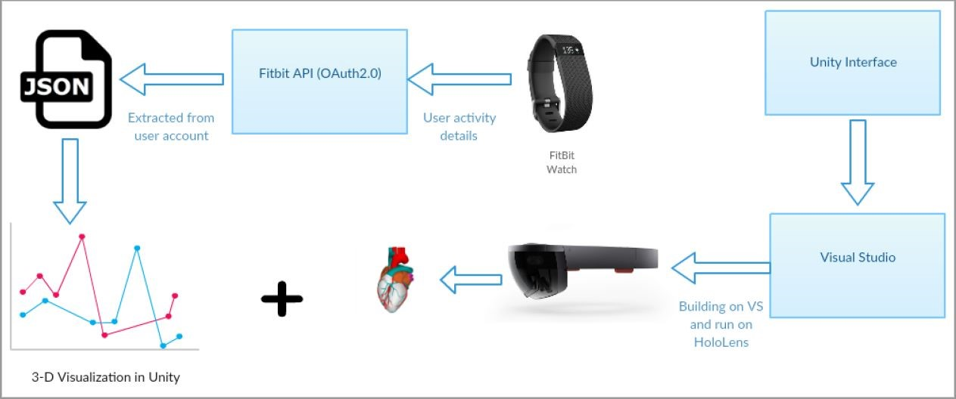

- Evaluation & Results: We ran Linear Regression algorithm on the dataset and tried get correlation between various attributes. Following screen shots show the results of our model built.
This is the heart data with 14 attributes in the txt format.

The below graph shows the scatter plot for healthy and unhealthy heart based on two attributes cholesterol and fasting blood sugar.
The second scatter plot shows the correlation between all the attributes from the dataset.

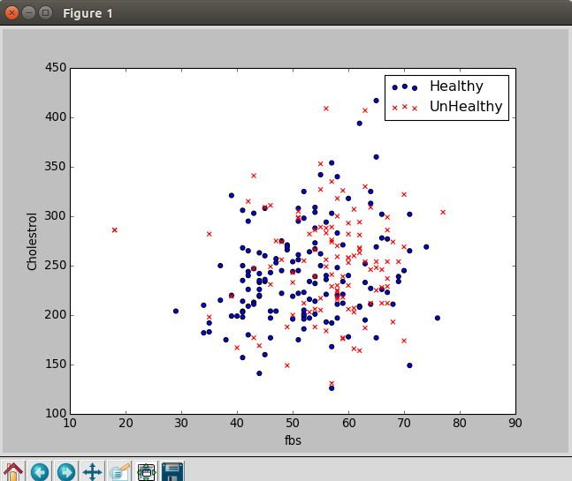

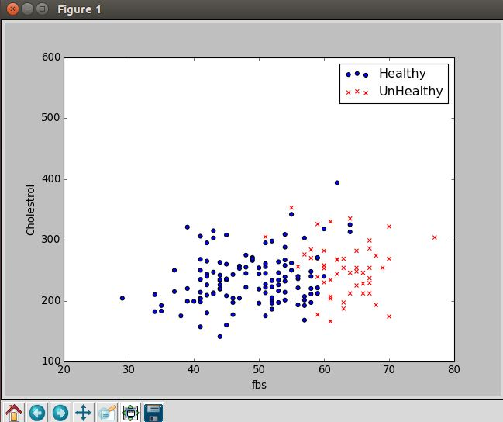

Implementation using Deep Neural Network

We have implemented the classification in deep neural networks with 13 features and 2 classes. This model contains 80 hidden nodes with 73% accuracy. We have created a web application that will allow user to enter all the 13 features and it will predict the condition of heart.
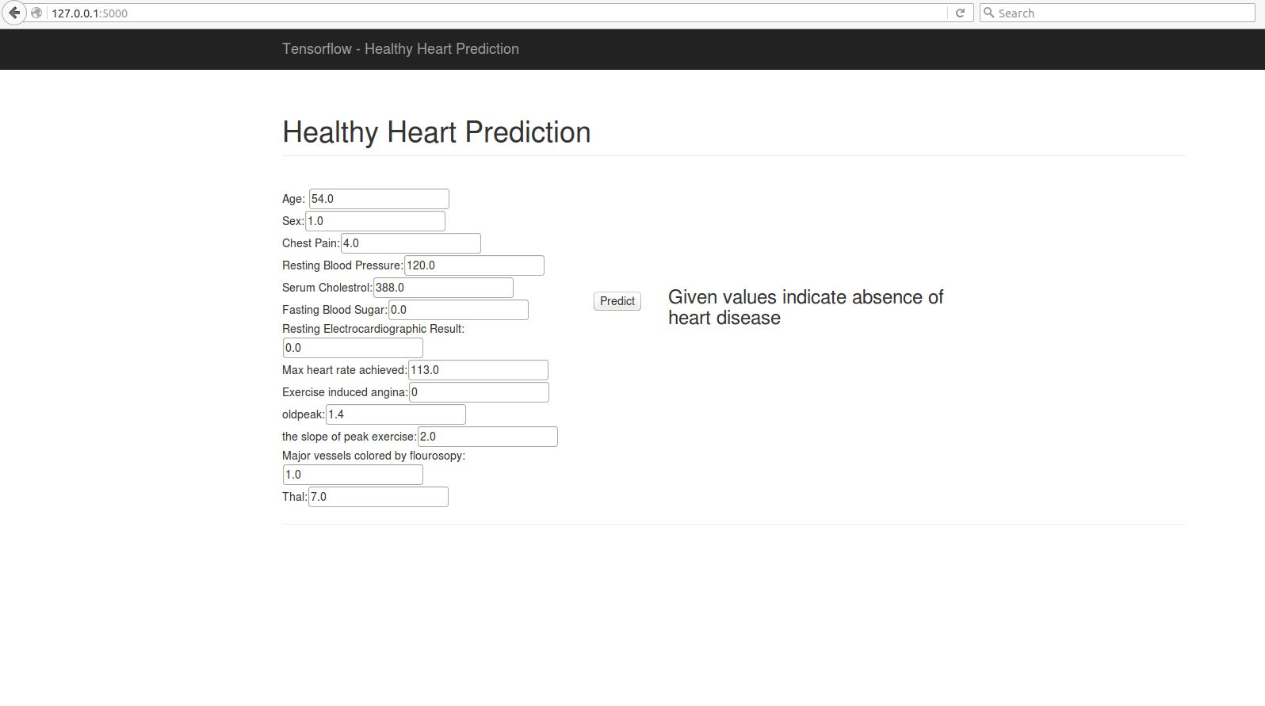

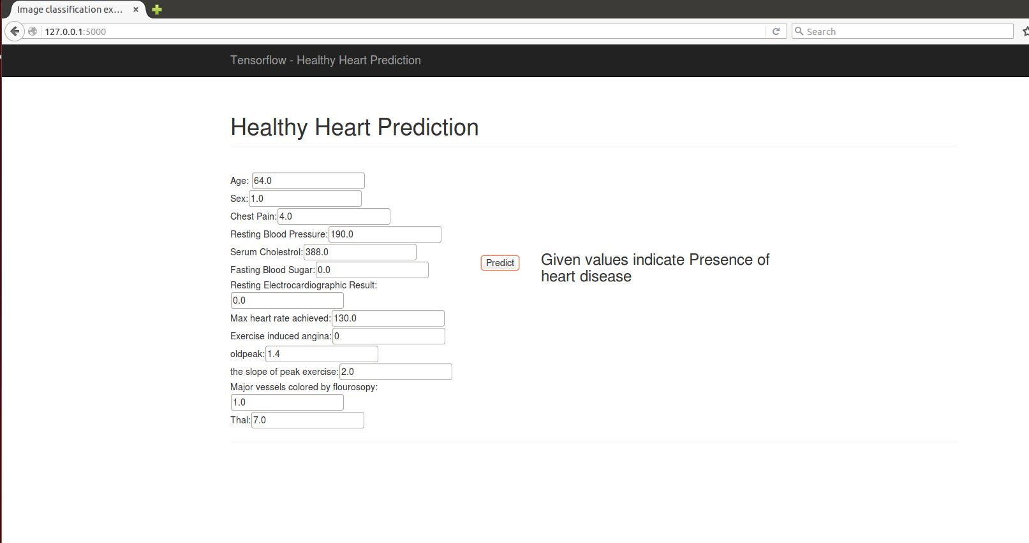

Discussion & Limitation
In this application we tried to use Microsoft HoloLens to show complete human heart which shows the dynamic 3D view, which enables us to better understand the topology of Human heart and its functionality. But due to lack learning resources from Microsoft we could only able to create a static Human heart with bi-directional control view and a 360-degree rotation. Lack of other heart disease data sets also limited our accuracy, which would have increased our training data set to help our data for better tuning to get effective results.

Conclusion
In the conclusion, we got pretty good results through Deep Neural Network, which we are able to predict the absence or presence of heart disease based on the input values given by the user.

Acknowledgment
We thank our esteemed Professor Dr. Yugyung Lee for her valuable guidance throughout this project to put our work in right path.

References
- https://www.biodigital.com/developers
- https://www.eonreality.com/portfolio-items/virtual-anatomy-simulationv
- https://developer.microsoft.com/en-us/windows/holographic/holograms_101
- https://github.com/orcasgit/python-fitbit
- https://github.com/bfetler/coronary_disease
- http://blog.mr-but-dr.xyz/en/programming/fitbit-python-heartrate-howto/
http://www.medpagetoday.com/practicemanagement/informationtechnology/59072
- http://anatomy4d.daqri.com/
- http://journals.plos.org/plosone/article?id=10.1371/journal.pone.0091276
- https://developer.microsoft.com/enus/windows/holographic/documentation
- http://pkp.io/blog/fitbit-to-googlefit-sync/
- https://archive.ics.uci.edu/ml/datasets/Heart+Disease

