1. Add new product (http://localhost:3000/api/products/new?prod_desc=9th product description&price=99&product_title=9th product)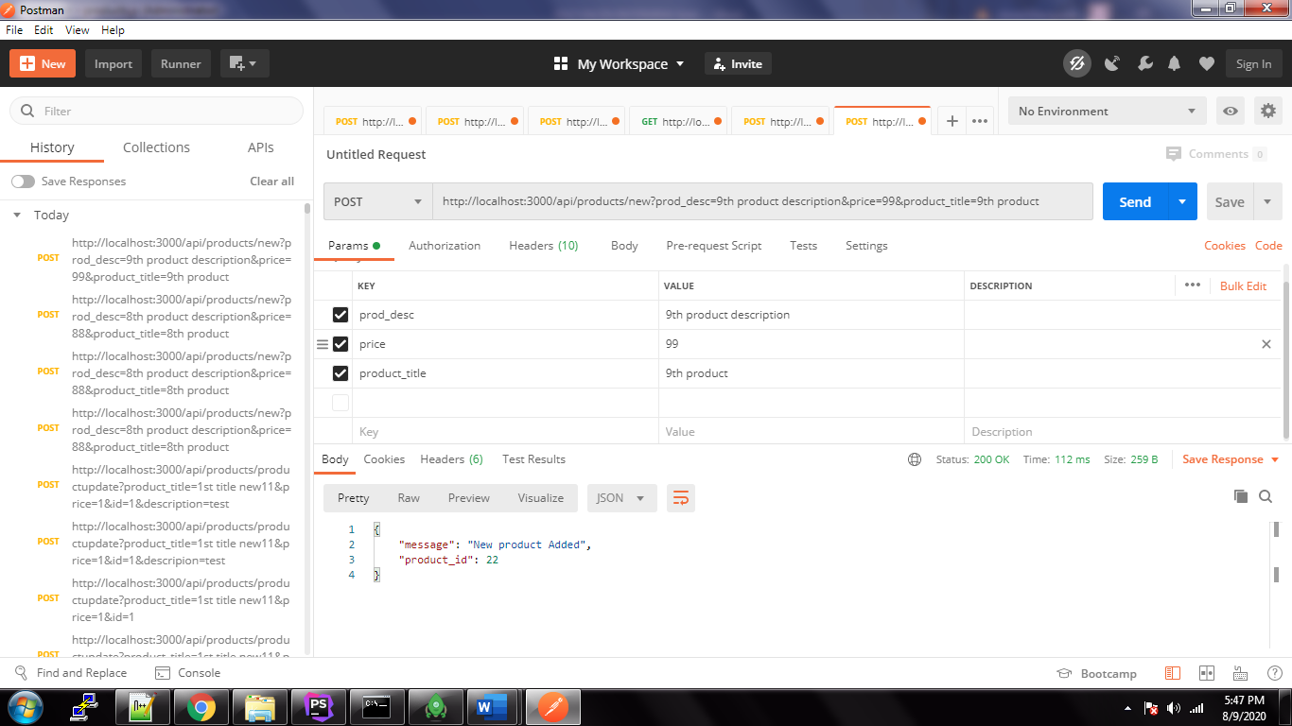

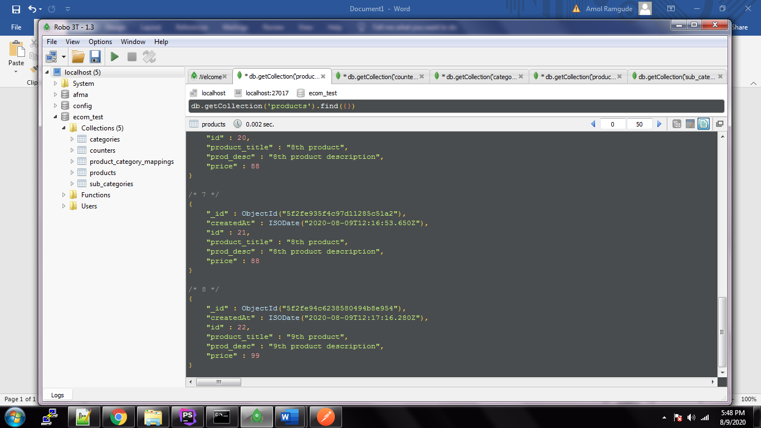

2. Add new category (http://localhost:3000/api/categories/new?title=test12345&description=test desc test 12345)

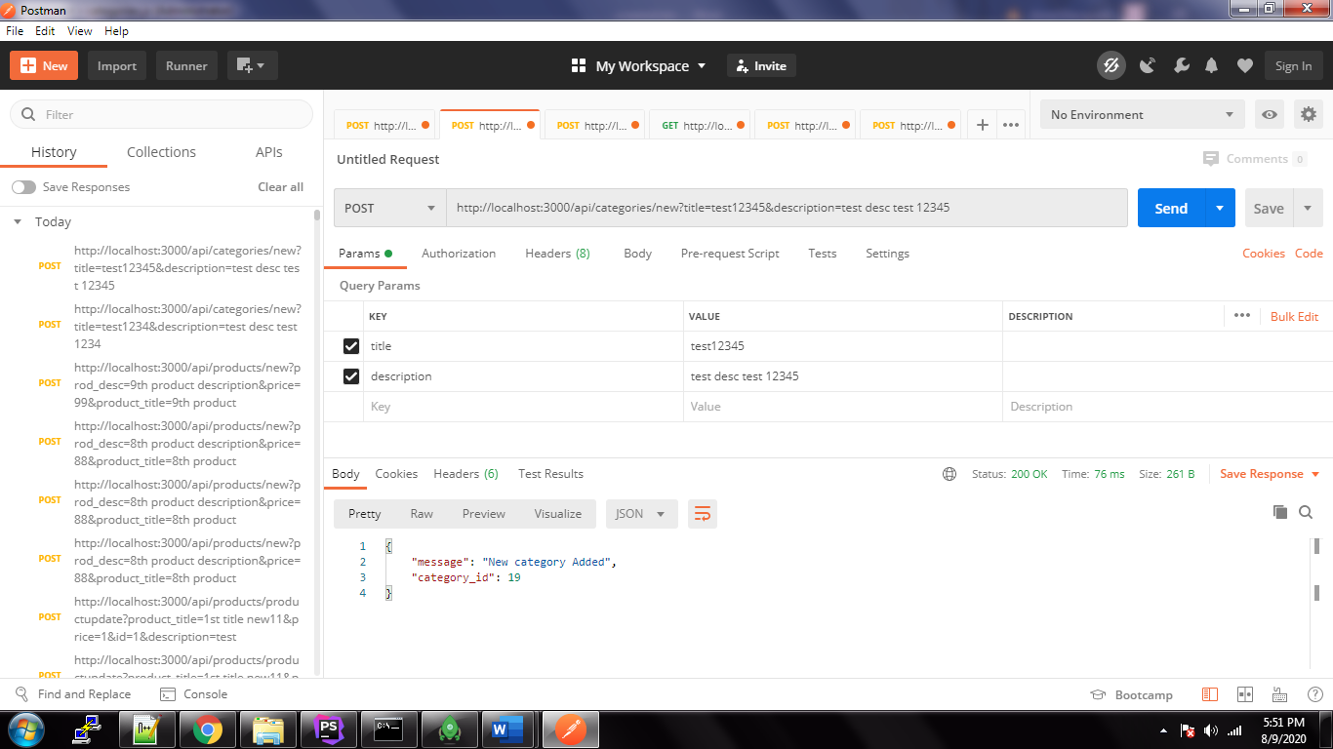

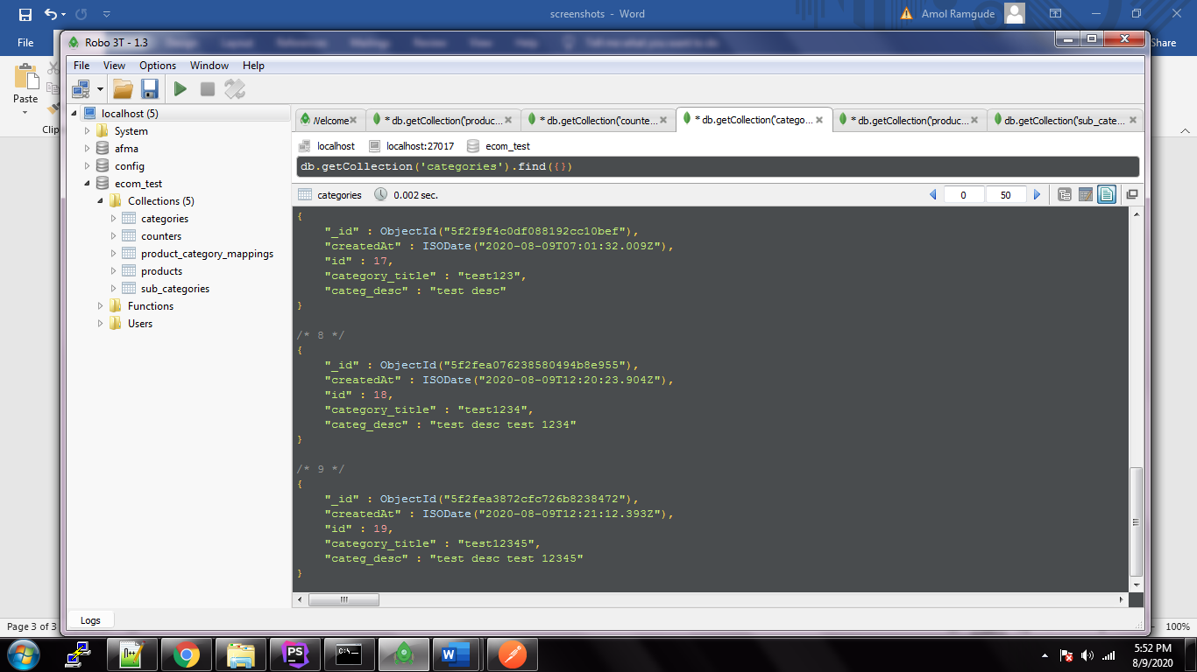

3. Product to category mappings (http://localhost:3000/api/products/productCategoryMapping/?pid=4&categories=[1,2])

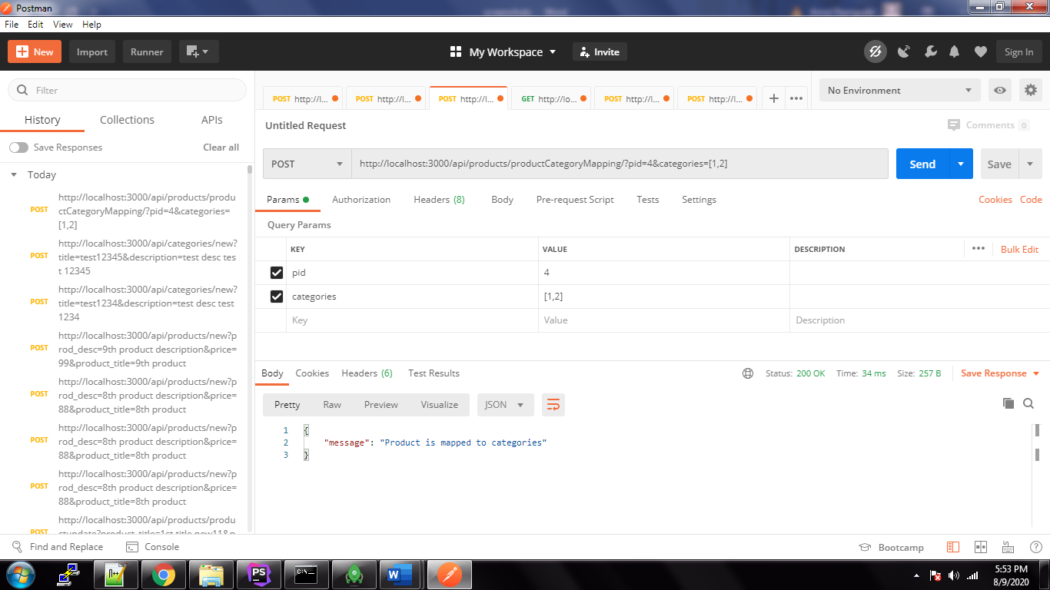

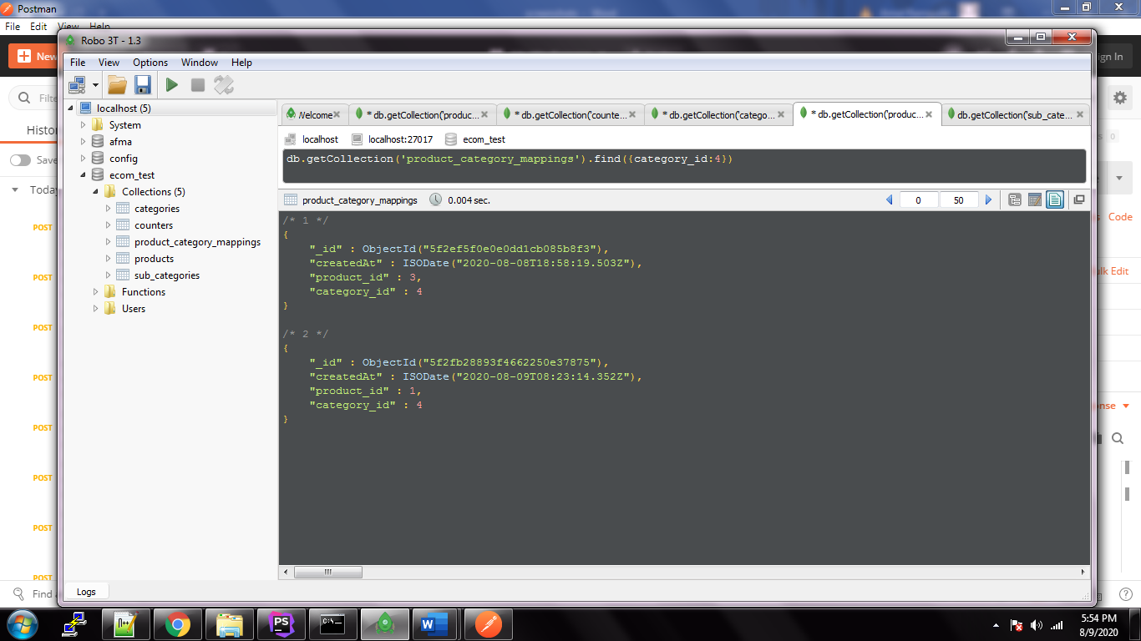

4. get All products from category(http://localhost:3000/api/products/getAllByCategory/3)

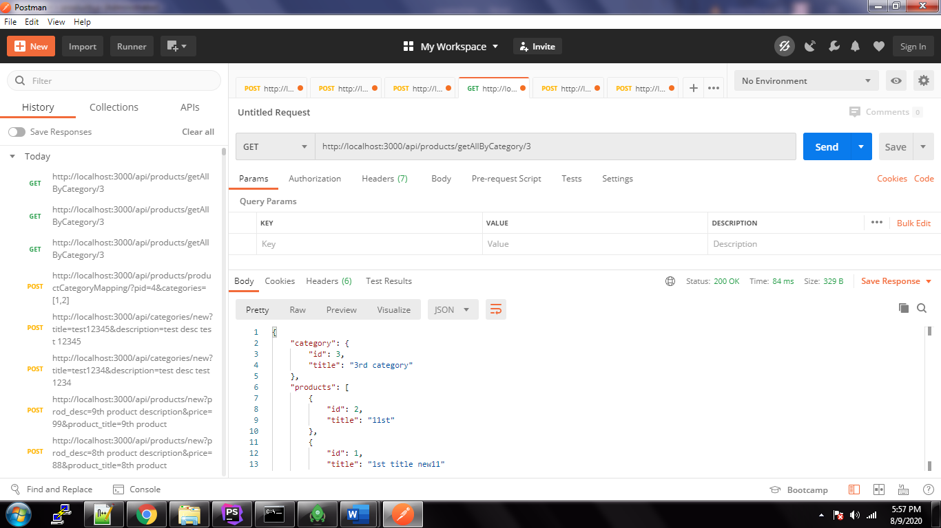

5. update product details (http://localhost:3000/api/products/productupdate?product_title=1st title new123&price=123&id=1&description=test) : id:1

Old product details

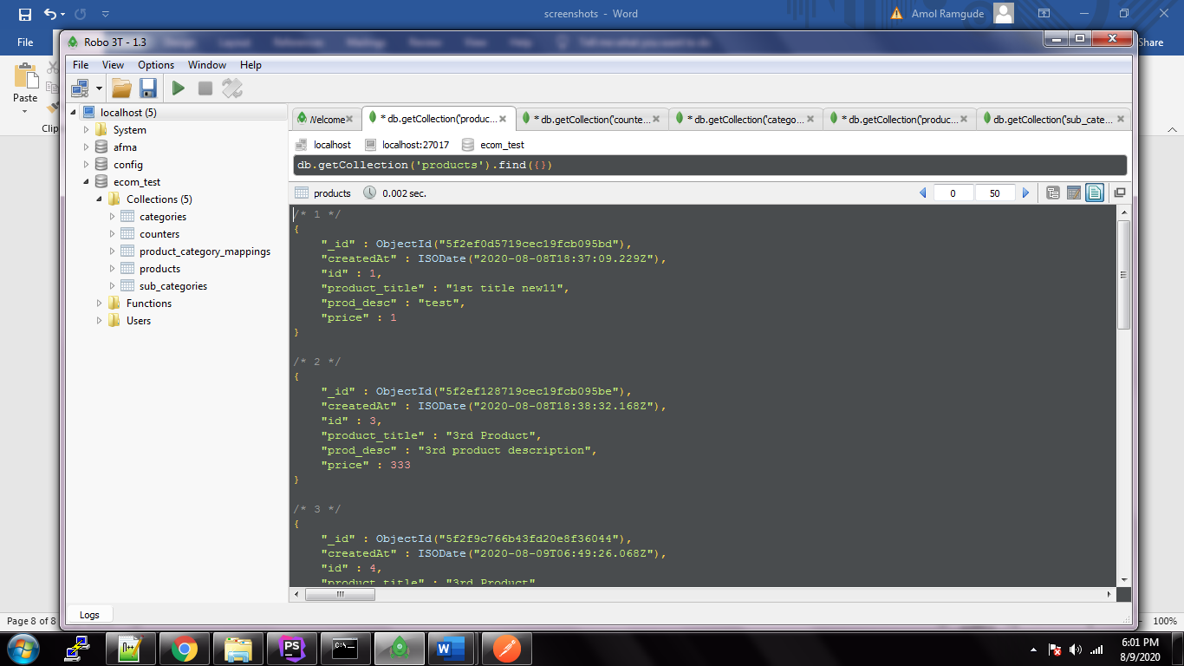

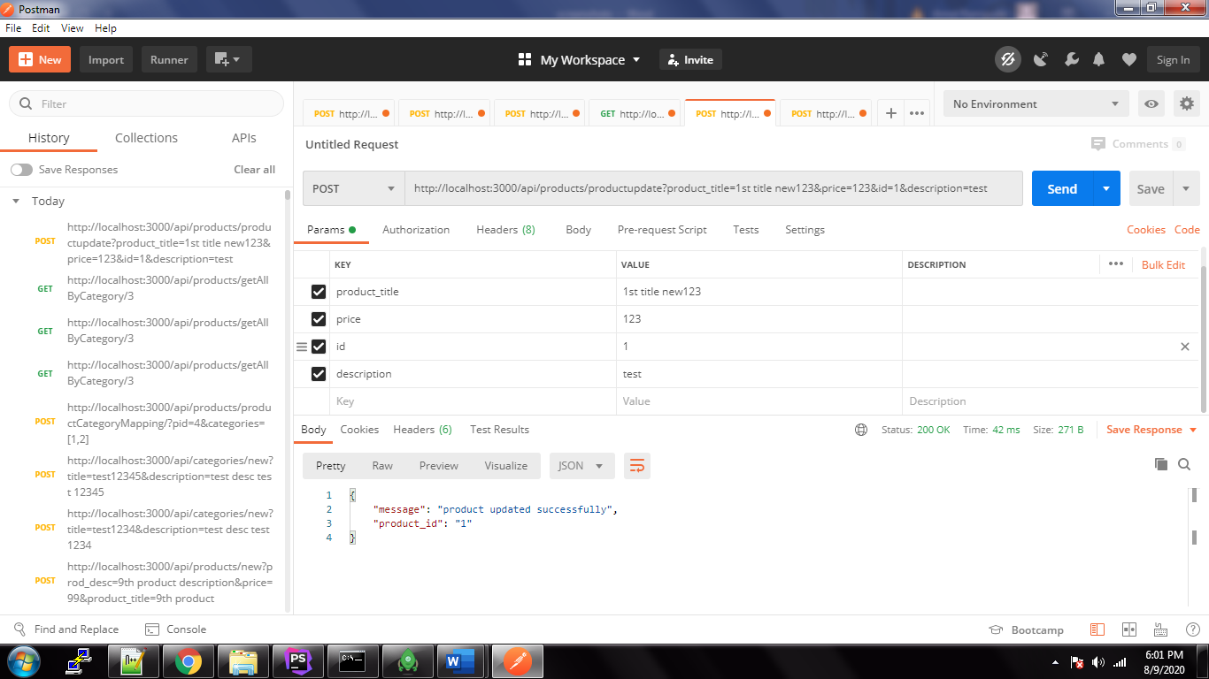

After Update product details:

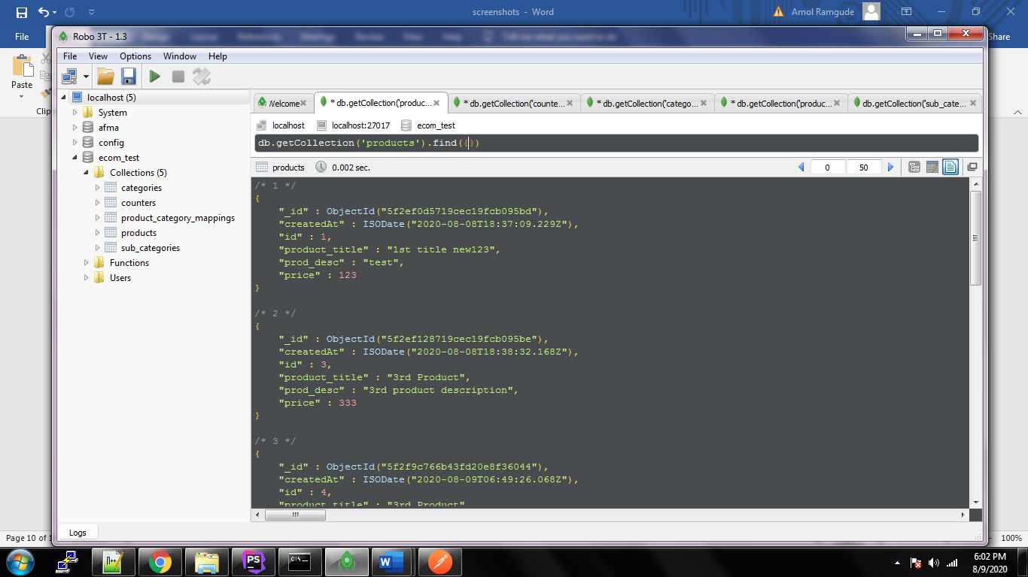

6. Find all categories with their children (http://localhost:3000/api/categories/getAll)

