iSched

A Web-Based Scheduling Management System with Constraint-Based Assignment Using Backtracking Algorithm

User Manual
and System Guide

Developed by:
BS Information Technology
Southern Luzon State University – Lucban Campus
Table of Contents
PAGE
Acknowledgments 3
Introduction 4
System Access 5
Registration and Sign-In 7
Getting Around 9
The Scheduling Workflow 11
Manage Schedules 12
Scheduling Rules the System Enforces 17
Guide for the Dean 18
Guide for the Department Chairperson 20
Guide for the Program Chairperson 22
Guide for the PATHFit Director 23
Guide for the NSTP Director 24
Faculty 25
Faculty Availability 26
Departments, Buildings and Rooms 27
System Logs 28
User Manual, Profile and Help 29
Troubleshooting 30

Acknowledgments
The development team is deeply grateful for all the contributions that made iSched: A Web-Based Scheduling Management System with Constraint-Based Assignment Using Backtracking Algorithm a success.

Development Team
PROJECT DEVELOPERS & RESEARCHERS:
GUNAY, CHERRY ROSE D.
HERNANDEZ, NORILYN E.
ORBETA, RAMIELLE ANTONETTE R.

Capstone Advisers
ADVISER: PROF. MARIEBETH P. SEÑO
CO-ADVISER: MR. JOHN C. VALDORIA

Capstone Panel Members
CHAIRPERSON: MR. RENATO R. MAALIW III
PANEL MEMBER: PROF. DEVIE S. BELLO
PANEL MEMBER: MR. REYNALDO DANGANAN

Institutional Partner
Southern Luzon State University – Lucban Campus
CAS Department Chairpersons: PROF. JOSEPHINE CAMSON, MNSD
PROF. MARIA GLORIA B. NADA, LCHD
PROF. JUDEIMAR A. UNGRIANO, SSD

Introduction

What is iSched?
iSched is a web-based class-scheduling system for Southern Luzon State University – Lucban Campus (SLSU). It lets Department Chairpersons, Program Chairpersons, Deans and the PATHFit and NSTP Directors prepare, check, approve and publish each college's class schedule for a term. Classes can be generated automatically by a constraint-based scheduler that uses a backtracking algorithm, or placed by hand, and every placement is checked against the same rules.

System Purpose and Objectives
- Replace manual, spreadsheet-based scheduling with one shared system for all colleges.
- Automatically place classes without double-booking faculty, rooms or sections.
- Follow the university's approval workflow: Department Chairpersons → Program Chairpersons → Dean.
- Respect faculty availability, specializations, workload limits and room types.
- Give oversight tools (System Logs) and printable exports (Schedule of Subjects, Teaching Load).

Functionalities
- Automatic schedule generation and manual Add / Edit / Delete of classes
- Faculty records, specializations, employment type (Regular / COSI) and per-term availability
- Buildings, rooms, laboratory specializations and room access restrictions
- Step-by-step workflow with finalization, submission, Dean approval and publishing
- Conflict detection, unassigned-class queue and lab-change requests
- Real-time notifications, audit trail and System Logs with five oversight tabs
- Exports: Schedule of Subjects and Teaching Load (printable)
- Built-in visual User Manual for every role

System Access

Who uses iSched?
Only chairs, deans and directors sign in. Faculty members are records in the system (their name appears on schedules and they have availability and specializations) but they do not log in; they receive their schedule as a printed Teaching Load from their chairperson.
Role in the system | Title shown in iSched | What the account does
Dean | Dean | Approves accounts of their own department and approves or returns the department's schedule. Reads System Logs. Read-only everywhere else.
Super Admin | Department Chairperson (CAS) | Plots GEC/GEL for every college, publishes the CAS schedule itself, finalizes GEC/GEL, manages CAS faculty.
Admin | Program Chairperson | Plots their program's major subjects, marks them done and submits the department schedule when every Program Chairperson is done.
PATHFit | PATHFit Director | Generates and edits PATHFit classes in every college's schedule. One account only.
NSTP | NSTP Director | Adds and edits NSTP classes by hand in every college's schedule. One account only.
Faculty | Faculty member | No login. A data record only.

Requirements
- A computer, tablet or phone with an up-to-date web browser (Chrome, Edge, Firefox or Safari).
- An internet connection.
- An email address, or a Google account, for sign-in.

Opening the System
- Open your web browser.
- Type the iSched address given by your department in the address bar and press Enter.
- The sign-in page appears.
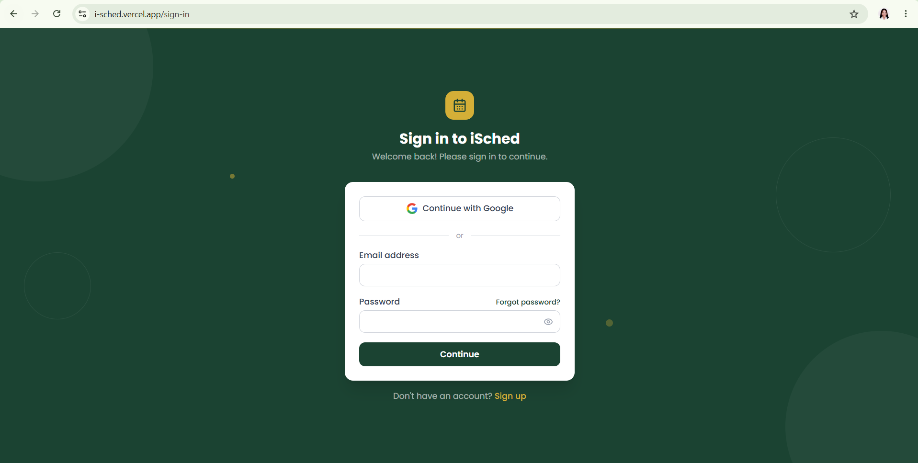
Figure 1. iSched sign-in page

Registration and Sign-In

Creating an Account (Sign-Up)
- On the sign-in page, choose Sign up.
- Enter your first name, last name, email address and password, or choose Continue with Google.
- Choose your role from the list: Dean, Department Chairperson, Program Chairperson, PATHFit Director or NSTP Director.
- Choose your college or department (and program, for a Program Chairperson).
- Submit the form. If you used email, open the confirmation link sent to your inbox.
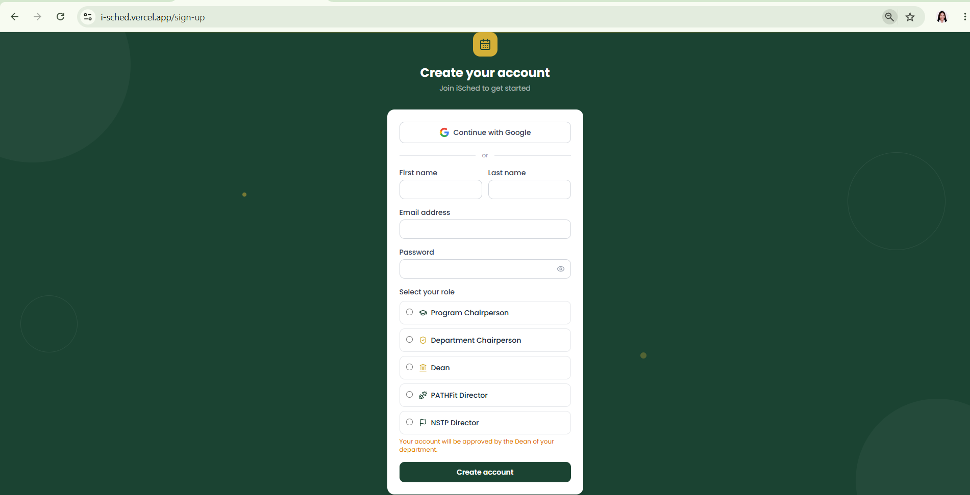
Figure 2. Sign-up form with role selection

Account approval
- The first Dean of a department is approved automatically; a second Dean for the same department is refused.
- The single PATHFit Director and single NSTP Director accounts are approved automatically; a second one is refused (the sign-up form tells you up front).
- Department Chairperson and Program Chairperson accounts wait for approval by their department's Dean. Until then a "pending approval" screen is shown.
Note: If you try to sign up with an email that already has an account, an "Account already exists" message appears. Use Sign in instead.

Signing In
- Enter your email and password, or choose Continue with Google.
- Choose Sign in. You land on your Dashboard.
- After signing in, it will directly go to you Dashboard.
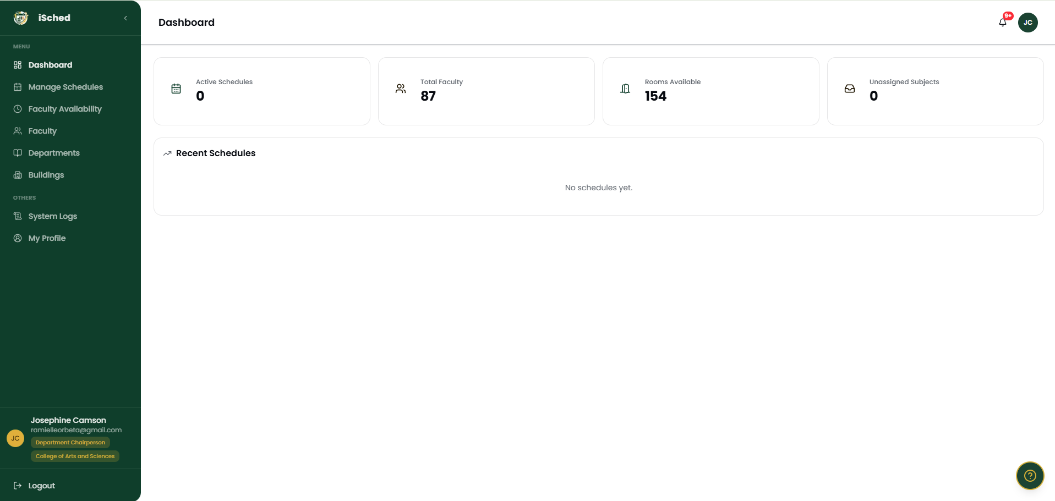
Figure 3. Notice shown after first sign-in

Signing Out
Open the profile menu at the top right and choose Log out.

Getting Around

Layout
- Sidebar (left): links to the pages your role may use. A spinner replaces the icon while a page loads.
- Top bar: college filter (for roles that may switch colleges), notifications bell and your profile menu.
- Help button: opens short tips for the page you are on.
Figure 4. Dashboard layout: sidebar, top bar and content

Pages by Role
Page | Dean | Dept. Chair | Prog. Chair | PATHFit / NSTP | Purpose
Dashboard | Yes | Yes | Yes | Yes | Overview and shortcuts
Manage Schedules | View | Yes | Yes | Yes | Plot, generate, approve
Faculty Availability | – | Yes | Yes | Yes | Per-term available hours
Faculty | – | Yes | Yes | Yes | Faculty records
Departments | View | Yes | Yes | – | Subjects, programs, sections
Buildings | – | Yes | Yes | – | Buildings, rooms, labs
User Management | Yes | – | – | – | Approve / manage accounts
System Logs | Yes | Yes | Yes | – | Activity, classes, summary, rooms
User Manual | Yes | Yes | Yes | Yes | Visual guide per role
My Profile | Yes | Yes | Yes | Yes | Your account details

Notifications
The bell shows unread notifications such as "GEC/GEL Finalized", "Everyone Is Done, Ready to Submit" or a schedule returned by the Dean. Selecting a notification opens the schedule it refers to.

The Scheduling Workflow
Every department's schedule for a term moves through the same steps. Each step is enforced by the system — a button is disabled, or a message explains what must happen first.
Step | Who | Action | Rule enforced
1 | CIT Program Chairperson | Plots laboratory subjects only | Phase 1 — laboratories first
2 | Department Chairpersons (3 department heads) | Generate / plot GEC and GEL, then Finalize my GEC/GEL | Cannot start in a CIT schedule until its labs are plotted; all three must finalize
3 | CIT Program Chairperson | Plots lecture subjects only | Phase 3 — lectures after GEC
4 | All Program Chairpersons | Add the rest of their major load, then Mark my subjects as done | Blocked until GEC/GEL is finalized by all three department heads
5 | A Program Chairperson | Submit for Approval | Only when every Program Chairperson of the department is done
6 | Dean | Approve (publish) or Return for Revision with a note | Approval is blocked while double-bookings remain

The Department Chairperson publishes the CAS schedule directly. A published schedule can be reset to Draft by the Department Chairperson.

Status of a Schedule
Status | Meaning
Draft | Being prepared. Chairs may add, edit, delete and generate.
Pending Approval | Submitted to the Dean. Locked until the Dean acts.
Published | Approved and live. Exports are available.

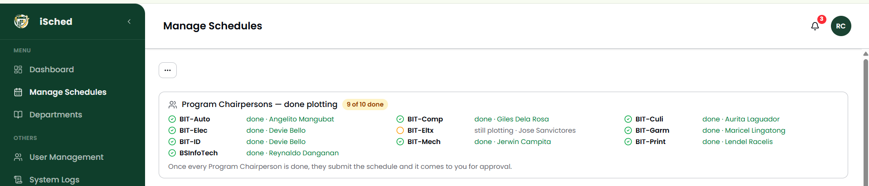
Figure 5. Workflow card showing who is done and who is still plotting

Manage Schedules

Opening a Schedule
- Choose Manage Schedules in the sidebar.
- Use the college filter at the top if your role may switch colleges.
- Select the schedule for the term from the list on the left. The classes appear on the right.
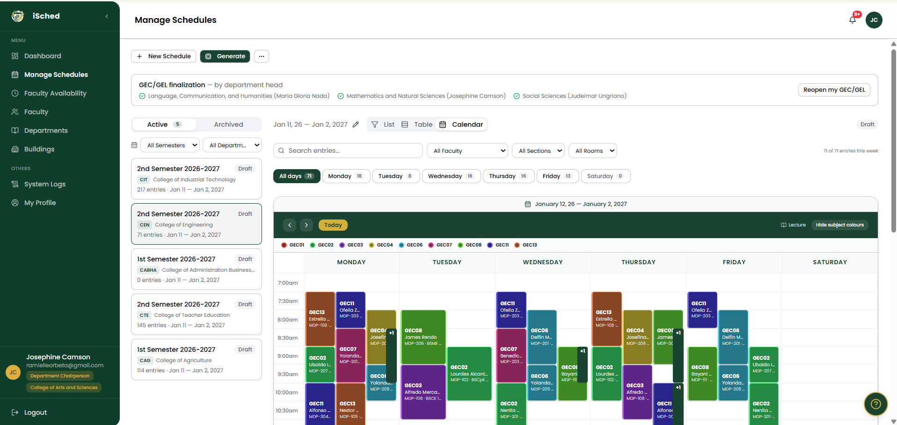
Figure 6. Schedule list and schedule detail

Viewing Classes
- List and Table: every class with section, subject, faculty, room, day and time. Rows are shown 10 per page.
- Calendar: a weekly timetable labelled every 30 minutes. Each subject has its own colour; conflicts are red.
- Day tabs: All days or a single weekday (Monday–Saturday) with the number of classes for each.
- Filters: Faculty, Section and Room.

Generating a Schedule
Generate places classes automatically. The system tries every faculty, room and time that satisfies the rules and backs up when a choice leads to a dead end.
- Open the schedule and choose Generate from the actions menu.
- Confirm in the dialog. A progress message appears while classes are placed.
- When it finishes, a message says how many classes were placed and how many could not be placed.
- Review the Conflicts and Unassigned panels above the list.
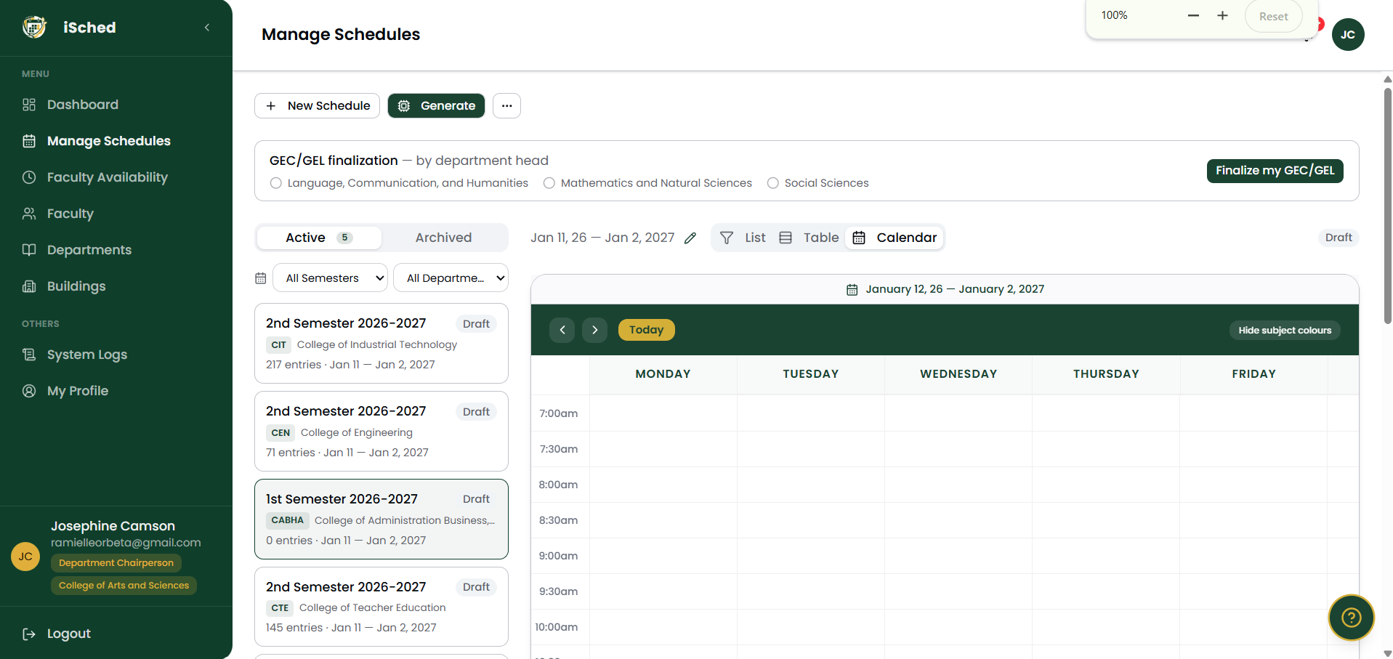
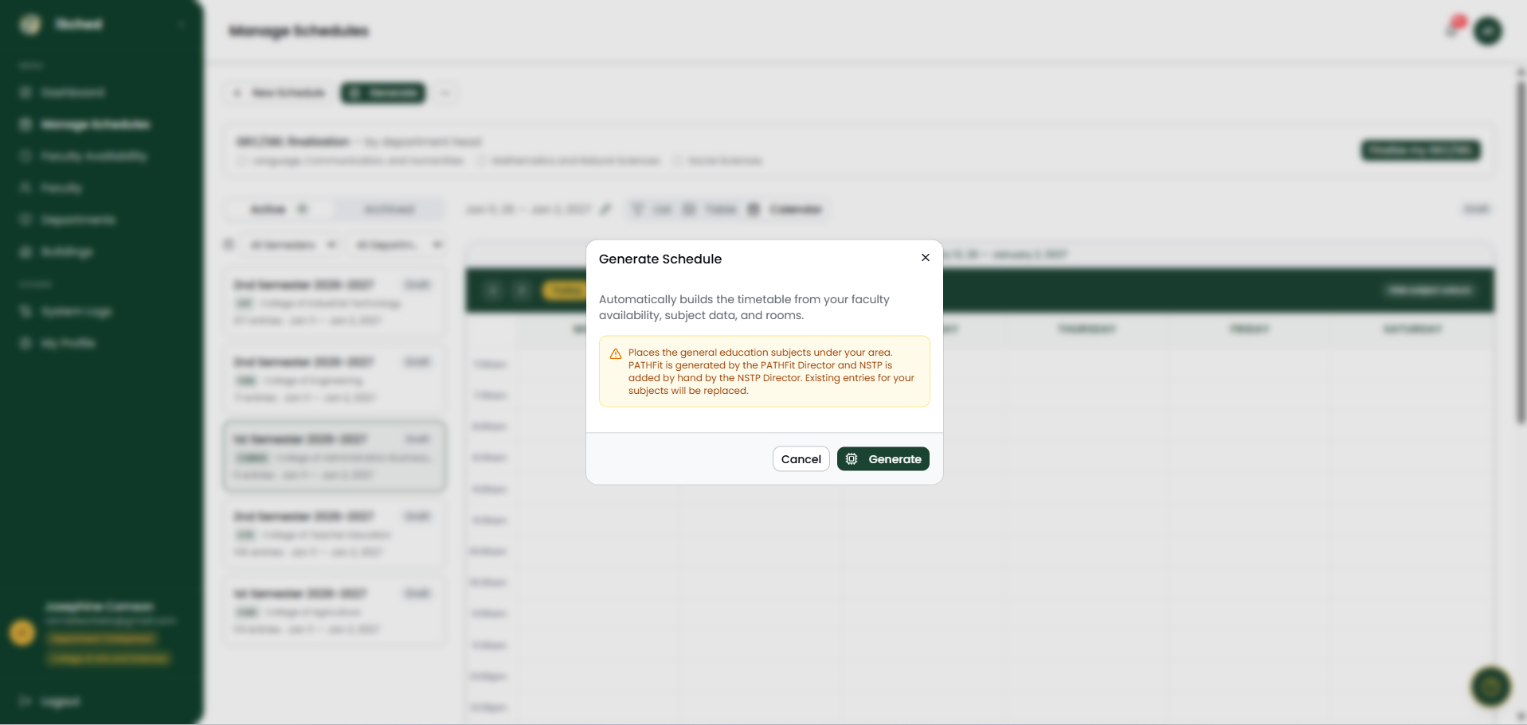

Figure 8. Generate confirmation dialog
Note: Generating replaces only the classes in your own scope. A Department Chairperson's run never touches Program Chairperson majors, PATHFit or NSTP, and already-plotted CIT laboratories are treated as fixed.

Adding a Class by Hand
- Choose Add Entry.
- Select the Section, then the Subject. Only subjects that section takes this term are offered.
- Select the Faculty (type to search). Only faculty tagged for that subject are offered.
- Select the Room. The list shows only rooms of the right type.
- Choose the day pattern — single day, MWF, TTh or custom days — and the start and end time.
- Choose Save. If a rule is broken, a message explains it.
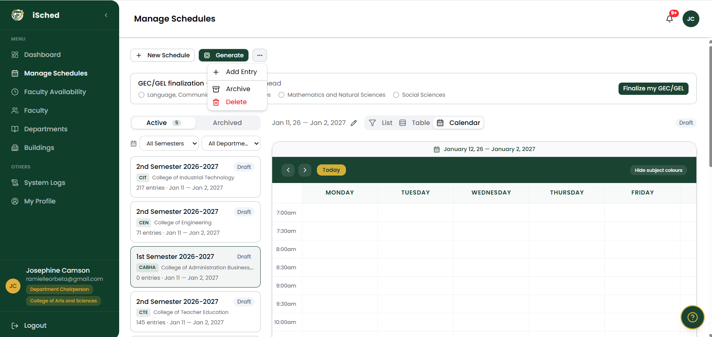
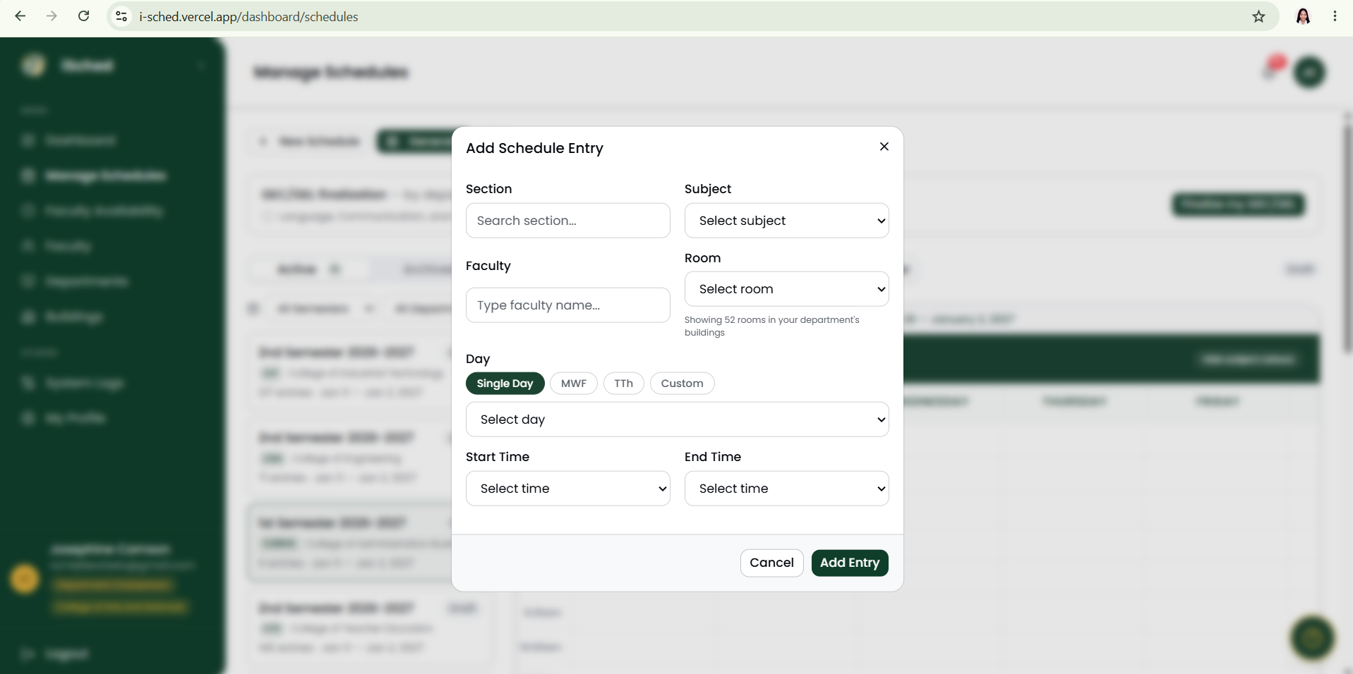
Figure 9. Add Entry dialog

Laboratory subjects: Set A and Set B
A laboratory is taught to two student groups. When you add a laboratory with no sets yet, one form takes both sets together — each with its own room, day and time. Each set is one continuous 3-hour class and the end time fills in automatically. If Set B cannot be saved, Set A is not kept, so a section never has only one set. If one set already exists, the form adds the remaining set.

Editing and Deleting
- Choose Edit on a class to change its faculty, room, day or time. The same checks apply.
- Choose Delete and confirm. Deleting a multi-day class (MWF/TTh) removes every day of it.

Conflicts
The Conflicts panel lists problems found in the schedule, such as a double-booked room or a laboratory with only one set. Fix the cause, or choose Mark Resolved to dismiss an item once it has been dealt with. All errors must be cleared before the Dean can approve.
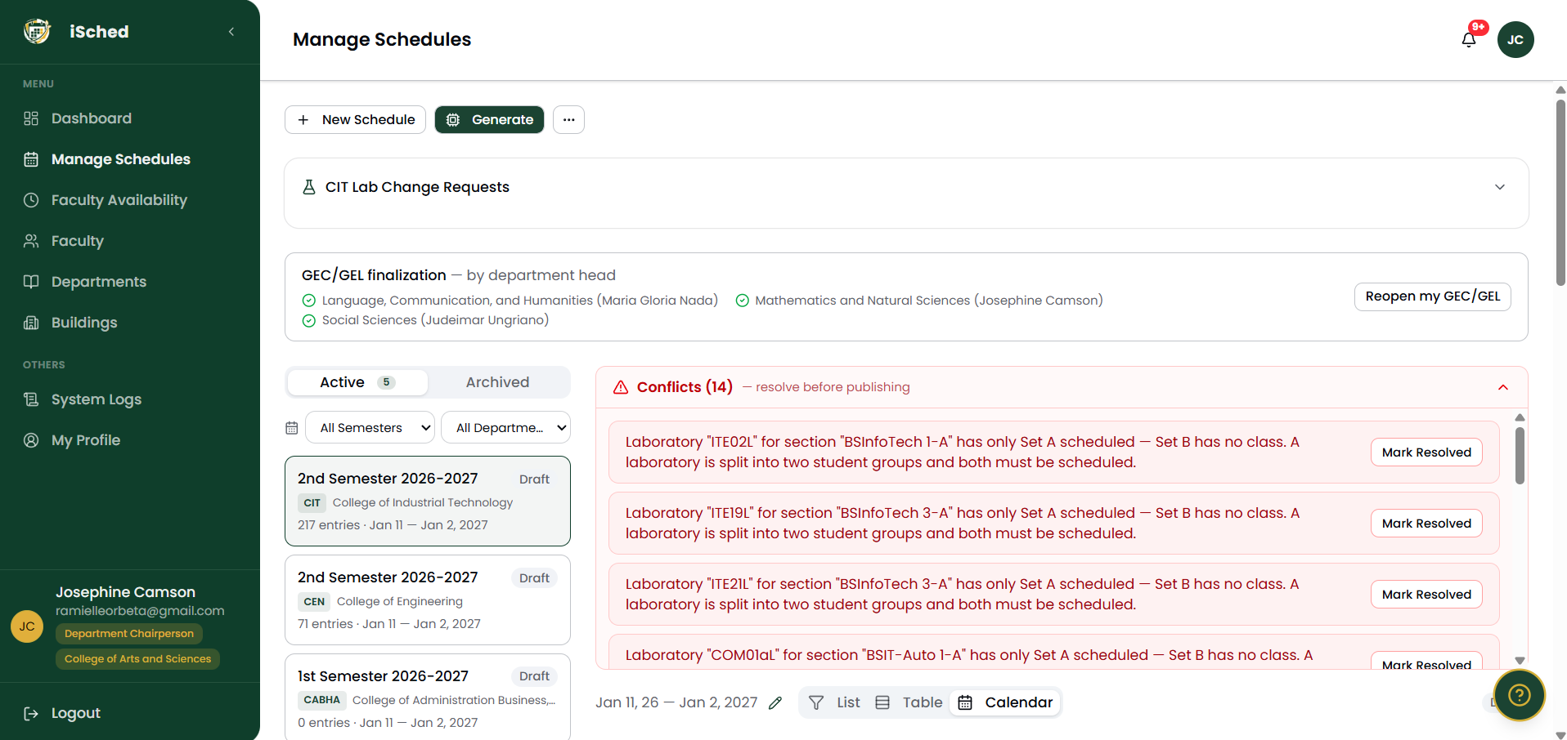
Figure 11. Conflicts panel with Mark Resolved

Unassigned Classes
Classes the generator could not place are listed with the reason (for example, no faculty available at a common time). Place them by hand with Add Entry, or request a faculty member (Program Chairperson).

Lab-Change Requests
If a CIT laboratory blocks a GEC class, the Department Chairperson sends a tracked request to the CIT Program Chairperson, who moves the lab or declines. Only the owning CIT Program Chairperson may add, move or delete CIT laboratory subjects.

Exports
Published schedules can be exported from the Export dialog:
- Schedule of Subjects (ISO format) — every class by section.
- Teaching Load — each faculty member's classes, units and hours. This is the printout faculty receive.
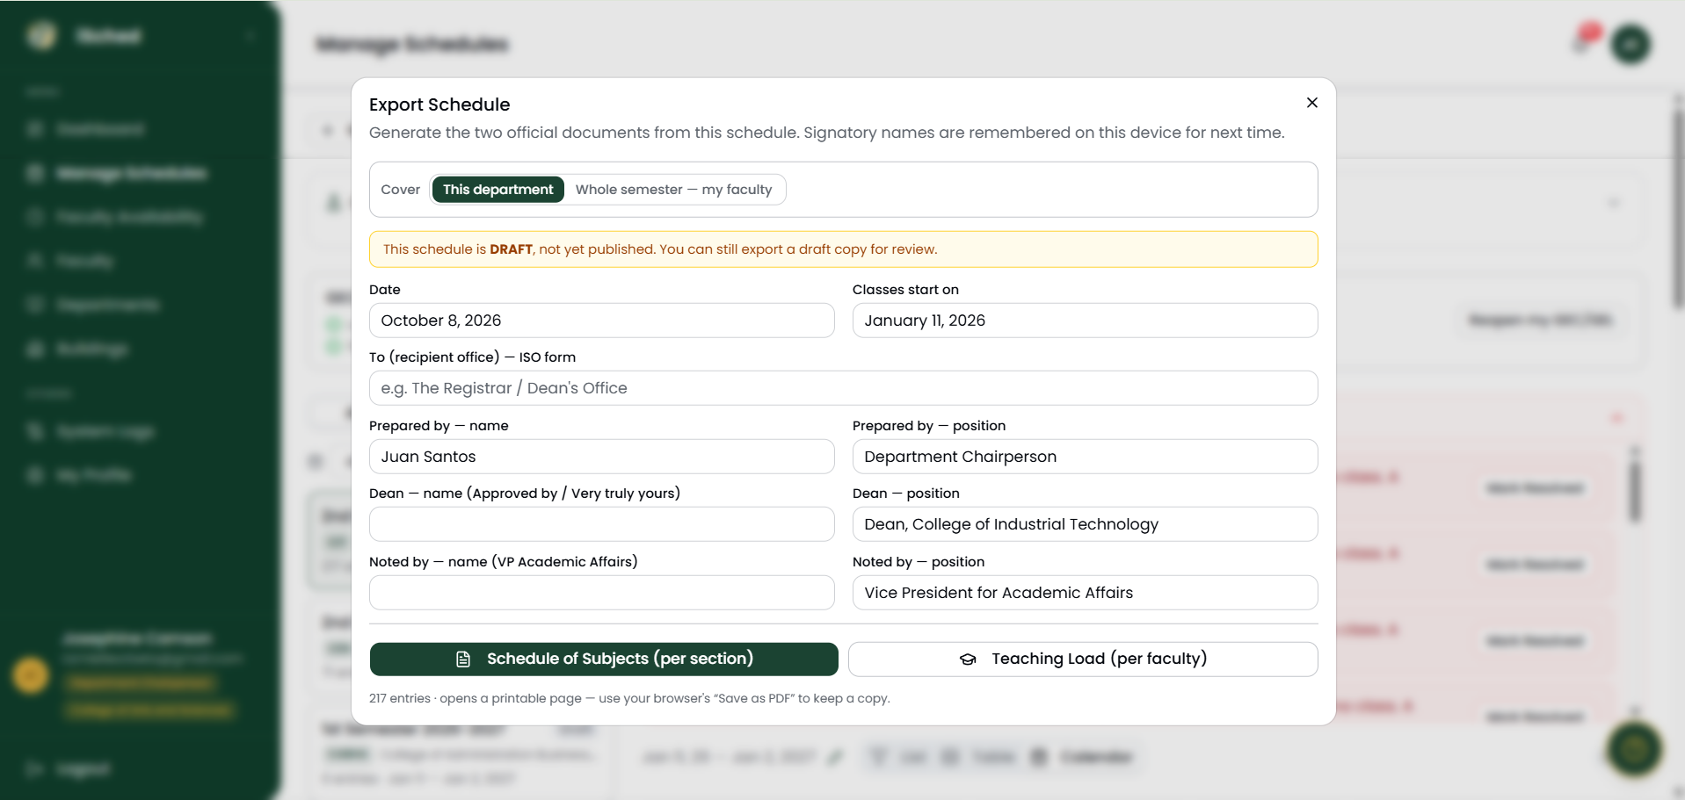
Figure 12. Export dialog

Scheduling Rules the System Enforces
Generated and hand-placed classes follow one rule set. These are the rules you will meet most often.
Rule | Detail
No double-booking | A faculty member, a room or a section cannot have two classes at the same time. Set A and Set B are different groups and may overlap.
Laboratory blocks | Every laboratory set is one continuous 3-hour class, whatever its unit count.
Lecture sessions | A lecture is spread over several days (for example MWF or TTh), never one 3-hour block.
GEC/GEL per-day limit | GEC/GEL sessions are 1 hour or 1 hour 30 minutes long.
Operating hours | Classes run between 7:30 AM and 8:00 PM.
Saturday | Only College of Allied Medicine (CAM) sections and NSTP classes may meet on Saturday.
Faculty availability | A class must fall inside the hours the faculty member marked for that term.
Specialization | Faculty must be tagged for the subject (its title or its code), for every subject including GEC, PATHFit and NSTP.
Workload | Regular faculty: 21 units/week; COSI faculty: 40 units/week; plus a maximum hours per week.
Room type | Lectures need a lecture room; laboratories need a laboratory; computer-based labs need a computer laboratory.
Lab specialization | A subject needing a specialized lab (for example Networking) uses only a matching lab.
Room access | A room restricted to certain departments or programs is used only by them.
Term isolation | A 1st-semester schedule uses only 1st-semester availability and subjects.

Guide for the Dean
The Dean's work is to approve the people and the schedule of their own department.

Dashboard
Shows schedules awaiting approval (with a Review & approve link), accounts awaiting approval, the department's schedules with status, unassigned and conflict badges, and the latest activity.
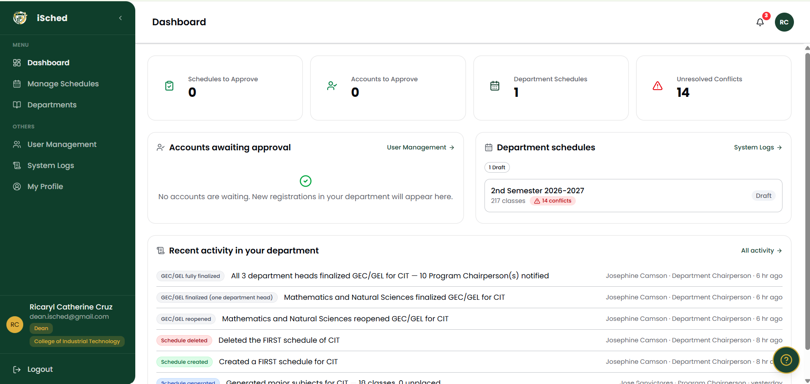
Figure 13. Dean dashboard

Approving Accounts (User Management)
- Choose User Management.
- Find the pending account and choose Approve. Choose Delete to remove an account permanently (this also removes its sign-in).
- To assign a Program Chairperson to a program, use Change Department.
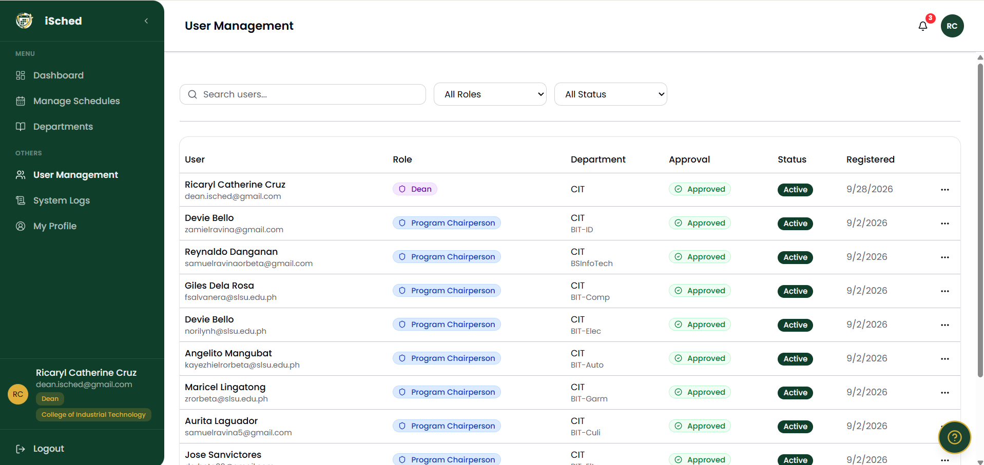
Figure 14. User Management

Approving the Schedule
- Open the schedule from the dashboard link or from Manage Schedules.
- Review the classes, the conflicts and the Program Chairpersons' completion list.
- Choose Approve to publish. If double-bookings remain, approval is refused and they are listed.
- Or choose Return for Revision and write a note. The schedule goes back to Draft and the chairs are notified.
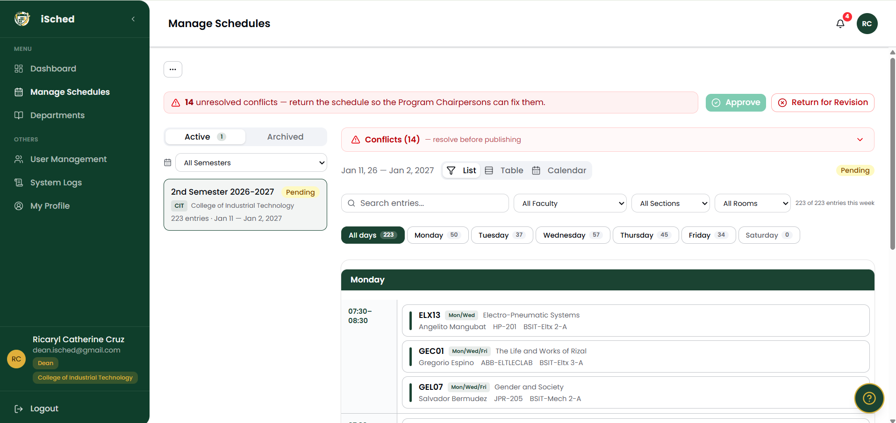
Figure 15. Approve and Return for Revision
Note: The Dean is read-only on every other page.

Guide for the Department Chairperson
Department Chairpersons head the CAS department head areas: Social Sciences; Language, Communication, and Humanities; and Mathematics and Natural Sciences. Together they are the three department heads.

Plotting GEC/GEL
- Open the schedule of any college (use the college filter).
- Choose Generate to place your area's GEC/GEL subjects for every section, or add classes with Add Entry.
- Check the result, then choose Finalize my GEC/GEL.
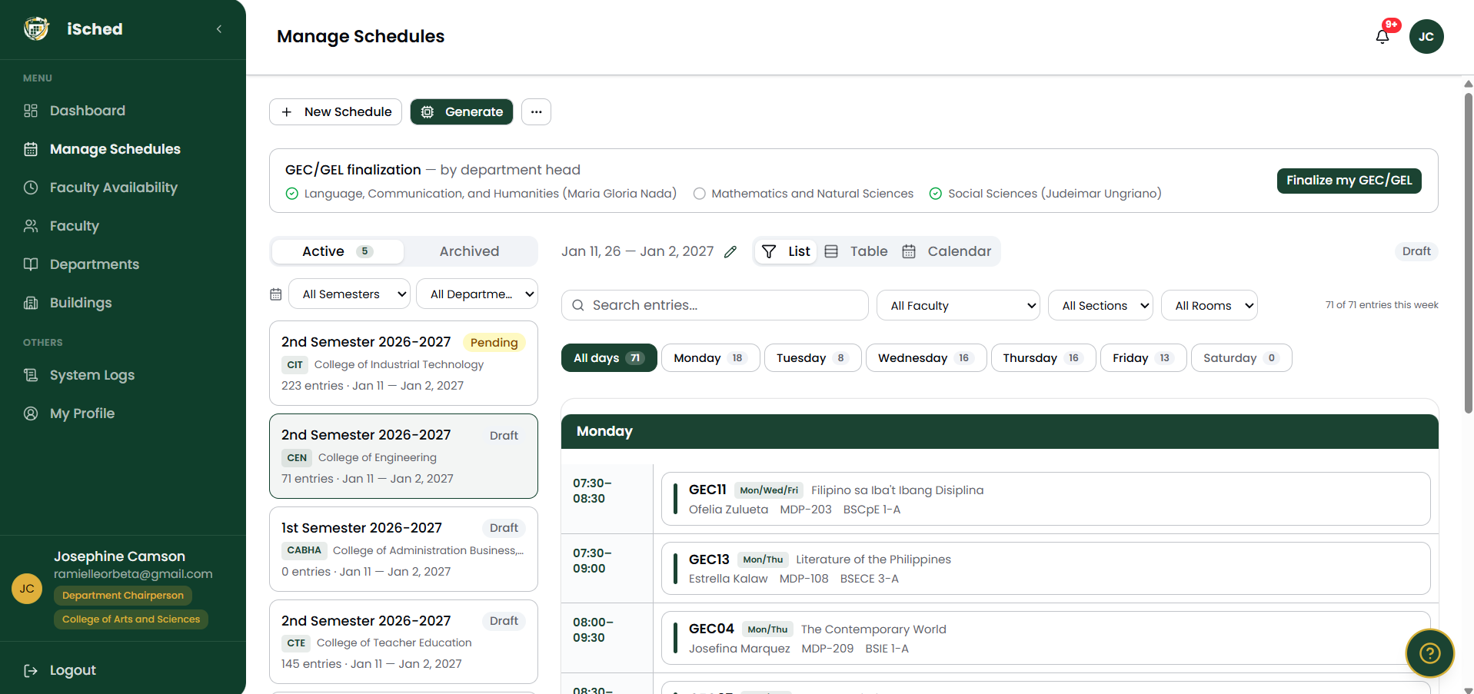
Figure 16. GEC/GEL finalization card for the three department heads
- Program Chairpersons can add their majors only after all three department heads have finalized that schedule.
- Finalizing reopens automatically if you add, edit, delete or regenerate a GEC/GEL class afterwards.
- In a CIT schedule you must wait until the CIT Program Chairperson has plotted the laboratories.

Faculty Requests
When a Program Chairperson requests an instructor, choose the faculty member to allocate. The instructor then joins that program's pool for the term.

Publishing and Resetting
You publish only the CAS schedule. You may reset or unpublish a published schedule back to Draft.

Other pages
- Faculty and Faculty Availability — manage your area's faculty (see the Faculty chapter).
- Departments, Buildings — subjects, sections, rooms.
- System Logs — all five tabs across every department.

Guide for the Program Chairperson

Preparing Your Program
- Departments: check the sections for each year level and the subjects of your program.
- Faculty: add your faculty with specializations and employment type.
- Faculty Availability: mark each faculty member's hours for the term.

Plotting Your Subjects
- Wait for the "GEC/GEL finalized" notification. (CIT chairs plot laboratories first, then lectures after GEC — see The Scheduling Workflow.)
- Open your department's schedule in Draft status.
- Choose Generate to place your major subjects, then fix anything left in Unassigned with Add Entry.
- Clear the conflicts.
- Choose Mark my subjects as done. Choose Reopen if you need to change something; adding, editing or regenerating also reopens it automatically.

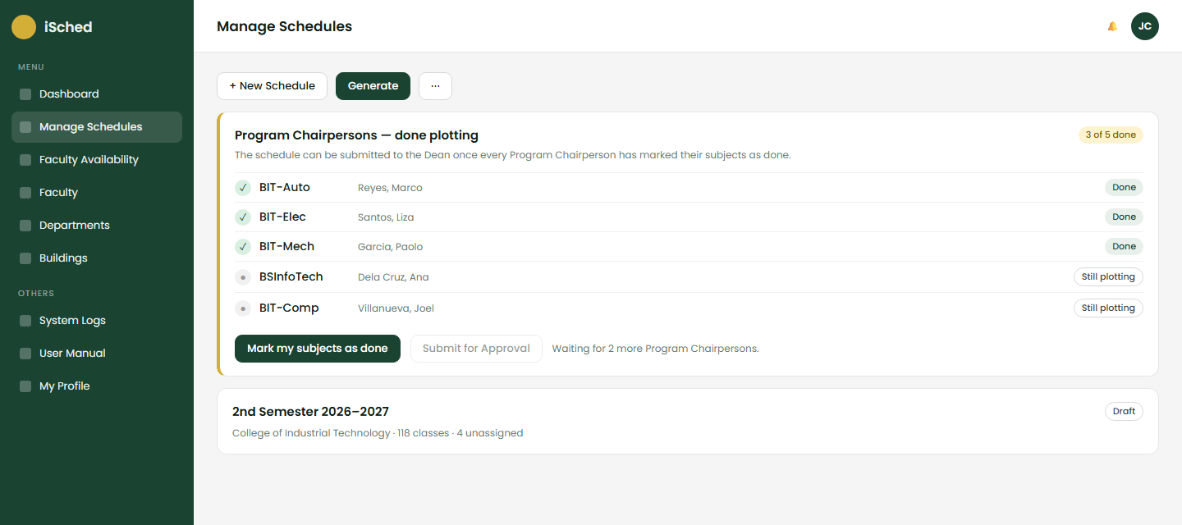
Figure 17. Program Chairpersons — done plotting

Submitting for Approval
When every Program Chairperson of the department is done, Submit for Approval becomes active. Choose it to send the schedule to the Dean. If the Dean returns it, the note appears and the schedule is back in Draft.

Requesting a Faculty Member
On the Faculty page choose Request faculty, pick the term and write the reason. The Department Chairperson allocates an instructor.

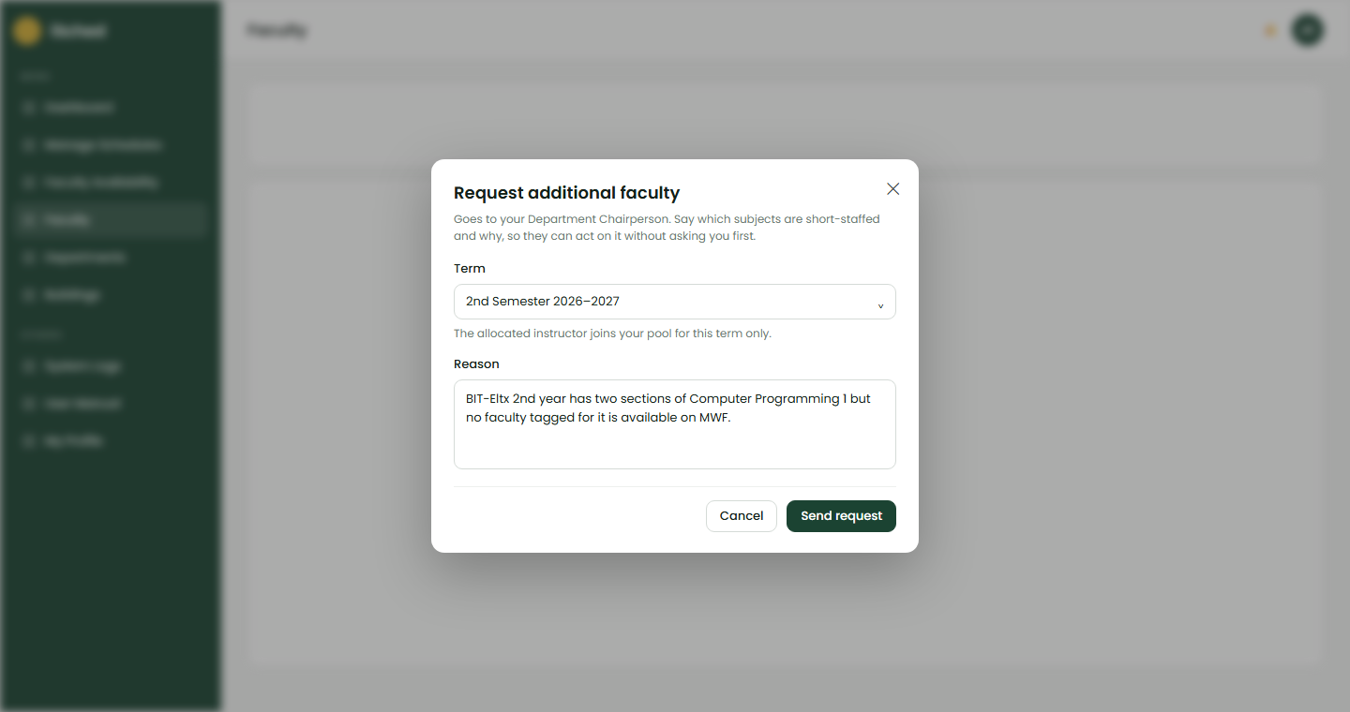
Figure 18. Request faculty

Guide for the PATHFit Director
There is exactly one PATHFit Director account. It works in every college’s schedule but only on PATHFit subjects.

Add Your Instructors
- Open Faculty and choose Add Faculty.
- Enter the first and last name and the employment type.
- Under Specializations, tick the PATHFit subjects the instructor teaches. At least one is required.
- Open Faculty Availability and mark the hours the instructor can teach for the term.

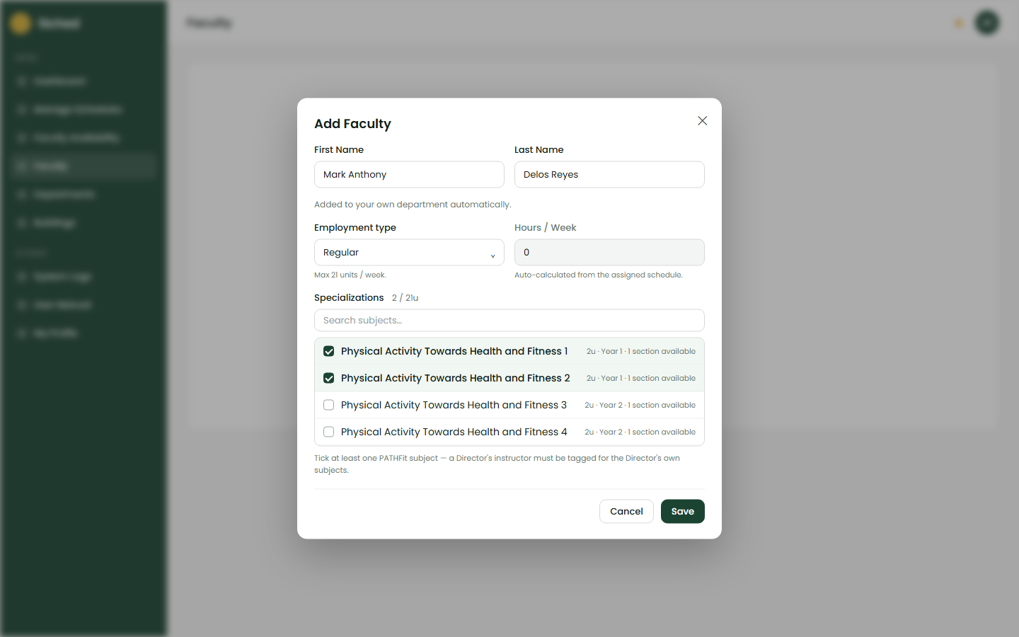
Figure 19. Add Faculty with PATHFit specializations

Generate PATHFit
- Open Manage Schedules, pick a college and its schedule.
- Choose Generate. Each section receives one continuous PATHFit block with one of your instructors.
- Review the Unassigned list for classes that could not be placed.

Venues and Limits
Venue | Most classes at the same time
Gymnasium | 4
Covered Court | 4
Field | 2

PATHFit may be held only in these three venues, and they are for PATHFit only. Adding a class to a full venue is refused.

Editing by Hand
Use Add Entry, Edit or Delete on any PATHFit class. Choose the venue from the three above and an instructor tagged for the subject.

Guide for the NSTP Director
There is exactly one NSTP Director account. NSTP is never generated: each class is added by hand.

Add Your Instructors
Add instructors on the Faculty page (tagged for NSTP) and mark their hours on Faculty Availability, the same way as for PATHFit.

Adding a Class
- Open Manage Schedules, pick the college and its schedule.
- Choose Add Entry, then the Section and the NSTP subject.
- Choose the instructor, room, day and time. NSTP may be held on Saturday.
- Choose Save.

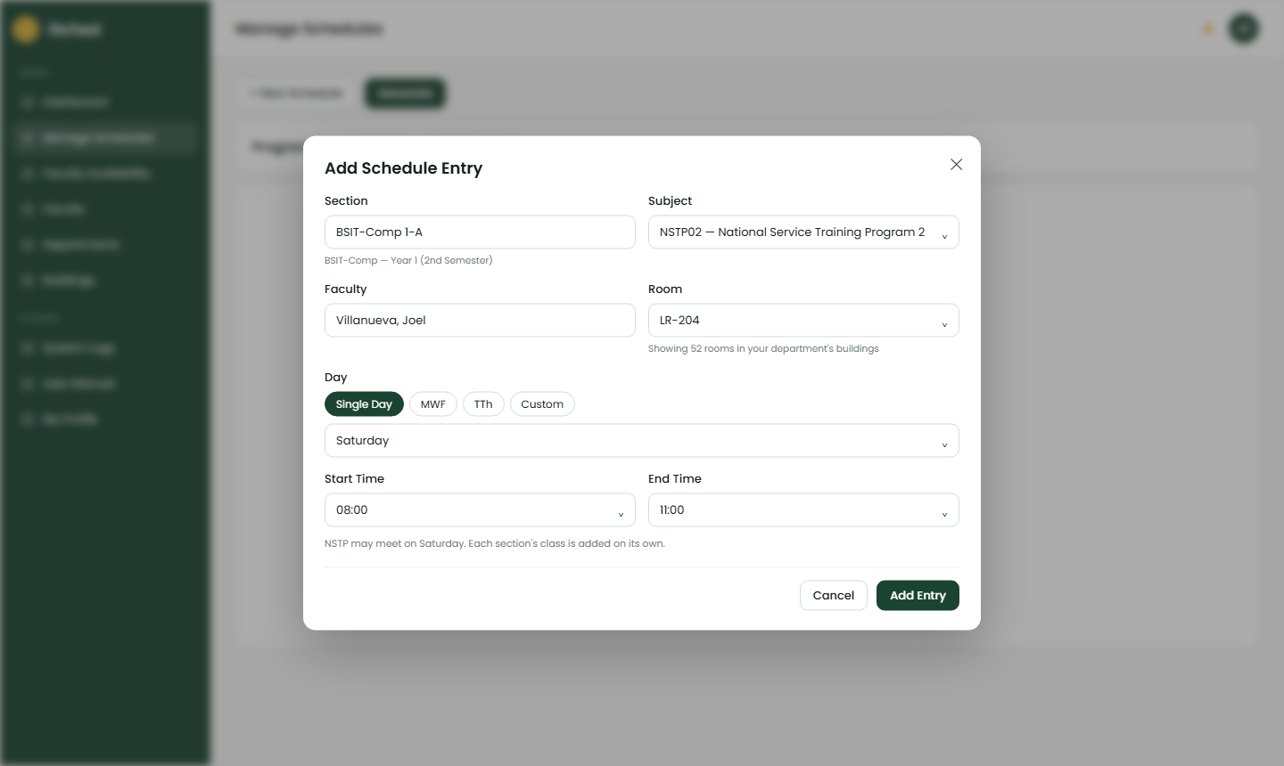
Figure 20. Adding an NSTP class

Editing and Deleting
Use Edit or Delete on any NSTP class. You cannot touch other subjects.

Faculty

Adding Faculty
- Choose Faculty, then Add Faculty.
- Choose Existing User to link an account, or New Faculty to enter a name (email is optional — faculty do not log in).
- Choose the Employment type: Regular (maximum 21 units a week) or COSI (maximum 40 units a week).
- Under Specializations, tick the subjects the person can teach and, if needed, how many sections.
- Choose Save.

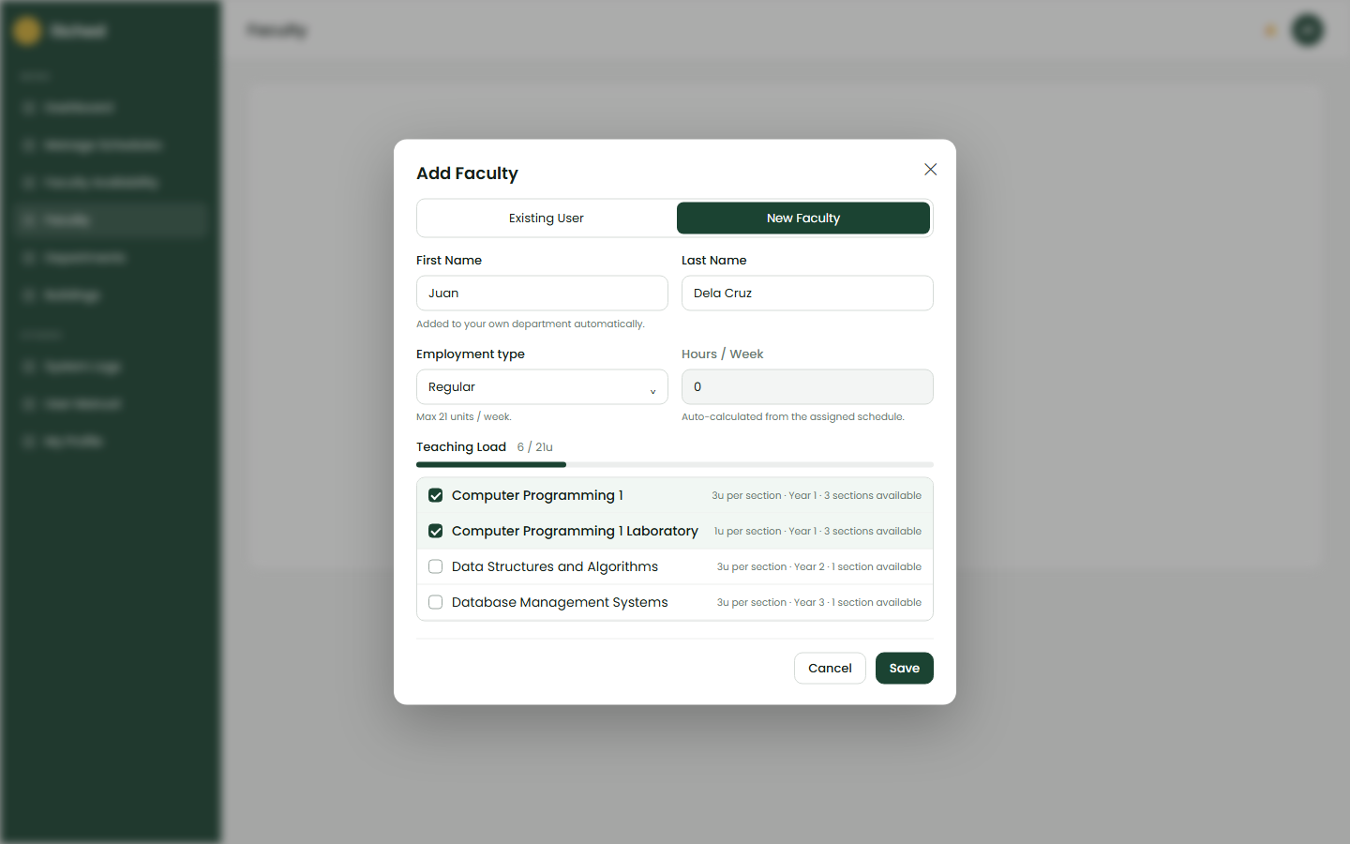
Figure 21. Add Faculty dialog

Editing and Deactivating
- Choose Edit to change name, type, specializations or status. Saving keeps specializations that are not shown in the list (for example another program’s subjects).
- Deactivate keeps the record visible, marked Inactive. Delete removes it permanently and asks you to confirm.

Reading the List
Faculty are grouped by department and shown 10 per page, for example “1–10 out of 42 faculty”. Each row shows the unit cap and the scheduled hours.

Faculty Availability
Availability is recorded for one term (academic year and semester). Only 1st and 2nd semesters are listed.

Marking Available Hours
- Choose Faculty Availability and pick the Term.
- On a faculty member’s card, drag across the timeline to mark available hours, or use a preset.
- Drag the end handle of a green block to resize it.
- Wait for “Saving availability…” to finish.

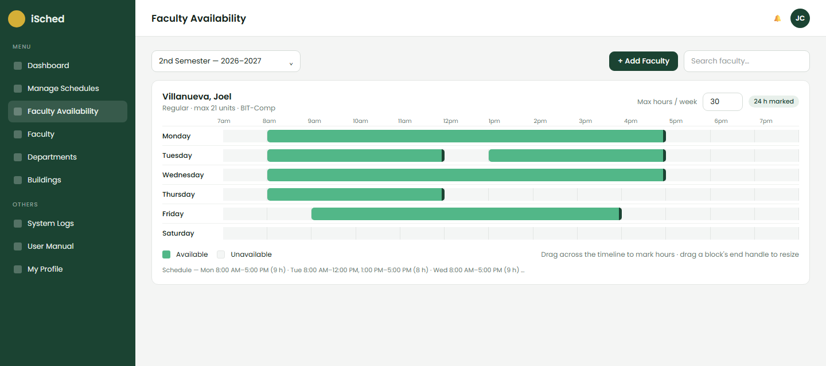
Figure 22. Availability timeline

Maximum Hours per Week
Each card has a Max hours / week box. Availability cannot exceed it, and the generator never schedules a person beyond it. Hatched cells show hours over the limit.
Note: Generation and hand-placement need availability for that term. If none is recorded, the system names the term and asks you to add it.

Departments, Buildings and Rooms

Departments
Shows each department’s programs, year levels, sections and subjects. Subjects have a type (lecture or laboratory), units, the room they need, and for GEC/GEL a longest session per day (1 hour or 1 hour 30 minutes).

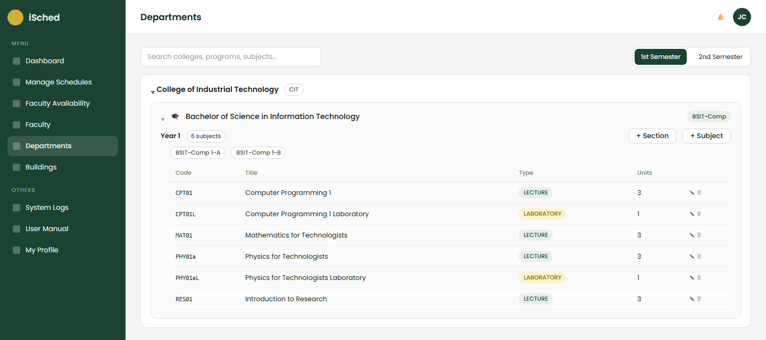
Figure 23. Departments page

Buildings and Rooms
- Add buildings and rooms, choose the room type (lecture room, laboratory, computer laboratory, lecture-lab) and, for labs, the laboratory specialization.
- Restrict a building to certain departments, or a room to certain departments or programs. A room with no restriction is open to all.
- The lab inventory lists laboratories by specialization.
- PATHFit venues (Gymnasium, Covered Court, Field) appear here as shared rooms.

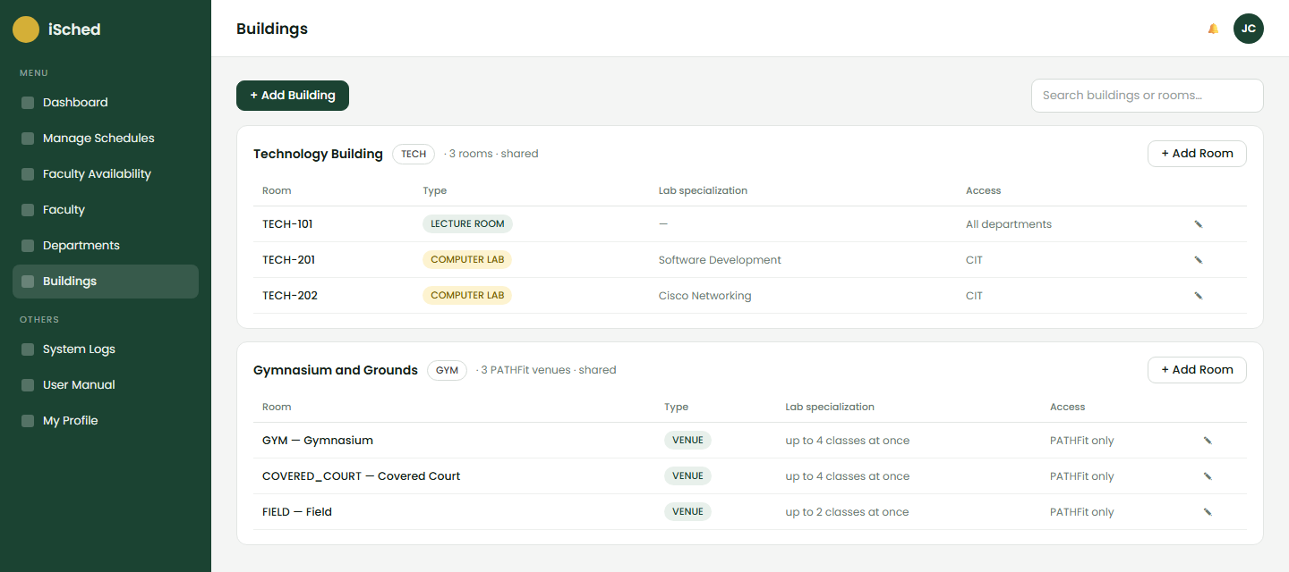
Figure 24. Buildings and rooms

System Logs
System Logs is the oversight page for the Dean, Department Chairperson and Program Chairperson. A Dean or Program Chairperson sees their own department; a Department Chairperson sees every department. Each department has its own colour throughout.
Tab | What it shows
Activity | Who did what and when: sign-ins, generations, class changes, approvals. Filter by action, role and date, expand a row for details, and Export CSV.
Schedules | Every schedule in scope with its department and status.
Classes | Every scheduled class of a term (section, course, subject, faculty, room, day and time) with totals, search, filters and CSV export.
Subject Summary | For every subject, which programs take it in which semester, planned versus scheduled.
Room Occupancy | A room-by-time grid for each building, one colour per department, with a list view.

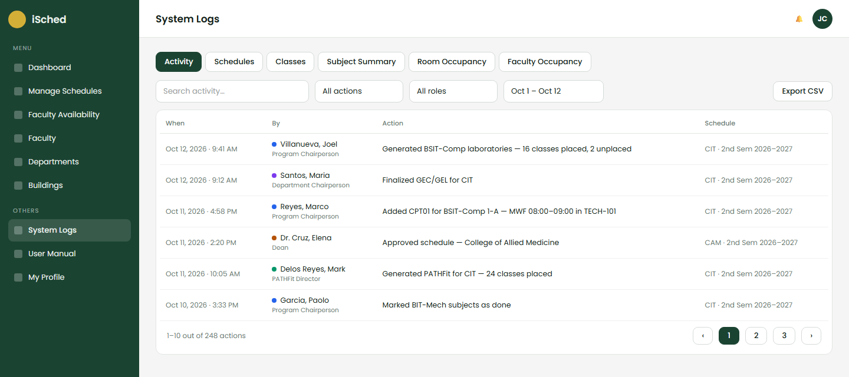
Figure 25. System Logs — Activity tab

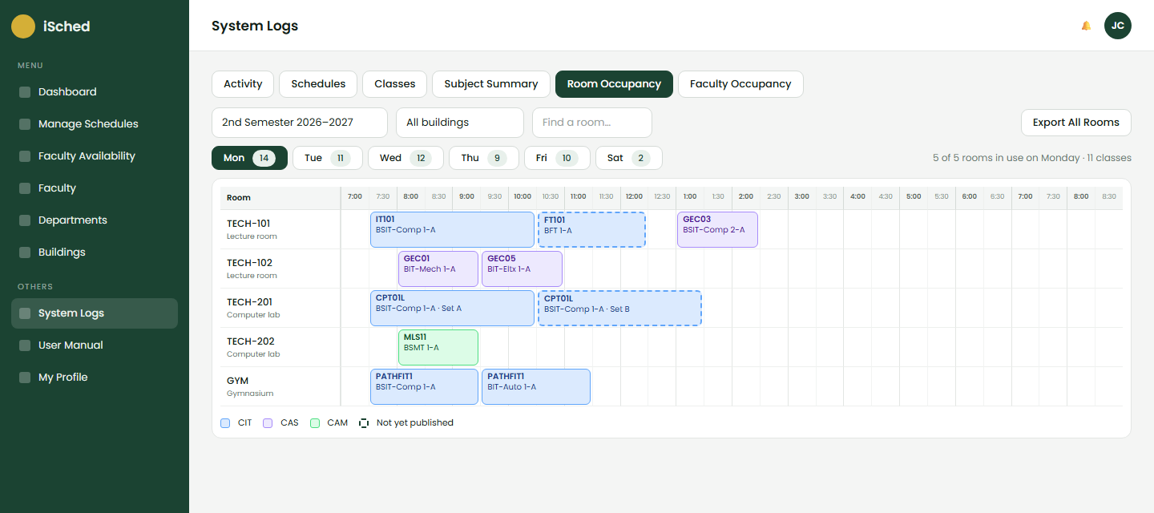
Figure 26. System Logs — Room Occupancy grid

User Manual, Profile and Help

Built-in User Manual
Choose User Manual in the sidebar. Your role's workflow opens first as a flowchart with the places each step happens; a role switcher shows the others.

My Profile
Choose My Profile to see and update your account details.

Page Help
The help button on each page shows short tips for that page and role.

Troubleshooting
Message or problem | What to do
"Waiting for GEC" | The three department heads must finalize GEC/GEL for this schedule first. The banner shows who is still pending.
"CIT laboratories are not plotted yet" | The CIT Program Chairperson must plot the laboratories before GEC/GEL for CIT.
Faculty conflict / Room conflict | That person or room is already booked at that time (possibly in another department's schedule). Choose another time or resource.
Specialization mismatch | Tag the faculty member for the subject on the Faculty page, or choose another person.
No availability recorded | Open Faculty Availability, choose the term and mark the hours.
Laboratory must be a 3-hour block | Each laboratory set must be exactly 3 hours.
Venue full | Gymnasium and Covered Court hold 4 PATHFit classes at a time, the Field 2. Choose another venue or time.
Set A and Set B must be scheduled together | Only one set could be placed, so neither was kept. Check faculty, room and availability, then generate again.
Submit for Approval is disabled | Every Program Chairperson of the department must mark their subjects done.

Privacy and Terms of Use

Privacy and Data Collected

iSched collects and stores names, institutional email addresses, user roles, and scheduling data exclusively to support university academic and administrative operations. Department chairs sign in using individual authenticated accounts, while faculty records are processed solely for section assignments, timetable generation, and printing official Teaching Loads without third-party sharing.

User Responsibility

Authorized users must secure their account credentials, ensure the accuracy of all submitted scheduling parameters, report system anomalies immediately, and strictly use platform data for legitimate university business.

System Ownership

The iSched application, including its source code, database design, user interfaces, and brand assets, remains the exclusive intellectual property of Southern Luzon State University – Lucban Campus.

All processing, storage, and retention of personal and operational data adhere to the Data Privacy Act of 2012 (Republic Act No. 10173) and internal SLSU administrative policies.

Contact and Support
For inquiries, technical support, or feedback regarding the iSched system, please reach out through the following contacts:
isched@gmail.com
Southern Luzon State University

