Flox Data solution Deployment Document
The document describes the deployment steps [manual] required to execute the data processing solution. The technology and platform used allows automated deployment but will require support technologies like DevOps. Ideally, the solution should be deployed based on DAB [Asset Bundles and Python wheel] through DevOps repository.
Data curation component: [Estimated time 5-7 minutes]
Deployment Files
File Name | Type | Description
camera_df | Ingestion, Standardization | Data Flow for Camera data files ingestion
environmental_df | Ingestion, Standardization | Data Flow for environmental data files ingestion
synthetic_df | Ingestion, Standardization | Data Flow for synthetic data files ingestion
dimension_df | Transformation | Data Flow for dimensions data
analytics_df | Transformation | Data Flow for producing aggregates data

Solution Deployment
Steps for deployment
- Create Databricks login on Databricks Free Edition.
This will provide access to databricks platform based on useremail.
  - Login Link
https://login.databricks.com/signup?provider=DB_FREE_TIER&dbx_source=www&itm_data=dbx-web&l=en-EN&tuuid=a645f379-a2ed-4da5-b9dd-7e949b11aae0&intent=SIGN_UP&sisu_state=eyJsZWdhbFRleHRTZWVuIjp7Ii9zaWdudXAiOnsidG9zIjp0cnVlLCJwcml2YWN5Ijp0cnVlLCJjb3Jwb3JhdGVFbWFpbFNoYXJpbmciOnRydWV9fX0%3D
  - Verify access works. Databricks Platform home Screen
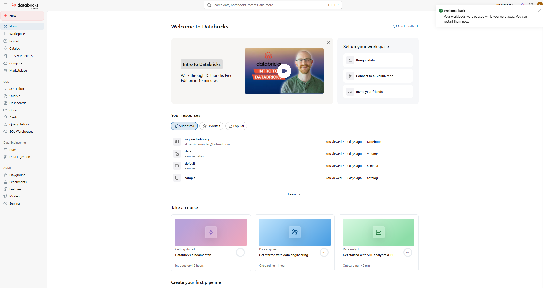
- Create Pipeline
  - Click on Jobs & Pipeline
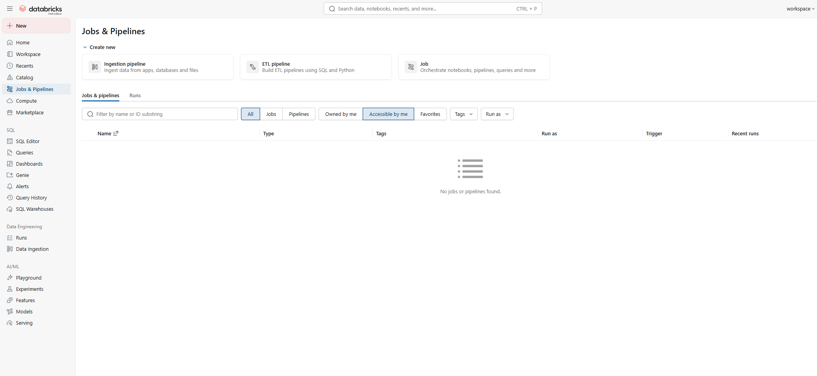
  - Click ETL Pipeline: This should open a new pipeline screen.
Specify Pipeline Name. Example flox_sample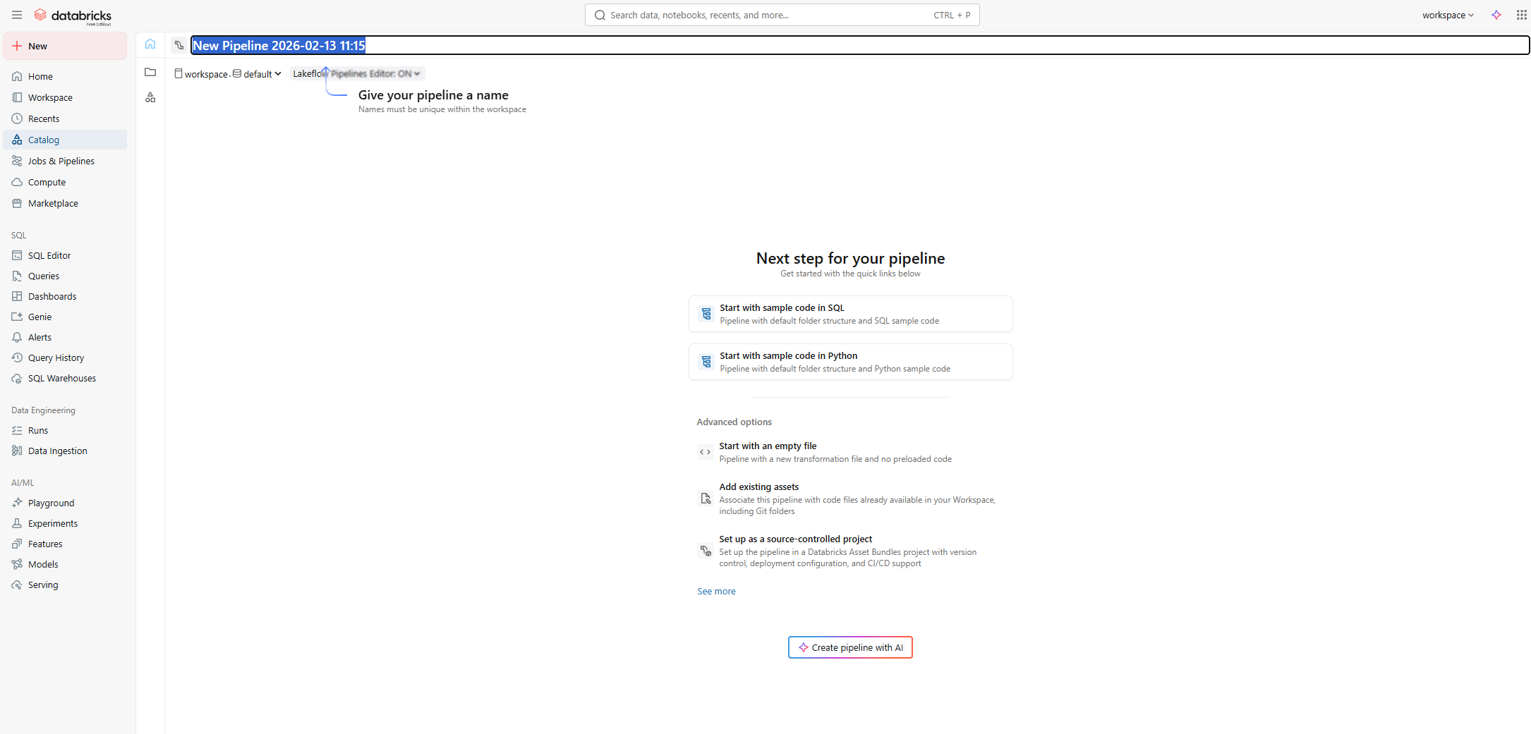
  - Press Start :[Start with empty file/Start with sample code in python]
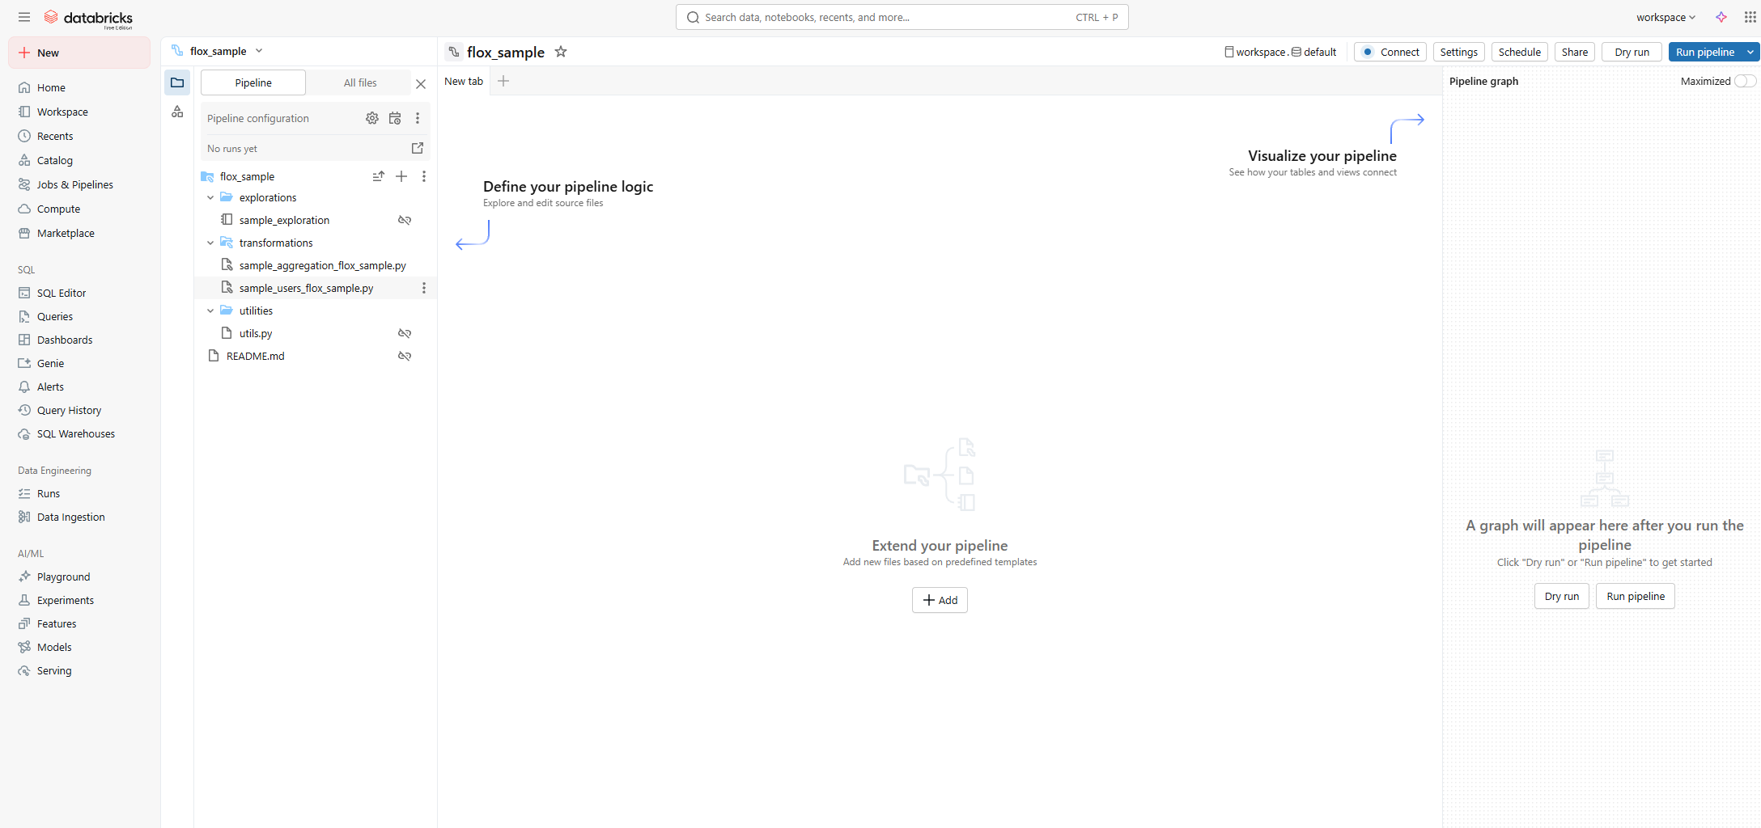
  - Remove All sample pipelines from exploration, transformation and utilities folder.
- Upload solution files to pipeline.
  - Press breadcrumb of Transformation folder.
  - Select upload files.
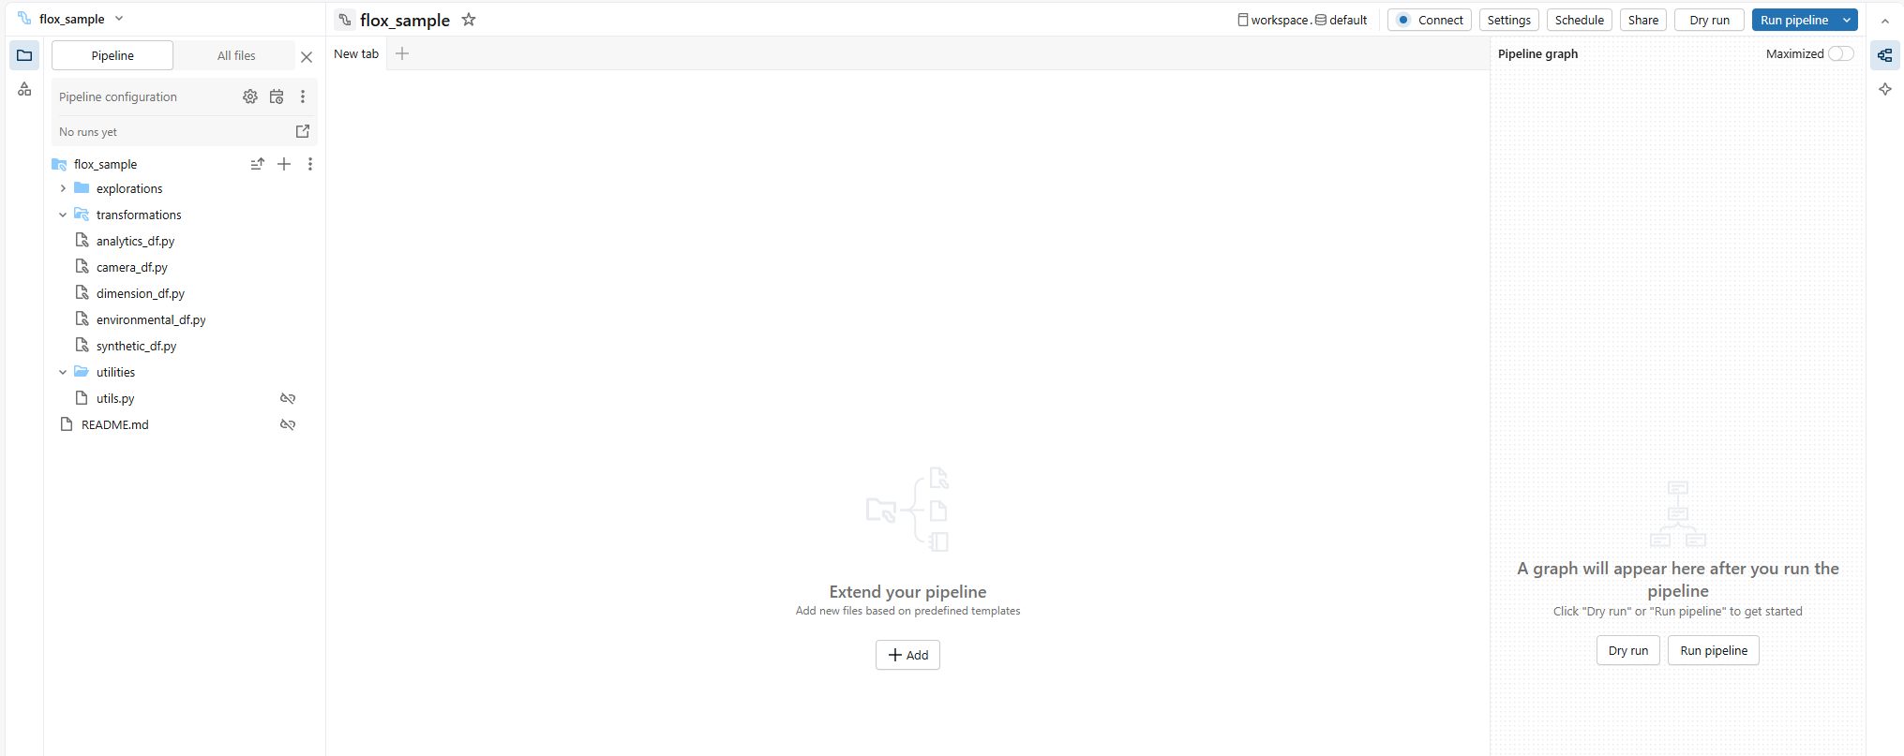
  - All files are uploaded to transformations directory

- Configure Landing directories
  - Open catalog window
  - Go to samples catalog
  - Expand default schema
  - Expand Volume
  - GoTo Data folder
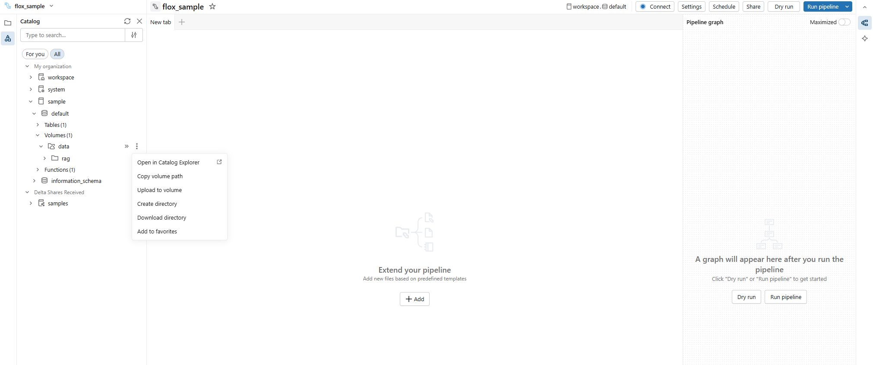
  - Create directories: flox/[camera/environmental/synthetic]
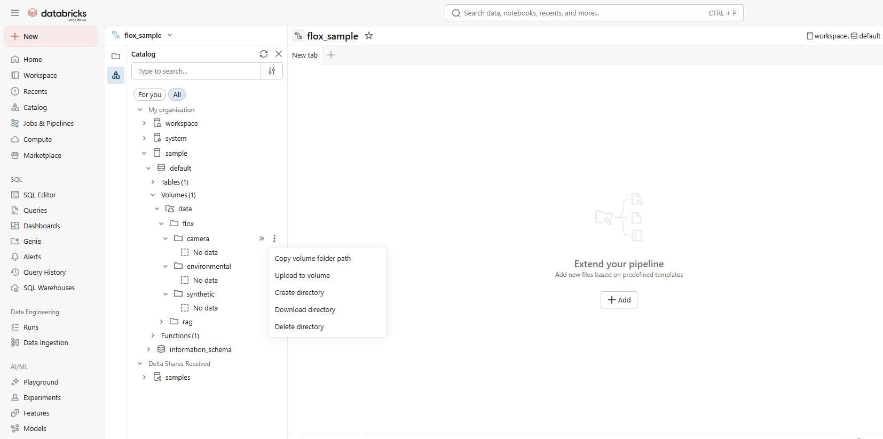
  - Upload data files into corresponding directories
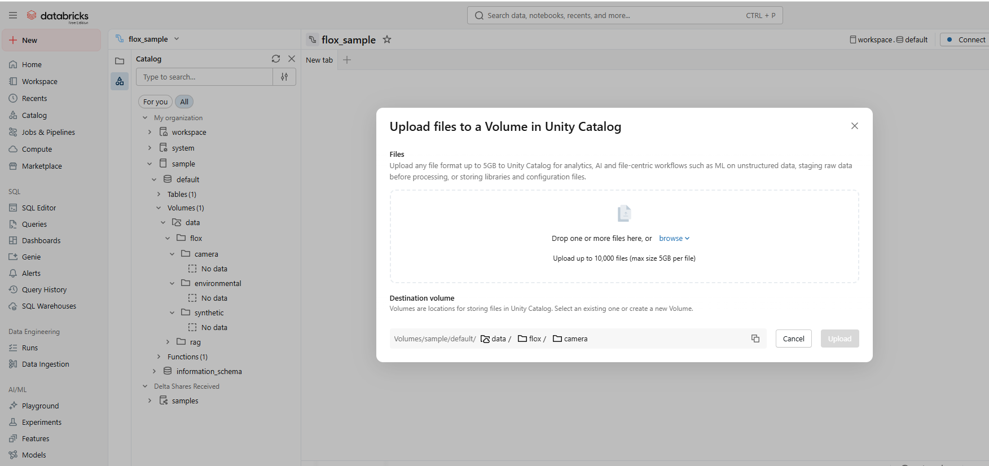
  - All files are uploaded to directories.
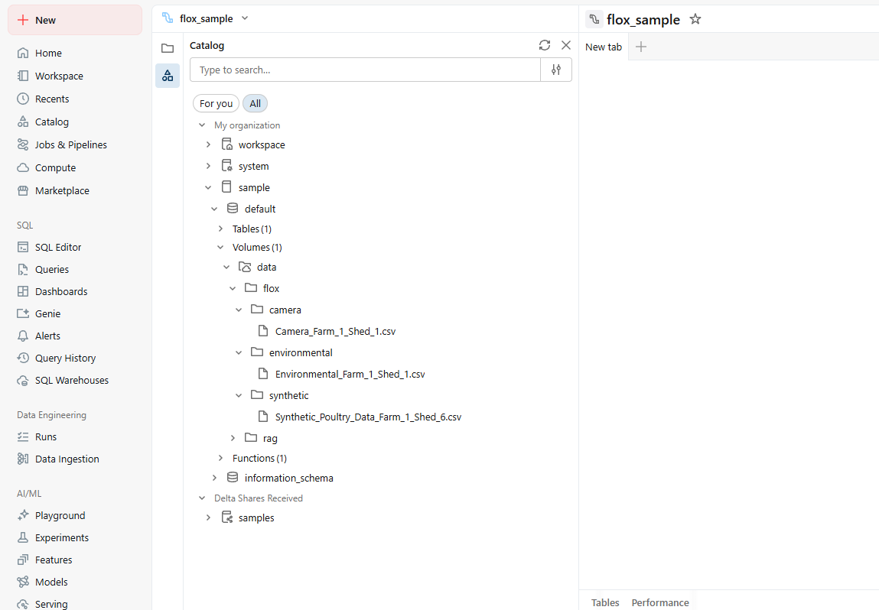
- If all previous steps are followed as-is, this step is not required.
Configure File and catalog path in scripts
  - Update each script with configured volume directory and catalog name
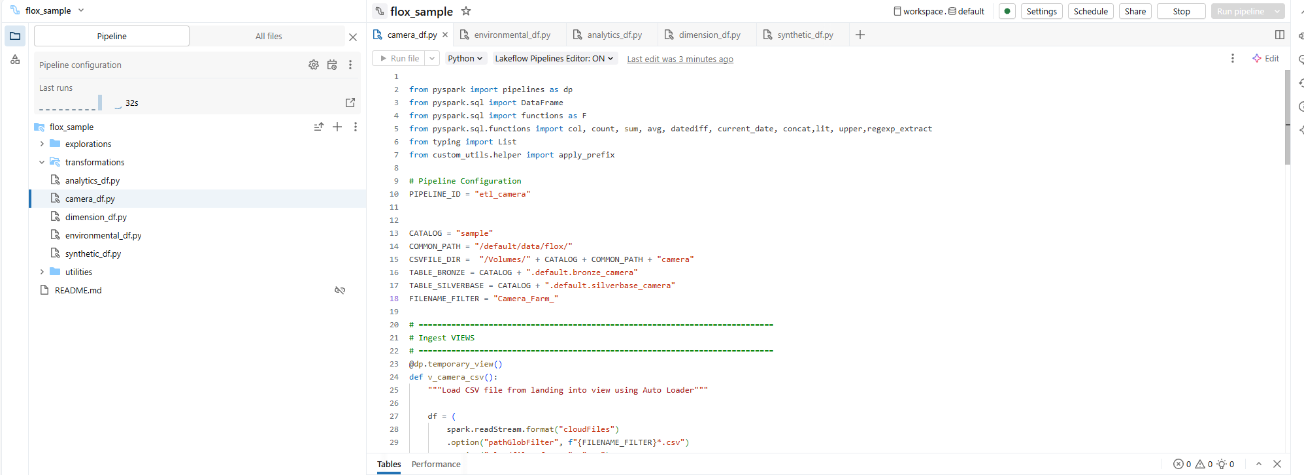
- Compile Pipeline
  - Press Dry Run to compile pipeline
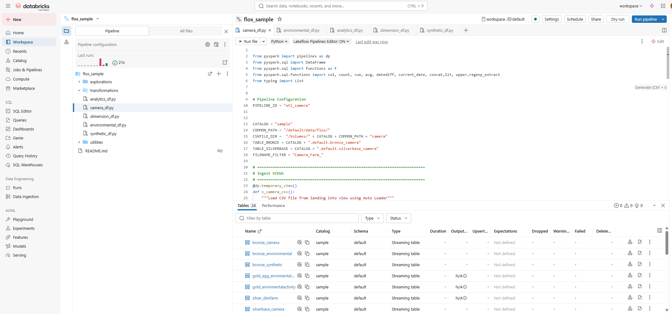
  - Should be success. Any issue, please look at the message and modify config. As required.
- Execute Pipeline
  - Execute pipeline by pressing Run Pipeline [Pipeline full refresh/pipeline run]
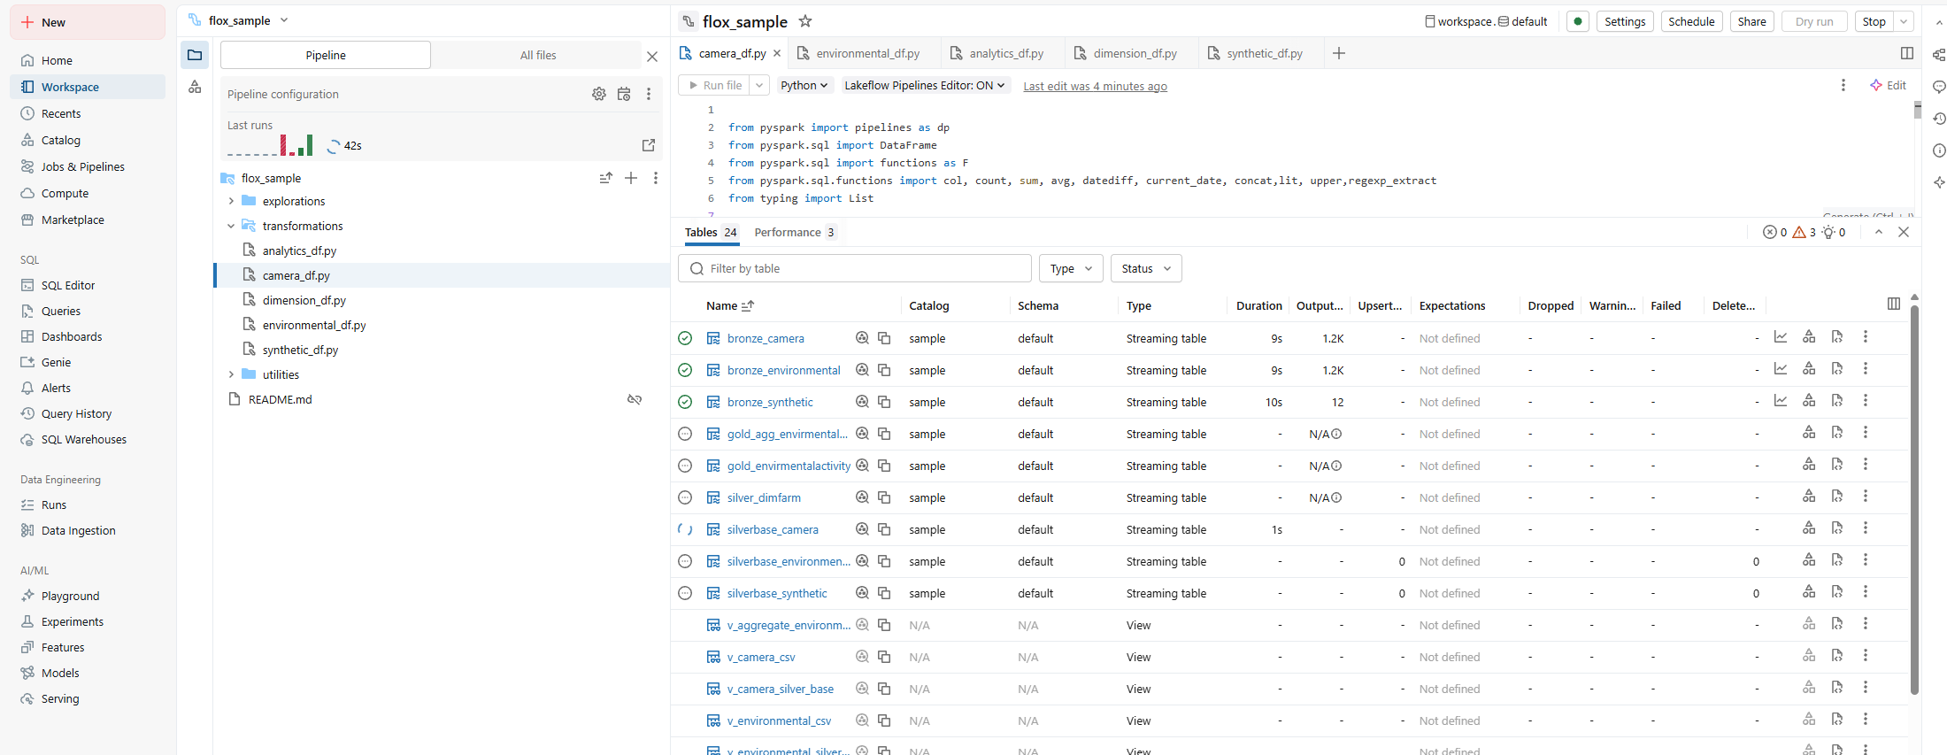
- Check Data processing
  - Expand Catalog ‘sample’, expand schema ‘default’, expand ‘tables’.
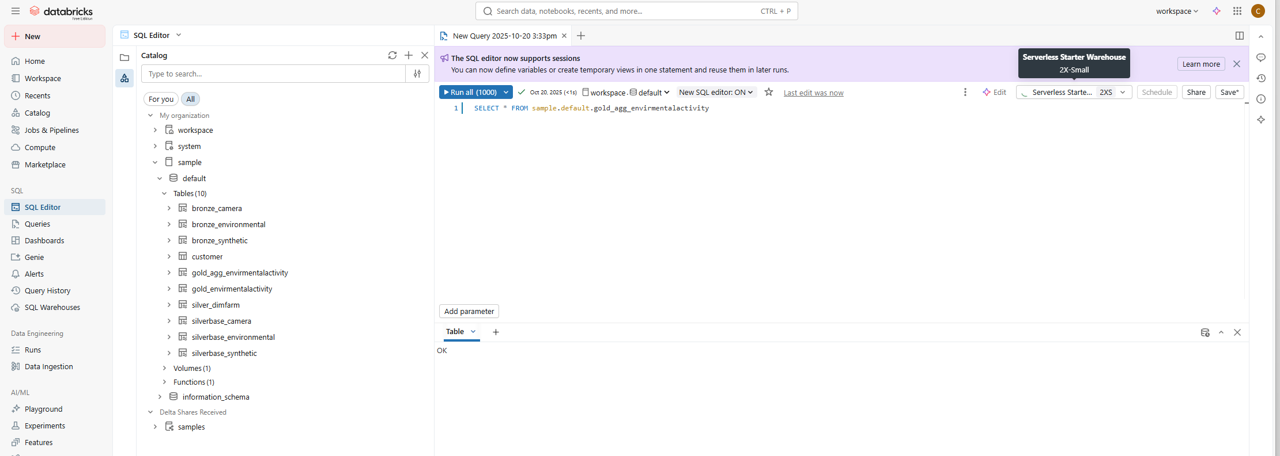

- Check Data
  - Open SQL Editor: Press SQL editor on side bar
  - Check if a cluster is running [Top right]. If Not, Press Start
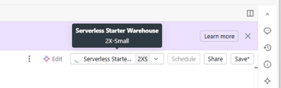
  - Write SQL to get data from tables. [Once server shows green]
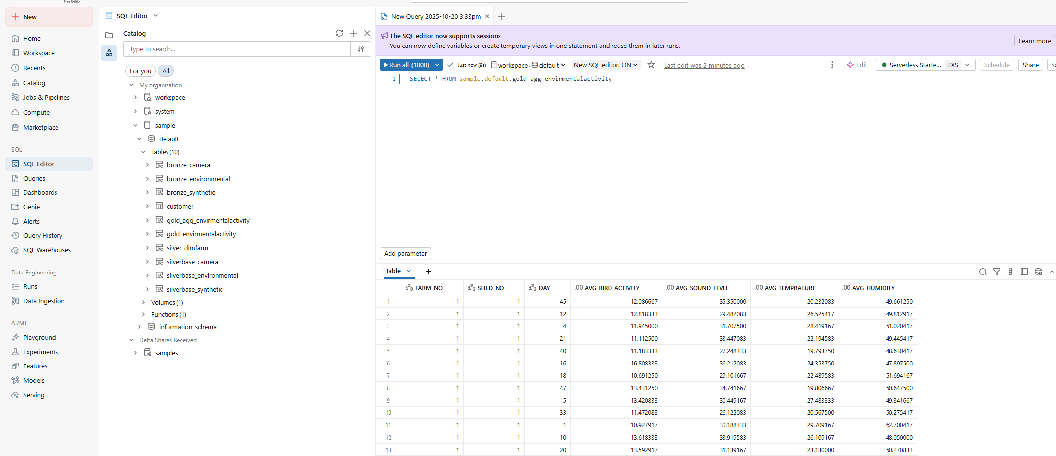

Data analytics component: [Estimated time 3-5 minutes]
Technology: Streamlit
Deployment Model: Docker image.
Deployment Files
Folder: Streamlit_app
Directory Structure:
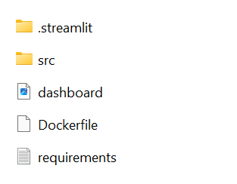
Specify Configuration secrets:
Hostname and Path
1. Go to databricks home page
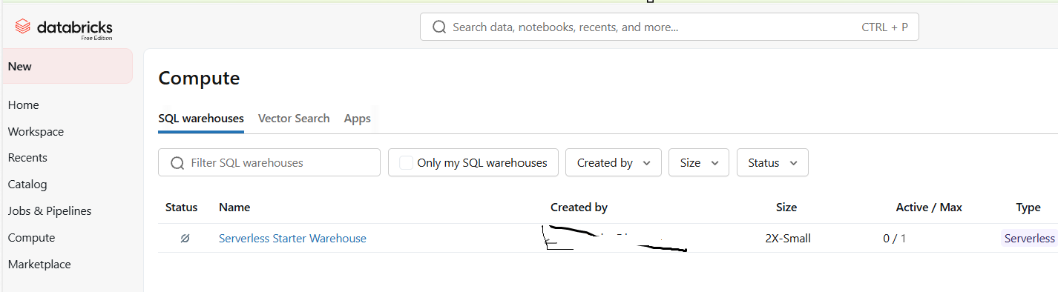

2. Open compute settings. Click on compute name and go to connections
Copy server hostname and HTTP Path 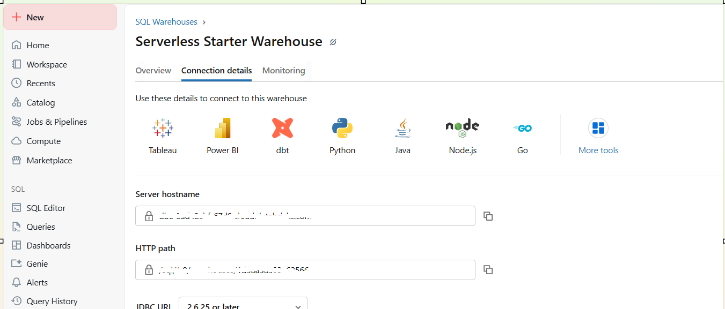

3. Get token
Open User [Upper right corner] settings
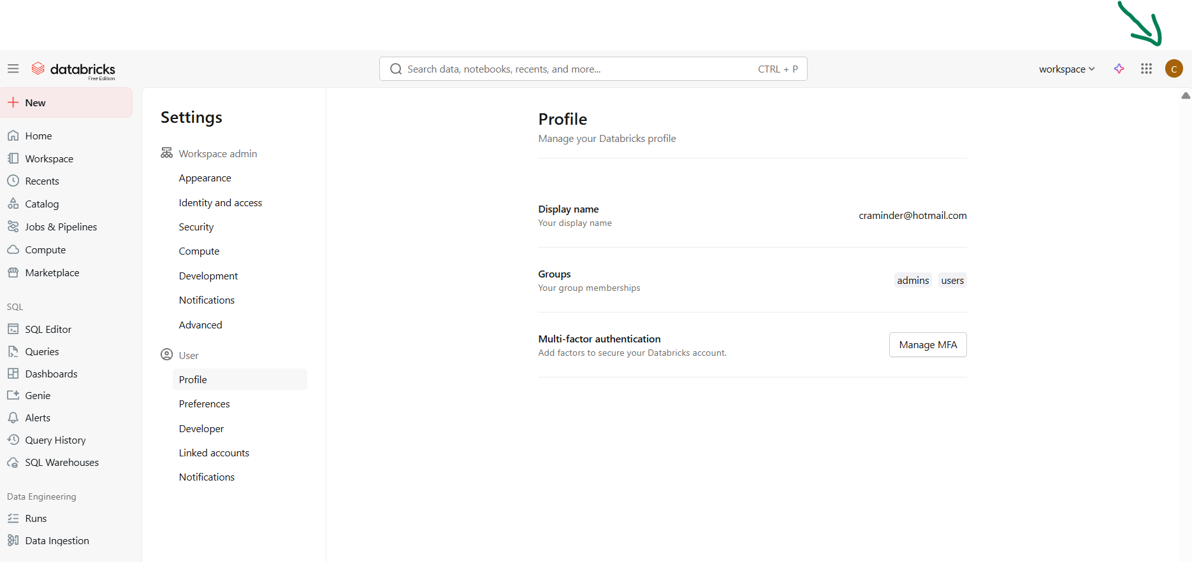
Go to developer and click Access tokens manage
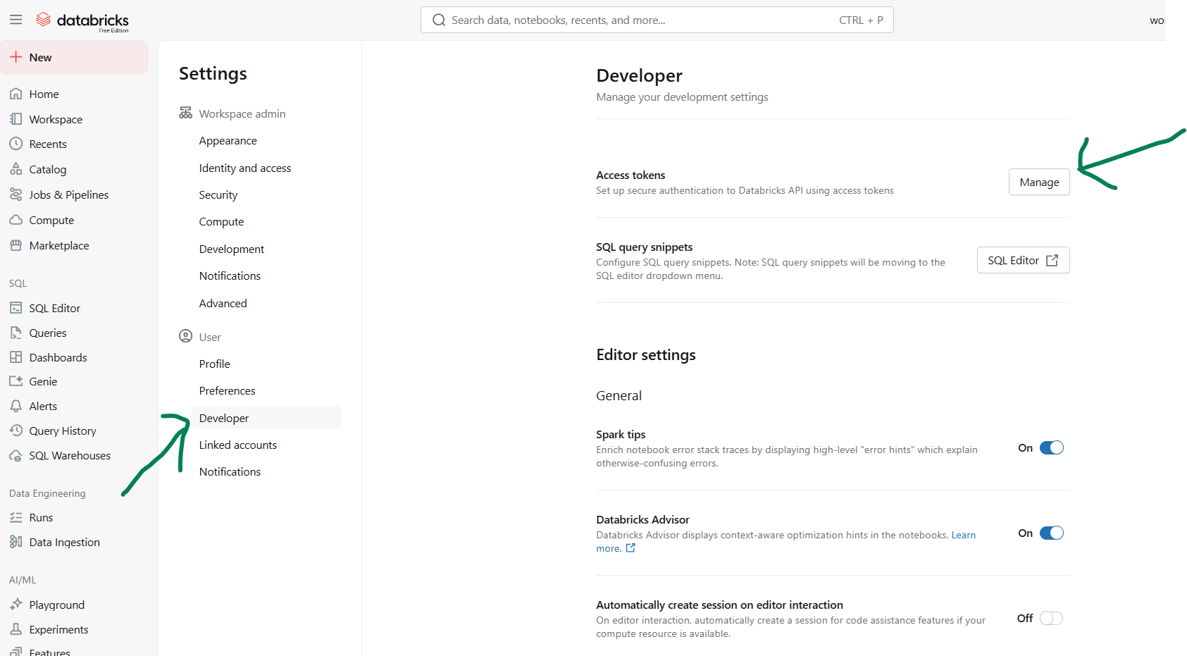
Generate Token and copy.
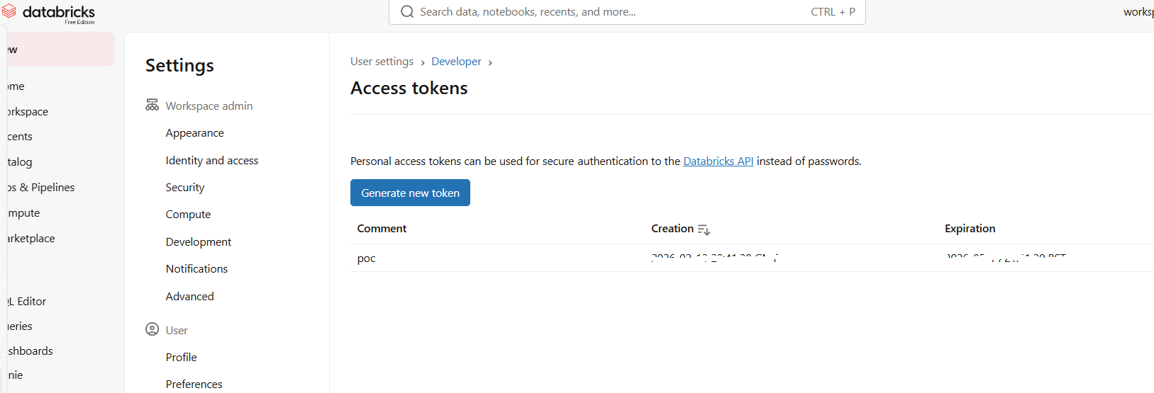
Add details to .streamlit/secrets
