Ray-Ban Meta GPT

Integration Testing

Gave the AI information about our project and the tools used in it(the glasses), explained the goal that we want to achieve and gave him an example photo with the perfect response to understand the concept, here are the results of the small testing done:

1.
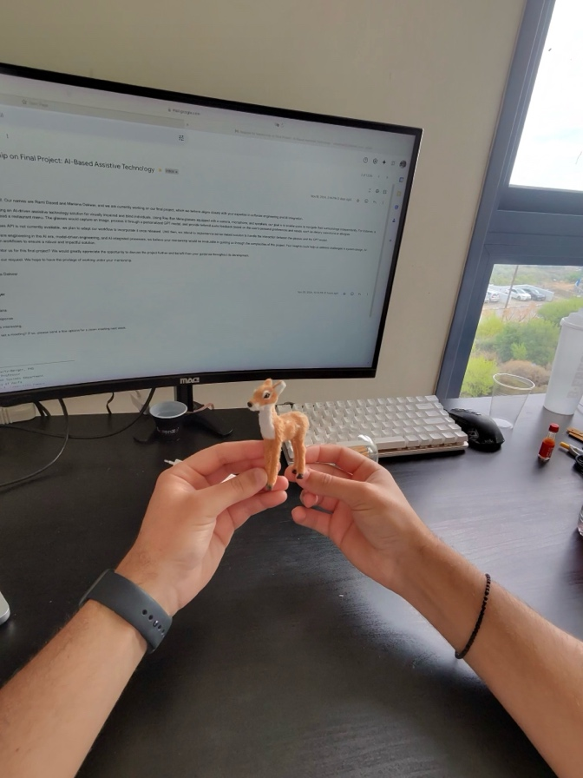
Objects Recognized:
1. Small deer figurine
2. Computer monitor (showing an email)
• Screen Header (email subject): “Mentorship on Final Project: AI-Based Assistive Technology”

Would you like me to read the entire text from the screen?

2.
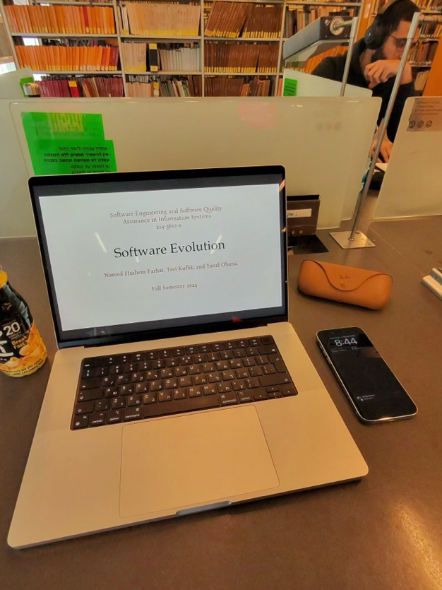

Objects Recognized:
1. Laptop (displaying a presentation/document)
• Header: “Software Engineering and Software Quality Assurance in Information Systems 214 3610-1”
• Title: “Software Evolution”
• Authors: “Narecd Hashem Farhat, Tsvi Kuflik, and Yuval Ohana”
• Semester: “Fall Semester 2024”
2. Phone (on the desk)

Would you like me to read all the text from the laptop screen?

3.
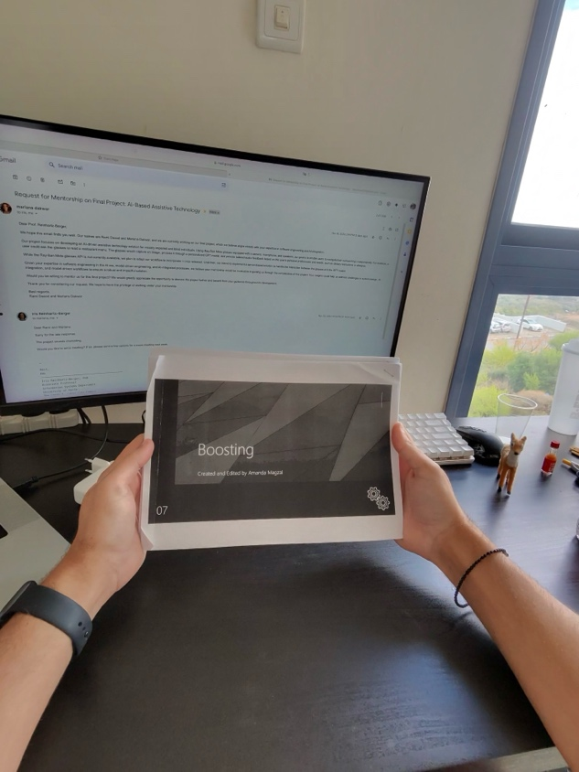

Objects Recognized:
1. Printed document
• Title/Heading: “Boosting”
• Subtitle: “Created and Edited by Amanda Magzai”
• Page Number: “07”
2. Computer monitor (showing an email)
• Screen Header (email subject): “Request for Mentorship on Final Project: AI-Based Assistive Technology”

Would you like me to read all the text from the document or from the screen?

4.
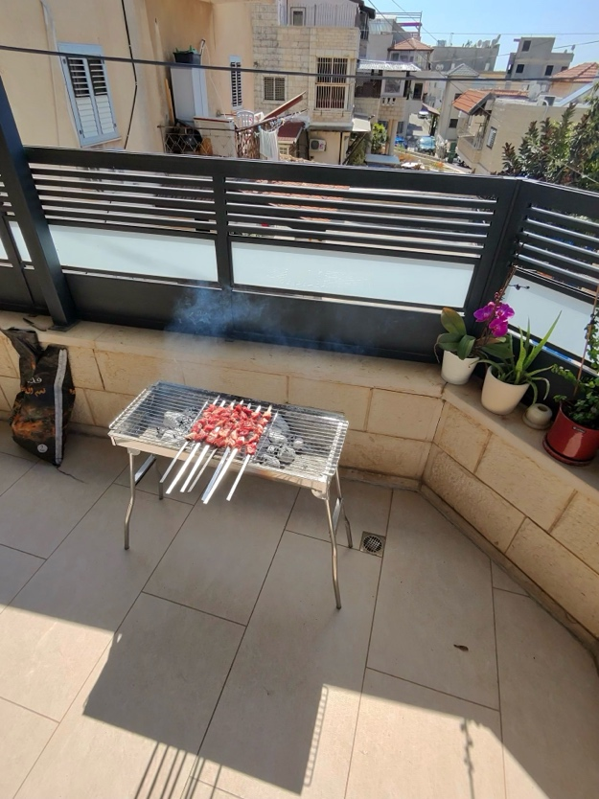

Objects Recognized:
1. Barbecue grill with skewers of meat
2. Potted orchid (on the right side)

No screens or documents with text detected.
Would you like me to check for any other details?

5.
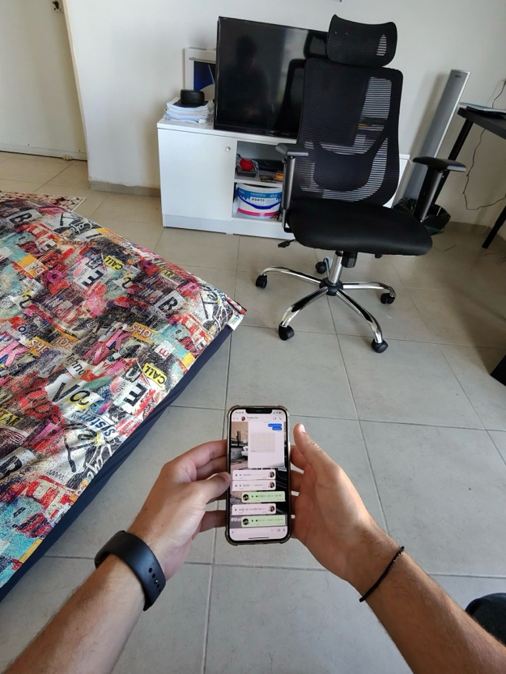

Objects Recognized:
1. Phone with a chat conversation on the screen
• Screen Header: (The contact’s name/number appears partially, not fully legible)

The text on the phone is somewhat small and partially visible. Would you like me to read the messages on the phone screen? If so, you may need to bring the phone closer or adjust the angle for a clearer view.

