

Web Development Report

CSY1018

1st Year Semester 1

<https://ramij-islington.github.io/CSY1018-assign1/> **Submitted by:**

Group:B Ramij Shrestha

Date:12/13/2015 UN ID: 014917442

Contents

Design & Development 2

Wireframes 3

Mock-up: Homepage 4

Mock-up: Bio.html 5

Mock-up: Contact Page 6

Mock-up: Cv page 7

Screenshot: HomePage 8

Screenshot: Bio 9

Screenshot: CV 10

Screenshot: Contact 11

Responsiveness 12

References 13

# Design & Development

The most challenging part of website was finding the color scheme. Testing with HSLA hue alpha opacity on Photoshop was scary and challenging however I compromised with the simple blend of colors. Using these colors on selected area was not difficult, I used light colors on negative spacing gradient. Finding icons in the web was challenging but to make it suit my page I edited with Photoshop As for my browser, I preferred Mozilla to Google chrome even though it has more APIs.

I tested my css with gradient colors which didn't make my color scheme have any relevance and lots of disorganization. Thus I used inspiring material design examples to help me get the right balance of colors. I think I fulfilled that.

# Wireframes

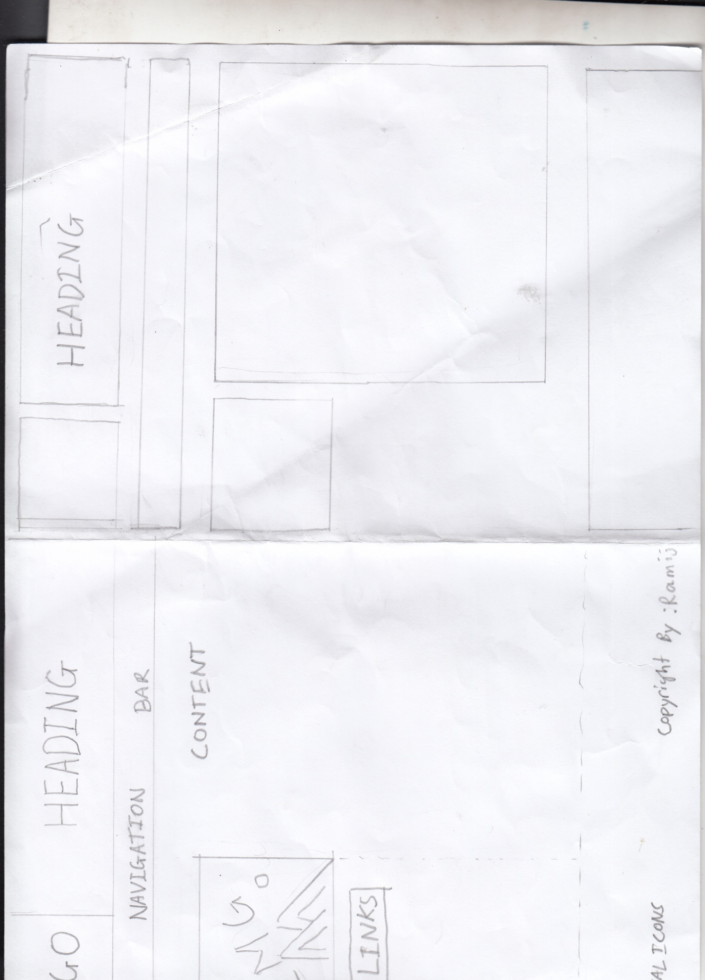

These two sketches show what the master page layout would be like with all its common features. I had seen many friends put their logo and navigation on the same header but I placed my logo next to the title inside the heading side by side. I have thought about making logo in photoshop.

The navigation bar sticking below it. Then have images to side with vertical links below it. These vertical links would be same as the navigation bar. Then on the footer, I will place social media icons and a copyright infringement.

As for the top sketch, I have enabled padding within a body or wrapper that gives negative spacing between the header, navbar and all elements within that body. This gives an artsy look to the page but this can devalue the spacing for contents and image size.

# Mock-up: Homepage

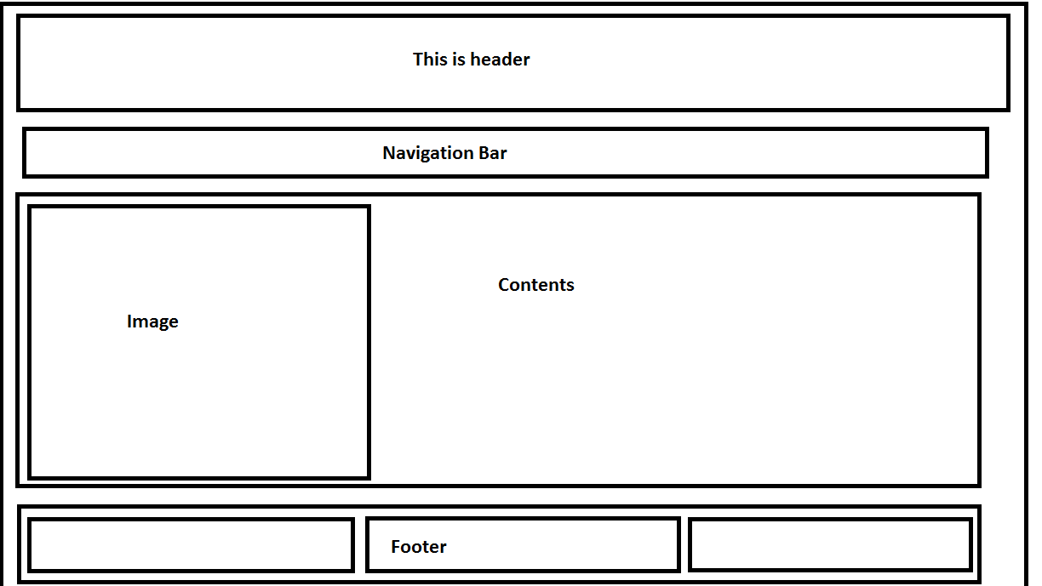

This is the homepage for mock-up which has suitable images for each page like a globe with text revolving around it. To apply this animation, I will need editing tools like fireworks and flash. Initially I was thinking about a body-width footer with the copyright infringement and icons aligned to bottom right and bottom left respectively but I decided on three flex items.

# Mock-up: Bio.html

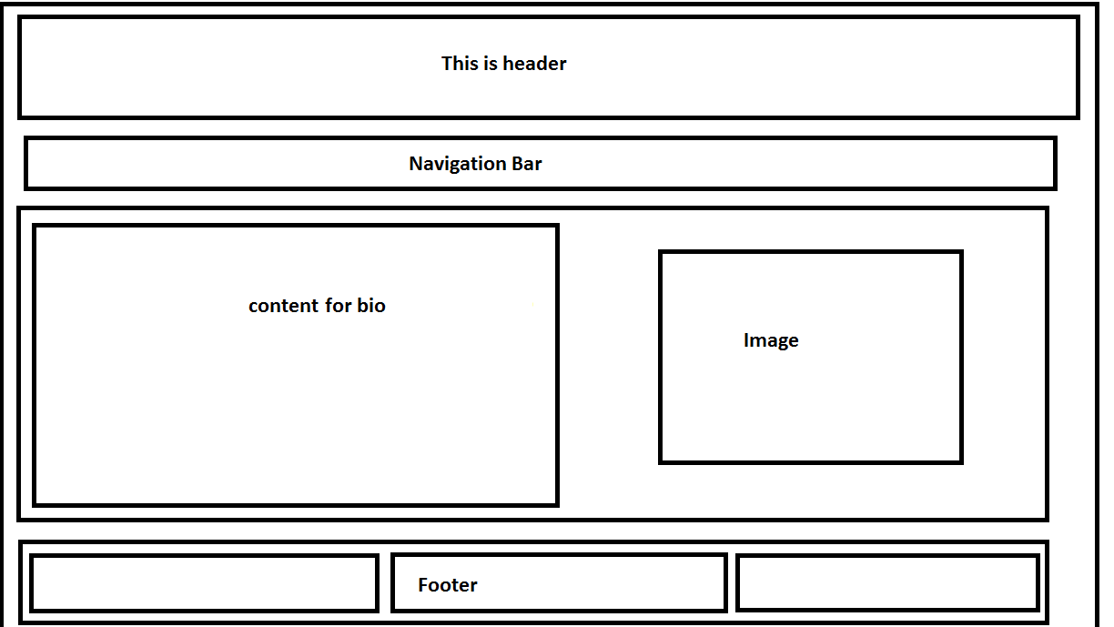

This is the mock-up for bio page which has the content and image reversed from the homepage. This will make the viewing of the page interesting and dynamic. Otherwise, it will be static and boring.

# Mock-up: Contact Page

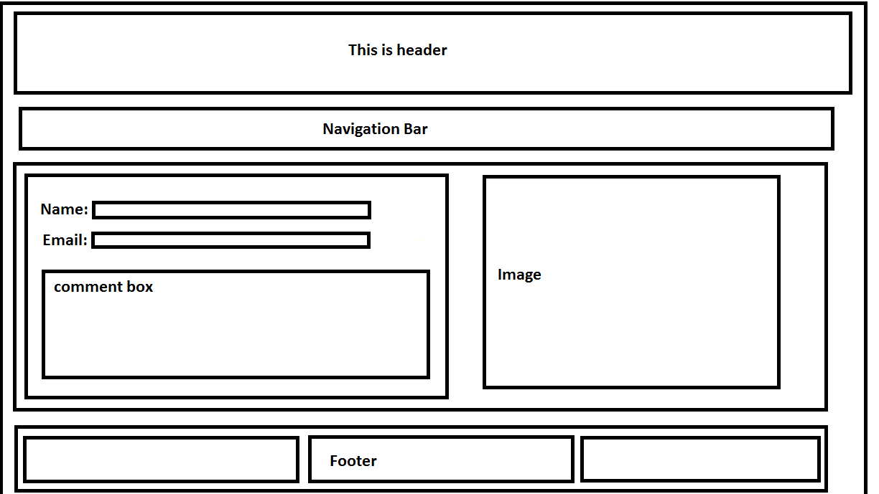

For the contact page, I have decided the same as the bio page which is reverse of placement of image and form. Previously mentioned, the image will have a globe with rotating text.

# Mock-up: Cv page

# cv.png

The CV page will have three flex items within the section. I have decided against putting the image for this page because I believe that the content is more important.

# Screenshot: HomePage

# Screenshot (19).png

I have learnt how to use the many properties of flex easily. Most of the troubleshooting and ideas I got was from codepen, w3schools, MDN and youtube videos. I did this project on my own. There were many cases where it took time to decide and adjust the paddings and margins. Also the number of flex items I should put on the footer. Initially it was one but then for better organisation and aesthetic point of view, I decided on three. I incorporated a transform:scale() to myanimation class (codepen,) and menubar. I applied transform: rotate() to my image.

# Screenshot: Bio

# Screenshot (21).png

I experimented with fixed background position with repeating image but decided against it. Thus I used material pallete to fill my elements with unique color. I made the edges or width of the header and navigation bar smaller to accomodate box-shadow. I defined box-shadow with grey color. Bio page will have two divisions in a section which will have contents in paragraph and photo.

# Screenshot: CV

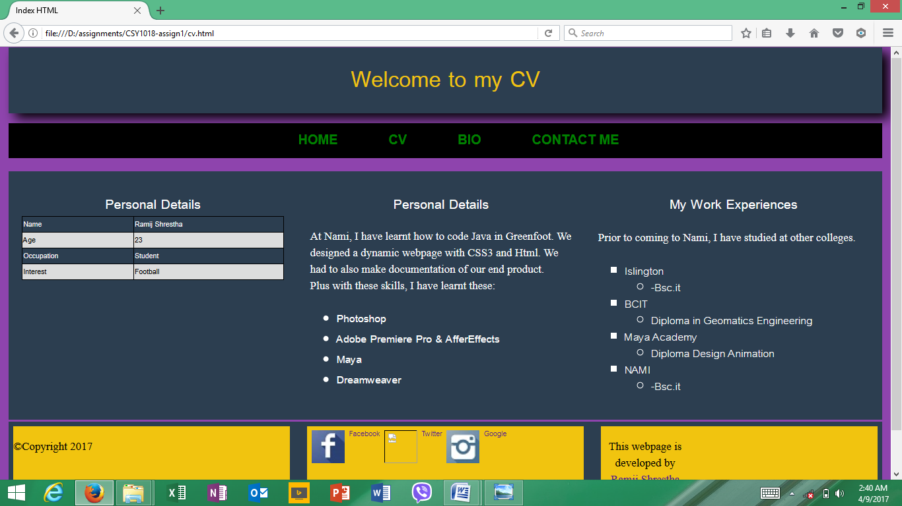

For my cv page, I have put personal details in table form using various css like colspan, rowspan and table collapse. As for the skills division, I have listed out the skills using unique list-style. Then I have work experiences and Education qualifications. I also included a link to my linkdin page which has my old certificates.

# Screenshot: Contact

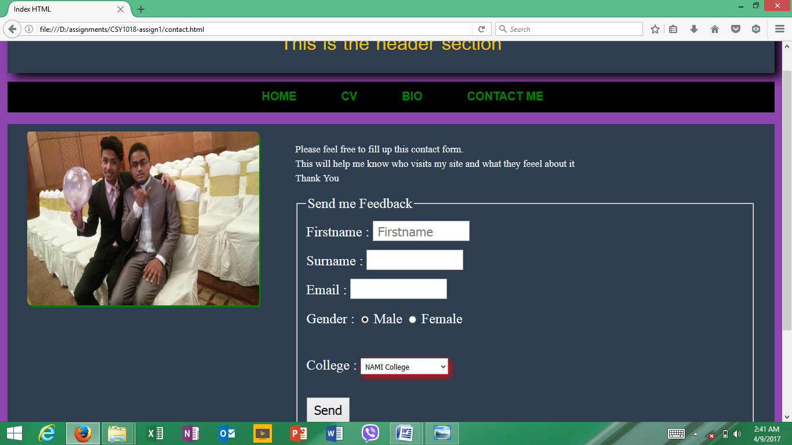

I have made the contact form within the fieldset. Similar to the bio page I have reversed the placement of image and form.

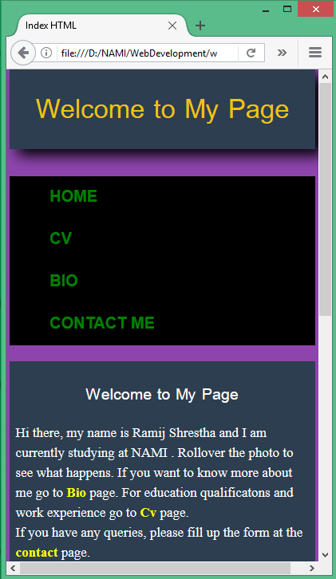

# Responsiveness

The basic mobile responsive view is very interesting because with little media query I was able to fit my elements properly. Instead of wrap I used no-wrap which gave adequate spacing between the elements. I didn't have elements to overflow in my media query.

# GitHub Challenges

In the begining of the project development process, I had to rename the project in GitHub unfortunately it overwrited my document with a blank one. I couldn't find solutions to recover it.

Also in midway when I tried pushing to GitHub, I had error "git.log is not recognized" in my system. So I inquired this problem to Dipak sir, he gave me a solution to re-clone the existing repo. Before this, in regards to my previous problem, I had backed up my new file if the new file had been overwritten my the previous file from GitHub. As expected, thus I copied and pushed my back ups to the GitHub.

Due to these glitches with GitHub, I didn't code my files from the repository but worked in my local folder. Then I would copy the files to the repository to push to GitHub.

# 

# References

Mozilla Developer Network and individual contributors. (2017). Using CSS Flexible Boxes. [online] Availableat:https://developer.mozilla.org/enUS/docs/Web/CSS/CSS_Flexible_Box_Layout/Using_CSS_flexible_boxes [Accessed 30 Mar. 2017].

Rose, T. (2017). *Animation Example Template*. [online] CodePen. Available at: http://codepen.io/UoN-ThomasRose/pen/rWYOve [Accessed 28 Mar. 2017].

Editorial Team. (2017). *Inspiring Material Design Examples with HTML & CSS - CreativeCrunk*. [online] CreativeCrunk. Available at: http://creativecrunk.com/inspiring-material-design-examples-with-html-css/ [Accessed 2 Apr. 2017].

Material Palette - Material Design Color Palette Generator. (2017). *Material Palette - Material Design Color Palette Generator*. [online] Available at: https://www.materialpalette.com/ [Accessed 28 Mar. 2017].

Stanford, J. (2017). *joel.sh - home of Joel Stanford*. [online] joel.sh. Available at: https://joel.sh/about [Accessed 9 Apr. 2017].