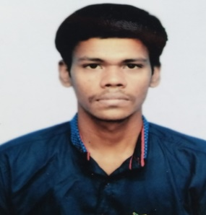 Resume

**Ramik Shit**

Kona Purba Pada, Benaras Road, Howrah-711114

**Mobile no. :-7980982059 DOB:- 03-03-1997 Email:-ramikshit05@gmail.com**

**Profile**

An optimistic coder looking forward to excel in a given task and deliver an excellence results, looking for an opportunity show the skills.

**Education**

College: Bachelor of Science(BSc.Gen) from Asutosh College(West Bengal)

Pass out (2019)

Secondary School: Sudhir Memorial High School(West Bengal)

Pass out (2015)

Primary School: Infant Jesus High School(Maharashtra)

Pass out (2013)

**Work Experience**

Fresher

**Software Courses**

* Certificate in Computer Application (CCA).
* Certificate in Computer Programing and Application (CCPA).
* Certificate in Advanced Computer Programming and Application (CACPA).
* Certificate in Software Engineering (CSE).

**Coding Language**

HTML, CSS, C#, Java and bit of JavaScript.

**Framework**

ASP.NET

**Database**

Microsoft SQL Server.

**Projects**

Personal Portfolio Website-

Student Examination with ASP.NET framework 4, with C# and internal SQL Server provided:-

GitHub Link- https://github.com/ramikshit97/ASP.NET-exam-project.git