SELF DRIVING CAR engineer nd

RAMIL SHARIFSOY | UDACITY | MAY 25, 2017 | COURSE PLAN

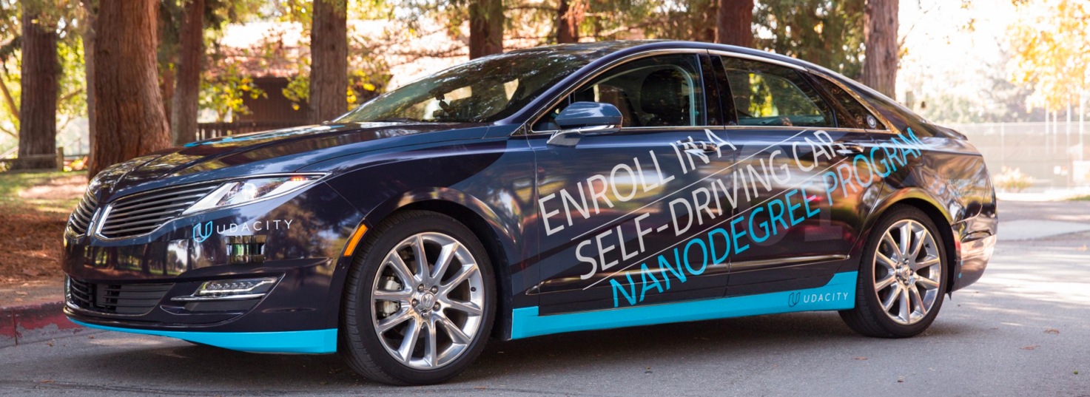

| Task | Due Date | Done | Initials |
| --- | --- | --- | --- |
| 1. Computer Vision and Deep Learning |  |  |  |
| * 1. Project: Finding Lane Lines | June 1 | X | rs |
| * 1. Neural Networks |  |  |  |
| * 1. Project: Traffic Sign Classifier | July 3 |  |  |
| * 1. Project: Behavioral Cloning | July 24 |  |  |
| * 1. Project: Advanced Lane Finding | August 7 |  |  |
| * 1. Machine Learning |  |  |  |
| * 1. Project: Vehicle Detection and Tracking | August 21 |  |  |
|  |  |  |  |
|  |  |  |  |
|  |  |  |  |
|  |  |  |  |
|  |  |  |  |
|  |  |  |  |
|  |  |  |  |
|  |  |  |  |
|  |  |  |  |
|  |  |  |  |
|  |  |  |  |
|  |  |  |  |
|  |  |  |  |
|  |  |  |  |
|  |  |  |  |
|  |  |  |  |
|  |  |  |  |
|  |  |  |  |
|  |  |  |  |
|  |  |  |  |
|  |  |  |  |
|  |  |  |  |
|  |  |  |  |
|  |  |  |  |
|  |  |  |  |
|  |  |  |  |
|  |  |  |  |
|  |  |  |  |
|  |  |  |  |
|  |  |  |  |
|  |  |  |  |
|  |  |  |  |
|  |  |  |  |
|  |  |  |  |