

**Project Title: NoteBank**

Course Name: Software Engineering & Design Pattern

Course Code: CSE 417

Submitted to,  
Dewan Ahmed Muhtasim  
Lecturer  
Department of Computer Science and Engineering  
Metropolitan University

Submitted by,  
Ramim Ahmed (222-115-141)

Mahinur Rahman Pamel (222-115-142)

Jahid Hasan (222-115-116)

Abu Taher Chowdhury (222-115-134)  
Batch: 57th (D)  
Department of Computer Science and Engineering  
Submission date: 11/08/25

# 

Contents

1.Project Title: Note Bank 3

2.Problem Addressed: 3

Problem: 3

3. Objectives: 3

4.Functional Requirements: 3

4.1 Core Features (Modules): 3

4.2 Programming Languages: 4

4.3 Frontend Framework: 4

4.4 Backend Framework: 4

4.5 IDE: 4

4.6 Use Case Diagram: 4

4.7 System Sequence Diagram: 6

1.User Registration 6

2.User Login 7

3.Forgot Password Request 8

4.Password Change Phase 9

5.Change Password 10

6.Profile Edit Form 11

7.View Dashboard 12

8.Note Upload 13

9.View Bookmarks 14

10.Feedback 15

11.Contributor 16

4.8 Wireframe (High-Level UI Idea): 17

4.9 Platform: 17

4.10 Version Control: 17

6.Non-Functional Requirements: 17

7. Development Workflow (Agile-based): 18

Sprint Planning: 18

# ****1.Project Title:**** Note Bank

# 2. ****Problem Addressed:****

In many universities, students depend on scattered and unorganized platforms such as Facebook groups, Google Drive links, and WhatsApp chats to:

* Share class notes and study materials
* Access faculty information
* Find assignments, lecture slides, and previous question banks
* Discuss exam preparation and academic updates

This fragmented approach leads to **inefficient manual sharing**, **missed important updates**, and **difficulty locating reliable resources**. The absence of a **centralized academic hub** limits collaboration, wastes time, and creates barriers to effective student engagement.

# 3. ****Objectives:****

The main objectives of the **NoteBank** project are:

1. **Centralize Academic Resources** – Create a single platform for storing and sharing class notes, assignments, lecture slides, previous question banks, and other study materials.
2. **Facilitate Easy Access** – Enable students to quickly search, filter, and download resources anytime, from any device.
3. **Enhance Collaboration** – Promote student-to-student and student-to-faculty engagement through resource sharing, feedback, and announcements.
4. **Ensure Quality of Materials** – Implement a rating and review system so students can evaluate and identify high-quality notes.
5. **Provide Faculty Information** – Offer a dedicated faculty directory with details such as contact information, office hours, and courses taught.
6. **Support Administrative Oversight** – Equip administrators with tools to manage users, approve uploads, and post official academic updates.
7. **Improve Academic Efficiency** – Reduce time spent searching for study materials and increase focus on learning.

# ****4.Functional Requirements:****

## 4.1 Core Features (Modules):

|  |  |
| --- | --- |
| **Module** | **Description & Functionalities** |
| **User Management** | - Register and login with email verification  - Role-based access (Student, Faculty, Admin)  - Password change and reset  - Profile edit (name, email, department, contact, profile picture etc) |
| **Dashboard** | - Personalized dashboard showing uploaded notes, bookmarks, recent activity, and notifications- Quick access to “My Notes” and frequently used features  - Showing total download, bookmarks, likes , average rating by others users. |
| **Note Sharing** | - Upload notes, assignments, lecture slides, and previous question banks etc.  - Categorize by course or subject- Search, filter, and sort resource  - Download and share materials  - Share the materials to others via share links. |
| **Bookmarks & My Notes** | - Bookmark favorite notes for quick access  - View “My Notes” section to manage uploaded files  - Edit (update) uploaded notes  - Delete uploaded notes |
| **Faculty Directory** | - Browse faculty profiles with department, contact details, courses taught, and social links |
| **Rating & Review System** | - Submit ratings and reviews for notes  - Display average rating and user feedback to indicate note quality |
| **Notification System** | - Real-time alerts for new uploads, comments, bookmarks, and announcements |
| **Admin Panel** | - Approve/reject uploaded resources  - Manage users and their roles- Post official academic notices  - View system analytics  - Admin can add new department, faculty, category note and others.  - Admin have full controls of notebank. |

## ****4.2 Programming Languages and Tools:****

* **Frontend:** HTML, TailwindCSS
* **Backend:** Django Rest Framework
* **Database Query:** Django SQLite
* **API Testing:** Postman

## ****4.3 Frontend Framework:****

* **React.js**: Component-based, SPA-friendly, large ecosystem
* **Tailwind CSS:** Utility-first, fast responsive styling

## 4.4 ****Backend Framework:****

* **Django + Django REST Framework**
  + Fast, secure, robust
  + Built-in admin
  + Great for API development

## 4.5 ****IDE:****

* VS Code (for both frontend and backend)

## ****4.6 Use Case Diagram:****

Includes:

* Student: Upload/download notes, update profile, view routines, join clubs
* Faculty: Upload notes, post announcements, manage academic calendar
* Admin: Manage all modules, moderate uploads, view analytics

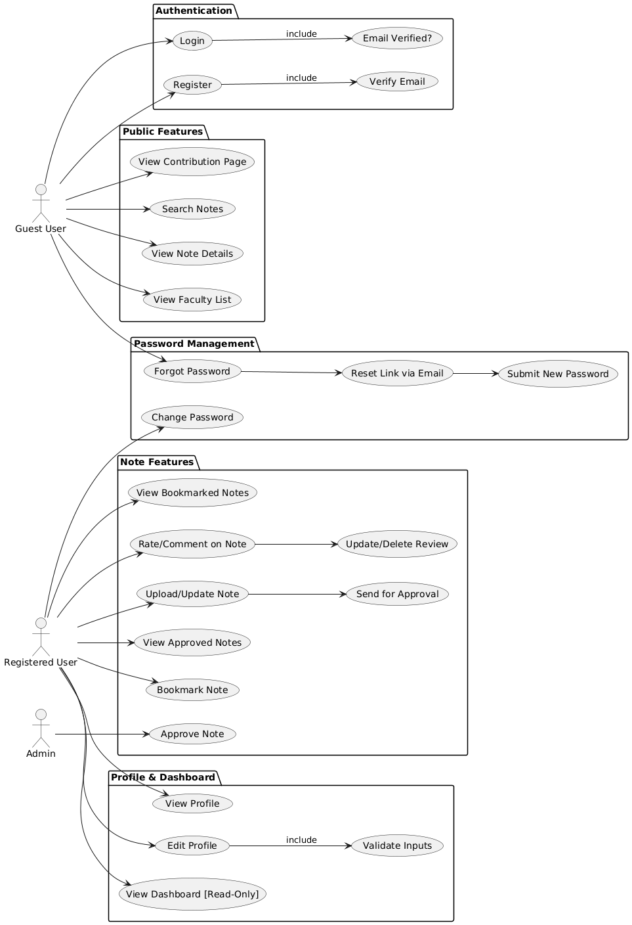

## 4.7 ****System Sequence Diagram:****

### 1.User Registration

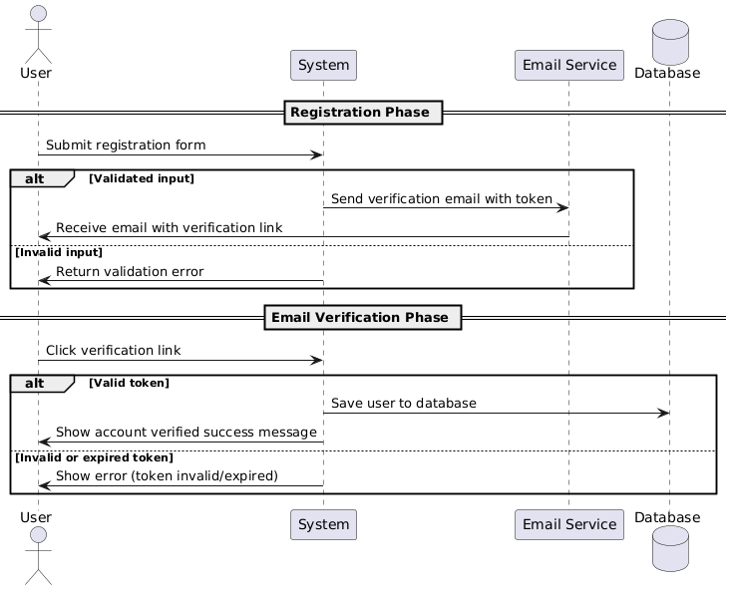

### ****2.User Login****

### ****3.Forgot Password Request****

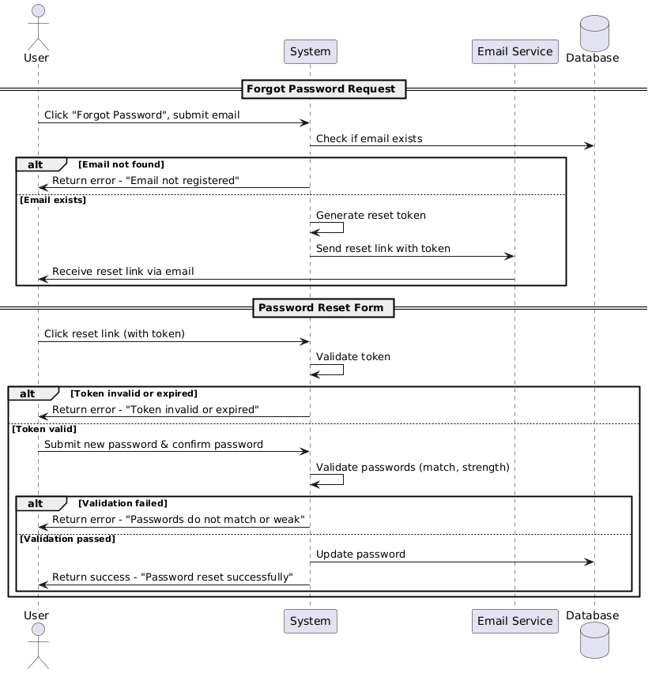

### 

### ****4.Password Change Phase****

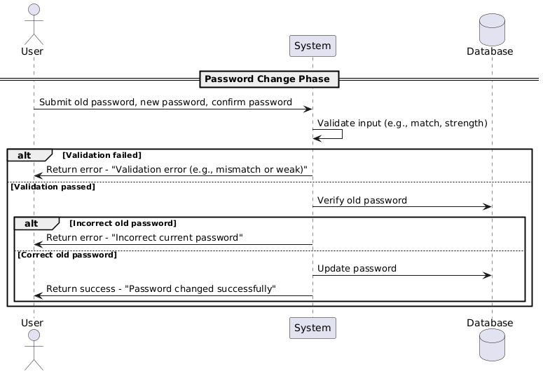

### 5.Change Password

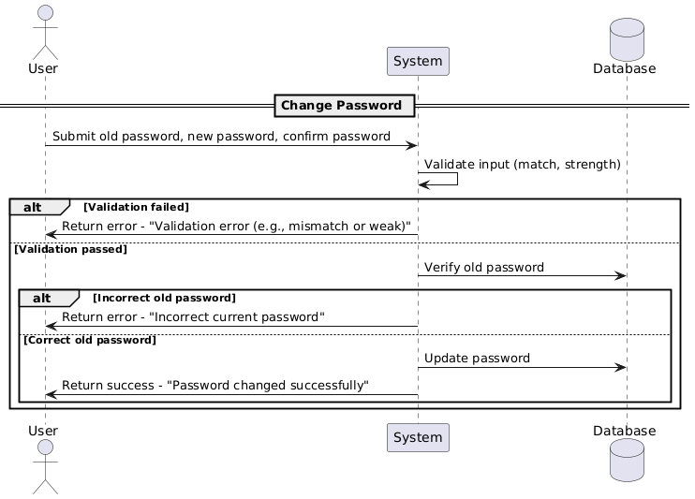

### 6.Profile Edit Form

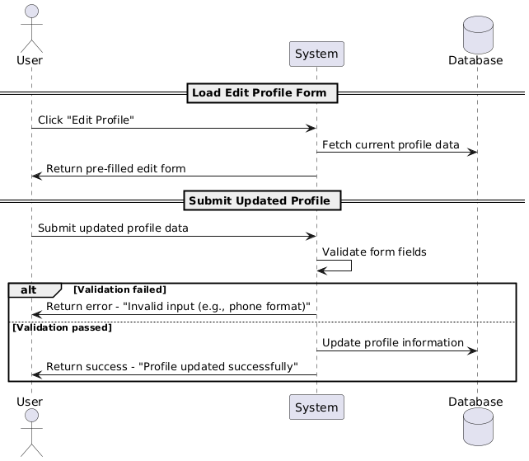

### 7.View Dashboard

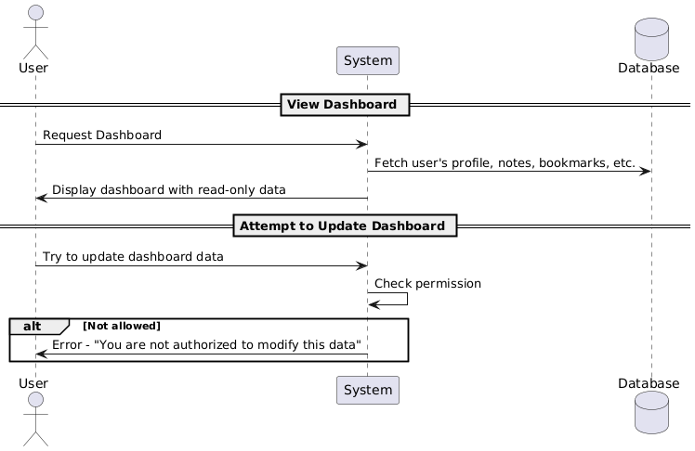

### 8.Note Upload

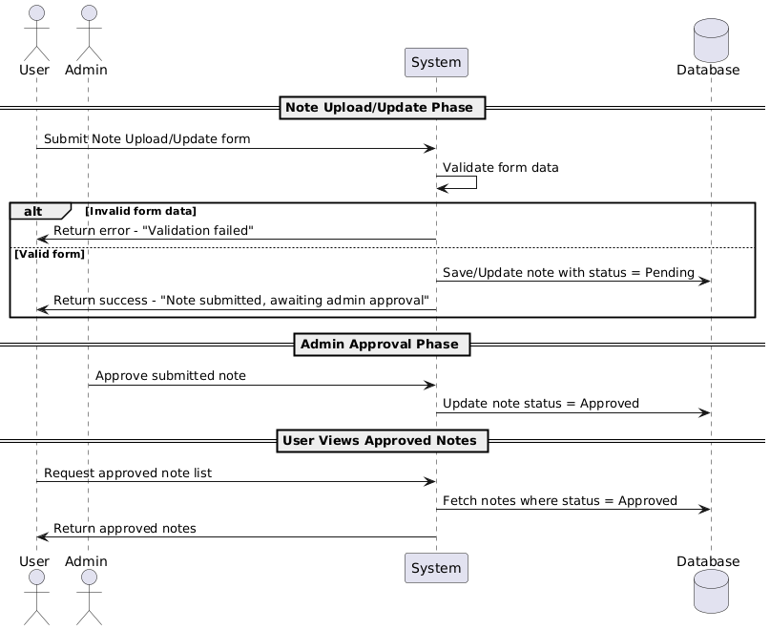

### 9.View Bookmarks

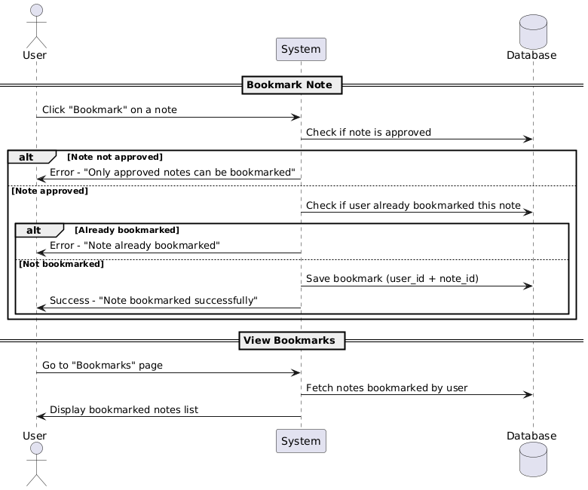

### 10.Feedback

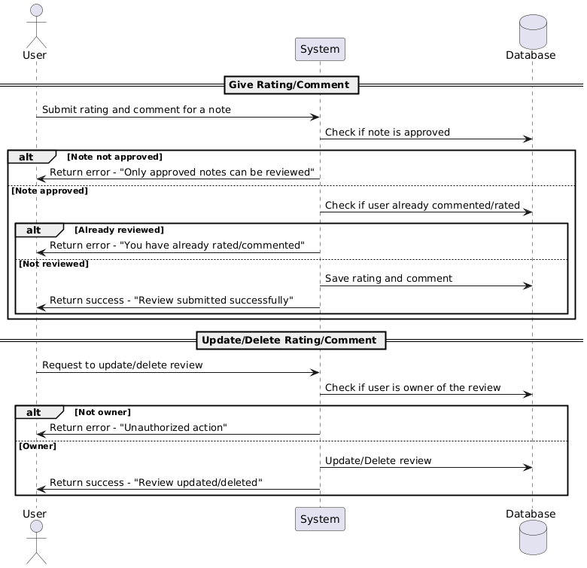

### 11.Contributor

## ****4.8 Wireframe (High-Level UI Idea):****

* Dashboard
* Notes Page with Filters
* Faculty Directory Cards
* Calendar View
* Profile Page

Tools for wireframe: Figma, Balsamiq, Adobe XD

## ****4.9 Platform:****

* **Backend server**: Django (run via Gunicorn)
* **Frontend**: React via Vite
* **Dev Platform**: Docker (optional) or XAMPP for MySQL, Node.js for environment
* **Database**: PostgreSQL or MySQL

## 4.10 ****Version Control:****

* **Git + GitHub**
* Project boards (Kanban)
* Issues & Pull Requests for code collaboration

# ****5.Non-Functional Requirements:****

|  |  |
| --- | --- |
| **Category** | **Details** |
| **Performance** | API should respond within 500ms |
| **Scalability** | Add new modules without major code changes |
| **Security** | JWT authentication, role-based access, input sanitization |
| **Reliability** | System must handle 100+ concurrent users |
| **Documentation** | API Docs with Swagger/Postman, code docstrings |
| **Time Constraints** | MVP in 3–4 weeks, full system in 8 weeks |
| **Hardware** | Core i5+, 8GB RAM dev machine |
| **Team Management** | Weekly sprint planning, version tagging, task assignment |

# 6. ****Development Workflow (Agile-based):****

## Sprint Planning:

* **Sprint 1**: Auth, user model, DB setup, React home/login/register
* **Sprint 2**: Note upload, category filter, view/download notes
* **Sprint 3**: Faculty module
* **Sprint 4**: Academic tracker, review system, notifications
* **Sprint 5**: final testing, bug fix