

**CSE327.9: System Modelling**

**PROJECT:** CricStics – A web-based application for ICC Men's Cricket World Cup 2023

**Activity diagram:**

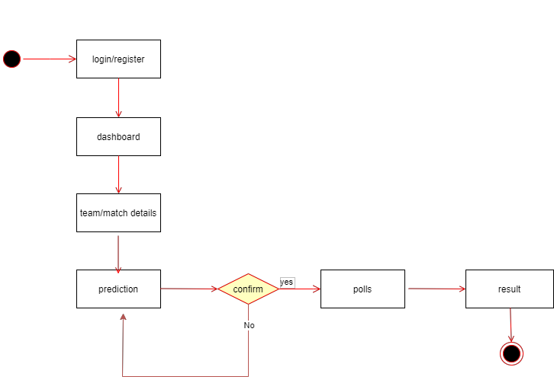

**Use-Case diagram:**

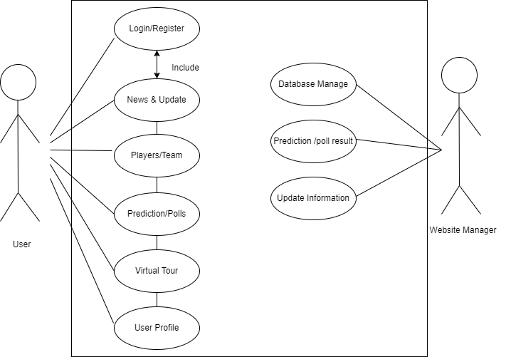

**Sequence diagram:**

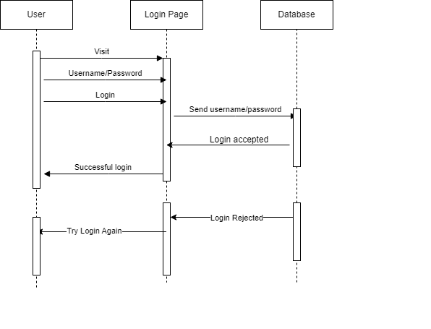

**Class diagram:** 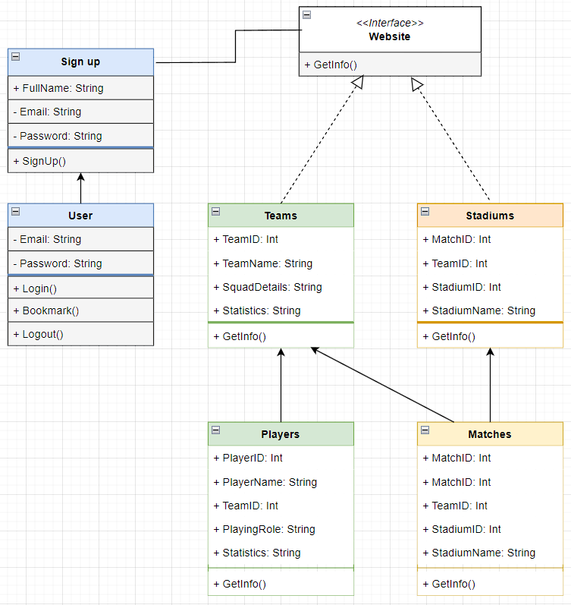

**State diagram:** 